The update of the reconstructed position correction and the energy in both crystal and glass region

Position correction (Crystals region)
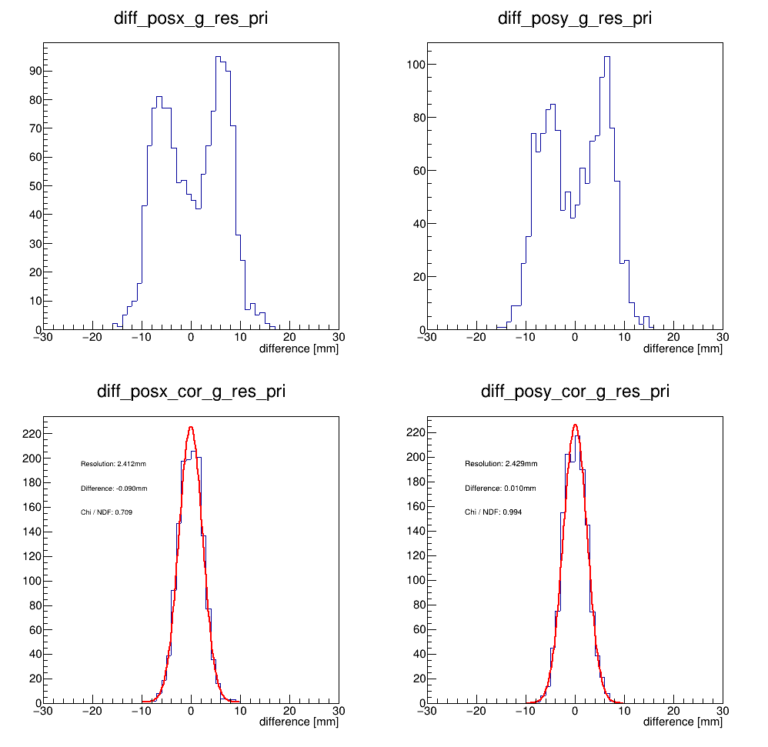
The plots are the difference of the primary project position and the position reconstruction corrected of the crystal region from -300mm < x < 300mm, -300mm < y < 300mm. Based on the result, both resolution are around 2.4 mm, and the deviation of the both peak are smaller than 0.01mm.

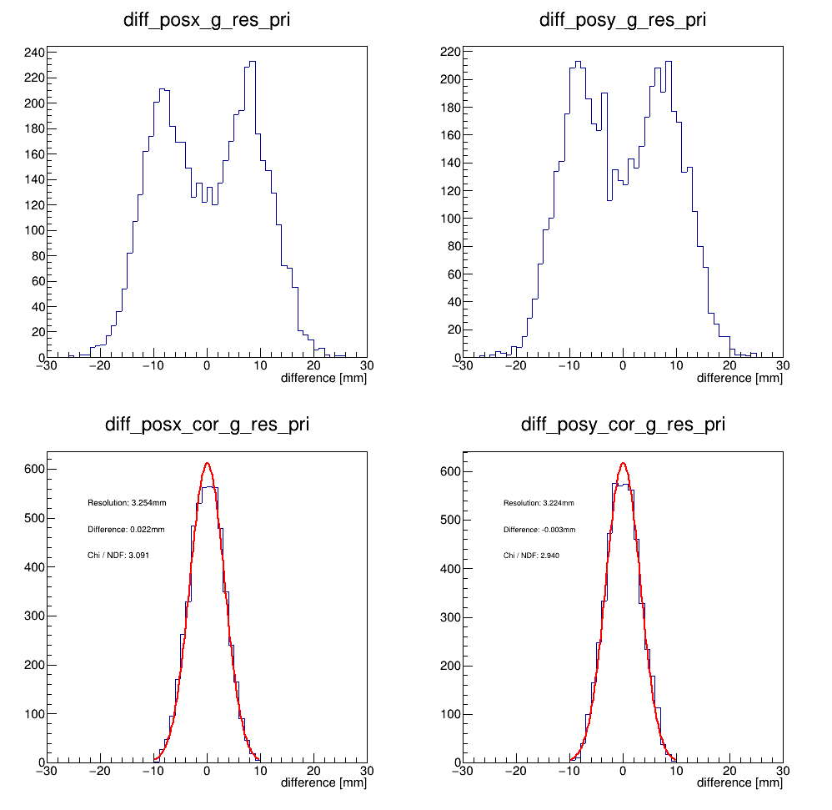
The plots are the difference of the primary project position and the position reconstruction corrected of the crystal region from -500mm < x < 500mm, -500mm < y < 500mm. Based on the result, both resolution are around 3.2 mm.

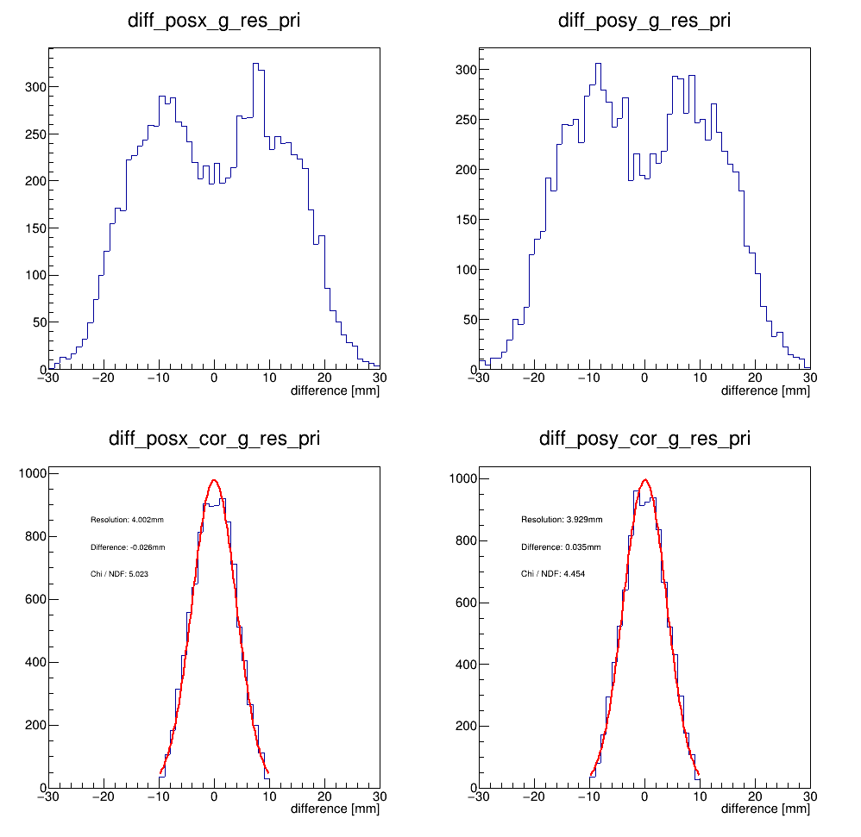
The plots are the difference of the primary project position and the position reconstruction corrected of the crystal region from -700mm < x < 700mm, -700mm < y < 700mm. Based on the result, both resolution are around 4.0 mm.

Basing on these comparison, we can find the region more far from the center, the reconstructed resolution get worse. The reason would be we just consider the 1-order of the correction, we need to consider the higher order correction for the large scattering angle. And the parameter a for calculation the shower depth of PbWO₄ crystal should be tuned, and this is obvious as we look into the reconstructed result of the single side of the crystal region.
Shower depth correction

The parameter a of the shower depth can be expressed as followed:

a = (0.3 * Clus_Energy^0.28) + 4.862) * 10.

The unit of a would be in [mm], and this formula is shower depth for the PbF₂ crystal. The PbWO₄ radiation length is smaller than the PbF_{2.} In the following plots, I will choose to tune the 4.862 (ao) to the smaller value, and see the result.
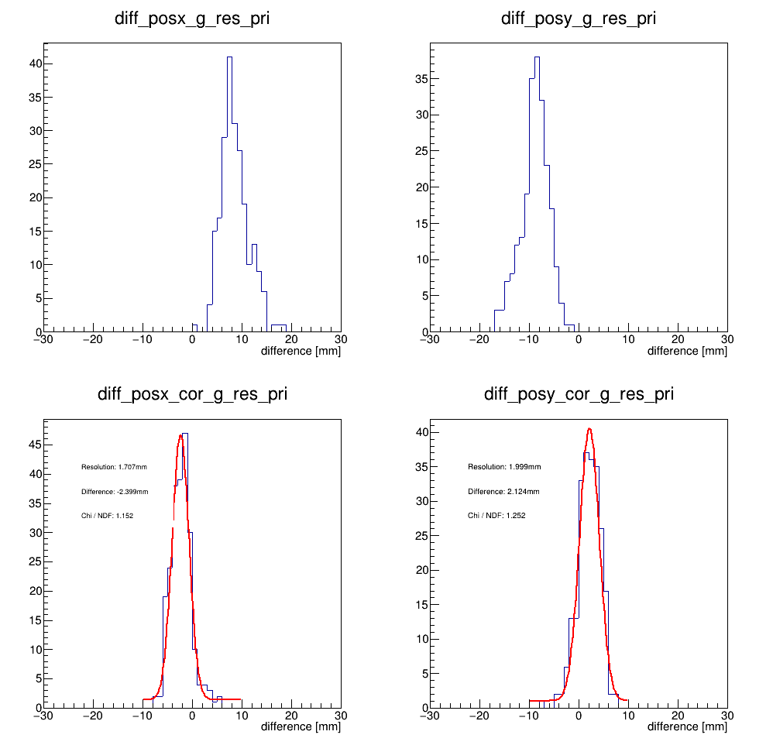
The plots are the difference of the primary project position and the position reconstruction corrected of the crystal region from -400mm < x < -200mm, 200mm < y < 400mm. In this case, ao is 4.862 and we can see both of them are over corrected, if you compared with the upper plots without the shower depth correction,
x: +8. -> -2.4,
y: -8. -> +2.1.

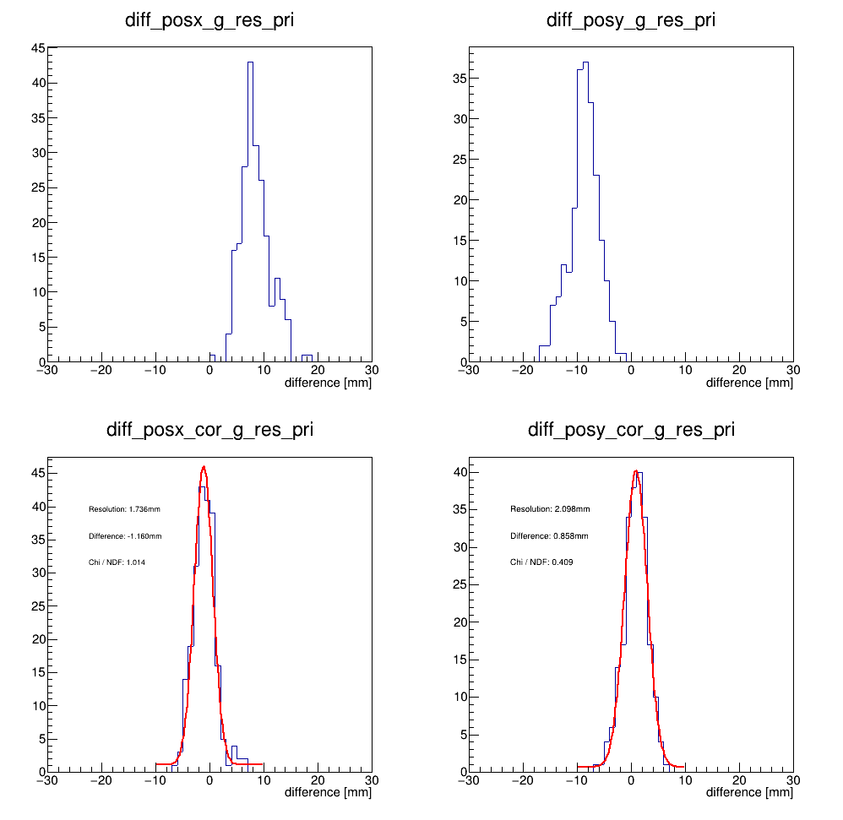
The plots are the difference of the primary project position and the position reconstruction corrected of the crystal region from -400mm < x < -200mm, 200mm < y < 400mm. In this case, ao is 3.862 and we can see the correction is better than the previous one.
x: +8. -> -1.1,
y: -8. -> +0.8.

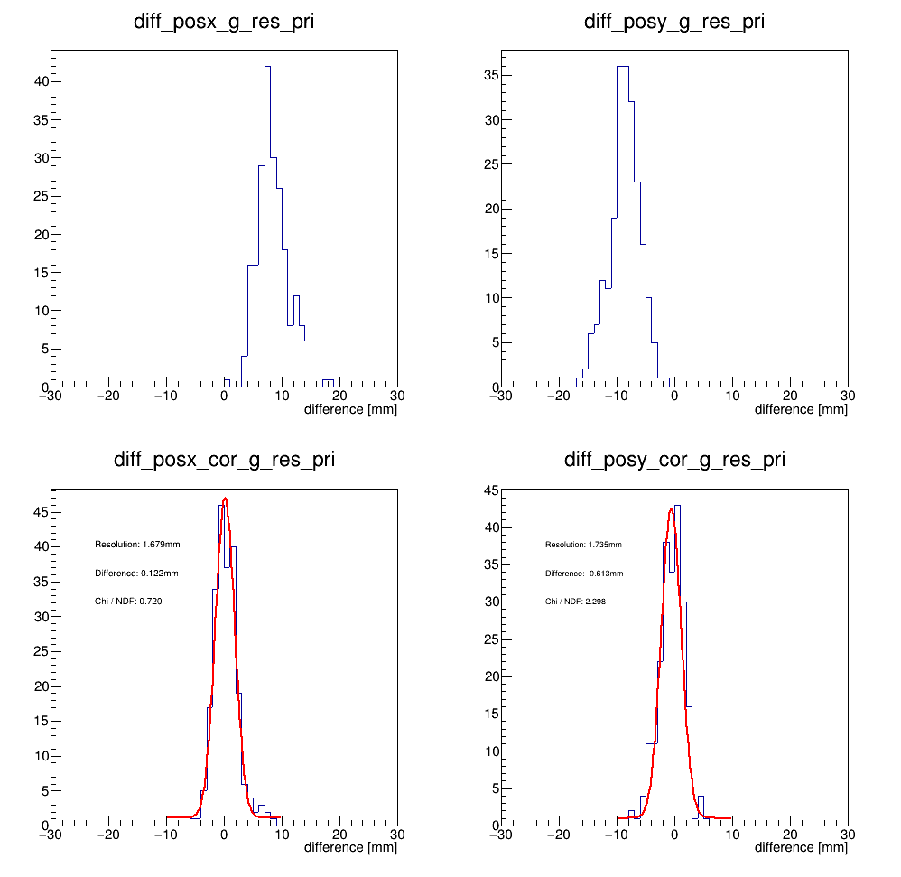
The plots are the difference of the primary project position and the position reconstruction corrected of the crystal region from -400mm < x < -200mm, 200mm < y < 400mm. In this case, ao is 2.862 and we can see the correction get better than the previous one again, and it seems good enough.
x: +8. -> +0.1,
y: -8. -> -0.6.

Now, we apply the smaller ao (2.862) to the shower depth formula and looks the result of the reconstructed result of the -700mm < x < 700mm, -700mm < y < 700mm.

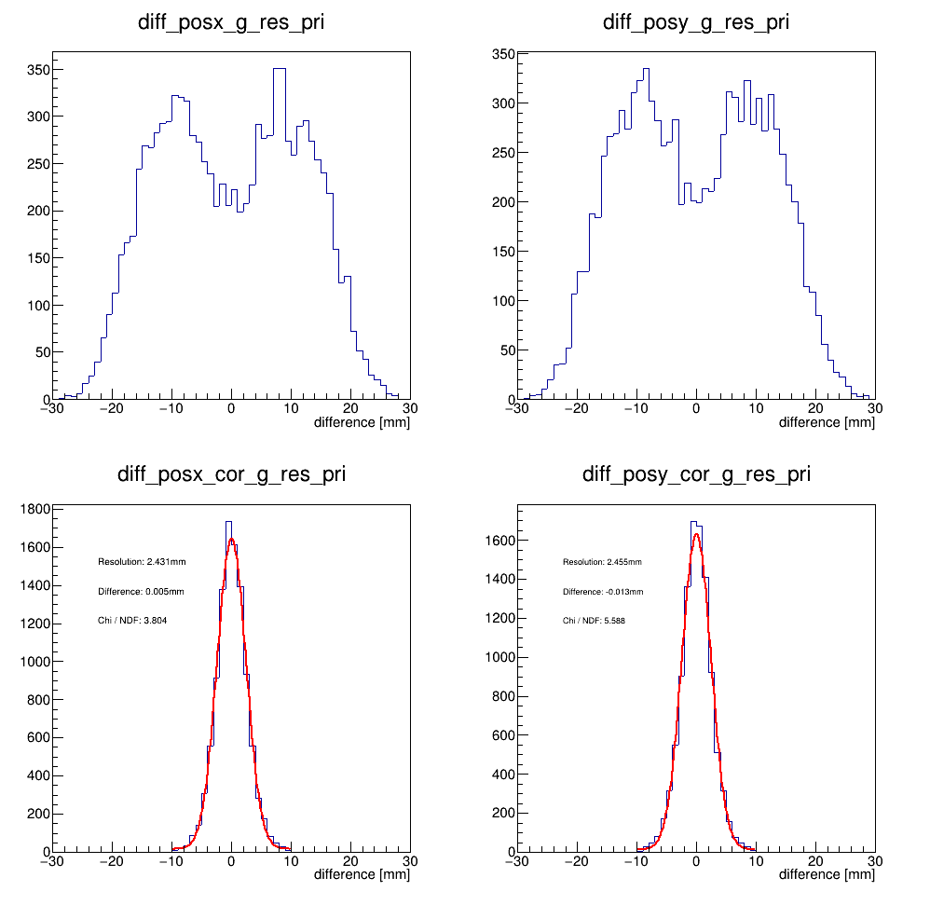
The plots are the difference of the primary project position and the position reconstruction corrected of the crystal region from -700mm < x < 700mm, -700mm < y < 700mm. With ao = 2.862, we can find the resolution, ~2.4mm, is better than the resolution, ~4.0mm, of ao = 4.862.

Energy reconstructed (Crystal)

The energy reconstruction of each event is to find the seed crystal first, which is the crystal with local max energy deposition. After finding the seed, starting to build the cluster based on this seed, the size of cluster is about 3 x crystal / glass size. Then, adding all the deposited energy in the cluster. The result is shown below:

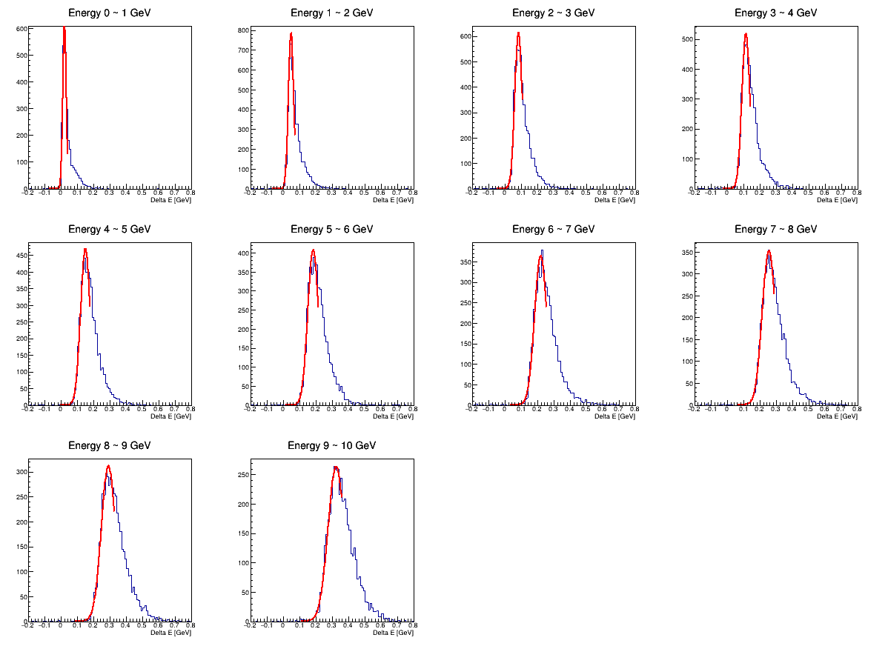
Here shows the comparison results of the primary photons energy and the reconstructed ones in the crystal region. The fit function of ten plots are Gaussian, and the fit range is varied with each plots.

Then we look into the energy resolution versus the energy variation, which can be described by the following function:

A + B/E^{0.5} + C/E

E is the energy of incoming particle, in this case is photon. And the fit result is shown below:

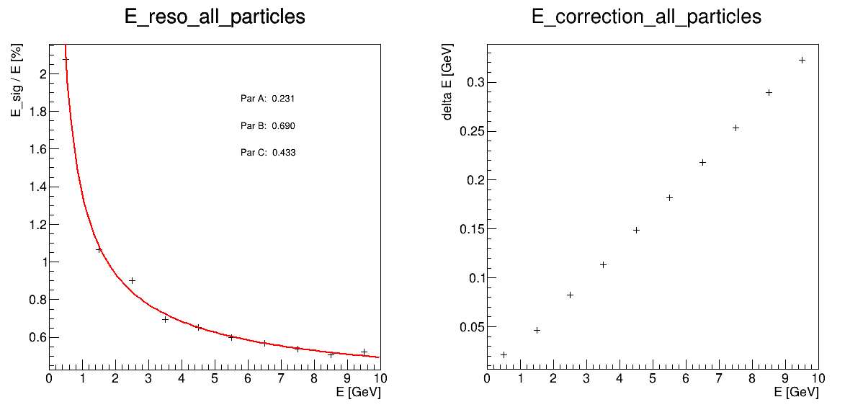
The left hand side plot shows the energy resolution v.s. different energy and also its fit results. The right hand side plot shows the average energy difference between the primary and the reconstruction, which is from the result of Gaussian fit.

The reconstruction regarding the glass region

In order to study the reconstruction performance in the glass region, I generate the primary event focus on the glass region, the same thing I did in the crystal region, and the hit map as shown below.

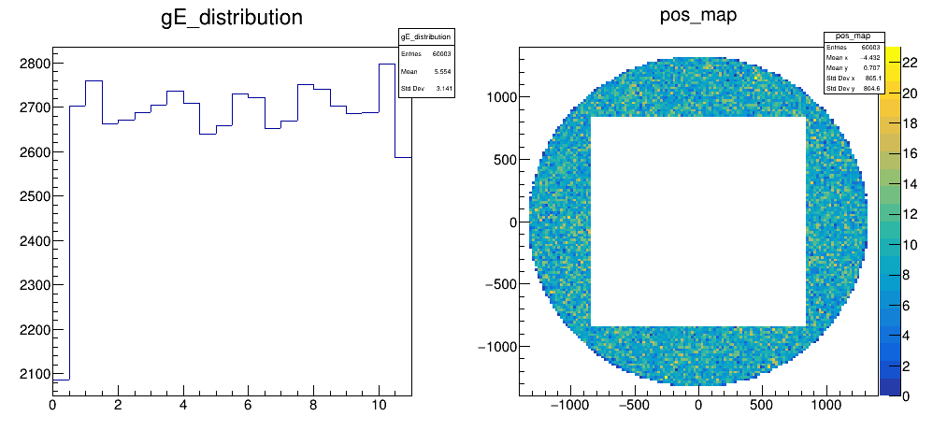
The unit of left hand side plot is GeV, and mm for the right hand side one.

Before showing the reconstruction results, I found the statistic of the glass region is smaller than the crystal one even the number of primary are same in both cases. And the reason is so many event in glass is too close the border, where my reconstructed algorithm can’t work well, or don’t hit the glass at all. For example:

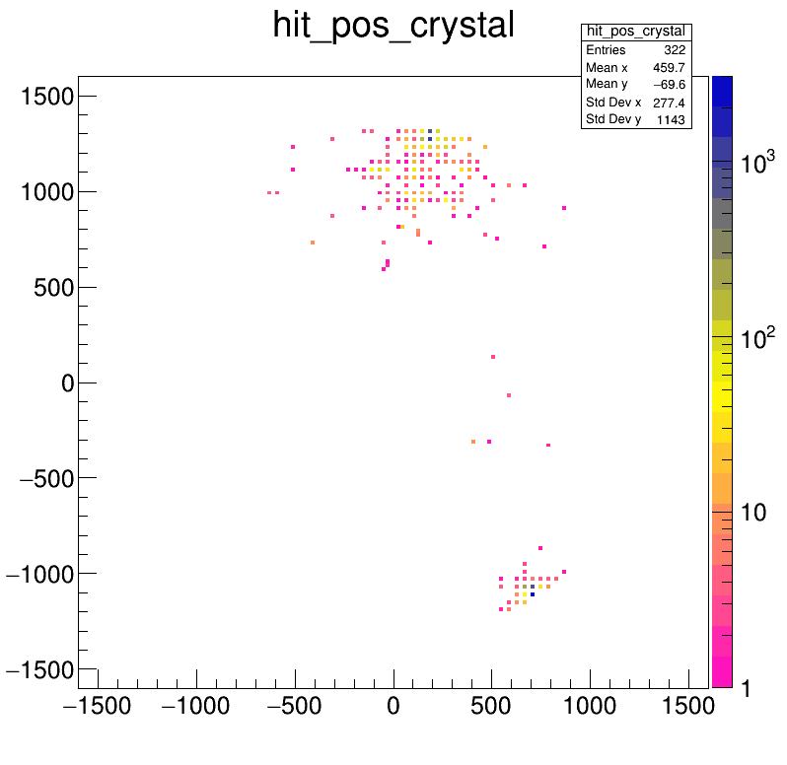

In this case, the project position of the primary photons are: [654.617, -1021.61], [1302.41, -90.0399], [183.731, 1229.77] respectively, where is mark by the black circle. In this case, we can find one of primary, the middle circle, doesn’t hit the glass and the other one, the lower circle, is too close the border, so only the upper one is reconstructed in my algorithm and the reconstruct position is [182.23, 1274.04].

Here are the reconstructed position and the energy results in the glass region:

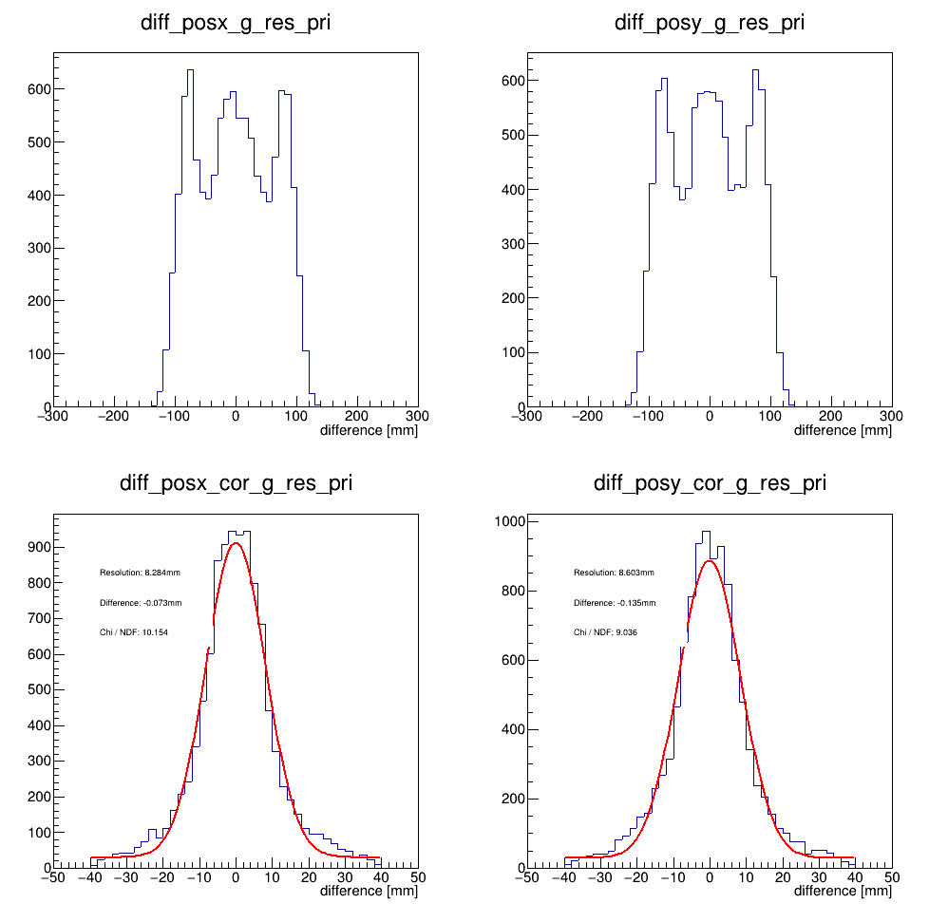
The upper 2 plots are the difference of the primary project position and the position reconstruction without corrected. The lower 2 plots are the difference of the primary project position and the position reconstruction corrected of the glass region from
x < -850mm, x > 850mm || y < -850mm, y > 850mm . Based on the fitting result, both resolution of x and y are around 8.4 mm. The parameter a I used in the glass region correction, is just 3 times larger than the crystal one, since the radiation length of the glass is roughly 3 times than the crystal one.

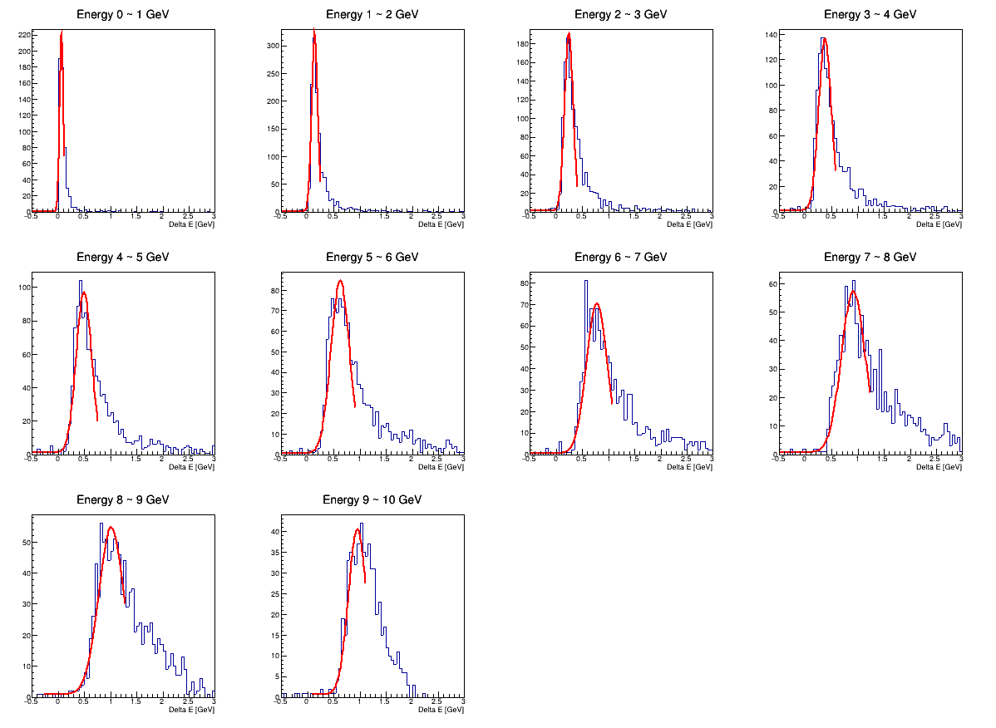
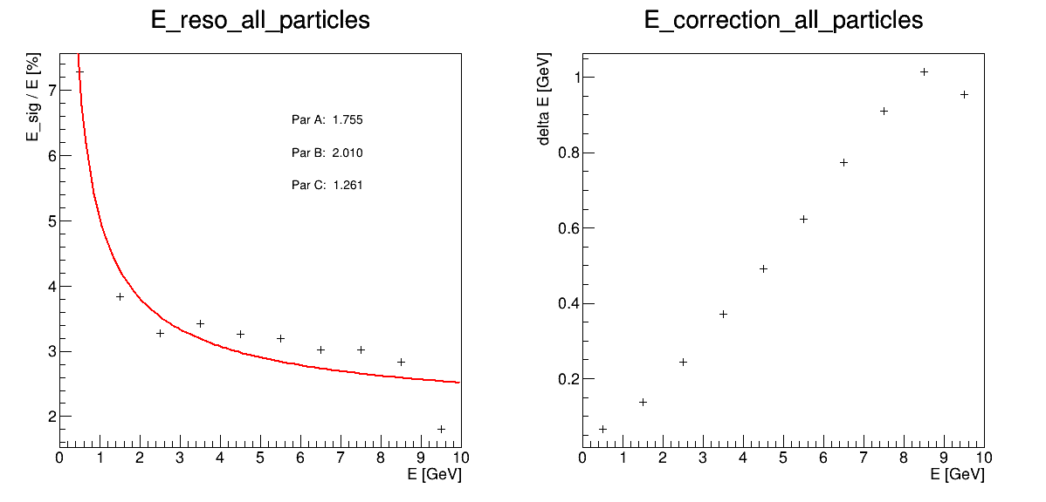
As the number of events in the glass case is not too much, the fitting for the high energy bin is not as good as crystal one, but it is enough for us to have the quick result of the energy resolution in the glass region. The energy resolution of different energy is shown in the lower left hand side plot.

