Formulas for friction factor in transitional regimes

Nian-Sheng Cheng

School of Civil and Environmental Engineering, Nanyang Technological University
Nanyang Avenue, Singapore 639798. Email: cnscheng@ntu.edu.sg

Abstract: This note concerns variations of the friction factor in the two transitional regimes, one between laminar and turbulent flows and the other between fully-smooth and fully-rough turbulent flows. An interpolation approach is developed to derive a single explicit formula for computing the friction factor in all flow regimes. The results obtained for pipe flows give a better representation of Nikuradse’s experimental data, in comparison with other implicit formulas available in the literature. Certain modifications are also made for applying the obtained friction formula to open channel flows.

Keywords: friction factor, transition, pipe flow, open channel flow, interpolation, laminar flow, turbulent flow, Reynolds number, resistance

Introduction

Nikuradse (1933) conducted his notable series of flow measurements with smooth and rough pipes over a wide range of Reynolds numbers. As a benchmark in hydraulic engineering, these measurements have served as a crucial database for verifying formulations developed for velocity profiles and flow resistance. In particular, Nikuradse’s work also offers valuable information for investigating sediment transport phenomena because similar sand-roughened boundaries are often employed for the laboratory study of various open channel flows over sediment beds.
The friction factor derived from Nikuradse’s experimental data appears to be different from the widely-used Moody diagram in that Nikuradse’s data show a ‘dip’ in the friction factor for turbulent pipe flows in the intermediate Reynolds number between fully-rough and fully-rough regimes. The dip phenomenon has been attributed to the pipe wall roughened by well-sorted sand particles, and it may become insignificant in commercial pipes with non-uniform distribution of roughness elements (Colebrook 1939). Similar transitional effects were also observed for other regular roughness configurations (Jimenez 2004). However, many fluid mechanics textbooks choose to start with Nikuradse’s experimental results for discussing different flow conditions and then recommend the Moody diagram for practical uses, but with almost no efforts devoted to explain and quantify the dip phenomenon (Bradshaw 2000).
Several formulas have been proposed in the literature for computing the friction factor separately for laminar flows, and fully-smooth and fully-rough turbulent flows, but they are not applicable directly for the transitional regimes (Hinze 1975). Some others, although applicable for the transitional regimes, need a trial procedure for estimating the friction factor (e.g. Brownlie 1981; Cheng and Chiew 1998; Ligrani and Moffat 1986; Yalin and Da Silva 2001). However, for practical purposes such as computer applications, a single friction equation that applies for all flow regimes is often required. Yen (2002) considered that this could be established with certain probability-based considerations. In this note, an interpolation method, which could be considered probability-related, is developed to derive a single explicit formula for computing the friction factor for various flow conditions including the transitional regimes.

Interpolation method

First, we consider the transition between laminar and turbulent flows, in which the variation of the friction factor is composed of laminar and turbulent components. It is assumed that the friction factor, f, is given by
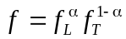 | (1)
where f_{L} is the friction factor for laminar flows, f_{T} is that for turbulent flows, and α is the weighting factor. The friction factor here is given by 8(u*/V)^{0.5}, where u* is the friction velocity and V is the cross-sectional mean velocity. In the sense of Yen’s (2002) probability conjecture, α can be considered the probability of the effect of the laminar component on the friction, and (1-α) the probability of the contribution of the turbulent component. Extremely, the flow remains in the laminar regime at α = 1 and switches to the turbulent regime at α = 0. As a result, α depends on the Reynolds number, Re (= VD/ν) where D is the pipe diameter and ν is the kinematic viscosity of fluid.
For turbulent flows, the friction factor varies with the Reynolds number and also can be altered by boundary roughness. At intermediate Reynolds numbers, a transitional regime exists between fully-smooth and fully-rough turbulent flows. To follow the approach in dealing with the laminar to turbulent flow transition, it is further assumed that
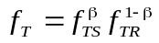 | (2)
where f_{TS} is the friction factor for fully-smooth turbulent flows, f_{TR} is that for fully-rough turbulent flows and β is the weighting factor. In terms of probability, β is used here to quantify the possible effect of the fully-smooth component on the turbulent friction while (1-β) is used to describe the possible effect of the fully-rough component. Therefore, β depends generally on the Reynolds number and boundary roughness height.
Substituting Eq. (2) into Eq. (1), we arrive at
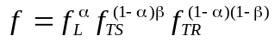 | (3)
To individually compute the three friction factors, f_{L}, f_{TS} and f_{TR}, we may use the following established results (Hinze 1975),
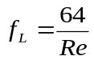 for laminar pipe flows, | (4)
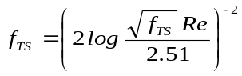 for fully-smooth turbulent pipe flows, and | (5)
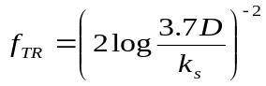 for fully-rough turbulent pipe flows. | (6)
where k_{s} is the roughness size that is taken as the sand grain diameter for Nikuradse’s experiments. Eq. (5) is the Prandtl’s friction law for smooth pipes and Eq. (6) is the von Karman’s formula for the fully rough regime. Since it involves a trial procedure in computing the friction factor, Eq. (5) is replaced here with
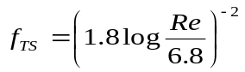 | (7)
Eq. (7), except for the constant 6.8 included, is the same as that previously given by Colebrook (1939). Other approximations similar to Eq. (7) were also reported by Barr (1977), Swamee and Jain (1976) and Haaland (1983). However, a best-fit analysis conducted in this study shows that Eq. (7) differs from Eq. (5) within ±1.2% for Re = 4000-10⁸, performing the best when compared with the other studies.
Substituting Eqs. (4), (6) and (7) into Eq. (3), the friction factor for pipes roughened by well-sorted sand grains is given by
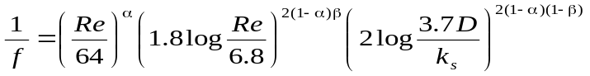 | (8)

Evaluation of α and β
First, we define an intermediate Reynolds number, Re_{LT}, at which the flow transition occurs between laminar and turbulent regimes. If Re is much smaller than Re_{LT}, the flow is largely characterised as laminar and thus   1 based on Eq. (1). Otherwise, the flow is turbulent and   0 if Re is much greater than Re_{LT}. With this consideration, the value of  would reduce with an increase in the ratio of Re/Re_{LT}. Mathematically, the relationship could be described by
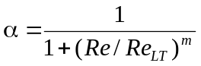 | (9)
where m is an exponent. Eq. (9) predicts α in the range of 0 to 1. At Re = Re_{LT}, α = 0.5 and thus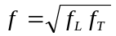 following Eq. (1), which implies that the contributions by the laminar and turbulent components are equivalent. This further suggests that Re_{LT} could be slightly greater than the critical Reynolds number at which the laminar flow just loses its stability. In this study, both Re_{LT} and m are evaluated by fitting Eq. (8) to Nikuradse’s data, with α given by Eq. (9) and β = 1. This yields that Re_{LT} ≈ 2720 and m ≈ 9. The comparison is shown in Fig. 1. Also superimposed on the figure are Eq. (4) for laminar flows and Eq. (5) together with its approximation, Eq.(7), for fully-smooth turbulent flows.
Similarly, to estimate β, we engage another intermediate Reynolds number, denoted by Re_{SR}, which is associated with the transition between fully-smooth and fully-rough turbulent flows. Different from Re_{LT} that appears as a constant, Re_{SR} varies with the relative roughness, r/k_{s}. From Eq. (2), it follows that β decreases from 1 to 0 if the turbulent flow changes from the fully-smooth to fully-rough regime. Therefore, it is reasonable to believe that β would reduce with an increase in the ratio of Re/Re_{SR}, approximately, in the form
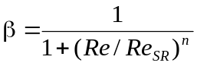 | (10)
where n is an exponent. Next, it is necessary to know how Re_{SR} varies with r/k_{s}. By taking Re_{SR} to be a Reynolds number halfway in the transition for a given r/k_{s} and using Tables 2-7 of Nikuradse (1933), one can get that Re_{SR} increases with increasing r/k_{s}. The result so estimated is plotted in Fig. 2, which shows that the relation of Re_{SR} to r/k_{s} is almost linear. Consequently, by assuming that Re_{SR} = r/k_{s} with  being a constant, Eq. (10) can be rewritten as
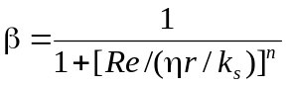 | (11)
With β given by Eq. (11) and also taking α = 0 for turbulent pipe flows, comparing Eq. (8) with Nikuradse’s data yields that η ≈ 320 and n ≈ 2, as presented in Fig. 3.
Finally, with α and β given by Eqs. (9) and (11) respectively, Eq. (8) is compared with the entire database by Nikuradse (1933) for smooth pipes and rough pipes with r/k_{s} ranging from 15 to 507. As shown in Fig. 4, Eq. (8) represents well the experimental data.

Comparison with previous studies

In the literature, there are no single formulas that are available to explicitly calculate the friction factor in various flow regimes to the writer’s knowledge. However, several empirical equations have been proposed for computing the function, B, which is related to f in the following form (e.g. Brownlie 1981; Cheng and Chiew 1998; Ligrani and Moffat 1986; Yalin and Da Silva 2001),
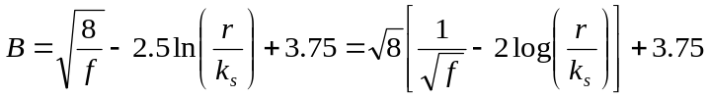 | (12)
Eq. (12) is derived by integrating the log law, u/u* = 2.5ln(y/k_{s}) + B, over the cross section of pipe. It should be mentioned that a trial procedure is required when using Eq. (12) for the evaluation of the friction factor because B is usually presented as a function of the roughness Reynolds number, k_{s}⁺, which is defined as 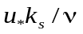 and equal to 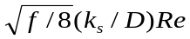.
The following four formulas are used to compare with the present study:
(1) Brownlie’s (1981) formula
(13)
where the coefficients, a_{i} (i = 0-6), are 1.3376, -4.3218, 19.454, -26.48, 16.590, -4.9407 and 0.57864, respectively, and b is taken as 3.58 by ensuring that B ≈ 8.5 for k_{s}⁺ > 100.
(2) Ligrani and Moffat’s (1986) formula s
(14)
(3) Cheng and Chiew’s(1998) formula
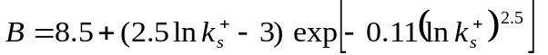 | (15)
(4) Yalin and Da Silva’s (2001) formula
(16)
Eqs. (13) to (16) are plotted in Fig. 5 together with Nikuradse’s data. All formulas predict smooth variations of B with k_{s}⁺, while the experimental data fluctuate particularly in the transitional regime, say, for 5 < k_{s}⁺ < 70. The scattering of the data points, perhaps partially due to experimental uncertainties, is clearly associated with the variation in r/k_{s}, as highlighted in the inset of Fig. 5. However, this r/k_{s}-dependence cannot be described by the previous formulas, which all relate B to k_{s}⁺ only. In addition, it should be mentioned here that the data series with r/k_{s} = 507, which clearly deviates from the main data trend, was not presented in the graph provided originally by Nikuradse (1933) and cited subsequently by others (e.g. Hinze 1975; Schlichting 1979) .
In the following, the friction factor is first computed using Eq. (8) for Re > 5000, and then substituted into Eq. (12) for evaluating B. The result obtained is plotted in Fig. 6. It shows that the effect of r/k_{s} is not significant for very small and very large k_{s}⁺, but becomes considerable in the transitional regime. This observation is consistent with Nikuradse’s measurements, as shown in Fig. 5.
Fig. 7 further details the difference between the B-values calculated with the current approach and those by the previous formulas for 5 < k_{s}⁺ < 70. In this figure, the vertical coordinate is defined as the relative error, E = ⏐B_{calculated} – B_{measured}⏐/B_{measured}, where B_{measured} is obtained through Eq. (12) from the friction factor measurements by Nikuradse (1933). The results indicate that the prediction errors are generally not more than 6%, but the present approach provides the best accuracy because of taking into account the effect of r/k_{s}. The average errors associated with Eqs. (13) to (16) are 1.4%, 1.5%, 1.7% and 1.5%, respectively, while that by the present study is 1.2%. The maximum errors associated with Eqs. (13) to (16) are 4.7%, 5.2%, 5.8% and 5.0%, respectively, while that by the present study is 4.3%.

Extension to open channel flows

To extend experimental or theoretical results that are obtained for pipe flows to open channel flows, one may use the concept of equivalent hydraulic radius, which is equal to D/4 for circular pipe flows and h, the flow depth, for wide open channel flows. However, practical applications of this concept indicate that further modifications are needed for computing the friction factor. For example, a shape factor, φ, could be used to effectively account for the influence of the cross section when applying the pipe resistance equations to open channels of any shape (Montes 1998). This shape factor is used as a multiplier for the hydraulic radius. For two-dimensional (2D) open channel flows, φ is equal to approximately 0.8, and thus the hydraulic radius, i.e. D/4, included in the pipe friction equations should be replaced with 0.8h. Another similar idea for estimating turbulent friction in noncircular ducts is to use the pipe-friction law based on an effective diameter (White 1991).
In this study, the concept of the shape factor is adopted. Therefore, D included in Eqs. (6) and (7) should be replaced with 4 × (0.8h) = 3.2h for 2D open channel flows. However, this change is only limited to turbulent flows and does not apply for the laminar friction. For 2D open channel flows, the laminar friction factor is given by f_{L} = 24/Re_{h}, which can be derived from the parabolic velocity distribution. Here, the depth-averaged velocity U is used for defining the Reynolds number Re_{h} (=Uh/ν), h is the flow depth, and the friction factor f is redefined as 8(u*/U)². With these considerations, Eq. (8) is rewritten as
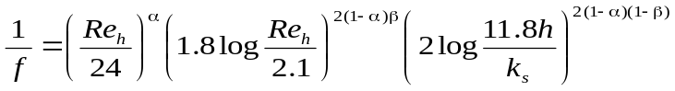 | (17)
In Eq. (17), the two constants, 2.1 and 11.8, are obtained here based on the concept of the shape factor, but they are almost the same as those suggested by Yen (2002). This implies that the approach based on the shape factor, although empirical, provides a reasonable connection between the friction factor in pipe flows and that in 2D open channel flows. Therefore, it is reasonable to apply the same approach for the evaluation of the α and β values, which are proposed for the transitional regimes. This yields that Eqs. (9) and (11), are rewritten as
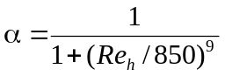 | (18)
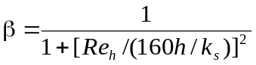 | (19)
Eq. (17) is applicable for 2D open channel flows over immobile boundaries comprised of unisized sediment. The variations of f computed using Eq. (17) is plotted in Fig. 8. To compare Eq. (17) with measurements, a database with wide ranges of Re_{h} and h/k_{s} for open channel flows, which is similar to that by Nikuradse, is needed but not available at the current stage. In addition, for open channel flows subject to significant sidewall effects, friction equations similar to Eq. (17) could be also developed with the shape factor being properly adjusted (Montes 1998). Such studies are worth further efforts.

Conclusions

A useful interpolation function is proposed for computing the friction factor for the two transitional regimes, one between laminar and turbulent flows and the other between fully-smooth and fully-rough turbulent flows. The resulted explicit formula represents well the experimental data by Nikuradse for pipes roughened by well-sorted sand grains, in comparison with other implicit formulas available in the literature. With the similar approach, a single explicit equation is also suggested for computing the friction factor in two-dimensional open channel flows for all flow regimes. It should be mentioned that the results presented are largely based on Nikuradse’s study, and thus their applications could be limited.

Notation
The following symbols are used in this note:
b = constant
B = friction factor-related parameter as given by Eq. (12)
D = pipe diameter
E = relative error
f = friction factor [f = 8(u*/V)² for pipe flows; f = 8(u*/U)² for open channel flows]
f_{L} = friction factor for laminar flows
f_{T} = friction factor for turbulent flows
f_{TR} = friction factor for fully-rough turbulent flows
f_{TS} = friction factor for fully-smooth turbulent flows
h = flow depth
k_{s} = roughness size that is taken as the sand grain diameter for Nikuradse’s experiments
k_{s}⁺ = u*k_{s}/ν
m = exponent
n = exponent
Re = Reynolds number for pipe flows (=VD/ν)
Re_{LT} = intermediate Reynolds number in the laminar-turbulent flow transition
Re_{SR} = intermediate Reynolds number in the fully smooth to fully rough turbulent flow transition
Re_{h} = Reynolds number for open channel flows (=Uh/ν)
r = pipe radius
U = depth-averaged velocity in open channel flows
u = longitudinal flow velocity
u* = friction velocity
V = cross-sectional average velocity
y = wall-normal distance
α = weighting factor
β = weighting factor
ν = fluid viscosity
η = constant

References
Barr, D. I. H. (1977). "Discussion of 'Accurate explicit equation for friction factor'." Journal of Hydraulics Division-ASCE, 103(HY3), 334-337.
Bradshaw, P. (2000). "A note on 'critical roughness height' and 'transitional roughness'." Physics of Fluids, 12(6), 1611-1614.
Brownlie, W. R. (1981). "Reexamination of Nikuradse roughness data." Journal of the Hydraulics Division-ASCE, 107(1), 115-119.
Cheng, N. S., and Chiew, Y. M. (1998). "Modified logarithmic law for velocity distribution subjected to upward seepage." Journal of Hydraulic Engineering-ASCE, 124(12), 1235-1241.
Colebrook, C. F. (1939). "Turbulent flow in pipes with particular reference to the transition region between the smooth and rough pipe laws." Proceedings of the Institution of Civil Engineers, 12, 393-422.
Haaland, S. E. (1983). "Simple and explicit formulas for the friction factor in turbulent pipe-flow." Journal of Fluids Engineering-Transactions of the ASME, 105(1), 89-90.
Hinze, J. O. (1975). Turbulence, McGraw-Hill, New York.
Jimenez, J. (2004). "Turbulent flows over rough walls." Annual Review of Fluid Mechanics, 36, 173-196.
Ligrani, P. M., and Moffat, R. J. (1986). "Structure of Transitionally Rough and Fully Rough Turbulent Boundary-Layers." Journal of Fluid Mechanics, 162, 69-98.
Montes, S. (1998). Hydraulics of open channel flow, ASCE Press, Reston, VA.
Nikuradse, J. (1933). "Stromungsgesetze in rauhen Rohren." Forschung auf dem Gebiete des Ingenieurwesens, Forschungsheft 361. VDI Verlag, Berlin, Germany (in German). (English translation: Laws of flow in rough pipes, NACA TM 1292, 1950).
Schlichting, H. (1979). Boundary-layer theory, McGraw-Hill, New York.
Swamee, P. K., and Jain, A. K. (1976). "Explicit equations for pipe-flow problems." Journal of Hydraulics Division-ASCE, 102(HY5), 657-664.
White, F. M. (1991). Viscous fluid flow, McGraw-Hill, New York.
Yalin, M. S., and Da Silva, A. M. A. F. (2001). Fluvial processes, IAHR, Delft, Netherlands.
Yen, B. C. (2002). "Open channel flow resistance." Journal of Hydraulic Engineering-ASCE, 128(1), 20-39.

