|  |  |  |  |
| --- | --- | --- | --- |
|  |  | **True Condition**  **資料的答案** | |
|  | **Total Population (T)** | **Positive**  **有、真、有發病** | **Negative**  **沒有、假、沒有發病** |
| **Predicted**  **Outcome**  **模型預測**  **出來的結果** | **Positive**  **有發病** | True Positive (TP)  真陽性 | False Positive (FP)  偽陽性 |
| **Negative**  **沒有發病** | False Negative (FN)  偽陰性 | True Negative (TN)  真陰性 |

混淆矩陣(Confusion matrix)

|  |  |  |  |  |  |
| --- | --- | --- | --- | --- | --- |
|  |  | **True Condition**  **資料的答案** | |  |  |
|  | **Total Population (T)** | **Positive**  **有發病** | **Negative**  **沒有發病** |  |  |
| **Predicted**  **Outcome**  **模型預測**  **出來的結果** | **Positive**  **有發病** | True Positive (TP)  真陽性 | False Positive (FP)  Type I error  偽陽性 | Positive predictive value (PPV), Precision  陽性預測值 $$\frac{TP}{TP+FP}$$ | False discovery rate (FDR)  陰性預測值 $$\frac{FP}{TP+FP}$$ |
| **Negative**  **沒有發病** | False Negative (FN)  Type II error  偽陰性 | True Negative (TN)  真陰性 | False omission rate (FOR) $$\frac{FN}{FN+TN}$$ | Negative predictive value (NPV) $$\frac{TN}{FN+TN}$$ |
|  |  | True Positive Rate (TPR) Sensitivity, Recall  靈敏性 $$\frac{TP}{TP+FN}$$ | False Positive Rate (FPR)  偽陽性率  Fall-out $$\frac{FP}{FP+TN}$$ | Positive likelihood ratio (LR+) =TPR/FPR  Negative likelihood ratio (LR-) = FNR/TNR  Diagnostic odds ratio (DOR) = LR+/LR-  F1-score = 2 $\frac{Precisiom×Recall}{Precisiom+Recall}$ F3-score  = $(1+β^{2})\frac{Precision×Recall}{\left({1+β}^{2}\right)TP + \left(β^{2}Precision\right) +Recall}$ = $\frac{TP}{\left({1+β}^{2}\right)TP + \left(β^{2}FN\right) + FP}$ G-measure = $\sqrt{Precision×Recall}$ | |
|  | Accuracy  正確率 $$\frac{TP+TN}{T}$$ | False Negative Rate (FNR)  偽陽性率  Miss rate $$\frac{FN}{TP+FN}$$ | True Negative Rate (TNR) Specificity  特異性 |

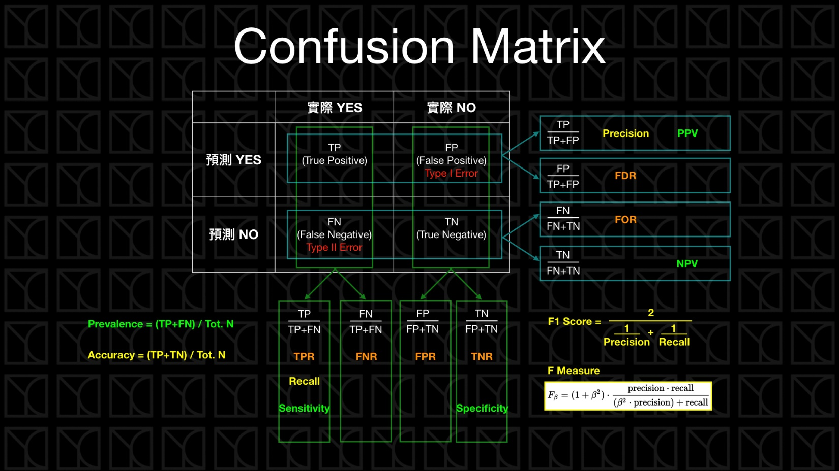

<https://www.ycc.idv.tw/confusion-matrix.html>