**ArcelorMittal Dofasco – Bentley Machine Learning Project Update**

Nov-16-2018

**Questions**

1. which bearing failed on January 14th, in or out?

2. looking at the bar plot below:

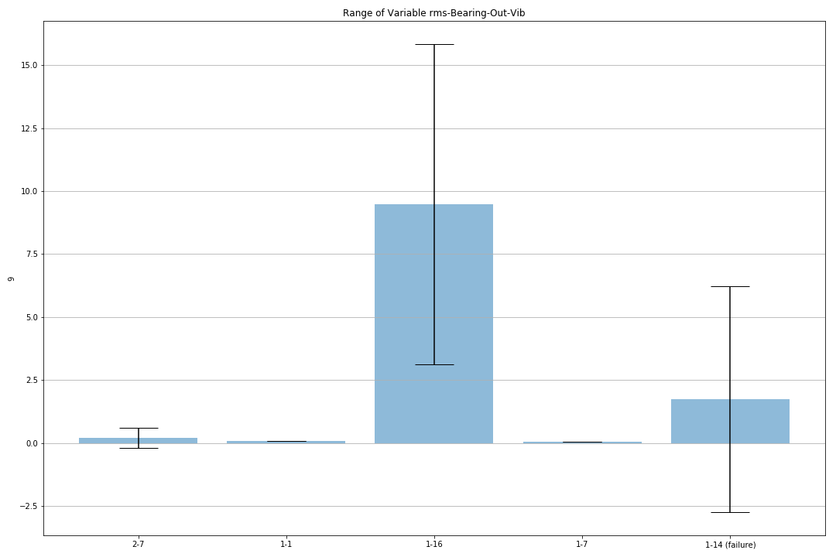why is the range of values for the Out Bearing Vibration so large on January 16th?

3. how do vibration experts currently determine if a bearing is failing?

4. could they have known two weeks before?

Thanks David. Below I have some preliminary results for you to look at.

The Self-Organizing Map (SOM) has been fully implemented in Python and Tensorflow.

The variables chosen for the SOM are the following (selected after careful analysis of results):

corr-Bearing-Out-Vib-Motor-In-Vib – pearson correlation between bearing out and motor in vibrations

corr-Bearing-Out-Vib-Motor-Out-Vib – pearson correlation between bearing out and motor out vibrations

corr-Bearing-In-Vib-Bearing-Out-Vib – pearson correlation between bearing in and bearing out vibrations

After training the SOM on data from February 7th, and testing it on all other days, the results are shown below.

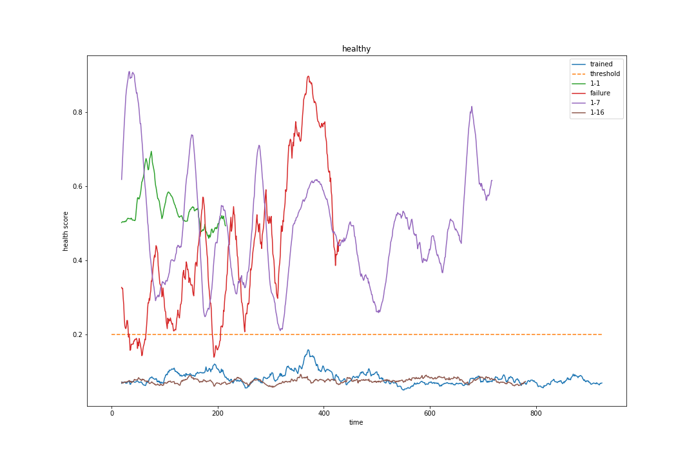  
Illustration 1: Health score of each dataset, labels show what day they are from.

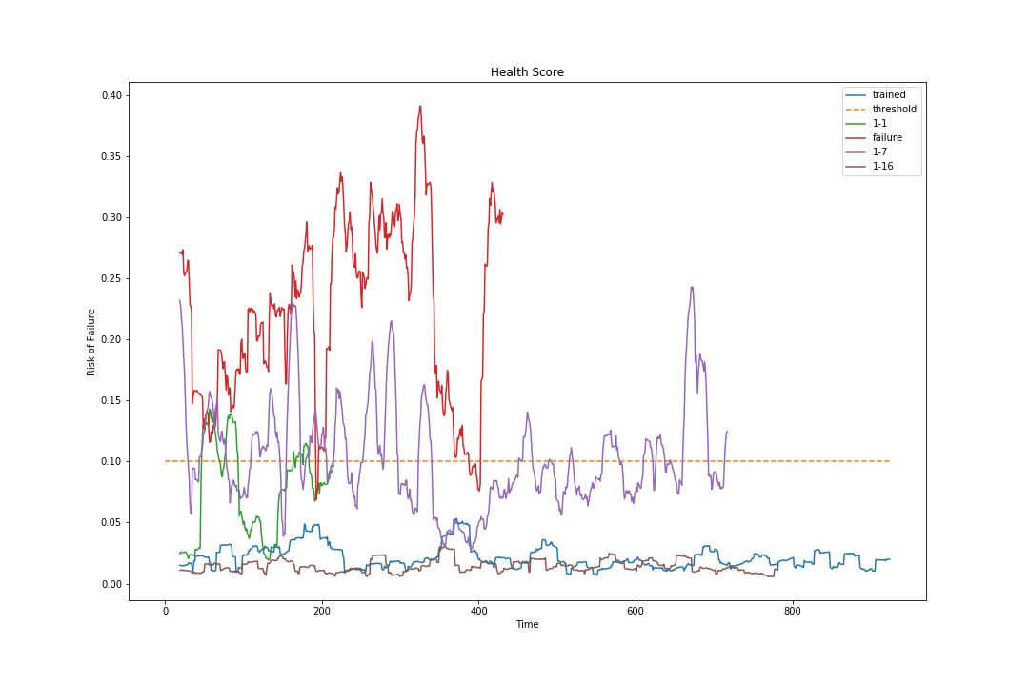  
Illustration 2: Standard deviation of the health score.

As you can see, we are getting good results. Using the health score you would be able to tell something was wrong with the fans **two weeks** before failure (on Jan. 1st).

I will continue to introduce other variables to see if I can smooth the health score. So far the results are very encouraging.