John Halloran and Jason Arnold

(1)This design thinking process for a human-robot interaction application was conducted by John Halloran and Jason Arnold. Our environments were musical performance areas. The two main areas observed were the Wind Ensemble in the Varsity Theater, a wide open stage and the Joan of Arc Chapel, a smaller more intimate setting.

(2-4) (pdf files of our observation notes have been attached to D2L)

Joan of Arc Chapel 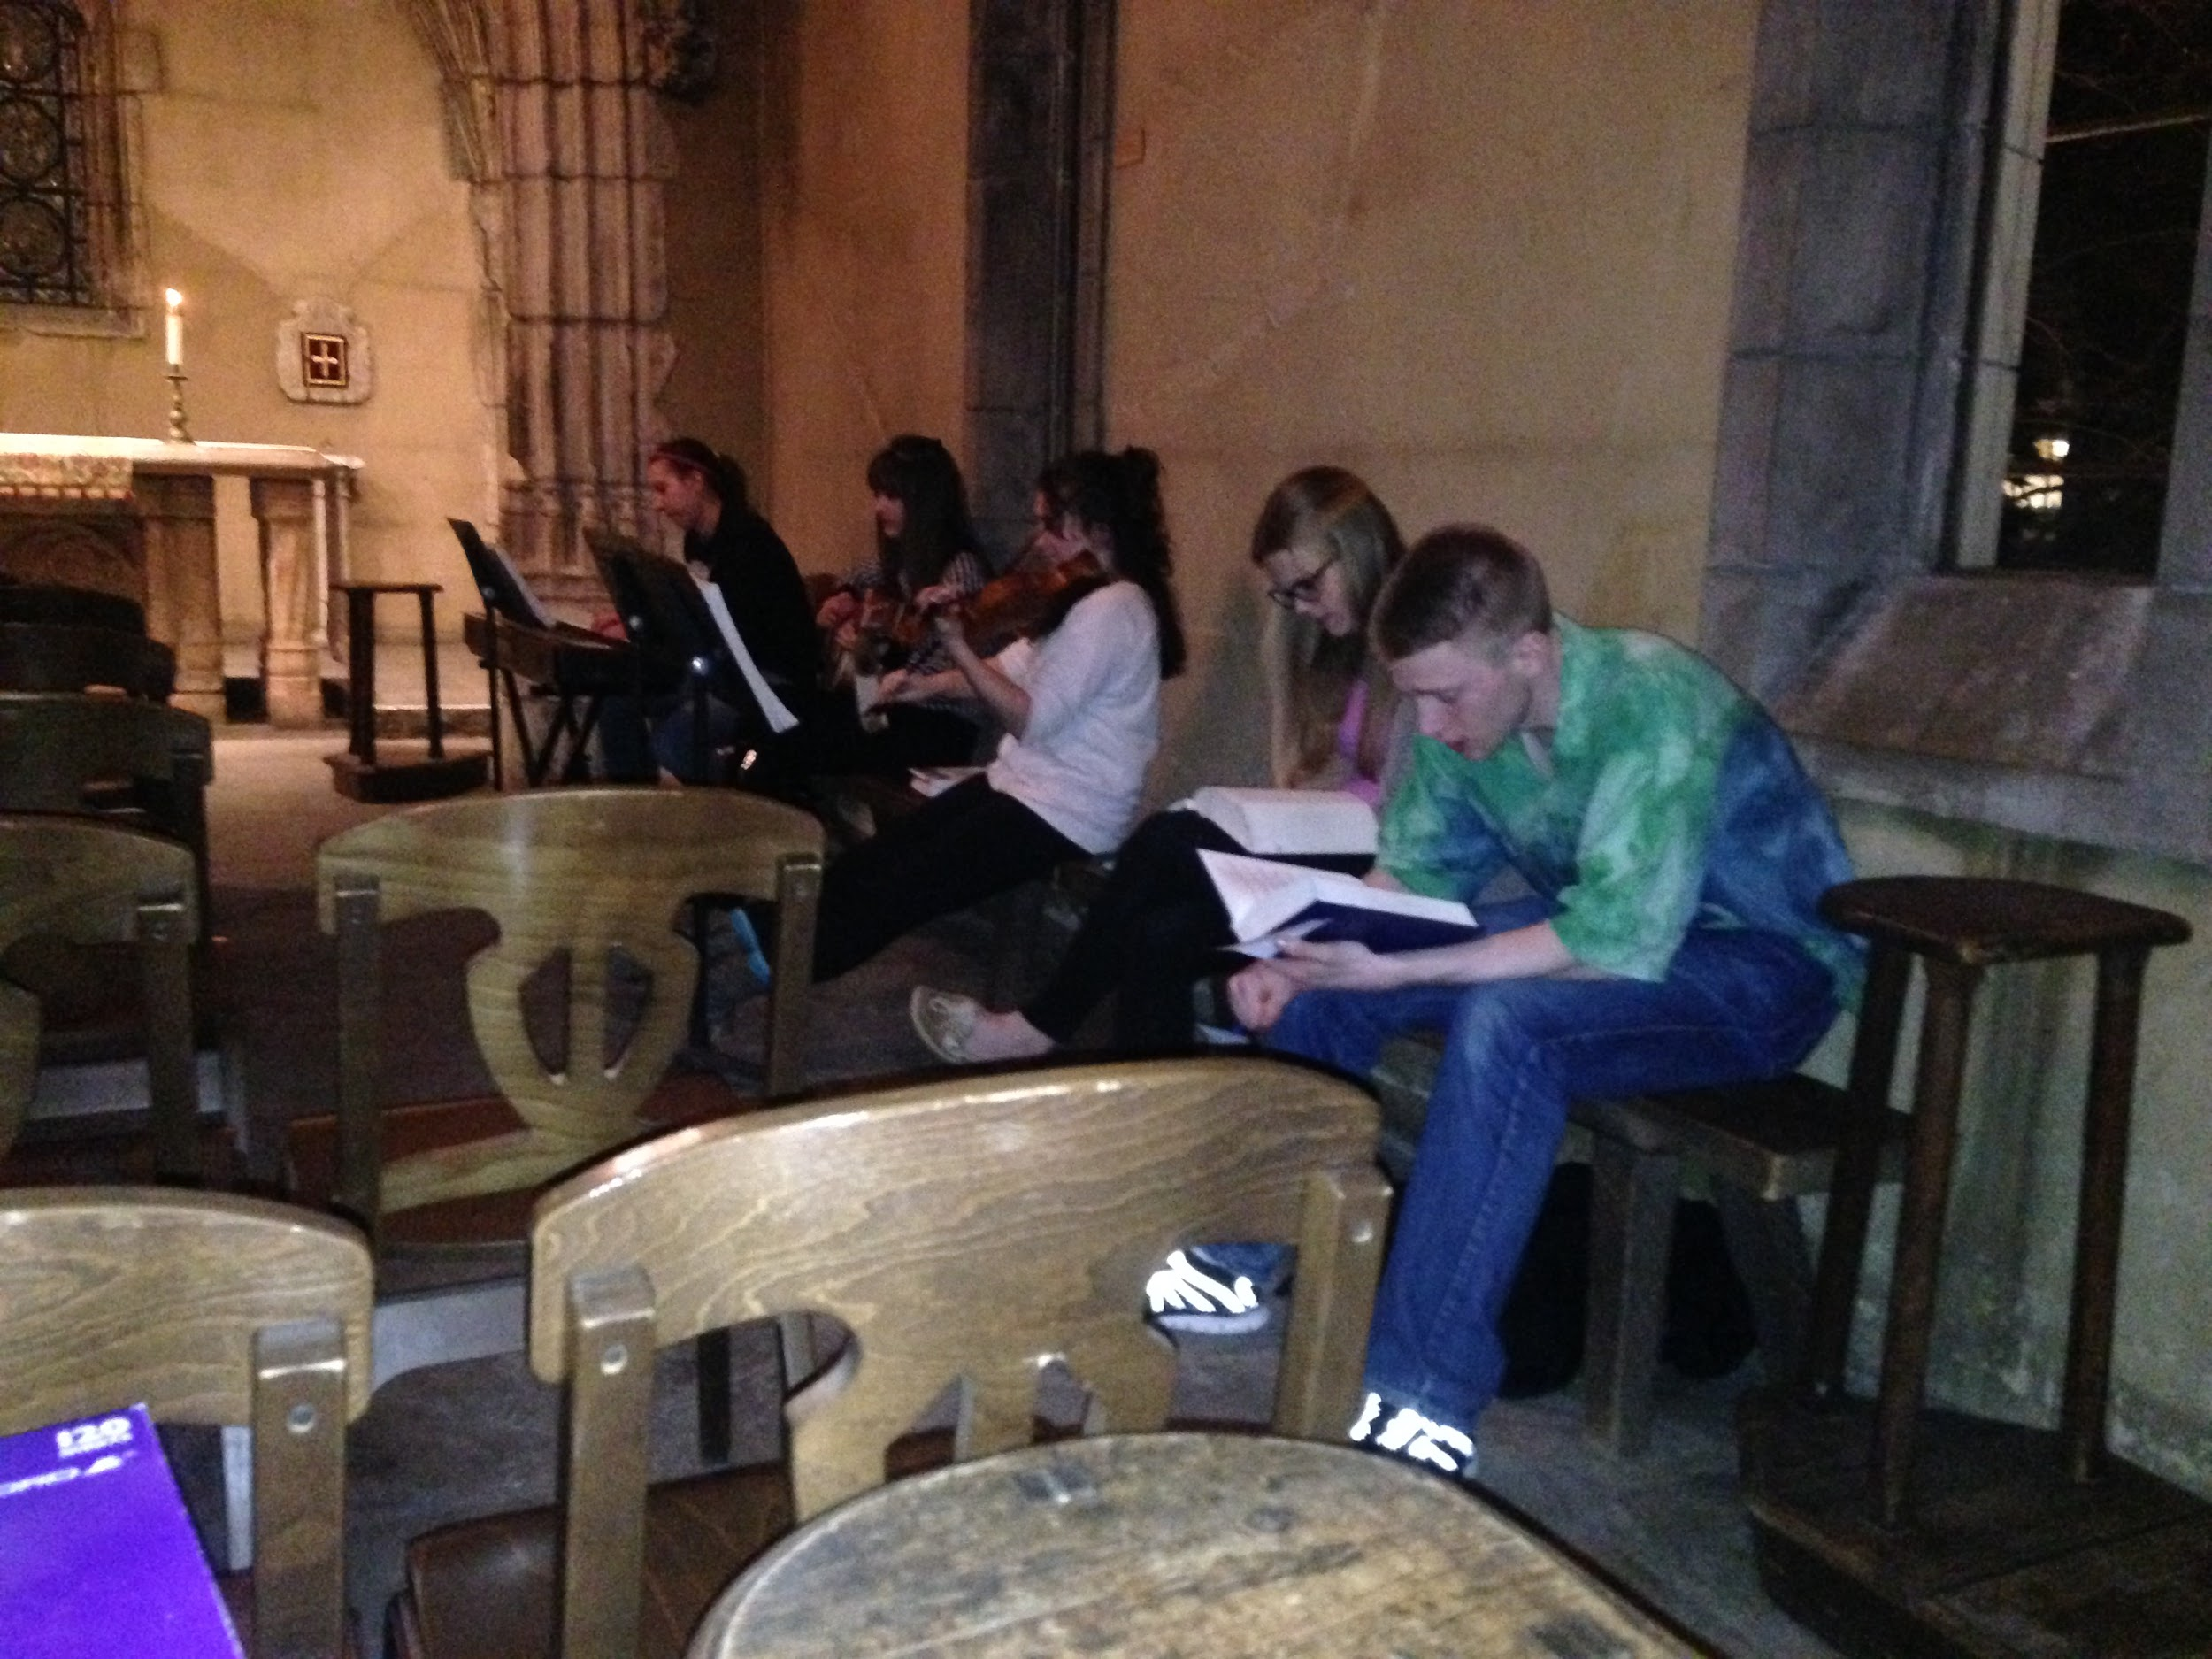

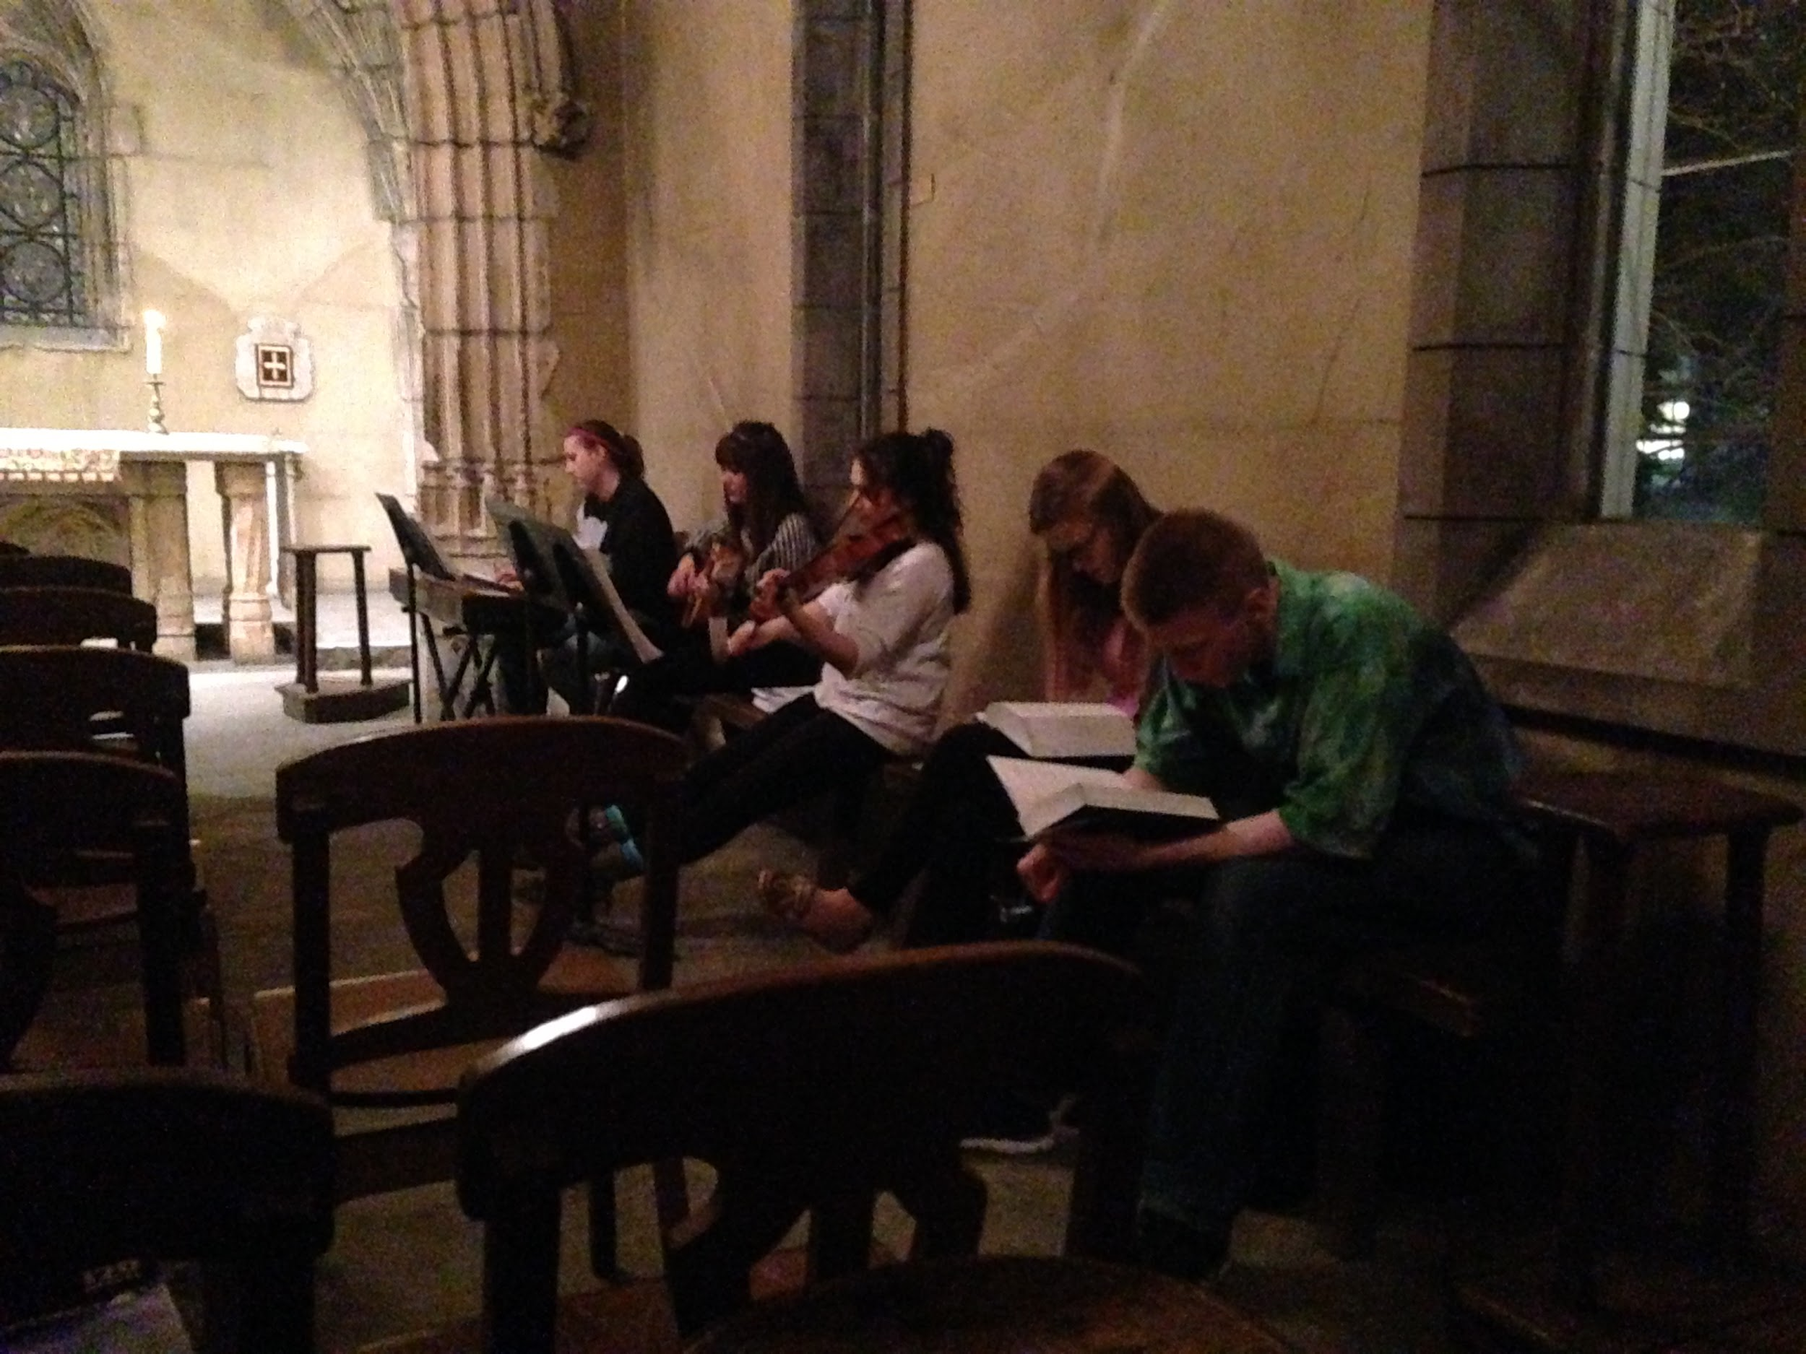

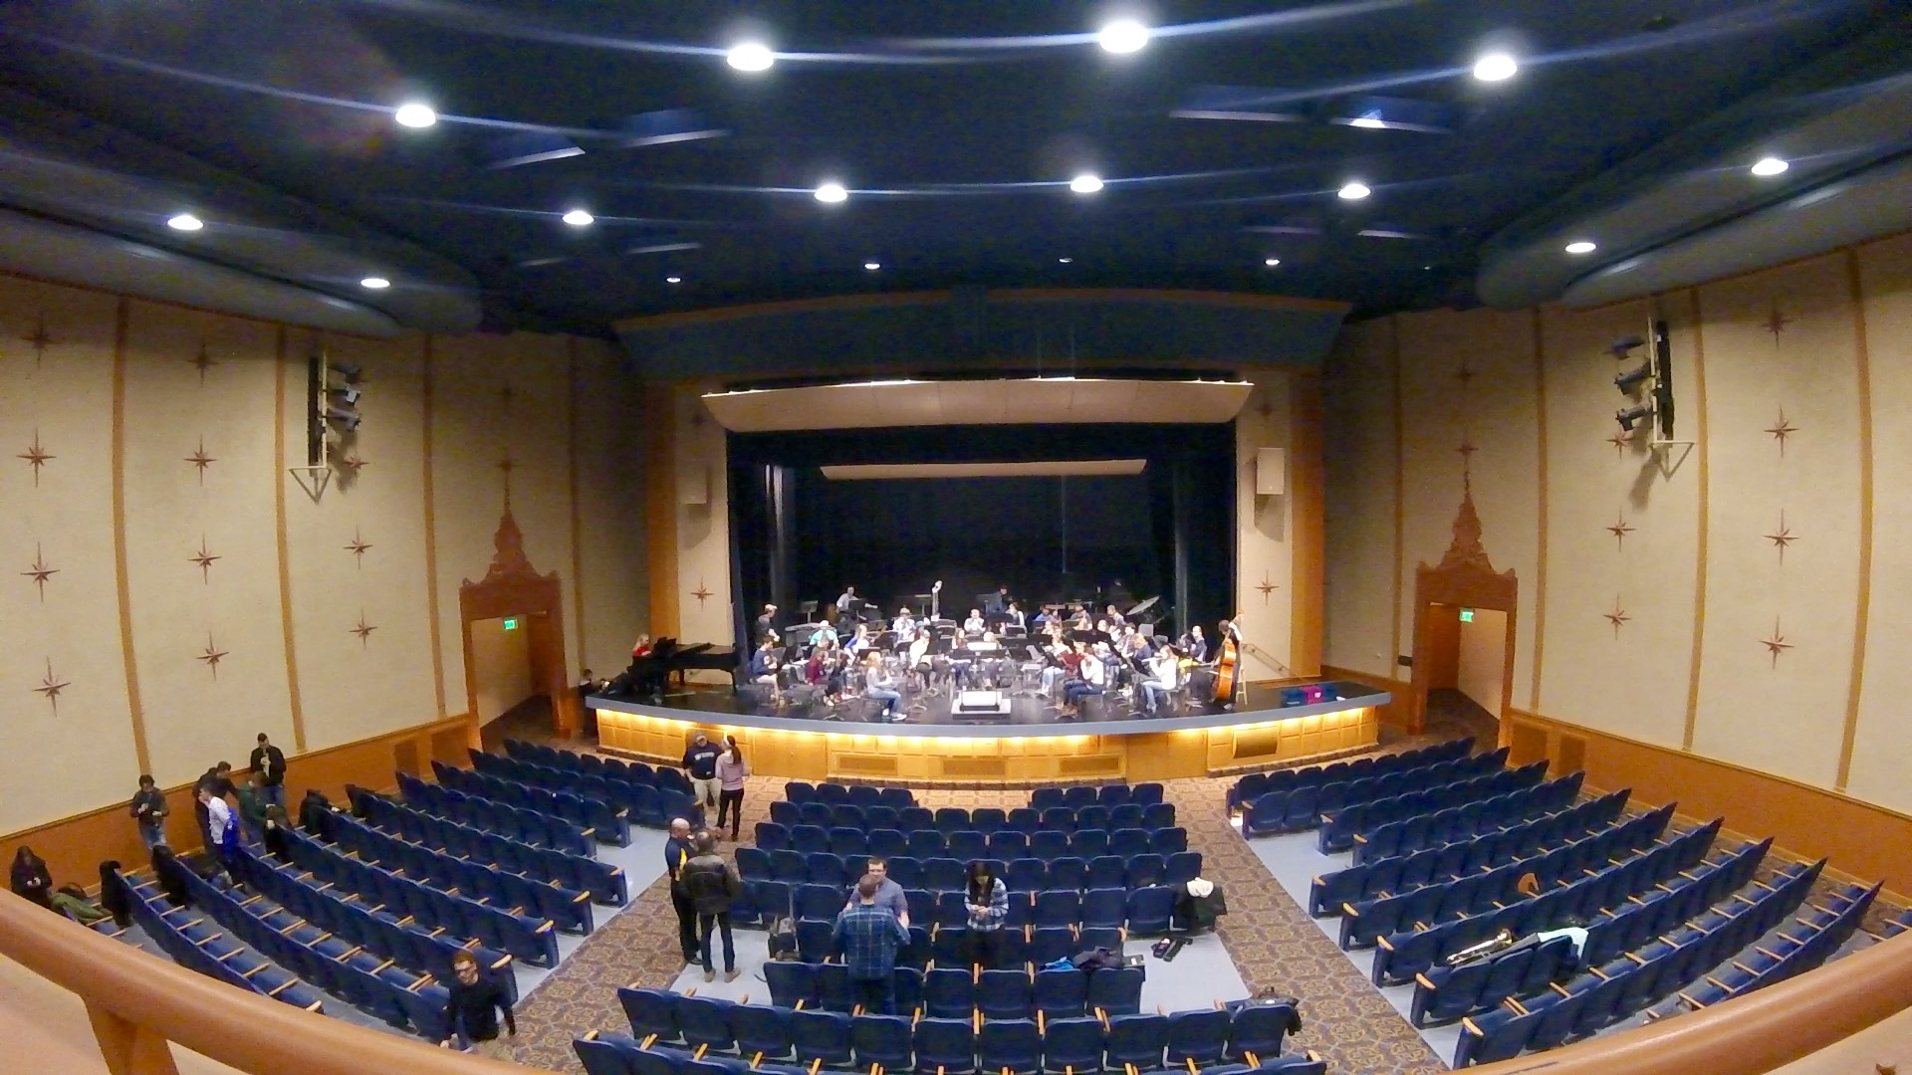

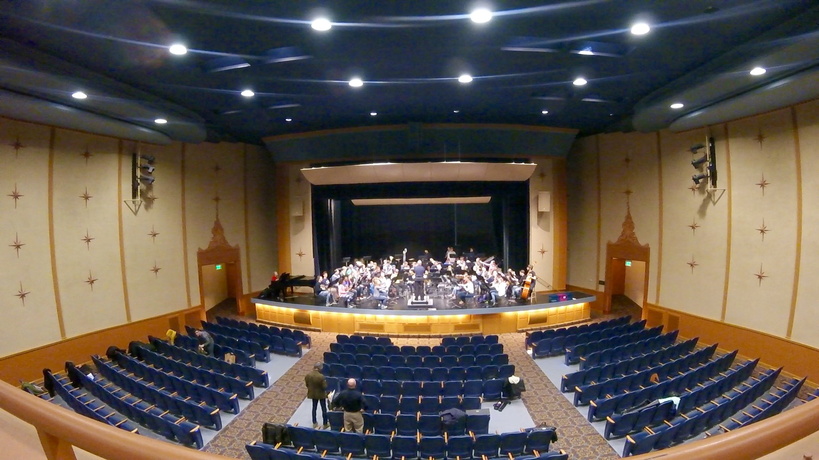

(5)For first hand notes on these environments, consult the scanned images of notes taken during our observations. Beginning with the Joan of Arc chapel. One of the most important things to note about the chapel is that it is a small, intimate space. Musicians and the congregation are in a tight space that adds to the experience. The instrumentation is light and invokes an actual emotional response as does most liturgical music. Instruments included piano, violin, a guitar, and a couple of singers. The group was small but sometimes it was a little bit hard to coordinate tempos and cues for when to start, which act as some needs for the group. The hard surfaces throughout the chapel add an immersive echo and a distinct tin-like quality that truly makes the music that much more engaging. The people throughout the chapel are just as important as the chapel itself. Graceful harmonies and strong confident melodies are evident solely due to Joan of Arc’s visitors and their musical understanding and confidence.

Varsity Theater featured the Marquette Wind Ensemble so the instrumentation was a far greater variety of brass, woodwind, percussion, and a string bass. The rehearsal experience is run by a conductor, a sole leader in which everyone is following. The musicians follow the conductor and play to his interpretations of the piece. Some of the difficulties involved is involving the mass group and keeping them focused since it appears to be very easy to lose focus. The most interesting observation regarding this rehearsal space are the people within. Both the musicians and the conductor had unique contributions to the feel of the environment. The large array of personalities and activities ranged far and wide, from loud and engaging extroverts to those who would barely lift their head. Furthermore, during the warm-up, all the musicians would hold the same note simply in order to tune their instrument properly. In doing so, the personalities shone through once again evidenced by the quieter and meekly played instruments versus those that were played with much gusto.

(6)We feel that an important need may present itself in the usability of the sheet music. A large distraction presented to the audience are the brightly white pages that require flipping in between pieces. By using a tablet or some other similar device, these pages can be eliminated. Furthermore, the noise as the pages turn will also be removed. The biggest need, however, discovered among our observations was just keeping everyone in check. Even if the group is big or small, it is very easy to lose focus and understanding of place in the piece. Cues can easily be missed. Perhaps this could be a result of not knowing the piece well enough so that the musicians just have to focus on coming together to perform. If anything in the piece does not sound good, the main problem comes to cues, whether if the conductor was off or the musician lost his place, cues are one of the biggest problems. We could definitely look into helping with cues and tempo keeping to help musicians play their music better. These are, however, organized rehearsals, which differs from an improvisational type of practice.

(7)As an example let’s think of a musician named Charlie. Charlie is a guitarist mainly playing jazz and funk style music. Charlie plays in small combo groups that consist of a drummer, a bassist, a saxophonist and a trumpeter. He spends approximately 30 hours with this group a week, consisting of both practice and performance. He spends about 15 hours of his own time in private practice by himself. Charlie’s hardest challenge is being able to stay in time with the band. In his own private practice he likes to go crazy and start doing crazy things on his guitar, but can often forget that he has a band to play with that he needs to keep in time. He should not be the one speeding up the group. He likes to record himself sometimes and hear exactly what he plays and listen to himself play specific sections of a piece so he can try and improve his sense of tempo and stay consistent with it.

(8)

**Cristina**

|  |  |
| --- | --- |
| Saying   * Work in groups is best * Discipline is a major key | Thinking   * Other people challenge me * I can do this * New ideas * I want to improve myself to get better |
| Doing   * Communicate * Showing-off (bragging rights) * Disciplining myself | Feeling   * Low self-esteem, lack of discipline * Competitive * accomplishment |

*Insights*

* Focused on goals
* Really want to impress people

*Surprises*

* Low-Self Esteem

*Contradictions*

* Low Self-Esteem vs. Feeling of Accomplishment

*Tensions*

* Trying to stay disciplined when working by yourself, but easier with others

**Jessica**

|  |  |
| --- | --- |
| Saying   * Don’t want to fall behind * I played something really hard * Don’t want to cap out on her talent | Thinking   * Goal in mind * Structured * What is her next goal for practice * Prefers to simply practice independently and improvise practice |
| Doing   * Clearing the mind * Improvising * Practicing a specific piece for performance | Feeling   * Entertained * Music calms her (emotional peace) * Frustrated at times, although she knows it is part of the process |

*Insights*

* Mindful of their own standing in a group

*Surprises*

* Frustration is normal

*Contradictions*

* Frustrations and Calming

*Tensions*

* Frustrations over difficult pieces

**John**

|  |  |
| --- | --- |
| Saying   * Give me the next hardest piece * Social work is most challenging, however, is definitely the most rewarding | Thinking   * How can I improve? * What is this person I’m playing with doing? * How and what can I do to better improve my partner |
| Doing   * Organized practice * Improvised practice * Balance the two * Work in groups * Plan ahead | Feeling   * There is always something to improve * Yet still feels accomplished with how far he’s come * Enjoyment from working with others |

*Insights*

* Positive Attitude is key

*Surprises*

* A large amount of instrumental range

*Contradictions*

* Likes setting goals, however, doesn’t know what his next goal should be

*Tensions*

* Wants to improve, but doesn’t know which instrument to improve upon

**Megan**

|  |  |
| --- | --- |
| Saying   * Organized practice is key to success * Impromptu practice is the most rewarding, however | Thinking   * Goals * Satisfaction of playing difficult pieces |
| Doing   * Trying to exercise patience (rather difficult) * Understands that there is failure that comes along with practice | Feeling   * Impatient in groups * Distracted * Escape from reality |

*Insights*

* Practice, no matter what kind, is key to success

*Surprises*

* Doesn’t enjoy practicing as much as other students

*Contradictions*

* Seems shy but speaks confidently about music

*Tensions*

* Can’t find enough time in the day to practice as much as she should

(9)Charlie is a guitarist who likes to play guitar for jazz combos. He does play melodies well at fast tempos, but often gets off-beat from the rest of the band and forgets to listen to himself and others. He needs a device that can help him stay on rhythm and help him listen to himself in his own practice routine where he could play and listen to what he just played.