Here are two code snippets that can be improved by using JS in order to make the website more responsive to users.

1. **Add a confirmation message before submitting a form**
2. Code snippe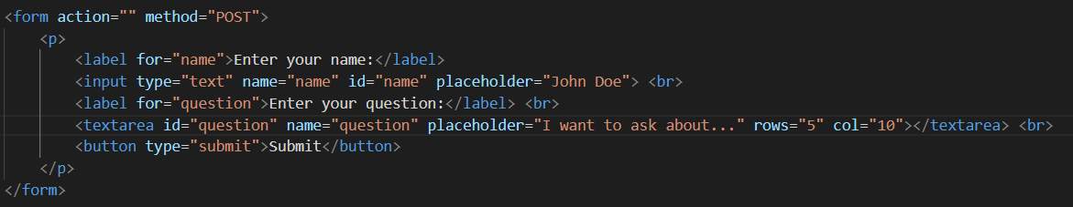t
3. Current outcome

When the user click on submit button, the form is immediately submitted. What if the user want a second layer of confirmation to correct their mistake in either typo or question?

1. Desired outcome

When the user click on submit button, there will be a confirmation message appear, asking to confirm their submission. The confirmation is proceeded if the user agree to do so.

1. Updated code snippet

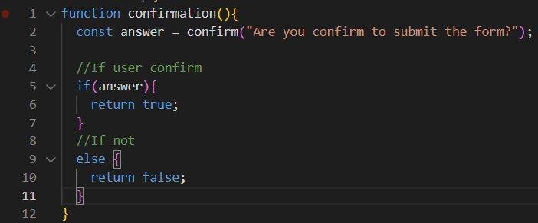e. Now, when user clicks on the Submit button, there will be a message on top of browser asking them to confirm their submission with two options of “OK” and “Cancel”.

1. **Add a warm greet to users who enter my main webpage**
2. Code snippet

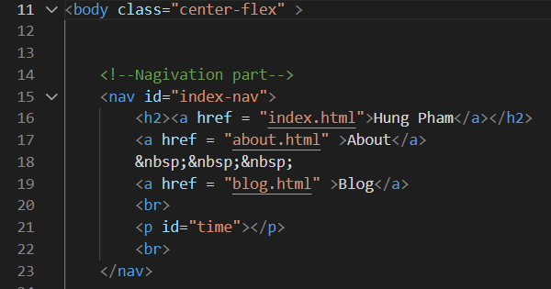

1. Current outcome

Like any other normal website, the webpage appears normally like default, nothing special or any notifications.

1. Desired outcome

I want to send my warm greeting to any user who enter website to make them feel a little bit more engaged with a small notification on top of the browser.

1. Updated code snipper

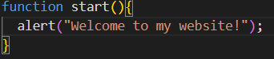

1. New outcome

