**表格目錄**

**圖目錄**

表格 1專案進度表

|  |  |  |  |
| --- | --- | --- | --- |
| **工作項目** | **開始日期** | **天數** | **結束日期** |
| PlanningMeeting | 12/29 | 1 | 12/29 |
| DevelopQuestionnaire | 12/30 | 11 | 1/9 |
| PrintandMailQuestionnaire | 1/13 | 9 | 1/21 |
| ReceiveResponses | 1/16 | 15 | 1/30 |
| DataEntry | 1/16 | 18 | 2/2 |
| DataAnalysis | 2/3 | 4 | 2/6 |
| WriteReport | 2/9 | 12 | 2/20 |
| DistributeDraftReport | 2/23 | 1 | 2/23 |
| SolicitComments | 2/24 | 4 | 2/27 |
| FinalizeReport | 3/2 | 5 | 3/6 |
| DistributetoBoard | 3/9 | 1 | 3/9 |
| BoardMeeting | 3/17 | 1 | 3/17 |

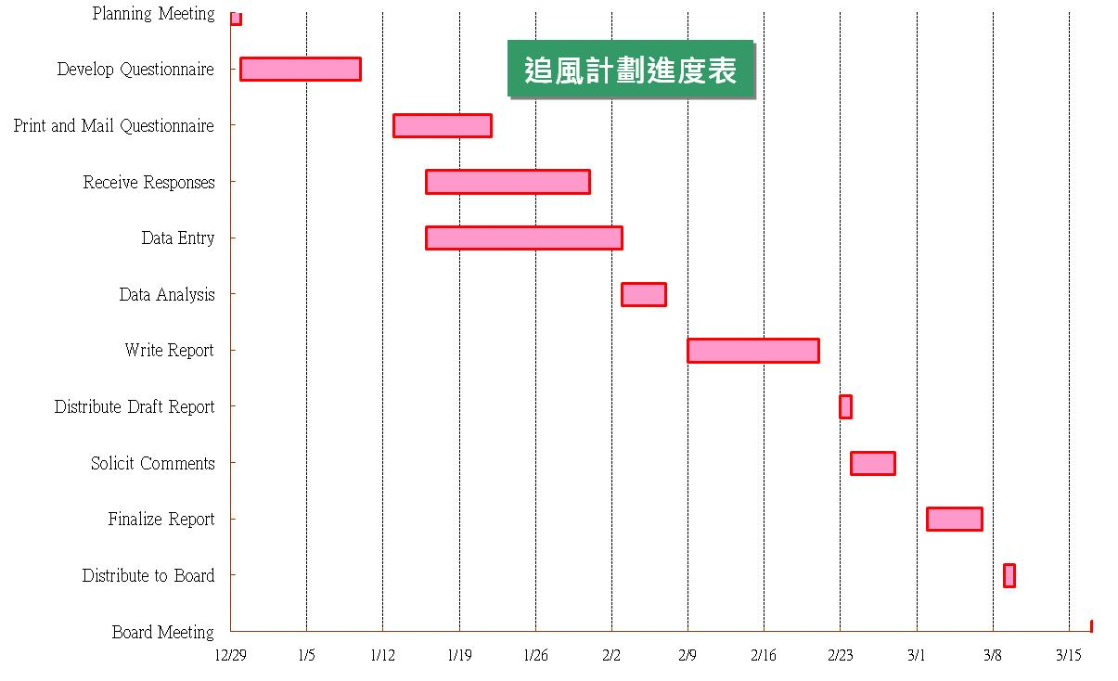

圖表 1 進度追蹤

表格 2 銷售金額統計表

|  |  |  |
| --- | --- | --- |
| 客戶名稱 | 銷售金額 | 累計銷售金額 |
| VINET | 13,120 | 13,120 |
| TOMSP | 47,781 | 60,901 |
| HANAR | 334,171 | 395,073 |
| VICTE | 91,824 | 486,897 |
| SUPRD | 228,754 | 715,651 |
| CHOPS | 131,684 | 847,335 |
| RICSU | 188,994 | 1,036,329 |
| WELLI | 60,682 | 1,097,011 |
| HILAA | 211,281 | 1,308,292 |
| ERNSH | 911,426 | 2,219,718 |
| CENTC | 29,261 | 2,248,979 |
| OTTIK | 132,658 | 2,381,636 |
| QUEDE | 66,648 | 2,448,285 |
| RATTC | 517,696 | 2,965,980 |
| FOLKO | 288,026 | 3,254,006 |
| BLONP | 193,799 | 3,447,805 |
| WARTH | 162,564 | 3,610,369 |
| FRANK | 241,923 | 3,852,292 |

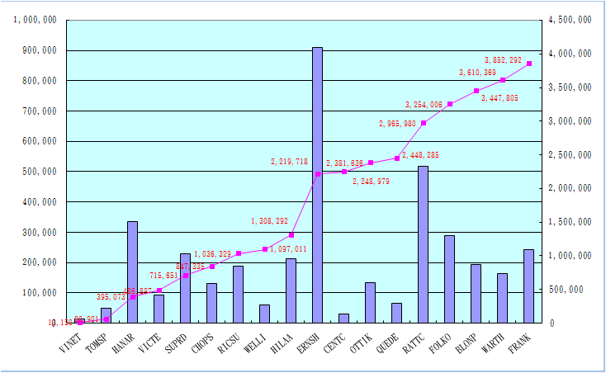

圖表 2 累計曲線圖