ch23_rmd

jjw

9 November 2020

width = 4

ggplot(mpg, aes(displ, hwy)) +  
 geom_point()

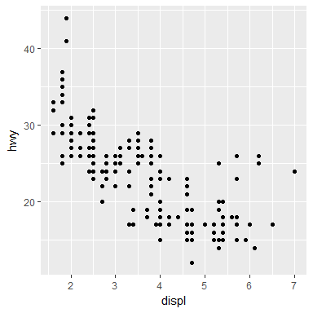

width = 6

ggplot(mpg, aes(displ, hwy)) +  
 geom_point()

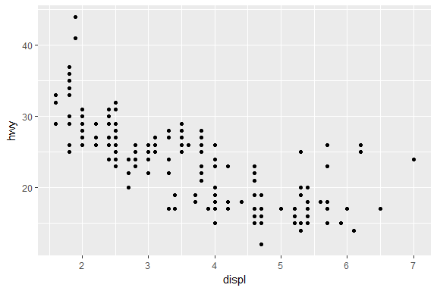

width = 8

ggplot(mpg, aes(displ, hwy)) +  
 geom_point()

