After the server installation is complete, access the address <http://127.0.0.1:8080/MsAlignPlus/>.

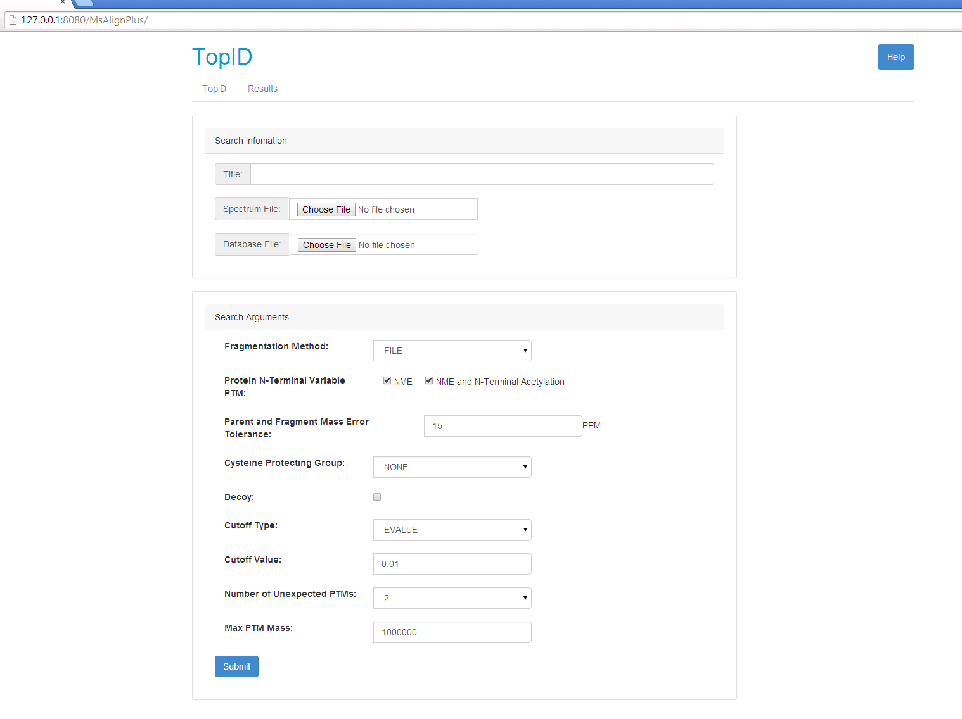

In the following text box, enter the title of the task, and it can not be empty.

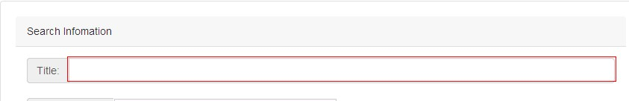

Select the input spectra file and database file in the file box whose name must be end with .msalign and .fasta:

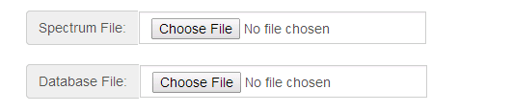

Set the arguments for the search in the following area and then click the button to submit,

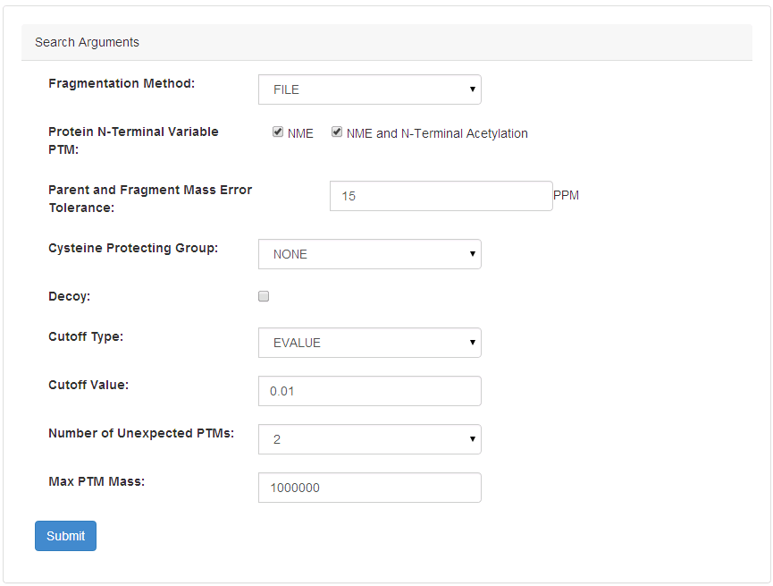

The it will show the window like the following pic if the task is submitted to the task list, Click the button “Submit Another Task” to return and submit another task or click “See Results” to show the task list .

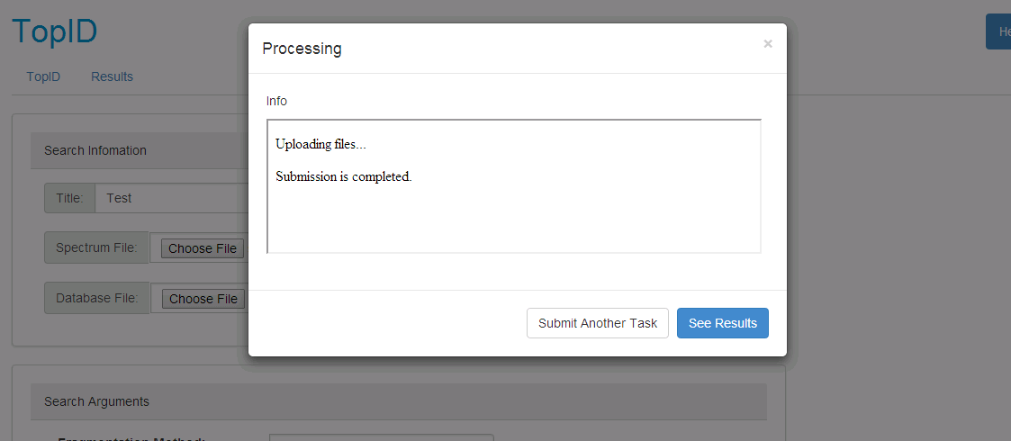

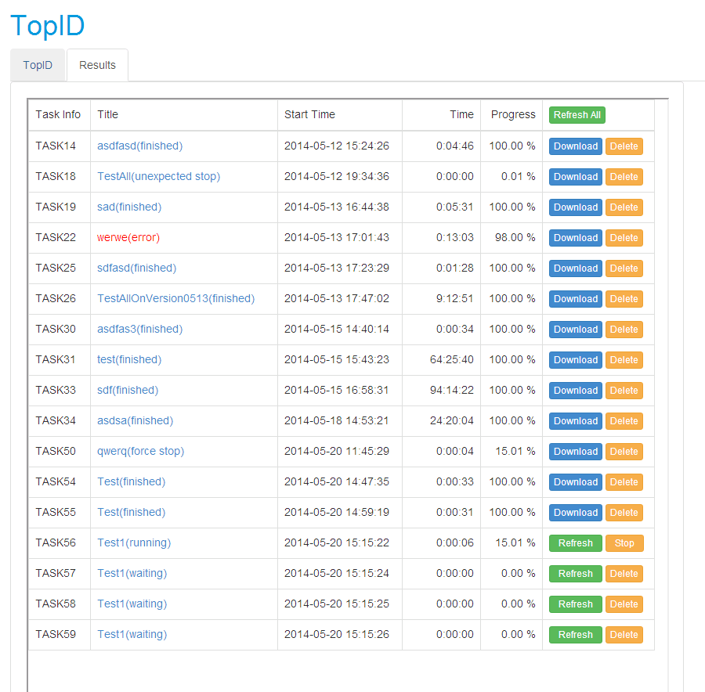

The function of these buttons in this page is :

|  |  |
| --- | --- |
|  | Refresh the hole table of the tasks |
|  | Refresh the Time and Progress of the task in the same row |
|  | Stop the running task which is in the same row with the button |
|  | Delete the task in the same row |
|  | Zipping all the task files and generate the download link as the follow pic |



If the title of the task ends with (finished) , the link of the title would show the result page

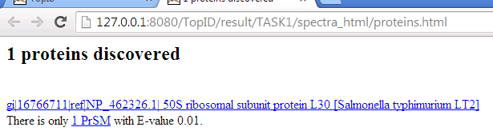

The titles with other states would forward to the file list in the task folder, and you can click the log .txt file to find what happened

