**Deploy Static Website on AWS:**

Requirements:

1. First, you will create an S3 bucket, configure the bucket for website hosting, and secure it using IAM policies.

The student has created a S3 bucket:

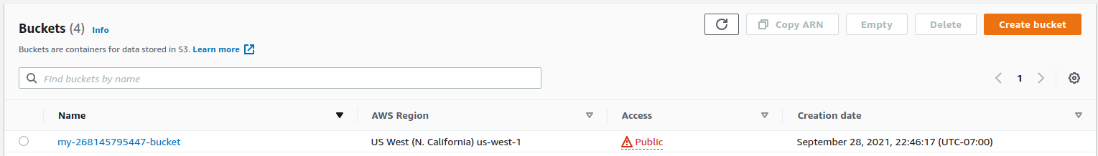

All website files should be added to the S3 bucket.

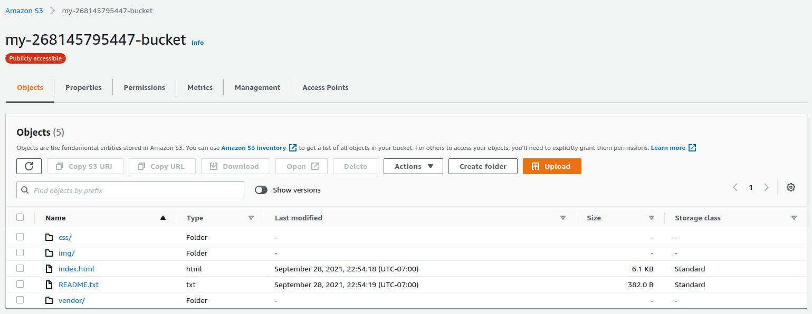

The bucket configuration should be set up to support static website hosting.

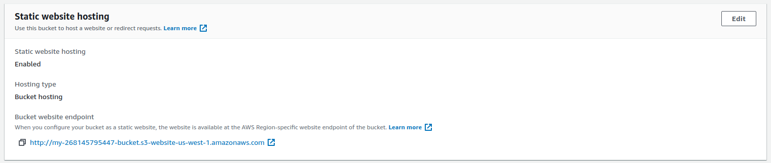

The permission access to the bucket should be configured.

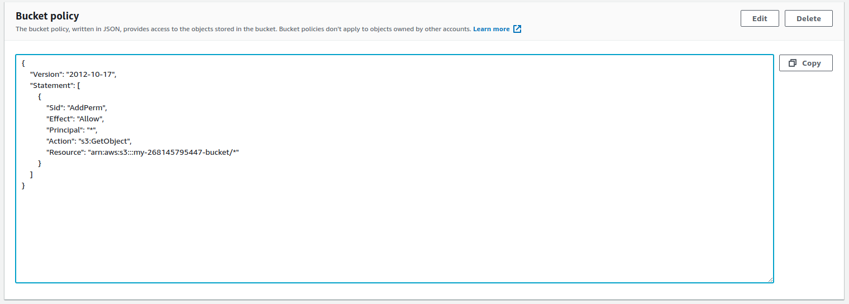

2. Next, you will upload the website files to your bucket and speed up content delivery using AWS’s content distribution network service, CloudFront.

The website should be distributed via CloudFront.

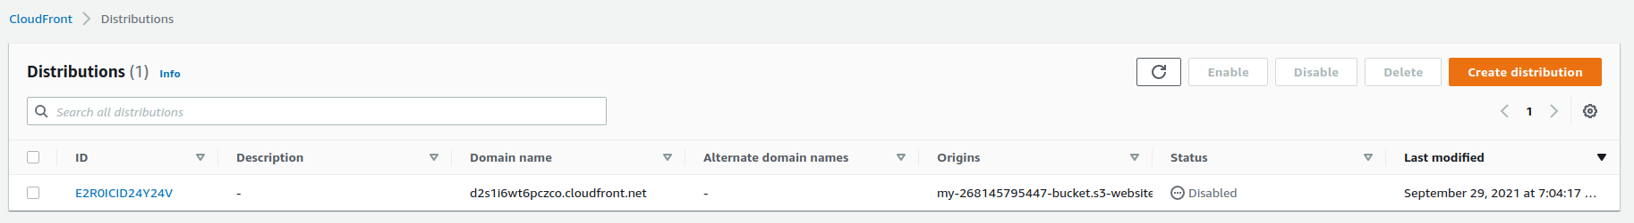

3. Lastly, you will access your website in a browser using the unique S3 endpoint.

The student should have provided the CloudFront domain name URL and website-endpoint URL for the website

CloudFront domain name: [https://d2s1i6wt6pczco.cloudfront.net](https://d2s1i6wt6pczco.cloudfront.net/)

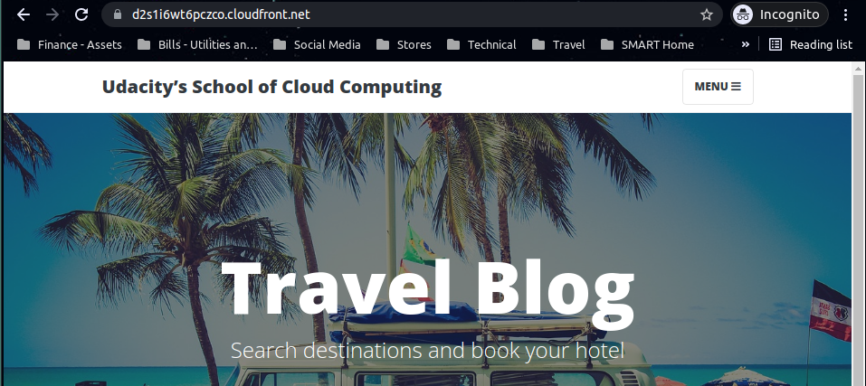

Website-endpoint: <http://my-268145795447-bucket.s3-website-us-west-1.amazonaws.com/>

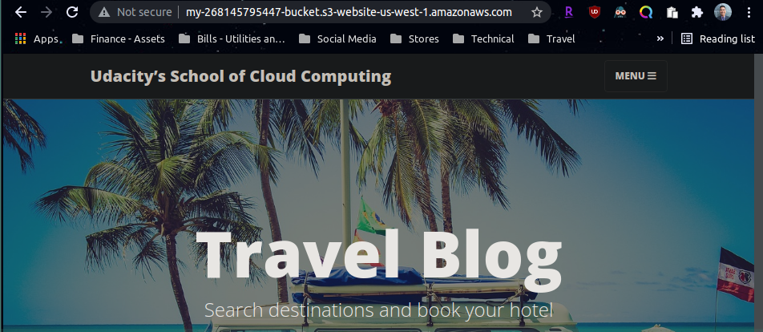

S3 object URL: <https://my-268145795447-bucket.s3.amazonaws.com/index.html>

[redirected to <https://my-268145795447-bucket.s3-us-west-1.amazonaws.com/index.html>]

