N20_Analysis

Johnny Soares

16 de fevereiro de 2017

## Setting Working Directory

I am setting my working directory which is located on Desktop.

setwd("C:/Users/johnny.soares/Desktop/testeR/Rcode")

## Read Input

I am reading N20 daa

N2O2014<-read.csv("./../data/N2O2014.csv")

## Creating Histogram

I am creating histogram of N20.

hist(x=N2O2014$N2Olog)

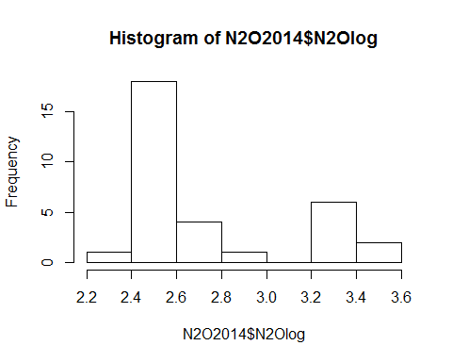

## Running ANOVA and summary of anova

We run ANOVA on N2O data

anova<-aov(N2O2014$N2Olog~N2O2014$Fonte)  
anova

## Call:  
## aov(formula = N2O2014$N2Olog ~ N2O2014$Fonte)  
##   
## Terms:  
## N2O2014$Fonte Residuals  
## Sum of Squares 3.823470 0.130638  
## Deg. of Freedom 7 24  
##   
## Residual standard error: 0.07377827  
## Estimated effects may be unbalanced

summary(anova)

## Df Sum Sq Mean Sq F value Pr(>F)   
## N2O2014$Fonte 7 3.823 0.5462 100.3 3.29e-16 ***  
## Residuals 24 0.131 0.0054   
## ---  
## Signif. codes: 0 '***' 0.001 '**' 0.01 '*' 0.05 '.' 0.1 ' ' 1

anova

## Call:  
## aov(formula = N2O2014$N2Olog ~ N2O2014$Fonte)  
##   
## Terms:  
## N2O2014$Fonte Residuals  
## Sum of Squares 3.823470 0.130638  
## Deg. of Freedom 7 24  
##   
## Residual standard error: 0.07377827  
## Estimated effects may be unbalanced

# Plotting N20

we are plotting N2o versus fertilizer treatments

plot(N2O2014$Fonte, N2O2014$N2Olog)

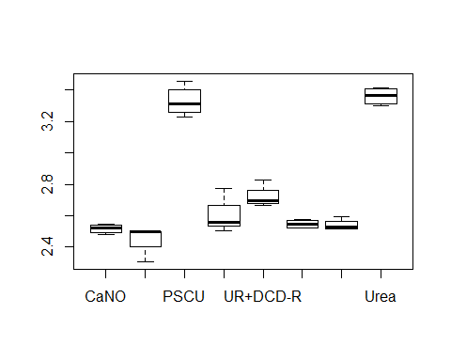

# Normal distribution

shapiro.test(resid(anova))

##   
## Shapiro-Wilk normality test  
##   
## data: resid(anova)  
## W = 0.96443, p-value = 0.3612

# Tukey test

TukeyHSD(anova)

## Tukey multiple comparisons of means  
## 95% family-wise confidence level  
##   
## Fit: aov(formula = N2O2014$N2Olog ~ N2O2014$Fonte)  
##   
## $`N2O2014$Fonte`  
## diff lwr upr p adj  
## NoN-CaNO -0.067593084 -0.24037264 0.1051864750 0.8917052  
## PSCU-CaNO 0.809821994 0.63704244 0.9826015525 0.0000000  
## UR+DCD-CaNO 0.082530343 -0.09024922 0.2553099015 0.7559473  
## UR+DCD-R-CaNO 0.203598514 0.03081896 0.3763780730 0.0131745  
## UR+DMPP-CaNO 0.030264228 -0.14251533 0.2030437865 0.9988294  
## UR+DMPP-R-CaNO 0.025196014 -0.14758354 0.1979755725 0.9996438  
## Urea-CaNO 0.842254089 0.66947453 1.0150336475 0.0000000  
## PSCU-NoN 0.877415078 0.70463552 1.0501946362 0.0000000  
## UR+DCD-NoN 0.150123427 -0.02265613 0.3229029852 0.1221175  
## UR+DCD-R-NoN 0.271191598 0.09841204 0.4439711567 0.0005736  
## UR+DMPP-NoN 0.097857312 -0.07492225 0.2706368702 0.5788338  
## UR+DMPP-R-NoN 0.092789098 -0.07999046 0.2655686562 0.6392219  
## Urea-NoN 0.909847173 0.73706761 1.0826267312 0.0000000  
## UR+DCD-PSCU -0.727291651 -0.90007121 -0.5545120923 0.0000000  
## UR+DCD-R-PSCU -0.606223480 -0.77900304 -0.4334439208 0.0000000  
## UR+DMPP-PSCU -0.779557766 -0.95233732 -0.6067782073 0.0000000  
## UR+DMPP-R-PSCU -0.784625980 -0.95740554 -0.6118464213 0.0000000  
## Urea-PSCU 0.032432095 -0.14034746 0.2052116537 0.9981829  
## UR+DCD-R-UR+DCD 0.121068171 -0.05171139 0.2938477302 0.3232259  
## UR+DMPP-UR+DCD -0.052266115 -0.22504567 0.1205134437 0.9696809  
## UR+DMPP-R-UR+DCD -0.057334329 -0.23011389 0.1154452297 0.9508282  
## Urea-UR+DCD 0.759723746 0.58694419 0.9325033047 0.0000000  
## UR+DMPP-UR+DCD-R -0.173334286 -0.34611385 -0.0005547278 0.0488648  
## UR+DMPP-R-UR+DCD-R -0.178402500 -0.35118206 -0.0056229418 0.0395341  
## Urea-UR+DCD-R 0.638655575 0.46587602 0.8114351332 0.0000000  
## UR+DMPP-R-UR+DMPP -0.005068214 -0.17784777 0.1677113447 1.0000000  
## Urea-UR+DMPP 0.811989861 0.63921030 0.9847694197 0.0000000  
## Urea-UR+DMPP-R 0.817058075 0.64427852 0.9898376337 0.0000000