**Task 2:**

API - <http://localhost:8080/api/import>

1. Run unit testing method generateCsv() to generated csv

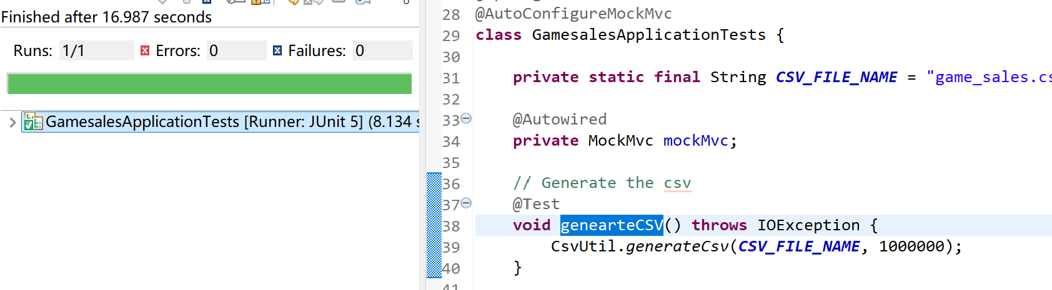

1. Use the postman to hit the endpoint

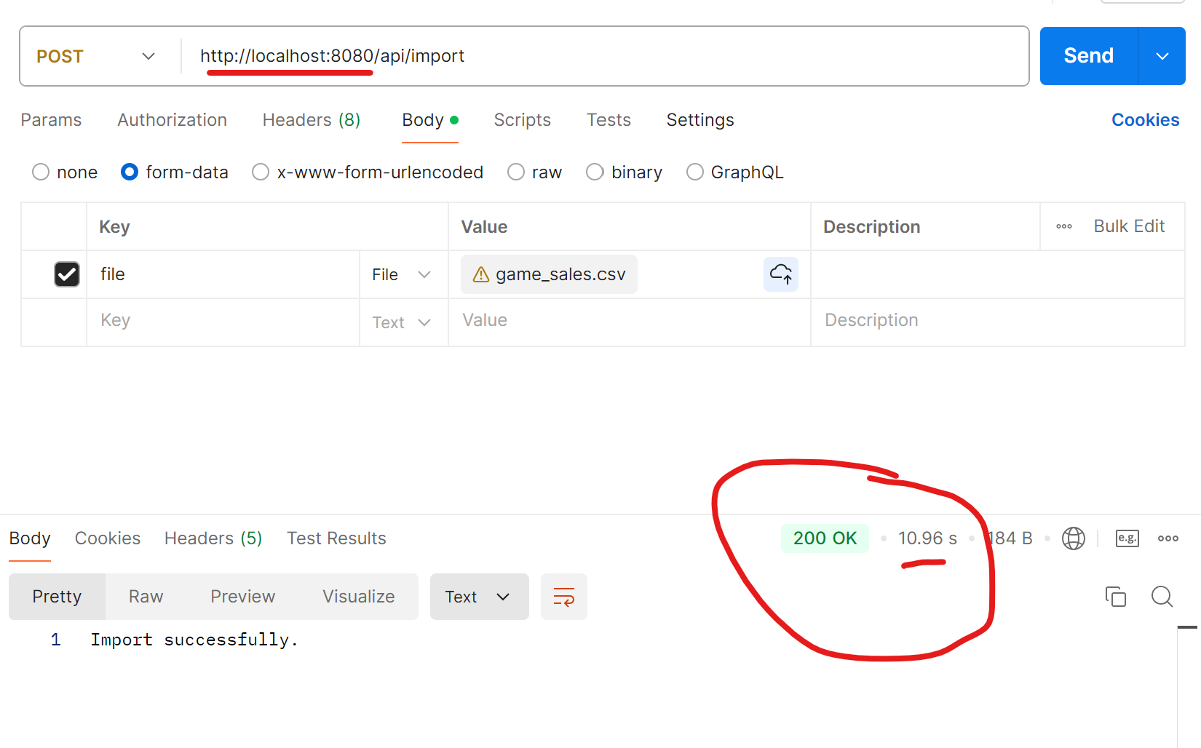

1. Check the db records –

Table - game_sales

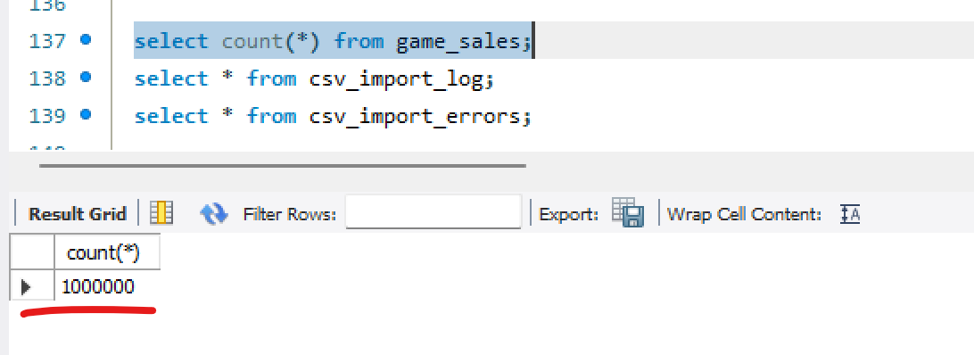

Table - csv_import_log

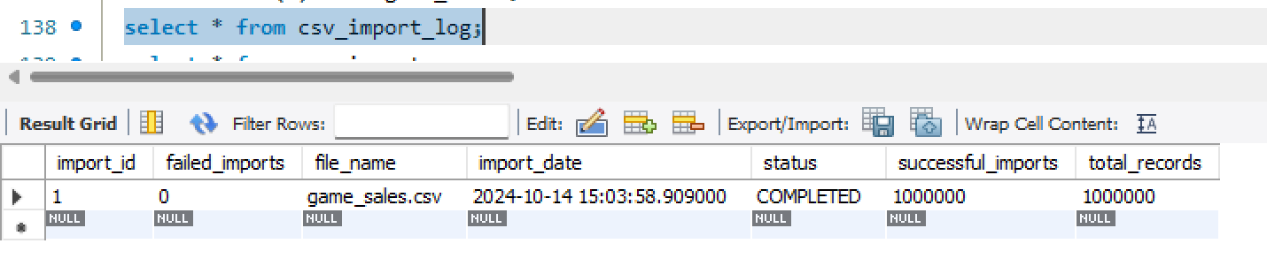

Table - csv_import_errors

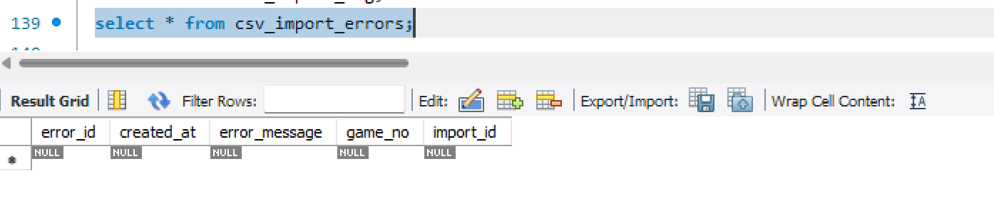

**Task 3:**

API - <http://localhost:8080/api/getGameSales>

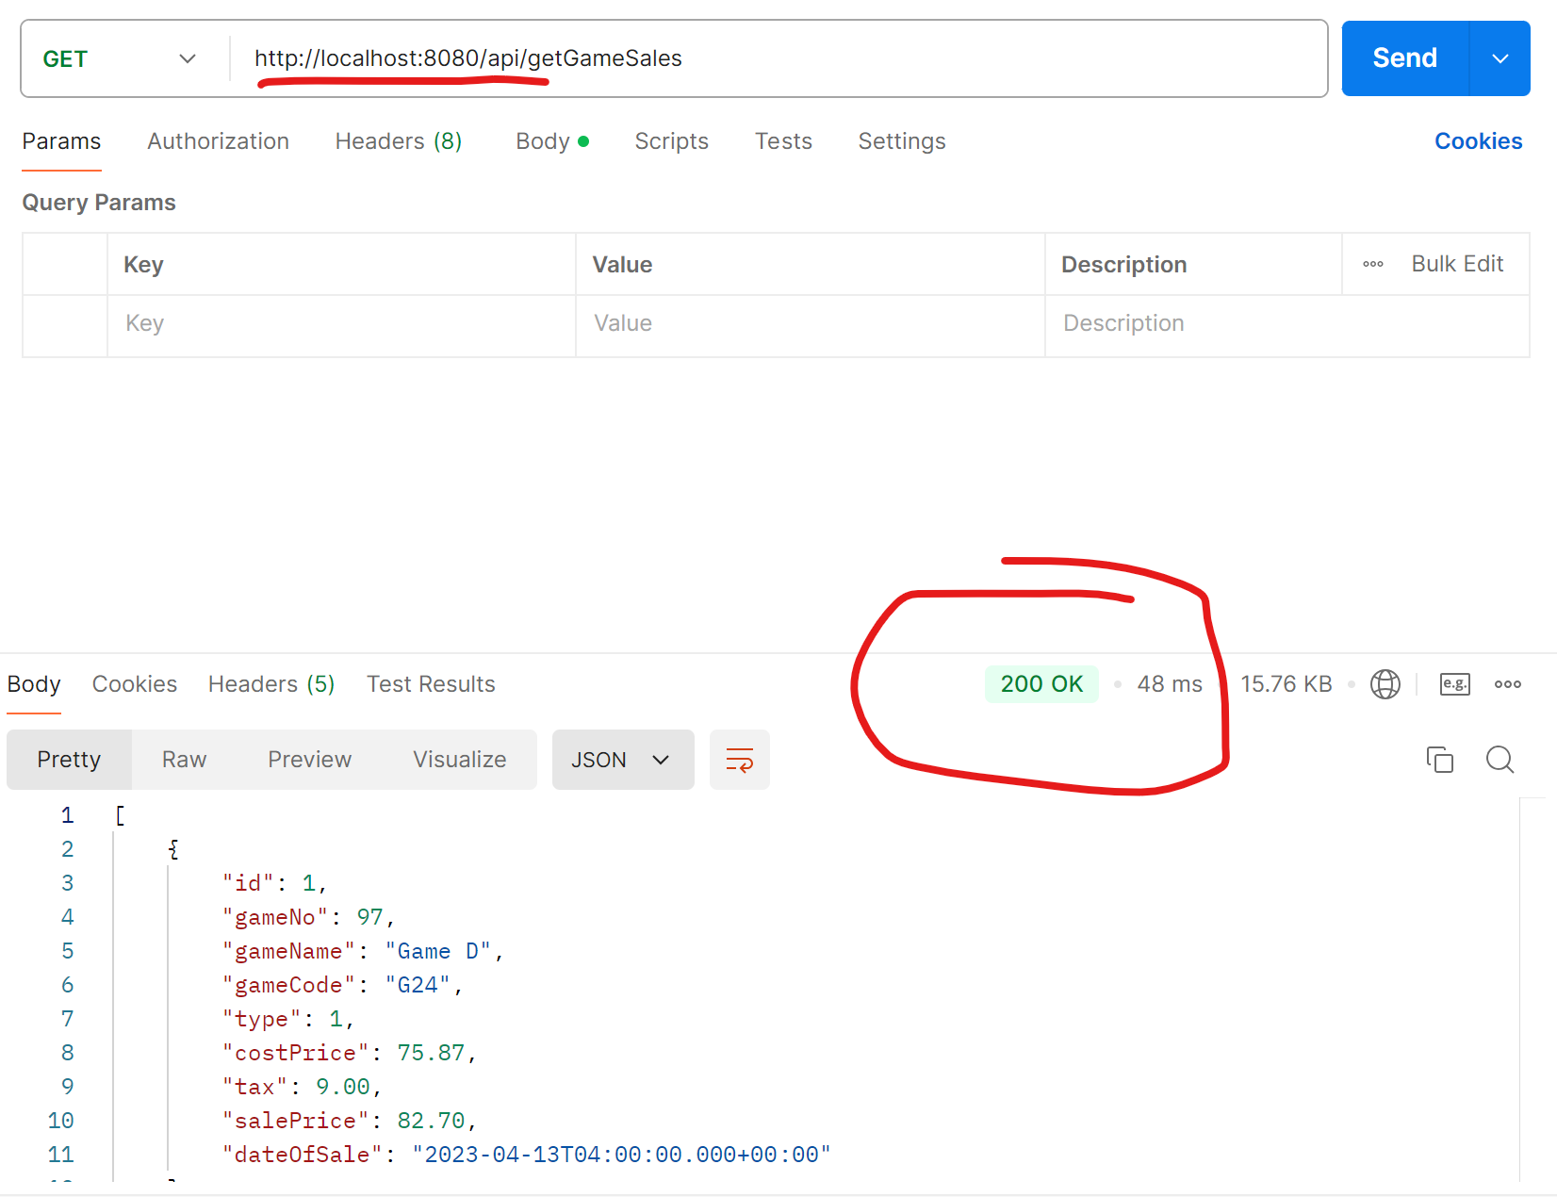

API endpoint - [http://localhost:8080/api/getGameSales?fromDate=2024-01-01 00:00:00&toDate=2024-12-20 23:30:59](http://localhost:8080/api/getGameSales?fromDate=2024-01-01%2000:00:00&toDate=2024-12-20%2023:30:59)

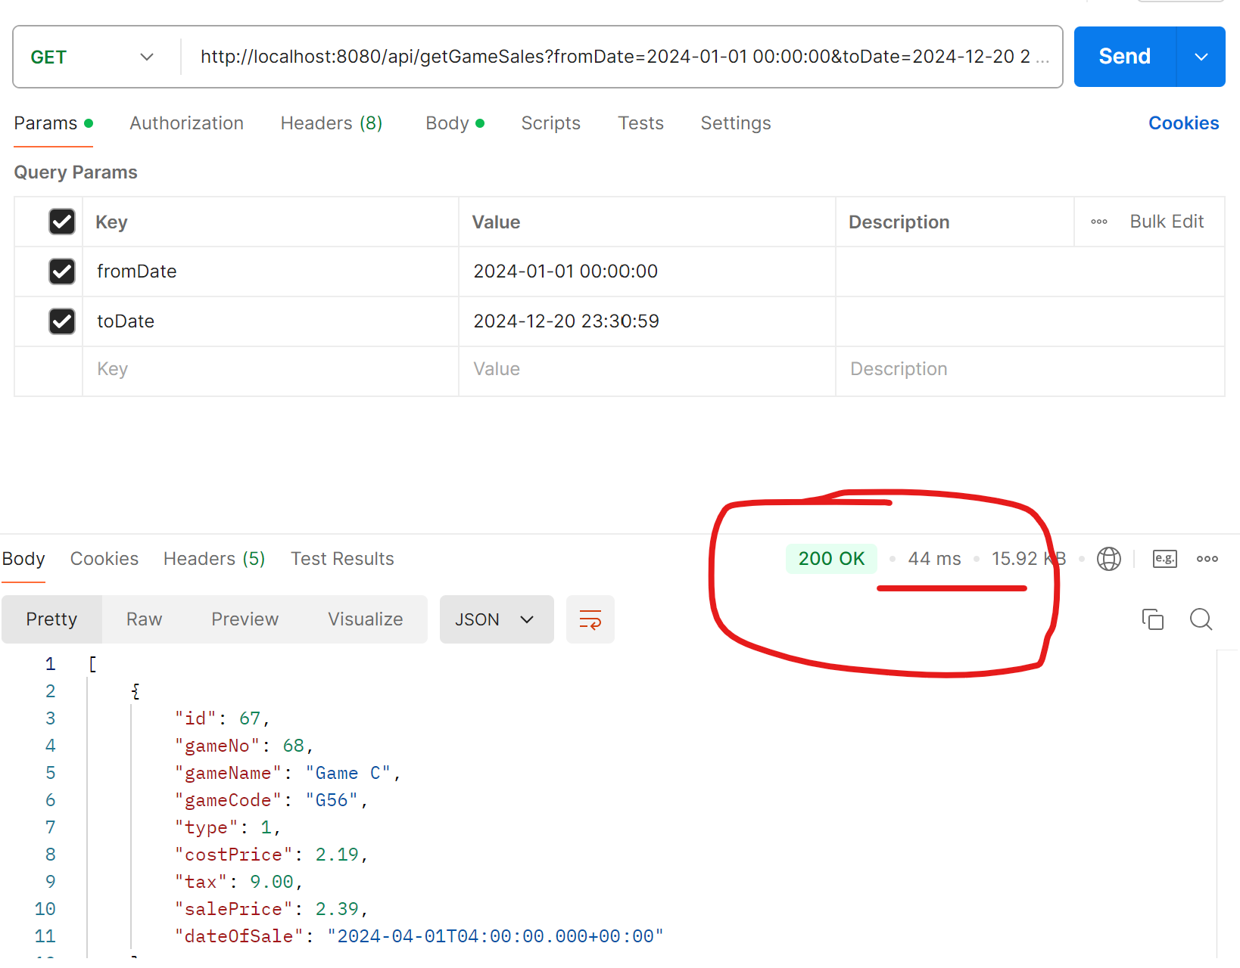

API endpoint –

[http://localhost:8080/api/getGameSales?fromDate=2024-01-01 00:00:00&toDate=2024-12-20 23:30:59&comparison=greater&salePrice=30](http://localhost:8080/api/getGameSales?fromDate=2024-01-01%2000:00:00&toDate=2024-12-20%2023:30:59&comparison=greater&salePrice=30)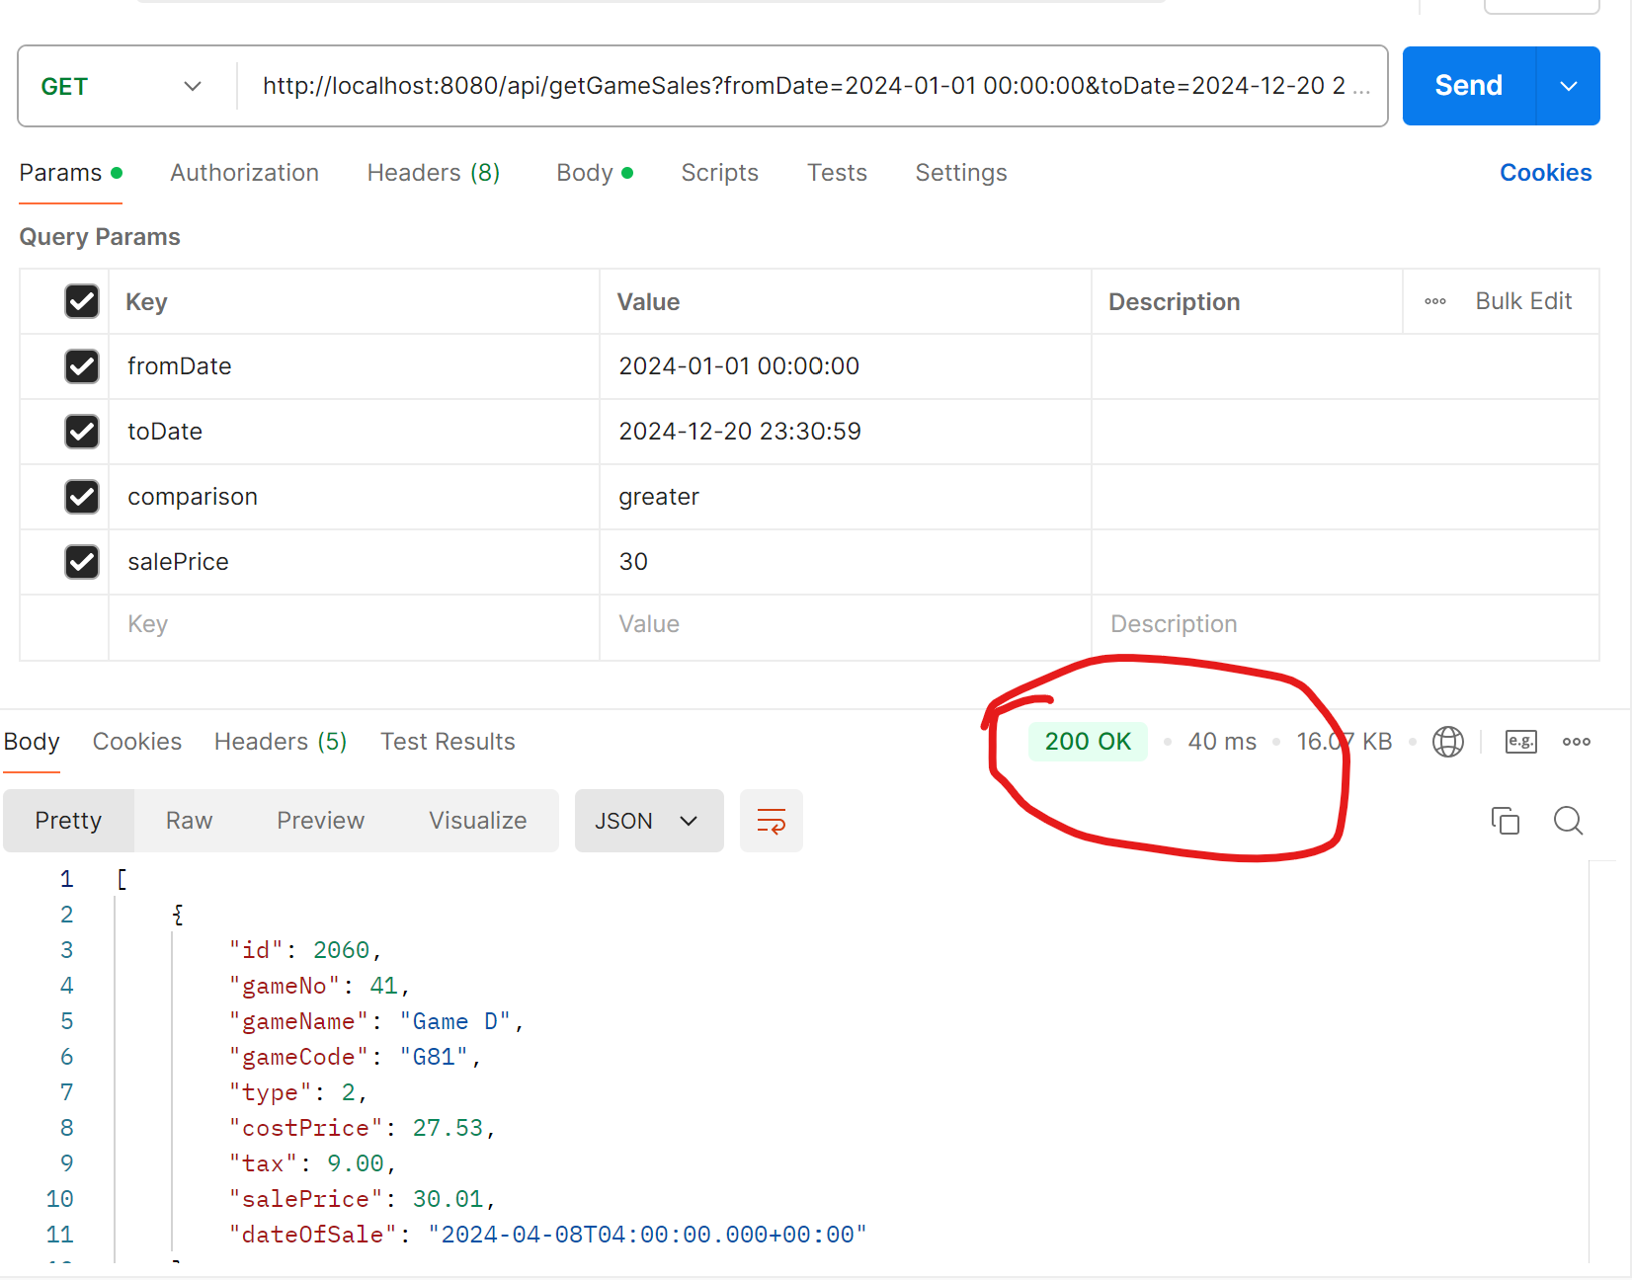

API endpoint –

[http://localhost:8080/api/getGameSales?fromDate=2024-01-01 00:00:00&toDate=2024-12-20 23:30:59&comparison=less&salePrice=60](http://localhost:8080/api/getGameSales?fromDate=2024-01-01%2000:00:00&toDate=2024-12-20%2023:30:59&comparison=less&salePrice=60)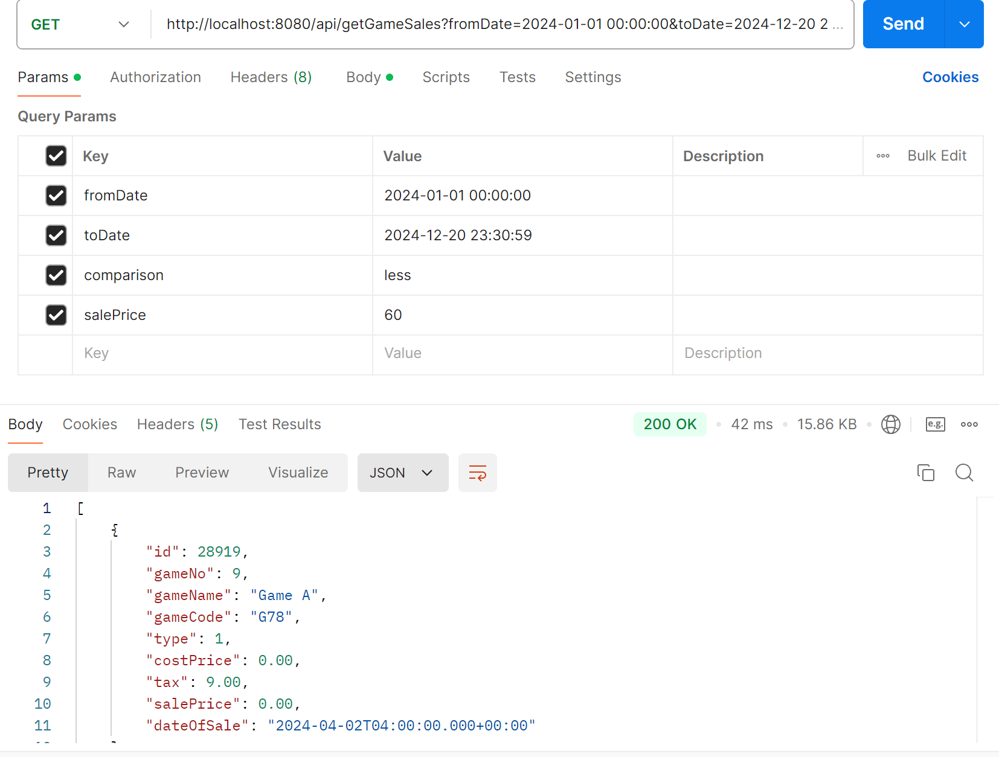

**Task 4:**

API - <http://localhost:8080/api/getTotalSales?fromDate=2024-01-01T00:00:00&toDate=2024-04-20T23:30:59&gameNo=2>