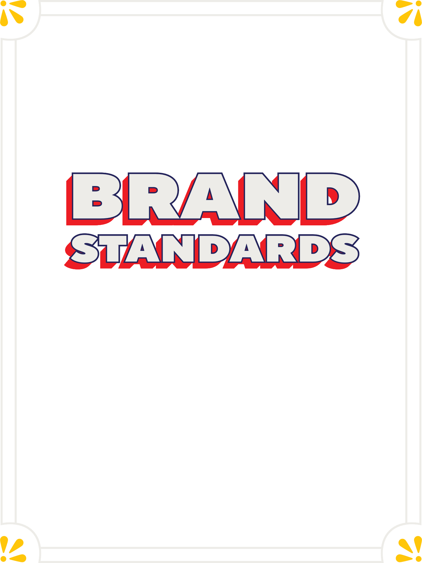

Everything you ever wanted to know about Chili's standards, but were too afraid to ask.

OUR PURPOSE
To Make Everyone Feel Special through a Fun Atmosphere, Delicious Food & Drinks with ChiliHead Hospitality.

Brinker International Payroll Company, 06/2025


BRAND STANDARDS
OVERVIEW

WHY ARE THE BRAND STANDARDS IMPORTANT?
When we execute the Brand Standards, we create a meaningful experience for our Guests and Team Members by delivering genuine ChiliHead Hospitality.
To our Guests, this experience looks like:
- An excited ChiliHead welcomes them to the party.
- Their Server is excited to serve them, makes them feel special and taken care of, like they're a regular.
- There is consistently delicious food and margaritas around the table.
- When they leave, they're already looking forward to their next visit.
Each member of your team plays an important role delivering on the Brand Standards and ChiliHead Hospitality Behaviors.

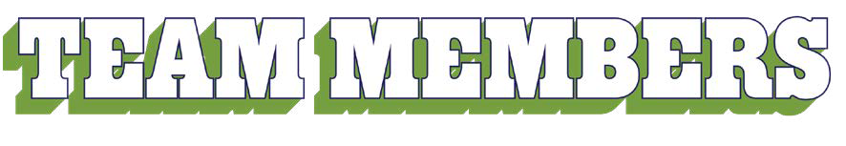
MANAGER: Host and coach the party.
- Proactively engage with all Guests and TMs.
- Praise and coach ChiliHead Hospitality Behaviors.

HOST: Welcomes all Guests to the party.
- Greet every Guest with a smile and “Hi! Welcome to Chili’s!”
- Open the door for arriving and departing Guests.

TO-GO: Make every Guest feel like they’re a regular.
- Greet every Guest with a smile and “Hi! Welcome to Chili’s!”
- Work the bag chit to ensure order accuracy and no missing items.
RUNNER: Elevate the Guest experience.
- Ask, “What more can I get you?”
- Run drinks/apps quickly and consistently pre-bus.

BUSSER: Take pride in a clean restaurant.
- Bus tables with the bus tub, wipe down tables and spot sweep.
- Use headset to communicate with Host about table status.
BARTENDER: Makes every Guest feel like they’re a regular.
- Greet Guests within 60 seconds and recommend a Marg and app.
- Make and deliver drinks in under 3 minutes.

SERVER: Makes every Guest feel like they’re a regular.
- Greet Guests within 60 seconds and recommend a Marg and app.
- Elevate the Guest experience with regular check-ins, silent refills and pre-bussing.
QA: Ensure the safety and quality of our Delicious Food.
- Proactively communicate order status to HOH and Managers.
- Validate all orders are made to spec and use
names to ensure food is delivered hot and fast.
HOH: Take pride in creating consistently Delicious Food.
- Ensure all orders are made to spec and every plate and To-Go box is 100% complete.
- Ensure all food safety and Chili's Clean measures are followed.

  - 5/10 Rule: 5 ft = smile, make eye contact and say something genuine and nice. 10 ft = smile and make eye contact.
all
  - Proper dress guidelines, including headsets.
  - Have fun! Make connections! Live our Purpose.

Brinker International Payroll Company, 06/2025
Pg 2 of 24


BRAND STANDARDS
TABLE OF CONTENTS

SAFETY & SECURITY

SAFETY CRISIS

REPORTING 4
Self Service Portal (SSP) 4
Reporting Illness Guidelines 4

FOOD SAFETY 4
Criticals 4
Practices 4

SECURITY

PROCEDURES 5
Safe Exiting/Entering 5
Back Door 5
Exterior Lights 5
TM Parking 5

POLICY GUIDELINES 5

TECHNOLOGY 6

FRONT OF HOUSE

EXTERIOR 7
Parking Lot & Landscaping 7

CHILI'S CLEAN 7
Managers 7
Team Members 7

HOST STAND 8
Host Behaviors 8
Host Set Up 8

DINING ROOM 9
Overall Area 9
Blinds 9
Tables, Booths, & Chairs 9
Server Station Setup 10
Table Setup 10
Service Model 11
Table Greeting 11
Bussing Tables 11
Tabletop Device Cleaning 12
Silverware Bagging 12
Refill Procedure 12
Birthday Procedures 12
Cash Handling 12

TEAM MEMBERS 12
Personal Items 12
TM Dress Guidelines 13
TM Food and Drinks 13
Shift Meals 13
BAR 13
Bar Setup 13
Bar Greet 14
Alcohol Specs 14
Liquor Bottle Setup 14
Margarita Taps 14
Empty Beer Kegs 14
Last Call 14
Serving Responsibly 14
TVS 15
TVs and Programming 15
TO-GO 16
To-Go Area 16
To-Go Systems 16

RESTROOM 17
Atmosphere 17
Restroom Checks 17

HEART OF HOUSE

PASSOUT / QA 18
Tip Policy 18
Bumping Orders 18
Split Items 18
Passout Setup 18

DISH AREA 19
Ecolab Owns 19
Restaurant Owns 19
Organization 19
Chemicals 19
Garbage Cans 19
Skillets and Trivets 19
Dish / Machine Maintenance 20
OFFICE 20
Office Door 20
Inside Office 21

MOP SINK / CHEMICALS 21
Mop Sink & Chemical Tower 21

PREP AREA 22
Overall Area 22
Prep Cards 22
Signage 22
Combi Oven 22
Retherm 22

WALK-IN / FREEZER 23
Dry Storage 23
Walk-In & Freezer, Beer
Cooler / Cage 23

COOK LINE 23
Line Setup 23
KDS 23
Equipment 23
Chemicals & Supplies 23
Cleaning 23

BACK DOOR /

PEST CONTROL 24
Interior 24
Exterior 24

BACK DOCK 24
Overall Area 24
Shed 24
Attic 24
Mechanical Room 24

Brinker International Payroll Company, 06/2025 Pg 3 of 24


BRAND STANDARDS

SAFETY CRISIS REPORTING
SELF SERVICE PORTAL (SSP) | - All crisis incidents MUST be reported in the Self Service Portal (SSP).  - Crisis incidents include the following:  - Police/Security Incidents  - Team Member/Guest Accidents  - Restaurant Closures  - Boil Water Notices  - Social Media Concerns/Media Inquiries  - Multiple Guests Reporting Illness After Dining/Foreign Objects in Food  - Team Member Reporting Illness/Health Department Investigation
REPORTING ILLNESS GUIDELINES | - When to use the Crisis Portal to report ill TM/Guest(s):  - Team Member(s):  - Three or more TMs call out for vomiting or diarrhea within seven days.  - Any TM seeks medical care and is diagnosed with a foodborne illness.  - Anytime a Health Department informs you they are investigating an illness.  - Guest(s):  - Multiple Guests reporting food related illness or symptoms.  - STEP 1: OPEN A TICKET  - Immediately report incident.  - STEP 2: INFORM  - GM/Manager MUST immediately inform DO.
FOOD SAFETY
CRITICALS | - Digital Quality Line Check completed shiftly.  - Digital Critical Checklist completed shiftly.  - Testing strips are taped to Daily Pull Thaw sheet.  - Cooling Log is reviewed and verified each week.
PRACTICES | - Follow posted Hand Washing Procedure as mandated.  - Gloves must always be worn when handling Ready To Eat Food.  - When handling burgers (on the Cook Line), use Burger mitts 100% of the time.  - Hat/hairnet worn 100% of the time by all HOH TMs, including Manager(s) and QA.  - Beard net MUST be worn 100% of the time (if applicable) including Manager(s).  - Hat/hairnet/beard guards MUST be stocked and hung outside the office door.  - Shoulder length or longer hair: pulled back in ponytail or bun, hair away from face, with no loose strands. HOH TMs and QA MUST also wear hat and/or hairnet.  - Fingernails: clean and neatly trimmed.  - Prep items ONLY in proper designated areas.  - Any TM exhibiting signs of foodborne illness may NOT work.  - Common symptoms include: Vomiting, diarrhea, juandice and sore throat with fever.  - TMs MUST properly cover infected/exposed wounds, lesions, cuts or boils with double barrier protection to be cleared to work.  - Double barrier example: band-aid covered by clothing/gloves.  - Manager ServSafe certified.  - TMs certified based on state regulations.  - Immediately enter any pest sighting in SSP every day seen.

Brinker International Payroll Company, 10/2025 Pg 4 of 24

BRAND STANDARDS

SECURITY PROCEDURES
SAFE EXITING/ ENTERING | - Opening: Manager is required to drive around the building to observe anything unusual and cannot enter the restaurant until a second TM arrives. Manager will enter the restaurant to disable the alarm system while the second TM waits inside their locked vehicle. Manager (from inside the restaurant) then watches TM enter the restaurant.  - Closing: Manager is required to observe the last TM walk to their vehicle while inside the locked restaurant. Once this TM is safely inside their locked vehicle, the Manager is to immediately set the alarm and exit through the front or To-Go door to their vehicle while TM observes from their vehicle.  - No Brinker TM can ever be in the restaurant alone, except when following Safe Exiting/Entering Procedure described above and second person MUST be a Brinker TM.  - TMs MUST enter through the back door in the morning prior to restaurant opening, however, no TMs are allowed to exit the restaurant after their shift via the rear door. TMs must exit via the most visible door (front door or To-Go door).  - No one can exit, enter or open the back door from one hour prior to close until open the following morning.  - All doors are required to be locked at closing - no TMs or Guests are allowed back in the restaurant after closing.  - The restaurant alarm system is required to be set each evening (unless a no close alarm is called in).  - The sharing of alarm pass codes is prohibited.
BACK DOOR | - Back door and security cage are NEVER propped open OR open at the same time (including deliveries) and must always be securely locked.  - Back door is NOT allowed to be opened one hour prior to close for any reason.  - Trash needs to be emptied prior to this time.  - Any remaining trash bags are consolidated and staged (closed/tied up) by the back door until the next a.m. shift.  - Detex system is engaged/armed during operating hours.  - NOTE: Ensure "Stop" sign is posted.
EXTERIOR LIGHTS | - Timers for exterior lights, including pole signs/neons, should be set for lights to remain on approximately one hour after last Manager and TM leave the restaurant.  - Adjust accordingly for daylight savings time change.
TM PARKING | - Prime spots are for Guests ONLY (front of building, To-Go parking, etc.)  - TMs should leave in pairs; safety is top priority.
POLICY GUIDELINES
- Chili's is committed to promoting an inclusive environment where everyone feels welcome, valued and respected. Chili's does not tolerate discrimination, harassment, or retaliation of any kind and strives to create a positive and diverse workplace where all TMs and Guests feel safe.
- TMs must be mindful of cell phone usage during a shift/in Guest's view and must prioritize Guest engagement. If it is necessary, TMs can discreetly and quickly use
their cell phone in a designated area (out of Guests view).

Brinker International Payroll Company, 10/2025 Pg 5 of 24

BRAND STANDARDS

POLICY GUIDELINES Continued
- It is crucial to ensure a safe and enjoyable work environment. All TMs must follow
Brinker Policies & Procedures Manual and abide by all federal, state and local laws.
- TMs MUST clock in for all hours worked.
- Social media standards:
  - Clearly state that any opinions you express are your own and do not reflect those of the Company.
  - DON’T disclose confidential business info about Chili's/Brinker, other TMs or our business partners.
  - DON’T post anything that’s discriminatory or would constitute a threat, intimidation, harassment or bullying.
  - If you see something communicated that could be potentially harmful to the company, report it immediately to your Manager, the Social Media team or the Public Relations team. Don’t respond to negative comments yourself.
  - DON’T post any Guest information or pictures without their consent, never
post any Guest information (ie. a receipt, tip amount or credit card details).
TECHNOLOGY
- iPads:
  - All iPads in cases, working and in good condition
  - iPad bulk charger stored in office (or safe/enclosed space)
  - iPads must be plugged in when not in use and left on overnight to ensure required updates are installed
- Tabletop Devices:
  - Clean and powered on during operating hours
  - Dining room: One device placed at the back of each table
  - Bar Top: One device placed at every third seat
  - To-Go: One device placed at To-Go counter in To-Go mode
  - Back-Up Devices: Two devices kept in office without batteries
    - Put batteries in once a week to receive any software updates
- Kitchen Hardware
  - KDS: dust/grease-free; cords neatly wrapped, screens clean/plastic wrapped
    - Do NOT manually power down KDS overnight
  - Two sticky chit printers working and in good condition on the Cook Line
  - One KitchenSync printer working and in good condition in the Prep Area
- Returned Merchandise Authorization (RMAs) Procedure
  - Enter RMA in SSP (one ticket per device) and mail out RMAs IMMEDIATELY.
Do NOT stockpile devices - send RMAs as they occur
  - Replacement device will be shipped once the return label is scanned at pick-up
- Laptops
  - Stored in the office and plugged in to charge when not in use
  - In FOH, ALWAYS lock screen and close laptop when away from keyboard
- Point of Sale (POS)
  - GMs must check POS units for unusual USB devices
- Radios
  - 24 working radios, earpieces and charging bays

Brinker International Payroll Company, 10/2025 Pg 6 of 24


BRAND STANDARDS

EXTERIOR
PARKING LOT & LANDSCAPING | - Sidewalks and parking lot in good condition - no potholes, no visible debris or trip hazards  - Parking lot lines are clearly visible  - Parking lot signs in good condition  - No trashcans present ONLY receptacle ash tray  - NOTE: Follow city and county health protocols for distance from front door  - Landscape in good appearance - NOT dead or overgrown, shrubbery at least 18 inches away from the building and six inches off the ground, rock or concrete barrier 12”-18” around building  - Paint, awnings, doors and windows are in good condition and clean  - Lighting is bright, no burned out bulbs - ONLY order bulbs through Chili's Lighting List  - BWeb > Forms and Policies > Forms > Supply Chain Forms > Chili's Lighting List  - Neon is bright with no burned out sections  - Exterior speakers working and music level set between 65-70 (SPLNFFT Noise Meter App)
EXTERIOR ATMOSPHERE EXPECTATIONS:
- Validate landlord responsibility vs. restaurant's prior to any exterior repairs
- If bench is not in good condition, DO/VPO discretion for removal
- Sprinkler functioning correctly and NOT spraying building
- No wood rot, no fogged windows
- No micro-trash
- Replace curb-stops/rebar
- Ground lights: CAP when not working or broken, do not replace
- Reference Chili's Postings Checklist for proper signage placement (To-Go doors, front doors, etc.)
CHILI'S CLEAN
MANAGER | - FOH/HOH Clean: Daily Sidework & Weekly Sparkle  - Daily Sidework  - Responsible for validating with closing TM  - Weekly Sparkle  - Responsible for assigning shiftly to appropriate TMs and validating completion  - FOH Clean - staged near Connection Board  - FOH Clean: Host - staged near Host stand, out of Guest view  - HOH Clean - staged near HOH Connection Board  - HOH Clean: Janitorial - staged near Mop Sink  - Deep Clean Checklist  - Responsible for handing appropriate weekly list to TM and validating completion  - Staged in office on key ring when not in use
TEAM MEMBERS | - Responsible for utilizing job aids to complete Daily Sidework/Weekly Sparkle and Deep Clean Checklist  - Closing TM responsible for validating TMs cut before them

Brinker International Payroll Company, 10/2025 Pg 7 of 24

BRAND STANDARDS

HOST STAND
HOST BEHAVIORS | - Greet every Guest with six menus in hand as soon as they walk through our doors with a smile and "Hi! Welcome to Chili's!"  - Open the door for arriving/departing Guests  - Use Host iPad for tracking table status (open, seated, needs bussing) for every table, every time  - Deliver kid silverware when seating Guests with kids  - Always honor/accommodate Guest seating requests, including large parties  - Use headset to:  - Communicate with Bussers about table status  - Communicate with Managers for guidance when seating large parties  - Perform open menu counts as requested by Manager on duty
HOST SET UP | - Host stand is organized, clutter-free and perpendicular to the front door (if applicable)  - No business cards  - No TM belongings  - No brooms, dust pans, paper towels or spray bottles  - Host iPad on strap and working  - Use second ipad for volume shifts  - Menus clean, organized and in Brand Standard menu holder  - Every menu has a feature card  - Kid menus are staged flat, NEVER folded and crayons are NEVER reused  - Braille menus (and Spanish menus if applicable) are stored within Host Stand  - Kid silverware stored at Host Stand  - High chairs/booster seats are in good condition, MUST be cleaned after every use and stored in appropriate location (varies by restaurant)  - Door mats present ONLY when it rains/snows and store when not in use  - No trash cans present
HOST ATMOSPHERE EXPECTATIONS:
- Inviting, clean fresh smell, clutter-free
- To be pest-free eliminate excess benches and minimize storage usage
- No stationary hand sanitizer (unless health codes mandate otherwise) - scrub wall to remove residue if required
- Greet every Guest with a smile and "Hi! Welcome to Chili's!" with six menus in hand; present and in front of Guests at all times, opening the door for arriving and departing Guests
- Everyone owns greeting Guests when a Host is not present - coach TMs for best practices during shift change/no Host hour

Brinker International Payroll Company, 10/2025 Pg 8 of 24

BRAND STANDARDS

DINING ROOM
During the shift, Manager is ALWAYS proactively on the floor engaging with Guests and observing/ coaching ChiliHead Hospitality Behaviors.
OVERALL AREA | - Inviting, clutter-free and organized  - Dust-free, high-dusting from ceiling to the floor  - Temperature set to 68˚ on heat or 72˚ on cool - set to Guest comfort  - Music level between 65-70 (SPLNFFT Noise Meter App)  - Lighting is bright, no burned out bulbs - ONLY order bulbs through Chili's Lighting List  - BWeb > Forms and Policies > Forms > Supply Chain Forms > Chili's Lighting List  - No brooms/dust pans visible - reference Brooms, Mops, Cans Placement for staging locations  - BWeb > OYR > Chili's Clean > Brooms, Mops, Cans Placement  - Doors unlocked at 10:45 a.m.
DINING ROOM ATMOSPHERE EXPECTATIONS:
- Manager validates swept floors, clean booths, tables and chairs with flashlight at EOD – trust but verify
- Pest-free: Immediately enter any pest sighting in SSP every day seen
- Clean from ceiling to the floor: high-dust areas
- Air balance can be a cause of dust: enter issues in Corrigo
  - Check air flow by pushing to exit through the To-Go door with hood fans on
- Floors are clear of debris, build up etc.
- Ensure floors/corners are being scrubbed with buffer and mopped by zone
- All paint is in good condition, touch up as needed - reference Interior Paint Guidelines
  - BWeb > OYR > Chili’s Clean > Interior Paint Guidelines
- All interior wood rot entered in Corrigo
- Uniform lighting – all LED, all fluorescent, no burned bulbs and light shield clean
BLINDS | - All blinds are functional and clean  - Blinds are ALWAYS open  - Individual blinds can be lowered upon Guest request due to sun, return to open once the sun goes down
TABLES, BOOTHS & CHAIRS | - Tables, booths, and chairs are clean, in good condition with no rips, residue or rust  - Chairs have working glides on all four legs  - Chairs are NEVER placed on tables and cushions are returned in place after cleaning
TABLES, BOOTHS & CHAIRS ATMOSPHERE EXPECTATIONS:
- Sticky, worn out or warped tables need to be replaced
- Ripped, broken, worn out cushions need to be replaced
- No visible rust

Brinker International Payroll Company, 10/2025 Pg 9 of 24

BRAND STANDARDS

DINING ROOM Continued
SERVER STATION  SETUP (pictured) | - Clean organized, clutter-free and cleaning products stored but NOT visible to Guests  - Server Stations ONLY have the following items stored:  - Sugar in:  - Two full sugar caddies (or two 1/2 bowls)  - Two salt and pepper grinders  - Straws in 1/9 pan  - Silverware  - Napkins  - NO condiments  - Tea and water pitchers staged on drip trays  - Clear pitcher: Water  - Brown pitcher: Unsweet tea  - Blue pitcher: Sweet tea (if applicable) | 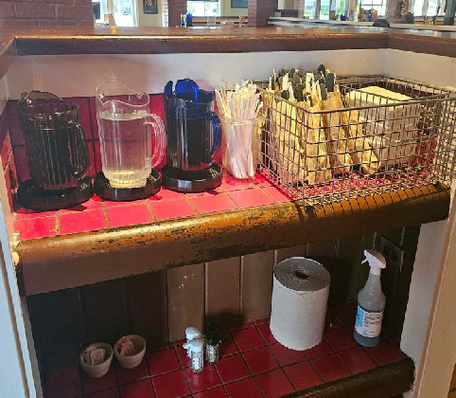
SERVER STATION ATMOSPHERE EXPECTATIONS:
- Free of clutter, no personal belongings, TM drinks, To-Go boxes, etc.
- Cleaning products are NOT to be left on Server ledges in Guests view
TABLE SETUP  (pictured) | - Tabletop device: One device on every table, clean and powered on during operating hours. Placed at back of table, with the front side of the device visible to Guests  - Ketchup: Clean bottle placed to the right of the tabletop device  - One table tent per table, clean and in good condition and placed in middle of table  - Reference Chili's Postings Checklist for photos  - Sent monthly in ChiliHead Chat  - BWeb > OYR > Chili's Postings Checklist | 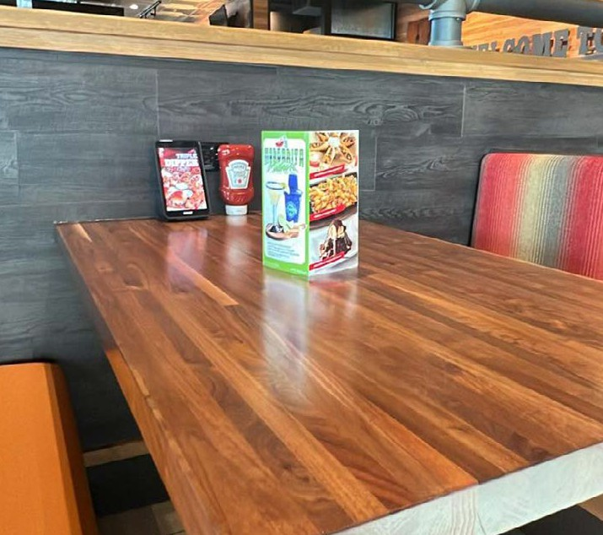
TABLE SETUP ATMOSPHERE EXPECTATIONS:
- With table set up, increased focus on walls surrounding tables - ensure they are clean and well maintained

Brinker International Payroll Company, 10/2025 Pg 10 of 24

BRAND STANDARDS

DINING ROOM Continued
SERVICE MODEL | - Servers use Team Member Handhelds (TMH) 100% of the time  - Immediately ring in and send each meal segment of an order on handheld  - drinks, "send"; apps, "send"; entrees, "send"; desserts, "send"  - For large parties: send no more than 6 orders at a time to the HOH  - All restaurants MUST have TMH iPads in cases  - Place TMH iPads on chargers when not in use  - A Runner and Busser are to be scheduled and present as business dictates  - Bar Servers and second Bartenders are to be scheduled and present as business dictates  - 80/20 Rule:  - Bartenders/Servers: 80% of time is spent in FOH, connecting with Guests, running food, pre-bussing and full hands in and out - 20% is focused on side work  - Runners: 80% of time is spent running drinks and apps, pre-bussing and spot sweeping - 20% is focused on bussing, helping up front and completing side work  - Busser: Use bus tub to clean table and keeps floors swept  - Use headset to communicate with Hosts about table status  - When delivering food, all TMs must ask "Is there anything else I can get for you?"
SERVICE MODEL ATMOSPHERE EXPECTATIONS:
- Use support staff (Hosts, Bussers, Runners and QA) to execute ChiliHead Hospitality Behaviors, deliver on our Purpose and Chili's Clean
TABLE GREETING | - Greet seated Guests within 60 seconds with silverware and napkins (one per Guest)  - For Bar/Lounge area: TM delivers menus prior to or at table greet  - Table greet always includes a recommendation for a marg and app. It will sound something like:  - "Hi! Welcome to Chili's! My name is Sarah. Can I get you all started with our Patron Frozen Marg and a Triple Dipper?"  - "Hi! Welcome to Chili's! My name is George. Can I get you all started with the  world's most popular Margarita, The Presidente and some Chips and Guac?"
BUSSING TABLES | - Dirty tables are flagged with a ketchup bottle standing upright, placed on the edge of the table  - Use the bus tub when bussing tables - wipe crumbs in to the bus tub to avoid falling onto floor  - Hold/move the tabletop device then spray the table with RAPID Multi Surface Cleaner 3 times. Then wipe the entire table and tabletop device with a paper towel. ALWAYS spray close to the table to prevent Guest coming in contact with the disinfectant mist. Reference Table to the Floor cleaning procedure  - BWeb > OYR > Chili's Clean > Table to the Floor  - Ensure booths, booth backs and chairs have been cleaned and reset with the proper table setup for the next Guest  - Bus tub staging  - One staged under bar three compartment sink  - One staged on bottom level of silverware shelf in dish area
Brinker International Payroll Company, 10/2025 Pg 11 of 24

BRAND STANDARDS

DINING ROOM Continued
TABLETOP DEVICE CLEANING | - Hold/move the tabletop device then spray the table with RAPID Multi Surface Cleaner 3 times. Wipe the entire table and tabletop device with a paper  towel. ALWAYS spray close to the table to prevent Guest coming in contact with the disinfectant mist. Reference Table to the Floor cleaning procedure  - BWeb > OYR > Chili's Clean > Table to the Floor  - NEVER spray device directly - ONLY spray brown paper towel  - Detail clean at end of night with RAPID Multi Surface Disinfectant Cleaner  sprayed on a brown paper towel
BUSSING TABLES ATMOSPHERE EXPECTATIONS:
- Coach proper cleaning procedures - ALWAYS use bus tubs
- NEVER stage bus tubs in dining room
SILVERWARE BAGGING | - Bagging is done in the HOH - NEVER in Guest's view  - Silverware bags: one fork, one knife, one straw (no straw for CA restaurants)  - Kid silverware bags: one fork and one straw (no straw for CA restaurants)  - ALWAYS wear gloves and follow the appropriate Silverware Bagging procedure  - BWeb > OYR > Culinary and Beverage > Job Aids > Silverware Bagging
REFILL PROCEDURE | - Teas and waters: use pitchers to refill tea and water at the table  - Coffee: bring a fresh cup to the table in a new mug  - Kid bevs: refill in a clean, unused kid cup and deliver to the table  - Single serve drinks must be rang in and charged, every time (no free refills)  - All other NA bevs: refill in a clean, unused mug and deliver to the table
BIRTHDAY PROCEDURES | - Birthday song sung upon request  - The standard birthday song is: “Happy happy birthday, from the Chili’s crew. We wish it was our birthday so we could party too, HEY!”  - The birthday song is NOT a loud announcement to the entire restaurant  - Guests may receive a free birthday scoop, using the Birthday Comp code on the POS  - Birthday scoop: served in a Pres glass with fudge and a cherry on top - reference Birthday Scoop procedure  - BWeb > OYR > Culinary and Beverage > Culinary Manual > Line Builds > Birthday Scoop  - Guests with a My Chili's birthday coupon can redeem for any free dessert
CASH HANDLING | - Servers are responsible for having their own cash bank  - NEVER handle cash on the floor or in front of Guests  - TMs are prohibited from accepting payment and/or tips via personal payment apps on their phone (Cash App, Zelle, Venmo etc.)
TEAM MEMBERS
PERSONAL ITEMS | - TM personal items must be kept out of Guest view in designated location  - NOTE: Recommend leaving personal items hidden in car or at home as Chili's is NOT responsible for lost or stolen items

Brinker International Payroll Company, 10/2025 Pg 12 of 24

BRAND STANDARDS

TEAM MEMBERS Continued
TM DRESS GUIDELINES | - All TMs must follow current Dress Guidelines  - BWeb > OYR > Dress Guidelines  - All FOH TMs (including Manager(s) and QA) must wear headset/radio at all times  - Shoulder length or longer hair: pulled back in ponytail or bun, hair away from face, with no loose strands - all HOH TMs in hats/hairnets (including Manager and QA), NO hats in FOH
TM FOOD AND DRINKS | - TM drinks must be stored in designated TM drink area in sealed cups with a lid and a straw  - TM food has a printed label, is stored in a 1/2 pan and placed in the walk-in  BELOW any restaurant product  - TMs are NOT permitted to sit at the bar top, on or off the clock
SHIFT MEALS | - TMs must order from the approved quarterly shift meal menu through the Bartender  - TM is able to sit in a closed zone (NOT in the bar area) away from Guests  - Managers must verify meals are rang in and discount the meals per shift
TEAM MEMBER EXPECTATIONS:
- Personal Items
  - TMs should NOT leave the restaurant for their personal belongings throughout the shift
  - Needs to be out of Guest view and NOT in a food service area
  - GM owns identifying a place for TMs belongings in each restaurant
- TMs MUST clock in for all hours worked
BAR
BAR SETUP | - Bar top:  - A bar table tent (with happy hour offerings) and tabletop device placed on the bar top at every third seat  - No bar spill mats present on bar top  - The rimmer must ALWAYS be filled with citrus sugar, kosher salt and lime juice  - Behind the bar:  - Bar three compartment sink must be set up first thing when opening Bar and water must be changed when visibly soiled or every 2 hours  - All bar tools are in place prior to shift (shake tins, jiggers, strainer, etc.)  - No more than two of each condiment behind the bar, stored away from Guest view (ketchup, salt and pepper, Tabasco, etc.)  - No To-Go supplies stored  - Coolers are neatly organized and clean, including sides, doors, racks and inside walls/bases  - EACH cooler MUST have a working thermometer present  - Ensure all prepped product is properly labeled and stored appropriately  - Glassware set up for efficiency (rocks by the well, cooler glasses in the chiller by the taps, etc.)  - Glassware placed on top of Brand Standard approved mats behind the bar to prevent sliding  - ALL beer pint glasses are ran through dish in respective drink racks  - Empty cash drawer must be left open at the end of the night

Brinker International Payroll Company, 10/2025 Pg 13 of 24

BRAND STANDARDS

BAR Continued
BAR GREET | - Bar top: Greet Guests within 60 seconds with a bev. nap (one per Guest)  - Cocktail/Lounge: Greet within 60 seconds with a menu, silverware and napkins (one per Guest)  - Table greet always includes a recommendation for a marg and app. It will sound something like:  - "Hi! Welcome to Chili's! My name is Sarah. Can I get you all started with our Patron Frozen Marg and a Triple Dipper?"  - "Hi! Welcome to Chili's! My name is George. Can I get you all started with the  world's most popular Margarita, The Presidente and some Chips and Guac?"
ALCOHOL SPECS | - Straws:  - All bar drinks are appropriately garnished and include sip straws/a clear wrapped straw, following the drinks line build  - Double Shots (X):  - A single shot is 1.25 oz. To make a double (X), add the .75 oz. to equal 2 oz.  - No more than 2 oz. of liquor is allowed in one glass unless it is a specialty drink  - Sidekicks:  - A sidekick adds .75 MORE ounces of liquor to a drink's line build and is served directly in the drink after measuring with jigger  - ONLY tequila and cordials can be poured as sidekicks - all other liquors are rang in as additional shots  - Liquor Upgrade:  - A liquor upgrade allows Guests to swap out the primary liquor with a higher-end liquor for an additional charge  - Tini:  - 2.5 oz martini pour (vodka or gin ONLY)  - Open Alcohol:  - Only used if your restaurant carries any beer, wine or liquor not included on the APL
LIQUOR BOTTLE SETUP | - Group like liquors, ONLY call liquors and above are to be showcased  - All pour spouts face to the left when looking at the label  - All display lights working and on during operating hours  - Display cages/top shelf display features high-end tequilas ONLY - no well liquors, no extra glassware etc.  - Display cage MUST be locked at all times and ONLY accessible to Manager(s)
BATCHED MARG OF THE MONTH (MOTM) | - Prep batch according to line build. Store prepped MOTM in store 'n pours with orange lids and orange spouts to identify prep product containing alcohol.  - Ensure each container has a Kitchen Sync label attached
EMPTY BEER KEGS | - Empty beer kegs must be kept in the security cage to help prevent theft
LAST CALL | - Last call is called 15 minutes prior to close by Bartender  - No drinks can be ordered or made past closing time - follow local guidelines for alcohol removal

Brinker International Payroll Company, 10/2025 Pg 14 of 24

BRAND STANDARDS

BAR Continued
SERVING RESPONSIBLY | - When serving alcoholic drinks, ALWAYS use your Responsible Alcohol Service  training and serve responsibly  - NEVER serve alcohol to a Guest who is showing any signs of intoxication  - No more than 2 oz. of liquor may be in one glass except specialty drinks (reference state specifc laws where applicable)
BAR ATMOSPHERE EXPECTATIONS:
- No foul smells - clean bars, floors and drains thoroughly
  - If foul smell persists after thorough cleaning, enter in Corrigo
- All beer glasses are brought to the dish area, NOT the bar
- Stemmed glassware and wine glasses MUST be washed by hand in the bar 3 compartment sink
- If you have fruit flies, your bar is dirty! This means more attention to cleaning and entered in SSP
- Check coolers, soda lines, drain screens and drain catch for build up
TVs
TVS AND PROGRAMMING | - What to show on the TVs  - Local/Regional live sporting events  - National live sporting events  - What NOT to show on the TVs  - Anything violent or graphic, or inappropriate  - MMA, UFC, Boxing or other violent action sports  - News programming  - Religious programming  - Special Circumstance Content  - Weather channel, when appropriate  - News programming over relevant or big events (keep in mind, news broadcasts can be polarizing so this is ONLY to be considered during times of crisis and significant national interest)  - National election results are acceptable, but do NOT show political debates or primary results  - Special requests from Guests, as long as they fit Chili’s guidelines  - Sound is ONLY allowed to be on one TV when a big game is being featured, otherwise, music is to be playing.  - TV remotes are to be paired to up to three televisions – reference the Remote Program job aid  - BWeb > OYR > Rollouts > Initiatives > Raise the Bar 2022 > Remote Program Guide  - TVs must have clear picture quality and are clean, residue and dust-free
TV ATMOSPHERE EXPECTATIONS:
- To help keep TVs clean and dust-free, an option is to have window cleaners clean TVs once a quarter
- Enter non-working TVs in Corrigo

Brinker International Payroll Company, 10/2025 Pg 15 of 24

BRAND STANDARDS

TO-GO
TO-GO AREA | - The ONLY items allowed on the To-Go counter top are:  - Brand Standard approved tip jar  - Three Dine-In menus  - One clean, powered on tabletop device in To-Go mode  - "Go to Bar" sign when no To-Go TM scheduled  - If staging racks are not in use, remove from Guest's view  - No personal items allowed in To-Go area - reference Team Member section  - Empty cash drawer must be left open at the end of the night
TO-GO SYSTEMS | - ALWAYS work the bag chit to ensure no missing items  - Greet Guests immediately with "Hi! Welcome to Chili's! How may I help you?"  - ALWAYS use the Guest's name  - Answer the phone within three rings with "Thank you for calling Chili's , this is , how may I help you?"  - NEVER accept credit card payment over the phone  - Always bump from To-Go KDS after bagging order to notify Guest order is ready
TO-GO ATMOSPHERE EXPECTATIONS:
- Mention the importance of no missing items
- Managers validate HOH complete boxes and bagged orders throughout the shift
- Clutter-free, no TM belongings
- Four or less To-Go parking spaces with appropriate signage

Brinker International Payroll Company, 10/2025 Pg 16 of 24

BRAND STANDARDS

RESTROOM
ATMOSPHERE | - Clean fresh smell  - One working air freshener per restroom  - Lighting is bright, no burned out bulbs - ONLY order bulbs through Chili's Lighting List  - BWeb > Forms and Policies > Forms > Supply Chain Forms > Chili's Lighting List  - Clean and functional fixtures, appliances, floors and partitions  - Urinals clean, free of buildup and urinal screen in use (replace at mid and EOP)  - Toilet bases and seats are tightly secured  - Stocked: hand soap, paper towels and toilet paper  - Cleaning supplies and equipment are NOT visible to Guest  - Two paper towel dispensers present per bathroom  - Minimum of one full and one partial roll of toilet paper per stall at all times  - Two trash cans per bathroom  - One floating trashcan stationed by door, one at sink  - All trashcans (including personal trashcans within stalls) are lined  - All faucets must be manually operated - no automatic faucets  - Baby changing table clean with straps present and functional clip  - Sound level set between 75-80 (SPLNFFT Noise Meter App)  - Mirrors with graffiti or peeling borders must be replaced
RESTROOM CHECKS | - All TMs are responsible for checking the restroom any time they use one and/or if they are assigned to do so by a Manager/QA and should report any issues to the MOD  - Restrooms MUST be cleaned/serviced by ONLY a TM clocked in at full minimum wage or greater  - Return air vents clean and dust-free  - Restroom checks include:  - Mirrors: clean with no water spots  - Floors and counter tops: clear of paper, trash and water/liquid  - Toilet/Urinal: flushed and clear of paper and trash  - Urinal screens present and in use  - Soap, paper towels and toilet paper properly stocked  - Trash is NOT overflowing  - All plumbing working properly, no clogs or leaks  - TMs must ALWAYS wash hands before returning to work
RESTROOM ATMOSPHERE EXPECTATIONS:
- Foul smells = dirty restrooms - reinforce the importance of restroom checks
  - If foul smell persists after thorough cleaning, enter in Corrigo
- No graffiti, mirror spots, peels, chipped paint etc.
- Check for loose toilet bases as well as green lime build-up at bases of toilets/urinals
  - No corrosion present on faucets/plumbing
- Transition to press pedal paper towel dispenser when replacements are needed
- Restroom checks prompt every 30 mins. on QA KDS - QA and MGR responsible for delegating restroom check to TM clocked in at full minimum wage or greater
- Floors dry and free from trash or debris
Brinker International Payroll Company, 10/2025 Pg 17 of 24


BRAND STANDARDS

PASSOUT / QA
TIP POLICY | - Tip sharing with QAs is purely voluntary and although Servers may voluntarily share tips directly with QAs, the QA position does NOT participate in any tip pool at Chili’s restaurants
BUMPING ORDERS | - Orders must be bumped one ticket at a time as they become ready
SPLIT ITEMS | - Split items at Guest request and make it right for them
PASSOUT SETUP | - QA line is organized, clean and well-stocked prior to, during and after every shift  - Floors to ceiling - clean and no clutter, including the top of passout  - Less is more - ONLY store what is needed (bottled sauces, crackers, etc.)  - Ensure plates are stacked so that the Cook Line is visible from QA Line  - EACH cooler MUST have a working thermometer present  - Lighting is bright, no burned out bulbs and light shield clean - ONLY order bulbs through Chili's Lighting List  - BWeb > Forms and Policies > Forms > Supply Chain Forms > Chili's Lighting List  - Soda bibs are opened upon delivery and staged appropriately - NEVER on the floor  - All other items need to be removed from cardboard boxes  - One Sani bucket with fully submerged towel - change every three hours or sooner if heavily soiled  - Connection Board is updated daily and has blank recognition cards accessible  - Posting/material up to date and set up per Chili's Postings Checklist  - Sent monthly in ChiliHead Chat  - BWeb > OYR > Chili's Postings Checklist
PASSOUT / QA ATMOSPHERE EXPECTATIONS:
- Less is more. No clutter. ONLY store what is needed
  - Clean all around - floors to ceilings
  - Floors always debris-free and dry
  - Casters clean and able to move - pull out equipment when cleaning
  - All shelves clean and grease-free (top, bottom, over inductions, etc.)
- If dessert hot well is not working properly, dispose at DO/VPO discretion (phasing out)
- Heat lamps clean and in working condition
- Brooms staged in proper areas (FOH vs. HOH brooms)
- Ensure restaurant has mineral oil for trivets and follows trivet maintenance procedures
- Connection Board is updated daily and being used as a communication tool for TMs
- Dispose of metal mounted To-Go cup holders if not in use

Brinker International Payroll Company, 10/2025 Pg 18 of 24

BRAND STANDARDS

DISH AREA
ECOLAB OWNS | - Monthly service maintenance - includes equipment cleanliness, working condition and TM training  - Replacing missing curtains, ensuring dish machine runs properly and replace  stickers (as needed)
RESTAURANT OWNS | - Monthly deliming  - Entering tickets in SSP for any Ecolab service outside of monthly visit (to replace curtains, stickers, etc.)
ORGANIZATION | - Floors clean and dry  - Pictured: place dirty silverware (forks, spoons, knives):  - Stage three 1/2 pans with warm water ONLY (no chemicals) and place on top level of  silverware shelf  - Pan spray and towel are easily accessible  - DO NOT store anything on top of the machine except pan spray for skillets  - Decoy system set up with like plates, bowls, smallwares, etc. stacked together  - Mugs and glassware placed in appropriate mug racks  - Stemmed glassware and wine glasses MUST be washed by hand in the bar 3 compartment sink  - All dish racks MUST be stored off the floor | 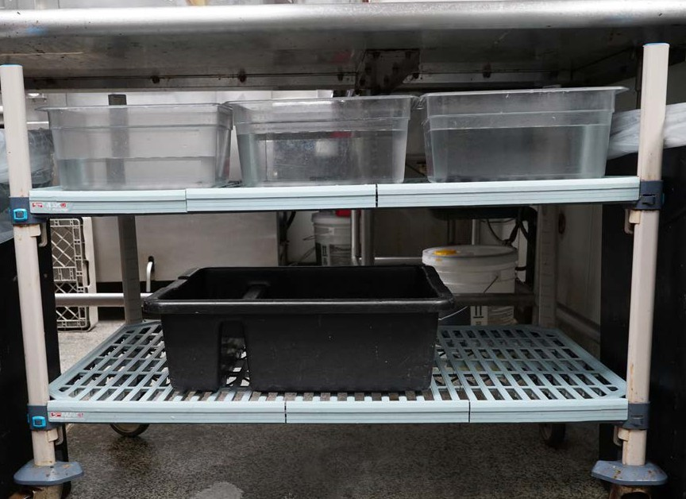
CHEMICALS | - Use chemicals ONLY for intended purpose and NEVER mix chemicals  - Use ONLY approved Ecolab chemicals with SDS (reference the Chemical Job Aid  for proper chemical handling)  - BWeb > OYR > Chili's Clean > Chemicals Approved Usage  - Solid Power is to be used ONLY in the dish machine  - DO NOT store any extra chemicals on or near the dish machine
GARBAGE CANS | - Trash cans (23-gallon Slim Jims) are cleaned/sanitized and triple-bagged  - Glass MUST be discarded in designated GLASS ONLY containers with lid and without trash bag
SKILLETS AND TRIVETS | - Small wooden trivets NEVER go through the dish machine (to prevent warping/ wear) Large trivets are dishwasher safe  - All TMs MUST wipe trivets with a sanitized towel and return to zone on QA Line  - NOTE: NEVER leave trivets in dish area  - Small trivets MUST be conditioned with mineral oil a minimum of once a quarter (reference the Skillet and Trivet Maintenance Job Aid)  - BWeb > OYR > Culinary and Beverage > Job Aids > Skillet Cleaning Job Aid

Brinker International Payroll Company, 10/2025 Pg 19 of 24

BRAND STANDARDS

DISH AREA Continued
DISH / MACHINE MAINTENANCE | - All dishes and pans need to be free of debris and product labels before going through the dish machine  - NOTE: All TMs are responsible for removing labels as labels will leave residue and clog the dish machine jets  - Load rack to capacity and with similar dishes and glasses  - Follow silverware washing procedure (reference Flatware Presoak & Wash Procedure)  - BWeb > OYR > Culinary and Beverage > Job Aids > Silverware Presoak Wash  - Deliming chemical/Lime-A-Way should be purchased and stored in the shed  - Dish water must be changed every two hours or sooner (as needed) to ensure water is clean  - Ensure dish water is changed when prompted by KDS  - Appropriate number of curtains must be installed each morning before starting a wash cycle - reference posted Ecolab stickers  - Spray handle and nozzles need to be cleaned daily to remove any obstructions so machine sprays properly  - NO metal brushes or steel wool  - Dish machine MUST be broken down at end of night and put back together each morning
DISH AREA ATMOSPHERE EXPECTATIONS:
- Use floor fans in HOH as needed
- Less is more. Clutter-free and organized - everything has a place
- NO chipped, cracked or melted pans/plateware
- NO colored tongs or colored cutting boards
- Chemicals are NEVER stored outside of designated area
- When checking cleanliness:
  - Above and below machine, chimney, curtains, etc.
  - All shelves, dish counters, sprayers, drains, piping, etc.
OFFICE
OFFICE DOOR | - Remains closed and locked at all times - NEVER prop office door open  - Free of debris, painted, can properly close and lock  - Reference Chili's Postings Checklist for signage guidelines  - Sent monthly in ChiliHead Chat  - BWeb > OYR > Chili's Postings Checklist

Brinker International Payroll Company, 10/2025 Pg 20 of 24

BRAND STANDARDS

OFFICE Continued
INSIDE OFFICE | - Safe must ALWAYS be locked, in working order and must have a lockable inner compartment with a key that ONLY the armored car carrier has access  - No cash visible and/or accessible to anyone except the Manager(s) on duty  - Store necessary paperwork in sealed bin according to Restaurant Record Retention Policy  - Discard necessary paperwork after 90 days  - NOTE: Reference Restaurant Record Retention Policy  - BWeb > Forms and Policies > Policies and Procedures > Document Retention Schedules > Restaurant Records Retention Policy  - Any lost and found items are secured in the office for up to 14 days  - Floors clean, dry and clutter-free  - TMs may use office privately for lactation purposes
OFFICE ATMOSPHERE EXPECTATIONS:
- To avoid harboring pest, less is more - clutter-free and organized
- Office door is NEVER propped open
- Trust but verify - Inspect tickets in Corrigo
- Inspect paperwork stored - discard outdated, old records
MOP SINK / CHEMICALS
MOP SINK & CHEMICAL TOWER | - Safety equipment accessible to all TMs  - Reference Chemical Safety Poster for proper chemical handling  - BWeb > OYR > Chili's Clean > Chemical Safety Poster  - NOTE: NEVER mix chemicals  - Reference Chili's Postings Checklist for signage guidelines  - Sent monthly in ChiliHead Chat  - Bweb > OYR > Chili's Postings Checklist  - Area cleaned and organized  - Mop bucket MUST be stored in mop sink  - NO hoses used inside the building  - RAPID Multi Surface Disinfectant Cleaner is used in all Guest areas  - Chemical tower clean, chemicals properly labeled and boxes ALWAYS locked  - NOTE: Managers are the ONLY ones who have chemical box keys  - Use chemicals ONLY for intended purpose and NEVER mix chemicals  - Spray bottles limited and have Ecolab label  - SDS Binder posted and up to date  - Extra chemical labels readily available  - Total of six Sani buckets with fully submerged towels: Prep, Zone 1, Zone 2, Zone 3, QA Line and Bar - Change every three hours or sooner if heavily soiled  - BWeb > OYR > Quality Assurance and Food Safety > SAFE > SAFE Sheets >  SAFESHEETS Sani Buckets
MOP SINK / CHEMICAL ATMOSPHERE EXPECTATIONS:
- ONLY Managers are allowed to have keys to chemical boxes
- Inspect correct chemicals are in the correct box
- Inspect amount of spray bottles - ONLY store what's needed

Brinker International Payroll Company, 10/2025 Pg 21 of 24

BRAND STANDARDS

PREP AREA
OVERALL AREA | - Clean and organized - less is more  - All systems posted and current:  - Cooling log, KS Prep sheets, HOH Connection Board, HOH Clean: Daily Sidework & Weekly Sparkle  - No pushpins or tacks in HOH  - EACH cooler MUST have a working thermometer present  - Knives placed on magnetic strips when not in use, blade up  - No knife boxes  - Lighting is bright, no burned out bulbs and light shield clean - consistent with Passout - ONLY order bulbs through Chili's Lighting List  - BWeb > Forms and Policies > Forms > Supply Chain Forms > Chili's Lighting List  - Cutting boards - white ONLY, clean and organized  - ALWAYS use appropriate safety gear (PPE, cut/heat gloves, etc.)
PREP CARDS | - Use 100% of the time  - Follow daily prep amounts and prepare item(s) to spec  - Must be validated by Manager on Duty
SIGNAGE | - Prep Zones must be properly labeled in their corresponding color  - Signs are posted on walls and NEVER hang from ceiling  - Ready to Eat: White  - Unwashed Produce: Green  - Raw Seafood: Blue  - Raw Meat: Red  - Raw Poultry: Yellow
COMBI OVEN | - Do NOT store anything on top of Combi  - ONLY store appropriate chemicals and smoker box on bottom shelf  - Do NOT store more than the maximum number of Combi racks  - Double Combi = 14 racks  - Single Combi = 7 racks
RETHERM | - Suitcases stored inside  - Have heat resistant gloves accessible and in good condition
PREP AREA ATMOSPHERE EXPECTATIONS:
- Pans
  - No chips, broken or melted pans
  - Stock ONLY what pans are needed
- Equipment and Tools
  - Nothing stored on top of Combi
  - Appropriate chemicals present
  - Store cutting boards appropriately when not in use
  - Proper amount of utensils are available and organized

Brinker International Payroll Company, 10/2025 Pg 22 of 24

BRAND STANDARDS

WALK-IN / FREEZER
DRY STORAGE | - Set up according to Walk-In/Dry Storage Schematics  - Clean, dry and organized from floor to ceiling tiles  - Behind shelves are clean and dry  - Shelving, casters, shelf clips and compressors are clean  - Lighting is bright, no burned out bulbs and light shield clean - ONLY order bulbs through Chili's Lighting List  - BWeb > Forms and Policies > Forms > Supply Chain Forms > Chili's Lighting List
WALK-IN & FREEZER, BEER COOLER / CAGE | - Set up according to Walk-In/Dry Storage Schematics  - Clean, dry and organized from floor to ceiling tiles  - EACH cooler MUST have a working thermometer present  - Behind shelves are clean and dry  - Bottled beer is pulled in increments of six  - Lighting is bright, no burned out bulbs and light shield clean - ONLY order bulbs through Chili's Lighting List
WALK-IN / FREEZER ATMOSPHERE EXPECTATIONS:
- Less is more. Clutter-free and organized
- No boxes on floors
- Keg dollies, stackers, dividers and shelf clips are clean and mold-free
- Replace shelf labels as needed
COOK LINE
LINE SETUP | - Hot food must ALWAYS have a lid and label and maintain temp of 165° to 175°  - ONE white cutting board per station - clean and in good condition  - ALWAYS use appropriate safety gear (PPE, cut/heat gloves, etc.)  - Clutter-free, organized with enough To-Go supplies needed per shift  - Product NEVER exceeds fill line
KDS | - Dust and grease-free; cords neatly wrapped, screens clean and plastic wrapped  - Work the first three orders on the screen; bump orders once 100% complete, including all sides, sauces and dressings  - Recook and refire items are priority
EQUIPMENT | - Follow fryer boil out schedule - 2nd, 4th and 5th Tuesday (5 week period). Discard each vat of oil as you go  - Always filter fryers when prompted  - Vent hoods are clean and in good condition  - Nothing stored on top of the equipment  - ALWAYS cover fryers with lid at night
CHEMICALS & SUPPLIES | - Use approved chemicals ONLY  - Have green scrubber, gloves, towels, brushes, grill screens and bricks on hand  - Reference Chemical Job Aid for proper chemical handling
CLEANING | - Follow Sparkle to know when and how often to clean each piece of equipment  - Use job aids 100% of the time

Brinker International Payroll Company, 10/2025 Pg 23 of 24

BRAND STANDARDS

COOK LINE Continued
COOK LINE ATMOSPHERE EXPECTATIONS:
- Less is more. Clutter-free and organized
- Make sure TMs move equipment to clean behind, backs, and corners of units
- Hood Vents - Give guidance on when and how often to clean
BACK DOOR / PEST CONTROL
INTERIOR | - Immediately enter any pest sighting in SSP every day seen  - Working fly lights (two minimum): One by back door and one near/in To-Go  - Air curtain must be functional each time the door is opened (if applicable)  - Bait traps against walls
EXTERIOR | - Immediately enter any pest sighting in SSP every day seen  - Door sweeps present and in good condition  - Bait traps against walls  - Working fly panels: two total (Device location depends on pest vendor)
BACK DOOR ATMOSPHERE EXPECTATIONS:
- Remove chains; Detex system is engaged/armed during operating hours
BACK DOCK
OVERALL AREA | - Reference the Back Dock Standards job aid  - BWeb > OYR > Quality Assurance and Food Safety > SAFE > SAFE Sheets > SAFE Back Dock Standards  - Clean, odor/clutter-free and organized (no extra equipment or shelving)  - Dumpster doors and lids ALWAYS closed  - Linen containers closed and clean (top, bottom, sides)  - All touch points are clean and properly working (handles, gates, buzzers, etc.)  - Brooms, mops and dust pans MUST be properly hung
SHED | - Door(s) have working closures and ALWAYS closed and locked  - Clean, organized and clutter-free - all items must be six inches off the ground  - Floor buffer stored in shed without brush head when not in use  - Store brush head on shelf, off of the ground  - If using for storage of paperwork, it must be sealed and in a plastic (Rubbermaid like) bin - NEVER use cardboard boxes
ATTIC | - (If applicable): Clean and organized - NEVER use for storage
MECHANICAL ROOM | - Keep water softening salt drum at least 50% full at all times  - Door(s) have working closures and ALWAYS closed and locked  - Rodent bait station present and against wall  - Clean and clutter-free - NEVER use for storage  - No water leaks present  - Water heater and wall heater (if applicable) in working condition
BACK DOCK ATMOSPHERE EXPECTATIONS:
- Clean, odor/clutter-free and organized atmosphere - no old equipment
- Linen bags tied before putting in bin
- Shed - items are labeled and organized; clutter-free
- Mechanical room - clean, no standing water and no items stored
  - NOTE: Not all restaurants require water softener

Chili's Brand Standards. Property of Brinker International. Chili’s name, design, and
Brinker International Payroll Company, 10/2025
related marks are trademarks of Brinker International. © 10/2025 Brinker International. All rights reserved.
Pg 24 of 24

