Model
Thoughts
Expand to view model thoughts
chevron_right
This is a complex system with many moving parts. To make it "easy to see and understand," we need to visualize it in layers, emphasizing the two main centers of gravity identified in your design principles:
- The Operational Hub: [[Email Triage]] (Where the user acts).
- The Context Hub: [[Memory Manager]] (Where the AI remembers).
Below is a visualization using Mermaid.js. This is a standard format for diagrams in Markdown (including Obsidian).
How to view this:
If you paste the code block below directly into an Obsidian note, it should render automatically if you have the Mermaid plugin enabled (which is usually default).

ChiliHead OpsManager System Flow
This visualization groups components into three logical layers:
- Top (Blue): User-Facing Pages - Where you interact with the system.
- Middle (Green): AI Agent Layer - The intelligent workers processing data in the background.
- Bottom (Yellow/Grey): Backend & Infrastructure - The APIs, databases, and services that power everything.
Key Concept: Notice how almost everything flows out of the Email Triage Hub, and almost all agents flow into and out of the central Memory Manager.
codeMermaid
%%{init: {'theme': 'base', 'themeVariables': { 'primaryColor': '#fff', 'edgeLabelBackground':'#fff', 'tertiaryColor': '#f4f4f4'}}}%%
graph TD
%% --- STYLES ---
classDef hub fill:#ffcccc,stroke:#ff0000,stroke-width:4px,color:#000,font-weight:bold;
classDef memory fill:#e6ccff,stroke:#6600cc,stroke-width:3px,color:#000,font-weight:bold;
classDef pages fill:#d9e6f2,stroke:#0066cc,color:#000;
classDef agents fill:#d9f2d9,stroke:#009933,color:#000;
classDef backend fill:#f2f2f2,stroke:#666,color:#000;
classDef external fill:#ffffcc,stroke:#cccc00,stroke-dasharray: 5 5,color:#000;

%% --- NODES ---

subgraph "User-Facing Pages (Frontend)"
ET[Email Triage / MAIN PAGE]:::hub
SI[Smart Inbox]:::pages
Todo[Todo List]:::pages
Deleg[Delegations]:::pages
CalPage[Calendar View]:::pages
TeamBd[Team Board]:::pages
TextTeam[Text Team SMS]:::pages
OC[Operations Chat]:::pages
DBM[Daily Brief Modal]:::pages
end

subgraph "AI Agent Layer (Intelligence)"
MM[Memory Manager / Shared Context]:::memory
TA[Triage Agent]:::agents
VA[Vision Agent]:::agents
DSA[Deadline Scanner]:::agents
DBG[Daily Brief Generator]:::agents
TCA[Task Categorizer]:::agents
DA[Delegation Analyzer]:::agents
AUBS[Action Assistant AUBS]:::agents
MCA[Message Composer]:::agents
CalA[Calendar Agent]:::agents
end

subgraph "Backend & Infrastructure"
PGDB[(PostgreSQL DB)]:::backend
State[State Manager]:::backend
Sync[Email Sync Service]:::backend
end

subgraph "External APIs"
Gmail(Gmail API):::external
GCalAPI(Google Calendar API):::external
OpenAI(OpenAI GPT-4o):::external
end

%% --- MAJOR FLOWS ---

%% 1. The Core Hub Flows (Email Triage)
ET -->|Fetches Emails| Gmail
ET -->|Requests Analysis| TA
ET -->|Scans for Deadlines| DSA
ET -->|Checks Status| State
ET -->|Stores Context| MM
ET -.->|Opens| DBM
ET -.->|Deep Dive| SI
ET -.->|Adds Tasks| Todo
ET -- Creates Events --> CalPage
ET -- Sends SMS --> TextTeam

%% 2. Triage & Analysis Flows
TA -->|Reads Thread| Gmail
TA -->|Analyzes Images| VA
TA -->|AI Analysis| OpenAI
TA -->|Caches Results| Sync
TA -->|Saves Data| PGDB
TA -- Stores Entities --> MM

%% 3. The Memory Hub (Bidirectional Context)
%% Agents reading/writing to memory
MM <--> TA
MM <--> DSA
DBG <-->|Get Context| MM
AUBS <-->|Get Context| MM
DA <-->|Team Context| MM
MM <-->|Persistent Storage| PGDB
%% Pages feeding memory
SI -->|User Context| MM
OC -->|Chat Context| MM
Todo -->|Completion Status| MM
Deleg -->|Team Context| MM

%% 4. User Action Flows (Smart Inbox & Chat)
SI -->|Render HTML| Gmail
SI -->|Extract Metrics| VA
SI <-->|Conversational Help| AUBS
SI -->|Draft SMS| MCA
OC <-->|Chat| AUBS
OC -->|Stores History| PGDB

%% 5. Task & Delegation Flows
Todo -->|Assign Quadrant| TCA
Todo -->|Stores Tasks| PGDB
Todo -->|Assigns| Deleg
Todo -- Links back to --> ET
Deleg -->|Suggest Assignments| DA
Deleg -->|Store History| PGDB
Deleg -- Notifies --> TextTeam

%% 6. Daily Brief Flows
DBM -->|Requests Summary| DBG
DBG -->|Fetch Data| PGDB
DBG -->|Fetch Events| GCalAPI
DBG -->|Generate| OpenAI
DBM -.->|Navigates to| ET
DBM -.->|Navigates to| Todo

%% Link external agents to APIs
VA --> OpenAI
CalA --> GCalAPI
MCA --> TextTeam
DSA --> GCalAPI
Model
Thoughts
Designing the Visualization
I'm currently focused on the specific design elements of the flowchart. I'm aiming for clarity and a visually engaging representation of the ChiliHead OpsManager system architecture. The goal is to make the relationships between components immediately apparent and intuitive.
Conceptualizing the Diagram
I'm now focusing on the high-level structure. I'm aiming for a clear visual hierarchy, with the email triage system at the core. The memory manager is also central, facilitating all the agent interactions. User pages and backend components are also considered essential. My main goal is to represent all the moving parts in a coherent and easily digestible manner, given that the previous graph was rejected.
Revising the Layout
I've been iterating on the visual representation, aiming for a more intuitive and fun presentation. The core system architecture, with its central email triage and interconnected agents, drives this. I want the flow of information to be instantly clear, so the layout is crucial. The agent relationships and data paths need to be visually distinct. I'm now focusing on ensuring that the roles of the agents are apparent from the diagram.
Focusing the Representation
I'm now zeroing in on the visual representation, especially the key roles of each AI agent and their relationships. I'm prioritizing immediate understanding of the system's core function. I'm exploring an infographic style, with a central hub, and a circular layout for the agents around that central point. The goal is to make the data flows intuitive, especially the function of the email triage system.
Conceptualizing the Visualization
I've finalized my mental model for the visualization. The Email Triage at the core with agents and user interfaces surrounding the central hub. I've sketched a rough hub-and-spoke layout, using distinct icons for the agents and user interfaces. I am aiming for an engaging flow of information with clear data paths and color-coded components, to visually represent the ChiliHead OpsManager architecture.
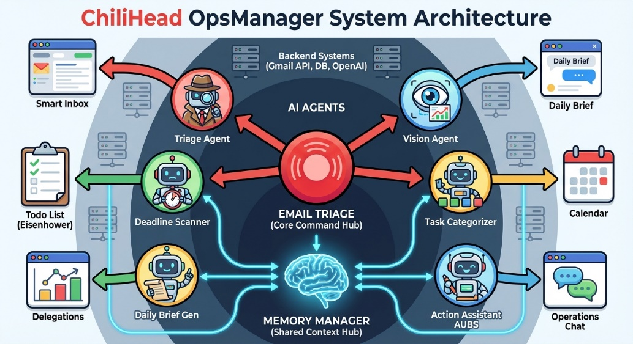

Assessing Visualization Clarity
I'm evaluating whether the visual representation aligns with the user's intent. The goal is to translate a complex process into an easily digestible format. I am focusing on identifying distinct visual elements for agents and interfaces within the requested 'fun flow chart' style, ensuring that the critical information is effectively communicated.
Evaluating Conceptual Mapping
I'm assessing how well the visual design captures the core concepts. The emphasis is on whether the 'fun flow chart' style successfully translates the underlying architecture. I have noted the use of distinct icons for agents and interfaces within the graphic. The focus is on verifying if it adequately represents the 'Email Triage' hub and the 'Memory Manager' connection.
Collapse to hide model thoughts
chevron_right
User
Yes, but and thats Why I needed this is Aubs should be kinda the Boss of all the agents Meaning she (they) actually should be the one qho receives all the information and genrates the daily breif and can speak to ever appointment task todo delegatio email and help push that info to me in a clear and excelent way like the smartest one in the room and all the others should be subagents who look for and help maintain infor for those tabs does that make sense?
Model
Refocusing Hierarchy
I'm now focusing on redesigning the infographic's core. "Action Assistant AUBS" needs to become the central element, acting as the primary agent overseeing everything. I'm aiming to visually represent this hierarchical shift while maintaining the original design's style. Replacing "Email Triage" is the immediate next step.
Prioritizing AUBS Role
I'm working on revising the infographic to highlight "Action Assistant AUBS" as the central figure. Currently, I'm focusing on visually portraying this hierarchical structure. All other agents will be subordinate to AUBS, with data flowing into AUBS and output flowing out. I'm aiming to keep the original visual style and making the Daily Brief generation a function of AUBS.

Examining Agent Relationships
I'm now focused on the agent relationships visualized. The central "AUBS" Boss figure is correctly identified, with all information flow accurately re-routed. I am confirming if the visual hierarchy reflects the requested roles and reporting structures.
Reviewing Hierarchy's Implementation
I'm verifying that the generated visual hierarchy precisely mirrors the prompt's intended roles and reporting structures. The key aspect under review involves the depiction of 'AUBS' as the central authority and the accurate information flow re-routing.
Collapse to hide model thoughts
chevron_right
20.6s
REPLACE_WITH_IMAGE_1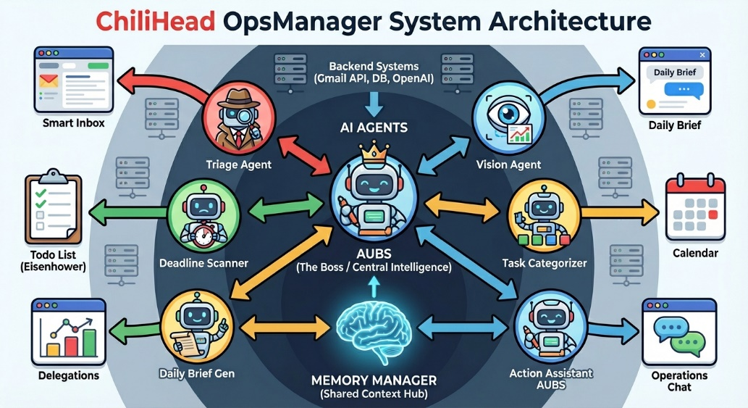
Use Arrow Up and Arrow Down to select a turn, Enter to jump to it, and Escape to return to the chat.

