**PSP0 Project Plan Summary**

|  |  |  |  |
| --- | --- | --- | --- |
| Student | JOHN DANY OSORIO RAMOS | Date | 24/01/2015 |
| Program | Conceptos Avanzados de Ing. De Sofrware | Program # | 01 |
| Instructor | LUIS DANIEL BENAVIDES | Language | Java |

|  |  |  |  |  |  |  |  |
| --- | --- | --- | --- | --- | --- | --- | --- |
| **Time in Phase (min.)** | **Plan** |  | **Actual** |  | **To Date** |  | **To Date %** |
| Planning |  |  | 35 |  | 35 |  | 14.95 |
| Design |  |  | 12 |  | 12 |  | 5.12 |
| Code |  |  | 133 |  | 133 |  | 56.8 |
| Compile |  |  | 0 |  | 0 |  | 0 |
| Test |  |  | 20 |  | 20 |  | 8.54 |
| Postmortem |  |  | 34 |  | 34 |  | 14.52 |
| Total | 200 |  | 234 |  | 234 |  | 100 |
|  |  |  |  |  |  |  |  |
| **Defects Injected** |  |  | **Actual** |  | **To Date** |  | **To Date %** |
| Planning |  |  | 0 |  | 0 |  | 0 |
| Design |  |  | 0 |  | 0 |  | 0 |
| Code |  |  | 1 |  | 1 |  | 100 |
| Compile |  |  | 0 |  | 0 |  | 0 |
| Test |  |  | 0 |  | 0 |  | 0 |
| Total Development |  |  | 1 |  | 1 |  | 100 |
|  |  |  |  |  |  |  |  |
| **Defects Removed** |  |  | **Actual** |  | **To Date** |  | **To Date %** |
| Planning |  |  | 0 |  | 0 |  | 0 |
| Design |  |  | 0 |  | 0 |  | 0 |
| Code |  |  | 1 |  | 1 |  | 100 |
| Compile |  |  | 0 |  | 0 |  | 0 |
| Test |  |  | 0 |  | 0 |  | 0 |
| Total Development |  |  | 0 |  | 0 |  | 100 |
| After Development |  |  | 0 |  | 0 |  |  |

**PSP Time Recording Log**

|  |  |  |  |
| --- | --- | --- | --- |
| Student | JOHN DANY OSORIO RAMOS | Date | 24/01/2015 |
| Program | Conceptos Avanzados de Software | Program # | 01 |
| Instructor | LUIS DANIEL BENAVIDES | Language | Java |

|  |  |  |  |  |  |  |
| --- | --- | --- | --- | --- | --- | --- |
| **Project** | **Phase** | **Start Date and Time** | **Int. Time** | **Stop Date and Time** | **Delta**  **Time** | **Comments** |
| PSP0 | Plan | 10:55 | 10 | 11:40 | 35 | Interrupción por salida de casa |
| PSP0 | Diseño | 11:40 | 3 | 11:55 | 12 | Diseño. Interrupción llamada celular |
| PSP0 | Codificación | 11:55 | 0 | 12:30 | 35 | Codificación – crear estructura proyecto maven y las clases diseñadas. |
| Día 2 |  |  |  |  |  |  |
| PSP0 | Códificación | 15:00 | 7 | 16:45 | 98 | Codificación de la solución. Interrupción por refigerio. |
| PSP0 | Pruebas | 16:45 | 0 | 17:05 | 20 | Pruebas. |
| PSP0 | PM | 17:05 | 31 | 18:10 | 34 | Completando documentos. Interrupción por comida. |
|  |  |  |  |  |  |  |
|  |  |  |  |  |  |  |
|  |  |  |  |  |  |  |
|  |  |  |  |  |  |  |
|  |  |  |  |  |  |  |
|  |  |  |  |  |  |  |
|  |  |  |  |  |  |  |
|  |  |  |  |  |  |  |

**PSP Defect Recording Log**

|  |  |
| --- | --- |
| Defect Types |  |
| 10 Documentation | 60 Checking |
| 20 Syntax | 70 Data |
| 30 Build, Package | 80 Function |
| 40 Assignment | 90 System |
| 50 Interface | 100 Environment |

|  |  |  |  |
| --- | --- | --- | --- |
| Student | JOHN DANY OSORIO RAMOS | Date | 24/01/2014 |
| Program | Conceptos Avanzados de sogtware | Program # | 01 |
| Instructor | Luis Daniel Benavidez | Language | JAVA |

|  |  |  |  |  |  |  |  |  |  |  |  |  |  |  |  |
| --- | --- | --- | --- | --- | --- | --- | --- | --- | --- | --- | --- | --- | --- | --- | --- |
| Project |  | | Date |  | Number |  | Type |  | Inject |  | Remove |  | Fix Time |  | Fix Ref. |
| PSP0 |  | | 24/01/2015 |  | 001 |  | 10 |  | Codificación |  | Codificación |  | 5 |  | X |
| Description: | | | Se presentó error al leer los archivos de la lista porque no se tuvo en cuenta las líneas en blanco. Se coloca validación en el método para omitirlas. | | | | | | | | | | | | | |
|  | | | | | | | | | | | | | | | | |
|  | | | | | | | | | | | | | | | | |
| Project |  | | Date |  | Number |  | Type |  | Inject |  | Remove |  | Fix Time |  | Fix Ref. |
|  |  | |  |  |  |  |  |  |  |  |  |  |  |  |  |
| Description: | | |  | | | | | | | | | | | | | |
|  | | | | | | | | | | | | | | | | |
|  | | | | | | | | | | | | | | | | |
| Project |  | | Date |  | Number |  | Type |  | Inject |  | Remove |  | Fix Time |  | Fix Ref. |
|  |  | |  |  |  |  |  |  |  |  |  |  |  |  |  |
| Description: | | |  | | | | | | | | | | | | | |
|  | | | | | | | | | | | | | | | | |
|  | | | | | | | | | | | | | | | | |
| Project |  | | Date |  | Number |  | Type |  | Inject |  | Remove |  | Fix Time |  | Fix Ref. |
|  |  | |  |  |  |  |  |  |  |  |  |  |  |  |  |
| Description: | | |  | | | | | | | | | | | | | |
|  | | | | | | | | | | | | | | | | |
|  | | | | | | | | | | | | | | | | |
| Project |  | | Date |  | Number |  | Type |  | Inject |  | Remove |  | Fix Time |  | Fix Ref. |
|  |  | |  |  |  |  |  |  |  |  |  |  |  |  |  |
| Description: | | |  | | | | | | | | | | | | | |
|  | | | | | | | | | | | | | | | | |

**Información adicional:**

Para efectos de pruebas se trabajaran los siguientes datos contenidos en el enunciado de la tarea:

|  |  |  |
| --- | --- | --- |
| Columna 0 | Columna 1 | Columna 2 |
| 186 | 160 | 15.0 |
| 699 | 591 | 69.9 |
| 132 | 114 | 6.5 |
| 272 | 229 | 22.4 |
| 291 | 230 | 28.4 |
| 331 | 270 | 65.9 |
| 199 | 128 | 19.4 |
| 1890 | 1657 | 198.7 |
| 788 | 624 | 38.8 |
| 1601 | 1503 | 138.2 |

Nota: también se leerá un archivo ubicado en la ruta \src\site\resourses\ArchivoPrueba\ListaNumeros.txt con el fin de ingresar datos personalizados. Inicialmente está cargado el archivo con los datos de la columna 2 de la anterior tabla.

|  |  |  |  |  |
| --- | --- | --- | --- | --- |
| **Test** | **Expected Value** | | **Actual Value** | |
|  | *Mean* | *Std. Dev* | *Mean* | *Std. Dev* |
| Columna 0 | 638.9 | 625.6 | 638.9 | 625.6339806770231 |
| Columna 1 | 550.6 | 572.03 | 550.6 | 572.026844746915 |
| Columna 2 | 60.32 | 62.26 | 60.32000000000001 | 62.25583060601187 |

**A continuación se muestran las imágenes capturados en el compilador de java producto del resultado de la ejecución de las pruebas unitarias:**

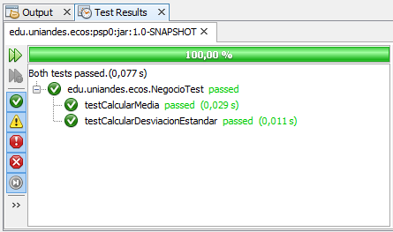

**Resultado de la prueba del método que calcula la media.**

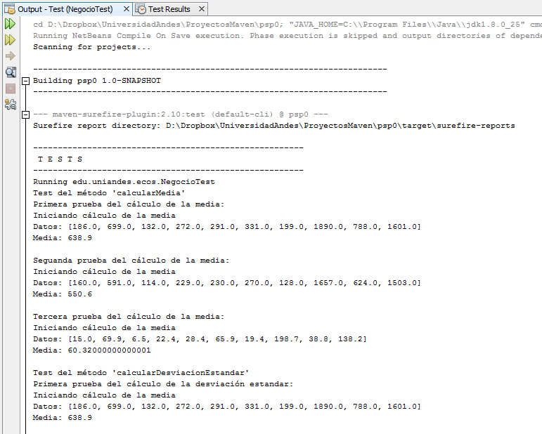

**Resultado de la prueba del método que calcula la desviación estandar.**

