VOCAL COACH
Architecture & Design Document
A real-time singing trainer for Windows and iPhone, built on .NET 10 MAUI
Version | 1.0
Date | October 2, 2026
Author | John Apolloni
Status | Reflects the code in VocalCoach.slnx (Core, App, Core.Tests)
Repository | C:\Users\johna\source\repos\VocalCoach

Contents

1. Application summary
Vocal Coach helps people develop their singing voice. It listens through the microphone, works out the pitch being sung about 43 times a second, and shows it against the target notes on a scrolling graph, so the singer can see at once whether they are sharp, flat or in tune. Around that live feedback the app wraps what a voice teacher would provide: structured exercises, coaching advice, a daily practice routine and a record of progress.
It is written in C# on .NET 10 MAUI. The same code base builds for Windows, used for development and testing today, and iOS, the intended release platform. All singing, scoring and coaching logic lives in a platform-independent library, so moving to iPhone means supplying only an audio adapter, and that adapter is already written.

1.1 What the singer can do
Feature | What it does
Guided practice | Ten exercises, from warm-up hums and lip trills through arpeggios, interval leaps, staccato and sirens, to cool-down slides. The app plays each pattern ("Listen"), the singer repeats it ("Sing"), and it moves up a semitone each time within the singer's comfortable range.
Visual pitch feedback | A piano-roll graph scrolls the target notes toward a "now" line while the singer's voice draws a coloured line: green on pitch, amber close, red off. Each target bar is exactly as thick as the allowed tolerance. A tuner needle shows cents sharp or flat.
Live coaching cues | Short instructions while singing, such as "A touch flat — lift slightly" or "On pitch — hold it there!".
Post-exercise coaching | A 0–100 score, accuracy, average offset and steadiness, a dot for every note, and two to four specific tips covering flat or sharp tendencies, wobble, scooping, octave errors and weak registers.
Today's practice | A daily routine of warm-up, then the two weakest or untried exercises, then cool-down, plus a day streak.
Range finder | The singer holds their lowest and highest comfortable notes. The app suggests a voice type and fits every exercise to that range.
Tuner & match mode | Free singing with live pitch, plus an ear-training drill: play a reference note and match it.
Progress & lessons | Score chart and history, and short lessons on breathing, posture, ear training, resonance, registers and vocal health.

1.2 Technology at a glance
Concern | Choice
Language / runtime | C# 13, .NET 10
UI framework | .NET MAUI single project, pages built in C#, GraphicsView drawables for real-time graphics
Targets | net10.0-windows10.0.19041.0 (unpackaged), net10.0-ios (iOS 15+)
Pitch detection | YIN algorithm, SIMD-accelerated, median-of-3 smoothing: 0.33 ms per analysis frame (Release)
Audio I/O | Windows: NAudio (WaveIn / WaveOut). iOS: AVAudioEngine with a PlayAndRecord session
Persistence | JSON files in FileSystem.AppDataDirectory (System.Text.Json)
Testing | xUnit, 25 tests on the Core library; a debug loopback audio rig for end-to-end checks

Design in one sentence
A pure, testable domain core (pitch, music, exercises, scoring, coaching, progress) sits beneath a thin MAUI presentation layer; the only platform-specific code is two small audio adapters behind the IAudioInput and IAudioPlayer interfaces.

2. Goals and design principles
Goal | How the design meets it
Portable to iPhone | All logic is in VocalCoach.Core, a plain net10.0 library with no UI or OS references. Platform code is limited to Platforms/Windows/WindowsAudio.cs and Platforms/iOS/IosAudio.cs. The UI uses an iPhone-style bottom tab bar and phone-shaped window proportions.
Real-time feedback | Pitch is analysed on the audio thread, about every 23 ms, with an allocation-free, vectorised YIN. The UI redraws at 60 Hz. Audio timestamps come from the sample clock, so scoring is not affected by UI jitter.
Musically correct coaching | Exercises follow standard voice-teaching practice: demonstrate, repeat, ascend by semitones and stay within the comfortable range. Scoring forgives the natural onset of a note and separates in-tune, steady and clean-onset singing.
Testable | The session timeline, scorer and coach are pure functions of time and samples, so tests feed synthetic pitch data and check scores and advice deterministically. An end-to-end test runs synthesised audio through the real tracker.
Private by default | Audio is processed in memory and never stored or sent anywhere. Only scores and settings are saved, locally. The iOS permission text says so.
Robust | Unhandled exceptions are logged to crash.log. JSON writes are atomic (write to a temporary file, then move). A corrupt file is preserved and the app starts with defaults.

3. System architecture
The solution is layered. Dependencies point downward only: presentation depends on services and the core, services depend on the core and on the audio interfaces, and platform adapters implement those interfaces. The core depends on nothing but the .NET base library.
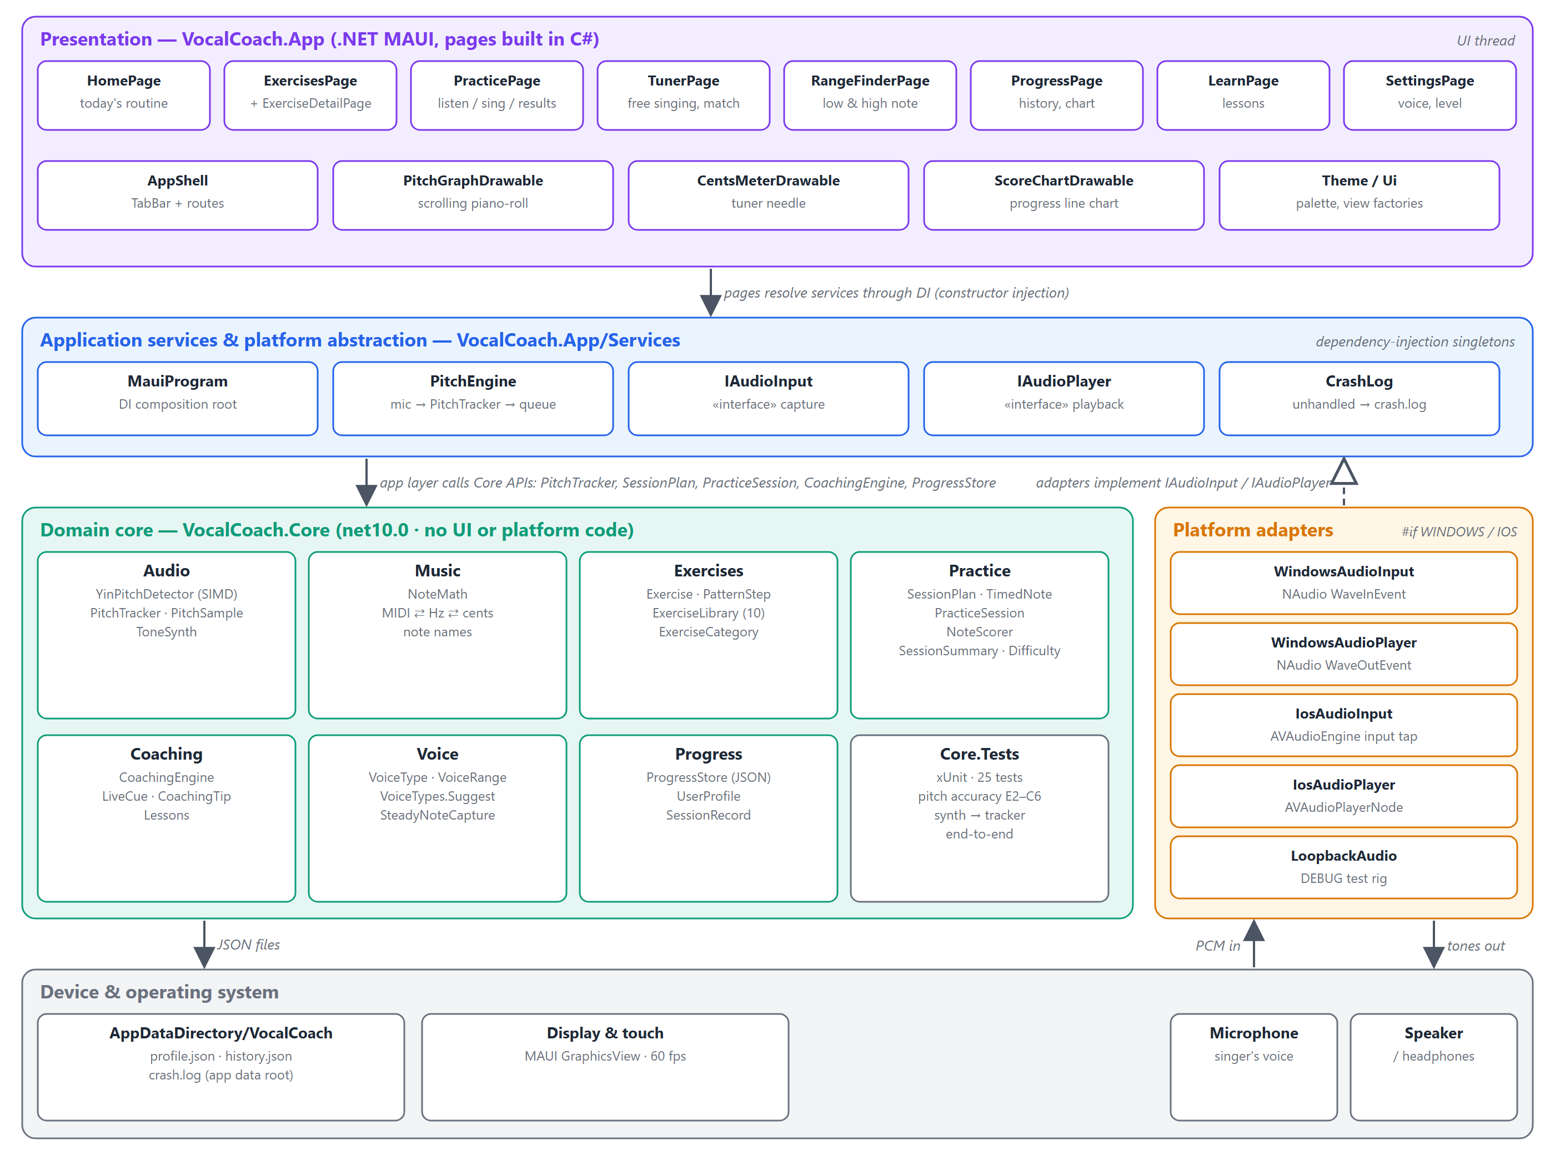
Figure 1. Layered architecture of Vocal Coach.

3.1 Layers
Layer | Contents | Responsibility
Presentation | 8 pages, AppShell, 3 drawables, Theme / Ui | Navigation, layout, 60 Hz rendering of pitch feedback, the frame loop that drives a practice session
Services & abstraction | MauiProgram, PitchEngine, IAudioInput, IAudioPlayer, CrashLog | Dependency-injection composition, bridging the audio thread to the UI thread, isolating the platform
Platform adapters | WindowsAudio*, IosAudio*, LoopbackAudio (DEBUG) | Microphone capture and buffer playback on each OS
Domain core | Audio, Music, Exercises, Practice, Coaching, Voice, Progress | All singing knowledge and logic, fully unit-tested
Device & OS | Microphone, speaker, display, app-data folder | Hardware and storage

3.2 Projects and folders
Project / folder | Purpose
src/VocalCoach.Core/Audio | YinPitchDetector, PitchTracker, PitchSample, ToneSynth
src/VocalCoach.Core/Music | NoteMath: MIDI, frequency, cents and note-name conversions
src/VocalCoach.Core/Exercises | Exercise, PatternStep, ExerciseLibrary (the catalogue)
src/VocalCoach.Core/Practice | SessionPlan, TimedNote, PracticeSession, NoteScorer, SessionSummary, Difficulty
src/VocalCoach.Core/Coaching | CoachingEngine (live cues, reviews, routines, tips), Lessons
src/VocalCoach.Core/Voice | VoiceType, VoiceRange, VoiceTypes, SteadyNoteCapture
src/VocalCoach.Core/Progress | ProgressStore, UserProfile, SessionRecord
src/VocalCoach.App/Pages | Home, Exercises (+ detail), Practice, Tuner, RangeFinder, Progress, Learn, Settings
src/VocalCoach.App/UI | PitchGraphDrawable, CentsMeterDrawable, ScoreChartDrawable, Theme, Ui helpers
src/VocalCoach.App/Services | IAudioInput, IAudioPlayer, PitchEngine, LoopbackAudio
src/VocalCoach.App/Platforms | Windows and iOS audio adapters, app delegates, Info.plist
tests/VocalCoach.Core.Tests | xUnit tests for every Core module

3.3 Composition and navigation
MauiProgram.CreateMauiApp is the composition root. It registers the platform audio adapters chosen at compile time (#if WINDOWS / #elif IOS), or LoopbackAudio in Debug builds when VOCALCOACH_LOOPBACK=1. PitchEngine and ProgressStore are registered as singletons and every page as transient. Pages receive their services through constructor injection.
AppShell defines a five-tab TabBar (Home, Exercises, Tuner, Progress, Learn) and four pushed routes: exercise?id=, practice?ids=a,b,c, rangefinder and settings. PracticePage takes a comma-separated queue of exercise ids, so a single exercise and the whole daily routine use the same page.

4. Component design

4.1 Pitch detection (Core/Audio)
YinPitchDetector implements the YIN fundamental-frequency estimator (de Cheveigné & Kawahara, 2002). It suits the voice well: it resists the strong harmonics that fool autocorrelation and is cheap enough for a phone.
- Difference function d(τ) = Σ (x[j] − x[j+τ])² for τ from 31 to 678 samples at 44.1 kHz (1400 Hz down to 65 Hz). SumSquaredDiff uses Vector<float> SIMD; this step is over 95% of the cost.
- Cumulative mean normalisation d′(τ) = d(τ) · τ / Σ d(1..τ), which removes the bias toward τ = 0.
- Absolute threshold: the first dip below 0.15, followed down to its local minimum.
- Parabolic interpolation around that minimum for sub-sample (sub-cent) precision. Clarity = 1 − d′(τ).
PitchTracker re-windows whatever buffer size the platform delivers into a 2048-sample ring and analyses every 1024 samples (about 23 ms, roughly 43 readings/s). Windows quieter than RMS 0.01, or with clarity below 0.80, are reported as unvoiced. Voiced readings pass through a median-of-3 filter that removes single-frame octave glitches without noticeable lag. Each reading becomes a PitchSample(Time, Midi?, Level), where Time comes from the sample count, not the wall clock.
ToneSynth renders reference tones (five harmonics, 15 ms attack, gentle decay, soft release) into a mono float[]. The whole session's reference audio is rendered up front, so playback is sample-accurate and every platform only needs a "play this buffer" service.

4.2 Exercises and the session timeline (Core/Exercises, Core/Practice)
An Exercise is a pattern of PatternSteps (a semitone offset from the root, or a rest, plus a length in beats), a tempo, a repetition count and a starting point above the bottom of the range. SessionPlan.Build turns an exercise and a VoiceRange into a flat list of TimedNotes:
- A 2-second lead-in, then for each repetition: the Listen phrase (or a single cue note when demonstration is off), one beat to breathe, the Sing phrase, and 1.5 beats to reset.
- The root starts StartAboveLow semitones above the range bottom and rises one semitone per repetition. Repetitions are clipped so the highest note never exceeds the comfortable range (a unit test checks every exercise against every voice type).
- Each note sounds for 94% of its step, so consecutive targets read as separate bars.
PracticeSession is driven purely by time. The UI calls AddSample for each pitch reading and Update(now) each frame. When a Sing note has been over for 100 ms, its samples are found by binary search, NoteScorer scores the note, and NoteScored fires. Finish scores anything left and builds the SessionSummary.

4.3 Scoring model
Measure | Definition
Onset grace | The first 0.15 s of each note is excluded from accuracy, since finding a pitch takes a moment. It is still used for scoop detection.
Hit fraction | Share of sustain-phase readings within ±tolerance of the target
Stability | 1 − (standard deviation of cents ÷ 50), clamped to 0–1
Coverage | min(1, voiced fraction ÷ 0.6). A note with less than 25% voiced readings counts as missed (score 0).
Note score | 100 × (0.75 × hit + 0.25 × stability × coverage)
Octave error | Median offset within 150¢ of ±1200¢. Score capped at 50 and reported separately.
Scoop | First two onset readings average below −max(50¢, 1.5 × tolerance), then settle within 1.5 × tolerance
Tendency | Average offset (excluding octave errors) beyond 0.4 × tolerance is reported as flat or sharp
Register check | Hit rate below the median note compared with above it. A gap over 20 points is flagged.

Skill level | Tolerance (± cents) | Bar thickness on graph
Beginner | 40 | 0.8 semitone row
Intermediate | 25 | 0.5 semitone row
Advanced | 15 | 0.3 semitone row

4.4 Coaching engine (Core/Coaching)
CoachingEngine is a set of stateless rules, written as a voice teacher would phrase them:
- Live(cents, tolerance) returns a LiveCue: on pitch, close (within 2× tolerance, with direction), off, far off (over 600¢, "listen again") or silent.
- Review(summary) returns 2–4 prioritised CoachingTips: microphone problems first (over half the notes missed), then octave errors, praise, pitch tendency (gentler wording when it is still inside tolerance), steadiness (over ±25¢), scooping, and register imbalance.
- TodaysRoutine(history, level, date) returns a warm-up (alternating by day), the two focus exercises with the lowest recent average (untried first, matched to level), and a cool-down.
- TipOfTheDay rotates through ten vocal-health and technique tips. Lessons holds seven short foundational lessons.

4.5 Voice and range (Core/Voice)
Voice type | Comfortable practice range
Bass | E2 – C4
Baritone | G2 – E4
Tenor | C3 – A4
Alto | F3 – D5
Mezzo-soprano | A3 – F5
Soprano | C4 – A5

The ranges are deliberately narrower than classical extremes, so a developing voice is never pushed. SteadyNoteCapture drives the Range Finder: it keeps a run of voiced readings within a 60¢ spread and, once the run lasts 1.5 s, returns the median note. VoiceTypes.Suggest picks the type whose range overlaps the measured range most, breaking ties by closest centre.

4.6 Persistence (Core/Progress)
ProgressStore keeps profile.json (UserProfile: voice type, optional measured range, level, demonstrate and play-along switches, setup flag) and history.json (a list of SessionRecords) under AppDataDirectory/VocalCoach. Writes go to a .tmp file and are then moved into place, so a crash cannot leave a half-written file. An unreadable file is copied to *.corrupt and replaced with defaults. The store also computes the day streak and best score per exercise.

4.7 Presentation (App/Pages, App/UI)
Page | Role
HomePage | Greeting, setup prompt for new users, streak, today's routine, tip of the day
ExercisesPage / ExerciseDetailPage | Catalogue grouped by category with best scores; detail shows the pattern in the singer's own key
PracticePage | Three panels: intro (instructions, coach's notes), live (graph, target and you labels, needle, cue, Stop), results (score, stats, note dots, tips, next / retry / done)
TunerPage | Big note name, Hz, needle, free-singing graph, reference note picker, match mode
RangeFinderPage | Intro, capture low note, capture high note (at least a fifth higher), result, save
ProgressPage | Streak, sessions this week, 7-day average, week-on-week accuracy change, score chart, recent sessions
LearnPage / SettingsPage | Expandable lessons; voice type, level, demonstrate, play-along

PitchGraphDrawable is the main visual-feedback component. It maps time to x (3 s of past, 5 s of future, "now" at a fixed line) and fractional MIDI to y, with a piano-key strip on the left. Target bars are drawn as thick as the tolerance band. The pitch trail is coloured per segment by its error against the Sing note active at that sample's timestamp. Readings in a note's onset grace window are drawn neutral, and the line breaks at jumps over 1.5 semitones so voice cracks never appear as false vertical strokes. The view centre glides toward the visible targets.

4.8 Platform audio adapters
 | Windows | iOS
Capture | NAudio WaveInEvent: 44.1 kHz, 16-bit mono, 4 × 20 ms buffers, converted to float | AVAudioEngine.InputNode tap of 1024 frames at the hardware rate; channel 0 copied out with Marshal.Copy
Playback | NAudio WaveOutEvent (100 ms latency) over an ISampleProvider wrapping the buffer | AVAudioPlayerNode scheduling one AVAudioPcmBuffer
Session / permission | Unpackaged desktop app; Windows privacy settings control mic access | AVAudioSession PlayAndRecord + DefaultToSpeaker + AllowBluetoothA2DP, 10 ms IO buffer; NSMicrophoneUsageDescription; MAUI Permissions.Microphone prompt

LoopbackAudio (Debug only) implements both interfaces: the "microphone" hears the player's buffer, played 12¢ flat to imitate a singer and paced by wall-clock time. It exercises the whole pipeline without a human or a sound card.

5. Class diagrams
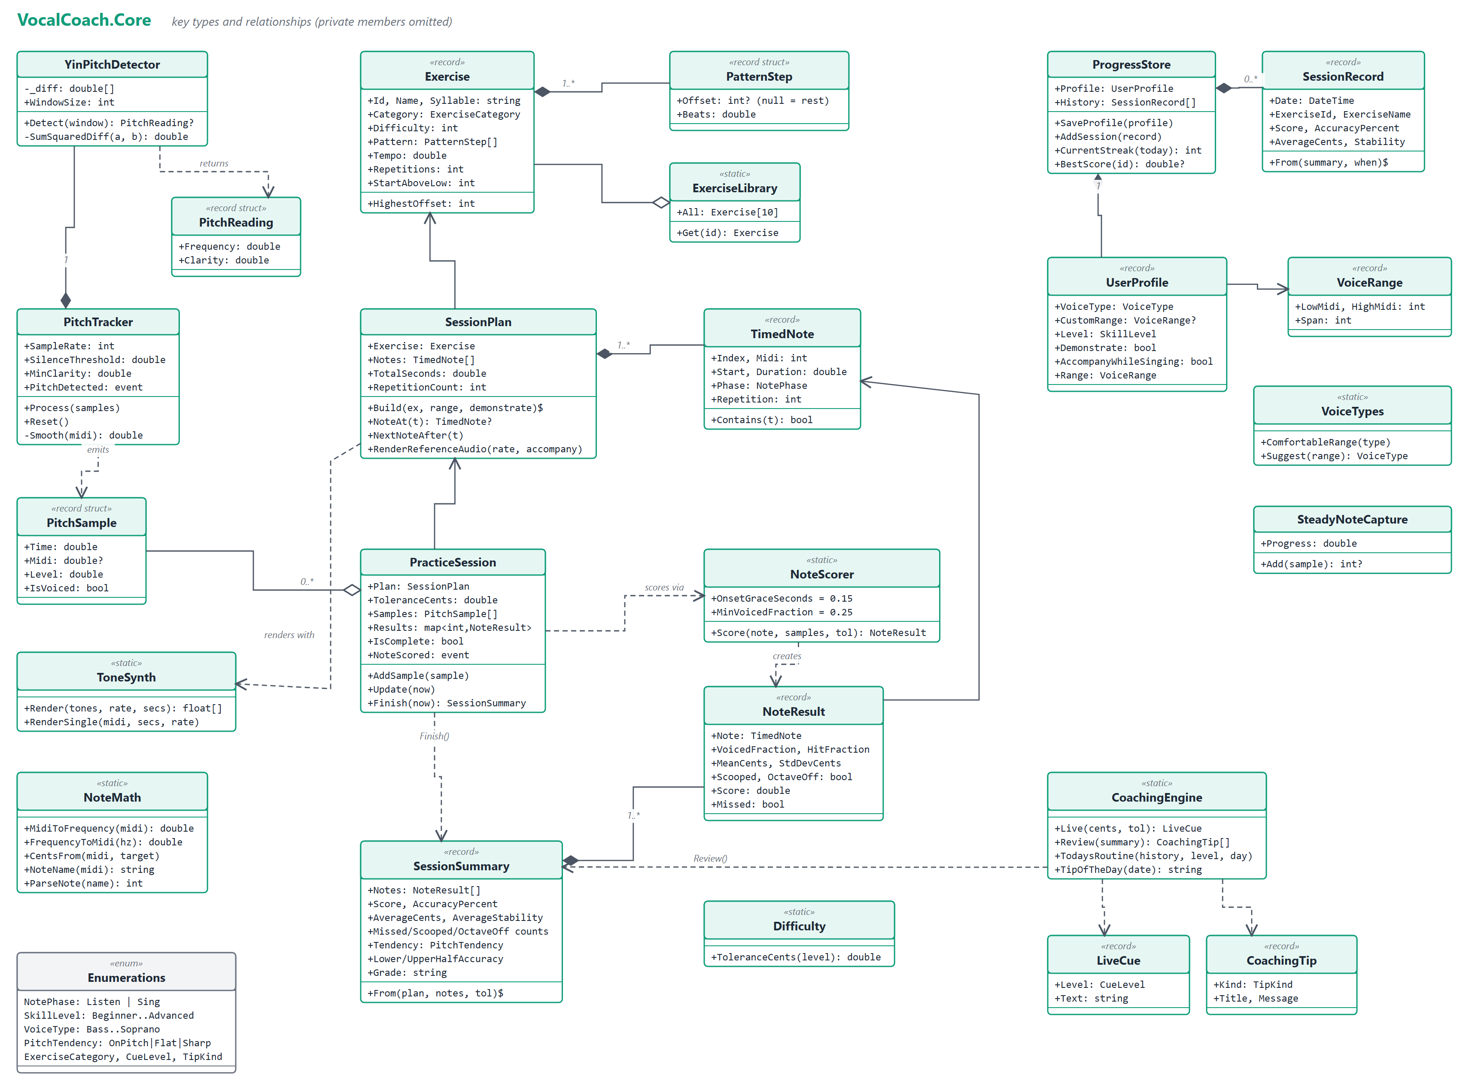
Figure 2. Class diagram: VocalCoach.Core. Filled diamond = composition, hollow diamond = aggregation, solid arrow = association, dashed arrow = dependency, $ = static.
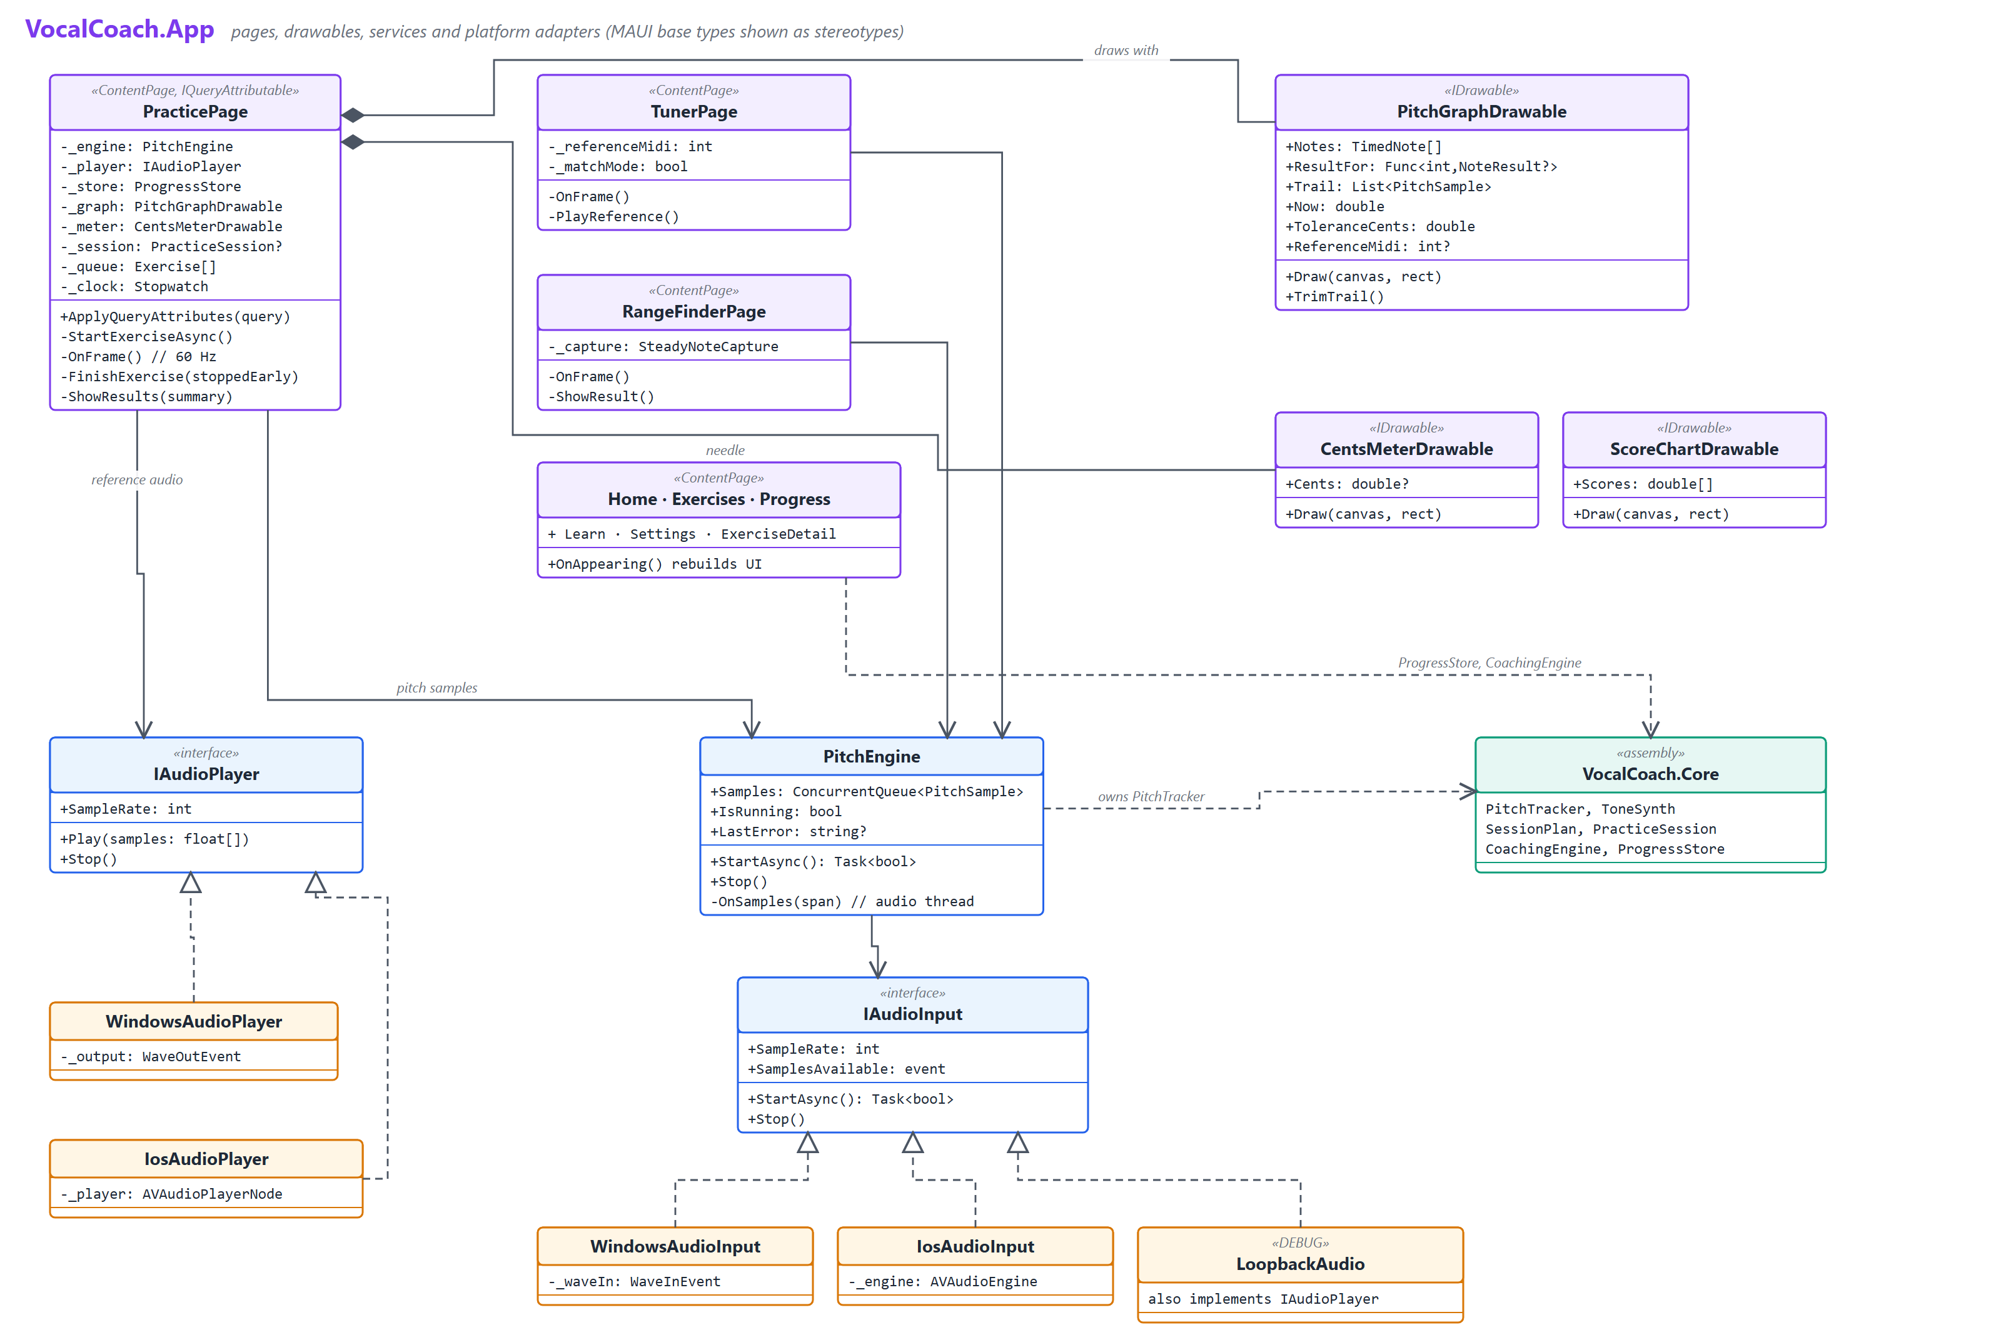
Figure 3. Class diagram: VocalCoach.App. MAUI base types are shown as stereotypes; dashed lines with hollow triangles show interface implementation.

5.1 Notes on the class model
- Immutable data, behaviour in a few classes. Measurements and results (PitchSample, TimedNote, NoteResult, SessionSummary, SessionRecord, UserProfile) are records or record structs. Mutable state lives only in PitchTracker, PracticeSession, SteadyNoteCapture and ProgressStore.
- Static rule sets. NoteScorer, CoachingEngine, NoteMath, ToneSynth and VoiceTypes are stateless, which makes them easy to test and safe to call from anywhere.
- Time is an input. No Core type reads a clock. PracticeSession.Update(now) and sample timestamps make every behaviour reproducible in tests.
- One page, many exercises. PracticePage owns the session lifecycle and composes the two drawables. The other pages are thin views over ProgressStore and the Core catalogues.
- Interfaces only where the platform differs. IAudioInput and IAudioPlayer are the only abstractions; everything else is concrete, which keeps the code easy to follow.

6. Data flow
Figure 4 uses DeMarco/Yourdon notation: circles are processes, shaded rectangles are external entities, and open-ended bars are data stores. Process 3.0 runs once when an exercise starts. Processes 1.0, 2.0, 5.0 and 6.0 form the real-time loop. Processes 7.0 and 8.0 run when the exercise ends.
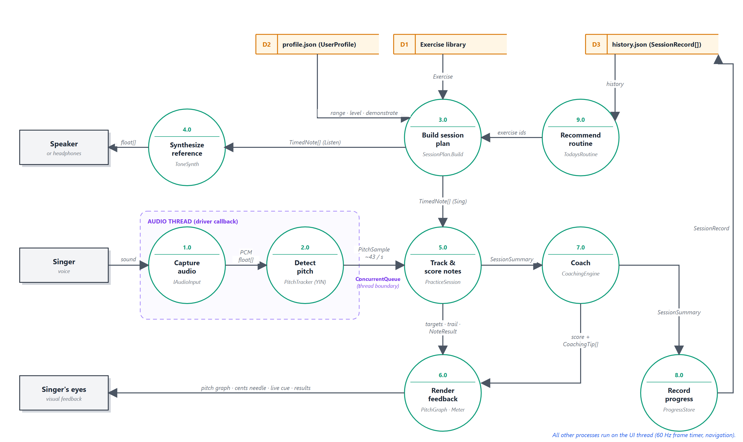
Figure 4. Data flow diagram: from the singer's voice to feedback, coaching and history.

6.1 The real-time loop
- Capture (1.0). The OS audio driver calls the adapter with a buffer (about 20 ms on Windows, 1024 frames on iOS). The adapter converts it to mono float and raises SamplesAvailable on the audio thread.
- Detect (2.0). PitchEngine.OnSamples feeds PitchTracker on the same thread. Each completed analysis enqueues a PitchSample on a ConcurrentQueue. This queue is the only point where data crosses between threads.
- Track & score (5.0). A 16 ms dispatcher timer on the UI thread drains the queue into PracticeSession and the graph's trail, then calls Update(now). Any Sing note that has ended is scored.
- Render (6.0). The frame sets PitchGraphDrawable.Now, trims the trail to the visible window and invalidates the GraphicsView. It also updates the target and "you" labels, the cents needle and the CoachingEngine.Live cue.

6.2 Clocks and synchronisation
The app uses two clocks. Pitch samples carry audio-clock time (sample count ÷ sample rate, at the centre of the analysis window), which reflects when the sound was actually captured, however late the buffer arrives. The playhead uses a Stopwatch started together with the microphone and player. Both start within a few milliseconds of each other and drift negligibly over an exercise. The remaining output latency (about 100 ms on Windows) is absorbed by the 150 ms onset grace and the 100 ms scoring delay. Calibrated latency compensation is listed as future work.

6.3 Session lifecycle
Step | Data produced | Where it goes
Start exercise | SessionPlan from Exercise (D1) and UserProfile (D2) | Reference audio rendered on a background task; graph targets
Play | float[] reference audio | IAudioPlayer, then speaker
Sing | PitchSample stream | PracticeSession, NoteResult per note
Finish / Stop | SessionSummary and CoachingTip[] | Results panel
Record | SessionRecord (skipped if stopped early with fewer than 3 notes sung) | history.json (D3)
Next visit | History | TodaysRoutine (9.0), Progress page

7. Key design decisions
Decision | Alternatives considered | Rationale
.NET MAUI single project | WPF/WinUI then Swift rewrite; Avalonia; Xamarin | One C# code base reaches both Windows and iOS; the iOS workload is already installed and the iOS target compiles today
YIN pitch detection | FFT peak picking; plain autocorrelation; McLeod (MPM) | Robust against strong vocal harmonics (fewer octave errors than FFT peaks), simple, allocation-free, 0.33 ms per frame
Pre-rendered reference audio | A real-time synthesiser on each platform | Sample-accurate timing, and the platform service stays trivial ("play this buffer")
Sample-clock timestamps | Stamping samples with the UI clock on arrival | Scoring is unaffected by buffer latency and UI jitter
Single ConcurrentQueue between threads | Locks around shared session state; marshalling every sample | Lock-free hand-off; all session state stays on the UI thread
Pages built in C# | XAML + MVVM | Pages are small and largely dynamic (built from data each visit). C# keeps the UI next to its logic and avoids binding boilerplate. MVVM can come later if pages grow.
JSON files for persistence | SQLite | Small data volume; no native dependency; human-readable; trivially portable
Tolerance-thick target bars | Thin target lines and a separate error readout | "Keep your line inside the bar" is understood instantly, with no musical knowledge needed

8. Quality attributes

8.1 Testing
Area | Tests
Note maths | Note-name parsing (sharps and flats), frequency ↔ MIDI round trips
Pitch detection | Voice-like signals with harmonics and noise from E2 (82 Hz) to C6 (1047 Hz), each within ±5¢; noise rejected; silence then voice through odd-sized chunks; synthesised tone detected as its note
End-to-end | A full exercise's reference audio through PitchTracker: every voiced reading within 50¢ of a playing note
Session plan | Every exercise × every voice type stays inside the comfortable range; repetitions ascend a semitone; Listen precedes Sing
Scoring & coaching | In-tune vs flat vs silent notes; octave and scoop detection; incremental scoring; a flat singer gets flat advice; direction of live cues
Voice & progress | Voice-type suggestion; steady-note capture after a slide; profile and history round trip; streak; routine composition

Beyond unit tests, the Windows app was exercised end-to-end with the loopback rig and Windows UI Automation, and the results screen correctly reported the simulated 12¢-flat tendency.

8.2 Performance
- Pitch analysis: 0.33 ms per frame in Release (about 1.4% of one core at 43 frames/s). The SIMD inner loop gave about a 2× speed-up even in Debug.
- Rendering a 64-second session of reference audio takes about 330 ms and runs on a background task before playback starts.
- The UI frame does no allocation-heavy work: samples are drained from the queue, and the trail is trimmed to the visible window plus one second.

8.3 Reliability and privacy
- CrashLog records AppDomain, TaskScheduler and WinUI unhandled exceptions with stack traces. It was used during development to find a microphone-permission crash on unpackaged Windows.
- Microphone start-up failures (no device, permission denied) are reported to the singer with a clear message instead of crashing the app.
- No audio is recorded or stored; only scores, settings and dates are written, locally.

9. iOS migration and future work

9.1 Steps to ship on iPhone
- Build on a Mac with Xcode (or pair Visual Studio with one), set the Apple team and a real bundle id, and run on a device.
- Verify IosAudioInput and IosAudioPlayer on hardware: sample rate, tap buffer size, routing to the speaker and to Bluetooth headphones, and interruption handling (phone calls, Siri).
- Add tab bar icons (SF Symbols or SVG MauiImages) and check layouts on small screens and with Dynamic Type.
- Consider one shared AVAudioEngine for input and output (tighter sync), and voice-processing mode for echo cancellation so "play along" works without headphones.

9.2 Known limitations and enhancements
Item | Notes
Latency calibration | Measure round-trip latency once per device and shift the scoring window to match
Play-along without headphones | The microphone hears the accompaniment; needs echo cancellation
Vibrato-aware scoring | Wide, regular vibrato currently lowers the steadiness score; detect it and score the centre pitch
Recording & playback | Let singers hear themselves back, which trains the ear fastest
Song mode | Import a melody (MIDI or MusicXML) and practise it with the same feedback
Cloud sync | Optional backup of history across devices
Accessibility | Colour-blind-safe palette option and VoiceOver labels on the live graph

Appendix A. Exercise catalogue
Exercise | Category | Level | Sing | Pattern (semitones) | Tempo
Descending Hum | Warm-up | 1 | Mm | 7 5 4 2 0 | 72
Lip Trill Five-Tone Scale | Warm-up | 1 | Brr | 0 2 4 5 7 5 4 2 0 | 100
Long Tones | Stability | 1 | Ah | 0 (4 beats) · 4 · 7 | 60
Major Arpeggio | Pitch accuracy | 2 | Ah / Ee | 0 4 7 12 7 4 0 | 90
Interval Leaps | Pitch accuracy | 2 | Nah | 0 4 0 5 0 7 0 12 0 | 80
Minor Five-Tone Scale | Pitch accuracy | 2 | Oh | 0 2 3 5 7 5 3 2 0 | 88
Staccato Arpeggio | Agility | 2 | Ha | 0 4 7 12 7 4 0 (short) | 96
Octave Siren | Range | 2 | Ng / Woo | 0 12 0 (glide) | 70
Nine-Tone Scale | Agility | 3 | Ah | 0–14 and back (8ths) | 112
Cool-down Slides | Cool-down | 1 | Hoo | 7 → 0 | 60

Appendix B. Key constants
Constant | Value | Location
Analysis window / hop | 2048 / 1024 samples | PitchTracker
Detectable range | 65 – 1400 Hz | YinPitchDetector
YIN threshold | 0.15 | YinPitchDetector
Silence RMS / min clarity | 0.01 / 0.80 | PitchTracker
Onset grace | 0.15 s | NoteScorer.OnsetGraceSeconds
Missed-note threshold | 25% voiced | NoteScorer.MinVoicedFraction
Graph window | 3 s past, 5 s future | PitchGraphDrawable
Steady-note hold | 1.5 s within 60¢ | SteadyNoteCapture
Frame timer | 16 ms | PracticePage, TunerPage

