Tutorial: Estimating Baobab Population in an Area

This tutorial will take you through the steps required to estimate the baobab population in an area using our current estimate raster. It can be done on any platform using QGIS, a free GIS application which can be downloaded from http://www.qgis.org

First, we need to load our density map. This is called a rester image. Open QGIS, click on the 'Layer' menu and select 'Add Raster Layer'. Navigate to the folder containing 'Baobab Density.tif' and select it. This should load the raster into the main view of QGIS. If the raster looks blank and grey, you can right click, choose properties, enter the 'Style' tab and change the contrast enhancement to 'Stretch to min-max' to make it easier to see (not necessary but useful).

Now that we have the raster loaded, lets add some extra layers. They will be vector layers this time, so go to the 'Layer' menu and select 'Add Vector Layer'. Add all the layers in the 'supplementary data' folder. You can drag layers in the left-hand view to change the order of which goes on first. Try to get your map looking like this (the colours may vary):

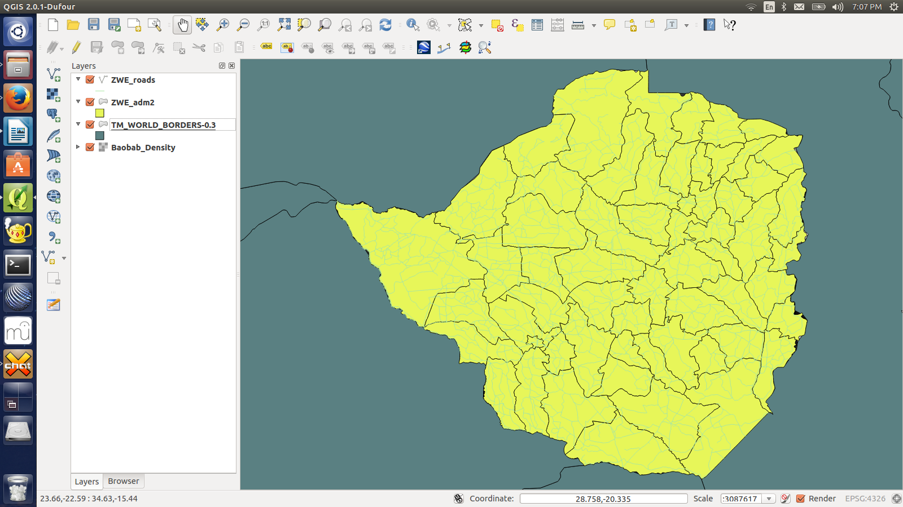
The next thing we need to do is to define an area that we would like to estimate the population for. To do this, we will create a new vector file. Go to Layer -> New -> New Shapefile Layer. Ensure you change it from a point shapefile to a polygon shapefile, then press OK. Save it as whatever you like.

You should see your new layer appear in the bar on the left. Click on your layer and enable edit mode by clicking this button:
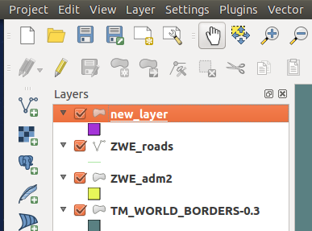

Then click the 'new feature' button. Draw out your area by left clicking and then right click to finish.Click OK in the dialog that will pop up about attributes – we don't need to add an id or anything like that – and then save the layer edits (the save button next to the edit button)

Now we want to create a point layer with points covering your new area. Click the 'Vector' menu, then 'Research Tools' -> 'Regular Points'. In the window that pops up, change the boundary layer to your new layer, change the point spacing to 0092 and click 'browse' to choose a name to save it as:
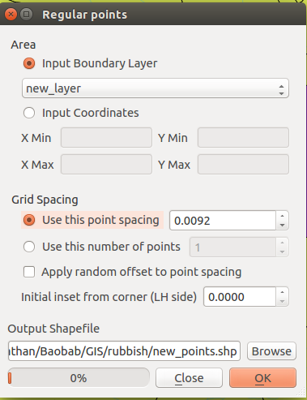

When prompted, add the new point layer and then close the 'regular points' window. Now we want to remove those points that lie outside our polygon. Go to 'Vector' -> 'Research Tools' -> 'Select By Location' and use that tool to select features in the point layer that intercept features in the first layer you created. This will select the features we want to keep, so right click the point layer, go to attribute table and click the 'toggle selection' button:
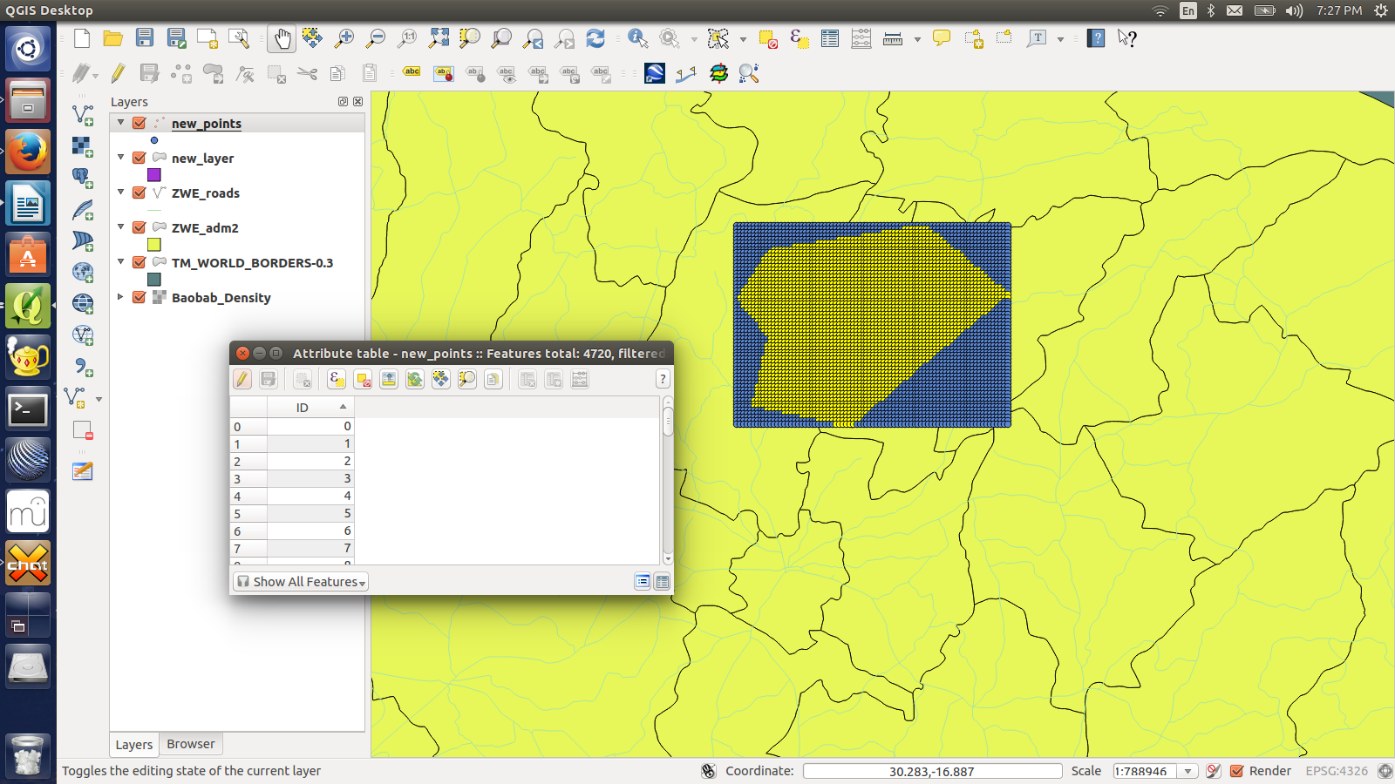
Then toggle editing mode and delete the selected features:
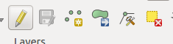
Delete selected features
Toggle edit mode

Nearly there... These points we have created each represent one square kilometer. We will need a plugin to get the value of the density raster underneath each point. If it is not installed already, install the 'Point Sampling Tool' by going to 'Plugins' -> 'Manage and Install Plugins', then 'Add More' and search for 'point sampling tool'

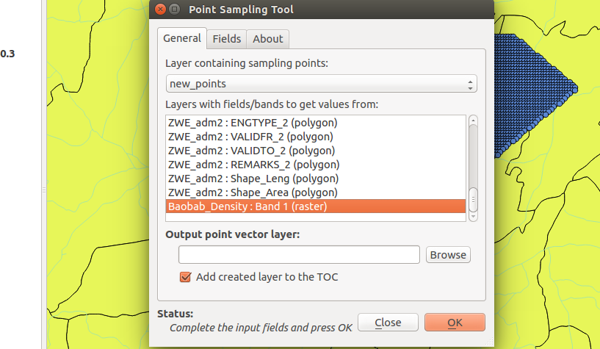
Once the plugin is installed, it can be found in 'Plugins' -> 'Analyses' -> 'Point Sampling Tool'. Make sure you have saved all changes to your point shapefile, then fire up point sampling tool, select your point layer as the input layer, choose 'Baobab Density: Band 1' in the 'Layers with fields/bands to get values from' box and choose a name to save it as:

Congratulations! We can now add up all the densities in the shapefile to get the total population in your area. The easiest way to do this is to right click the layer, open attributes table, select one, Ctrl + A to select all the Ctrl + C to copy and paste into an excel spreadsheet. You can the sum the Baobab Density Column to get the total.

Apologies for this apparently convoluted method and the hastily written tutorial – I usually do this with a few custom scripts but setting that up would be much harder than just doing the above steps. I hope this is easy enough to understand, but if you have questions don't hesitate to email me johnowhitaker@gmail.com

