

**De La Salle University- Manila**

**Gokongwei College of Engineering**

LBYCPA1

Programming Logic and Design Laboratory

Project Proposal

Sale System

Christian Matthew Evalla

John Paolo Enriquez

Edge Matthew Fernandez

**Project Description**

Give an overview of the project. Describe the problem to be solved. Enumerate the technical objectives. Show how the project will be done.

The proponents of this project will create a POS Software that is used by the customers to buy products from a Computer Hardware store. The software can be used for online stores. The POS software will be capable of adding customer orders, and accepting payment. The POS Softwar will make it easier to see previous transactions as it can save transactions of different customers for the manager, or even the customers themselves can see their previous transactions in their accounts.

Technical Objectives:

* A security measure that needs a username and password before being able to use the POS system
* A menu system that has its products taken from an excel file and you can add to cart the different
* A shopping cart system that has a saving and loading feature which means you can save various carts and name them if you want to buy a set of items later on.
* Transaction history is saved in the account and lets you view it whenever you want

**IPO**

Present and discuss the IPO model.

1. Enhanced security and anti-fraud protection.

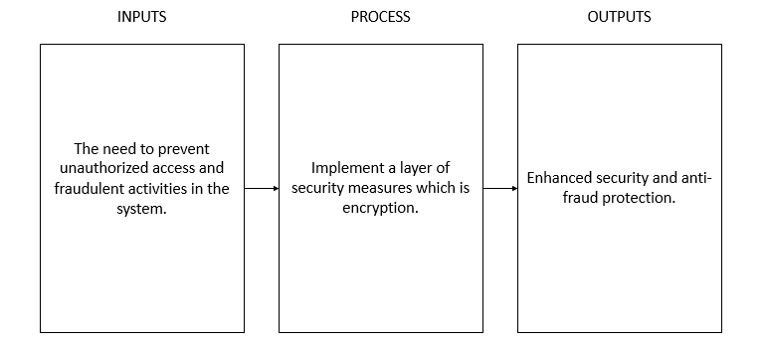

1. Menu Display

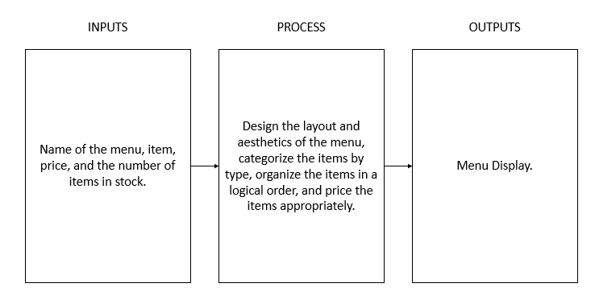

1. Action on Orders

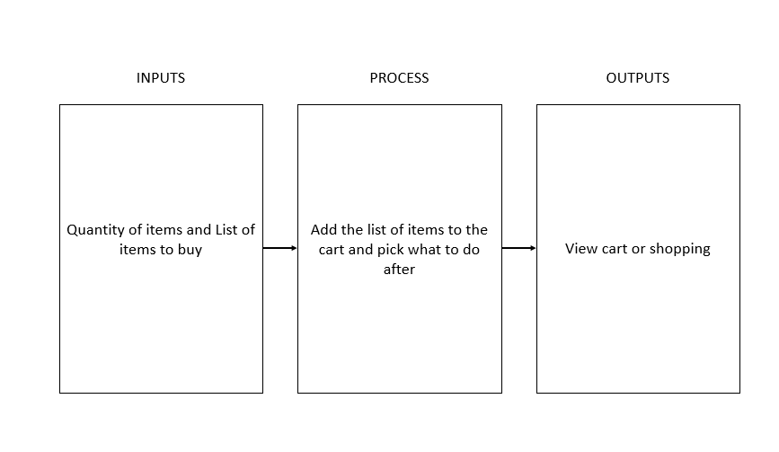

1. Receipt

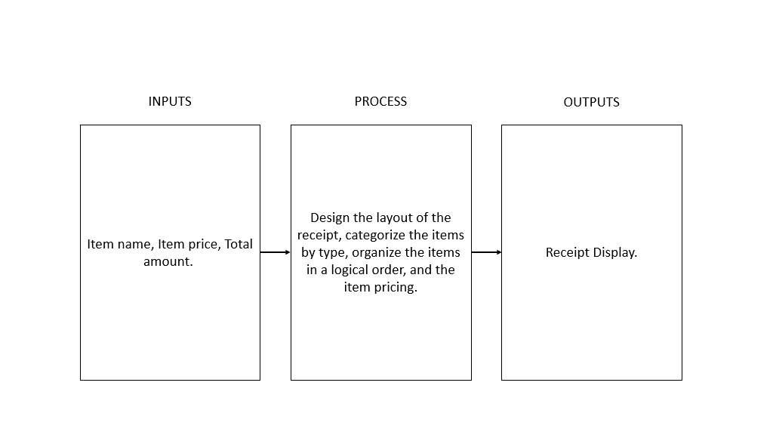

1. Saving Cart Items
2. Save and load cart with name system

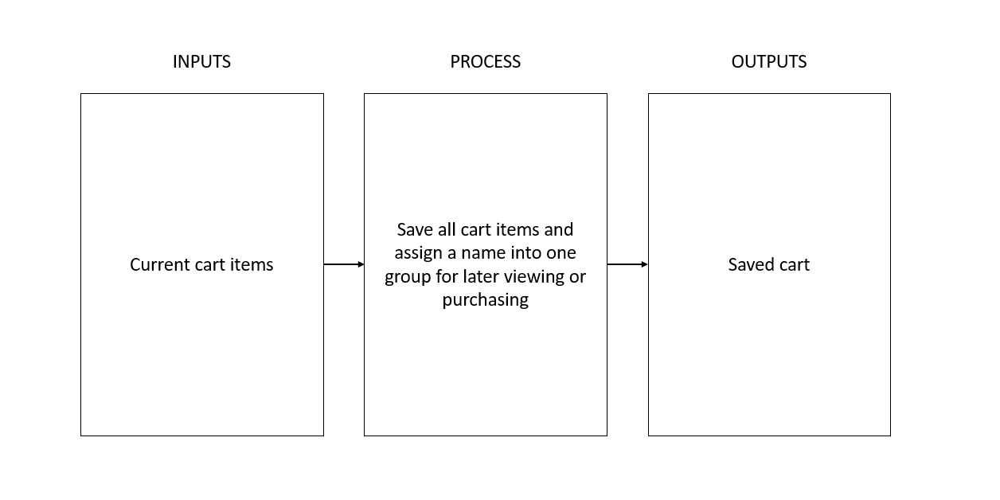

**Methodology**

The students will use GitHub as the main programming platform for the creation of the project. For the process of the program, the first operation of the program will use if and loop statements that will serve as the enhanced security and anti-fraud protection. Parts II and IV (Menu Display & Receipt) will utilize print functions to display the overall presentation of the program to the user. On the other hand parts III and V (Actions on Orders & Saving Cart Items), the students will apply the concepts of looping arrays to successfully run the program in order to receive the desired output.

How are you going to do it? Present an overall system flowchart on how your project should work. Include a description of Python concepts that will be used to develop the project.

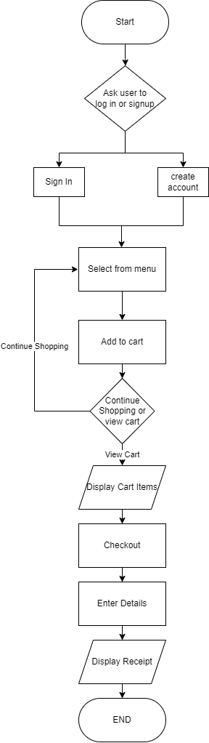

This POS System has three main features and extra features which are optional:

1. Account system where you log-in or sign up. Loops, If.. else statements will be used, as well as file handling to save and read account information.
2. Menu System, It reads the menu from a given excel file which includes item id, item name, item price, and item description. Openpyxl module shall be used to read the excel values, then it will be stored in lists for the user to add to cart. The menu is scalable, it is able to accept any amount of items in the excel and use in the code.
3. Cart System, the user will add to cart all the items of his choice and these will be stored in a list which will then be displayed once the user chooses to view the cart. Looping function and try.. except function of python will be used to catch errors and repeat the shopping process.
4. Extra Planned Features:
   * Save and load cart feature which allows users to save and load their cart for later purchases.
   * Categorized items, this feature allows similar items to be categorized for easier access for the user.

**Schedule of Activities**

Provide a timetable or Gantt chart of your deliverables. Indicate who does what and when the deliverables will be accomplished.

* Enriquez
  + Documentation of the project
    - Phase 3 Documentation Finish (March 30)
* Evalla
  + Coding output of the project
    - Phase 3 Project Coding Finish (March 30)
* Fernandez
  + Coding output of the project
    - Phase 3 Project Coding Finish (March 30)

**References**

Cite the resources that will be used for the project.

Deutch, K. (2022). What is a POS System? Squareup. Retrieved from <https://squareup.com/us/en/townsquare/what-pos-system>

Dublino, J. (2023). Cash Register Buying Guide: POS vs. Cash Registers vs. Tablet mPOS <https://www.business.com/articles/cash-register-vs-pos-system/>

Glend, V. (2022). 5 things that will happen if you don’t use POS System in your restaurant. <https://www.hashmicro.com/blog/5-things-that-will-happen-if-you-dont-use-pos-system-in-your-restaurant/>

Hayes, A. (2022) What Is a POS System and How Does It Work? <https://www.investopedia.com/terms/p/point-of-sale.asp>

Kim, Y. & Lim, J. (2011). A POS system based on the remote client-server model in the small business environment. *Management Research News*, *34*(12), 1334–1350. <https://doi.org/10.1108/01409171111186432>