**DOCUMENTATION:**

**MEMBERS:**

JOHN LEO F. PASTRANO

BEVERLY JANE L. JAVIER

JOSEPHAUL PASCO

**FEATURE AND DESCRIPTION:**

1. **Drawer Navigation:**

Drawer navigation provides a side menu accessible by swiping or tapping, offering easy access to various sections or functionalities of the app.

It enhances user experience by organizing navigation options in a convenient, accessible menu structure.

1. **Bottom Tab Navigation:**

Bottom tab navigation displays tabs at the bottom for effortless navigation between different sections or features of the app.

It offers a visually intuitive way for users to switch between main functionalities, improving overall usability.

1. **Stack Navigation with Multiple Screens:**

Stack navigation allows seamless navigation between multiple screens, with each new screen stacked on top of the previous one.

Users can easily navigate back to previous screens, providing a straightforward and hierarchical navigation structure.

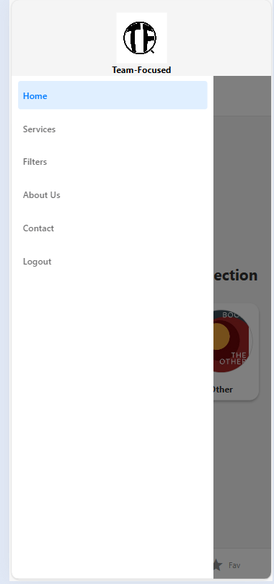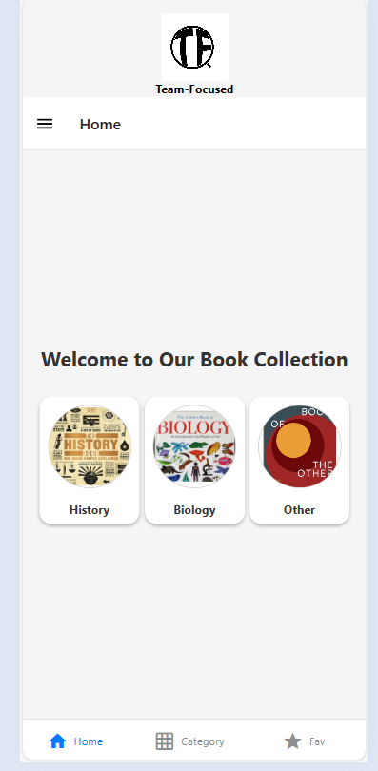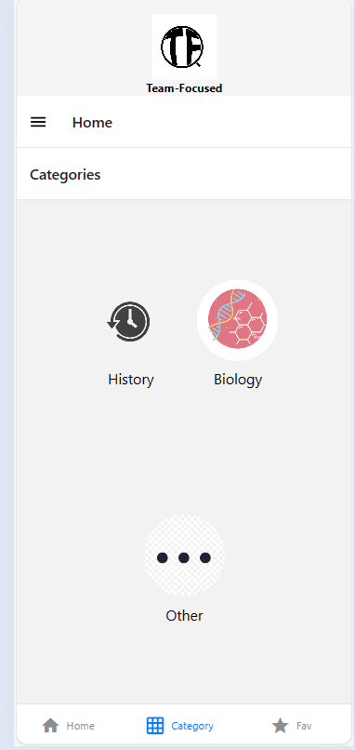**SAMPLE IMAGES OUTPUT:**

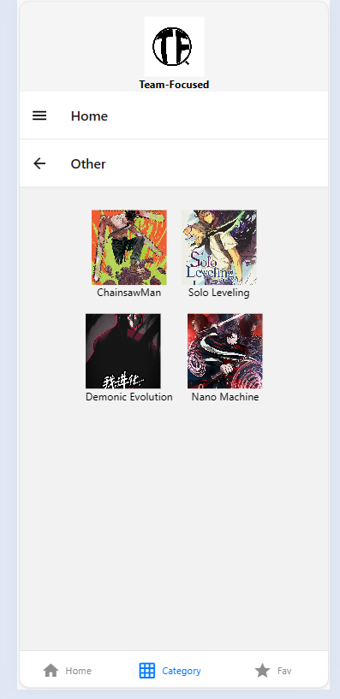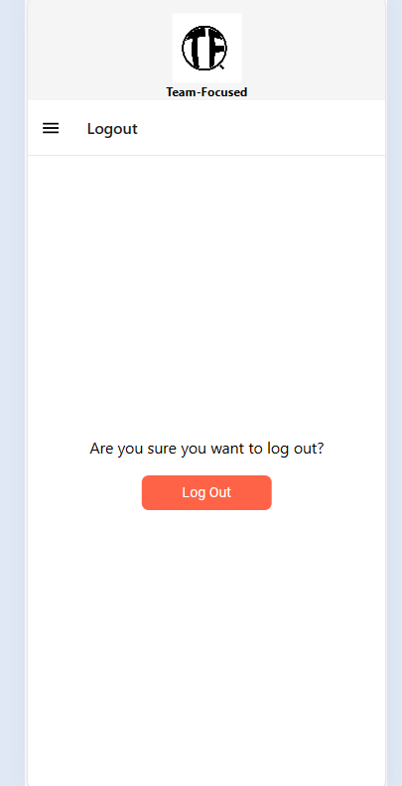

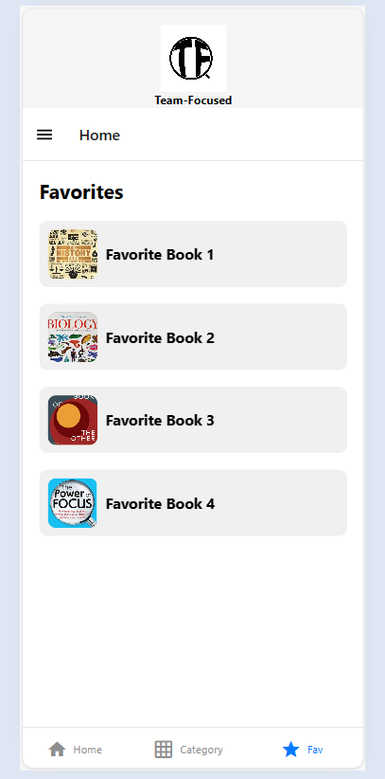

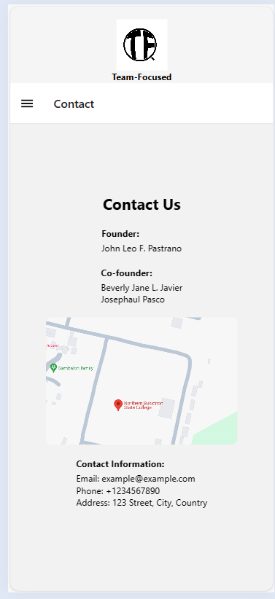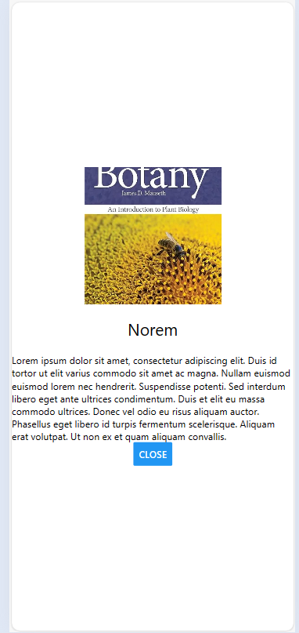

**SOURCE CODE:**