Development of a Web-Based Calamansi Juice Yield Prediction System Using Regressions
________________________________
A Capstone Project Presented to the Faculty of the IT and Computer Education Unit
Leyte Normal University
Tacloban City
________________________________
In Partial Fulfillment of the
Requirements for the Degree
Bachelor of Science in Information Technology
________________________________
by:
Jessalyn P. Billante
Ma. Teressa R. Denden
Mary Joana A. Querioso
John Paul B. Tiu

Chapter 1
This chapter presents the background and context of the study, highlighting the challenges in estimating calamansi juice yield using traditional manual methods and introducing the proposed web-based system that compares three linear regression algorithms Simple Linear Regression, Multiple Linear Regression, and Polynomial Regression to predict the juice yield of calamansi (Citrus microcarpa) based on size and weight. It also outlines the objectives of the study and the scope and limitations of the proposed system.

Introduction
Agriculture plays a significant role in the economic development and food production of many countries, particularly in tropical regions where calamansi-based crops serve as primary sources of income. In the calamansi industry, knowing how much juice a batch of calamansi can produce is a practical concern for farmers, vendors, and processors who rely on this information for planning, pricing, and managing their resources. Calamansi (Citrus microcarpa), widely grown across tropical regions, is particularly valued for its juice, which directly affects its market price. Being able to predict juice yield before processing helps farmers and producers plan their harvests, distribution, and operations more effectively (Xu et al., 2025).
At present, the common way to measure juice yield is through manual extraction, where each calamansi is cut and squeezed to collect the juice. While this gives accurate

results, it is also destructive, tedious, and impractical when working with large volumes of calamansi. For small-scale use, this may be manageable, but for bigger operations, doing it for every single calamansi wastes both time and produce. There is clearly a need for a smarter approach that can estimate yield without having to physically extract juice from every calamansi (Vijayakumar et al., 2022).
Researchers in agriculture have long observed that the physical traits of a calamansi, such as its size and weight, can tell a lot about how much juice it contains. Bigger calamansi tend to produce more juice, and these observable characteristics make it possible to build predictive models that estimate juice content without needing to destroy the calamansi in the process (Yan et al., 2025).
In recent years, machine learning has found its way into agricultural research, offering new tools for improving yield prediction. Among the widely used approaches are variants of linear regression ranging from simple single-predictor models to polynomial models that capture non-linear relationships. These methods are interpretable and practical, making them well-suited for agricultural applications (Hernández et al., 2025).
Studies have shown that prediction systems powered by machine learning can outperform traditional methods in both accuracy and efficiency. By giving farmers and processors early estimates of how much yield to expect, these systems make planning much easier and more reliable (Yuvasri & Nagarajan, 2025).
In this study, calamansi samples were collected and sorted by size (small, medium, and large), individually weighed, and their juice was extracted and recorded.
These data were used to build and compare three regression algorithms: Simple Linear Regression (using weight only), Multiple Linear Regression (using weight and size), and Polynomial Regression of degree 2 (using weight, size, and their interaction and quadratic terms). This comparison allows the study to identify which approach best predicts juice yield based solely on physical characteristics.
The system developed in this study is intended to be a practical tool that farmers, vendors, and juice processors can actually use. Rather than spending time and resources manually squeezing every calamansi just to estimate output, users can simply enter the total weight and size breakdown of their calamansi, choose a prediction algorithm, and get an immediate predicted juice yield.

Purpose and Description
This study was conducted with the goal of designing, developing, and evaluating a web-based system that can predict how much juice a batch of calamansi (Citrus microcarpa) can produce based on the size and weight of the calamansi, by training and comparing three linear regression algorithms.
To do this, calamansi samples were sorted by size into small, medium, and large categories, and each calamansi was individually weighed. Juice was then extracted from the samples and the output measured. The collected samples were used to train all three regression models: Simple Linear Regression (weight only as predictor), Multiple Linear Regression (weight and size as predictors), and Polynomial Regression of degree 2 (weight, size, and their squared and interaction terms as predictors).
The result is a web-based system built with Python and Streamlit where users can enter the total weight of their calamansi batch in kilograms (which the system internally converts to grams before passing to the trained model) along with the number of small, medium, and large calamansi and their preferred algorithm. The system will instantly provide a predicted juice yield in milliliters. The whole approach avoids the need for ripeness classification or image processing, and instead focuses on simple, measurable physical traits that anyone can observe.
The system includes a secure login feature with role-based access control, distinguishing between regular users and an administrator. Regular users such as farmers, vendors, and juice processors can make predictions and view their own prediction history. The administrator has full access to all prediction logs, user management tools, and model performance metrics. All predictions are saved to a database along with a timestamp for future review. User passwords are secured through one-way hashing before being stored, ensuring that account information is protected.
The research followed a quantitative approach, going through the stages of data collection, model development, and system evaluation to make sure the final product is both accurate and usable.

Project Context
For many Filipino farmers, vendors, and juice processors, calamansi is more than just a crop it is a source of livelihood. Despite this, there is still no widely accessible and efficient way to estimate how much juice a batch of calamansi can produce before it is processed. This gap makes it harder for sellers and processors to sort their produce, set fair prices, and decide how much to prepare for production.
Version Date: Aug. 27, 2026 Version no. 2
This study was developed as a direct response to that problem. Instead of squeezing every calamansi to find out its juice content, users can now rely on a prediction system built from actual calamansi samples. By comparing three regression algorithms, the study provides not only a functional prediction tool but also a clear picture of which modeling approach performs best on real calamansi data. All of this translates to less wasted produce, less time spent, and more efficient operations overall.
The system was built with local use in mind. Not everyone has access to highend technology or laboratory equipment, so keeping things simple and accessible was a priority. This makes it a cost-effective option for agricultural stakeholders who need practical tools they can actually use in the field.

Objectives of the Study
The general objective of this study is to develop a web-based calamansi juice yield prediction system that trains and compares three linear regression algorithms
Simple Linear Regression, Multiple Linear Regression, and Polynomial Regression (degree 2).
Specifically, this study aims:
- To collect and categorize calamansi samples into three size groups such as small,medium, and large based on defined physical criteria, and to record the individual weight (in grams) of each sample using a digital kitchen scale, ensuring a complete dataset with zero missing values prior to model training.
- To measure the actual juice yield (in milliliters) of each categorized calamansi sample using a standardized manual extraction method cutting with a knife and measuring with a standard syringe produces a reliable dataset that serves as the ground truth for all three regression models.
- To train three linear regression models Simple Linear Regression (weight only),
Multiple Linear Regression (weight and size), and Polynomial Regression of degree 2 (weight, size, and their squared and interaction terms) using an 80:20 training-to-test split, targeting an R² score of at least 0.80 and the lowest achievable Mean Absolute Error (MAE) for the best-performing model.
- To design a fully functional web-based prediction system using Python and Streamlitthat accepts user inputs for total weight (in kilograms) and size distribution of a calamansi batch, allows selection of a prediction algorithm, displays the predicted juice yield in milliliters, and presents a side-by-side comparison of all three algorithm results, with role-based access control for regular users and administrators, prediction history logging, and secure password storage.
- To evaluate the prediction accuracy of all three regression models using R² and MAE metrics on the held-out test set, and to assess the system's performance efficiency by measuring the average response time of the web application (target: under 2 seconds per prediction) and confirming stable deployment on Streamlit Cloud.

Scope and Limitations
This study covers the design, development, and evaluation of a web-based calamansi juice yield prediction system. The system was evaluated based on
internationally recognized software quality characteristics, specifically focusing on functional suitability, usability, reliability, and performance efficiency.
Version Date: Aug. 27, 2026 Version no. 2
In terms of functional suitability, the system is scoped to predict the juice yield of calamansi (Citrus microcarpa) using three linear regression variants Simple Linear Regression, Multiple Linear Regression, and Polynomial Regression (degree 2), with size category (small, medium, large) and individual weight (in grams) as the only input features. Users enter the total batch weight in kilograms, which the system internally converts to grams before processing. The system performs the functions it was designed for, which is to accurately predict juice yield based on user-provided physical
characteristics of calamansi.
In terms of performance efficiency, the system was developed to respond promptly to user inputs and deliver predictions without unnecessary delays. The dataset used to train the models was derived from actual juice extractions conducted during the study period, ensuring that the system operates on real, grounded data.
In terms of usability, the system was designed to be simple and accessible for its intended users, farmers, vendors, and juice processors who may not have technical backgrounds. The interface was kept straightforward so that users can input the total weight and size distribution of a calamansi batch and receive an immediate predicted juice yield without requiring specialized knowledge or equipment. However, formal User Acceptance Testing (UAT) with actual farmers was outside the scope of this study, as the primary focus was on algorithmic development and technical validation.
In terms of reliability, the system consistently produces predictions based on the trained regression models. However, its predictive accuracy is directly dependent on the quality and consistency of the collected data, and results may vary across different calamansi varieties or seasonal batches not represented in the dataset.
Version Date: Aug. 27, 2026 Version no. 2
The study was conducted in Tacloban City, Leyte, Philippines, where calamansi samples were sourced from local market vendors and suppliers. The findings and the developed system are therefore most applicable to calamansi trading and processing activities within this locale and surrounding areas in the region. The dataset covers samples collected within Tacloban City during the study period only, and results may not fully represent calamansi from other regions or growing conditions.
The study does not account for internal factors such as chemical composition, ripeness level, soil type, or growing conditions, as these fall outside the scope of the measurable physical characteristics targeted by this research. The system was built as an experimental academic prototype and has not been validated for large-scale commercial deployment. Predictions generated by the system should not be used as the sole basis for pricing, purchasing, production, or other financial decisions during research testing or initial deployment. Further refinement and broader data collection would be necessary before wider use.
Additionally, quality characteristics such as security, portability, compatibility, and maintainability were not covered in this study, as they are beyond the scope of its current academic purpose and development stage. However, security measures including password hashing (SHA-256), role-based access control, and HTTPS encryption were implemented to protect user accounts and data, as the system includes user registration and prediction logging functionality.
Version Date: Aug. 27, 2026 Version no. 2
Version Date: Aug. 27, 2026 Version no. 2

Chapter 2
This chapter offers a thorough analysis of the literature and associated systems pertinent to the creation of a web application that uses regression-based machine learning to forecast the juice production of calamansi (Citrus microcarpa). Regression algorithms (Simple Linear Regression, Multiple Linear Regression, and Polynomial Regression) applied to agricultural datasets, studies on calamansi as a commercially significant agricultural crop in the Philippines, physical fruit characteristics as predictors of juice yield, and current web-based systems for fruit and crop yield prediction are all covered in this review. The synthesis of these works identifies the gap in readily available, pre-extraction juice yield estimation tools for Filipino calamansi farmers, vendors, and processors, and provides the theoretical and empirical basis for the current study's approach of using batch weight and size category as input features to address.
2.1 Related Literature

A. Calamansi (Citrus microcarpa) and Its Juice Industry
Abal et al. (2024) conducted a study on the nutritional composition and antioxidant properties of calamansi (Citrus microcarpa) peels subjected to different drying processes, published in Nusantara Bioscience. While their central concern was the peel byproduct of calamansi juicing, the study confirmed that calamansi grown in the Philippines is primarily cultivated and utilized for its juice, with the juicing process generating the peel as a secondary material. The authors further noted that the
Philippines is a significant exporter of calamansi juice to countries such as Japan, South
Korea, Hong Kong, the United States, and Canada, underlining the commercial and economic importance of juice yield in calamansi production. This commercial significance directly substantiates the need for a reliable juice yield estimation system such as the one proposed in the current study, particularly for Filipino farmers, vendors, and processors who depend on calamansi juicing for their livelihood.
The bioactive and commercial potential of calamondin (Citrofortunella microcarpa) was reviewed comprehensively by Nguyen et al. (2023), published in PMC/Nutrients. The authors detailed that calamondin the alternative name for calamansi is valued precisely for its high juice content, distinctive flavor, and bioactive compound profile including phenolics and flavonoids. Their review established that all parts of the calamondin fruit, particularly the juice and pulp, serve applications ranging from ready-to-drink beverages to food ingredients and herbal medicine. The review's emphasis on the fruit's juice as its primary economic derivative validates the focus of the present study on predicting juice yield specifically, rather than total fruit weight or other attributes, as juice volume is the most commercially relevant measurable output for stakeholders in the calamansi value chain.
In a study examining the citrus industry in Nueva Vizcaya, Philippines, Idquival et al. (2023), publishing in the International Journal of Research in Engineering, Science and Management, analyzed production trends, market challenges, and the value chain of citrus farming in the region. Their findings revealed that smallholder citrus farmers in the Philippines continue to face difficulties in estimating the volume of juice they can extract from their harvests a gap that affects pricing decisions, buyer negotiations, and production planning. This contextual finding provides direct empirical support for the development of the calamansi juice yield prediction system in the present study, as it highlights an unmet need for accessible, pre-extraction yield estimation tools among Filipino farmers who do not have access to laboratory-grade equipment or expensive sensing technology.

B. Physical Characteristics of Fruit as Predictors of Yield and Quality
Sabouri et al. (2025), publishing in Scientific Reports (Nature), developed machine learning models including Support Vector Regression (SVR), Multivariate Linear Regression (MLR), Multi-Layer Perceptron (MLP), and Decision Tree regression to non-destructively estimate the fresh weight of plum fruits based on physical dimensions derived from smartphone images. Their study established that fruit dimensions measurable, non-invasive physical properties, can serve as strong predictors of weight with R² values as high as 0.9369. This finding is directly relevant to the present study, which similarly relies on calamansi weight and size category (small, medium, large) as measurable physical input features, without any image processing or destructive extraction. Both studies share the foundational principle that observable physical traits provide sufficient information for predicting a fruit-related quantity of interest.
A study by Basak et al. (2022), published in Agronomy (MDPI), applied machine learning models to non-destructively estimate the weight of strawberry fruits from physical measurements, achieving high predictive accuracy. The authors demonstrated that when traditional destructive methods are replaced by regressionbased models trained on measurable features, the result is faster, more scalable, and more practical for large-batch operations. Basak et al. also underscored that multiple regression techniques should be compared when working with agricultural datasets, since the relationship between physical inputs and output quantities may vary in linearity. This methodology directly informs the comparative approach of the present study, which trains and evaluates three regression models Simple Linear Regression, Multiple Linear Regression, and Polynomial Regression to determine which best fits the calamansi juice yield dataset.
Wen et al. (2023) explored the use of non-destructive, affordable in-field measurement to predict the sugariness a juice-derived quality attribute measured in degrees Brix of strawberries, publishing their findings in Frontiers in Plant Science. The study validated that commodity-level hardware, combined with regression modeling, can provide acceptable prediction accuracy for fruit juice quality traits without requiring laboratory-grade instrumentation. The authors cautioned that the conventional 'harvest-first, analysis-second' paradigm comes too late for practical preharvest decision-making. This argument mirrors the motivation underlying the current study: by predicting calamansi juice yield from easily measurable physical characteristics before extraction begins, farmers and processors can make more timely and informed decisions about pricing, distribution, and production planning.
Amirat et al. (2021), published in PMC, demonstrated in a study on fresh peach fruit that juice volume is among the most dominant parameters when predicting multiple chemical quality indicators using artificial neural network (ANN) and multiple regression models. The ANN model achieved R² values between 0.974 and 0.998, far outperforming the MLR models. A sensitivity analysis in the same study revealed that juice volume contributed 33–50% of the predictive power for key chemical outputs, confirming that juice is not merely a downstream product but a central informational attribute in fruit quality modeling. While the present study uses juice yield as the predicted output rather than the input, this finding reinforces the strong informational relationship between physical fruit properties and juice-related variables.

C. Regression Algorithms for Agricultural Prediction
Chicco et al. (2021), writing in PeerJ Computer Science, conducted a comprehensive comparative evaluation of regression evaluation metrics and concluded that R² (coefficient of determination) is more informative than MAE, MSE, RMSE, MAPE, and SMAPE as a standard metric for evaluating regression models. The authors argued that R² directly indicates how well a model explains the variance in the data, making it the preferred metric when communicating model fit to non-specialist audiences, such as agricultural stakeholders and academic evaluators. The present study adopts R² and MAE as its primary evaluation criteria, consistent with this recommendation, targeting an R² of at least 0.80 for the best-performing regression model on the test set.
Piekutowska et al. (2021), publishing in Agronomy (MDPI), compared Multiple Linear Regression (MLR) and artificial neural network (ANN) models for predicting the yield of very early potato cultivars before harvest. Using MAE and MAPE as error metrics, the study found that most models produced MAPE values below 15%, indicating a good level of fit. The ANN outperformed MLR in overall quality metrics, but the authors noted that MLR remained competitive and interpretable, particularly for datasets of moderate size. Their use of an 80:20 training-to-test split mirrors the data partitioning strategy employed in the present study. This study validates the methodological framework of using MLR as a viable and interpretable regression approach for crop yield prediction even when more complex alternatives exist.
Kuradusenge et al. (2023), publishing in Agriculture (MDPI), applied Polynomial Regression, Random Forest, and Support Vector Regressor to predict the yields of Irish potatoes and maize using weather data from Rwanda. The study used R² and RMSE as evaluation metrics and found that while Random Forest performed best overall, Polynomial Regression remained a competitive option, particularly when nonlinear relationships between predictors and yield were present. Their work provides empirical justification for including Polynomial Regression as one of the candidate models in the current study's comparative analysis, where the relationship between calamansi size, weight, and juice yield may exhibit curvature or interaction effects that linear models cannot fully capture.
Conradt (2022), writing in the International Journal of Biometeorology (Springer), evaluated multiple linear regression as the core methodology for weatherbased crop yield prediction across 401 districts in Germany, using an algorithm called ABSOLUT v1.2. The study demonstrated that a broad exhaustive testing of predictor combinations through multiple linear regression can explain a significant portion of observed yield variations. Crucially, the author highlighted that interpretability is a key advantage of MLR over black-box methods a consideration that is directly applicable to the present study, where the target users are farmers and processors who benefit from transparent, understandable prediction logic rather than opaque algorithmic outputs.
Ansarifar et al. (2021), publishing in Scientific Reports (Nature), introduced an interaction regression model for corn and soybean yield prediction that explicitly incorporated interaction terms between predictor variables. Their model achieved a relative root mean square error of 8% or less across multiple Midwest states, outperforming standard machine learning algorithms. The inclusion of interaction terms between weight and size in the Polynomial Regression model of the current study is conceptually aligned with this approach recognizing that the combined effect of calamansi size and weight on juice yield may not be fully captured by their independent contributions alone.
A review by Lagrazon and Tan (2023) cited in a broader remote sensing yield estimation review established that Multiple Linear Regression (MLR) continues to be one of the most commonly used approaches in RS-based yield estimation, particularly under conditions where relationships are approximately linear but predictor intercorrelations are minimal. Additionally, the review established that when agricultural datasets demonstrate multicollinearity or non-linear growth trajectories, Polynomial Regression offers a more suitable extension by integrating higher-order polynomial terms. This theoretical framework directly underpins the rationale for the three-algorithm structure of the current study, which tests both linear and polynomial approaches to determine the best fit for calamansi juice yield data.

D. Machine Learning in Agriculture and Yield Prediction Systems
Anbananthen et al. (2021), writing in F1000Research, conducted a comprehensive development of a hybrid machine learning decision support system for crop yield prediction, comparing gradient boosting, random forest, stacked generalization, and LASSO regression. The study explicitly stated that its goal was to develop a web application providing farmers with an approximation of how much crop yield to expect and to find the relationship between yield (dependent variable) and independent variables. The system produced fast and accurate responses to farmers through its web interface. This directly mirrors the design intent of the current study, which builds a web application for juice yield prediction where users input physical batch characteristics and immediately receive a predicted yield in milliliters.
Yuvasri and Nagarajan (2024), publishing in Computers (MDPI), conducted a performance analysis of multiple machine learning models for crop yield prediction in
South India using crops such as rice, sorghum, cotton, and sugarcane. The study assessed multiple regression-based models on historical agricultural datasets, confirming that machine learning-based prediction systems consistently outperform traditional experience-based farmer estimation in both accuracy and reliability. The study also noted that farmers traditionally predict crops based on region, soil, weather, and their own experience, which leads to inaccurate estimates particularly under the increasingly unpredictable climate conditions of the present day. This empirical argument directly parallels the motivation of the present study in replacing manual, experience-based juice yield estimation with a data-driven prediction system.
Maheswari et al. (2021), writing in Frontiers in Plant Science, published a comprehensive review of deep learning-based semantic segmentation techniques for fruit yield estimation in orchards. The review highlighted that manual yield estimation in agricultural settings is labor-intensive, time-consuming, and imprecise and that intelligent estimation systems offer more benefits to farmers in decisions related to harvesting, marketing, and logistics. While the current study employs regression rather than deep learning, both approaches share the same overarching objective: replacing destructive, labor-intensive yield quantification with a faster and scalable prediction system. The review's finding that estimation systems are beneficial regardless of complexity level reinforces the practical value of even simpler regression-based approaches such as the one implemented in the current study.
Raptis et al. (2025), publishing in MDPI Remote Sensing, developed a Pythonbased Streamlit web application for automating satellite data processing and generating wheat yield estimates for smallholder farmers in Greece. The system used regression analysis within a Python environment and presented results directly to farmers via a Streamlit interface, which was selected specifically for its cost-effectiveness and accessibility for non-technical users. The present study similarly employs Python and Streamlit to build its calamansi juice yield prediction web application, validating the technical suitability of this framework for agricultural prediction tools intended for non-expert users.
Rani et al. (2023), publishing in Scientific Reports (Nature), developed a machine learning-based optimal crop selection system for smart agriculture, comparing multiple machine learning models on soil and climate datasets. Their system was developed with the explicit goal of minimizing computational cost while maximizing usability for smallholder farmers who lack access to high-end infrastructure. The study underscored that systems designed for agricultural end-users must prioritize interpretability and practical usability alongside technical accuracy. This principle guides the design of the current study's system, which uses simple regression algorithms rather than complex ensemble or deep learning models specifically because these are interpretable and deployable in low-resource environments typical of Philippine calamansi farming communities.
A study focused on improving decision support systems with machine learning, published in the Agronomy Journal (Wiley, 2023), identified financial cost and inaccessibility as major barriers to DSS adoption among small farmers. The authors found that free-to-use or subscription-based web platforms significantly reduce adoption barriers, particularly for smallholder farmers who cannot afford commercial software. They also noted that university-developed academic prototypes serve an important role in bridging the gap between scientific innovation and practical field use. The web-based system developed in the current study designed as an academic prototype accessible without specialized equipment aligns with this recommended approach for maximizing accessibility and uptake among the target agricultural user base.
A tropical fruit production modeling review by Castano et al. (2024), published in Frontiers in Agronomy, documented a large surge in publications on machine learning and IoT applications for tropical fruit yield modeling beginning in 2021, with rapid acceleration through 2022 and 2023. The review established that 'machine learning,' 'forecasting,' and 'internet of things' are the most recurring keywords in fruit crop modeling research, and that the data-driven modeling trend is increasingly reaching tropical crop varieties including citrus. The current study is positioned at the intersection of these trends, applying machine learning to calamansi, a tropical citrus fruit using a focused and low-technology data collection approach (weight and size measurements rather than satellite or IoT sensors).
Yan et al. (2025), confirmed that physical traits of calamansi can be used to build predictive models that estimate juice content without the need to destroy the fruit. The theoretical grounding provided by these two studies directly justifies the present study's decision to use size and weight as sole predictors for juice yield, and confirms that regression-based modeling on physical characteristics is a scientifically valid approach within current agricultural research.
Chicco et al. (2021) and Géron (2022) both established that the 80/20 train-test split is among the most widely adopted data partitioning strategies in machine learning because it provides a large enough training set for the model to generalize while reserving a meaningful test set for unbiased evaluation. The 80:20 split is particularly suitable for moderately sized datasets, such as the one collected in the current study, where maximizing the volume of training data is important for model stability. The present study adopts this split ratio explicitly, with all three regression models trained on 80% of the collected calamansi samples and evaluated on the remaining 20% using
R² and MAE

2.2 Related System

A. Citrus and Fruit Yield Prediction Systems
Vijayakumar et al. (2023), publishing in Smart Agricultural Technology (Elsevier), developed three machine learning-based models for tree-level citrus yield prediction using UAV imagery and ground-based fruit detection. Model 1 used UAV imagery alone; Model 2 added ground-based single-side fruit counts; and Model 3 combined UAV and bilateral ground-based counts. The study demonstrated that combining multiple types of observational data significantly improved prediction accuracy compared to traditional manual counting. This system shares the same core objective as the current study providing pre-harvest citrus yield estimates to growers but is distinguished by its reliance on high-cost drone and imaging infrastructure. The current study develops a more accessible alternative that uses only weight and size measurements, making it viable for small-scale Filipino calamansi farmers without specialized equipment.
Moussaid et al. (2022), publishing in Informatics (MDPI), developed an intelligent machine learning-based system for predicting citrus fruit yield before the harvest period, using five years of field and satellite data from a Moroccan citrus orchard of 50 parcels. Their system incorporated climate data, irrigation volume, fertilization dose, and parcel size as inputs, and employed Multiple Linear Regression (MLR) and Partial Least Squares (PLS) regression as prediction algorithms. This system is the most thematically proximate to the present study among all related systems, as it applies regression-based modeling specifically to citrus yield prediction.
The current study differs in scope focusing on individual-level calamansi juice yield extraction using only weight and size rather than orchard-level tonnage, but draws directly on the regression methodology established in this precedent.
Ebaid et al. (2024), writing in Agronomy (MDPI), employed an artificial neural network (ANN) to predict the yields of five citrus varieties including Valencia orange, Murcott mandarin, and Bearss Seedless lime using weather factors and heat unit accumulation as inputs over 12 growing seasons. Although the prediction target was agricultural tonnage rather than juice volume, the system established that citrus yield prediction from measurable inputs is learnable and practically deployable. The study's methodology, which collected data systematically over multiple seasons and training a model from that data mirrors the data-driven approach adopted in the present study, which collected juice yield data from physically measured calamansi samples over its study period and used that data to train three regression models.
A machine vision-based citrus grading system described by Li et al. (2025), published in Systems Science & Control Engineering (Taylor & Francis), integrated diameter measurement, coloring rate evaluation, and roundness analysis to perform automated grading of citrus fruits in accordance with Chinese national standard GB/T 12947-2008. The system classified citrus into grading categories based on size, color, and shape features. The current study is related to this system in its use of size categories (small, medium, large) as a key classification input, but differs in its purpose the present study uses size as a predictor of juice yield rather than a quality grading output, and does not require machine vision hardware, making it far more accessible to smallholder farmers.

B. Agricultural Decision Support and Yield Prediction Web Systems
Anbananthen et al. (2021), publishing in F1000Research, developed a hybrid machine learning decision support system for crop yield prediction accessible via a web page interface. The system compared multiple algorithms including random forest, gradient boosting, and stacked generalization, presenting results instantly to users through a web-based interface. The study's system architecture a web front end that accepts user input, passes it to a trained ML model, and displays the prediction is structurally identical to the system developed in the current study. Both systems also share the objective of providing fast, reliable, accessible yield estimates to farmers who would otherwise rely on imprecise traditional methods.
Sable et al. (2025), publishing in Frontiers in Computer Science, developed a
Streamlit-based web application that applied multiple regression algorithms including Linear Regression and Decision Tree to historical market price data from Pune, India, to determine the optimal harvest timing for agricultural commodities. The system evaluated models using MSE and R² and found the Decision Tree model achieved the highest R² score of 99%. Users input crop type and desired pricing to receive harvest timing recommendations through the Streamlit interface. The current study parallels this system's architecture Streamlit front end, regression algorithm comparison, and R²-based evaluation but applies the approach to a different prediction problem: estimating calamansi juice yield in milliliters from batch weight and size inputs.
Raptis et al. (2025), publishing in MDPI Remote Sensing, built a Streamlitbased Python web application for automating Sentinel-2 satellite data processing and providing smallholder wheat farmers with actionable yield forecasts. The application used GNDVI and LAI as the most reliable predictors and applied regression analysis within a Python environment. The system was designed to be cost-effective and accessible for farmers who are not remotely sensing specialists. The present study's web system shares the Python-Streamlit technical stack and the same accessibility priority for non-technical users, though it replaces satellite-derived indices with simple physical input data (batch weight in kilograms and calamansi count by size category), making it operable without internet-connected sensing devices.
A machine learning-based crop selection system described by Rani et al. (2023), in Scientific Reports (Nature), developed a web-based interface allowing farmers to input soil and climate parameters and receive crop recommendations. The system compared multiple machine learning models and was explicitly designed for smallholder farmers who cannot afford commercial agricultural software. Like the current study, this system targeted agricultural users without technical expertise and prioritized simplicity and accessibility in its web interface design. The difference lies in the prediction task crop selection versus juice yield but both systems apply the same design philosophy of translating machine learning outputs into practical, immediately actionable information for farming end-users.
Yuvasri and Nagarajan (2024), publishing in Computers (MDPI), built a machine learning-based crop yield prediction system for South Indian crops, comparing multiple models and reporting R² values and error metrics. While their system was evaluated primarily as a research prototype rather than as a fully deployed web application, the study included visualizations of model performance that allow users to compare algorithm outputs side by side. The current study adopts a similar side-byside comparison display in its Streamlit interface, where all three regression models (SLR, MLR, Polynomial) are compared simultaneously for every user-submitted
prediction query.
An intelligent crop recommendation and disease detection system developed by Omara et al. (2023), published in Frontiers in Artificial Intelligence, provided realtime information feedback to smallholder farmers via a web-based interface. The system used machine learning to diagnose crop diseases and offer treatment recommendations based on user-submitted symptom reports, logging all interactions for review. The current study's prediction history logging feature which records all user-submitted predictions with timestamps for later review by both users and administrators is directly inspired by this approach, recognizing that maintaining a record of predictions enables farmers and processors to track changes in juice yield estimates over time and across batches.

C. Systems with Role-Based Access and Prediction Logging
A study on User Acceptance Testing of an electronic data preprocessing system published in the Jurnal Mahasiswa Ilmu Komputer (2023) evaluated system quality using ISO 9126 dimensions functionality, reliability, usability, and efficiency with a Likert scale instrument, achieving a usability score of 84.25% (Good) and efficiency of 92.00% (Very Good). The study used questionnaires with positive-to-negative gradation options administered to multiple respondents. While the current study does not include formal User Acceptance Testing, it draws on the ISO 9126 quality dimensions for its technical evaluation approach, focusing on model accuracy (R² and MAE) and system response time as primary performance indicators.
Adebiyi et al. (2020), publishing in Hindawi Journal of Food Quality, developed a machine learning-aided mobile system for farmland optimization using Random Forest and BigML, deployed through a mobile interface (Appery.io). The system accepted user inputs such as location, crop type, soil type, and spacing to generate optimization recommendations. The study noted that the mobile/web system needed to accommodate users who have limited technological familiarity. Like this system, the current study's web application is designed to accept non-technical user inputs and immediately return a prediction without requiring the user to understand the underlying mathematical model. Both systems also include some form of user account
management to track interactions.
The crop yield prediction system by Anbananthen et al. (2021), also referenced as a related literature source included a web-based interface with clear user roles, distinguishing between the farmer/end-user who submits inputs and the researcher/administrator who reviews model outputs and performance metrics. This dual-role design is reflected in the current study's system, which implements role-based access control (RBAC) distinguishing between regular users (farmers, vendors, processors) who make predictions and view their own prediction history, and an administrator who has full access to all prediction logs, user management tools, and model performance metrics.
Version Date: Aug. 27, 2026 Version no. 2
A crop damage prediction framework published in Scientific Reports (Waltz et al., 2025) proposed the future development of a user-friendly decision support system to empower farmers with accessible tools providing actionable insights, recommendations, and visualizations. Their system framework emphasized the importance of role-separated access distinguishing operational users from system administrators and highlighted prediction logging as an essential feature for monitoring model performance over time. The current study's system design directly implements these recommendations, incorporating both role-based access control and prediction history logging with timestamps, supporting the administrators' ability to monitor and review the system's outputs in real-world use.

D.Python and Streamlit-Based Prediction Applications
Akkem et al. (2024), cited in Scientific Reports, developed a Streamlit-based crop recommendation system with advanced Explainable Artificial Intelligence (XAI) for smart farming, published in Neural Computing and Applications. Their system used Streamlit to create an accessible web front end that allowed farmers to receive crop recommendations with explanations for why a particular crop was suggested. The study confirmed that Streamlit is among the most suitable frameworks for deploying machine learning models in agricultural contexts because it requires minimal front-end coding expertise and can be maintained by researchers without full-stack web development skills. The present study adopts Streamlit for the same reasons, building its calamansi juice yield prediction interface with Python logic and Streamlit's reactive UI components.
Waltz et al. (2025), publishing in Frontiers in Artificial Intelligence, developed a cyberinfrastructure for machine learning applications in agriculture at The Ohio State University, processing one terabyte of multimodal data (UAV imagery, soil sensors, weather sensors) collected during the 2023 growing season. The paper discussed the challenges of building scalable ML agricultural systems that remain accessible to different user types. While this system is far more complex than the one in the current study, it reinforces the principle that web-based interfaces serving multiple stakeholder types (researchers, farmers, extension agents) require role-differentiated access structures a principle implemented in the current study through its RBAC architecture distinguishing regular users from administrators.
A system developed for precision agriculture by Rani et al. (2023) in Scientific Reports included a web-based interface designed specifically to minimize the technical knowledge required for agricultural decision-making. The system's quantitative results, achieved through 10-fold cross-validation and metrics including accuracy and F1score, demonstrated that even relatively simple models can achieve high performance when carefully designed and evaluated. The current study shares this philosophy prioritizing simplicity, interpretability, and practical deployment while using regression-specific metrics (R² and MAE) as its evaluation benchmarks.
A crop yield optimization study by Sable et al. (2025) in Frontiers in Computer Science also addressed the importance of displaying prediction history in agricultural web applications, allowing users to review past queries and compare how predicted values evolved over time. Their Streamlit-based system stored historical data for registered users, enabling longitudinal analysis of market predictions. The current study's prediction history feature which logs all predictions with a timestamp, algorithm used, input parameters, and predicted output is directly analogous to this functionality, providing both users and administrators with a traceable record of how the system has been used.

E. Security, Usability, and Evaluation of Agricultural Web Systems
Provos and Mazieres (1999), widely cited in subsequent cybersecurity literature, introduced the bcrypt password hashing algorithm as a more secure alternative to traditional cryptographic hash functions. By 2023, a study published through USENIX on the 25-year retrospective of bcrypt confirmed that the algorithm remains one of the most widely deployed password hashing mechanisms in web applications because its work factor can be adjusted over time to keep pace with increasing computational power. The present study uses one-way password hashing before storing user credentials in the database, consistent with this established best practice for protecting user account security in web-based systems.
A study on secure hashing in web applications published in IEEE proceedings (2023) found that 48.94% of surveyed web application frameworks use BCRYPT hashing a positive trend toward more secure password storage confirming its widespread adoption across application domains. The study compared BCRYPT, SHA256, and MD5, finding that BCRYPT consistently outperforms older hashing algorithms in resistance to brute-force and rainbow table attacks. The secure password storage implemented in the current study's system, using one-way hashing of user passwords before database storage, is grounded in these industry best practices documented in the cybersecurity literature.
A UAT survey report conducted by TestMonitor (2023) across software development professionals found that UAT remains the final, most critical quality validation stage before software release, ensuring that a system works as expected for real-world end users. The survey also confirmed that Likert scale questionnaires remain the most common instrument for measuring satisfaction and usability in UAT processes. While the current study focuses on technical validation through model accuracy metrics (R² and MAE) and system response time rather than formal UAT, this literature establishes the importance of user-centered evaluation as a recommended direction for future work.
A study on cyberinfrastructure for agricultural machine learning by Waltz et al. (2025) emphasized that agricultural machine learning systems must be validated not only for technical performance metrics but also for their usability with intended enduser populations including farmers and extension workers. The authors argued that a system achieving high model accuracy but failing in user usability metrics provides less real-world value than a well-designed, accessible system with moderate prediction performance. The current study addresses the technical validation component through model accuracy evaluation (R² and MAE) and system performance testing (response time), while acknowledging that usability testing with end-users is a recommended direction for future research and development.
A field-based crop disease recommender system by Omara et al. (2023), published in Frontiers in Artificial Intelligence, developed a web-accessible system for smallholder farmers in Uganda that combined machine learning with a natural language interface. The system was validated through user testing with farmers who provided feedback through structured questionnaires. The study found that even users with low technology literacy could successfully use the system after minimal onboarding, demonstrating that well-designed agricultural web applications can achieve high usability scores with non-technical users. The current study's calamansi juice yield prediction system is similarly designed for non-technical users farmers, vendors, and processors with a simple input interface that requires no prior knowledge of machine learning or statistical methods.
Version Date: Aug. 27, 2026 Version no. 2

Chapter 3
This chapter explains the technical concepts, tools, and technologies used in the development of the system. It includes discussions on the three linear regression algorithms used, system architecture, software and hardware components, and other technical elements necessary for predicting calamansi juice yield.
Technical Background

Current System
Calamansi farming and juice processing in the Philippines have long relied on manual, hands-on methods to assess and manage calamansi yield. In the current practice, farmers and vendors have no reliable way to estimate how much juice a batch of calamansi will produce without actually squeezing the calamansi. The entire process begins with a visual inspection of the calamansi, where farmers sort the calamansi by size. This sorting is informal and inconsistent, with no standardized criteria applied across different handlers or locations.
Once sorting is done, juice yield is determined through manual extraction. Each calamansi is cut open and squeezed either by hand or with a basic handheld juicer. The extracted juice is collected and measured using ordinary kitchen tools such as cups or bowls, which are not always calibrated accurately. This method, while straightforward, is both destructive and time-consuming. Every calamansi used for yield estimation cannot be sold or used for other purposes, which adds up to significant waste especially in larger batches.
Pricing and processing decisions are also largely based on intuition in the current setup. Without a reliable yield estimate, vendors often underprice or overprice their produce, and juice processors struggle to plan their production volumes accurately. There is no system in place that records or tracks juice yield data over time, which means farmers and processors cannot use past information to improve their decisions. All records, if kept at all, are written manually on paper or simply remembered, making it difficult to identify patterns or refine practices.
These limitations highlight a clear gap in the current system. The lack of a structured, data-driven approach to estimating calamansi juice yield leads to inefficiencies, waste, and missed opportunities for better planning. There is a need for a smarter and more accessible tool that can give farmers and processors a reliable prediction of juice yield before extraction begins, without requiring them to destroy any of their produce in the process.

Proposed System
The proposed system is a Web-Based Calamansi Juice Yield Prediction System developed using Python and Streamlit. It trains and compares three regression algorithms to predict the volume of juice measured in milliliters that can be extracted from a given batch of calamansi based on two input variables: the total weight of the batch entered by the user in kilograms, which the system internally converts to grams before passing to the trained model, and the count of small, medium, and large calamansi. The system was trained on a dataset of real calamansi samples that were physically weighed using a digital kitchen scale and juiced during the data collection phase of this study, with juice volume measured using a standard syringe.
When a user submits their inputs, the system computes a weighted average size score from the calamansi counts and converts the weight to grams before passing all values to the trained regression model. The model then produces a predicted juice yield in milliliters. All predictions are saved to a database along with a timestamp and can be reviewed later through the prediction history feature.
The system includes role-based access control, distinguishing between regular users and administrators. Regular users can make predictions and view their own history, while administrators have access to all prediction logs, user management tools, and model performance results. User passwords are secured using SHA-256 hashing before being stored in the database.
Name of  Software | Features Used in Project  Development | Purpose
Python 3.x | General-purpose programming  language with extensive libraries for data science and machine learning | Serves as the core backend language for data processing, model training, and system  logic
Streamlit | Open-source Python framework for building interactive web-based prediction systems with minimal code | Used to build the web-based user interface where users can input data and receive  predictions
scikit-learn | Python machine learning library providing tools for model training, evaluation, and prediction | Used to train and deploy all three regression models for juice yield prediction
SQLite3 | Lightweight, file-based relational database system requiring no separate server setup | Stores user accounts and prediction history logs with role-based access control
pandas | Python library for data manipulation  and analysis using DataFrame  structures | Used to load, clean, and  process the calamansi dataset during model training
Software Table 1 :

NumPy | Fundamental Python library for numerical computation and array  operations | Supports mathematical calculations in feature engineering and prediction processing
joblib | Python library for lightweight  pipelining and model serialization | Saves and loads the trained regression models as .pkl  files for real-time predictions
hashlib (SHA-  256) | Python built-in library for  cryptographic hashing functions | Secures user passwords through one-way SHA-256 hashing before storing in the database
Visual Studio  Code | Lightweight source code editor with built-in Git, debugging, and extension support | Primary development  environment used for writing, testing, and debugging the
system code

Python 3.x served as the primary programming language for the entire system. Its wide support for data science and machine learning libraries made it the most suitable choice for this project. Streamlit was used to build the web-based system interface, allowing the team to create an interactive and user-friendly prediction system without the need for separate frontend development. Its ability to turn Python scripts into fully functional web-based prediction systems made the development process faster and more straightforward.
For the machine learning component, scikit-learn provided implementations for all three regression algorithms. Simple Linear Regression and Multiple Linear
Regression were implemented using scikit-learn’s LinearRegression class. Polynomial
Regression (degree 2) was implemented using a Pipeline that combines
PolynomialFeatures (degree=2, include_bias=False) with LinearRegression, allowing the model to automatically generate squared and interaction terms from the weight and size inputs. pandas and NumPy were used together to load, clean, and process the dataset, as well as to handle numerical computations involved in feature engineering.
SQLite3 was chosen as the database solution because of its simplicity and ease of integration with Python. It stores all user account information and prediction history without requiring a separate database server, keeping the system lightweight and easy to deploy. joblib was used to save all three trained models as separate .pkl files so that they can be loaded instantly during prediction without retraining. Password security is handled through Python’s built-in hashlib library using SHA-256 hashing, ensuring that user passwords are never stored in plain text. Visual Studio Code was the development environment used throughout the project for writing, testing, and debugging the code.

Name of  Hardware | Features Used in Project  Development | Purpose
Personal  Computer /  Laptop | Minimum 4GB RAM, dual-core  processor, internet connectivity, standard keyboard and display | Used for developing, running, and testing the system and training the prediction model
Digital Kitchen  Scale | Digital display, portable, used for measuring weight in grams | Used to measure the individual weight of each calamansi sample in grams during data  collection
Knife | Standard kitchen knife with a sharp blade suitable for slicing small citrus calamansi | Used to cut each calamansi in half before manually squeezing  out the juice during  experimentation
Standard Syringe | Marked in milliliters, transparent barrel with visible measurement markings | Used to measure the volume of juice extracted from each  calamansi sample in milliliters

Hardware Table 2:

Smartphone / Browser capability, internet Allows end users such as
Tablet connection, any modern mobile farmers and vendors to access
operating system the web-based prediction
system in the field

A personal computer or laptop was the primary hardware used throughout the development of the system. It was used to write and run the code, train the machine learning model, and test the system. A dual-core processor and a minimum of 4GB RAM were sufficient to handle the computations involved, given the relatively small size of the dataset.
During the data collection phase, a digital kitchen scale was used to measure the weight of each calamansi sample in grams. Accurate weight measurement was critical since weight is one of the two main input variables. Each calamansi was then cut in half using a knife and the juice was manually squeezed out by hand. A standard syringe was used to measure the exact volume of juice obtained from each sample in milliliters. This simple extraction method ensured that the data collected was consistent and reliable enough to train an accurate model.
On the user side, the web-based system is designed to be accessible from any device with a browser and an internet connection, including smartphones and tablets. This is especially important for the intended users such as farmers and vendors in local markets, who may not always have access to a desktop computer but can easily use a mobile device to access the web-based prediction system in the field.

People-ware
The proposed system involves the following users, all of whom must access the system through log-in credentials:
- System Administrator - has full access to the system and is responsible for managinguser accounts and maintaining the database records. The administrator also oversees the overall performance of the system and monitors all prediction logs generated by regular users. In addition, the administrator manages user roles, can remove accounts, and reviews the model performance dashboard showing evaluation metrics such as R² score and Mean Absolute Error to ensure the system is functioning accurately and
reliably.
- User (Farmer / Vendor / Juice Processor) - refers to the primary end users of thesystem such as calamansi farmers, vendors, and juice processors. After logging in, regular users can access the prediction feature by entering the total weight of their calamansi batch in kilograms, the count of small, medium, and large calamansi, then selecting their preferred algorithm (Simple Linear Regression, Multiple Linear Regression, or Polynomial Regression). The system then provides them with a predicted juice yield in milliliters. Regular users can also view their own prediction history to track and review past results.
- System Developer / Maintenance Personnel - are responsible for the initial development, deployment, and ongoing maintenance of the system. They handle the installation and configuration of the system, perform updates and bug fixes, and optimize the regression models and system components as needed. They also ensure that the database, prediction logic, and user interface continue to function correctly over time and address any technical issues that may arise during system operation.
Security Measures
The system implements the following security measures to protect user accounts and data:

1. Password Security - User passwords are hashed using SHA-256 before storage in the database. Plain text passwords are never stored. Passwords must meet the following requirements:
• Minimum 8 characters
• At least one uppercase letter (A-Z)
• At least one lowercase letter (a-z)
• At least one number (0-9)
• At least one special character (!@#$%^&*)

2. Data Encryption - The system is deployed using HTTPS, encrypting all data transmitted between the user's browser and the server. This prevents unauthorized interception of data during transmission.

3. Role-Based Access Control - The system implements role-based access control (RBAC) distinguishing between regular users and administrators:
• Regular users can only view their own prediction history
Version Date: Aug. 27, 2026 Version no. 2
• Administrators have access to all prediction logs, user management tools, and model performance metrics
• Administrator access is restricted to authorized personnel only

4. Model Protection - All trained model files (.pkl) are stored server-side and are not accessible through the web interface. This prevents unauthorized access to or manipulation of the prediction models.

5. Input Validation - All user inputs are validated and sanitized before being passed to the regression models. This prevents errors caused by invalid data and protects against malicious input injection.

6. Data Retention - Prediction records will be retained for 3 years after the completion of the study, in accordance with LNU research data management guidelines. After the retention period, all data will be permanently deleted from the database and all backup systems.

7. Database Access - Only the system administrator and the researchers have access to the database. Access is password-protected and role-based. All access is logged with timestamps for audit purposes. The administrator can view all user activity for monitoring but cannot modify prediction records.
Version Date: Aug. 27, 2026 Version no. 2
8. Data Breach Response - In the event of a data breach, the researchers will follow this procedure:
• Immediately secure the system and change all passwords
• Notify the LNU-REC within 24 hours via ethics@lnu.edu.ph
• Assess if any user data was compromised (no personal data is stored, so risk is minimal)
• Document the incident and implement measures to prevent recurrence

9. Backup and Server Security - The system is deployed on Streamlit Cloud, which provides built-in security features including HTTPS encryption and secure server infrastructure. Regular backups of the database are maintained to prevent data loss.

Version Date: Aug. 27, 2026 Version no. 2

Chapter 4
This chapter presents the research methodology used in developing the WebBased Calamansi Juice Yield Prediction System Using Regression, including data collection, dataset preparation, system design, and model training. It also discusses the results obtained from the system testing and evaluation, as well as the analysis and interpretation of the prediction accuracy and system performance.

METHODOLOGY, RESULTS, AND DISCUSSION

4.1 REQUIREMENTS ANALYSIS
Requirement’s analysis is an important phase in system development that identifies the necessary functional and non-functional requirements needed for the system to operate effectively. It defines what the system must do and the conditions under which it must operate. For the proposed Development of a Web-Based Calamansi Juice Yield Prediction System Using Regression, the requirements focus on ensuring that the system performs efficiently, safely, and securely.
The requirements were identified based on the system’s objectives, expected users, and operational environment. These requirements serve as guidelines for system developers to ensure that the developed system meets the needs of users while
maintaining reliability and security.

Requirements | Description | Rationale
Response Time | The system must generate juice yield predictions within 2 seconds of user input submission. | Fast response time ensures usability for farmers and vendors who need immediate feedback  during sorting and  pricing activities.
Prediction Accuracy | The system should generate  accurate juice yield predictions using the best-performing  regression model based on weight and size. | Accurate predictions provide reliable results that users can trust for production planning and pricing decisions.
Input Processing | The system must correctly accept and process user inputs for total weight, cala size distribution (small, medium, large), and the  selected algorithm. | Proper input handling  ensures that the regression model receives correctly formatted data,

Table 3: Performance Requirements of the Proposed System

preventing erroneous
predictions.
Throughput | The system should handle up to 100 prediction queries per session without performance degradation. | Vendors and processors often evaluate multiple  batches in a single  session, requiring reliable  and consistent  throughput.
System Responsiveness | The system interface should respond to user inputs within 1–2 seconds. | Quick response time enhances usability and  provides smooth
interaction for users.

The performance requirements highlight the need for a highly responsive prediction system capable of generating juice yield estimates based on user-provided inputs. Prediction accuracy is critical because each misprediction affects the reliability of juice yield estimation, which is essential for farmers, vendors, and processors making production and pricing decisions. Throughput ensures that the system can handle multiple batch queries within a single session without slowing down. System responsiveness guarantees that predictions appear almost instantaneously, ensuring seamless user interaction and maintaining confidence in the system’s outputs.

Table 4: Safety Requirements of the Proposed System
Requirement | Description | Safeguard
Input Validation | The system should verify that all user inputs are within acceptable ranges before  processing them. | Prevents invalid or out-ofrange values from being passed to the regression model, avoiding erroneous  predictions.
Error Handling | The system should identify and manage errors during input processing or prediction  generation. | Helps maintain system  stability and notifies users when inputs are missing,  invalid, or outside acceptable ranges.
Data Integrity | The trained regression model parameters and dataset must be protected from accidental modification. | Protects the integrity of all three prediction model, ensuring that predictions  remain accurate and  consistent.
Controlled Processing | The system should limit input fields to their defined data types and value ranges. | Prevents excessive or incorrect data entry that could cause processing errors or incorrect model outputs.
The safety requirements are crucial for smooth system operation and preventing disruptions. Input validation ensures the system accepts only properly formatted data, preventing errors during the prediction process. Error handling mechanisms allow the system to continue functioning even when unexpected problems occur, such as missing fields or out-of-range values, by detecting issues and notifying the user. Data integrity measures protect the regression model and dataset from accidental modification, maintaining the accuracy and consistency of predictions. Controlled processing limits inputs to their defined data types and value ranges, preventing incorrect data entry from causing processing errors or inaccurate model outputs.

Table 5: Security Requirements of the Proposed System

Requirement Description Implementation
All inputs and outputs are stored in the database linked to the user's account. No additional personal data is collected.
Store model files in protected server-side directories inaccessible via the web
interface.
Role-based access control separates user and admin
dashboards. Users can only view their own prediction history.

The system shall store only
Data Privacy prediction inputs and outputs tied to user accounts. No
sensitive personal information beyond username is collected.

The trained regression model
Secure Data Storage and dataset must be stored
securely and not exposed to end users through the interface.

Only administrators should be
Access Control able to access all prediction logs,
manage users, and view model
performance metrics.
The application shall be Deploy via Streamlit Cloud with
Secure Deployment deployed using HTTPS to HTTPS enabled to protect data
encrypt data in transit between during transmission. the user's browser and the server.

The security requirements are paramount in modern software systems, especially those handling data and machine learning models. Password security through SHA-256 hashing ensures that even if the database is compromised, user credentials remain protected. Secure storage of all three regression model files in protected serverside directories maintains their integrity and prevents unauthorized access. Access control mechanisms ensure that only administrators can view all prediction logs, manage users, and inspect model performance dashboards.

4.2 Design of Software, Systems, Product, and/or Processes

4.2.1 System Development Life Cycle (SDLC)
The development of the proposed system followed the Iterative Software Development Life Cycle (SDLC) Model. The iterative model is a development approach in which the system is built and improved through repeated cycles or iterations. Each iteration involves planning, designing, implementing, and testing a portion of the system. After each cycle, the system is evaluated and refined before moving to the next iteration. Unlike traditional linear development models, the iterative model allows developers to gradually enhance the system through continuous improvements. This approach is particularly useful for projects involving machine learning and statistical modeling, where system performance can be improved through repeated testing and adjustments. In this study, the iterative model allowed the researchers to progressively improve the accuracy of all three regression models. Each iteration involved refining the feature engineering process, comparing model performance metrics, and testing the prediction results against the defined accuracy thresholds. The comparison of three algorithms (Simple LR, Multiple LR, and Polynomial Regression) was itself an iterative evaluation to identify the best-
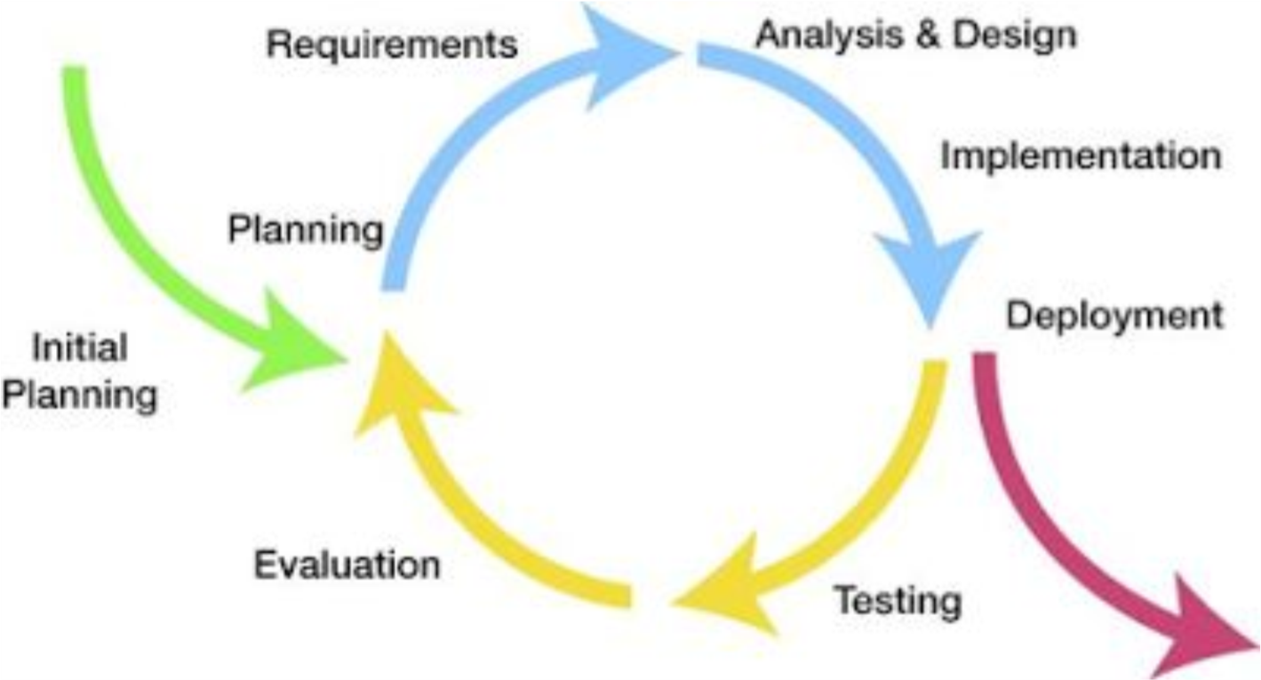
performingapproach.
Figure 1. Iterative Model of the Study
- Initial Planning – The initial planning phase marks the beginning of the system development process. In this stage, the researchers identified the main problem that the study intends to address. The traditional method of measuring calamansi juice yield involves physically extracting juice from each calamansi using a knife and standard syringe, which is a destructive and time-consuming process. This limitation motivated the researchers to explore a data-driven approach that could estimate juice yield from observable physical characteristics, specifically calamansi weight and size without damaging the calamansi. During this phase, the objectives of the research were clearly defined, and the feasibility of comparing three regression algorithms on the collected calamansi dataset was established.
- Planning – The planning phase involves organizing the activities required to complete the project successfully. During this stage, the researchers developed a structured timeline outlining the tasks needed to implement the proposed system. Key activities identified in this phase included collecting and measuring calamansi samples, designing the system architecture, implementing data preprocessing steps, training all three regression models, and conducting system testing. The researchers also identified the hardware and software tools required for system development, including the digital kitchen scale for weight measurement and the standard syringe used for juice volume measurement during data collection.
- Requirements – The requirements phase focuses on identifying the functional and non-functional requirements. Functional requirements include allowing users to enter the total weight in kilograms, size breakdown, and preferred algorithm; processing the inputs through the selected regression model; displaying the predicted juice yield; and showing a comparison of all three algorithm predictions.
- Analysis and Design – The analysis and design phase focuses on developing the system architecture and designing the workflow of the system. Several system diagrams were created to illustrate how the system components interact. The researchers also designed the data preprocessing pipeline, which includes input validation, weighted average size score computation, and prediction modeling for all three algorithms.
- Implementation – The implementation phase involves translating the system design into an actual working system. The system was developed using Python. scikit-learn was used to implement all three regression algorithms. Simple and Multiple Linear
Regression were implemented using LinearRegression. Polynomial Regression (degree
2) was implemented using a Pipeline combining PolynomialFeatures and
LinearRegression. All three models were serialized using joblib as separate .pkl files. The Streamlit interface allows users to select which algorithm to use and displays a side-by-side comparison of all three predictions.
- Testing – Testing is conducted to verify that the developed system operates according to the defined requirements. White-box testing was conducted to verify individual functions including input parsing and prediction pipeline operation for all three models. Black-box testing assessed functional suitability, usability, performance efficiency, and reliability based on internationally recognized software quality characteristics. The performance of all three regression models was evaluated using Mean Absolute Error (MAE) and the coefficient of determination (R²).
- Deployment – Deployment refers to the process of making the system available for use by the intended users. In this study, the developed system was deployed through a Streamlit interface hosted on Streamlit Cloud, allowing users to access the prediction system through any modern browser without requiring local installation or technical setup.
- Evaluation – The evaluation phase assesses the overall performance of the system after testing and deployment. The researchers reviewed prediction results across all three algorithms and compared their metrics. If system performance was not satisfactory, adjustments were made including retraining models with different hyperparameters or refined data splits.

Table 6: Test Plan
Test Case | Description | Expected Result | Assessment
Input Validation  Test | Submit inputs with missing fields, zero weights, and invalid size counts. | The system displays descriptive error messages and does not generate a prediction. | Verify that all invalid inputs are caught before reaching any regression model.
Prediction Accuracy Test | Submit known calamansi sample data and compare system output with actual measured juice yield. | Predicted values fall within acceptable error margins (R² ≥  0.80 for the best model). | Evaluate prediction accuracy using R² and MAE for all  three models.
Model Integration  Test | Submit the same input to all three algorithms and verify that individual predictions are computed correctly. | End-to-end pipeline processes inputs and returns a prediction without errors. | Verify that Simple  LR, Multiple LR, and Polynomial  Regression each produce independently correct outputs.
Interface Test | Test the Streamlit web application interface for | Interface responds to user inputs within  1–2 seconds and | Verify that the interface responds to user inputs within 1-2 seconds and
usability and displays results displays results
responsiveness. clearly. clearly.

The test plan is designed to validate every stage of the prediction workflow. Input validation testing ensures the system correctly handles missing or out-of-range data before it reaches the regression model. Prediction accuracy testing confirms that the model produces reliable juice yield estimates by comparing system outputs against actual measured values from the dataset. Integration testing verifies the complete data pipeline from user input through preprocessing and model inference to output display. Interface testing validates usability, ensuring that results are displayed clearly and without delay. This comprehensive testing approach ensures the system operates efficiently and meets user expectations.
Version Date: Aug. 27, 2026 Version no. 2

Table 7: Security Plan
Security Measure | Description | Purpose
User Authentication | All users must log in with credentials. Administrators have a separate login path. | Use secure login credentials to enforce role-based access control.
Password Hashing | All passwords are hashed using SHA-256 before storage. Plain text passwords are never stored. | Ensures user passwords remain secure even if the database is accessed.
Model Protection | Regression model .pkl files are stored server-side and are not accessible via the UI. | Prevents unauthorized access to or manipulation of the prediction model.
Input Sanitization | All user inputs are validated and sanitized before being passed to the model. | Prevents injection attacks and protects against erroneous model inputs.
The security plan reinforces the protection of both user data and model assets. Since the system processes agricultural data, data privacy measures ensure that no personal information is stored or transmitted beyond what is necessary for the system to function. Model protection mechanisms maintain the integrity of all three regression models by preventing direct access to their parameters through the interface. Input sanitization protects the system against malformed data entries that could produce incorrect predictions or cause processing errors.

Table 8: Maintenance Plan
Maintenance Activity | Description | Frequency
Dataset Update | Add new calamansi samples from additional harvest seasons to improve model  training. | Periodically, per harvest season.
Model Retraining | Retrain all three regression models with updated data to maintain prediction accuracy and verify which algorithm remains best-performing. | When the dataset is expanded or prediction error exceeds acceptable threshold.
System Fixing | Improve system performance, fix bugs, and update Python library dependencies. | As needed, upon discovery of issues or quarterly dependency review.
The maintenance plan ensures the long-term reliability of the prediction system. Periodic dataset updates allow all three regression models to adapt to calamansi variations across different harvest seasons, improving prediction accuracy over time. Model retraining ensures that predictions remain accurate as the dataset expands, accounting for differences in calamansi characteristics across growing conditions. System fixing addresses software issues that may arise during operation, while dependency updates keep the application compatible with the latest versions of its core libraries. This proactive maintenance strategy ensures the system remains robust and accurate in real-world, continuous-use scenarios.

4.2.2 GANTT CHART
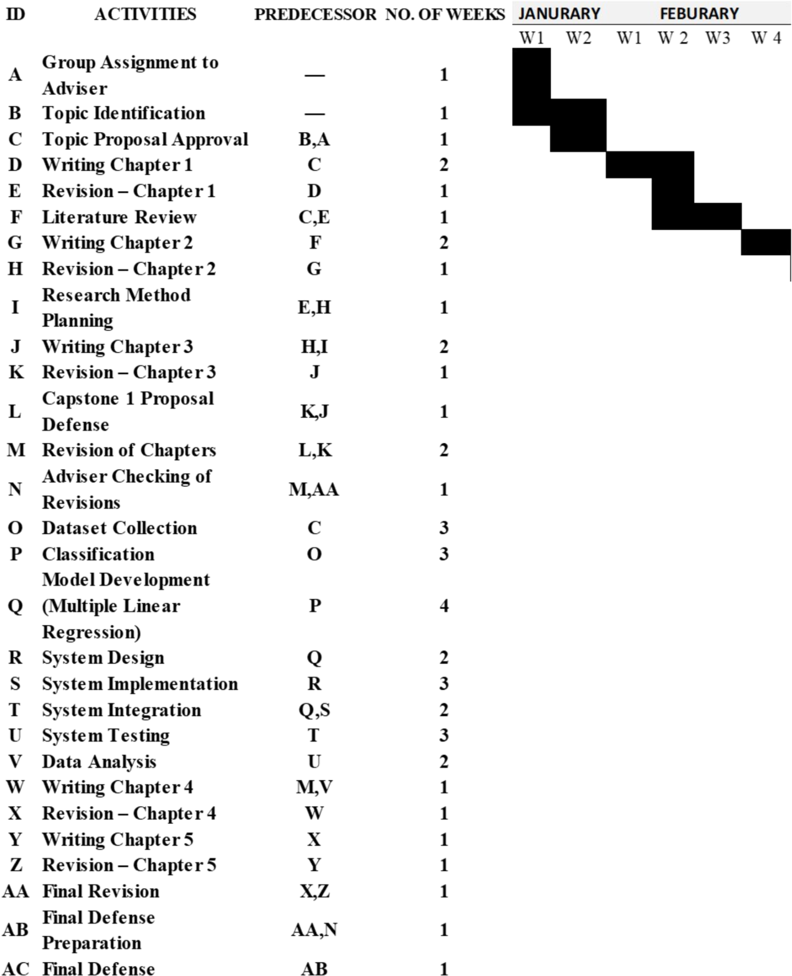
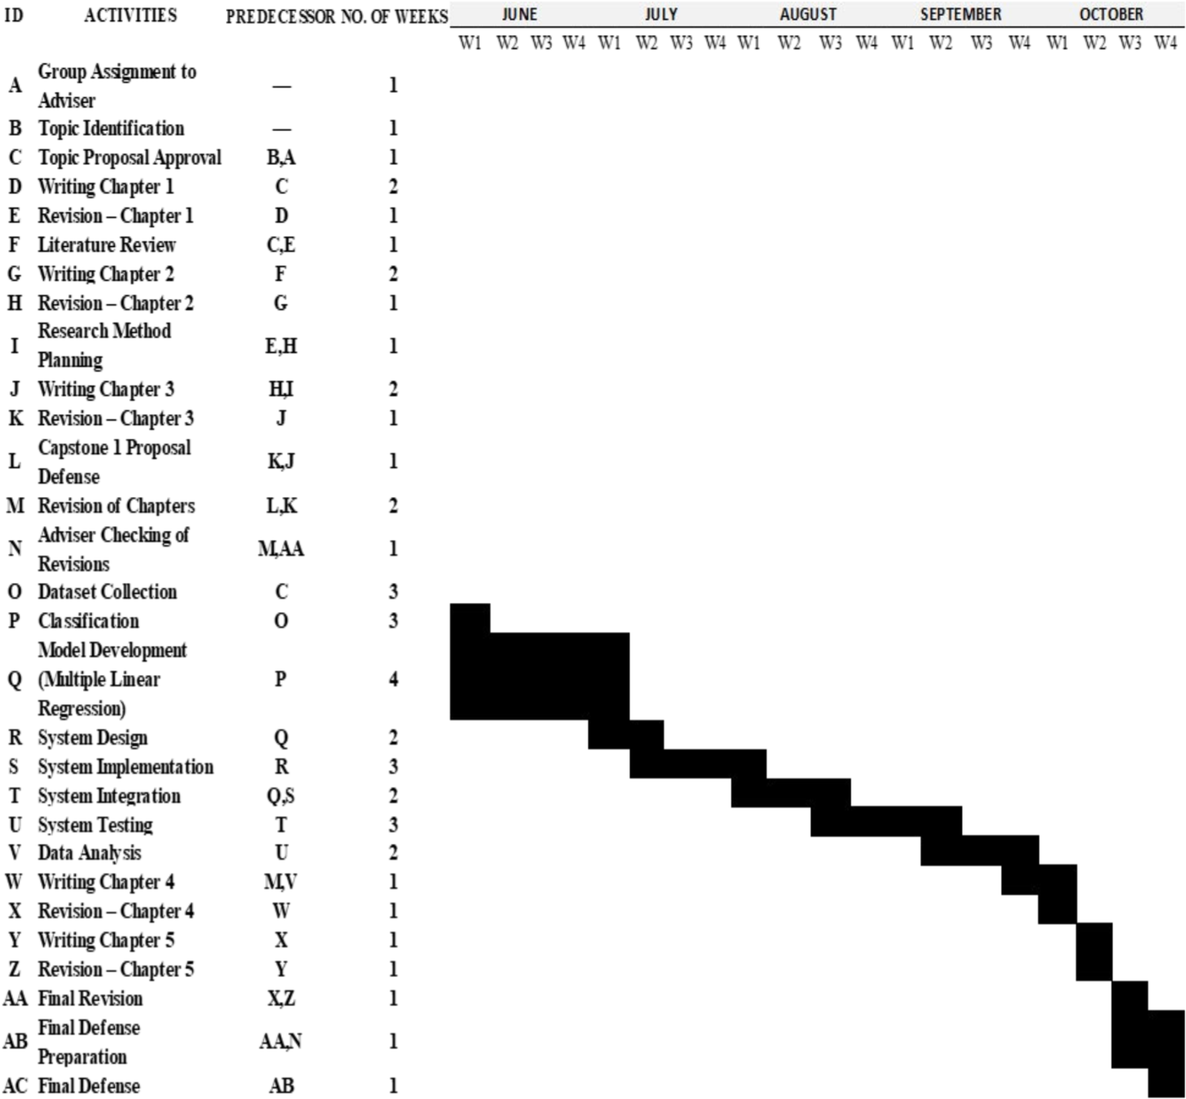

PERT CHART
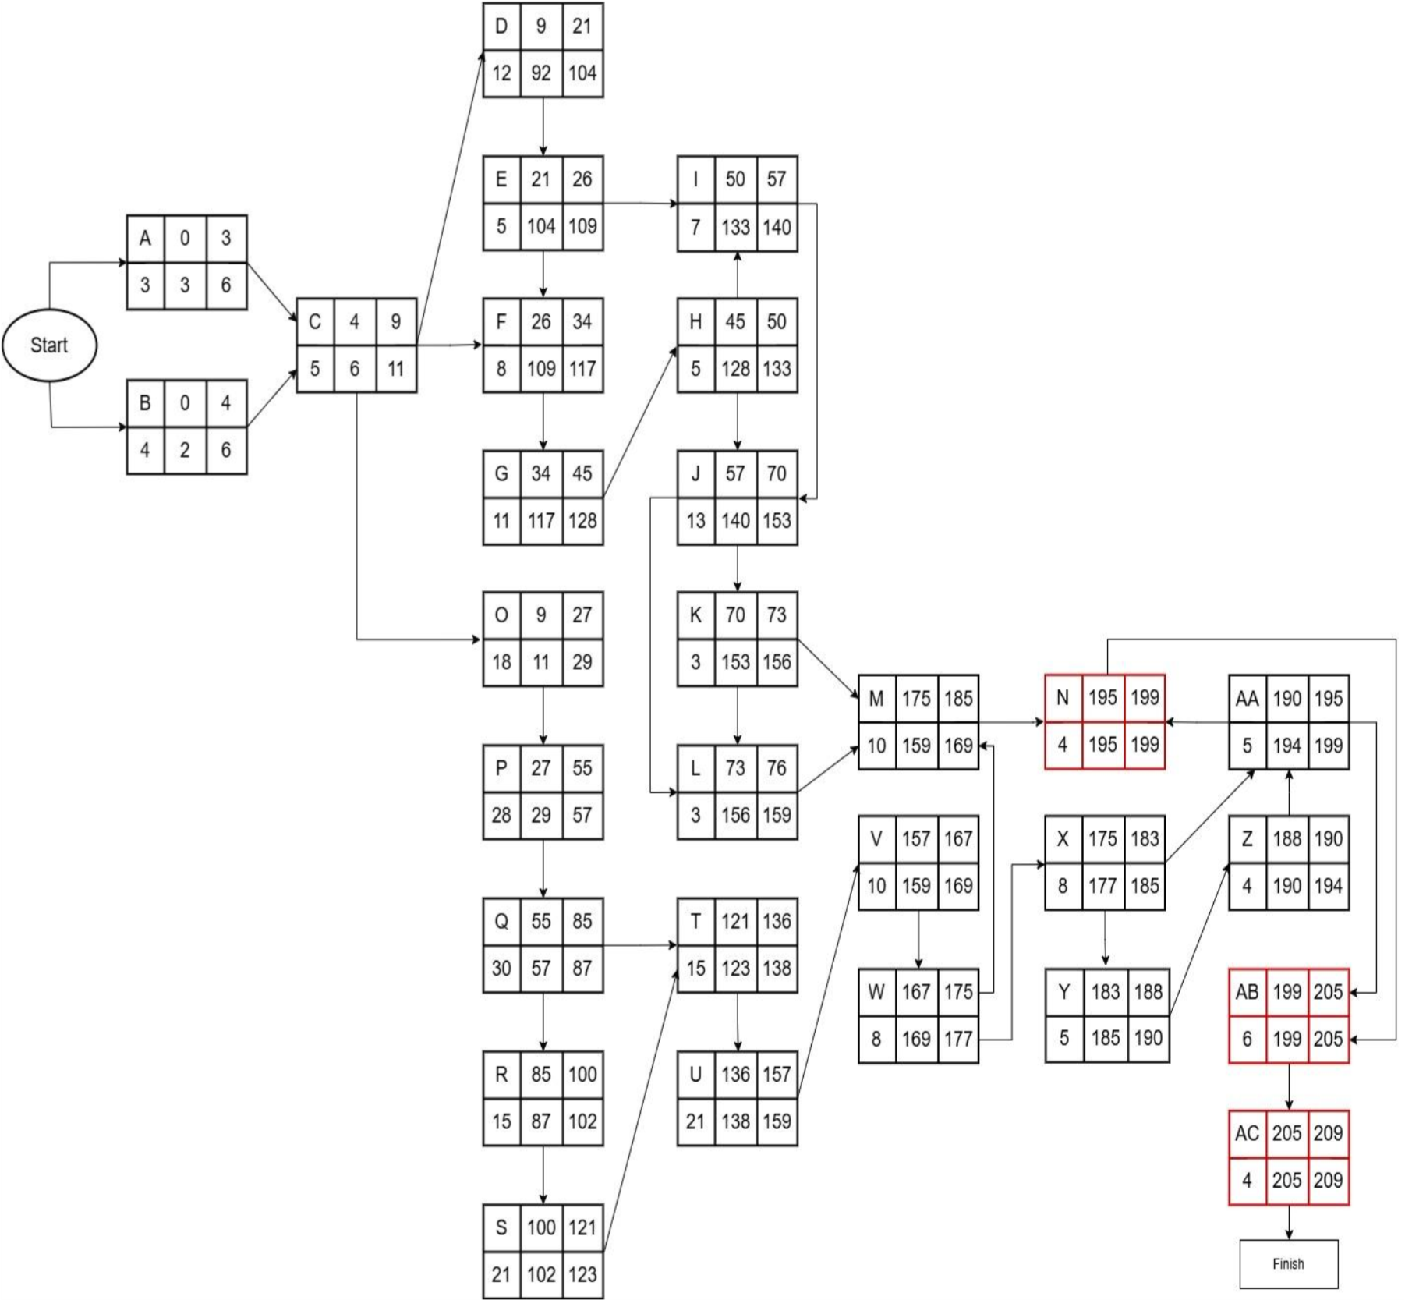
Critical Path: N,AB, AC
Figure 2. PERT Chart of the Proposed System

Table 9: Activity List |  | Regressions
ID | Activity | Start Date | End Date | Duration (Weeks) | Predecessor
A | Group Assignment to Adviser | 01/20/2026 | 01/22/2026 | 1
B | Topic Identification | 01/23/2026 | 01/26/2026 | 1 | A,O
C | Topic Proposal Approval | 01/27/2026 | 01/31/2026 | 1 | B
D | Writing Chapter 1 | 02/01/2026 | 02/12/2026 | 2 | C
E | Revision – Chapter 1 | 02/13/2026 | 02/17/2026 | 1 | D
F | Literature Review | 02/18/2026 | 02/25/2026 | 1 | E
G | Writing Chapter 2 | 02/26/2026 | 03/08/2026 | 2 | F
H | Revision – Chapter 2 | 03/09/2026 | 03/13/2026 | 1 | G
I | Research Method Planning | 03/14/2026 | 03/20/2026 | 1 | E,H
J | Writing Chapter 3 | 03/21/2026 | 04/02/2026 | 2 | H
K | Revision – Chapter 3 | 04/03/2026 | 04/05/2026 | 1 | J
L | Capstone 1 Proposal Defense | 04/06/2026 | 04/08/2026 | 1 | E,H,K
M | Revision of Chapters 1–3 | 04/09/2026 | 04/18/2026 | 2 | L
N | Adviser Checking of Revisions | 04/19/2026 | 04/22/2026 | 1 | M
O | Dataset Collection | 04/23/2026 | 05/10/2026 | 3 | C

Development of a Web-Based Calamansi Juice Yield Prediction System Using

P | Classification of size | 05/11/2026 | 06/05/2026 | 3 | O
Q | Model Development  (Three Linear  Regression) | 06/06/2026 | 07/05/2026 | 4 | P
R | System Design | 07/06/2026 | 07/20/2026 | 2 | Q
S | System Implementation | 07/21/2026 | 08/10/2026 | 3 | R
T | System Integration | 08/11/2026 | 08/25/2026 | 2 | S
U | System Testing | 08/26/2026 | 09/15/2026 | 3 | T
V | Data Analysis | 09/16/2026 | 09/25/2026 | 2 | U
W | Writing Chapter 4 | 09/26/2026 | 10/03/2026 | 1 | M
X | Revision – Chapter 4 | 10/04/2026 | 10/07/2026 | 1 | W
Y | Writing Chapter 5 | 10/08/2026 | 10/12/2026 | 1 | X
Z | Revision – Chapter 5 | 10/13/2026 | 10/16/2026 | 1 | Y
AA | Final Revision | 10/17/2026 | 10/21/2026 | 1 | X,Z
AB | Final Defense Preparation | 10/22/2026 | 10/27/2026 | 1 | AA
AC | Final Defense | 10/28/2026 | 10/31/2026 | 1 | AB

CONTEXT DIAGRAM
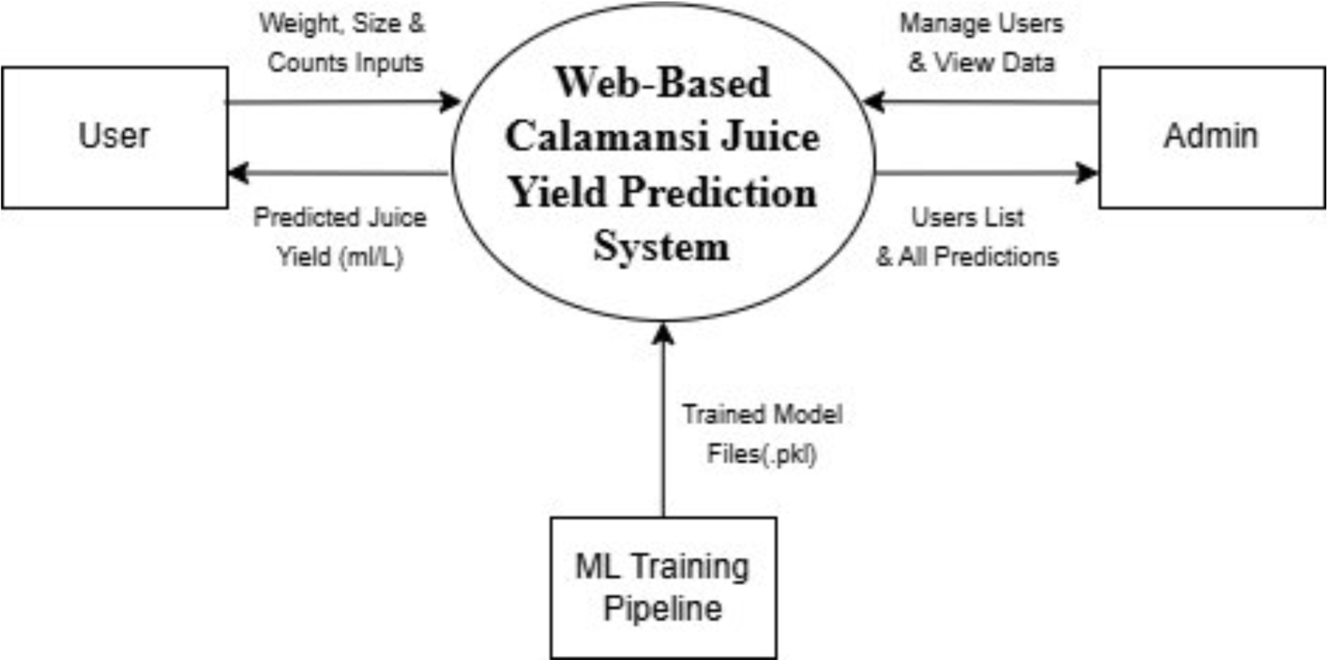
Figure 3. Context Diagram of the Current System

DATA FLOW DIAGRAM
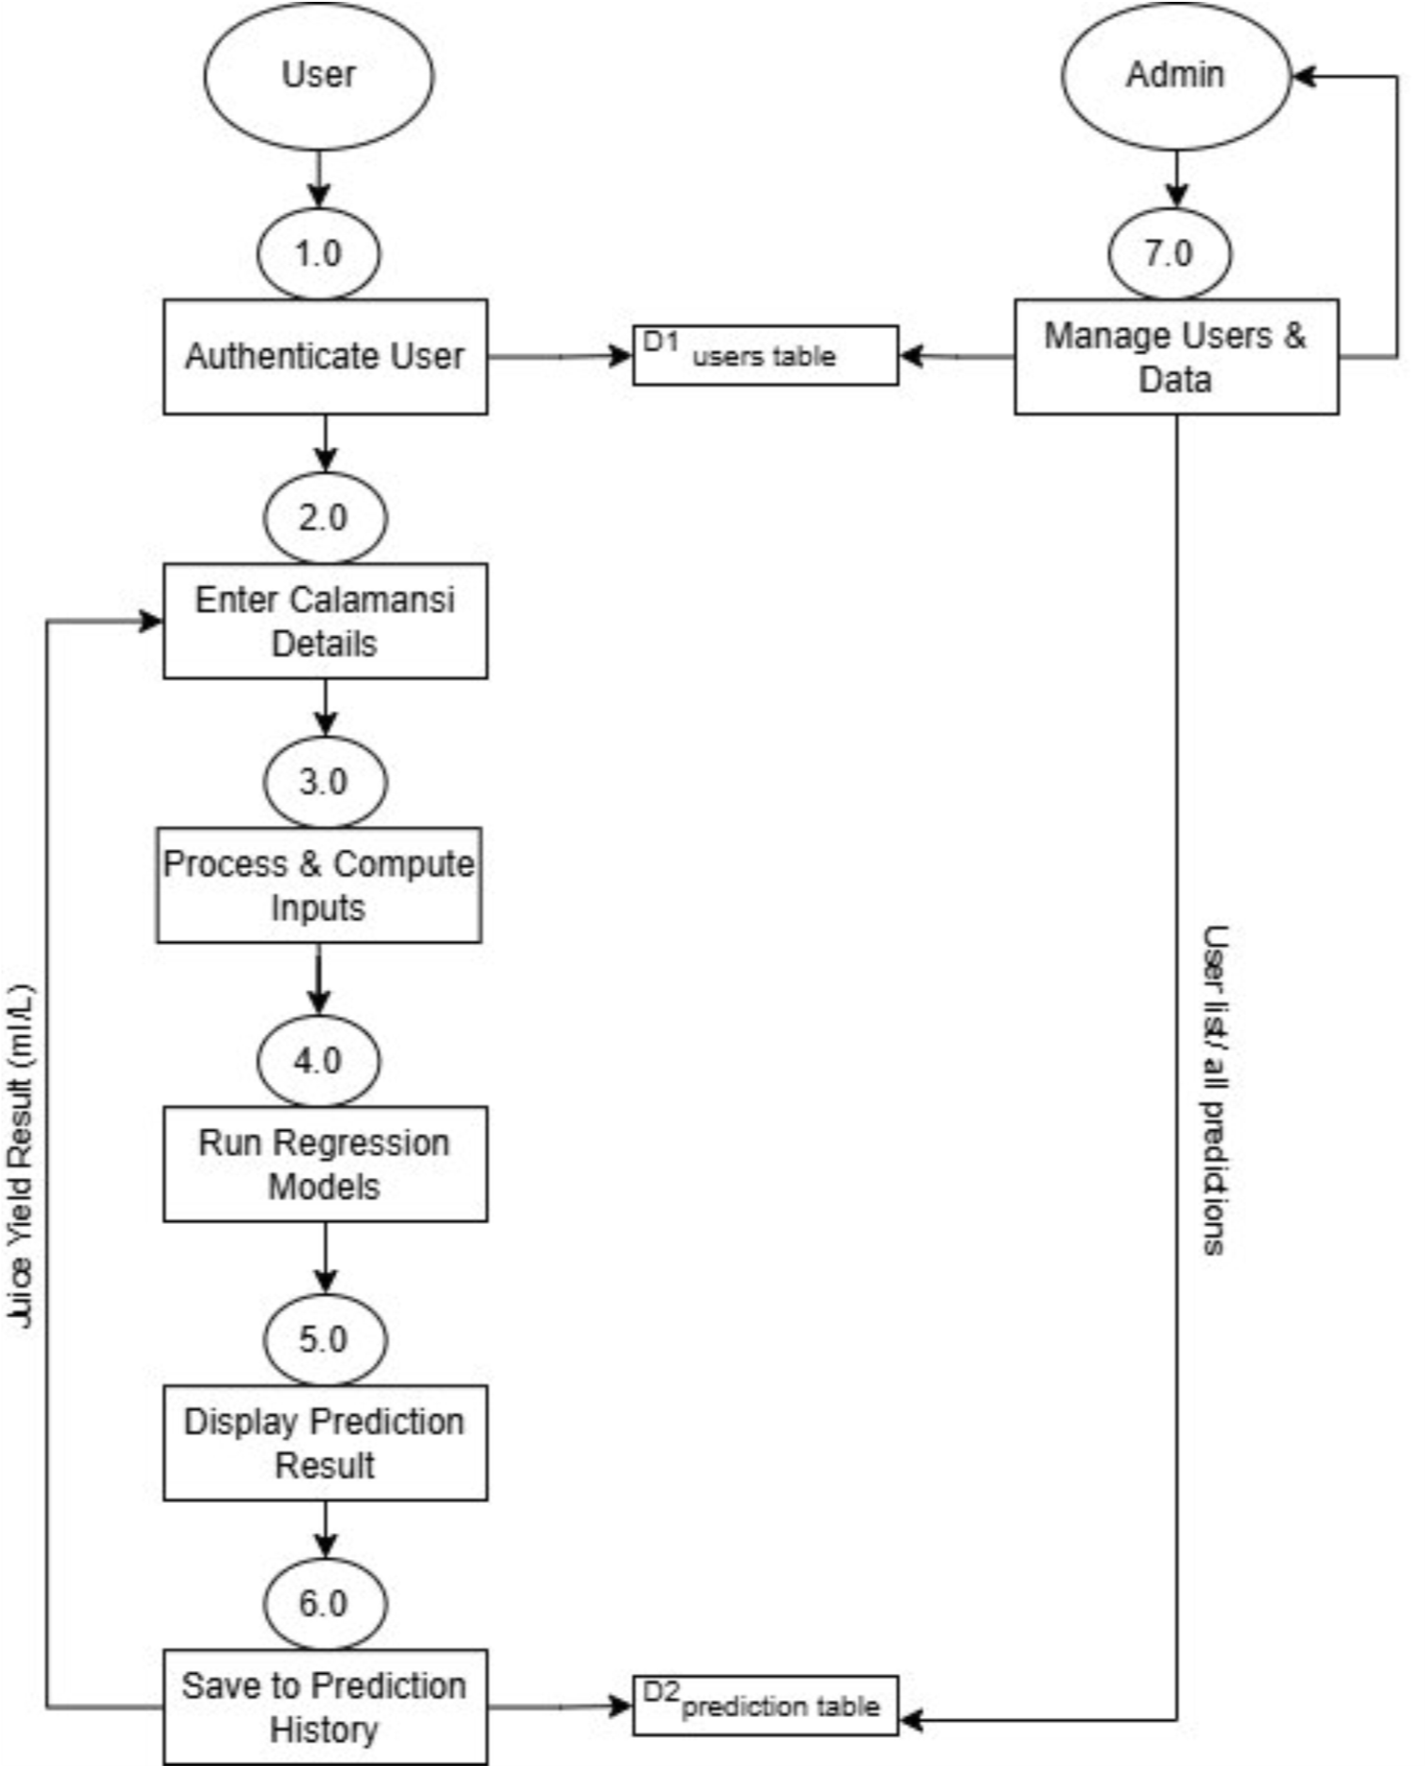
Figure 4. Data Flow Diagram of the Study

SYSTEM FLOWCHART
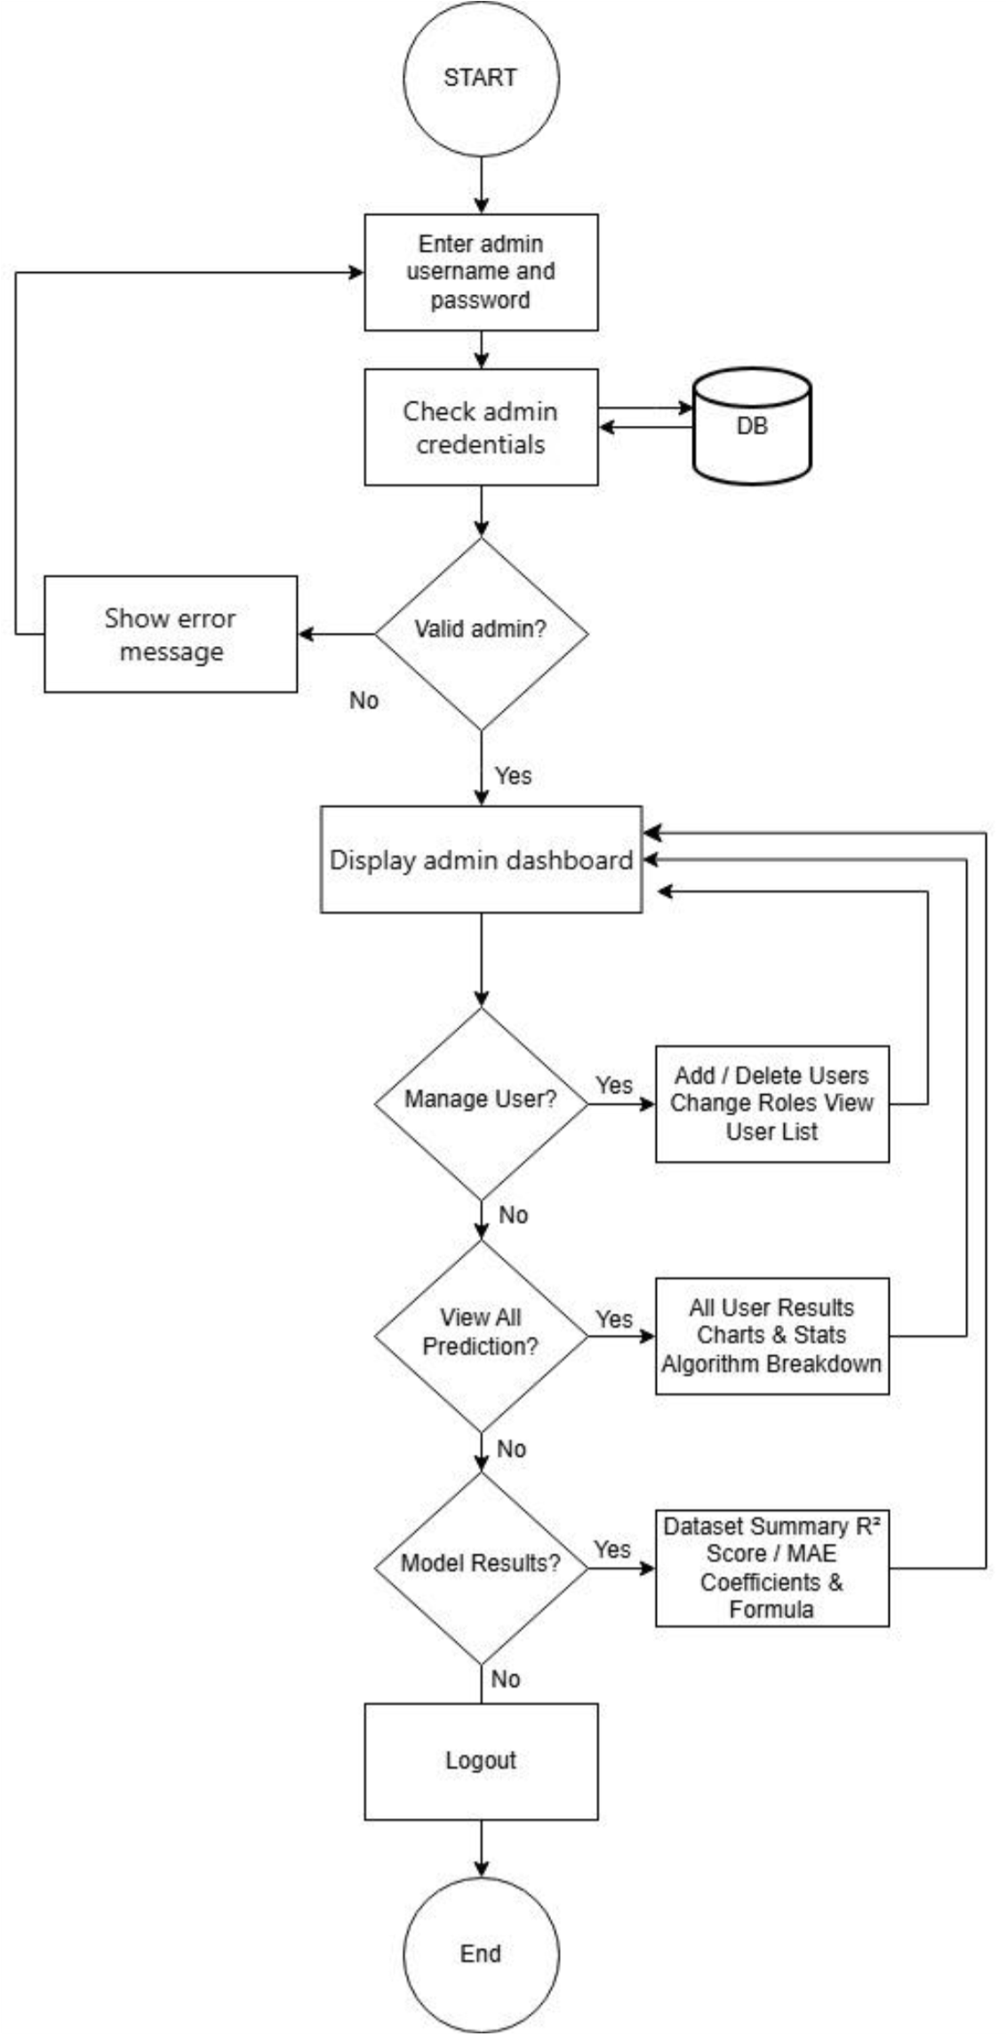
Figure 5. System Flowchart for Admin of the Proposed System

SYSTEM FLOWCHART
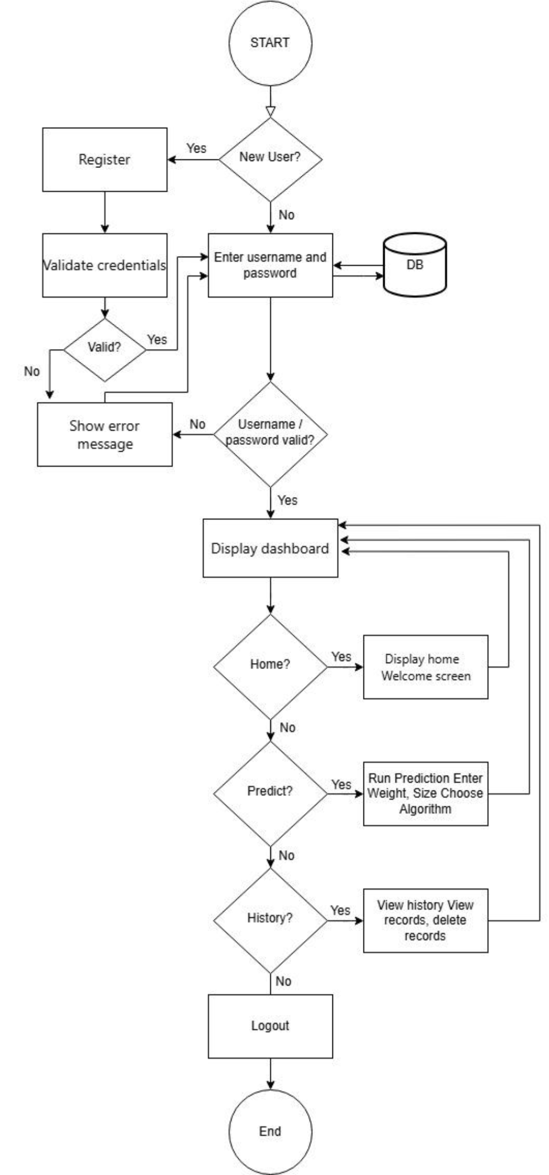
Figure 5.1 System Flowchart for User of the Proposed System

Entity Relationship Diagram
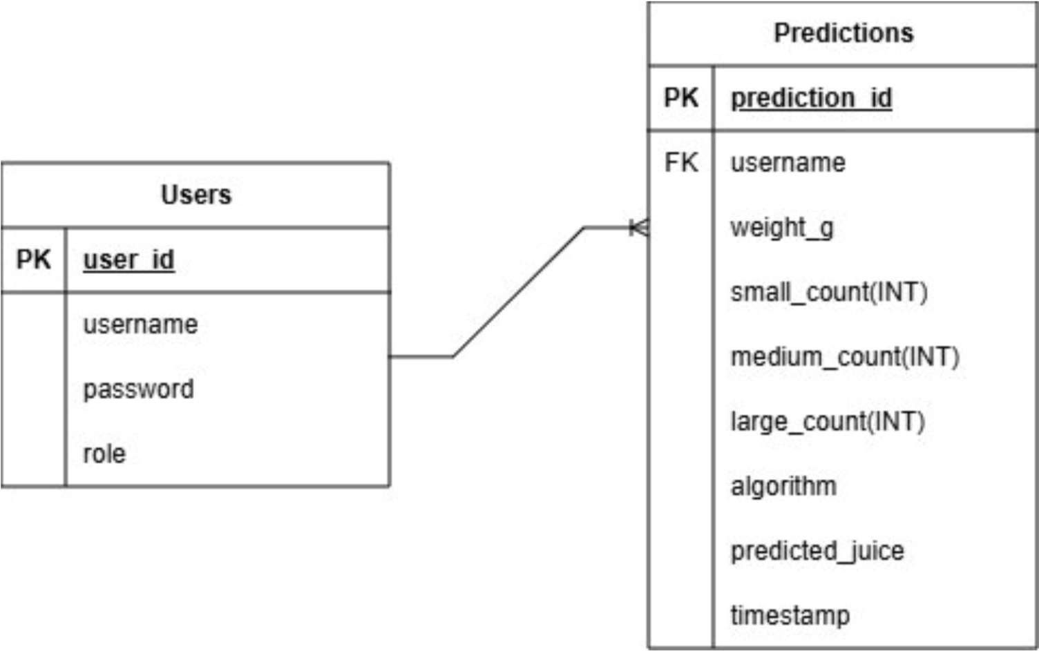
Figure 6. ERD of the Study

Database Normalization
The proposed Web-Based Calamansi Juice Yield Prediction System uses two database tables: the Users table to manage account credentials and roles, and the Predictions table to store all prediction records submitted by users. To ensure data integrity, prevent redundancy, and optimize data operations, both tables were normalized to Third Normal Form (3NF). Normalization organizes the system data related to user credentials, roles, prediction inputs, and prediction outputs into structured tables, improving query efficiency and supporting accurate system operation and record keeping.

Normal Form | Requirements | Compliance Actions
1NF | Atomic attributes; no repeating  groups. | The Predictions table contains single-value attributes: id, username, weight_g, small_count, medium_count, large_count, algorithm, predicted_juice, timestamp
2NF | Full primary key dependency. | All attributes depend entirely on

Normalization Process

the primary key (id), ensuring no partial dependencies.
3NF No transitive dependencies. Attributes such as weight_g and
algorithm are directly related to the prediction id, with no indirect dependencies.

Normalized Schema
CREATE TABLE Users ( user_id INTEGER PRIMARY KEY AUTOINCREMENT, username TEXT NOT NULL UNIQUE, password TEXT NOT NULL,
role TEXT CHECK(role IN ('admin', 'user')) NOT NULL
);
CREATE TABLE Predictions (
id INTEGER PRIMARY KEY AUTOINCREMENT, username TEXT NOT NULL, weight_g REAL NOT NULL, small_count INTEGER NOT NULL, medium_count INTEGER NOT NULL, large_count INTEGER NOT NULL, algorithm TEXT NOT NULL,
predicted_juice REAL NOT NULL,
timestamp TEXT NOT NULL,
FOREIGN KEY (username) REFERENCES Users(username)
);

Verification and Benefits
Tested: Sample data was inserted and queried successfully. Normalization ensures that updates to individual prediction records remain consistent and do not introduce redundancy across user accounts.
Query Efficiency: Retrieving records for evaluation is fast and reliable using simple queries such as: SELECT * FROM Predictions WHERE algorithm = 'Polynomial
Regression (d=2)';
Data Integrity: Each prediction has a unique ID, preventing duplication and ensuring consistent records across all three algorithm logs.
Scalability: The normalized table can handle growth as more predictions are added by users over time without redundancy or performance issues.
Discussion: Normalizing the Predictions table ensures that all user prediction records remain clean, consistent, and free of redundant data. This is critical for a system that logs predictions from three different algorithms, as it allows administrators to query and analyze algorithm usage patterns efficiently while maintaining fast data retrieval.

Use Case
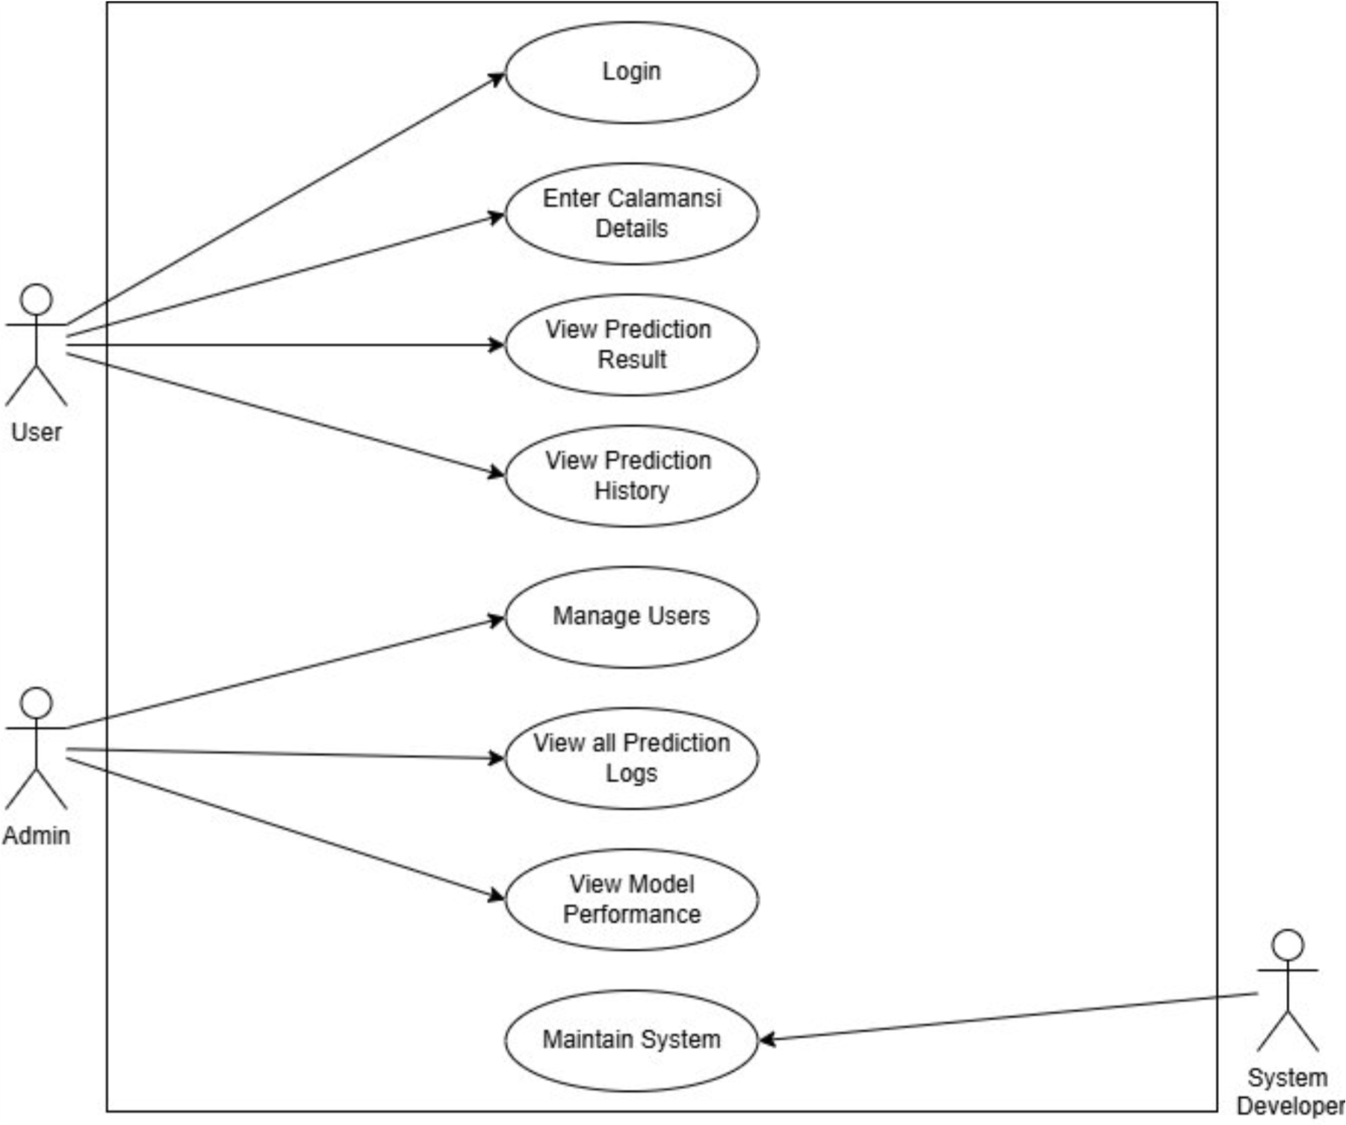
Figure 7. Use Case of the Study
The diagram shows that the user can perform key system functions starting with entering the total weight and size distribution (small, medium, large counts) of their calamansi batch and selecting a preferred prediction algorithm, which together serve as the primary inputs for the prediction system. Once the inputs are submitted, the system validates the data, computes a weighted average size score, and passes the processed inputs to the selected regression model to predict juice yield in real time. All three algorithm predictions are displayed simultaneously for comparison.
The user can view the predicted juice yield in milliliters and liters and use the results to inform production planning and pricing decisions. This diagram effectively highlights the workflow of the system and the essential functionalities accessible to the user, emphasizing algorithm selection, real-time prediction, and transparent comparison of results.

4.3 Description of the Prototype
The prototype developed in this study is a Web-Based Calamansi Juice Yield Prediction System built using Python and Streamlit. The system trains and compares three regression models to estimate juice yield based on two observable physical characteristics of the calamansi: weight and size category.
The main objective of the prototype is to provide a non-destructive and automated method for predicting calamansi juice yield without manually squeezing every calamansi. The prototype is composed of hardware and software components that work together to perform input processing, prediction modeling, and result display.
- Input Module – The system presents users with an input form consisting of three primary fields: (1) total batch weight in kilograms, (2) quantity breakdown by calamansi size small, medium, and large, and (3) the preferred prediction algorithm (Simple Linear Regression, Multiple Linear Regression, or Polynomial Regression degree 2). Input validation is applied before submission to ensure that all fields are filled and that values fall within acceptable ranges.
- Data Preprocessing and Feature Encoding – Each submitted input is preprocessed before being passed to the regression models. The total weight entered in kilograms is converted to grams. A weighted average size score is computed from the calamansi counts using the formula: avg_size = (1 × small + 2 × medium + 3 × large) / total_count.
For Simple Linear Regression, only the weight in grams is used as input. For Multiple Linear Regression and Polynomial Regression, both weight and the computed average size score are used. This encoding step replicates the preprocessing applied during model training, ensuring consistency between training and inference.
- Machine Learning Model – Three regression models trained on the collected calamansi samples are used. (a) Simple Linear Regression uses only weight as a predictor. It achieved R² = 0.8135 and MAE = 0.6800 ml. (b) Multiple Linear Regression uses weight and size as predictors. It achieved R² = 0.8112 and MAE = 0.6861 ml. (c) Polynomial Regression (degree 2) uses weight, size, weight², weight×size, and size² as predictors. It achieved the best performance with R² = 0.8197 and MAE = 0.6692 ml. All three models are stored as separate .pkl files and loaded at runtime for real-time predictions.
- System Interface – The system is deployed through a Streamlit interface hosted on Streamlit Cloud, presenting results in real time. Upon submission of the inputs, the system displays the predicted juice yield in milliliters. The interface was designed for simplicity, requiring no prior technical knowledge from the user, and is accessible through any modern browser without requiring local installation. The system also provides a prediction history page where users can review their past submissions, and an administrator dashboard for managing users and monitoring model performance.

Project Title
Development of a Web-Based Calamansi Juice Yield Prediction System Using
Multiple Linear Regression

Project Description
This project develops a web-based system that predicts the juice yield of calamansi based on observable physical characteristics specifically weight and size category by training and comparing three linear regression algorithms: Simple Linear Regression, Multiple Linear Regression, and Polynomial Regression (degree 2). The system provides real-time predictions through a Streamlit web application accessible via any modern web browser.
Objectives:
- To collect and categorize calamansi samples into three size groups small, medium,and large based on defined physical criteria, and record the individual weight (in grams) of each sample using a calibrated digital scale, within the data gathering phase of the study.
- To measure and record the actual juice yield (in milliliters) of each categorizedcalamansi sample using standard extraction methods during the experimentation phase.
- To develop, train, and compare three linear regression models Simple Linear
Regression (weight only), Multiple Linear Regression (weight and size), and Polynomial Regression of degree 2 (weight, size, and their squared and interaction terms) using an 80:20 training-to-test split, targeting an R² score of at least 0.80 and the lowest achievable Mean Absolute Error (MAE) for the best-performing model, by the end of the model development phase.
- To design and implement a fully functional web-based prediction system usingPython and Streamlit that accepts user inputs for total weight and size distribution of a calamansi batch, allows selection of a prediction algorithm, displays the predicted juice yield in milliliters and liters, and shows a side-by-side comparison of all three algorithm results, by the end of the system development phase.
- To evaluate the prediction accuracy of all three regression models using R² and MAE metrics on the held-out test set, and to assess the system's performance efficiency by measuring the average response time of the web application (target: under 2 seconds per prediction) and confirming stable deployment on Streamlit Cloud, during the evaluation phase of the study.
Version Date: Aug. 27, 2026 Version no. 2
Module | Specific  Objectiv e/s | Hardw are  Requir ements | Softwa re  Requir ements | Durati on  (Days) | Perso n  Involv ed | Estimat ed  Budget  (PHP) | Risk  Assessme nt and  Mitigatio n  Strategie s | Evaluati on and  Monitori ng
Data  Collecti on | Collect and sort  calamans i samples  by size and weight. | Digital kitchen scale,  standar d syringe | Micros oft  Excel | 10  Days | Resear cher | 2000 | Inconsist ent size  assessme nt;  mitigate by  defining  clear size categorie s (small  <10g, medium  10-14g, large >14 g) before  collection begins. | Inspect dataset for  complete ness and  verify no missing values before model training.
Juice  Yield  Measur ement | Measure actual juice  yield  (mL) of each  sample using a  knife and standard syringe  to serve as  ground truth | Knife  Standa rd syringe | None | 10  Days | Resear cher | 300 | Measure ment  inaccurac ies;  mitigate  by using  standardi zed  extraction  methods and  repeated measure ments. | Compare recorded juice  yield  values and  verify  measure ment  consisten cy across samples.

Table 10: Implementation Plan Table

 | data.
Data  Preproc essing and  Model  Develo pment | Encode size as  numeric, split  dataset  80:20, and train and  compare all three  regressio n models achievin g R² ≥  0.80. | Laptop  /  Person al  Compu ter  (min.  8GB  RAM) | Python, scikitlearn,  pandas,  NumPy,  Jupyter  Notebo ok | 20  Days | Resear cher /  Devel oper | 0 | Model  underfitti ng;  mitigate by  reviewing feature  selection and  trying  polynomi  al  features if linear models  underperf orm. | Evaluate all three models  using R² and  MAE on the test set and  compare against target metrics.
Web  Applica tion  Deploy ment | Develop and  deploy a  Streamlit web  applicati on that  accepts user  inputs and  displays  real-time juice  yield  predictio ns. | Laptop  /  Person al  Compu ter,  stable  interne  t  connec tion | Python,  Streaml it, VS  Code | 5 Days | Resear cher /  Devel oper | 0 | System errors or  incorrect output  display;  mitigate by  debuggin g and  testing the  applicatio n before  deployme nt. | Conduct system testing and  verify  that all  predictio  n outputs are  correct and  displayed properly.

4.4 Ethical Considerations

Declaration of No Conflict of Interest
The researchers affirm that this study was developed purely for academic purposes as part of the requirements for the Bachelor of Science in Information Technology program at Leyte Normal University. No financial assistance, sponsorship, or external influence from any company, organization, or individual was involved in the design, development, or evaluation of the system.
The study was carried out independently to ensure that the results remain objective and unbiased. The researchers also confirm that there are no personal, professional, or financial conflicts of interest that could affect the integrity of the research.
This study does not involve interviews, surveys, or any form of direct human data collection that requires sensitive personal information. No names, contact details, addresses, or other private identifiers were gathered or stored during the entire process.
The focus of the research is strictly on calamansi physical measurements such as weight, size, and juice yield, as well as the development of a regression-based prediction system. Any system testing or interaction is limited to using the application for prediction purposes only and does not require users to disclose personal or
confidential information.
Because of this, the risk of privacy issues, identity exposure, or data misuse is very minimal. The researchers ensured that all procedures remain ethical, transparent, and centered on academic integrity and data privacy.

Confidentiality and Data Protection Plan (Data Privacy Act Compliant)
This study fully observes the Data Privacy Act of 2012 (Republic Act No. 10173) to ensure that all data used in the research are properly protected, handled responsibly, and used only for legitimate academic purposes.
The system processes only non-personal agricultural data, specifically measurements of calamansi weight, size, and juice yield. It does not collect or store personal information such as names, addresses, contact numbers, or any form of sensitive personal identifiers. In cases where unintended personal data may appear during data collection, these are immediately removed or anonymized before storage to ensure that privacy is not compromised at any point.
All datasets, trained models, system logs, and evaluation outputs are securely stored in password-protected devices accessible only to the researchers. These files are used strictly for academic development, testing, and evaluation of the system and are not shared publicly without proper authorization or ethical approval. The researchers also apply data minimization principles by collecting only the information necessary for system training and evaluation. No unnecessary or unrelated data are retained. After the completion of the study, temporary files and unused data will be properly deleted or archived following institutional research guidelines.
For any user interaction or system testing, participants remain anonymous whenever possible. They are not required to provide personal information beyond what is needed to operate the system. All generated results and user interactions are treated with strict confidentiality. Through these measures, the study ensures that all data are handled with care, integrity, and responsibility while fully complying with ethical standards and legal requirements under the Data Privacy Act of 2012.

Dissemination Plan
The findings of this study will be formally presented to the faculty panel of
Leyte Normal University as part of the completion requirements for the Bachelor of Science in Information Technology program. A copy of the research output will also be submitted to the university’s research office and library for academic reference and future studies.
In addition, the developed web-based calamansi juice yield prediction system will be demonstrated to selected users such as farmers, vendors, and juice processors. This demonstration aims to show how the system can provide practical value by helping users estimate juice yield efficiently without the need for manual extraction.

