**John Russel Alvarez Discrete Structure #430 - CS 1201**

**BSCS DS 1C**

**Activity No. 2 Module 9 Finals**

**Direction:** Read the instruction and questions carefully. Upload the answer only in jpeg or pdf format. Use the sample filename – Act1_Module9_JABanocnoc.

1.Find the adjacency list of the graph below. Plot the list in a matrix

|  | **A** | **B** | **C** | **D** | **E** |
| --- | --- | --- | --- | --- | --- |
| **A** | **0** | **1** | **0** | **1** | **0** |
| **B** | **1** | **0** | **1** | **0** | **1** |
| **C** | **0** | **1** | **0** | **0** | **0** |
| **D** | **1** | **0** | **0** | **0** | **1** |
| **E** | **0** | **1** | **0** | **1** | **0** |

2. Get the adjacency list from the graph below. Put the list on the table provided.

| Vertex | Adjacency List |
| --- | --- |
| A | B, D |
| B | A, C, D |
| C | B |
| D | A, B |
| E |  |

**3. Find the adjacency list of the graph below. Plot the list in a matrix**

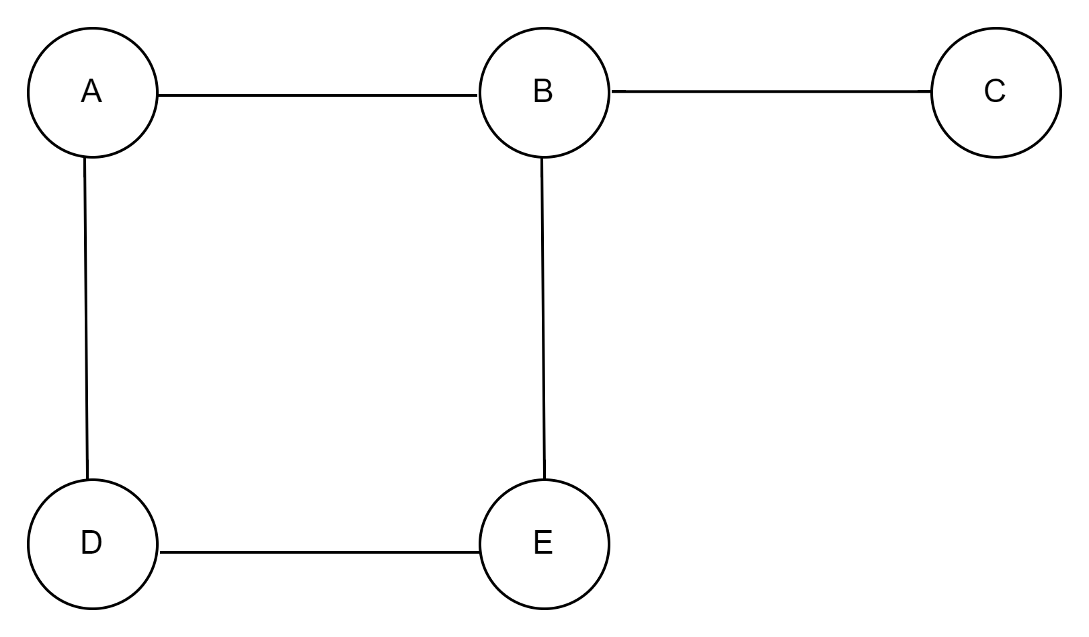

4. Get the vertices and adjacency list from the graph below. Put the list on a table.

| Vertex | Adjacency List |
| --- | --- |
| A | B, C, D |
| B | A |
| C | A, K |
| D | A, K, L |
| J | L, M |
| K | C, D, L |
| L | D, J, K |
| M | J |