NATIONAL UNIVERSITY
Manila

A Design of Dried Cacao Bean Defect and Size Detection for Automated Sorting

A Capstone Design Project
presented to the Faculty of Computer Engineering

In partial fulfillment of the requirements
For the conferral of the degree of
Bachelor of Science in Computer Engineering

Feliciano, Justin Mark P.
Gutierrez, Gino R.
Pandoy, Yeshuah Emmanuel B.
Relevo, Ralph Andrei P.
Sacramento, Marc Harry M.

Engr. Jeffrey T. Leonen

August 2026

TABLE OF CONTENTS
TABLE OF CONTENTS 2
LIST OF FIGURES 7
LIST OF TABLES 8
1 PROJECT BACKGROUND 10
1.1 Introduction 10
1.2 Community and Their Needs 11
1.3 The Problem 12
1.4 Objective of the Project 12
1.5 Significance of the Project 13
1.6 Scope and Limitation of the Project 13
1.7 Design Process 14
Figure 1: Design Process 14
1.8 Definition of Terms 16
2 DESIGN INPUTS 17
2.1 Design Constraints 17
2.2 Design Standards 18
2.3 Software Knowledge 19
2.4 Hardware Knowledge 20
3 PROJECT / SYSTEM DESIGN 22
3.1 Input-Process-Output 22
Figure 2: Input-Process-Output 22
3.2 System Flowchart 23
Figure 3. System Flowchart 23
3.3 Illustrative Diagram 24
Figure 4: Illustrative Diagram 24
3.4 Discussion of Design Alternatives 25
3.4.1 Design 1: Robotic Arm-Based Sorting System 25
Figure 5: Design Alternative 1 - Robotic-Arm-Based Sorting System 25
Figure 6: Design 1 Schematic Diagram 26
Table 1: Design 1 – Specifications of Materials to be used 26
Table 2: Design 1 Constraints – Economics 27
Table 3: Design 1 Constraints – Sustainability 29
Table 4: Design 1 Constraints – Functionality 31
Table 5: Design 1 Constraints – Manufacturability 32
Table 6: Design 1 Constraints – Power Consumption 32
3.4.2 Design 2: 5-Channel Sorting System 34
Figure 7: Design Alternative 2 – 5-Channel Sorting System 35
Figure 8: Design 2 Schematic Diagram 36
Table 7: Design 2 Constraints – Specifications of Materials to be Used 36
Table 8: Design 2 Constraints – Economics 37
Table 11: Design 2 Constraints – Manufacturability 41
Table 12: Design 2 Constraints – Power Consumption 42
3.4.3 Design 3: Conveyor-Based Sorting System 43
Figure 9: Design Alternative 3 - Conveyor-Based Sorting System 44
Figure 10: Design 3 Schematic Diagram 45
Table 13: Design 1 – Specifications of Materials to be Used 45
Table 14: Design 2 Constraints – Economics 46
Table 15: Design 3 Constraints – Sustainability 48
Table 16: Design 3 Constraints – Functionality 50
Table 17: Design 3 Constraints – Manufacturability 50
Table 18: Design 3 Constraints – Power Consumption 51
3.5 Software Design 53
3.5.1 Software Development Life Cycle 53
Figure 11: Iterative Software Development Model 53
3.5.2 System Algorithm 54
3.5.3 Data Flow Diagram 55
Figure 12: Context Diagram 55
4 Design Analysis and Trade-offs 57
4.1 Summary of Constraints 57
Table 19: Summary of Constraints 57
4.2 Design Tradeoff Analysis 58
Table 20: Preference and Importance of the Design Constraints 59
4.2.1 Trade-offs Analysis 1: Economic Cost 59
Table 21: Economic Cost of the Three (3) Proposed Designs 59
4.2.2 Trade-offs Analysis 2: Sustainability 61
Table 22: Sustainability of the Three (3) Proposed Designs 61
4.2.3 Trade-offs Analysis 3: Functionality 63
Table 23: Functionality of the Three (3) Proposed Designs 63
4.2.4 Trade-offs Analysis 3: Manufacturability 65
Table 24: Manufacturability of the Three (3) Proposed Designs 65
4.2.5 Trade-offs Analysis 3: Power Consumption 67
Table 25: Power Consumption of the Three (3) Proposed Designs 67
4.3 Normalized values of the Three Designs 68
Table 26: Normalized Values of the Three (3) Designs 69
Table 27: Scores of the Three (3) Proposed Designs 70
4.4 Designer’s Raw Ranking of the Three Designs 70
Table 28: Designer’s Raw Ranking for the Three (3) Proposed Designs 71
4.5 Influence of Design Trade-offs in the Final Design 71
4.6 Sensitive Analysis 72
4.6.1 Iteration 1: 10-9-8-7-8 Importance Weight Combination 72
Table 29: Iteration 1. 10-9-8-7-8 Importance Weight Combination 73
4.6.2 Iteration 2: 9-10-8-8-7 Importance Weight Combination 73
Table 30: Iteration 2. 9-10-8-8-7 Importance Weight Combination 73
4.6.3 Iteration 3: 8-9-10-8-7 Importance Weight Combination 73
Table 31: Iteration 3. 8-9-10-8-7 Importance Weight Combination 73
4.6.4 Iteration 4: 7-8-9-10-8 Importance Weight Combination 74
Table 32: Iteration 4. 7-8-9-10-8 Importance Weight Combination 74
4.6.5 Iteration 5: 8-7-8-9-10 Importance Weight Combination 74
Table 33: Iteration 5. 8-7-8-9-10 Importance Weight Combination 74
4.6.6 Iteration 6: 10-8-7-8-9 Importance Weight Combination 75
Table 34: Iteration 6. 10-8-7-8-9 Importance Weight Combination 75
4.6.7 Iteration 7: 9-7-10-8-8 Importance Weight Combination 75
4.6.8 Iteration 8: 8-10-9-7-8 Importance Weight Combination 76
Table 36: Iteration 8. 8-10-9-7-8 Importance Weight Combination 76
4.6.9 Iteration 9: 7-8-8-9-10 Importance Weight Combination 76
Table 37: Iteration 9. 7-8-8-9-10 Importance Weight Combination 76
4.6.10 Iteration 10: 8-9-7-10-8 Importance Weight Combination 77
Table 38: Iteration 10. 8-9-7-10-8 Importance Weight Combination 77
4.7 Summary of Sensitivity Analysis 77
Figure 13: Sensitivity Analysis Results using Radar Graph 78
REFERENCES 79
APPENDICES 80
APPENDIX 1. INTERVIEW REQUEST LETTER 80
APPENDIX 2. NEEDS ASSESSMENT REPORT 81
APPENDIX 3. DESIGN ALTERNATIVE 1: ROBOTIC ARM-BASED SORTING SYSTEM 83
APPENDIX 4. DESIGN ALTERNATIVE 2: 5-CHANNEL SORTING SYSTEM 83
APPENDIX 5. DESIGN ALTERNATIVE 1: ROBOTIC ARM-BASED SORTING SYSTEM 83

LIST OF FIGURES
Figure 1: Design Process 14
Figure 2: Input-Process-Output 22
Figure 3. System Flowchart 23
Figure 4: Illustrative Diagram 24
Figure 5: Design Alternative 1 - Robotic-Arm-Based Sorting System 25
Figure 6: Design 1 Schematic Diagram 26
Figure 7: Design Alternative 2 – 5-Channel Sorting System 35
Figure 8: Design 2 Schematic Diagram 36
Figure 9: Design Alternative 3 - Conveyor-Based Sorting System 44
Figure 10: Design 3 Schematic Diagram 45
Figure 11: Iterative Software Development Model 53
Figure 12: Context Diagram 55
Figure 13: Sensitivity Analysis Results using Radar Graph 78

LIST OF TABLES
Table 1: Design 1 – Specifications of Materials to be used 26
Table 2: Design 1 Constraints – Economics 27
Table 3: Design 1 Constraints – Sustainability 29
Table 4: Design 1 Constraints – Functionality 31
Table 5: Design 1 Constraints – Manufacturability 32
Table 6: Design 1 Constraints – Power Consumption 32
Table 7: Design 2 Constraints – Specifications of Materials to be Used 36
Table 8: Design 2 Constraints – Economics 37
Table 9: Design 2 Constraints – Sustainability 38
Table 10: Design 2 Constraints – Functionality 40
Table 11: Design 2 Constraints – Manufacturability 41
Table 12: Design 2 Constraints – Power Consumption 42
Table 13: Design 1 – Specifications of Materials to be Used 45
Table 14: Design 2 Constraints – Economics 46
Table 15: Design 3 Constraints – Sustainability 48
Table 16: Design 3 Constraints – Functionality 50
Table 17: Design 3 Constraints – Manufacturability 50
Table 18: Design 3 Constraints – Power Consumption 51
Table 19: Summary of Constraints 57
Table 20: Preference and Importance of the Design Constraints 59
Table 21: Economic Cost of the Three (3) Proposed Designs 59
Table 22: Sustainability of the Three (3) Proposed Designs 61
Table 23: Functionality of the Three (3) Proposed Designs 63
Table 24: Manufacturability of the Three (3) Proposed Designs 65
Table 25: Power Consumption of the Three (3) Proposed Designs 67
Table 26: Normalized Values of the Three (3) Designs 69
Table 27: Scores of the Three (3) Proposed Designs 70
Table 28: Designer’s Raw Ranking for the Three (3) Proposed Designs 71

PROJECT BACKGROUND

Introduction
The cacao industry is experiencing increasing global and domestic demand driven by rising consumption of chocolate and cocoa-based products, expanding applications in the food, cosmetics, and pharmaceutical industries, and the recognition of cacao as a health-related commodity. This growing demand has contributed to a global supply–demand gap in cocoa beans. In the Philippines, cacao production has gradually increased through government-supported expansion programs; however, production levels remain insufficient to meet demand, resulting in continued reliance on imports and limited export competitiveness. Production constraints such as smallholder farming structures, low yield efficiency, and post-harvest inefficiencies further affect overall industry output
Post-harvest processing of cacao involves multiple stages, with sorting and grading serving as a critical step that directly determines bean quality and market value. During this stage, cacao beans are manually evaluated based on external physical characteristics such as size, shape, and visible defects, and are subsequently classified into quality grades. However, this process is largely dependent on human visual inspection, making it inherently subjective and prone to inconsistency. Variations in worker judgment, fatigue during high-volume processing, and difficulty in identifying defective beans such as moldy, broken, or insect-damaged samples contribute to reduced grading reliability. Additionally, the manual process is time-consuming and labor-intensive, limiting scalability in high-production environments.
Recent studies have explored automated cacao bean classification systems using computer vision and deep learning approaches. A study from (Jhon et al., 2024) used YOLOv5 and CNN, with 469 training datasets to classify and evaluate cacao beans based on their internal characteristics, and it achieved precision of 0.879, recall of 0.883, and mean average precision at 50 of 0.902. Researchers from (Usman & Indrabayu, 2026) proposed a computer vision-based system using YOLOv11 model with 1,3378 datasets to detect accurately the physical appearance of defected cacao beans. Since they used a conveyor belt, the researchers implemented a method called Multi-scale Wiener Filter to improve the detection accuracy that is blurred due to the conveyor movement, and it achieved a precision of 0.986, a recall of 0.985, and a mAP at 50 of 0.979. Another study classified and detected defects on cacao beans using image processing techniques and machine learning, and their parameters were area, aspect ratio, texture entropy, and color uniformity. The classification was based on ASEAN Standard for Cocoa Bean (ASEAN Standard 34:2014), and it achieved a reliability rating of 96.2% (Natnat & Arboleda, 2026). A study from (Casindac et al., 2025) used YOLOv8 model to detect and classify defected and good dried cacao beans for the improvement of post-harvest quality control. They used 1,015 annotated datasets and it achieved a precision of 88.6%, recall of 91.5%, and mAP at 50 of 95.9%. Another study employed CNN deep learning algorithm to categorize the cacao beans into seven classes, which are good beans, bean clusters, fractured beans, flat beans, insect-damaged beans, germinated beans, and moldy beans. They used a high-quality camera and LED light strips for image acquisition, and the results were 99.38% training accuracy, precision of 99.59%, recall of 99.54%, and F1-score of 99.57% (Rosales & Pagcaliwagan, 2025).
Most existing implementations mentioned are developed under controlled imaging conditions and rely on fixed datasets, limiting their robustness in real-world processing environments. Furthermore, many systems remain at either software-only or prototype-level hardware implementation stages, with limited deployment of fully integrated real-time embedded sorting systems
Therefore, we have come up with “KakaoSort”, an embedded machine vision system for automated cacao bean defect detection and size sorting using a YOLO-based deep learning model. It aims to classify cacao beans based on visible external defects and size categories through image processing with a hardware-based sorting machine. The system uses a camera module and embedded processing unit to improve the consistency, speed, and accuracy of cacao bean classification and sorting. In addition, the prototype uses motor-driven actuators to separate cacao beans according to their predicted classification that provides automated solution for post-harvest cacao processing operations.

Community and Their Needs
The intended users of the proposed system are cacao processors, cacao enterprises, and cacao farmers involved in post-harvest cacao processing, particularly small-to-medium cacao businesses in the Philippines. Based on the needs analysis, one of the major challenges faced by cacao processors is the manual sorting of cacao beans during post-harvest processing. According to the interviewee, the process of cacao bean segregation and sorting, where workers separate defective beans and classify good beans into different sizes based on visual judgment, is highly labor-intensive, time-consuming, subjective, and costly.
One kilogram of cacao beans may contain around 700 to 1,000 beans based on a farm from Agusan Del Sur. Workers, therefore, require significant effort to process large quantities as they sort an average of 50 kilograms per day, which they process for 8 hours manually. The interviewee emphasized that sorting accuracy is inconsistent because the process relies heavily on human judgment, which is subjective and varies with the experience and familiarity of the worker. Each worker visually examines the beans one by one, checking for external defects such as mold, insect damage, and physical deformities, while simultaneously estimating bean size by eye to separate them into categories. As a result, cacao beans are not consistently classified into their proper sizes, especially when workers are handling large volumes over extended periods. This inconsistency negatively affects roasting quality when beans of different sizes are roasted together, since smaller beans tend to be overcooked while larger beans remain undercooked, which also affects the taste and quality consistency of cacao products and may lead to customer dissatisfaction and loss of business opportunities. Furthermore, the manual sorting process becomes a limitation to profitability when customers require urgent orders, forcing processors to either delay delivery and risk losing opportunities or sell unsorted beans at lower prices.
The interviewee expressed the need for a system that improves both speed and accuracy in cacao bean classification and sorting. Faster processing would allow enterprises to meet customer deadlines, increase productivity, reduce labor expenses, and accommodate larger orders. Improved classification accuracy would also help maintain consistent product quality, increase customer trust, and attract premium buyers who require properly sorted cacao beans. In terms of technology adoption, the interviewee showed positive acceptance toward a camera-based and AI-assisted cacao bean classification and sorting system. According to them, image processing can effectively assist in identifying physical defects and sorting beans according to size. However, the interviewee noted that some internal qualities, such as moisture content and fermentation level, may still require additional testing methods beyond image analysis alone.
Overall, the needs analysis indicates that cacao processors require an affordable, accessible, accurate, and automated cacao bean classification and sorting system that minimizes manual labor, improves consistency, and increases operational efficiency. These identified needs serve as the primary motivation for the development of the design project.

The Problem
Challenges in cacao bean defect detection and size sorting remain, particularly in small-to-medium processing operations that still rely on manual inspection and classification methods. Traditional cacao bean defect detection is still performed manually through human visual inspection, particularly small, clustered, mouldy, fractured, and flat beans. This process is highly labour-intensive, time-consuming, and dependent on worker experience, which often leads to subjective and inconsistent classification results. Inconsistent bean size sorting negatively affects product quality because beans of different sizes roast unevenly. Smaller beans may become over-roasted while larger beans remain under-roasted, resulting in inconsistent flavors, reduced product quality, and possible customer dissatisfaction.
Existing automated cacao bean classification studies using computer vision and deep learning have shown promising results; however, many systems are limited to controlled laboratory environments, software-only implementations, or non-real-time prototypes.

Objective of the Project
General Objective
The study aims to design and develop an embedded machine vision system for automated cacao bean defect detection and size sorting using a YOLOv8-based object detection model.
Specific Objectives
Considering the general objective, it intends to pursue the following:
- Develop a YOLOv8-based object detection model capable of detecting defective cacao beans, classifying them as acceptable or defective based on externally visible characteristics, and classifying beans into medium and large size categories, achieving at least:
  - Precision ≥ 89%
  - Recall ≥ 92%
  - Mean Average Precision at IoU 0.5 (mAP@0.5) ≥ 96%
- Integrate an automated logging system for recording, storing, and retrieving cacao bean records, along with generating statistics on the total number of beans processed and the distributions of defect and size categories.
- Design and evaluate an embedded machine vision system for cacao bean defect detection and size sorting by comparing it with traditional manual sorting methods in terms of:
a. Sorting accuracy ≥ 5 percentage points higher than manual sorting
b. Processing time for an equivalent batch of cacao beans reduced by at least 20% compared with traditional manual sorting.

Significance of the Project
This study aims to provide technological advancement and improve the efficiency of cacao bean classification and sorting for the following:
Cacao Processing Enterprises and Cooperatives. The study provides an automated approach to support large-scale cacao processing operations by improving consistency and standardization in bean classification and sorting. It may serve as a foundation for integrating AI-based grading systems into production workflows, reducing dependence on manual sorting and improving operational efficiency.
Cacao Farmers. The research offers cacao farmers a practical tool for improving post-harvest decision-making through automated cacao bean classification. This may help reduce losses due to manual sorting errors and support better grading outcomes, potentially increasing market value and income.
Agricultural Agencies. The study provides insights into the application of machine vision and AI in cacao production systems. It may serve as a reference for supporting or promoting digital agriculture initiatives, automation programs, and technology adoption in the cacao industry.
Researchers. The research serves as a reference for researchers in the fields of computer vision, embedded systems, and precision agriculture. It provides a basis for further studies on real-time object detection systems, AI-based agricultural automation, and embedded machine learning applications in crop quality assessment.
In addition, this study supports Sustainable Development Goal (SDG) 2: Zero Hunger by improving post-harvest efficiency and reducing food loss, and SDG 9: Industry, Innovation, and Infrastructure by promoting the use of accessible machine vision technology in small-scale agricultural processing.

Scope and Limitation of the Project
Scope
The study focuses on the development of an embedded machine vision system for cacao bean external physical defect detection, including small, flat, mouldy, fractured, and clustered beans, and size sorting into medium and large categories. The system implements a YOLOv8-based object detection model for image-based classification of cacao beans according to externally visible defects and size categories. It also integrates a hardware-based sorting mechanism that uses motor-driven gates to physically separate cacao beans based on their predicted classification. An automated logging system is developed for recording, storing, and retrieving classification results, as well as generating statistics on the total number of beans processed and the distribution of defect and size categories. The developed system is evaluated by comparing its sorting accuracy and processing time with traditional manual sorting methods.
Delimitation
The system classifies cacao beans solely based on externally visible physical characteristics and does not assess internal quality attributes such as cut test results, moisture content, fermentation level, or chemical composition. The system is evaluated under controlled lighting and imaging conditions, and variations in illumination or environmental conditions may affect detection performance. The study focuses only on the predefined quality classes, which are acceptable and defective, and the size categories, which are medium and large, included in the dataset.

Design Process
The engineering design process is a systematic series of steps that engineers follow to develop solutions to real-world problems. Figure 1 illustrates the engineering design process that will be followed in the proposed design project.
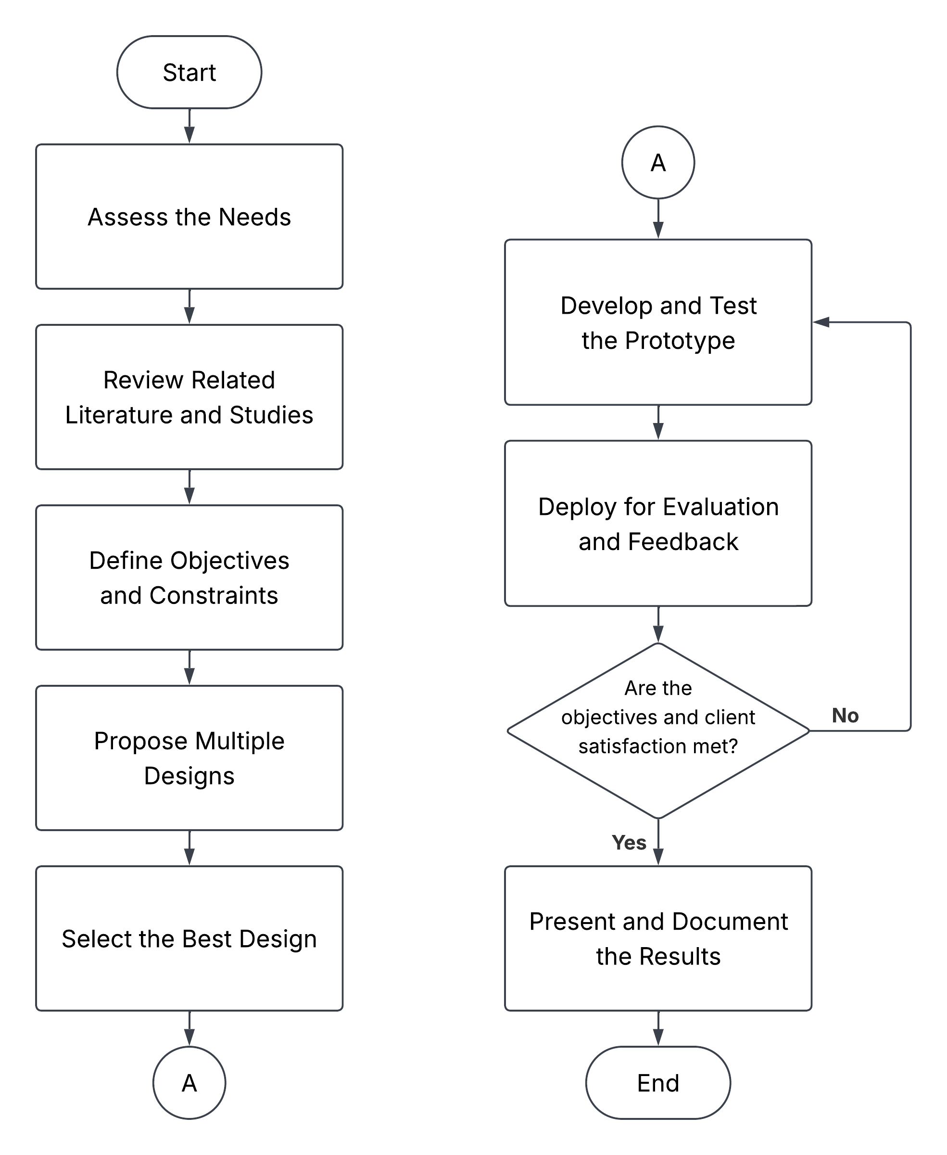

Figure 1: Design Process
- Assess the Needs: The design process began by identifying a real-world problem that aligned with the assigned Sustainable Development Goals (SDGs). Interviews were conducted with the target community to identify their needs and the challenges that required an engineering solution. Based on the needs assessment, the study identified a complex engineering problem involving the manual and labor-intensive sorting of cacao beans, resulting in inconsistent quality classification and inefficient post-harvest processing under high production volumes.
- Review Related Literature and Studies: Relevant literature, existing technologies, and similar studies on cacao bean sorting were reviewed to better understand the identified problem. Existing solutions were analyzed to identify research gaps and opportunities for improvement. The review revealed the use of computer vision and machine learning for cacao bean classification while identifying a gap in the development of an automated physical sorting system.
- Define Objectives and Constraints: The objectives were formulated based on the identified problem while also considering the research gaps identified in the literature review. These objectives were developed to be Specific, Measurable, Achievable, Relevant, and Time-bound (SMART) and were aligned with the statement of the problem. The project's scope, limitations, and design constraints were also established to define the boundaries of the study.
- Propose Multiple Designs: Three design concepts were developed to address the identified problem. The proposed designs may differ in their hardware components, software models, system processes, and features, depending on the approach taken to address the identified problem. Each design was evaluated based on its trade-offs with respect to the established design constraints, including economic cost, sustainability, functionality, manufacturability, and power consumption.
- Select the Best Design: The alternative designs will be compared through a detailed analysis of their trade-offs with respect to the established design constraints. An engineering design scoring method and a decision matrix will be developed to evaluate and rank the three alternative designs objectively. The impact of each trade-off on the final design selection will be examined, and the design with the highest overall evaluation score will be selected for prototype development.
- Develop and Test the Prototype: The prototype will be developed by integrating the hardware and software components into a functional system, guided by the detailed system design and specifications that will serve as the blueprint for prototype development. The prototype will then undergo functional testing to verify that it meets the established design objectives and is ready for deployment and evaluation.
- Deploy for Evaluation and Feedback: The prototype will be deployed to the intended beneficiary for evaluation. System performance and client feedback will be collected to determine whether the project objectives and user requirements have been achieved. If the objectives are not met or further improvements are required, the identified issues will be assessed, and the necessary design improvements will be implemented before repeating the development and testing process.
- Present and Document the Results: The project's methodology, results, discussion, and conclusions will be presented through written documentation and oral presentations. This step will communicate that the project's objectives have been met and that the proposed solution has addressed the identified problem.

Definition of Terms
Cacao Beans – the processed dried cacao seeds that serve as the input material of the system for classification and sorting
Cacao Bean Classification – the process to identify and assign cacao beans into predefined categories based on visible defects and size
Cacao Bean Sorting – the physical separation of cacao beans into different bins using the system’s mechanical components based on the model’s classification output
Computer Vision – the use of image processing techniques that allow the system to analyze and interpret visual features of cacao beans for automated classification
Defective Beans – cacao beans which are moldy, slaty, insect-damaged, insect-infested, germinated, or broken
Mean Average Precision (mAP) – the performance metric used to evaluate the accuracy of the YOLO model across all cacao bean classes
Precision – the correctness of the model’s positive predictions in identifying cacao bean classes
Recall – the model’s ability to correctly detect all relevant cacao beans in the dataset
Throughput – the number of cacao beans processed by the system per minute during operation
YOLOv8 – the object detection model used in the system to perform real-time classification of cacao beans from captured images

DESIGN INPUTS

Design Constraints
The system is subject to several design constraints that define the boundaries and limitations within which the system must be designed and implemented. These constraints have different factors that influenced key design decisions throughout the development process.
Accuracy (mAP@0.5)
Accuracy refers to how well a detection algorithm correctly identifies and locates cacao beans in an image. Mean Average Precision at IoU 0.5 (mAP@0.5) measures the model’s overall detection performance using a 0.5 Intersection over Union threshold, where a higher value indicates better detection accuracy. In this proposed system, accuracy is measured using mAP@0.5 to compare how well each algorithm detects and classifies cacao beans.
Detection Time (FPS)
Detection time refers to how quickly a detection algorithm processes an image and produces a detection result. Frames per second (FPS) measure how many images or frames the model can process within one second, where a higher FPS indicates faster detection. In this proposed system, detection time is measured using FPS because the selected algorithm must process cacao bean images quickly enough to support continuous automated sorting.
Computational Efficiency (Parameter Count)
Computational efficiency refers to how much computational complexity an algorithm requires to perform detection. Parameter count represents the total number of trainable parameters contained in the model, where a lower parameter count generally indicates a lighter model with lower computational requirements. In this proposed system, computational efficiency is measured using parameter count to compare how suitable each detection algorithm is for deployment on the embedded system.
Memory Utilization (RAM Usage)
Memory utilization refers to the amount of system memory required by a detection algorithm while performing inference. Peak GPU memory usage measures the highest amount of GPU memory consumed during model execution, where a lower value indicates lower memory demand. In this proposed system, memory utilization is measured using peak GPU memory usage to compare how efficiently each detection algorithm uses available computing resources.
Reliability (Recall)
Reliability refers to the ability of a detection algorithm to consistently identify actual cacao beans without missing valid detections. Recall measures the proportion of actual target objects that are successfully detected by the model, where a higher recall indicates fewer missed detections. In this proposed system, reliability is measured using recall because the selected algorithm should minimize missed cacao beans during defect detection and size sorting.

Design Standards
The design and development of the system adhere to established engineering and technological standards to ensure system reliability, classification accuracy, and operational efficiency. The following IEEE, ISO, PNS, and ASEAN standards will guide the implementation of the machine vision, embedded systems, and software components of the project:
ASEAN Standards 34:2014 – Cocoa Beans
Defines the quality requirements and classification of cocoa beans based on physical defects and quality characteristics. It serves as the reference for identifying acceptable and defective cacao beans used in training, validating, and evaluating the proposed computer vision system.
ISO/IEC 25010 – Systems and Software Quality Requirements and Evaluation
Specifies quality characteristics for software systems, including functional suitability, performance efficiency, reliability, and maintainability. This standard serves as a reference for assessing the software quality of the proposed embedded machine vision system, including the performance of the candidate detection algorithms and the selected algorithm during final system operation.
ISO 15003:2019 – Agricultural Engineering – Electrical and Electronic Equipment – Testing Resistance to Environmental Conditions
Specifies test methods for evaluating the resistance of electrical and electronic equipment used in agricultural machinery against environmental conditions such as temperature, humidity, dust, and vibration. It serves as a reference for ensuring that the Raspberry Pi 5, camera module, sensors, and other electronic components of the proposed system maintain reliable operation under typical post-harvest agricultural environments.
PNS/BAFS PAES 253:2018 – Agricultural Machinery – Cacao Huller – Specifications
Specifies the design, fabrication, safety, and performance requirements for cacao processing machinery. Although the proposed machine is intended for defect detection and size sorting rather than cacao hulling, the standard is used only as a supporting reference for the construction, safety, and operational considerations of post-harvest cacao processing machinery.
IEEE 2755 – Standard for Artificial Intelligence and Machine Learning
Provides a reference for terminology and concepts related to artificial intelligence and machine learning systems. It supports the proper description and evaluation of the detection algorithms considered in the study, including YOLO11n, MobileNet-SSDv3, and EfficientDet-Lite0.
IEEE 29119 – Software and System Testing Standards
Outlines standardized procedures for software testing, including test planning, execution, validation, and documentation. This standard guides the planning, execution, and documentation of software tests used to compare the three detection algorithms in terms of accuracy, detection time, computational efficiency, memory utilization, and reliability. It also supports the testing of the selected algorithm after integration with the automated sorting system.
IEEE 1012 – Standard for System, Software, and Hardware Verification and Validation
Defines requirements for verification and validation processes throughout the system development lifecycle. This standard guides the verification and validation of the candidate detection algorithms, the selected machine learning model, and the fixed hardware sorting mechanism to confirm that the final system meets its intended design objectives.
ISO 9241 – Ergonomics of Human-System Interaction
Defines how user interfaces should be designed to ensure usability, safety, and accessibility. This standard guides the layout and interaction design of the Raspberry Pi Touch Display interface, ensuring that system monitoring, classification results, and operational controls are presented in a clear and user-friendly manner for cacao processors with varying levels of technical familiarity.

Software Knowledge
The development of the design project requires knowledge in computer vision, machine learning, and embedded systems programming. The researchers must be familiar with image processing concepts, object detection, dataset preparation, model training, and model evaluation to ensure accurate defect detection and size classification of cacao beans. The following will be used in the development process:
Object Detection Algorithms. Three (3) object detection algorithms, namely YOLO11n, MobileNet-SSDv3, and EfficientDet-Lite0, are evaluated as design alternatives for cacao bean detection and classification. The algorithms are compared using the same dataset and test conditions based on accuracy, detection time, computational efficiency, memory utilization, and reliability. Based on the design trade-off analysis, the algorithm with the highest overall score is selected for integration into the embedded machine vision system.
Arduino IDE. Used to program the microcontroller responsible for directly controlling the vibrating feeder motor, the stepper motors, and other motor-driven components. Using C and C++, the team writes and uploads code that manages bean release timing from the rotating container and the actuation of each flipper based on the detection and classification results produced by the selected object detection algorithm running on the Raspberry Pi.
KiCad. Used for designing and laying out the printed circuit boards (PCBs) and schematic diagrams that interconnect the Raspberry Pi, microcontroller, motor drivers, and sensors. It allows the team to plan wiring paths, verify circuit connections, and prepare accurate schematics before physical assembly, reducing the risk of wiring errors across the system's multiple motors and lanes.
SolidWorks. Used to design and visualize the physical structure of KakaoSort, including the hopper, the rotating container with its five holes, the conveyor and aligner assembly, and the sorting bin enclosure. Through 3D modeling, the team ensures that all mechanical components fit properly, that bean spacing through the rotating feeder is consistent, and that the overall structure supports smooth bean flow from input to sorting.
Python. Used for model training, testing, evaluation, and programming the Raspberry Pi, which serves as the main processing unit of the system. Python is used to implement and evaluate the three candidate detection algorithms and later run the selected YOLO11n inference pipeline for cacao bean detection and classification. It also processes detection results into control signals for the sorting mechanism and manages the display of system information on the touch display.
Tinkercad. Used to simulate and test Arduino-based circuits virtually prior to physical implementation. The team uses it to verify motor control logic for the rotating feeder and stepper motor flippers, test timing sequences, and check circuit behavior, helping catch design issues early and reducing the risk of damaging physical components during assembly.
Raspberry Pi OS. Serves as the operating system of the Raspberry Pi 5. It provides the environment for executing Python programs, running the selected YOLO11n model, receiving camera input, communicating with the microcontroller, and managing the touch display during system operation.
GitHub. Serves as a version control platform for storing and managing the project's source code, including the training and evaluation scripts for the three detection algorithms, Raspberry Pi programs, and microcontroller firmware. It allows the researchers to track code changes, maintain different model implementations, and manage updates throughout the development process.
Android Studio. Utilized to develop the companion mobile application for monitoring KakaoSort's operation. The app allows users to view real-time classification results, sorting statistics, and system status remotely, enhancing usability for cacao processors overseeing the sorting process.

Hardware Knowledge
Raspberry Pi 5. Serves as the main processing unit of the proposed system. It runs the selected object detection model to perform cacao bean defect detection and size classification, processes the images captured by the camera, and sends the resulting classification commands to the Arduino for motor control. It also manages the touch display and presents system information and sorting results to the user.
Arduino. Works alongside the Raspberry Pi to control the mechanical components of the sorting system. It receives classification commands from the Raspberry Pi through serial communication and controls the stepper motor, servo motor, and vibration motor based on the required sorting sequence. This allows the Raspberry Pi to focus on image processing and object detection while the Arduino handles motor timing and actuation.
Raspberry Pi Camera Module 3. Captures images of cacao beans positioned on the rotating sorter disc. It provides the visual input required by the selected object detection model to identify defective beans and classify acceptable beans according to their size. Consistent image capture is needed to support accurate detection and classification before each bean is directed to its corresponding sorting chute.
Motor Driver. Acts as an interface between the Arduino and the motors that require higher current than the microcontroller can directly provide. It controls the power supplied to the motors and allows the Arduino to manage their speed, direction, and movement safely. The appropriate motor driver is selected according to the voltage and current requirements of each motor used in the system.
Power Supply. Provides the electrical power required by the Raspberry Pi, Arduino, camera module, motors, lighting, display, and other electronic components. Since the system operates as a stationary machine, power is supplied through an AC-to-DC source rather than a battery. The power supply must provide the required voltage and current for stable operation of all components during continuous sorting.
Stepper Motor. Provides the controlled rotational movement of the sorter disc that receives cacao beans from the hopper and feed tube. Its precise step-by-step rotation allows each bean compartment on the disc to move sequentially through image acquisition and sorting positions. The Arduino controls the stepper motor through a motor driver to maintain consistent positioning and timing during operation.
Servo Motor. Controls the sorting mechanism that directs each cacao bean into the appropriate sorting chute based on the classification result produced by the detection model. The servo moves to predetermined angular positions to guide the bean toward its assigned category. Its controlled angular movement allows the sorting mechanism to respond quickly and accurately to commands from the Arduino.
Vibration Motor. Provides vibration to the hopper to help maintain a continuous flow of cacao beans toward the feed tube. The vibration reduces the possibility of beans accumulating or becoming stuck near the hopper outlet, which can cause clogging and interrupt the sorting process. The motor is controlled to provide enough movement to assist bean flow without causing excessive scattering or uncontrolled feeding.
Ring Light. Provides consistent, even illumination over the imaging area as cacao beans pass beneath the Raspberry Pi Camera Module. It reduces unwanted shadows and changes in brightness that may affect the appearance of the beans in the captured images. Stable lighting helps the selected detection model produce more consistent defect and size classification results.
Hopper. Serves as the initial storage and feeding section of the system, holding cacao beans before they enter the sorter. Its shape directs the beans toward the outlet and feed tube, while the vibration mechanism helps prevent clogging near the lower section. The hopper supports a steady flow of beans into the rotating sorter disc for image detection and subsequent sorting.

PROJECT / SYSTEM DESIGN
This chapter outlines the framework and operation of the proposed system, including the overall design, process flow, and key considerations for performance and efficiency. It provides a clear understanding of how the system functions from input to output.

Input-Process-Output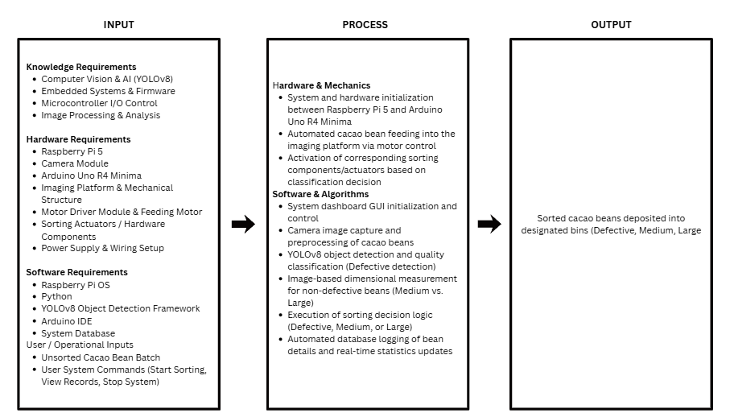

Figure 2: Input-Process-Output
In the Input-Process-Output model, the input stage includes all resources needed to design and operate the automated KakaoSort system. It covers knowledge requirements, hardware requirements, software requirements, and user operational inputs. Knowledge requirements include the technical understanding necessary to integrate computer vision, embedded systems, and microcontroller I/O control. Such knlowledge ensures the machine functions accurately during defect detection and sorting operations.
The hardware and software knowledge focuses on integrating the physical and digital systems that enable KakaoSort to function efficiently. The hardware involves the camera module, feeding motor, and sorting actuators managed by the Raspberry Pi 5 and Arduino Uno R4 Mega. On the software side, Python and the Arduino IDE are used for programming automation, while the YOLOv8 framework handles the AI-driven classification. Together, these components ensure accurate and reliable sorting performance.
The process stage integrates hardware and software to perform automated cacao bean sorting tasks. The system initializes hardware communication, feeds beans onto the imaging platform, and captures images for processing. The YOLOv8 model executes quality classification and dimensional measurement to determine the sorting decision. Based on this logic, the microcontrollers activate the corresponding actuators to deposit the sorted beans into their designated bins, while automatically updating real-time statistics and database logs.

System Flowchart
Figure 3 represents the operational logic of the automated cacao bean sorting system. It depicts the sequence of operations, the relationships between hardware and software components, and the overall flow of data from system startup to the sorting of cacao beans and recording of sorting results.
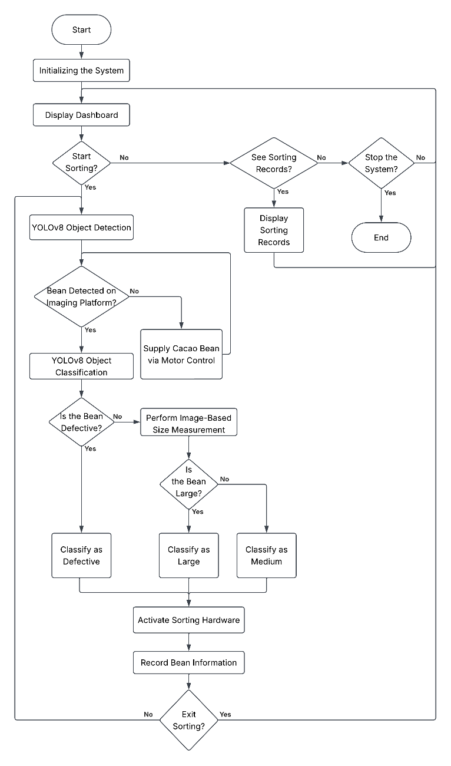

Figure 3. System Flowchart
The system begins by initializing and displaying a dashboard, from which the user may choose to start sorting, view previous sorting records, or stop the system. Once sorting is initiated, the motor control mechanism supplies cacao bean to the imaging platform. The YOLOv8 object detection model analyzes the image of cacao beans on the platform to determine whether the bean is defective. Cacao beans identified as defective are immediately classified, while non-defective beans undergo an image-based size measurement to determine whether they are large or medium. Based on this classification, the sorting hardware is activated to move the bean into its assigned container, and the corresponding bean information is recorded before the system returns to check for the next bean on the imaging platform. This cycle continues until the user selects the option to stop the sorting process.

Illustrative Diagram
The illustrative diagram provides a visual representation of how KakaoSort functions as an integrated system. It outlines the interaction between the user interface, processing units, camera module, and mechanical components, showing the overall workflow of the machine during operation. This diagram serves as a guide for understanding how commands are transmitted, how data flows through the system, and how each component contributes to achieving fully automated and precise cacao bean sorting.
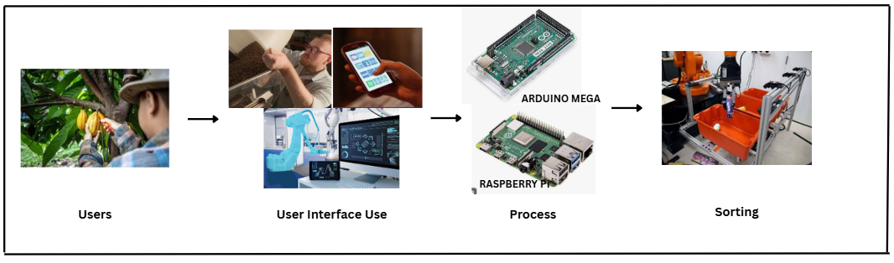

Figure 4: Illustrative Diagram
As shown in Figure 4, the Illustrative Diagram model illustrates how the KakaoSort system operates through the interaction of its main components. The process begins with the user, typically a cacao processor or farmer, who accesses the system through the 5-inch Raspberry Pi Touch Screen Display or the companion mobile application. This interface allows the user to control the machine, view real-time classification results, and monitor its operational status and sorting statistics.
The interface communicates with the Raspberry Pi 5, which functions as the main processing unit of the system. It handles the transmission of user commands, processes the live camera feed through the YOLOv11 object detection model, and coordinates sorting functions, while the Arduino microcontroller sends control signals to the motor drivers that manage the system's feeding mechanism and sorting actuators. Through this setup, the system integrates microcomputer intelligence with electromechanical components, allowing efficient automation of the post-harvest sorting process. The user-friendly interface provides easy control and monitoring, while the Raspberry Pi ensures accurate execution of classification commands. The combined system enhances precision, reduces manual labor, and promotes productivity for small-to-medium cacao businesses.

Discussion of Design Alternatives
In the development of [TITLE], each design alternative was evaluated based on accuracy, detection time, computational efficiency, memory utilization, and reliability. These constraints are used to compare YOLO11n, MobileNet-SSDv3, and EfficientDet-Lite0 under the same dataset and testing conditions. The results of the comparison will support the selection of the most suitable detection algorithm for integration into the hardware system of the automated dried cacao bean sorter.

Design 1: YOLOv11n
The Robotic Arm-based Sorting System design focuses on precise, individualized handling of cacao beans during classification and sorting. In this design, beans are fed from the hopper onto a staging platform one at a time, where Raspberry Pi Camera Module captures an image of the bean under a ring light for consistent lighting. The image is then processed by a YOLOv8-based object detection model running on the Raspberry Pi 5, which classifies the bean according to its size category and the presence of external defects. Once classified, a robotic arm driven by twelve servo motors picks up the individual bean and places it into the chute corresponding to its predicted classification, while additional stepper motors handle batch separation, platform wiping, and anti-clustering vibration to keep beans moving steadily onto the platform. An Arduino Mega2560 coordinates the arm and motor operations based on commands from the Raspberry Pi, and a dedicated mobile application, rather than an onboard display, stores and presents the resulting classification database to the operator. This bean-by-bean handling approach favors sorting accuracy and gentle bean handling over raw throughput, making it best suited for smaller processing volumes where precision is prioritized.

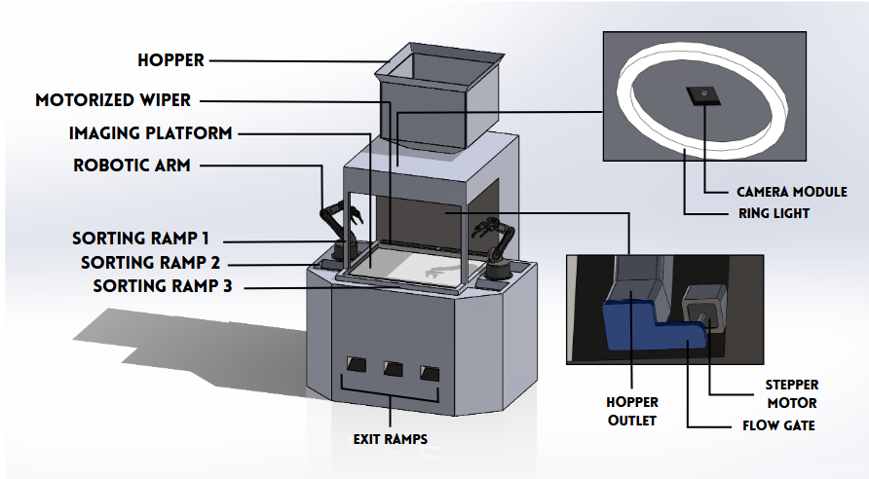

Figure 5: Design Alternative 1 - Robotic-Arm-Based Sorting System

Circuit Design
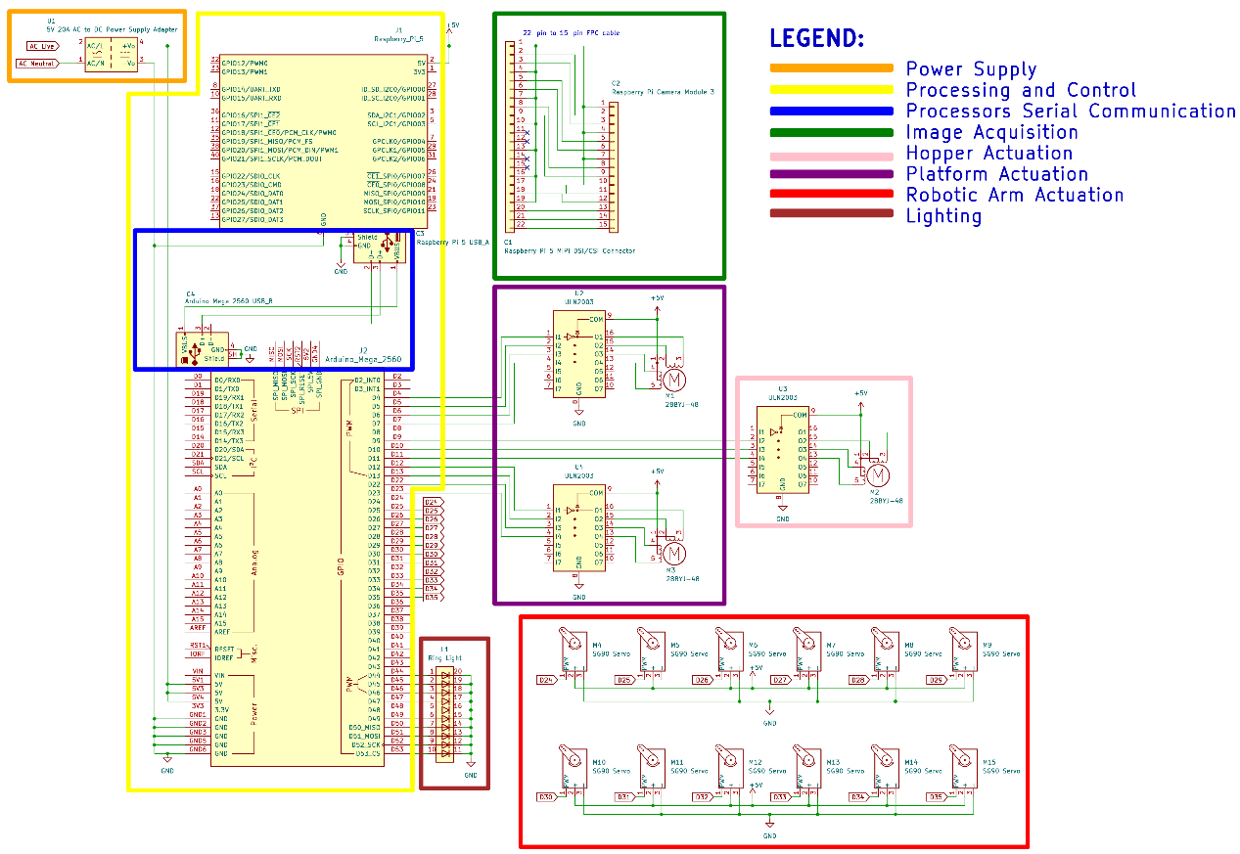

Figure 6: Design 1 Schematic Diagram
Specification of Materials to be Used
For the robotic arm-based design of KakaoSort, the material specifications focus on precise, individualized handling of each cacao bean during classification and sorting. The system requires a hopper and platform to feed and stage the beans, a camera and ring light for consistent image capture, and a bank of servo motors driving the robotic arm frame to physically pick and place beans into the correct chute. Stepper motors handle batch separation, platform wiping, and anti-clustering vibration, while the Raspberry Pi and Arduino coordinate image processing and motor control. Unlike Designs 2 and 3, which rely on the built-in LCD display to store and present the sorting database, this design pairs the system with a dedicated mobile application that stores and displays the bean classification database. These materials were selected to support accurate, faster bean sorting suited for smaller processing volumes.

Table 1: Design 1 – Specifications of Materials to be used
Materials | Quantity
Raspberry Pi 5: Model B, 4 GB  (Link) | 1
Raspberry Pi Camera Module 3  (Link) | 1
Arduino Mega2560 CH340  (Link) | 1
Hopper  (To be fabricated) | 1
Stepper Motor 28BYJ-48 with ULN2003 Driver  (Link) | 3
SG90 Micro 9g Servo Motor  (Link) | 12
Ring Light  (Link) | 1
5-inch Raspberry Pi Touch Screen Display  (Link) | 1
Machine Housing (Stainless Steel)  (To be fabricated) | 1
PLA Filament for Robotic Arm Frame  (Link) | 1
DC 5V 20A LED Power Supply  (Link) | 1
Design Constraints
The feasibility of the system is guided by five design constraints outlined in the preceding chapter: Economic, Sustainability, Functionality, and Manufacturability, and Power Consumption. These factors directly drive the design and development choices moving forward.
Economic Cost
This constraint accounts for the overall cost of materials required to build the prototype. After evaluating the economics, the design offering the lowest total cost while still meeting functionality requirements is chosen as the most economical.

Table 2: Design 1 Constraints – Economics
Materials | Cost (₱) | Quantity | Total (₱)
Raspberry Pi 5; 4GB  (Link) | 9,459 | 1 | 9,459
Raspberry Pi Camera Module 3  (Link) | 3,502 | 1 | 3,502
Arduino Mega2560 CH340  (Link) | 984 | 1 | 984
Hopper  (To be fabricated) | 3,000 | 1 | 3,000
Stepper Motor 28BYJ-48 with ULN2003 driver  (Link) | 125 | 3 | 375
SG90 Micro 9g Servo Motor  (Link) | 67 | 12 | 804
Ring Light  (Link) | 320 | 1 | 320
Machine Housing (stainless steel)  (To be fabricated) | 5,000 | 1 | 5,000
PLA Filament for Robotic Arm Frame  (Link) | 799 | 1 | 799
DC 5V 20A LED Power Supply  (Link) | 890 | 1 | 890
Total Cost for the Machine |  |  | 25,133
Application Cost (Android Studio)  (Link) | 0 | 1 | 0
Total Cost for App Development |  |  | 0
Total |  |  | 25,133
Table 2: Design 1 Constraints – Cost breaks down the financial requirements for the KakaSort machine and its supporting application. The total cost of the machine is ₱24,243, while the application development cost is ₱0, since it is free, resulting in an overall project cost of ₱24,243. These costs include the major electronic components, motors, machine housing, hopper fabrication, and PLA filament for the 3D-printed robotic arm frame required to construct the prototype. Overall, this total gave us the estimated budget required to implement the proposed system.
Indirect Cost
Indirect costs cover necessary project support expenses that are not directly tied to building or component purchasing for the KakaoSort Machine. These costs support smooth operations throughout development, testing, and documentation, despite not being physical parts of the final product.
Transportation – Travel costs associated with buying materials, conducting field tests, attending consultations, and moving components or prototypes.
Supplies – Consumable items, such as paper, ink, adhesives, documentation supplies, and minor fabrication/testing tools, that are not incorporated into the final system.
Electricity – Power consumed to charge the machine’s power supply, operate tools, run testing equipment, and power devices used during project development.
Sustainability
This constraint accounts for the overall longevity of the KakaoSort Machine’s materials. It assesses the expected average lifespan of all mechanical and electronic. A higher rating signifies that the system is built with durable, high-quality materials that reduce industrial waste and enhance the long-term return on investment.

Table 3: Design 1 Constraints – Sustainability
Component | Expected Lifespan of Components (Years)
Raspberry Pi 5 (4GB)  https://www.bgr.com/2158222/how-long-do-raspberry-pi-lasts/ | 10 years
Raspberry Pi Camera Model 3  https://www.displaymodule.com/blogs/knowledge/how-long-do-ips-displays-typically-last | 5 years
Arduino Mega2560 CH340  https://arduino.stackexchange.com/questions/37436/life-span-of-arduino | 20 years
Hopper  https://www.smetals.co.uk/how-long-will-stainless-steel-last-a-complete-guide/ | 30 years
Stepper Motor 28BYJ-48  https://www.ariat-tech.com/blog/guide-to-nema-17-stepper-motors-how-they-work,advantages-and-disadvantages,how-to-use-them,and-their.html | 5 years
ULN2003 Stepper Motor Driver Board  https://easyelecmodule.com/uln2003-stepper-motor-driver-board/ | 10 years
SG90 Micro 9g Servo Motor  https://www.a-m-c.com/servomotor-lifespan/ | 3.4 years
Machine Housing (stainless steel)  https://www.smetals.co.uk/how-long-will-stainless-steel-last-a-complete-guide/ | 30 years
PLA Filament for Robotic Arm Frame  https://jlc3dp.com/blog/how-long-filament-lasts | 4 years
Ring Light  https://www.kentfaith.com.au/blog/article_how-long-do-led-ring-lights-last_466?srsltid=AfmBOootu1F__wLULdfC0GltJJzO5mUNEe1cSR8tQJYbbt--ngmwI3zc | 3 years
DC 5V 20A LED Power Supply  https://hitlights.com/blogs/premium-led-strip-lighting/how-long-do-led-power-supplies-last | 5 years
Table 3: Design 1 Constraints – Sustainability presents the expected lifespan of the major mechanical, structural, and electronic components of the KakaoSort Machine. The stainless-steel machine housing and hopper have the longest expected lifespan at 30 years each, providing durable structural components for the system. Meanwhile, components such as the SG90 servo motors, ring light, and camera have shorter expected lifespans and may require replacement during the machine's operational life.
Where:
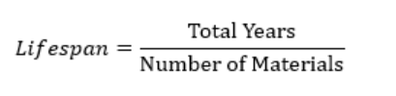
Based on the estimated lifespans, the proposed system has an average expected lifespan of approximately 11.4 years. The modular design allows individual components with shorter lifespans to be replaced without replacing the entire machine, supporting long-term usability and reducing material waste.
Functionality
This constraint accounts for how well the system performs its intended purpose of classifying and sorting cacao beans while allowing users to operate it without difficulty. Ease of use describes how simple and intuitive it is for the user to interact with the system’s controls, view the dashboard, and place beans on the imaging platform. A design that requires fewer steps, less learning time, and minimal user effort is considered more functional. The design with the highest ease of use is therefore chosen as the most functional.

Table 4: Design 1 Constraints – Functionality
Criteria | 5  Very Easy | 4  Easy | 3  Moderate | 2  Difficult | 1  Very Difficult | Total
User Interface / Dashboard  How easy is it to navigate and understand the dashboard? | ✔ |  |  |  |  | 5
Learning Time  How much time and effort are required to learn how to operate the system? | ✔ |  |  |  |  | 5
Manual Bean Placement  How easy is it to place cacao beans on the imaging platform? | ✔ |  |  |  |  | 5
Accessibility  How easy is it to access and review the sorting logs and records? |  | ✔ |  |  |  | 4
Total |  |  |  |  |  | 19
Table 4: Design Constraints – Functionality outlines the usability evaluation of the KakaTsek system based on User Interface/Dashboard, Learning Time, Manual Bean Placement, and Accessibility. The User Interface/Dashboard, Learning Time, and Manual Bean Placement received a rating of 5 – Very Easy, while Accessibility received a rating of 4 – Easy. Collectively, these scores result in a total functionality score of 19, indicating that the system is designed to be easy to operate, understand, and access.
Manufacturability
This constraint accounts for the maximum allowable time and complexity needed to assemble the physical components, ensuring assembly stays within the ideal timeframe for hardware and software development. The design is intended to be efficient to build and service, as it uses modular components and standard fasteners that avoid the need for specialized tools or complex fabrication techniques.

Table 5: Design 1 Constraints – Manufacturability
Criteria | 1  Very Slow | 2  Slow | 3  Moderate | 4  Fast | 1  Very Fast | Total
Hardware Developing |  |  | ✔ |  |  | 3
Software Developing |  | ✔ |  |  |  | 2
Total |  |  |  |  |  | 5
Table 5: Design 1 Constraints – Manufacturability presents the manufacturability assessment of the proposed system based on two categories: Hardware Developing and Software Developing. Hardware Developing is assigned a score of 3 – Moderate, while Software Developing is assigned a score of 2 – Slow. The hardware development involves the fabrication of the robotic arm, stainless-steel housing and hopper, 3D-printed components, and use of multiple motors and electronic components. Meanwhile, software development involves the use of the YOLOv8 model, embedded control, automated logging, and software application. The individual scores are summed up to obtain a total manufacturability score of 5, indicating that the proposed design requires a relatively moderate hardware development process but more time and effort for software development.
Power Consumption
This constraint accounts for the electrical power required to operate Design 1. It is measured by calculating the total power consumption of the system's electrical components during operation. The design with the lowest total power consumption is selected as the most suitable.

Table 6: Design 1 Constraints – Power Consumption
Electric Components | Quantity | Voltage (V) | Ampere (A) | Wattage(W)
Raspberry Pi 5: 4 GB | 1 | 5V | 5.0A | 25W
Raspberry Pi Camera Module 3 | 1 | 3V | 0.25A | 0.75W
Arduino Mega2560 CH340 | 1 | 5V | 0.5A | 2.5W
Stepper Motor 28BYJ-48 | 3 | 5V | 0.2A | 1W*3
ULN2003 Stepper Motor Driver Board | 3 | 5V | 0.5A | 2.5W*3
SG90 Micro 9g Servo Motor | 12 | 5V | 0.2A | 1W*12
Ring Light | 1 | 5V | 0.8A | 4W
Total |  |  |  | 54.75W
Table 6: Design 1 Constraints – Power Consumption shows the estimated electrical power consumption of the major components used in the machine. The system has an estimated total power consumption of 154.75 W during operation. Since the machine operates through a direct electrical connection, its power consumption is evaluated based on the combined wattage of its components. A lower total power consumption indicates greater electrical efficiency while maintaining the required functionality of the system.
Design Standards
ASEAN Standards 34:2014 - Cocoa Beans
Serves as the classification basis for the acceptable and defective categories that the robotic arm sorts each bean into. Because this design handles beans individually, accurate application of the standard defect criteria directly determines correct arm placement.
ISO 9283 - Manipulating Industrial Robots: Performance Criteria and Related Test Methods
Guides the evaluation of the robotic arm's positioning accuracy and repeatability, which are critical for consistently picking a single bean from the platform and placing it into the correct chute without dropping or misplacing beans.
PNS/BAFS PAES 253:2018 - Agricultural Machinery - Cacao Huller - Specifications
Serves as a reference for the design, construction, and safety requirements of the hopper, platform, and housing that support the robotic arm assembly during cacao processing.
ISO 15003:2019 - Agricultural Engineering - Electrical and Electronic Equipment - Testing Resistance to Environmental Conditions
Applies to the twelve servo motors, stepper motors, camera, and Raspberry Pi used in this design, ensuring these components remain reliable under typical post-harvest processing conditions such as dust and vibration from the arm's repeated motion.
IEEE 2755 - Standard for Artificial Intelligence and Machine Learning
Provides the terminology and conceptual framework applied in structuring the YOLOv8-based object detection model that classifies each bean as it is presented individually to the robotic arm, ensuring consistent understanding of defect classes and detection outputs throughout development.
ISO/IEC 25010 - Systems and Software Quality Requirements and Evaluation
Supports evaluation of the software quality attributes, particularly reliability and performance efficiency, required for the YOLOv8 classification model and arm-control software to operate together in real time as each bean is individually picked and sorted.
IEEE 29119 - Software and System Testing Standards
Guides the testing procedures used to validate the classification accuracy and cycle time of the robotic arm, supporting comparison of this design's sorting speed against traditional manual sorting methods.
IEEE 1012 - Standard for System, Software, and Hardware Verification and Validation
Guides the verification and validation of the YOLOv8 classification model and the robotic arm's pick-and-place hardware prior to deployment, confirming that detection accuracy and arm positioning meet the design's intended objectives.
ISO 9241 - Ergonomics of Human-System Interaction
Guides the layout of the Raspberry Pi touch display used to present classification results and system controls to the operator by loading beans onto the imaging platform, ensuring the interface remains clear during arm-based sorting operation.

Design 2: 5-Channel Sorting System
The 5-Channel Sorting System design releases five cacao beans at a time through a compartmented container to minimize clustering while still supporting a higher processing volume than individual arm-based handling. Beans are loaded into a five-bean compartment, where a vibration mechanism combined with three synchronized stepper motors encloses, releases and holds each bean in place as it moves towards the imaging section. A Raspberry Pi Camera Module and ring light capture the image of each bean, which is then classified by a YOLOv8-based object detection model running on the Raspberry Pi 5. Once classified, five additional stepper motors, each assigned to its own sorting channel, physically direct the bean into the bin corresponding to its predicted size or defect category. An Arduino R4 Minima coordinates the vibration, release and sorting motors, while a 5-inch Raspberry Pi Touchscreen built directly into the machine housing displays the classification results, system status, and sorting logs without relying on an external mobile device. By balancing controlled, low-clustering bean release with parallel sorting channels, this design targets medium processing volumes that require both reasonable throughput and consistent accuracy.
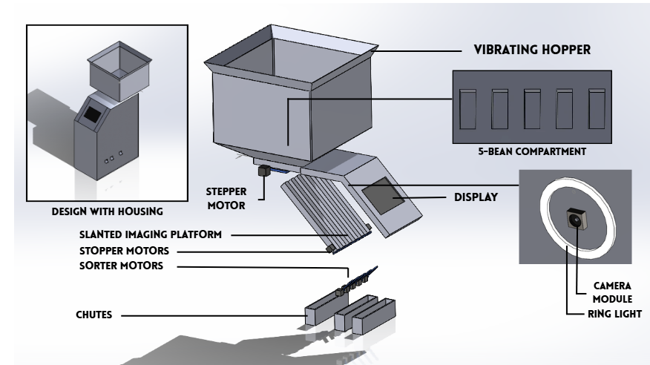

Figure 7: Design Alternative 2 – 5-Channel Sorting System

Circuit Design
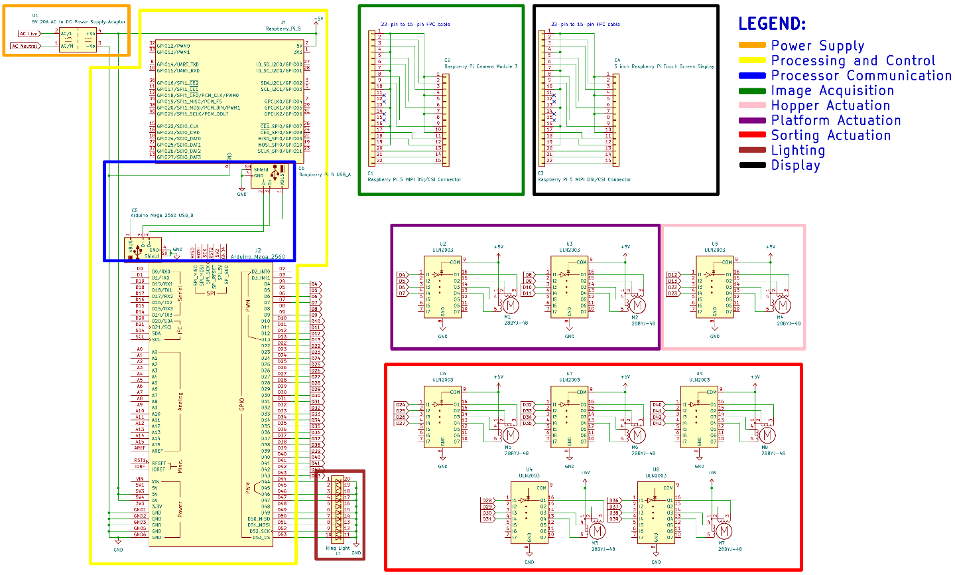

Figure 8: Design 2 Schematic Diagram
Specification of Materials to be Used
For the 5-Channel design of KakaoSort, the material specifications focus on releasing five cacao beans at a time through the compartments so they can be classified and sorted with minimal clustering. In addition to the hopper and camera and lighting setup shared with the other designs, this configuration relies on a compartmented container with an integrated vibration mechanism and a set of stepper motors that enclose the compartment, release beans toward the imaging section, and hold them in place while classification occurs. Five additional stepper motors handle the final physical sorting, each assigned to its own channel. These materials were selected to balance throughput and sorting accuracy for medium processing volumes.

Table 7: Design 2 Constraints – Specifications of Materials to be Used
Materials | Quantity
Raspberry Pi 5: Model B, 4 GB  (Link) | 1
Raspberry Pi Camera Module 3  (Link) | 1
Arduino Mega2560 CH340  (Link) | 1
Hopper  (To be fabricated) | 1
Container (With 5-Bean Compartment and Vibration Mechanism)  (To be fabricated) | 1
Stepper Motor 28BYJ-48 with ULN2003 Driver  (Link) | 8
Ring Light  (Link) | 1
5-inch Raspberry Pi Touch Screen Display  (Link) | 1
Machine Housing (Stainless Steel)  (To be fabricated) | 1
DC 5V 20A LED Power Supply  (Link) | 1
Design Constraints
The feasibility of the system is guided by five design constraints outlined in the preceding chapter: Economic, Sustainability, Functionality, and Manufacturability, and Power Consumption. These factors directly drive the design and development choices moving forward.
Economics
This constraint accounts for the overall cost of materials required to build the prototype. After evaluating the economics, the design offering the lowest total cost while still meeting functionality requirements is chosen as the most economical.

Table 8: Design 2 Constraints – Economics
Materials | Cost (₱) | Quantity | Total (₱)
Raspberry Pi 5; 4GB  (Link) | 9,459 | 1 | 9,459
Raspberry Pi Camera Module 3  (Link) | 3,502 | 1 | 3,502
Arduino Mega2560 CH340  (Link) | 984 | 1 | 984
Hopper  (To be fabricated) | 3,000 | 1 | 3,000
Stepper Motor 28BYJ-48 with ULN2003 driver  (Link) | 125 | 8 | 1,000
5-inch Raspberry Pi Touch Screen Display  (Link) | 2,500 | 1 | 2,500
Ring Light  (Link) | 320 | 1 | 320
Machine Housing (stainless steel)  (To be fabricated) | 5,000 | 1 | 5,000
DC 5V 20A LED Power Supply | 890 | 1 | 890
Total |  |  | 26,655
Table 8: Design 2 Constraints – The total cost of the machine is ₱25,221 and these costs include the major electronic components, such as the stepper motors, 5-inch display, machine housing, and hopper fabrication, required to construct the prototype. Overall, this total gave us the estimated budget required to implement the Design 2 proposed system.
Indirect Cost
Indirect costs cover necessary project support expenses that are not directly tied to building or component purchasing for the KakaoSort Machine. These costs support smooth operations throughout development, testing, and documentation, despite not being physical parts of the final product.
Transportation – Travel costs associated with buying materials, conducting field tests, attending consultations, and moving components or prototypes.
Supplies – Consumable items, such as paper, ink, adhesives, documentation supplies, and minor fabrication/testing tools, that are not incorporated into the final system.
Electricity – Power consumed to charge the machine’s power supply, operate tools, run testing equipment, and power devices used during project development.
Sustainability
This constraint accounts for the overall longevity of the KakaoSort Machine’s materials. It assesses the expected average lifespan of all mechanical and electronic. A higher rating signifies that the system is built with durable, high-quality materials that reduce industrial waste and enhance the long-term return on investment.
Table 9: Design 2 Constraints – Sustainability
Component | Expected Lifespan of Components (Years)
Raspberry Pi 5 (4GB)  https://www.bgr.com/2158222/how-long-do-raspberry-pi-lasts/ | 10 years
Raspberry Pi Camera Model 3  https://www.displaymodule.com/blogs/knowledge/how-long-do-ips-displays-typically-last | 5 years
Arduino Mega2560 CH340  https://arduino.stackexchange.com/questions/37436/life-span-of-arduino | 20 years
Hopper  https://www.smetals.co.uk/how-long-will-stainless-steel-last-a-complete-guide/ | 30 years
5-inch Raspberry Pi Touch Screen Display  https://www.origin-ic.com/blog/raspberry-pi-touchscreen/47760#heading-14 | 5.7 years
Stepper Motor 28BYJ-48  https://www.ariat-tech.com/blog/guide-to-nema-17-stepper-motors-how-they-work,advantages-and-disadvantages,how-to-use-them,and-their.html | 5 years
ULN2003 Stepper Motor Driver Board  https://easyelecmodule.com/uln2003-stepper-motor-driver-board/ | 10 years
Machine Housing (stainless steel)  https://www.smetals.co.uk/how-long-will-stainless-steel-last-a-complete-guide/ | 30 years
Ring Light  https://www.kentfaith.com.au/blog/article_how-long-do-led-ring-lights-last_466?srsltid=AfmBOootu1F__wLULdfC0GltJJzO5mUNEe1cSR8tQJYbbt--ngmwI3zc | 3 years
5V 20A DC LED Power Supply  https://hitlights.com/blogs/premium-led-strip-lighting/how-long-do-led-power-supplies-last | 5 years
Table 9: Design 2 Constraints – Sustainability presents the expected lifespan of the major mechanical and electronic components used in Design 2. The estimated lifespans range from 3 to 30 years, with the stainless-steel hopper and machine housing providing the longest expected service life of 30 years each. The combined expected lifespan of all listed components is 11.07 years, which is used to determine the overall sustainability rating of Design 2.
Where:
Based on the estimated lifespans, the proposed system has an average expected lifespan of approximately 12.37 years. The modular design allows individual components with shorter lifespans to be replaced without replacing the entire machine, supporting long-term usability and reducing material waste.
Functionality
This constraint accounts for how well the system performs its intended purpose of classifying and sorting cacao beans while allowing users to operate it without difficulty. Ease of use describes how simple and intuitive it is for the user to interact with the system’s controls, view the dashboard, and place beans on the imaging platform. A design that requires fewer steps, less learning time, and minimal user effort is considered more functional. The design with the highest ease of use is therefore chosen as the most functional.
Table 10: Design 2 Constraints – Functionality
Criteria | 5  Very Easy | 4  Easy | 3  Moderate | 2  Difficult | 1  Very Difficult | Total
User Interface / Dashboard  How easy is it to navigate and understand the dashboard? | ✔ |  |  |  |  | 5
Learning Time  How much time and effort are required to learn how to operate the system? | ✔ |  |  |  |  | 5
Manual Bean Placement  How easy is it to place cacao beans on the imaging platform? | ✔ |  |  |  |  | 5
Accessibility  How easy is it to access and review the sorting logs and records? |  |  | ✔ |  |  | 3
Total |  |  |  |  |  | 18
Table 10: Design 2 Constraints – In this design, there will be a use of 5-inch display for the user interface and dashboard. The User Interface/Dashboard, Learning Time, and Manual Bean Placement received a rating of 5 – Very Easy, while Accessibility received a rating of 3 – Easy. Collectively, these scores result in a total functionality score of 18, indicating that the system is designed to be easy to operate, understand, and moderately access.
Manufacturability
This constraint accounts for the maximum allowable time and complexity needed to assemble the physical components, ensuring assembly stays within the ideal timeframe for hardware and software development. The design is intended to be efficient to build and service, as it uses modular components and standard fasteners that avoid the need for specialized tools or complex fabrication techniques.

Table 11: Design 2 Constraints – Manufacturability
Criteria | 1  Very Slow | 2  Slow | 3  Moderate | 4  Fast | 1  Very Fast | Total
Hardware Developing |  |  | ✔ |  |  | 3
Software Developing |  |  |  | ✔ |  | 4
Total |  |  |  |  |  | 7
Table 11: Design 2 Constraints – Hardware Developing is assigned a score of 3 – Moderate, while Software Developing is assigned a score of 4 – Fast. The hardware development involves a 5-channel, stainless-steel housing and hopper, and use of multiple stepper motors and electronic components. Meanwhile, software development involves the use of the YOLOv8 model, embedded control, automated logging, and 5-inch monitor that is attached on the machine to display user interface and data analytics. The individual scores are summed up to obtain a total manufacturability score of 6, indicating that Design 2 requires a moderate amount of time for hardware and less for software development.
Power Consumption
This constraint accounts for the electrical power required to operate Design 2. It is measured by calculating the total power consumption of the system's electrical components during operation. The design with the lowest total power consumption is selected as the most suitable.

Table 12: Design 2 Constraints – Power Consumption
Electric Components | Quantity | Voltage (V) | Ampere (A) | Wattage(W)
Raspberry Pi 5: 4 GB | 1 | 5V | 5.0A | 25W
Raspberry Pi Camera Module 3 | 1 | 3V | 0.25A | 0.75W
Arduino Mega2560 CH340 | 1 | 5V | 0.5A | 2.5W
Stepper Motor 28BYJ-48 | 8 | 5V | 0.2A | 1W*8
ULN2003 Stepper Motor Driver Board | 8 | 5V | 0.5A | 2.5W*8
Ring Light | 1 | 5V | 0.8A | 4W
5-inch Raspberry Pi Touch Screen Display | 1 | 3.3V | 0.32A | 1.056W
Total |  |  |  | 61.306W
Table 12: Design 2 Constraints – The system in Design 2 has an estimated total power consumption of 61.306 W during operation. Since the machine is connected directly to a stable electrical outlet, power consumption is evaluated based on the combined wattage of its electrical components rather than battery capacity or runtime. A lower total power consumption indicates greater energy efficiency; therefore, this design has much more power usage than design 1.
Design Standards
ASEAN Standards 34:2014 - Cocoa Beans
Defines the defect and quality criteria used to classify each bean as it is released, one at a time, from the five-bean compartment for imaging and sorting.
ISO 15003:2019 - Agricultural Engineering - Electrical and Electronic Equipment - Testing Resistance to Environmental Conditions
Serves as a reference for ensuring that the vibration motor, compartment stepper motors, camera, and Raspberry Pi continue to operate reliably despite the continuous mechanical vibration this design relies on to separate and release beans.
PNS/BAFS PAES 253:2018 - Agricultural Machinery - Cacao Huller - Specifications
Guides the design, fabrication, and safety considerations for the hopper and compartmented container, which must reliably meter beans into individual slots without damaging them.
ISO/IEC 25010 - Systems and Software Quality Requirements and Evaluation
Supports the evaluation of timing reliability between the three synchronized stepper motors that enclose, release, and hold beans in place, since inconsistent timing directly affects sorting accuracy in this design.
IEEE 2755 - Standard for Artificial Intelligence and Machine Learning
Provides the terminology and conceptual framework applied in structuring the YOLOv8-based object detection model that classifies each bean as it is released from the five-bean compartment, ensuring consistent understanding of defect classes and detection outputs throughout development.
IEEE 29119 - Software and System Testing Standards
Guides the testing procedures used to validate the release timing, classification accuracy, and throughput of the compartment-based design, supporting comparison of its sorting speed against traditional manual sorting methods.
IEEE 1012 - Standard for System, Software, and Hardware Verification and Validation
Guides the verification and validation of the classification model and the three synchronized stepper motors controlling compartment release prior to deployment, confirming that detection accuracy and bean-release timing meet the design's intended objectives.
ISO 9241 - Ergonomics of Human-System Interaction
Guides the layout of the Raspberry Pi touch display used to present classification results and system controls to the operator, ensuring the interface remains clear during compartment-based sorting operation.

Design 3: Conveyor-Based Sorting System
The Conveyor-Based Sorting System design supports continuous, single-file movement of cacao beans through the imaging and sorting stages to achieve the highest throughput among the three designs. Beans are fed from the hopper into a singulation container and guided into a single line by an aligner before being carried along a 552 mm mini conveyor belt past a Raspberry Pi Camera Module and ring light for image capture. Each bean is classified in real time by a YOLOv8-based object detection model running on the Raspberry Pi 5 as it passes through the imaging zone. Based on the classification result, two SG90 servo motors, mounted above and at the midpoint of the conveyor, perform a 180-degree sweep to divert the bean into the corresponding medium or large-size bin as it continues along the belt. An Arduino R4 Minima manages the timing between the conveyor drive, servo actuation, and imaging events, while a 5-inch Raspberry Pi touchscreen mounted on the machine displays live sorting progress, system status, and classification logs. This continuous-flow approach favors higher-throughput, uninterrupted processing suited for larger batches of cacao beans.
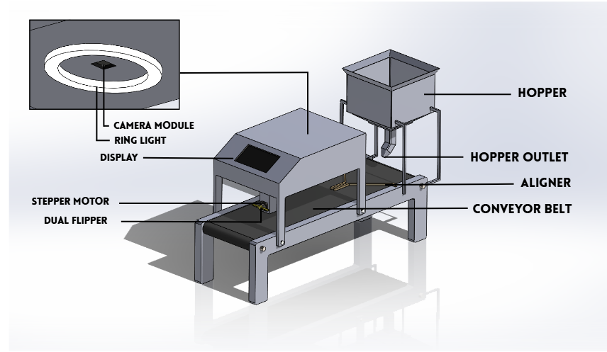

Figure 9: Design Alternative 3 - Conveyor-Based Sorting System

Circuit Design
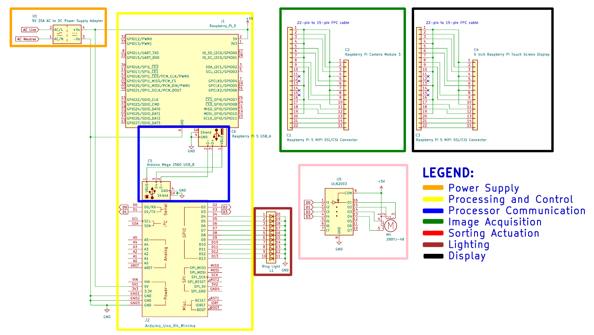

Figure 10: Design 3 Schematic Diagram

Specification of Materials to be Used
For the conveyor-based design of KakaoSort, the material specifications focus on continuous, single-file movement of cacao beans through the imaging and sorting stages. Beans are fed from the hopper into a singulation container, guided into a straight line by an aligner, and carried along a conveyor belt past the camera and ring light for classification. Two servo motors, mounted above and at the midpoint of the conveyor, use an 180-degree sweep to sort beans into the medium and large bins. These materials were selected to support higher-throughput, continuous-flow processing suited for larger batches of beans.

Table 13: Design 1 – Specifications of Materials to be Used
Materials | Quantity
Raspberry Pi 5: Model B, 4 GB  (Link) | 1
Raspberry Pi Camera Module 3  (Link) | 1
Arduino R4 Minima  (Link) | 1
Hopper  (To be fabricated) | 1
Container (For Singulation)  (To be fabricated) | 1
Aligner  (To be fabricated) | 1
552mm Mini Conveyor Belt  (Link) | 1
SG90 Micro 9g Servo Motor  (Link) | 1
Ring Light  (Link) | 1
Machine Housing (Stainless Steel)  (To be fabricated) | 1
5-inch Raspberry Pi Touch Screen Display  (Link) | 1
Chute  (To be fabricated) | 3
24V 300W DC LED Power Supply  (Link) | 1
Design Constraints
The feasibility of the system is guided by five design constraints outlined in the preceding chapter: Economic, Sustainability, Functionality, and Manufacturability, and Power Consumption. These factors directly drive the design and development choices moving forward.
Economics
This constraint accounts for the overall cost of materials required to build the prototype. After evaluating the economics, the design offering the lowest total cost while still meeting functionality requirements is chosen as the most economical.

Table 14: Design 2 Constraints – Economics
Materials | Cost (₱) | Quantity | Total (₱)
Raspberry Pi 5; 4GB  (Link) | 9,459 | 1 | 9,459
Raspberry Pi Camera Module 3  (Link) | 3,502 | 1 | 3,502
Arduino R4 Minima  (Link) | 440 | 1 | 440
552mm Mini Conveyor Belt  (Link) | 4,779 | 1 | 4,779
Hopper  (To be fabricated) | 3,000 | 1 | 3,000
Stepper Motor 28BYJ-48 with ULN2003 driver  (Link) | 125 | 1 | 125
5-inch Raspberry Pi Touch Screen Display  (Link) | 2,500 | 1 | 2,500
Ring Light  (Link) | 320 | 1 | 320
Machine Housing (stainless steel)  (To be fabricated) | 5,000 | 1 | 5,000
24V 300W DC LED Power Supply  (Link) | 326 | 1 | 326
Total |  |  | 29,451
Table 14: Design 2 Constraints – The total cost of the machine is ₱29,451 and these costs include the major electronic components, such as the servo motors, 5-inch display, machine housing, and hopper fabrication, required to construct the prototype. Overall, this total gave us the estimated budget required to implement the Design 3 proposed system, which is much more expensive than design 1 and 2.
Indirect Cost
Indirect costs cover necessary project support expenses that are not directly tied to building or component purchasing for the KakaoSort Machine. These costs support smooth operations throughout development, testing, and documentation, despite not being physical parts of the final product.
Transportation – Travel costs associated with buying materials, conducting field tests, attending consultations, and moving components or prototypes.
Supplies – Consumable items, such as paper, ink, adhesives, documentation supplies, and minor fabrication/testing tools, that are not incorporated into the final system.
Electricity – Power consumed to charge the machine’s power supply, operate tools, run testing equipment, and power devices used during project development.
Sustainability
This constraint accounts for the overall longevity of the KakaoSort Machine’s materials. It assesses the expected average lifespan of all mechanical and electronic. A higher rating signifies that the system is built with durable, high-quality materials that reduce industrial waste and enhance the long-term return on investment.

Table 15: Design 3 Constraints – Sustainability
Component | Expected Lifespan of Components (Years)
Raspberry Pi 5 (4GB)  https://www.bgr.com/2158222/how-long-do-raspberry-pi-lasts/ | 10 years
Raspberry Pi Camera Model 3  https://www.displaymodule.com/blogs/knowledge/how-long-do-ips-displays-typically-last | 5 years
Arduino R4 Minima  https://arduino.stackexchange.com/questions/37436/life-span-of-arduino | 20 years
Hopper  https://www.smetals.co.uk/how-long-will-stainless-steel-last-a-complete-guide/ | 30 years
552mm Mini Conveyor Belt  https://hitlights.com/blogs/premium-led-strip-lighting/how-long-do-led-power-supplies-last | 5 years
5-inch Raspberry Pi Touch Screen Display  https://www.origin-ic.com/blog/raspberry-pi-touchscreen/47760#heading-14 | 5.7 years
Stepper Motor 28BYJ-48  https://www.ariat-tech.com/blog/guide-to-nema-17-stepper-motors-how-they-work,advantages-and-disadvantages,how-to-use-them,and-their.html | 5 years
ULN2003 Stepper Motor Driver Board  https://easyelecmodule.com/uln2003-stepper-motor-driver-board/ | 10 years
Machine Housing (stainless steel)  https://www.smetals.co.uk/how-long-will-stainless-steel-last-a-complete-guide/ | 30 years
Ring Light  https://www.kentfaith.com.au/blog/article_how-long-do-led-ring-lights-last_466?srsltid=AfmBOootu1F__wLULdfC0GltJJzO5mUNEe1cSR8tQJYbbt--ngmwI3zc | 3 years
24V 300W DC LED Power Supply  Link | 5 years
Table 15: Design 3 Constraints – Sustainability presents the expected lifespan of the major mechanical and electronic components used in Design 3. The estimated lifespans range from 3 to 30 years, with the hopper and stainless-steel machine housing having the longest expected service life of 30 years each. The combined expected lifespan of all listed components is 128.7 years, which is used to determine the overall sustainability rating of Design 3.
Where:
Based on the estimated lifespans, the proposed system has an average expected lifespan of approximately 11.7 years. This design is much closer to design 2 and has much more expected lifespan than the design 1.
Functionality
This constraint accounts for how well the system performs its intended purpose of classifying and sorting cacao beans while allowing users to operate it without difficulty. Ease of use describes how simple and intuitive it is for the user to interact with the system’s controls, view the dashboard, and place beans on the imaging platform. A design that requires fewer steps, less learning time, and minimal user effort is considered more functional. The design with the highest ease of use is therefore chosen as the most functional.

Table 16: Design 3 Constraints – Functionality
Criteria | 5  Very Easy | 4  Easy | 3  Moderate | 2  Difficult | 1  Very Difficult | Total
User Interface / Dashboard  How easy is it to navigate and understand the dashboard? | ✔ |  |  |  |  | 5
Learning Time  How much time and effort are required to learn how to operate the system? | ✔ |  |  |  |  | 5
Manual Bean Placement  How easy is it to place cacao beans on the imaging platform? | ✔ |  |  |  |  | 5
Accessibility  How easy is it to access and review the sorting logs and records? |  |  | ✔ |  |  | 3
Total |  |  |  |  |  | 18
Table 16: Design 3 Constraints – In this design, there will be a use of 5-inch display for the user interface and dashboard as well. The User Interface/Dashboard, Learning Time, and Manual Bean Placement received a rating of 5 – Very Easy, while Accessibility received a rating of 3 – Easy. Collectively, these scores result in a total functionality score of 18, indicating that the system is designed to be easy to operate, understand, and moderately access, similar to design 2.
Manufacturability
This constraint accounts for the maximum allowable time and complexity needed to assemble the physical components, ensuring assembly stays within the ideal timeframe for hardware and software development. The design is intended to be efficient to build and service, as it uses modular components and standard fasteners that avoid the need for specialized tools or complex fabrication techniques.

Table 17: Design 3 Constraints – Manufacturability
Criteria | 1  Very Slow | 2  Slow | 3  Moderate | 4  Fast | 1  Very Fast | Total
Hardware Developing |  |  | ✔ |  |  | 3
Software Developing |  |  |  | ✔ |  | 4
Total |  |  |  |  |  | 7
Table 17: Design 2 Constraints – Hardware Developing is assigned a score of 3 – Moderate, while Software Developing is assigned a score of 4 – Fast. The hardware development involves an integration of the conveyor belt for the movement of cacao beans while in image processing, while software development involves the implementation of the YOLOv8 model, embedded control, automated logging, and user interface/dashboard for the data analytics. The individual scores are summed up to obtain a total manufacturability score of 7, indicating that Design 3 requires a moderate amount of time and effort for hardware development while its software development can be completed relatively quickly.
Power Consumption
This constraint accounts for the electrical power required to operate Design 3. It is measured by calculating the total power consumption of the system's electrical components during operation. The design with the lowest total power consumption is selected as the most suitable.

Table 18: Design 3 Constraints – Power Consumption
Electric Components | Quantity | Voltage (V) | Ampere (A) | Wattage(W)
Raspberry Pi 5: 4 GB | 1 | 5V | 5.0A | 25W
Raspberry Pi Camera Module 3 | 1 | 3V | 0.25A | 0.75W
Arduino R4 Minima | 1 | 5V | 0.25A | 1.25W
552mm Mini Conveyor Belt | 1 | 24V | 0.5A | 12W
Stepper Motor 28BYJ-48 | 1 | 5V | 0.2A | 1W
ULN2003 Stepper Motor Driver Board | 1 | 5V | 0.5A | 2.5W
Ring Light | 1 | 5V | 0.8A | 4W
5-inch Raspberry Pi Touch Screen Display | 1 | 3.3V | 0.32A | 1.056W
Total |  |  |  | 47.556W
Table 18: Design 3 Constraints – The system in Design 3 has an estimated total power consumption of 46.056 W during operation. A lower total power consumption indicates greater energy efficiency; therefore, this design is much less power usage than design 1 and 2.
Design Standards
ASEAN Standards 34:2014 - Cocoa Beans
Defines the defect and quality criteria used to classify beans as they pass single file along the conveyor belt through the imaging zone.
PNS/BAFS PAES 253:2018 - Agricultural Machinery - Cacao Huller - Specifications
Serves as a reference for the design, construction, and safety requirements of the hopper, singulation container, aligner, and conveyor housing used to move beans continuously through the system.
ISO 15003:2019 - Agricultural Engineering - Electrical and Electronic Equipment - Testing Resistance to Environmental Conditions
Ensures that the conveyor drive motor, sorting servo motors, camera, and Raspberry Pi maintain reliable operation under the continuous mechanical motion and dust exposure typical of conveyor-based post-harvest processing.
IEEE 29119 - Software and System Testing Standards
Guides the testing procedures used to validate the throughput of this design, supporting the comparison of its continuous-flow processing speed against traditional manual sorting methods.
IEEE 2755 - Standard for Artificial Intelligence and Machine Learning
Provides the terminology and conceptual framework applied in structuring the YOLOv8-based object detection model that classifies beans as they move single-file along the conveyor, ensuring consistent understanding of defect classes and detection outputs throughout development.
ISO/IEC 25010 - Systems and Software Quality Requirements and Evaluation
Supports evaluation of the software quality attributes, particularly performance efficiency and reliability, needed to sustain real-time classification and servo actuation as beans move continuously along the conveyor.
IEEE 1012 - Standard for System, Software, and Hardware Verification and Validation
Guides the verification and validation of the classification model and the conveyor-and-servo sorting mechanism prior to deployment, confirming that detection accuracy and bin-sorting placement meet the design's intended objectives.
ISO 9241 - Ergonomics of Human-System Interaction
Guides the layout of the Raspberry Pi touch display used to present classification results and system controls to the operator, ensuring the interface remains clear during continuous conveyor-based sorting operation.

Software Design
The software design applied to the design alternatives consists of machine vision, image processing, classification, size measurement, sorting decision, motor control, automated logging, and user interface components. The image processing application is developed in Python and runs on Raspberry Pi OS installed on Raspberry Pi 5, while the Arduino IDE is used to develop the firmware for motor control and other hardware operations performed by the Arduino Uno R4 Minima. YOLOv8 is utilized for cacao bean detection and classification, while the software coordinates the resulting data with the size measurement, sorting decision, motor control, and automated logging processes. The user interface provides a means of monitoring the system and displaying relevant classification and sorting results throughout the sorting process.

Software Development Life Cycle
The study applies the Iterative Model (see Figure 11) as the software development life cycle. The system requires repeated testing and evaluation of its YOLOv8 detection, quality classification, size measurement, sorting decision, motor control, automated logging, and user interface components to achieve the desired system performance. Feedback from the client and evaluation results can then be incorporated into subsequent iterations, allowing the software design to be refined throughout the development process.
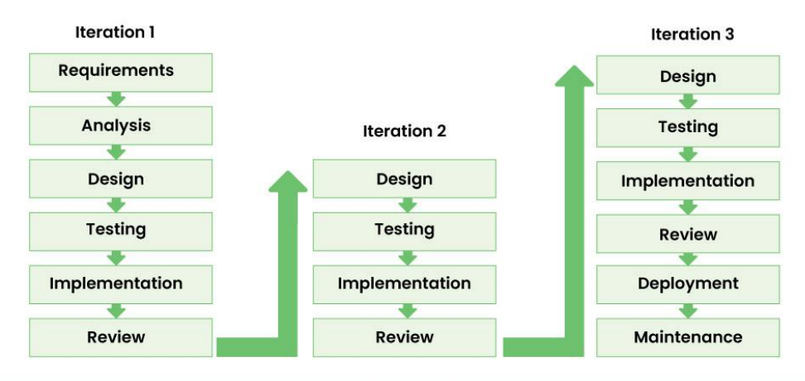

Figure 11: Iterative Software Development Model
1. Requirements & Analysis: The functional, technical, and performan ce requirements of the proposed system are identified and analyzed based on the objectives of the study. This includes determining the requirements for machine vision, bean classification, size measurement, sorting, hardware control, automated logging, and user interaction. The identified requirements serve as the basis for developing the overall system design.
2. Design: A preliminary design of the overall system is developed based on the identified requirements. This includes planning the software architecture, electronic components, mechanical structure, machine vision setup, and integration between the different subsystems. The design may be revised based on the results of testing and evaluation.
3. Testing: The proposed designs and individual components are evaluated to determine their suitability before full implementation. Preliminary testing includes evaluating the YOLOv8 model, camera and lighting setup, size measurement approach, actuator operation, and selected hardware components. Problems identified during testing provide feedback that may be used to revise the system design.
4. Implementation: The system is developed and assembled based on the evaluated design. This includes implementing the software, training and integrating the YOLOv8 model, configuring the electronic components, and constructing the mechanical components. The developed components are then integrated to form the complete prototype.
5. Review: The implemented system is evaluated based on the testing results, system operation, and feedback from the client. Identified problems and areas for improvement are analyzed, and necessary modifications are made to the software, hardware, mechanical components, or their integration. The revised system then proceeds through another iteration of the development process.
6. Deployment & Maintenance: The completed prototype is deployed for final evaluation and operation. The system's performance and reliability are monitored during operation, and necessary corrections or improvements are made to maintain its functionality and performance.

System Algorithm
The study presents the pseudocode below that describes the sequence of operations to be followed by the automated cacao bean sorting system. The pseudocode defines the system's processes, decisions, inputs, and outputs from system initialization until the sorting process is stopped by the user.
START
Initialize the system
Display the system dashboard
Wait for user to load a cacao bean batch.
Wait for user to start the sorting process
WHILE(sorting process is active) DO
Feed one cacao bean into the imaging area.
Detect the cacao bean using the camera.
IF(cacao bean detected) THEN
Capture the image of the cacao bean.
Process the captured image.
Detect and classify the cacao bean using YOLOv8.
IF(cacao bean is defective) THEN
Classify the bean as DEFECTIVE.
Activate the corresponding sorting component.
ELSE
Measure the size of the cacao bean.
IF(cacao bean is within the medium-size range) THEN
Classify the bean as MEDIUM.
Activate the corresponding sorting component.
ELSE
Classify the bean as LARGE.
Activate the corresponding sorting component.
END IF
END IF
Display the sorting information on the dashboard.
Store the cacao bean sorting record in the database.
Update the sorting statistics.
END IF
Check whether the user has stopped the sorting process.
END WHILE
Display the final sorting information and statistics.
END

Data Flow Diagram
Figure 12 illustrates the level 0 data flow diagram of the design project. It shows the interaction and flow of data between the user, the system, the sorting component, and the database.
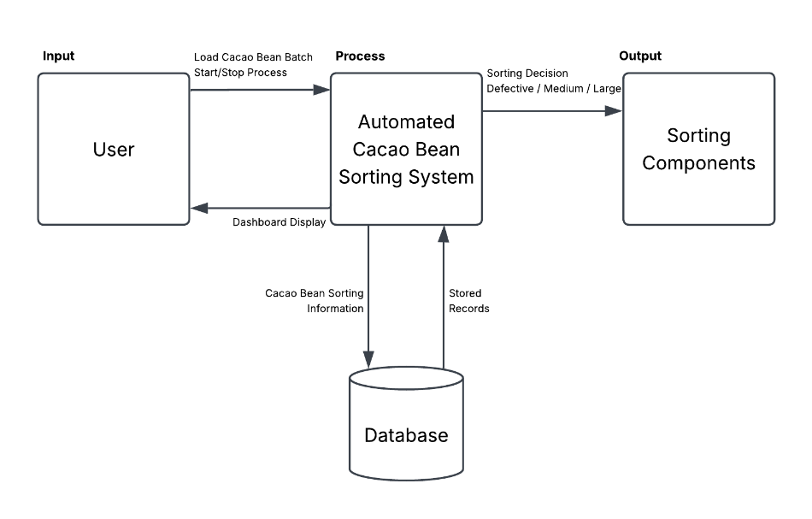

Figure 12: Context Diagram
The user provides inputs such as loading a cacao bean batch and starting or stopping the sorting process. The system processes the cacao beans and generates sorting decisions, classifying them as defective, medium, or large, which are sent to the sorting components. The system also provides dashboard displays containing cacao bean sorting information to the user and stores the corresponding sorting records in the database for recording and monitoring purposes.

Design Analysis and Trade-offs
This chapter presents the design analysis and trade-offs involved in developing the KakaoSort: Automated Cacao Defect Detection and Size Sorting Using Embedded Machine Vision System. It begins with an overview of the design constraints used to assess the proposed designs, followed by a detailed comparison of their performance in terms of economic cost, power consumption, sustainability, manufacturability, and functionality. The chapter also presents the scoring and normalization methods used to compare the three alternative designs and determine their overall performance. The results of the trade-off analysis are used to identify the design that best meets the project requirements and the needs of the intended users.

Summary of Constraints
Design constraints establish the limitations of the project and guide the selection of the best solution from the available alternatives. This project is primarily guided by considerations related to Economic Cost, Power Consumption, Sustainability, Manufacturability, and Functionality.

Table 19: Summary of Constraints
Designs | Economic Cost | Power Consumption | Sustainability | Manufacturability | Functionality
Design 1: Robotic Arm-Based | ₱25133 | 54.750 W | 10.22 years | 6 | 19
Design 2:  5-Channel | ₱26,655 | 61.306 W | 11.07 years | 6 | 18
Design 3: Conveyor-Based | ₱29,451 | 47.556 W | 11.70 years | 7 | 18
As shown in Table 19, the three designs present clear trade-offs among Material Cost, Power Consumption, Average Lifespan, Manufacturability, and Functionality. Design 1 (Robotic Arm-Based) is the most economical, with the lowest material cost of ₱25,133, and is the easiest to use, achieving the highest functionality score of 19. However, it has the shortest average lifespan of 10.22 years. Design 2 (5-Channel) has a material cost of ₱26,655 and an average lifespan of 11.07 years, but it has the highest power consumption at 61.306 W. Both Design 1 and Design 2 obtained a manufacturability score of 6. Design 3 (Conveyor-Based), while having the highest material cost of ₱29,451, provides the longest average lifespan of 11.70 years, the lowest power consumption of 47.556 W, and the highest manufacturability score of 7, making it the most favorable in terms of lifespan, energy consumption, and development and assembly time. In terms of functionality, Design 2 and Design 3 both obtained a score of 18, slightly lower than Design 1's score of 19.

Design Tradeoff Analysis
Design trade-offs are used to evaluate the three proposed KakaoSort Machine designs by comparing their strengths and weaknesses across the defined design constraints. Since no single design can achieve the best performance in all criteria, the trade-off analysis helps determine which alternative provides the best overall performance based on the project requirements. The five constraints considered are Economic, Power Consumption, Sustainability, Manufacturability, and Functionality.
To ensure a fair and systematic comparison, each constraint is evaluated according to its preference direction. Economic and Power Consumption, follow a minimization preference, where a lower value indicates better performance. Meanwhile, Sustainability, Functionality, and Manufacturability follow a maximization preference, where a higher value represents better performance.
The trade-off analysis uses a normalization approach to convert the raw values of the three designs into comparable scores based on their respective preference directions. The normalized values are calculated using either a minimization or maximization equation, depending on the nature of each constraint. Economic and Power Consumption use the minimization approach, where lower values receive higher normalized scores. Meanwhile, Sustainability, Functionality, and Manufacturability use the maximization approach, where higher values receive higher normalized scores. The normalized scores are then combined with the assigned percentage importance of each constraint to determine the overall score of each design. The design with the highest overall score is considered the most favorable alternative based on the defined project requirements.
For criteria that follow a maximization preference, the following equation is used:
Equation 4.1
For criteria that follow a minimization preference, the following equation is used:
Equation 4.2
Where:
After normalizing the raw values according to their respective preference directions, the normalized scores are combined using their corresponding importance percentages. The overall score of each design is calculated using:
Equation 4.3
Where:

Table 20: Preference and Importance of the Design Constraints
Constraint | Preference | Importance (raw) | % Importance
Economic Cost | Minimization | 7 | 16.67%
Sustainability | Maximization | 9 | 21.43%
Manufacturability | Maximization | 10 | 23.81%
Functionality | Maximization | 8 | 19.05%
Power Consumption | Minimization | 8 | 19.05%

Trade-offs Analysis 1: Economic Cost
Economic accounts for the overall cost required to build and develop the KakaoSort Machine, including the electronic components, motors, fabricated parts, and application development expenses associated with each design. Since this constraint follows a minimization preference, the design with the lowest overall cost, representing the most cost-efficient use of resources, is considered the most economical design.

Table 21: Economic Cost of the Three (3) Proposed Designs
Design No. | Design | Economic Cost
1 | Robotic Arm-based | ₱25,133
2 | 5-Channel | ₱26,655
3 | Conveyor-based | ₱29,451
Table 21 presents the total economic cost of the three proposed designs based on the electronic components, motors, fabricated parts, and application development expenses required to build the KakaoSort Machine. Design 1: Robotic Arm-based has a total cost of ₱25,133, indicating the lowest overall expense among the three designs. Design 2: 5-Channel has a total cost of ₱26,655, while Design 3: Conveyor-based has the highest total cost of ₱29,451, indicating the least favorable economic design.
Since economics follows a minimizing preference, a lower cost represents a more cost-efficient design. Therefore, Design 1 ranks first, followed by Design 2, while Design 3 ranks last under this constraint.
Design 1: Economic Normalization (Minimization)
The total cost for Design 1 is ₱25,133. The highest value among the economic constraint is ₱29,451, while the lowest value is ₱25,133.
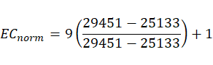
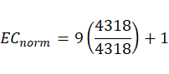
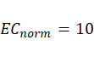
With the economic constraint, using equation 4.2, the normalized value of Design 1 is 10.00.
Design 2: Economic Normalization (Minimization)
The total cost for Design 2 is ₱26,655. The highest value among the economic constraint is ₱29,451, while the lowest value is ₱25,133
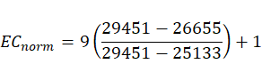
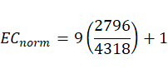
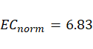
With the economic constraint, using equation 4.2, the normalized value of Design 2 is 6.14.
Design 3: Economic Normalization (Minimization)
The total cost for Design 3 is ₱29,451. The highest value among the economic constraint is ₱29,451, while the lowest value is ₱24,243
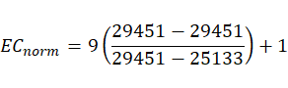
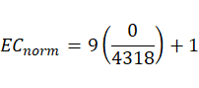
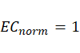
With the economic constraint, using equation 4.2, the normalized value of Design 1 is 1.00.

Trade-offs Analysis 2: Sustainability
Sustainability accounts for the overall longevity of the KakaoSort Machine’s materials. It assesses the expected average lifespan of all mechanical and electronic components. Since this constraint follows a maximization preference, the design with the highest sustainability score, representing more durable materials and greater long-term usability, is considered the most sustainable design.

Table 22: Sustainability of the Three (3) Proposed Designs
Design No. | Design | Sustainability
1 | Robotic Arm-based | 11.4 years
2 | 5-Channel | 12.37 years
3 | Conveyor-based | 11.7 years
Design 1: Sustainability Normalization (Maximization)
The sustainability score for Design 1 is 11.4. The highest value among the sustainability constraint is 12.37, while the lowest value is 11.4.
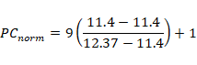
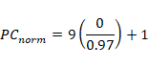
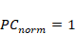
With the sustainability constraint, using equation 4.1, the normalized value of Design 1 is 1.00.
Design 2: Sustainability Normalization (Maximization)
The sustainability score for Design 2 is 11.07. The highest value among the sustainability constraint is 11.70, while the lowest value is 11.4.
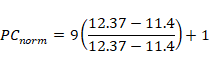
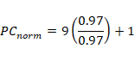
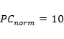
With the sustainability constraint, using equation 4.1, the normalized value of Design 2 is 10.00.
Design 3: Sustainability Normalization (Maximization)
The sustainability score for Design 3 is 11.7. The highest value among the sustainability constraint is 12.37, while the lowest value is 10.22.
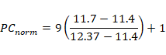
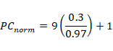
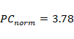
With the sustainability constraint, using equation 4.1, the normalized value of Design 3 is 3.78.

Trade-offs Analysis 3: Functionality
Functionality accounts for how well the sorting machine performs its intended purpose while allowing users to operate the system without difficulty. The functionality is evaluated based on the ease of navigating the user interface and dashboard, the time and effort required to learn the system, the ease of manually placing cacao beans on the imaging platform, and the accessibility of sorting logs and records. Since this constraint follows a maximization preference, the design with the highest functionality score, representing greater ease of use and user accessibility, is considered the most functional design.

Table 23: Functionality of the Three (3) Proposed Designs
Design No. | Design | Functionality
1 | Robotic Arm-based | 19
2 | 5-Channel | 18
3 | Conveyor-based | 18
Table 23 presents the functionality scores of the three proposed designs based on the ease of operation and user interaction with the cacao bean sorting machine. Design 1: Robotic Arm-based has a functionality score of 19, indicating the highest level of ease of use among the three designs. Design 2: 5-Channel and Design 3: Conveyor-based both have a score of 18, indicating similar levels of functionality. Since functionality follows a maximization preference, a higher score represents greater ease of use and accessibility. Therefore, Design 1 ranks first, while Design 2 and Design 3 are tied for second under this constraint.
Design 1: Functionality Normalization (Maximization)
The functionality score for Design 1 is 19. The highest value among the functionality constraint is 19, while the lowest value is 18.
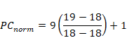
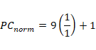
With the functionality constraint, using equation 4.1, the normalized value of Design 1 is 10.00.
Design 2: Functionality Normalization (Maximization)
The functionality score for Design 2 is 18. The highest value among the functionality constraint is 19, while the lowest value is 18.
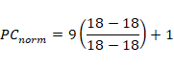
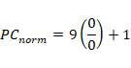
With the functionality constraint, using equation 4.1, the normalized value of Design 2 is 1.00.
Design 3: Functionality Normalization (Maximization)
The functionality score for Design 3 is 18. The highest value among the functionality constraint is 19, while the lowest value is 18.
With the functionality constraint, using equation 4.1, the normalized value of Design 3 is 1.00.

Trade-offs Analysis 3: Manufacturability
Manufacturability accounts for the time required to build the sorting machine using the tools, materials, and assembly methods involved in its construction. The assembly period is described to measure the total time required to put all components of the system together, including the hardware integration of the exit ramps and electronics. Since this constraint follows a maximization preference, the design with the highest manufacturability score, representing faster and easier development and assembly, is considered the most manufacturable design.

Table 24: Manufacturability of the Three (3) Proposed Designs
Design No. | Design | Manufacturability
1 | Robotic Arm-based | 6
2 | 5-Channel | 6
3 | Conveyor-based | 7
Table 24 presents the manufacturability scores of the three proposed designs based on the time and complexity required to develop and assemble the cacao bean sorting machine in hardware and software. Design 1: Robotic Arm-based has a manufacturability score of 6, indicating the lowest development and assembly speed among the three designs. Design 2: 5-Channel has a score of 6, while Design 3: Conveyor-based has the highest score of 6, indicating the most favorable manufacturability performance is design 7.
Since manufacturability follows a maximization preference, a higher score represents faster and easier development and assembly. Therefore, Design 3 ranks first, followed by Design 1 and 3.
Design 1: Manufacturability Normalization (Maximization)
The manufacturability score for Design 1 is 6. The highest value among the manufacturability constraint is 7, while the lowest value is 6.
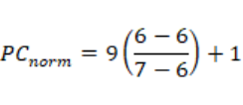
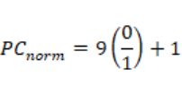
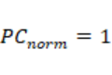
With the manufacturability constraint, using equation 4.1, the normalized value of Design 1 is 1.00.
Design 2: Manufacturability Normalization (Maximization)
The manufacturability score for Design 2 is 6. The highest value among the manufacturability constraint is 7, while the lowest value is 6.
With the manufacturability constraint, using equation 4.1, the normalized value of Design 2 is 1.00.
Design 3: Manufacturability Normalization (Maximization)
The manufacturability score for Design 3 is 7. The highest value among the manufacturability constraint is 7, while the lowest value is 6.
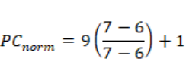
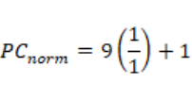
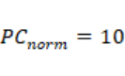
With the manufacturability constraint, using equation 4.1, the normalized value of Design 3 is 10.

Trade-offs Analysis 3: Power Consumption
Power Consumption accounts for the electrical power required to operate the sorting machine. It is measured by calculating the total power consumption of the system's electrical components during operation. Since this constraint follows a minimization preference, the design with the lowest total power consumption, representing greater energy efficiency, is considered the most favorable design.

Table 25: Power Consumption of the Three (3) Proposed Designs
Design No. | Design | Power Consumption (W)
1 | Robotic Arm-based | 54.75 W
2 | 5-Channel | 60.056 W
3 | Conveyor-based | 47.556 W
The power consumption of the three proposed designs based on the combined wattage of their electrical components. Design 3: Conveyor-based has the lowest power consumption at 47.556 W, indicating the highest energy efficiency among the three designs. Design 1: Robotic Arm-based consumes 54.750 W, while Design 2: 5-Channel has the highest power consumption at 61.306 W, indicating the least favorable energy efficiency. Since power consumption follows a minimization preference, a lower value represents better performance. Therefore, Design 3 ranks first, followed by Design 1, while Design 2 ranks last under this constraint.
Design 1: Power Consumption Normalization (Minimization)
The power consumption value for Design 1 is 54.750. The highest value among the power consumption constraint is 61.306, while the lowest value is 47.556.
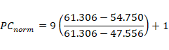
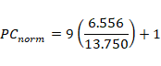
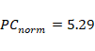
Design 2: Power Consumption Normalization (Minimization)
The power consumption value for Design 2 is 61.306. The highest value among the power consumption constraint is 61.306, while the lowest value is 47.556.
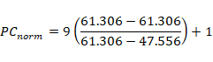
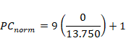
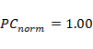
Design 3: Power Consumption Normalization (Minimization)
The power consumption value for Design 3 is 47.556. The highest value among the power consumption constraint is 61.306, while the lowest value is 47.556.
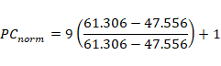
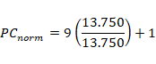
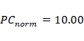

Normalized values of the Three Designs
The summary of the normalized values of each design helps show the trade-offs. We evaluated each design's performance using these values across five (5) design constraints: Economic, Sustainability, Manufacturability, Functionality, and Power Consumption. Next, we multiplied these normalized values by their percentage importance and added them up to get the total score for each design.

Table 26: Normalized Values of the Three (3) Designs
Constraints | Design
Constraints | Design 1: Robotic Arm-based | Design 2:  5-Channel | Design 3: Conveyor-based
Economic | 10 | 6.83 | 1
Sustainability | 1 | 10 | 3.78
Manufacturability | 1 | 1 | 10
Functionality | 10 | 1 | 1
Power Consumption | 5.29 | 1 | 10
Table 26 shows the summarized normalized values of the five constraints for each of the three proposed designs. Design 1 Robotic Arm-based obtains the highest normalized values in Economic (10) and Functionality (10), while it receives the lowest values in Sustainability (1) and Manufacturability (1). Its Power Consumption obtains a normalized value of 5.29, indicating an intermediate performance compared with the other designs. Design 2 5-Channel obtains its highest normalized value in Manufacturability (10), followed by Sustainability (6.16) and Economic (6.83). It receives the lowest normalized values of 1 in both Functionality and Power Consumption. Design 3 Conveyor-based obtains the highest normalized values in Sustainability (10) and Power Consumption (10). It receives a normalized value of 5.5 in Manufacturability, while both Economic and Functionality obtain the lowest value of 1.
Equation 4.3 was used to calculate the overall score of each design from these normalized values.
Computing for the score of design one (1) robotic arm-based:
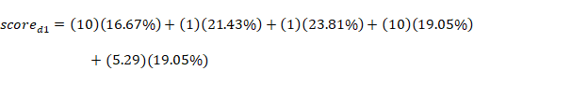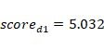
The score of design 1 is 5.032
Computing for the score of design two (2) 5-Channel:
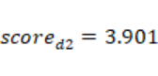
The score of design 2 is 3.901
Computing for the score of design three (3) conveyor-based:
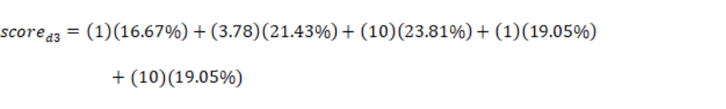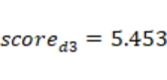
The score of design 3 is 5.453

Table 27: Scores of the Three (3) Proposed Designs
Design No. | Design | Score
1 | Robotic Arm-based | 5.032
2 | 5-Channel | 3.901
3 | Conveyor-based | 5.453

Designer’s Raw Ranking of the Three Designs
The average percentage for the three designs is based on how the designers ranked each restriction and variable. The designers gathered the table data to show the trade-offs, then added up the total values and divided them to get the overall average.

Table 28: Designer’s Raw Ranking for the Three (3) Proposed Designs
Constraints | Criterion Importance |  | Design Alternatives
Constraints | Raw | Percentage | Design 1 | Design 2 | Design 3
Economic | 7 | 16.667% | 10 | 6.83 | 1
Sustainability | 9 | 21.43% | 1 | 10 | 3.78
Manufacturability | 10 | 23.81% | 1 | 1 | 10
Functionality | 8 | 19.05% | 10 | 1 | 1
Power Consumption | 8 | 19.05% | 5.29 | 1 | 10
Total | 42 | 100% | 5.032 | 3.901 | 5.453
Table 28 presents the importance levels assigned to each design constraint and the normalized scores obtained by the three proposed designs. Among the five constraints, Manufacturability received the highest importance score of 10, followed by Sustainability with 9. Functionality and Power Consumption were each assigned an importance score of 8, while Economic received a score of 7. These values represent the group’s assessment of how strongly each constraint should influence the selection of the final design.
The raw ranking shows how each design performs across the five constraints based on their normalized values. Design 1: Robotic Arm-based obtained the highest scores in Economic (10) and Functionality (10), while receiving a Power Consumption score of 5.29. Design 2: 5-Channel obtained the highest score in Sustainability (10) but received the lowest scores of 1 in Manufacturability, Functionality, and Power Consumption. Design 3: Conveyor-based obtained the highest scores in Manufacturability (10) and Power Consumption (10), while receiving a Sustainability score of 3.78.
Based on the weighted ranking, Design 3 obtained the highest overall score of 5.453, followed by Design 1 with 5.033, while Design 2 obtained 3.901. Design 3's high scores in Manufacturability and Power Consumption contributed to its leading weighted score, while Design 1 performed strongly in Economic and Functionality. Design 2 performed best in Sustainability but received lower scores across the other constraints. Based on the assigned importance weights and normalized values, Design 3: Conveyor-based ranked first, followed by Design 1: Robotic Arm-based, while Design 2: 5-Channel ranked third.

Influence of Design Trade-offs in the Final Design
The influence of the design trade-offs is determined by evaluating the normalized values, designer preferences, and the total weighted scores of each design. These trade-offs help identify which design best satisfies the client’s requirements by balancing cost, efficiency, manufacturability, usability, and component lifespan. By analyzing how each constraint contributes to the final score, the decision-making process becomes systematic and aligned with the priorities established in the earlier sections.
Based on the results of the trade-off analysis and the weighted computations, Design 3: Conveyor-Based System achieved the highest overall score, making it the most suitable design. Design 3 performed exceptionally well in the most important constraints, specifically Power Consumption, Sustainability, and Manufacturability, which collectively contributed a significant portion of the design’s total weight. Since these constraints were assigned high importance percentages, Design 3 benefited greatly from having the most energy-efficient operation, the highest expected structural lifespan, and stable single-file transport for reliable real-time classification among the three alternatives.
Design 1: Robotic Arm-Based System ranked second. Although it excelled in Economic Cost and offered basic functional viability, its lower throughput, mechanical complexity, and higher power demands reduced its weighted score.
Design 2: 5-Channel System had the lowest overall score. While it demonstrated strong performance in Manufacturability and mechanical simplicity, it scored poorly in consistent pod orientation, image stability, and overall system functionality. These weaknesses significantly impacted its standing, especially because stable image acquisition for YOLOv8 classification is prioritized highly based on raw importance ratings.
In conclusion, the trade-off evaluation clearly indicates that Design 3 is the optimal choice, as it best satisfies the client’s requirements and provides the highest overall performance across the weighted constraints. Its advantage in the most critical design parameters demonstrates that it offers the best balance between energy efficiency, long-term sustainability, ease of manufacturing, and overall system practicality.

Sensitive Analysis
Sensitivity analysis was conducted to determine whether the ranking of the three design alternatives remains stable when the importance assigned to the decision criteria is varied. The analysis considers accuracy, detection time, computational efficiency, memory utilization, and reliability as the five decision criteria. Ten iterations were performed by varying the weights assigned to these criteria while maintaining a constant total weight of 40 for every iteration. This approach allows different decision-priority scenarios to be evaluated while keeping the overall weighting basis consistent. The resulting scores and rankings of the three design alternatives were then compared across all iterations to determine the stability and robustness of the selected design.

4.6.1 Iteration 1: 10-6-7-8-9 Importance Weight Combination
In Iteration 1, the weights assigned to Economic Cost, Power Consumption, Sustainability, Manufacturability, and Functionality are 10, 9, 8, 7, and 8, respectively, as shown in Table 29.

Table 29: Iteration 1. 10-6-7-8-9 Importance Weight Combination
Decision Criteria | Criteria Importance (0–10) | Percentage (%) | Ability to Satisfy the Criterion (0–10)
Decision Criteria | Criteria Importance (0–10) | Percentage (%) | Design 1 | Design 2 | Design 3
Accuracy | 10 | 25.00% | 0.9984 | 0.9738
Detection Time | 6 | 15.00% | 62.8 | 67.73 | 1.00
Computational Efficiency | 7 | 17.50% | 140 | 73 | 1.00
Memory Utilization | 8 | 20.00% | 2582932 | 3758900 | 5.33
Reliability | 9 | 22.50% | 0.9897 | 0.9505 | 10.00
Total | 40 | 100.00% | 2583136.578 | 3759042.554 | 3193354.371
Table 29 shows the results of Iteration 1 based on the assigned importance weights. Design 1 obtained a total score of 5.78, while Design 2 obtained 4.103 and Design 3 obtained 4.959. Based on these results, Design 1 obtained the highest total score and was therefore ranked first in Iteration 1.

4.6.2 Iteration 2: 9-10-8-8-7 Importance Weight Combination
In Iteration 2, the weights assigned to Economic Cost, Power Consumption, Sustainability, Manufacturability, and Functionality are 9, 10, 8, 8, and 7, respectively, as shown in Table 30.

Table 30: Iteration 2. 9-10-8-8-7 Importance Weight Combination
Decision Criteria | Criteria Importance (0–10) | Percentage (%) | Ability to Satisfy the Criterion (0–10)
Decision Criteria | Criteria Importance (0–10) | Percentage (%) | Design 1 | Design 2 | Design 3
Accuracy | 9 | 21.43% | 10 | 6.83 | 1
Detection Time | 10 | 23.81% | 5.29 | 1 | 10
Computational Efficiency | 8 | 19.05% | 1 | 10 | 3.78
Memory Utilization | 8 | 19.05% | 1 | 1 | 10
Reliability | 7 | 16.67% | 10 | 1 | 1
Total | 42 | 100.00% | 5.45 | 3.96 | 5.39
Table 30 shows the results of Iteration 2 based on the assigned importance weights. Design 1 obtained a total score of 5.45, while Design 2 obtained 3.96 and Design 3 obtained 5.39. Based on these results, Design 1 obtained the highest total score and was therefore ranked first in Iteration 2.

4.6.3 Iteration 3: 8-9-10-8-7 Importance Weight Combination
In Iteration 3, the weights assigned to Economic Cost, Power Consumption, Sustainability, Manufacturability, and Functionality are 8, 9, 10, 8, and 7, respectively, as shown in Table 31.

Table 31: Iteration 3. 8-9-10-8-7 Importance Weight Combination
Decision Criteria | Criteria Importance (0–10) | Percentage (%) | Ability to Satisfy the Criterion (0–10)
Decision Criteria | Criteria Importance (0–10) | Percentage (%) | Design 1 | Design 2 | Design 3
Accuracy | 8 | 19.05% | 10 | 6.83 | 1
Detection Time | 9 | 21.43% | 5.29 | 1 | 10
Computational Efficiency | 10 | 23.81% | 1 | 10 | 3.78
Memory Utilization | 8 | 19.05% | 1 | 1 | 10
Reliability | 7 | 16.67% | 10 | 1 | 1
Total | 42 | 100.00% | 5.13 | 4.25 | 5.31
Table 31 shows the results of Iteration 3 based on the assigned importance weights. Design 1 obtained a total score of 5.13, while Design 2 obtained 4.25 and Design 3 obtained 5.31. Based on these results, Design 3 obtained the highest total score and was therefore ranked first in Iteration 3.

4.6.4 Iteration 4: 7-8-9-10-8 Importance Weight Combination
In Iteration 4, the weights assigned to Economic Cost, Power Consumption, Sustainability, Manufacturability, and Functionality are 7, 8, 9, 10, and 8, respectively, as shown in Table 32.

Table 32: Iteration 4. 7-8-9-10-8 Importance Weight Combination
Decision Criteria | Criteria Importance (0–10) | Percentage (%) | Ability to Satisfy the Criterion (0–10)
Decision Criteria | Criteria Importance (0–10) | Percentage (%) | Design 1 | Design 2 | Design 3
Accuracy | 7 | 16.67% | 10 | 6.83 | 1
Detection Time | 8 | 19.05% | 5.29 | 1 | 10
Computational Efficiency | 9 | 21.43% | 1 | 10 | 3.78
Memory Utilization | 10 | 23.81% | 1 | 1 | 10
Reliability | 8 | 19.05% | 10 | 1 | 1
Total | 42 | 100.00% | 5.032 | 3.901 | 5.453
Table 32 shows the results of Iteration 4 based on the assigned importance weights. Design 1 obtained a total score of 5.33, while Design 2 obtained 3.901 and Design 3 obtained 5.45. Based on these results, Design 3 obtained the highest total score and was therefore ranked first in Iteration 4.

4.6.5 Iteration 5: 8-7-8-9-10 Importance Weight Combination
In Iteration 5, the weights assigned to Economic Cost, Power Consumption, Sustainability, Manufacturability, and Functionality are 8, 7, 8, 9, and 10, respectively, as shown in Table 33.

Table 33: Iteration 5. 8-7-8-9-10 Importance Weight Combination
Decision Criteria | Criteria Importance (0–10) | Percentage (%) | Ability to Satisfy the Criterion (0–10)
Decision Criteria | Criteria Importance (0–10) | Percentage (%) | Design 1 | Design 2 | Design 3
Accuracy | 8 | 19.05% | 10 | 6.83 | 1
Detection Time | 7 | 16.67% | 5.29 | 1 | 10
Computational Efficiency | 8 | 19.05% | 1 | 10 | 3.78
Memory Utilization | 9 | 21.43% | 1 | 1 | 10
Reliability | 10 | 23.81% | 10 | 1 | 1
Total | 42 | 100.00% | 5.57 | 3.83 | 4.959
Table 33 shows the results of Iteration 5 based on the assigned importance weights. Design 1 obtained a total score of 5.57, while Design 2 obtained 3.83 and Design 3 obtained 4.595. Based on these results, Design 1 obtained the highest total score and was therefore ranked first in Iteration 5.

4.6.6 Iteration 6: 10-8-7-8-9 Importance Weight Combination
In Iteration 6, the weights assigned to Economic Cost, Power Consumption, Sustainability, Manufacturability, and Functionality are 10, 8, 7, 8, and 9, respectively, as shown in Table 34.

Table 34: Iteration 6. 10-8-7-8-9 Importance Weight Combination
Decision Criteria | Criteria Importance (0–10) | Percentage (%) | Ability to Satisfy the Criterion (0–10)
Decision Criteria | Criteria Importance (0–10) | Percentage (%) | Design 1 | Design 2 | Design 3
Accuracy | 10 | 23.81% | 10 | 6.83 | 1
Detection Time | 8 | 19.05% | 5.29 | 1 | 10
Computational Efficiency | 7 | 16.67% | 1 | 10 | 3.78
Memory Utilization | 8 | 19.05% | 1 | 1 | 10
Reliability | 9 | 21.43% | 10 | 1 | 1
Total | 42 | 100.00% | 5.89 | 3.889 | 4.893
Table 34 shows the results of Iteration 6 based on the assigned importance weights. Design 1 obtained a total score of 5.89, while Design 2 obtained 3.889 and Design 3 obtained 4.893. Based on these results, Design 1 obtained the highest total score and was therefore ranked first in Iteration 6.

4.6.7 Iteration 7: 9-7-10-8-8 Importance Weight Combination
In Iteration 7, the weights assigned to Economic Cost, Power Consumption, Sustainability, Manufacturability, and Functionality are 9, 7, 10, 8, and 8, respectively, as shown in Table 35.
Table 35: Iteration 7. 9-7-10-8-8 Importance Weight Combination
Decision Criteria | Criteria Importance (0–10) | Percentage (%) | Ability to Satisfy the Criterion (0–10)
Decision Criteria | Criteria Importance (0–10) | Percentage (%) | Design 1 | Design 2 | Design 3
Accuracy | 9 | 21.43% | 10 | 6.83 | 1
Detection Time | 7 | 16.67% | 5.29 | 1 | 10
Computational Efficiency | 10 | 23.81% | 1 | 10 | 3.78
Memory Utilization | 8 | 19.05% | 1 | 1 | 10
Reliability | 8 | 19.05% | 10 | 1 | 1
Total | 42 | 100.00% | 5.36 | 4.39 | 4.88
Table 35 shows the results of Iteration 7 based on the assigned importance weights. Design 1 obtained a total score of 5.36, while Design 2 obtained 4.39 and Design 3 obtained 4.88. Based on these results, Design 1 obtained the highest total score and was therefore ranked first in Iteration 7.

4.6.8 Iteration 8: 8-10-9-7-8 Importance Weight Combination
In Iteration 8, the weights assigned to Economic Cost, Power Consumption, Sustainability, Manufacturability, and Functionality are 8, 10, 9, 7, and 8, respectively, as shown in Table 36.

Table 36: Iteration 8. 8-10-9-7-8 Importance Weight Combination
Decision Criteria | Criteria Importance (0–10) | Percentage (%) | Ability to Satisfy the Criterion (0–10)
Decision Criteria | Criteria Importance (0–10) | Percentage (%) | Design 1 | Design 2 | Design 3
Accuracy | 8 | 19.05% | 10 | 6.83 | 1
Detection Time | 10 | 23.81% | 5.29 | 1 | 10
Computational Efficiency | 9 | 21.43% | 1 | 10 | 3.78
Memory Utilization | 7 | 16.67% | 1 | 1 | 10
Reliability | 8 | 19.05% | 10 | 1 | 1
Total | 42 | 100.00% | 5.45 | 4.039 | 5.239
Table 36 shows the results of Iteration 8 based on the assigned importance weights. Design 1 obtained a total score of 5.451, while Design 2 obtained 4.039 and Design 3 obtained 5.239. Based on these results, Design 1 obtained the highest total score and was therefore ranked first in Iteration 8.

4.6.9 Iteration 9: 7-8-8-9-10 Importance Weight Combination
In Iteration 9, the weights assigned to Economic Cost, Power Consumption, Sustainability, Manufacturability, and Functionality are 7, 8, 8, 9, and 10, respectively, as shown in Table 37.

Table 37: Iteration 9. 7-8-8-9-10 Importance Weight Combination
Decision Criteria | Criteria Importance (0–10) | Percentage (%) | Ability to Satisfy the Criterion (0–10)
Decision Criteria | Criteria Importance (0–10) | Percentage (%) | Design 1 | Design 2 | Design 3
Accuracy | 7 | 16.67% | 10 | 6.83 | 1
Detection Time | 8 | 19.05% | 5.29 | 1 | 10
Computational Efficiency | 8 | 19.05% | 1 | 10 | 3.78
Memory Utilization | 9 | 21.43% | 1 | 1 | 10
Reliability | 10 | 23.81% | 10 | 1 | 1
Total | 42 | 100.00% | 5.46 | 3.69 | 5.17
Table 37 shows the results of Iteration 9 based on the assigned importance weights. Design 1 obtained a total score of 5.46, while Design 2 obtained 3.69 and Design 3 obtained 5.17. Based on these results, Design 1 obtained the highest total score and was therefore ranked first in Iteration 9.

4.6.10 Iteration 10: 8-9-7-10-8 Importance Weight Combination
In Iteration 10, the weights assigned to Economic Cost, Power Consumption, Sustainability, Manufacturability, and Functionality are 8, 9, 7, 10, and 8, respectively, as shown in Table 38.

Table 38: Iteration 10. 8-9-7-10-8 Importance Weight Combination
Decision Criteria | Criteria Importance (0–10) | Percentage (%) | Ability to Satisfy the Criterion (0–10)
Decision Criteria | Criteria Importance (0–10) | Percentage (%) | Design 1 | Design 2 | Design 3
Accuracy | 8 | 19.05% | 10 | 6.83 | 1
Detection Time | 9 | 21.43% | 5.29 | 1 | 10
Computational Efficiency | 7 | 16.67% | 1 | 10 | 3.78
Memory Utilization | 10 | 23.81% | 1 | 1 | 10
Reliability | 8 | 19.05% | 10 | 1 | 1
Total | 42 | 100.00% | 5.349 | 3.61 | 5.54
Table 38 shows the results of Iteration 10 based on the assigned importance weights. Design 1 obtained a total score of 5.349, while Design 2 obtained 3.61 and Design 3 obtained 5.54. Based on these results, Design 3 obtained the highest total score and was therefore ranked first in Iteration 10.

Summary of Sensitivity Analysis
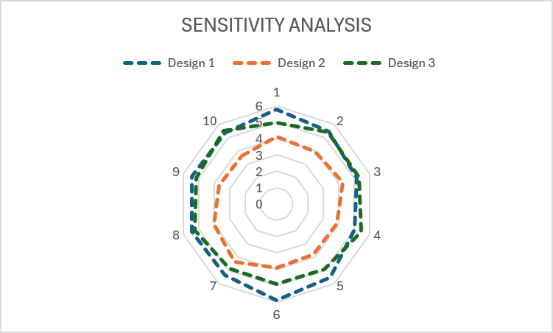

Figure 13: Sensitivity Analysis Results using Radar Graph
Figure 13 shows the results of the sensitivity analysis across ten (10) different importance weight combinations. The blue plot represents Design 1: Robotic Arm-based, which maintains high scores throughout the iterations and obtains the highest score in several weighting combinations. The orange plot represents Design 2: 5-Channel, which consistently remains below the other two designs across the ten iterations. The green plot represents Design 3: Conveyor-based, which performs closely with Design 1 and obtains the highest score in some iterations.
Across the ten (10) iterations, Design 1 and Design 3 remain the two leading alternatives despite changes in the assigned importance weights. The close distance between their plot lines shows that both designs remain competitive under different weighting conditions. Design 1 performs better when greater importance is given to Economic Cost and Functionality, while Design 3 performs better when Power Consumption and Manufacturability receive greater importance. Design 2 consistently obtains lower overall scores and does not surpass Design 1 or Design 3 in the tested iterations. The results show that Design 1 and Design 3 are both strong design alternatives, with the final ranking depending on how much importance is assigned to each design constraint.

REFERENCES
Adhitya, Y., Prakosa, S. W., Köppen, M., & Leu, J. S. (2020). Feature extraction for cocoa bean digital image classification prediction for smart farming application. Agronomy. https://doi.org/10.3390/agronomy10111642
Casindac, K. I., Cabije, P. M., Calimpusan, R.-A. C., & Cillo, C. M. (2025). Image-Based Analysis and Optimization of Physical Defect Classification in Dried Cacao Beans (Theobroma cacao L.). https://www.researchgate.net/publication/399119097_Image-Based_Analysis_and_Optimization_of_Physical_Defect_Classification_in_Dried_Cacao_Beans_Theobroma_cacao_L
Department of Agriculture - Bureau of Agricultural Research. (2022). Philippine Cacao Industry Roadmap 2021-2025. https://pcaf.da.gov.ph/wp-content/uploads/2022/06/Philippine-Cacao-Industry-Roadmap-2021-2025.pdf
Gonzales, M. V. (2024). Cacao Industry: Its Status, Opportunities and Challenges. International Journal of Science and Management Studies (IJSMS). https://doi.org/10.51386/25815946/ijsms-v7i6p120
Hortinela IV, C. C., & Tupas, K. J. R. (2022). Classification of Cacao Beans Based on their External Physical Features Using Convolutional Neural Network. https://ieeexplore.ieee.org/document/9864337
Jhon, C., Pariñas, C., Agcaoili, H. B., Danao, D. R., Tulauan, J. M., & Axalan, M. M. (2024). CACAO BEANS CLASSIFIER USING CONVOLUTIONAL NEURAL NETWORK (Kakaw-Suri). 4(2). https://csu.org.ph/jpas/article/view/52
Magdaraog, E. M. D. (2026). Forecasting Theobroma Cacao Value of Production in the Philippines Using Time Series Modeling Approach. https://al-kindipublisher.com/index.php/jmss/article/view/12330/11152
Natnat, J., & Arboleda, E. (2026). Cacao Bean Classification and Defect Detection Based on ASEAN Standard Using Image Processing and Machine Learning. https://www.researchgate.net/publication/400063890_Cacao_Bean_Classification_and_Defect_Detection_Based_on_ASEAN_Standard_Using_Image_Processing_and_Machine_Learning
Rosales, M. A., & Pagcaliwagan, A. M. (2025). Computer Vision in Agriculture: Cacao Bean Sorting Using Deep Learning. IEEE. https://ieeexplore.ieee.org/document/11365143
Usman, F. F., & Indrabayu, I. (2026). Improved Accuracy of Detection of Physical Defects in Cocoa Beans with Multi-Scale Wiener Filter on Conveyor Machine. 1713–1718. https://doi.org/10.1109/icimcis68501.2025.11327328

APPENDICES

APPENDIX 1. INTERVIEW REQUEST LETTER


APPENDIX 2. NEEDS ASSESSMENT REPORT
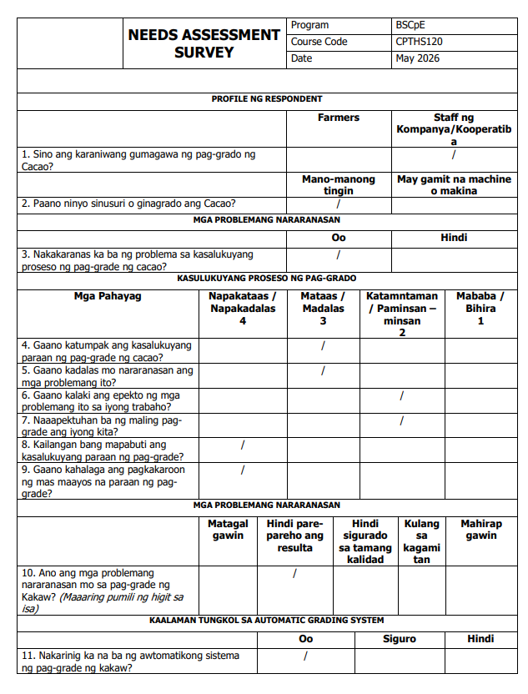



APPENDIX 3. DESIGN ALTERNATIVE 1: ROBOTIC ARM-BASED SORTING SYSTEM

APPENDIX 4. DESIGN ALTERNATIVE 2: 5-CHANNEL SORTING SYSTEM

APPENDIX 5. DESIGN ALTERNATIVE 1: ROBOTIC ARM-BASED SORTING SYSTEM

