NAME: JOHN PAUL V. TANION YR/SEC: 3RD/ OLAU333E0010

SOURCE CODE

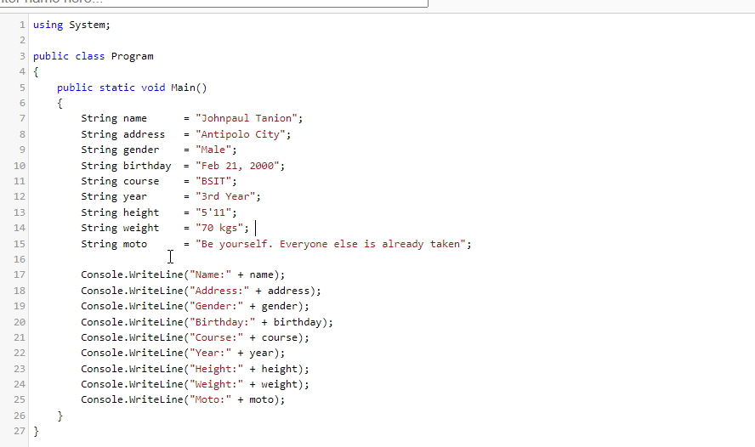

OUTPUT

