NAME: JOHN PAUL V. TANION YR/SEC: 3RD/ OLAU333E0010

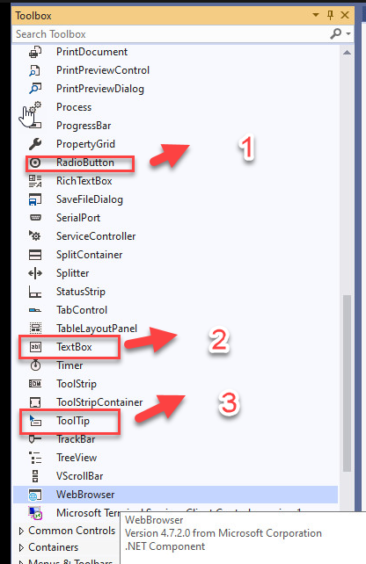

1. The user can choose one choice from a list of options using radio buttons. If you believe the customer needs to view all possible alternatives side by side, you should utilize radio buttons for optional sets that are mutually incompatible.
2. A text box is a document object that allows you to type and place text anywhere in the page. Text boxes may be handy for highlighting certain text as well as moving text about in your page.
3. When you hover your mouse over a piece of text or an icon on a website or in a software program, a message with information displays.