Notification Email to Sender email once SEND MONEY processed.

1. Sample Email notification for Bank Deposit:

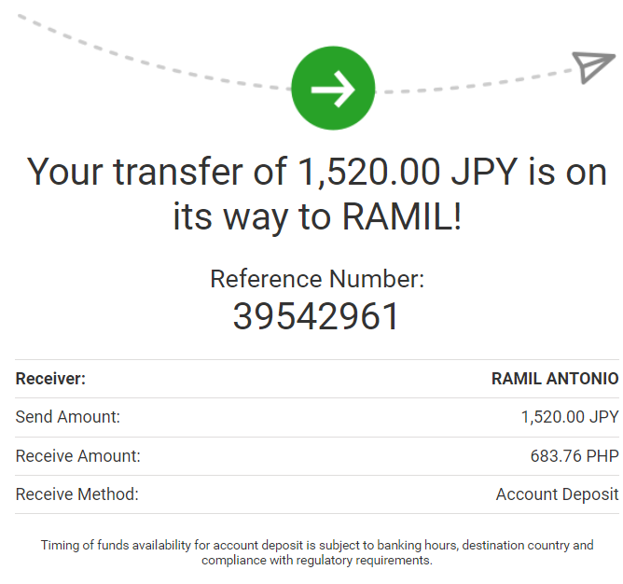

1. Sample Email notification for Cash Pick up:

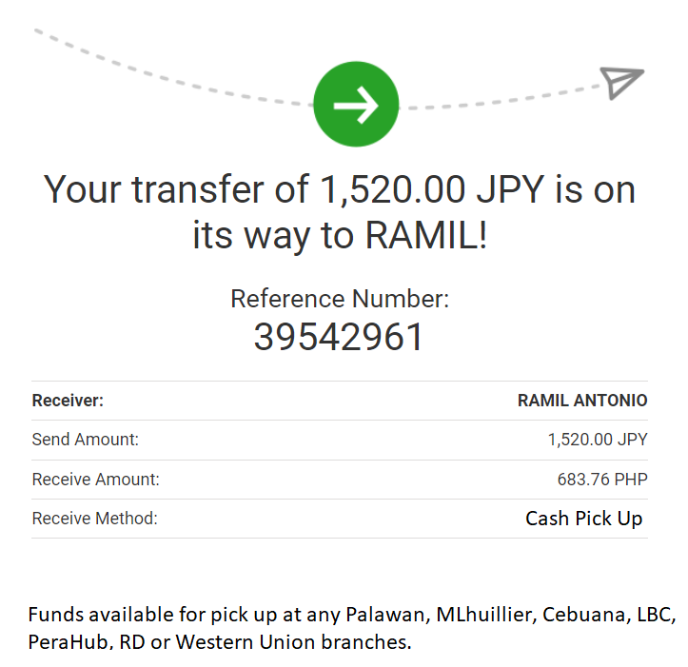

Notification Email to Sender email once SEND MONEY **CREDITED OR CLAIMED**

1. Sample Email notification for Bank Deposit:

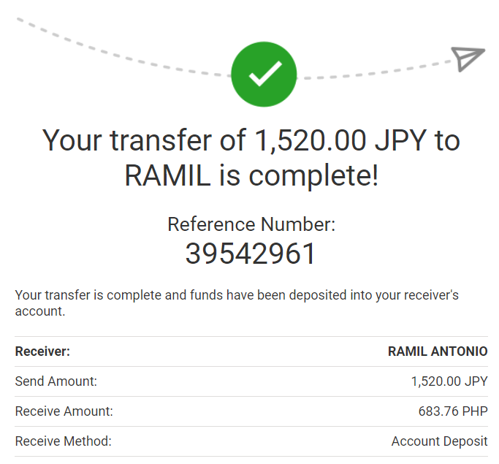

1. Sample Email notification for Cash Pick Up:

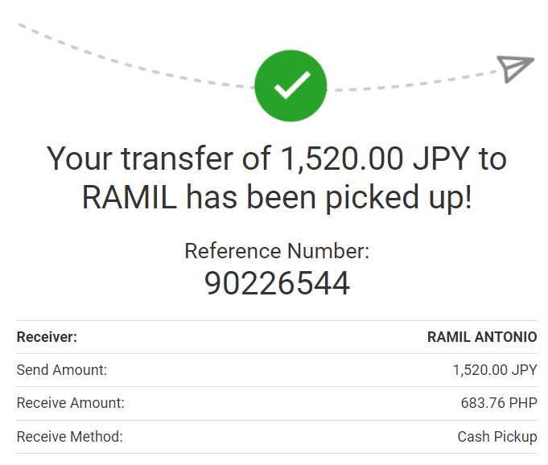

Notification Email to RECEIVER’S email once transaction has been processed.

I suggest to add EMAIL ADDRESS FIELD on receiver’s details so they can receive email.

1. Sample email notificatio for Bank Deposit

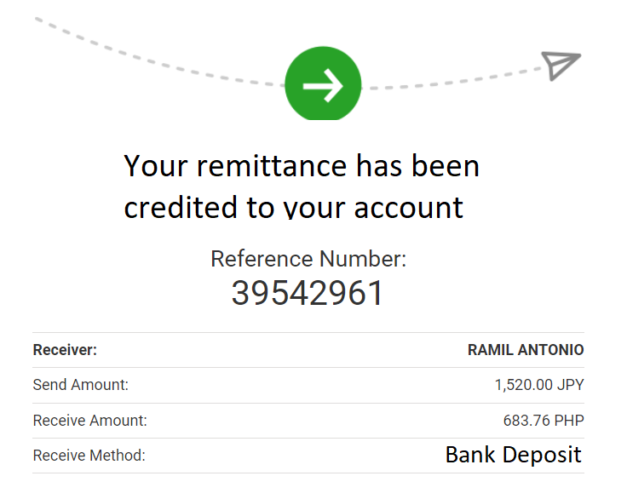

1. Sample Email notification for Cash Pick UP

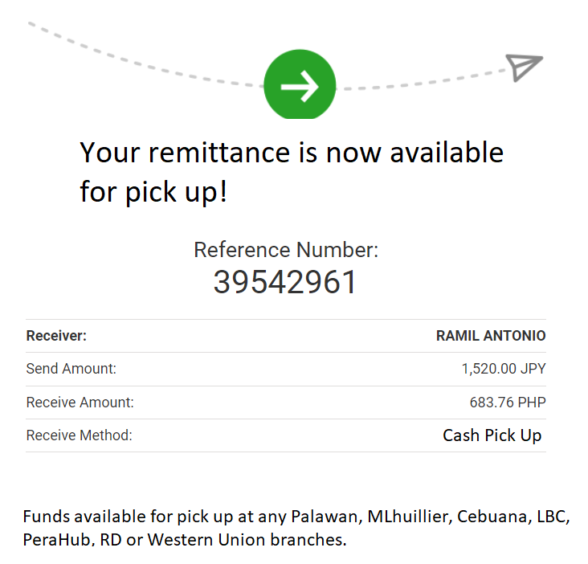

For ADD Beneficiary if **CASH PICK** UP need to disabled the Account Number:

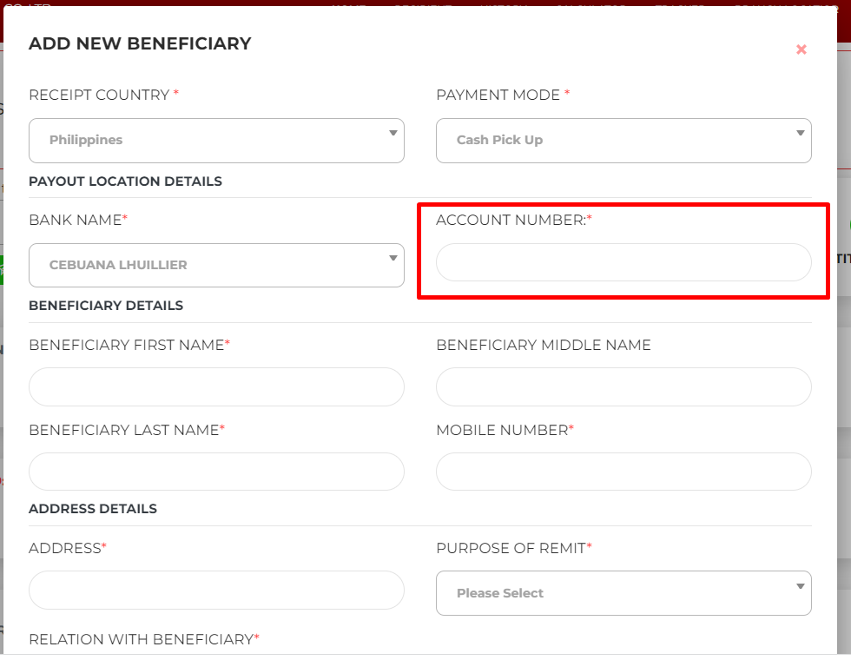

For Bank deposit need to add notes: Please enter 10 digits Account Number

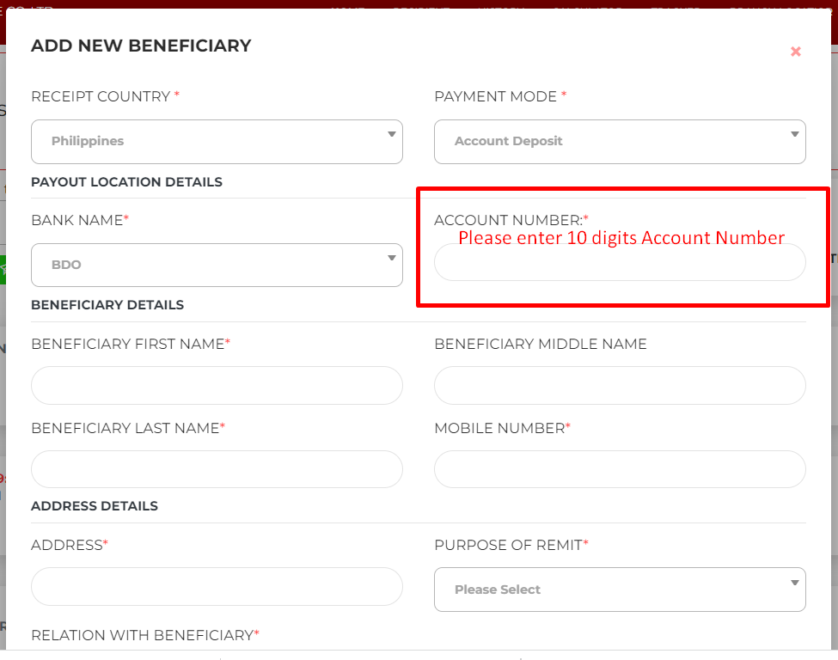

For Others, need to put extra field where they can put words:

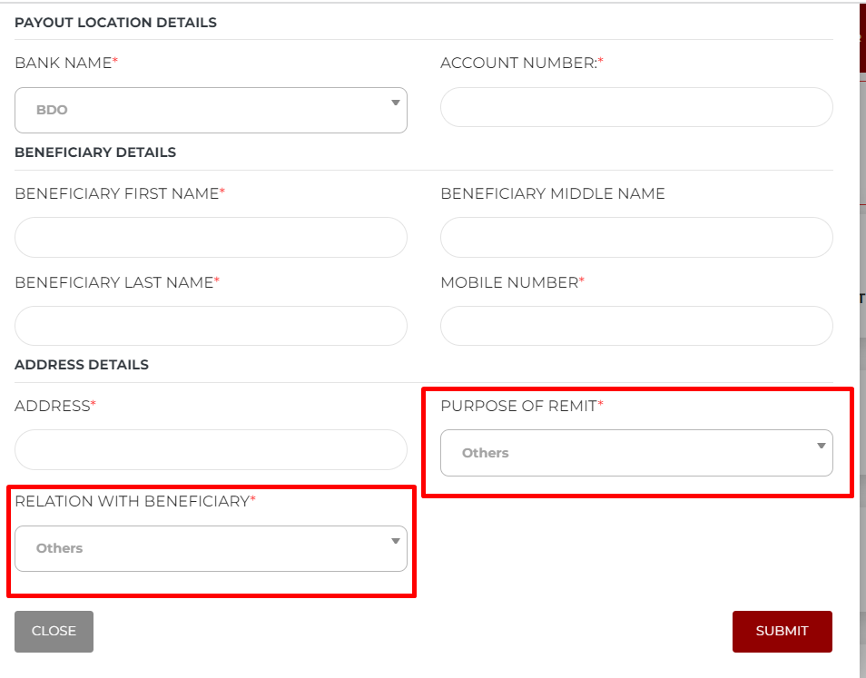

**numeric validation on mobile phone numbers**

Creation of USERS under Mobile number should be pure Number. Should be No alphabet.

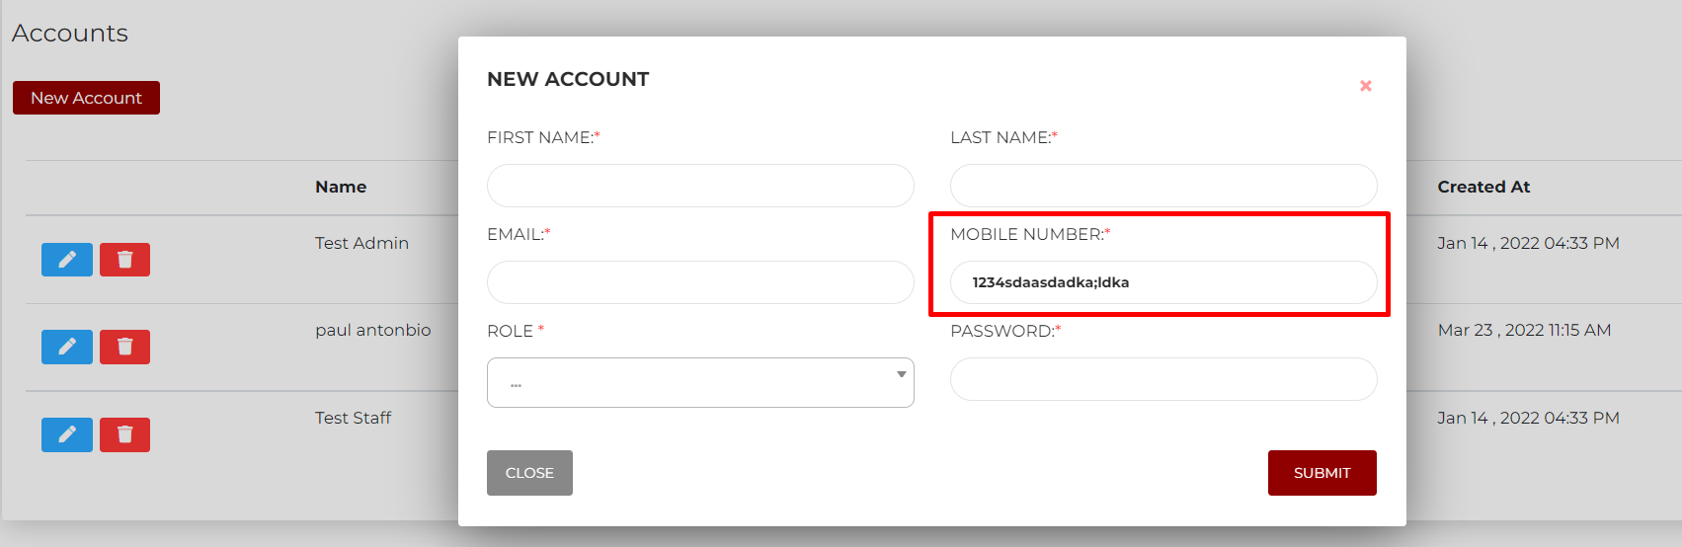

UPDATE PROFILE DETAILS: PLEASE ADD **CANCEL BUTTON**

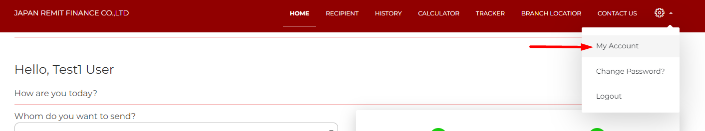

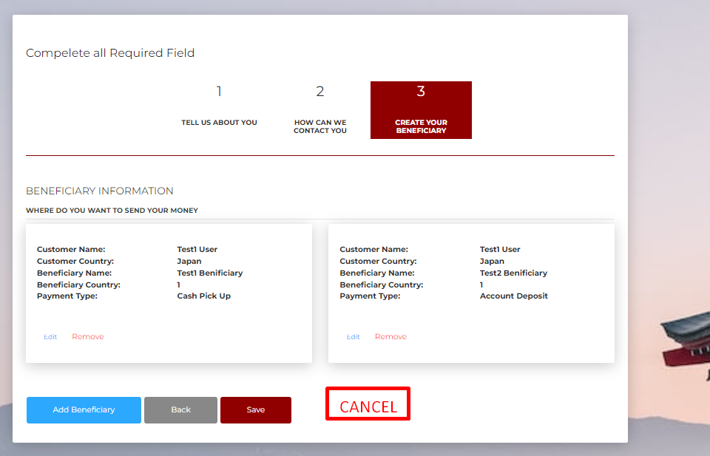

Please change the word PAYMENT MODE to **“DELIVERY Type”**

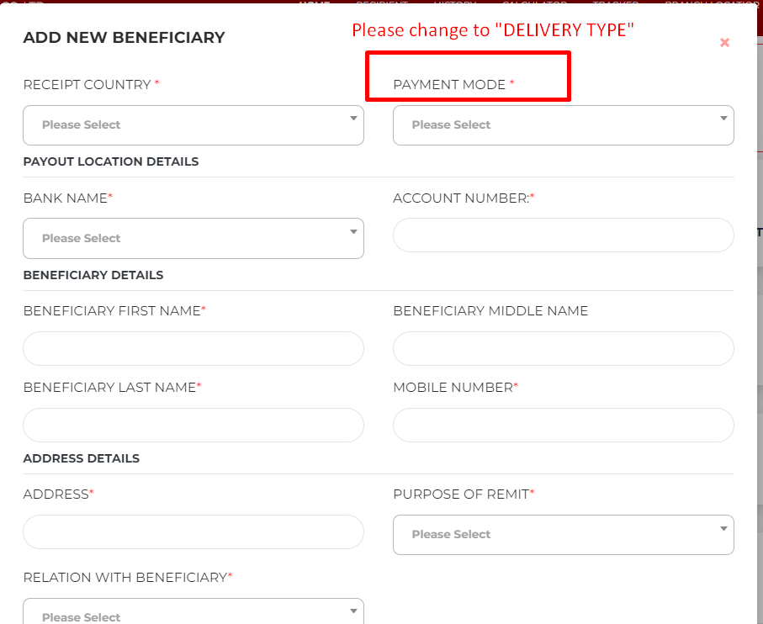

**Make transaction detail at least have options savable / printable**

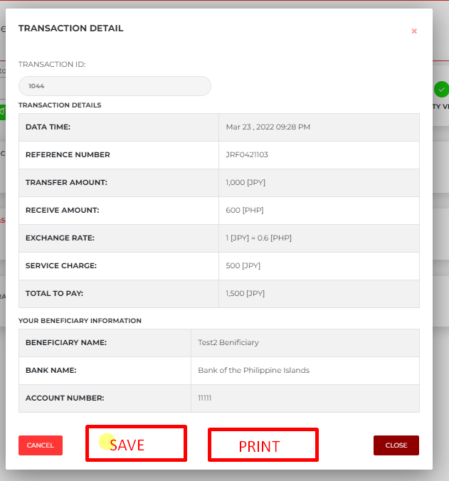

**transaction report: payment column should be before status: pagpalitin lang.**

