|  |  |  |  |
| --- | --- | --- | --- |
| NAME OF STUDENT | John Paul V. Tanion | COURSE AND SECTION | BSIT / OLAU133E8 |
| STUDENT NUMBER | UA190016 | DATE SUBMITTED | June 26 / 2022 |

PF1 ACTIVITY 6 & 7

OUTPUT  
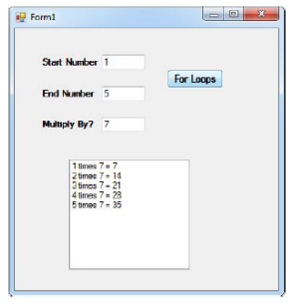

SOURCE CODE

using System;

public class Exercise6

{

public static void Main()

{

int j,n;

Console.Write("\n\n");

Console.Write("Display the multiplication table:\n");

Console.Write("-----------------------------------");

Console.Write("\n\n");

Console.Write("Input the number (Table to be calculated) : ");

n= Convert.ToInt32(Console.ReadLine());

Console.Write("\n");

for(j=1;j<=10;j++)

{

Console.Write("{0} X {1} = {2} \n",n,j,n*j);

}

}

}