John-Peter Krause
u23533529
Cos 330 Prac 3

Task 1
For my benign apps I used the following well-known benign apps: vlc, putty, notepad++, firefox and gimp.

Firefox:
VLC:
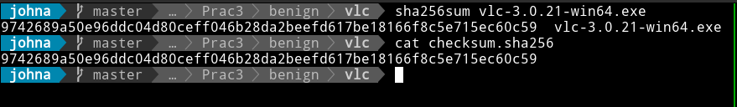
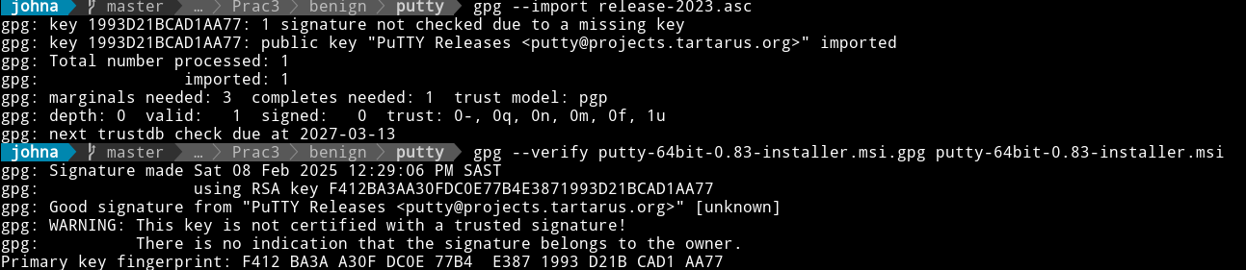
Putty:

Notepad++:
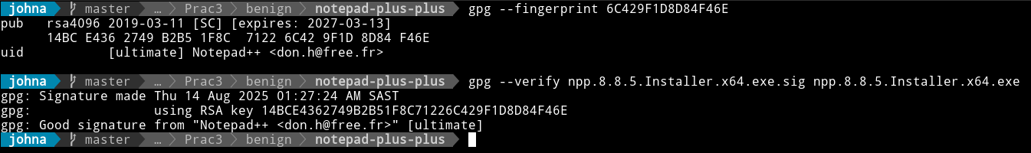
Gimp:
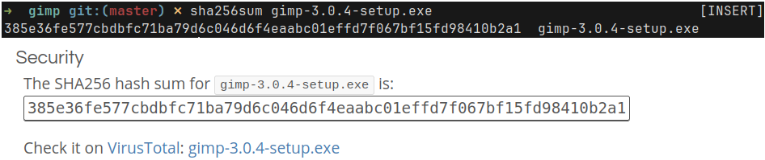
For malware I used malwareBazaar, it ended up being a lot easier to use than virusshare.com and theZoo, because I could filter by exe and didn't have to get special access or use an api to grab files.
The malware I got didn’t have proper names, so I will refer to them by their numbers.
What makes the integrity even more obvious is that the executables are named with their hashes(something malwareBazaar does) so it’s easy to see that the hashes match as when comparing. Additionally I included a screenshot from what the site says the hash is from the download page.

Malware 1:
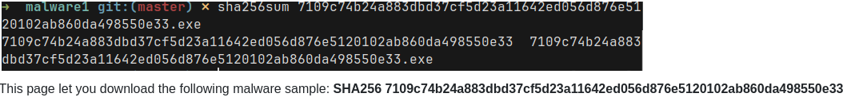
Malware 2:
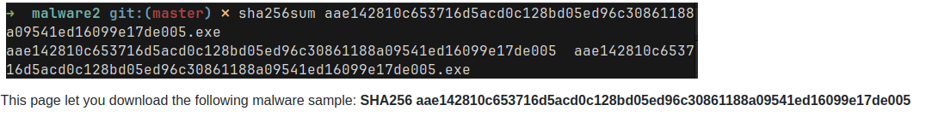

Malware 3:
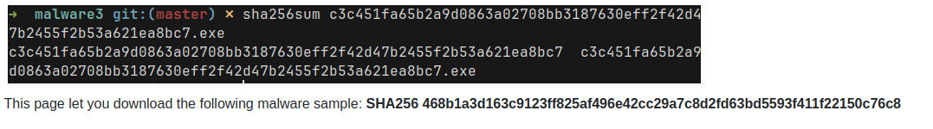

Malware 4:
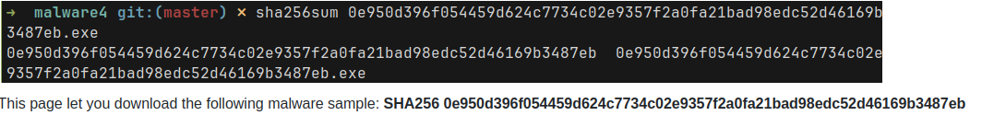

Malware 5:
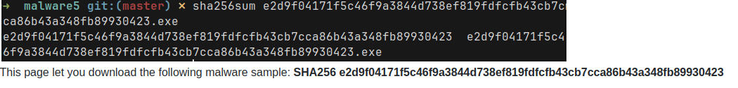

Task 2

I moved the malware files into my virtual machine in order to prevent accidental damage to my machine, but I also removed execute permissions as an extra precaution. Other precautions I added was not including any executables into version control and using a chroot so that my vm was isolated further.

I created a bash script that retrieves data from the executables. The script also made use of upx and a python dependency pefile.
I successfully ran the script that extracts file types, import tables, reading metadata like timestamps, compiler information and urls and strings.

Malware analysis
I opted to use Rizin for binary analysis, becasuse I have a Linux machine. Some samples could not be parsed by Rizin due to malformed PE headers, which itself is indicative of packing or anti-analysis techniques used in malware.

I used upx analysis to see if any of the executables were packed by upx, but none were.
Binwalk also did not identify any embedded file signatures, which probably means they used non-standard packing or encryption methods to conceal the payload.
The absence of these results don't mean my analysis failed, instead they are meaningful in themselves. Benign executables are typically uncompressed while malware often employes custom packing techniques undetectable by standard tools.

Benign analysis
Rizin also failed for all the benign exe's, so I cannot use that meaningfully when creating my YARA scripts to classify malware.
Binwalk also didn't identify any embedded file signatures.
None of the benign apps were packed by upx, which makes sense, but also I cannot use this meaningfully when creating my yara scripts.
The benign apps all have trusted imbedded urls for example microsoft.com and digicert.com, which will make it easier to identify malware when compared to their urls - which are urls like chiark.greenend.org.uk.

Comparison of graphs
I used a python script to retrieve data from bash script output, organize into csv and plot them using matplotlib.
Import function count:
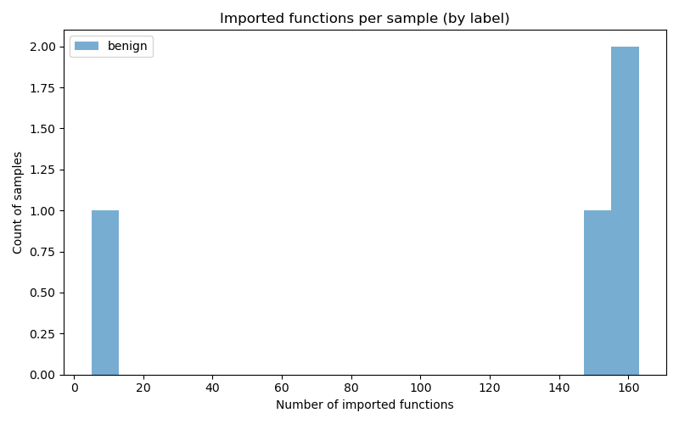
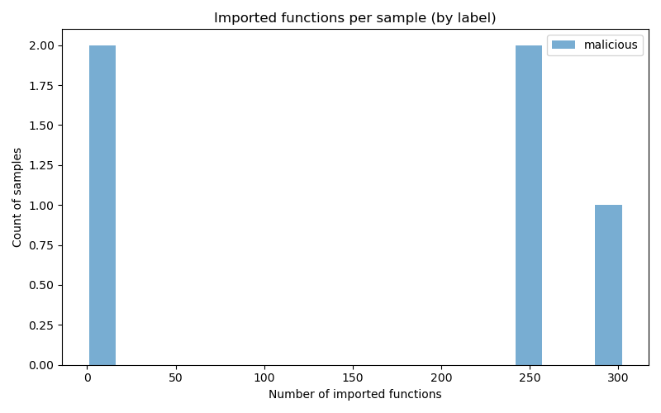

benign exe's typically import 10-160 functions, with most clustering around 150-160 and around 10. Malicious exe's show a much wider distribution importing 0-300+ functions. I will create yara rules that flag exe's with unusually high import counts >200 or suspiciously low < 5 imports.

Strings:
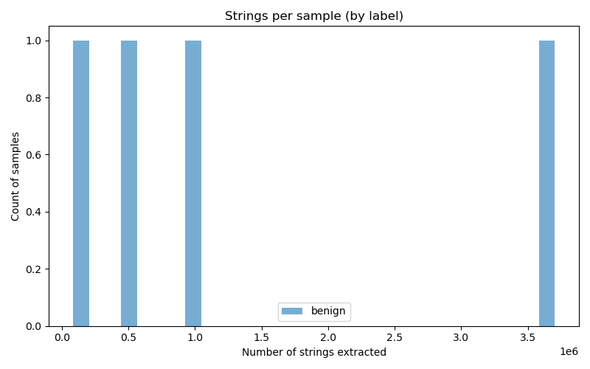
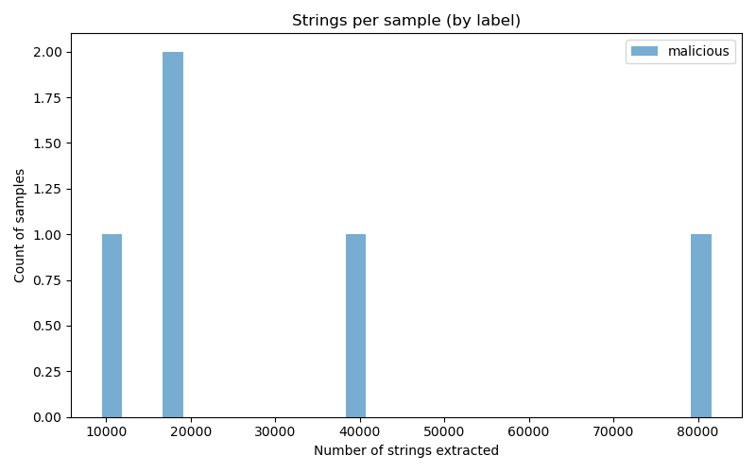

The benign apps have significantly higher strings ranging from 0-4 millions whereas the malicious have around 10-80k strings. Thus files with unusually low strings counts in the 10k-80k range will be flagged.

Suspicious Keywords:
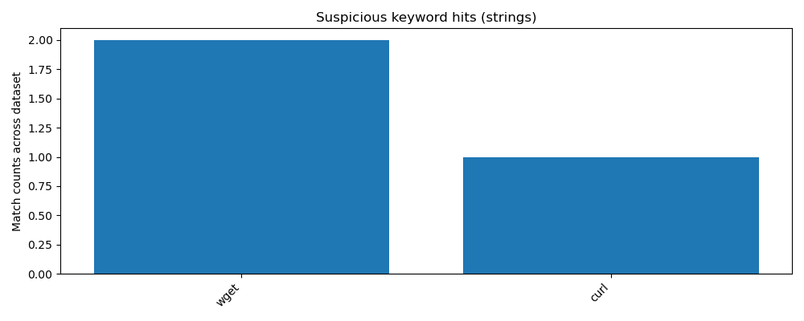
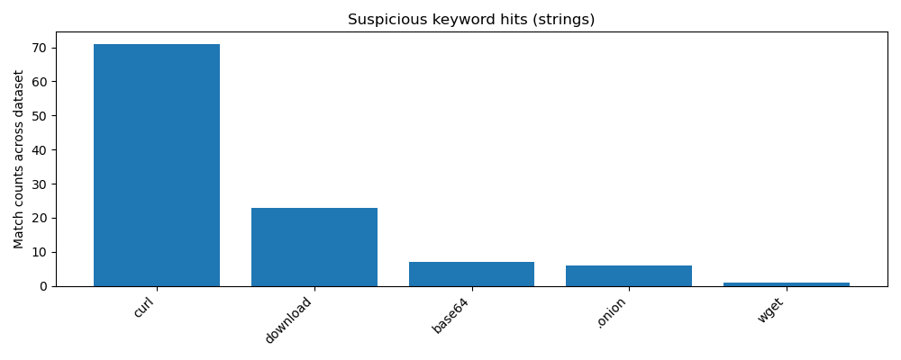

Malicious files have high amounts of curl, download and moderate amount of base64, onion(very suspicious) and wget. Benign apps have minimum presence of these keywords. I will high occurences of curl, any occurence of onion and download + base64 and wget to flag malware in my yara files.

Dll imports:
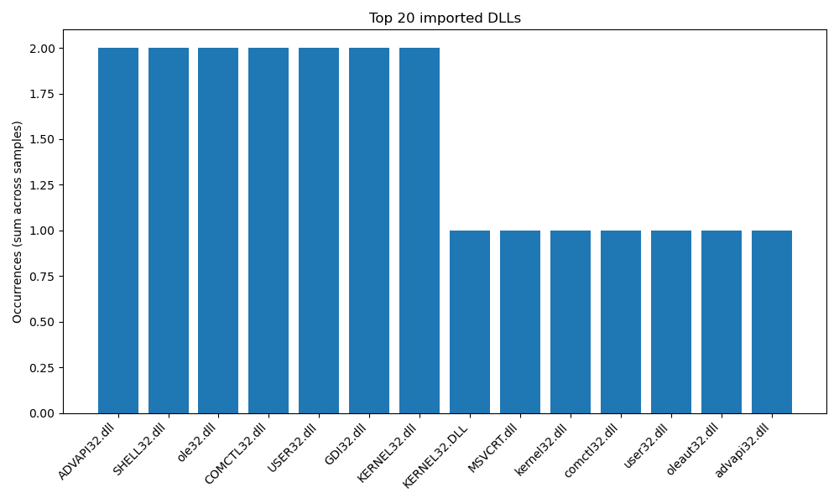
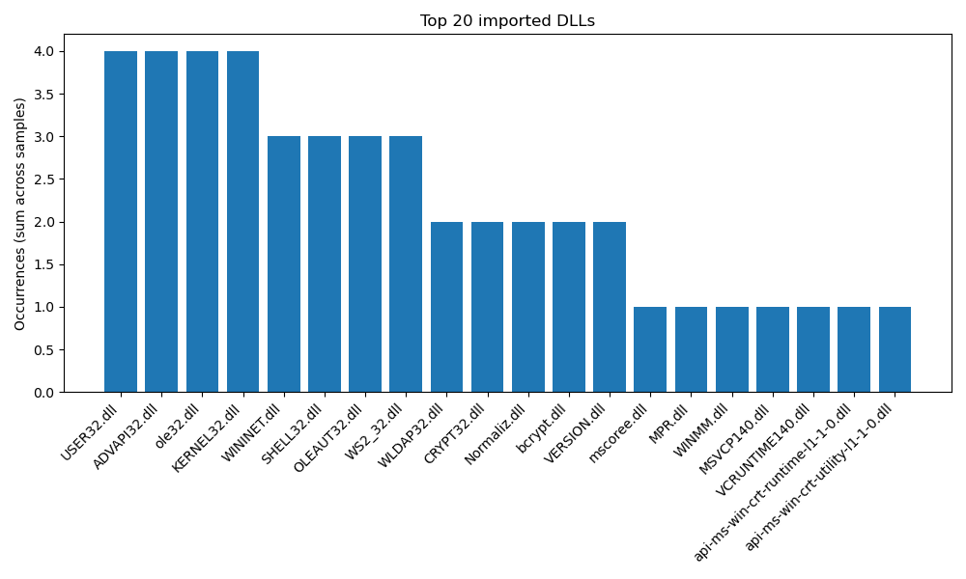

Malware has a heavy reliance on USER32.dll, ADVAPI32.dll, OLE32.dll and KERNEL32.dll and moderate use of WININET.dll, SHELL32.dll, OLEAUT32.dll, WS2_32.dll. Benign apps have way more diverse dll usage with lower individual concentrations. In my yara I will flag certain dll combinations.

Import function analysis:
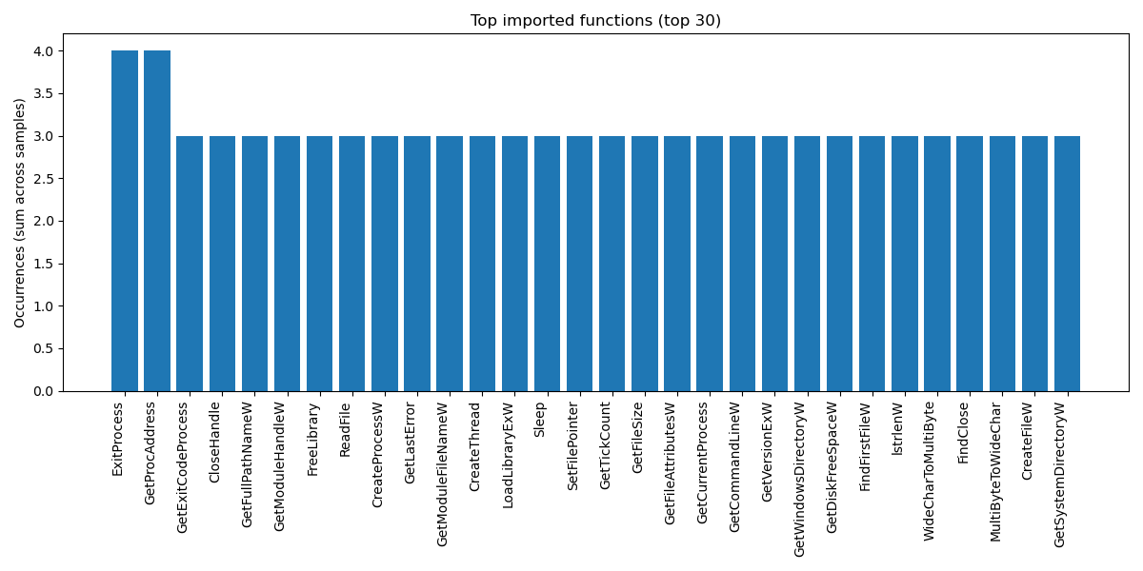
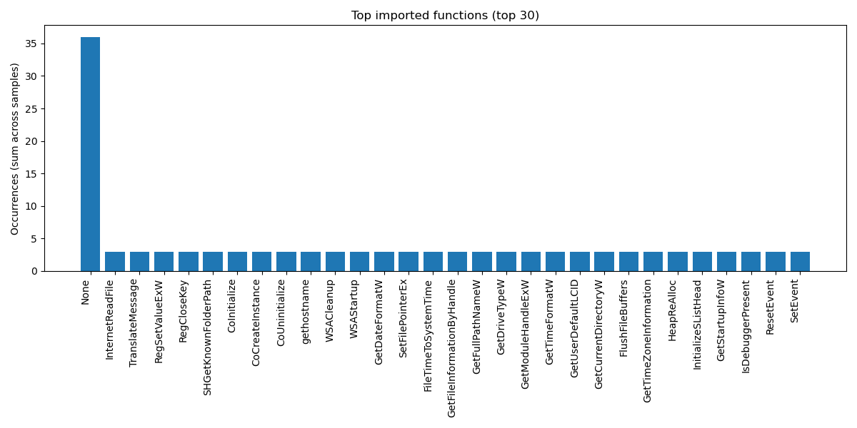

Malicious files show an extreme spike in one unnamed function 36+ occurences, while benign files show a more balanced function usage. For yara I will look at unusual concentrations of specific imported functions.

Urls patterns:
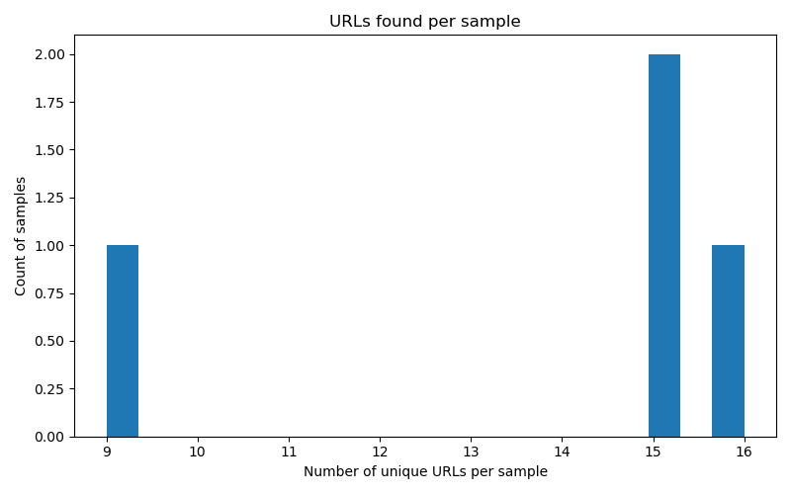
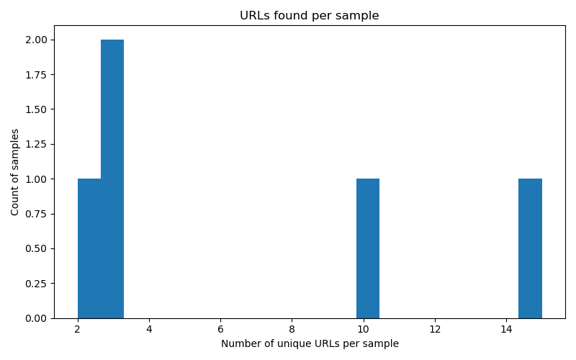

Malware contains fewer unique urls whereas benign show a more diverse set of urls, however in my samples I didn't get a large enough diference in my opinion to apply a hard rule for my yara files.

