# Purpose and Scope

EMC testing at a third-party is expensive, time consuming, logistically difficult, and often times a project requirement. The last thing you want is to fail EMC and have to re-test and go through the entire ordeal again. It is expensive, defeating, and stressful.

Over the years I have been successful in passing IEC EN 61000 test standards on the first attempt. I am not an EMC expert by any means, but enough testing and forethought can really boost the chances of success.

# EMC Testing Standard

This document will cover what to expect and methods for passing the following standards:

* 1. IEC EN 55011/CISPR16-4-2 *Radiated Emissions*
  2. IEC EN 61000-4-2 *ESD Immunity*
  3. IEC EN 61000-4-3 *Radiated Immunity*
  4. IEC EN 61000-4-4 *Electrical Fast Transients*
  5. IEC EN 61000-4-5 *Surge Immunity*
  6. IEC EN 61000-4-6 *Conducted RF Immunity*

# EMC Prep

* 1. It is the engineer’s responsibility to ensure all the required testing equipment, cabling, and tools are brought to the third-party EMC lab. If something is forgotten, it will ruin your day.
  2. The EMC lab will have a soldering bench with typical tools found at a soldering bench.
  3. The EMC lab will also have a slew of parts commonly used to troubleshoot and fix EMI issues. Things like metal tapes, foil, various shielding, etc.
  4. You will have to bring everything else.
  5. Decide how you will determine pass/fail.
     1. I like to make a generic test sheet where DUT data is gathered pre, during, and post EMC test. This will probably be filled out by hand since EMC testing goes fast, so give yourself room to write.
     2. Figure out what data you want to capture pre and post. These parameters should be the same.
     3. Figure out what metrics you can monitor during the test. This is something where an erroneous signal would be an indicator of a failure.
     4. It’s also a good idea to print 30+ copies of this test sheet, 3-hole punch them, and put them in a binder.
     5. If data collection is required on a scope, save the configuration settings so you can quickly recall the setup and data can be acquired as quick as possible.
  6. Here is a method to ensure nothing is left behind:
     1. The engineer should know the product well. The assembly steps, key components, electronics & schematics, dominant frequencies…
     2. Have a dedicated EMC tool bag. An electricians backpack works well, I like this [one](https://shop.welkinland.com/collections/tool-backpacks/products/full-open-tool-bag-backpack).
     3. Set up the DUT in the lab to mimic how you will monitor and acquire data at the EMC lab. Bring all this equipment, cables, adapters, and extras in case you need to extend some lengths.
     4. The equipment the EMC lab uses for ‘Conducted Immunity’ requires a custom cable for AC & DC systems that don’t interface with a standard NEMA plug. You must take a NEMA 5-15P and break it out to mate with the systems power input. Hot = V+, Neutral = V-. Example Below:

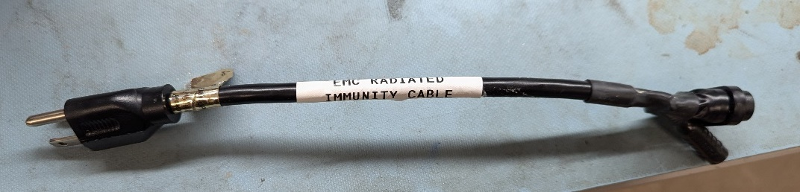

Figure . Example of Conducted Immunity Cable

* + 1. Go through the task of taking the DUT apart, removing internal boards, cables, and non-electronic parts. Now you have a stack of tools required to work on the DUT, go ahead and pack these.
    2. Make sure you have cables to interface with the DUT (power, I/O, comms, etc). These cables should be long enough to pass outside the EMC chambers (20+ feet). The cables should also reflect the end-use cable design.
    3. Do all the pre-emptive testing that you can. Rent or buy an [ESD simulator](https://www.esdguns.com/16-kv-esd-guns/23-haefely-onyx-16-kv-esd-generator-gun.html#/order_type-rental_1_month), spectrum analyzer, and near field probes.
    4. Don’t rush. The day before EMC testing. Take your time to think about what you need and pack out the bag and equipment.
    5. Use Appendix A: EMC Packout List as a guide to prepare for the EMC lab.

# IEC EN 55011 Radiated Emissions

* 1. If you’re going to fail EMC, it will probably be here.
  2. The DUT will be put on wood table toward the back of a very large chamber/faraday cage. There will be an antenna in the corner of the chamber opposite to the DUT. The antennas job is to pick up an RF signals that are radiating out of the DUT. The DUT will be placed 10M from the antenna. The interior surfaces of the chamber are constructed of radiation absorbent materials to prevent emissions from bouncing and causing constructive interference on the antenna.
  3. There will be a small feedthrough in the floor of the chamber underneath the table. This allows connections to be made to the DUT and ran outside of the testing chamber into the antechamber. The antechamber is where testing equipment is kept such as laptop, power supply, scope, AWG.
  4. The DUT will be tested in several orientations: Front, back, left, and right.
  5. There are different frequency ranges and levels of this standard. The ranges I have experience with are 30MHz – 1Ghz. The specification for passing is the following:
     1. 30MHz – 230MHz = 40dBuV
     2. 230MHz – 1GHz = 47dBuV
  6. The measurement types are over the frequency ranges are: Peak, Quasi-Peak, and Average and the settings for each are:
     1. Peak = RBW is 120kHz, VBW is 3MHz
     2. Quasi-Peak = RBW is 120kHz, VBW is 3MHz
     3. Average = RBW is 1MHz, VBW is 10Hz
  7. There is testing that can be done in the lab prior to formal EMC testing using fairly inexpensive testing equipment.
     1. [EMC Near Field Probes](https://www.digikey.com/en/products/detail/b-k-precision/PR262/9963117)
     2. [Spectrum Analyzer](https://www.digikey.com/en/products/detail/siglent-technologies-na-inc/SSA3032X/10455225)
     3. The lab is obviously not a calibrated environment, but it does a good enough job of pointing out frequencies which more strongly emit from the DUT. Taking a few hours to sniff the DUT and look for peaks is time well spent.
     4. In example below radiated emissions had failed at 625MHz with an amplitude of 47.276dBuV (spec is 47dBuV). Taking the DUT back to the lab, the spectrum analyzer picked up a 625MHz peak at 46.16dBuV while using the 20mm loop near field probe. Pretty dang close to what the EMC lab measured. From my experience and observations if you pick up a peak that’s within 10dBuV below the spec, that is probably cause for concern. After implementing an improvement to shielding, the issue was extinguished.

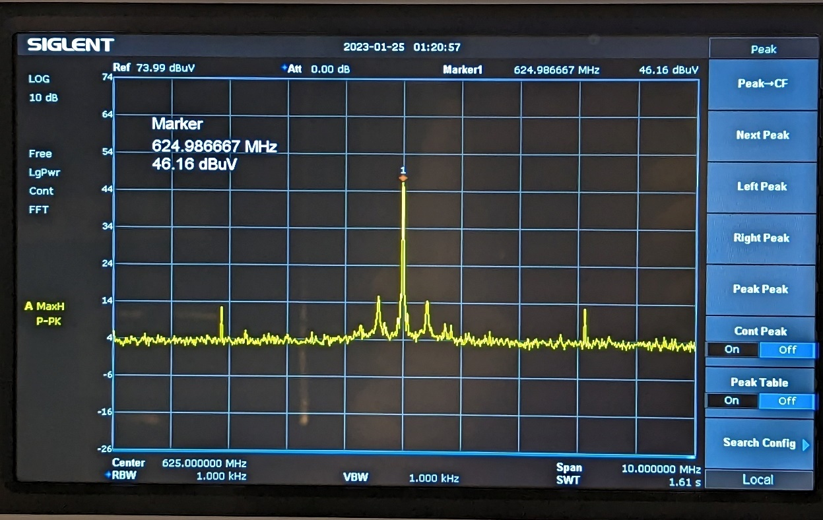

Figure 2. Failed Peak at 625MHz

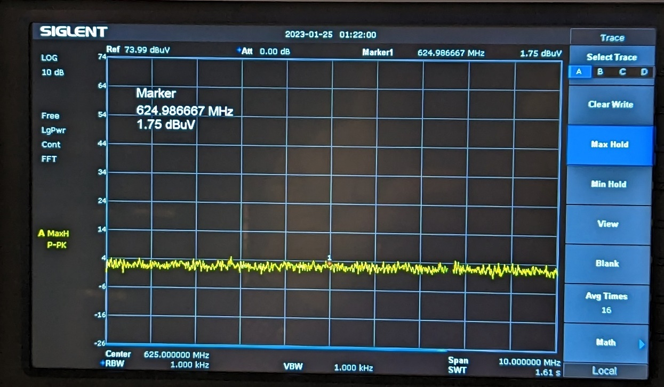

Figure 3. 625MHz Peak After Shielding Improvement

## 

# IEC EN 61000-4-2 ESD Immunity

* 1. The EMC technicians’ job is to thoroughly test the product or more simply put: break your device. And trust me, they enjoy this test.
  2. The electrostatic discharge specifications are the following:
     1. Contact Discharge Levels: ±2kV, ±4kV, ±8kV
     2. Air Discharge Levels: ±8kV, ±15kV
     3. Interruption to normal circuit function is allowed, however the DUT must return to a normal functioning state without user intervention.
  3. The EMC technician will zap the chassis and any exposed connector pins with both direct contact and air. The polarity will alter between positive and negative pulses with respect to the ground plane.
  4. This test is a bit nerve-racking, but surprising easy to pass. Passing ESD immunity starts at the design.
  5. Generally Good Design Rules to Follow:
     1. DUT will ideally be a fully enclosed metal chassis.
     2. The signal return of the electronics will be directly connected to the chassis.
     3. The externally exposed contacts are kept to a minimum.
     4. Any exposed contacts are protected from an ESD event, i.e., bi-directional TVS. The protection diode is placed such that it is the first device in the signal chain allowing it to absorb the event before damaging components down-stream.
     5. When possible, choose components with built in ESD protection.
  6. Perform in house ESD testing prior to the EMC lab
     1. Rent or buy an [ESD simulator](https://www.esdguns.com/16-kv-esd-guns/23-haefely-onyx-16-kv-esd-generator-gun.html#/order_type-rental_1_month).
     2. Create your own “ground plane” to mimic the EMC lab. This can a large solid piece of copper clad. Connect two conductors to this ground plane. One lead will tie into protective earth and the other lead will tie into the PCB through a mounting hole or similar. Place a thin piece of mylar over the copper clad. Now you can test your board on a simulated ground plane.

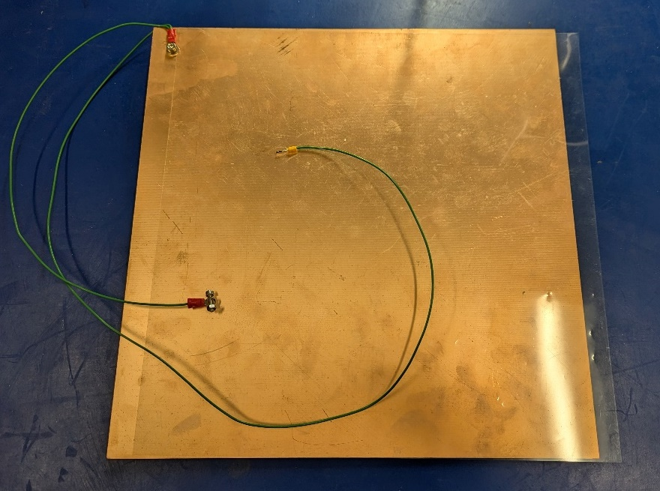

Figure 4. Home Brewed ESD Ground Plane

* + 1. Zap the PCB and monitor performance. If you pass ESD here, you should be just fine at the EMC lab.

# IEC EN 61000-4-3 Radiated Immunity

* 1. This is a tough standard to perform a pre-compliance test on and gain confidence in. Here is a method <https://www.youtube.com/watch?v=44E3rbdrn1Y>, but it is pretty inconvenient if you don’t already have this equipment sitting around.
  2. Similar to Radiated Emissions, the DUT will be placed in a chamber with an antenna directed at it sweeping frequencies and field strength. The engineer will be outside of the chamber monitoring the unit for failures.
  3. The specifications are as followings:
     1. 80MHz – 6GHz, AM 80% 1kHz modulated sine wave
     2. The field strength for 80MHz – 1GHz is 10V/m
     3. The field strength for 1GHz – 6GHz is 3V/m
     4. The test will be performed with both vertical and horizontal antenna polarities.
     5. The test will be repeated with the DUT in four orientations: Left, Right, Front, Back.
  4. I have never failed this test. Risks of failure could include the conditions of a non-metal chassis, chassis with large holes, unshielded cables, poorly shielded cables, or cables with impedance imbalance.
  5. High speed signals, sensitive analog signals, signals prone to cross-talk, or signals which are sensitive to common mode currents will be the main concern here.

# IEC EN 61000-4-4 Electrical Fast Transient

* 1. Electrical fast transients, commonly referred to as EFT, simulates everyday inductive switching. It is not too dissimilar from ESD or Surge. The main difference is the pulse width, amplitude, and injection method. EFTs are injected via a coupling decoupling network (CDN) with the use of a capacitive coupling clamp.
  2. Typical EFT waveforms are shown below.

* 1. This setup, just like radiated immunity, is a bit inconvenient to perform pre-compliance tests on, or at least to meet proper pulse shapes. However, there are a couple of quick, dirty, and cheap methods to boost confidence.
     1. The idea behind EFT test is very quickly simulate if the circuit has issues with everyday inductive switching. So you can take a filthy switching power supply, gate it with a mechanical relay (w/ FET & flyback), and pulse that relay at ~8Hz. Setup the signals you want to monitor on the scope with a mask test or infinite persistent turned on. Let it run for several days while periodically checking the results.

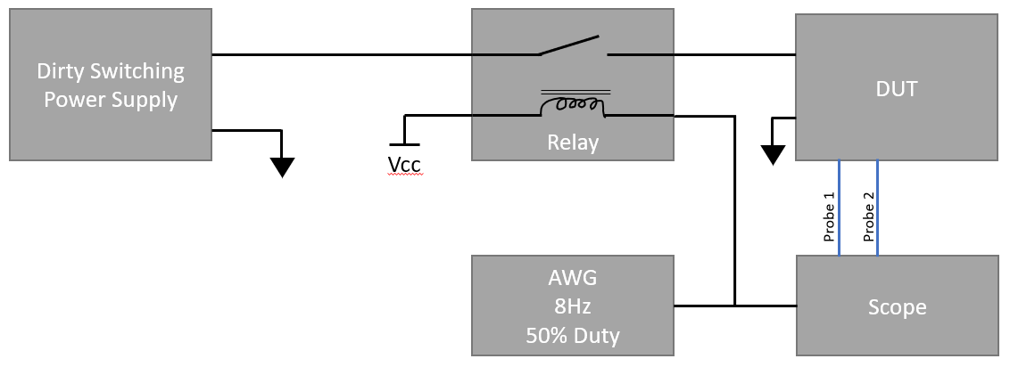

* + 1. Another method is to use an AWG drive a relay with a buzzer on the contacts pulled up to the input voltage. This will provide an inductive kick on the line. This is a good method for debugging issues since the pulses can be tracked through the electronics. Running this test for half an hour should be sufficient.

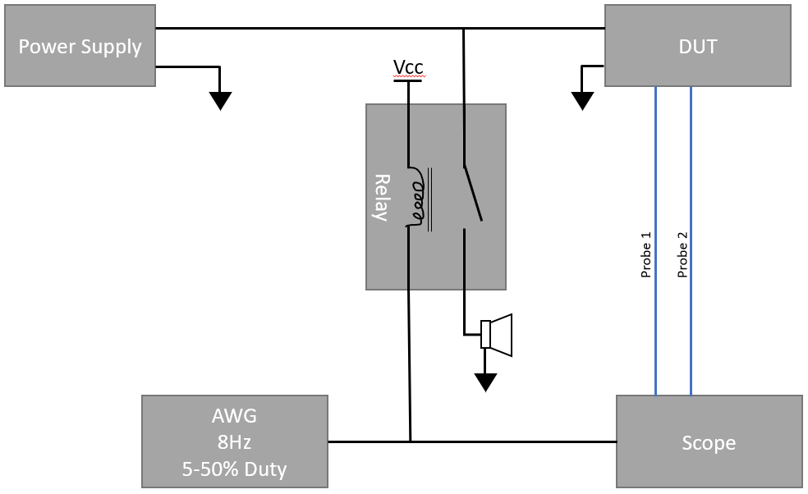

# IEC EN 61000-4-6 Conducted RF Immunity

* 1. This test injects sweeping frequencies of noise into the circuit
  2. Pre-Compliance and further explanation TBD
  3. Failures are due to mistakes made in design. There needs to be enough filtering to account for and snub out differential mode and common mode noise. For DM, ferrite beads. For CM, common mode chokes.
  4. Output from electronic system to black box, add galvanic isolation. Best way to deal with ground loops and noise.
  5. in-rush current limiters, power sequencing to reduce in-rush and flickering

**Appendix A: EMC Testing Packout List**

**Project:**

**Part Number:**

**Revision:**

**Engineer:**

**Testing Date:**

**Product**

Device Under Test (DUTs)

Any cables that may connect to the device. Ensure they are 20+ ft long and closely represent the end-use.

**Tools**

6-in-1 Screwdriver

Small Phillips Screwdriver

Small Flat-Head Screwdriver

Metric Allen Wrenches

Imperial Allen Wrenches

Wire Cutters

Wire Strippers

Solder

Flux

Solder Braid

Pliers

Box Cutter/Scissors

ESD Tweezers

Zip Ties

Flashlight

X-Acto Knife

Sealed-Edge Wipes

IPA Bottle

Aluminum Tape

Electrical Tape

Measuring Tape

Drill

Drill Bits

Pens, Sharpies

Latex/Nitrile Glove

**Equipment****, Cables, and Connectors**

Oscilloscope

Scope Probes, Current Probe

Power Supply

Function/Pulse Generator

Handheld Multimeter

Thermal Camera

Laptop, Mouse, Charger

BNC Cables

BNC to Alligator Clip Cables

BNC Splitters

NEMA-15 AC Power Cables

NEMA-15 to Banana Jack Cable (Conducted Immunity DC Adapter Cable)

**Project Specific Materials/Tooling**

Binder full of empty test plan sheets (~30)

# Revision History

|  |  |  |  |
| --- | --- | --- | --- |
| **Revision** | **Description** | **Author** | **Date** |
| 01 | Initial Release | J. Petrilli | 11/10/2024 |
|  |  |  |  |