**Mobile App Metrics (11/15)**

*Summary:*

***Mobile App*** version 1.4, releasing on 11/15, continues to drive customer engagement, revenue, digital interaction and improved app ratings. Key 1.4 features include Bring Your Own Device (BYOD), Add On Accessory (along with Upgrade/Add-A-Line), More Everything/Share Everything integration, and Data Gifting.

*Details:*

* BYOD:
* Customers can bring their own device, adding a new line to an account.
* Smartphones, tablets and connected devices can be added.
* Scan or manually enter the device ID and SIM information.
* Customers can view and confirm the device details, the selected phone number, service address and billing breakdown (due today and due monthly).

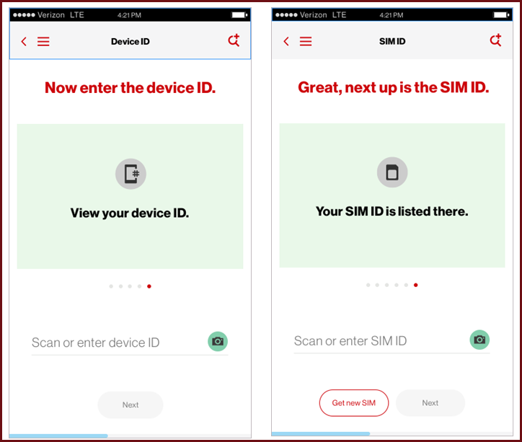

* Add On Accessory:
* Increased revenue opportunity with context-sensitive suggestions (based on the device in the cart).
* Option of selecting more accessories from the list of predefined categories
* Accessory colors are customizable.
* Customer can view and confirm the following details:
  + Device Details – Image and name
  + Accessory Details – Image and name
  + Selected phone number
  + Shipping Address
  + Delivery Method
  + Payment Method
  + Service Address
  + Billing breakdown (due today and due monthly)

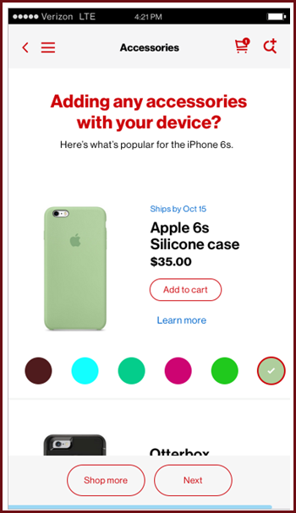

* More Everything/Share Everything:
* This release supports More Everything-to-More Everything and More Everything-to-The Verizon Plan 2.0 changes.
* Data Only, Canada/Mexico, SMB and Winback More Everthing route to My Verizon Mobile.
* 38 consumer plans are supported.

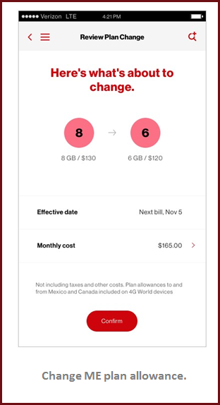 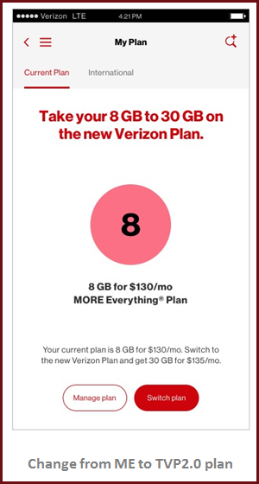

* Data Gifting:
* The customer can send a data gift to another Verizon customer.
* Entry points are via the Data Redeemed screen, Data Hub overview and Data Gift Miniguide.
* If the customer is ineligible to send a gift an error screen is displayed.
* The customer receives a confirmation screen before and after the gift is sent.

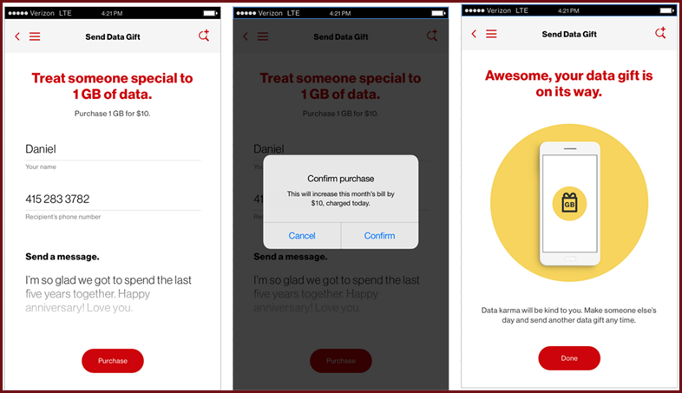

* Other 1.4 Functionality:
  + Feed cards Redesign (Color/Priority)
  + Feed cards Dismissal
  + Further SMART integration: Customer feedback, In-Store pickup, Store Locator auto refresh)

1.3 Metrics:

* App metrics as of 11/08:
* Android App Rating: 4.12
* iOS App Rating: steady at 4.2

|  |  |
| --- | --- |
|  | **TOTAL** |
| Unique Visitors | CONFIDENTIAL |
| Safety Mode Enabled | CONFIDENTIAL |
| Add A Line (AAL)+Upgrade Now | CONFIDENTIAL |
| Bill Payment | CONFIDENTIAL |

|  |  |  |
| --- | --- | --- |
| **PopData** | | |
| **Activity** | **11/08/16** | **TOTAL** |
| PopData Successful Customer Purchases | CONFIDENTIAL | CONFIDENTIAL |

|  |  |  |
| --- | --- | --- |
| **Live Chat** | | |
| **Activity** | **11/08/16** | **TOTAL** |
| Managing My Account | CONFIDENTIAL | CONFIDENTIAL |
| Shopping Verizon | CONFIDENTIAL | CONFIDENTIAL |
| Travelling Abroad | CONFIDENTIAL | CONFIDENTIAL |
| Understanding My Bill | CONFIDENTIAL | CONFIDENTIAL |
| Understanding My Device | CONFIDENTIAL | CONFIDENTIAL |
| Total | CONFIDENTIAL | CONFIDENTIAL |

|  |  |  |
| --- | --- | --- |
| **FAMILY BASE** | | |
| **Activity** | **11/08/16** | **TOTAL** |
| Family Base Transactions/Changes | CONFIDENTIAL | CONFIDENTIAL |

**Stream Pass metrics:**

There have been XX,XXX (CONFIDENTIAL) orders of Stream Pass via the MVM app since 10/25/16:

*Benefits:*

* Increased revenue.
* Customer satisfaction.