///////////////////////////
HEAT_LOAD_ON
///////////////////////////
// DO NOT MODIFY THIS SEQUENCE
// THIS IS THE SEQUENCE FOR THE FUNCTION POINTER ARRAY FURTHER ABOVE IN THIS FILE.
// THERE IS A COMPLEX RELATIONSHIP BETWEEN SETTING THE MUX AND WHEN YOU CAN READ (TIME DELAY)
// WITH THIS SEQUENCE IT TAKES 937 milliseconds to complete a loop iteration
// THE FOLLOWING # OF SAMPLES ARE RECORDED:
// TEMP DIODE x 2 samples
// COOLER AMPS x 9 samples
// COOLER_VOLTS x 4 samples
// HEAT_LOAD_V x 4 samples
// HEAT_LOAD_I x 3 samples
// THRMCPL1 x 1 sample
// THRMCPL2 x 1 sample
// THRMCPL3 x 1 sample
ADC0_Read_Temp_Diode();
ADC1_Read_Cooler_Amps();
ADC0_Read_Temp_Diode();
ADC0_Set_MUX_Cooler_Volts();
ADC1_Read_Cooler_Amps();
ADC0_Throw_Away_Reading();
ADC1_Read_Cooler_Amps();
ADC1_Set_MUX_Heat_Load_V();
Read_Thermocouple_1();
ADC0_Read_Cooler_Volts();
ADC1_Throw_Away_Reading();
ADC0_Read_Cooler_Volts();
ADC1_Read_Heat_Load_V();
ADC0_Read_Cooler_Volts();
ADC1_Read_Heat_Load_V();
ADC0_Read_Cooler_Volts();
ADC0_Set_MUX_Cooler_Amps();
ADC1_Read_Heat_Load_V();
Read_Thermocouple_2();
ADC0_Throw_Away_Reading();
ADC1_Read_Heat_Load_V();
ADC1_Set_MUX_Heat_Load_I();
ADC0_Read_Cooler_Amps();
ADC1_Throw_Away_Reading();
ADC0_Read_Cooler_Amps();
ADC1_Read_Heat_Load_I();
ADC0_Read_Cooler_Amps();
ADC1_Read_Heat_Load_I();
ADC1_Set_MUX_Cooler_Amps();
ADC0_Read_Cooler_Amps();
ADC1_Throw_Away_Reading();
ADC0_Read_Cooler_Amps();
ADC0_Set_MUX_Temp_Diode();
Read_Thermocouple_3();
ADC0_Throw_Away_Reading();
ADC1_Read_Cooler_Amps();

//////////////////////////////////
HEAT LOAD OFF
///////////////////////////////////
// DO NOT MODIFY THIS SEQUENCE
// THERE IS COMPLEX RELATIONSHIP BETWEEN SETTING THE MUX AND WHEN YOU CAN READ FROM THE SETTING
// WITH THIS SEQUENCE IT TAKES 1004 milliseconds to complete a loop iteration
// THE FOLLOWING # OF SAMPLES ARE RECORDED:
// TEMP DIODE x 3 samples
// COOLER AMPS x 15 samples (ADC1 dedicated to reading cooler current)
// COOLER_VOLTS x 10 samples
// THRMCPL1 x 1 sample
// THRMCPL2 x 1 sample
// THRMCPL3 x 1 sample
ADC0_Read_Temp_Diode();
ADC1_Read_Cooler_Amps();
ADC0_Read_Temp_Diode();
ADC1_Read_Cooler_Amps();
ADC0_Read_Temp_Diode();
ADC0_Set_MUX_Cooler_Volts();
//printf("Converted %f V to %d counts\n", volts, corrected_counts);
ADC1_Read_Cooler_Amps();
Read_Thermocouple_1();
ADC0_Throw_Away_Reading();
ADC1_Read_Cooler_Amps();
ADC0_Read_Cooler_Volts();
ADC1_Read_Cooler_Amps();
ADC0_Read_Cooler_Volts();
ADC1_Read_Cooler_Amps();
ADC0_Read_Cooler_Volts();
ADC1_Read_Cooler_Amps();
ADC0_Read_Cooler_Volts();
ADC1_Read_Cooler_Amps();
ADC0_Read_Cooler_Volts();
ADC1_Read_Cooler_Amps();
Read_Thermocouple_2();
ADC0_Read_Cooler_Volts();
ADC1_Read_Cooler_Amps();
ADC0_Read_Cooler_Volts();
ADC1_Read_Cooler_Amps();
ADC0_Read_Cooler_Volts();
ADC1_Read_Cooler_Amps();
Read_Thermocouple_3();
ADC0_Read_Cooler_Volts();
ADC1_Read_Cooler_Amps();
ADC0_Read_Cooler_Volts();
ADC0_Set_MUX_Temp_Diode();
ADC1_Read_Cooler_Amps();
ADC0_Throw_Away_Reading();

ADC0:
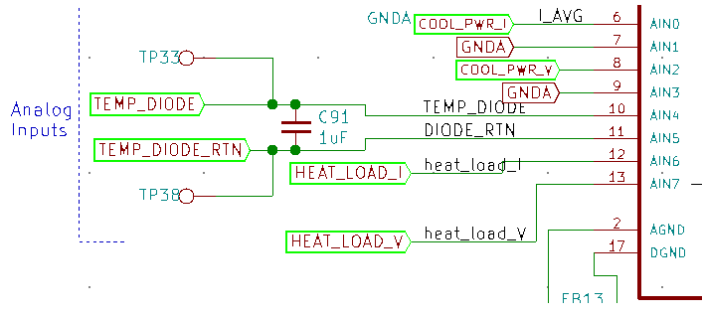
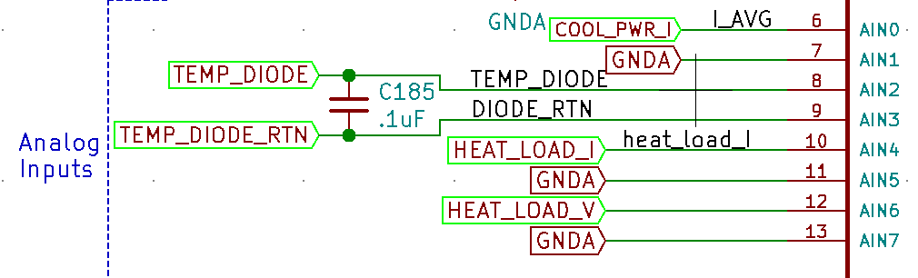
ADC1:

