AdvancedText2SpeechEditor

Sprint Report

**Two girls and a half man**

Tucaliuc Agnes Monalisa, 3346

Joanis Prifti, 3321

Ioanna Charpantidou, 4199

**VERSIONS HISTORY**

|  |  |  |  |
| --- | --- | --- | --- |
| **Date** | **Version** | **Description** | **Author** |
| **12/04/2021** | v.0 | Create packets and a diagram of the project | **Two girls and a half man** |
| **22/04/2021** | v.1 | Execution of DocumentReader, ExcelReader, WordReader, OtherFileReader in packet input | **Two girls and a half man** |
| **27/04/2021** | v.2 | Execution of DocumentDecoder, ReaderAtBashDecorator, ReaderRot13Decorator in packet input | **Two girls and a half man** |
| **7/05/2021** | v.3 | Execution of DocumentReaderFactory in packet input | **Two girls and a half man** |
| **8/05/2021** | v.4 | In packet model we implemented Document and TTSFacade classes | **Two girls and a half man** |
| **11/05/2021** | v.5 | In packet view we started creating the gui | **Two girls and a half man** |
| **19/05/2021** | v.6 | In packet commands we started implementing action listeners for the buttons | **Two girls and a half man** |
| **24/05/2021** | v.7 | In packet commands we started implementing voice and voice manager | **Two girls and a half man** |
| **25/05/2021** | v.8 | Last modifications to achieve scalability | **Two girls and a half man** |
| **27/05/2021** |  | REPORT | **Two girls and a half man** |

# Introduction

This document provides information concerning the sprints of the project.

## Document Structure

The rest of this document is structured as follows. Section 2 describes out Scrum team and specifies the Sprint's backlog. Section 3 specifies the main design concepts for this release of the project.

# Scrum team and Sprint Backlog

## Scrum team

|  |  |
| --- | --- |
| **Product Owner** | **Two girls and a half man(TM)** |
| **Scrum Master** | **Two girls and a half man(TM)** |
| **Development Team** | **Two girls and a half man(TM)** |

## Sprints

|  |  |  |  |  |
| --- | --- | --- | --- | --- |
| **Sprint No** | **Begin Date** | **End Date** | **Number of weeks** | **User stories** |
| **1** | **22/04** | **7/05** | **2** | **US1: Open Document** |
| **2** | **7/05** | **24/05** | **2** | **US2: Save Document** |
| **3** | **19/05** | **25/05** | **1** | **US3: Play Contents** |
| **4** | **19/05** | **25/05** | **1** | **US4: Play Line** |
| **5** | **19/05** | **25/05** | **1** | **US5: Setting Volume** |
| **6** | **19/05** | **25/05** | **1** | **US6: Replay Contents** |

# Use Cases

## Open Document

|  |  |
| --- | --- |
| **Use case ID** | 1 |
| **Actors** | User |
| **Pre conditions** | To have the document saved to the PC, in a valid format.. |
| **Main flow of events** | 1. The use case starts when the user presses the “Open” button at the upper panel of the GUI. 2. A window opens. 3. The user finds the file at the PC’s path.   4. The user presses the “Open” button (at the new window) . |
| **Alternative flow 1** | At step 4 the user can double click the file to open it. |
| **Alternative flow 2** | At step 4 the user can select the file and press enter to open it. |
| **Post conditions** | The text area is overwritten with the file content the user chose. |

## Save Document

|  |  |
| --- | --- |
| **Use case ID** | 2 |
| **Actors** | User |
| **Pre conditions** | - |
| **Main flow of events** | 1. The use case starts when the user presses the “Save” button at the upper panel of the GUI.  2. A window opens.  3. The user chooses a name for the file (the name must contain the .format type extension.  4. The user chooses the path the file will be saved to.  5. The user presses the “Save” button (at the new window) . |
| **Alternative flow 1** | Step 4 can happen at step 3 and step 4 can happen at step 3. |
| **Alternative flow 2** | - |
| **Post conditions** | The file is saved at the chosen path. |

## Clear

|  |  |
| --- | --- |
| **Use case ID** | 3 |
| **Actors** | User |
| **Pre conditions** | The text area contains at least one character either by directly writing to the text area or by opening an existing file from the user’s system. |
| **Main flow of events** | 1. The use case starts when the user presses the “Clear” button at the upper panel of the GUI. |
| **Post Conditions** | The text area clears up. |

## Encryption/Decryption

|  |  |
| --- | --- |
| **Use case ID** | 4 |
| **Actors** | User |
| **Pre conditions** | The text area contains at least one character either by directly writing to the text area or by opening an existing file from the user’s system. |
| **Main flow of events** | 1. The use case starts when the user presses one of the “At_Bash”, “Rot_13” or “None” button at the right panel of the GUI. |
| **Alternative flow 1** | 1. The user can alternate between the encryption types.  2. If the same button is pressed again decryption occurs. |
| **Post conditions** | The file is encoded of decoded with the chosen encryption/decryption (or stays the same if “None” button is pressed). |

## Lock

|  |  |
| --- | --- |
| **Use case ID** | 5 |
| **Actors** | User |
| **Pre conditions** | The text area contains at least one character either by directly writing to the text area or by opening an existing file from the user’s system. |
| **Main flow of events** | 1. The use case starts when the user presses the “Lock” button at the right panel of the GUI. |
| **Post Conditions** | The text area locks up and user can not erase any character from the text area, clear the text area or write to the text area. |

## Play

|  |  |
| --- | --- |
| **Use case ID** | 6 |
| **Actors** | User |
| **Pre conditions** | 1. The text area contains at least one character either by directly writing to the text area or by opening an existing file from the user’s system.  2. The user must have his system volume at 100% for better hearing of the speech output. |
| **Main flow of events** | 1. The use case starts when the user adjusts the volume by moving the bar from the slider, which is positioned at the right bottom of the GUI panel.  2. The user presses the “Play” button at the bottom panel of the GUI. |
| **Post conditions** | The contents of the text area are being spoken out loud by the app. |

## Play Line

|  |  |
| --- | --- |
| **Use case ID** | 7 |
| **Actors** | User |
| **Pre conditions** | 1. The text area contains at least one character either by directly writing to the text area or by opening an existing file from the user’s system.  2. The user must have his system volume at 100% for better hearing of the speech output. |
| **Main flow of events** | 1. The use case starts when the user adjusts the volume by moving the bar from the slider, which is positioned at the right bottom of the GUI panel.  2. The user enters a valid number in the text field at the bottom panel of the GUI.  3. The user presses the “Play Line” button. |
| **Post conditions** | The contents of the text area at the line the user chose are being spoken out loud. |

## Replay

|  |  |
| --- | --- |
| **Use case ID** | 8 |
| **Actors** | User |
| **Pre conditions** | 1. The user must have played (or played a line) at least once.  2. The user must have his system volume at 100% for better hearing of the speech output. |
| **Main flow of events** | 1. The use case starts when the user presses the “Replay” button. |
| **Post conditions** | All the played contents from the beginning are being spoken out loud by the system. |

# Design

## Architecture

For this project we created 5 packets.

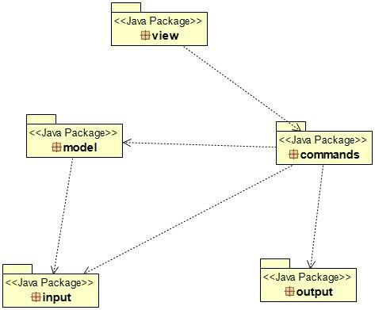

**Package view:**  In this package we created the GUI class that contains the graphical user interface and AdvancedText2SpeechApp class that has the main method.

**Package output:** In this package we created classes that read and create the files for the project.

**Package model:** In this package we created Document and TTSFacade classes that help combining files with freetts library.

**Package input:** In this package we created the classes responsible for reading any kind of file type and decoding it in ROT13 or AtBash.

**Package commands:** In this package we have the CommandsFactory responsible for the buttons’ operation.

## 4.2 Patterns

|  |  |  |  |
| --- | --- | --- | --- |
| **PatternNo** | **Name** | **Packet or classes** | **Description** |
| **1** | **GoF Command Pattern** | **commands packet** | **Allows us to pass actions as parameters to methods or objects, which subsequently execute those actions.** |
| **2** | **GoF Facade pattern** | **TTSFacade class** | **Facade defines a higher-level class that makes a subsystem or library easier to use.** |
| **3** | **GoF Strategy pattern** | **Document class, input class, output class** | **Reads any kind of Document type and decoding it in ROT13 or AtBash or reads and creates the Documents for the project.** |
| **4** | **GoF Decorator pattern** | **ReaderAtbashDecorator, ReaderRot13Decorator classes** | **Will allow to easily combine a decoding strategy with a particular file opening strategy.** |

## 4.3 Design

Below you can see the Class Uml of the project.

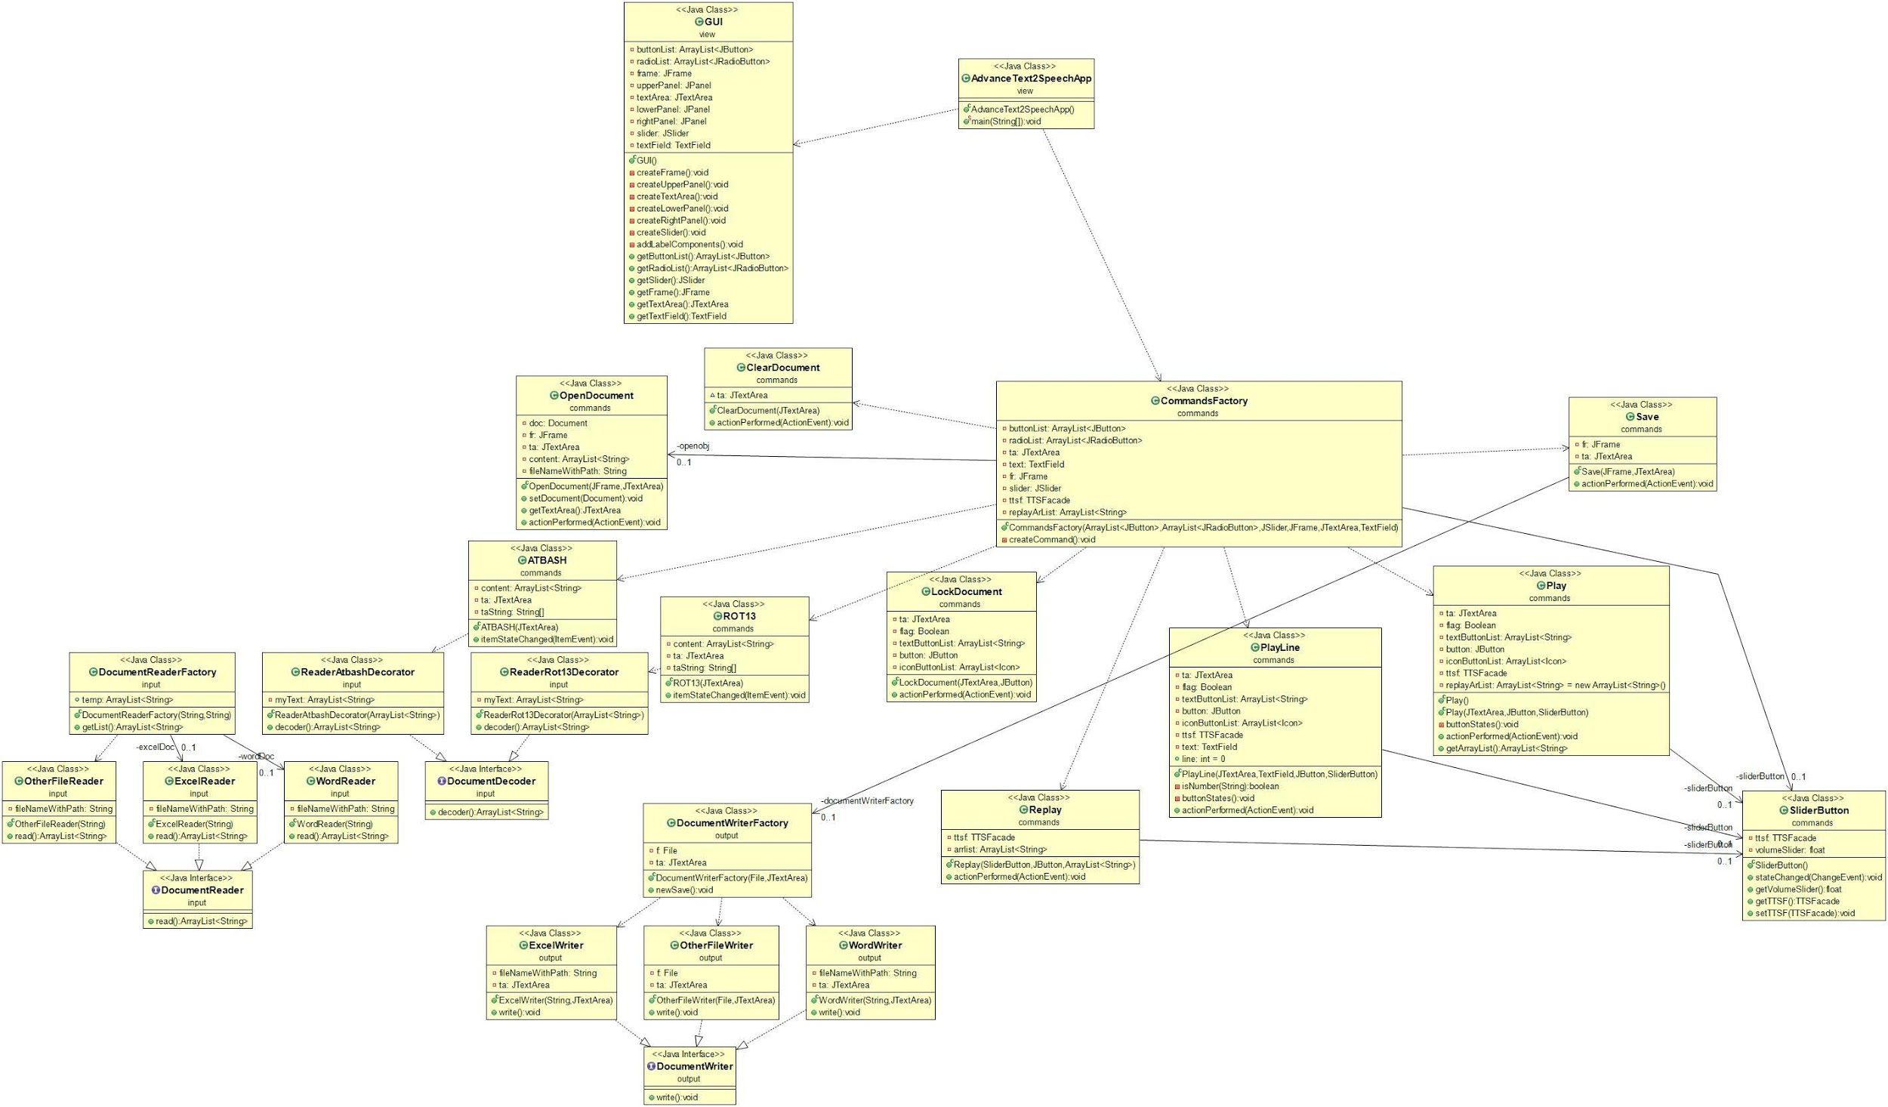

|  |  |
| --- | --- |
| **Class Name: AdvanceText2SpeechApp** | |
| **Responsibilities:**   * has the main method * calls the GUI class * calls the CommandsFactory class | **Collaborations:**   * with the commands packet that contains CommandsFactory |

|  |  |
| --- | --- |
| **Class Name: GUI** | |
| **Responsibilities:**   * Creates the Frame * Creates the Panels * Creates the TextArea * Creates the Slider | **Collaborations:**   * it is called from the other classes in the packet |

|  |  |
| --- | --- |
| **Class Name: ATBASH** | |
| **Responsibilities:**   * AtBash itemListener for the radioButton, encrypts and decrypts | **Collaborations:**   * with the input package to get ReaderAtbashDecorator * and the GUI class to get TextArea |

|  |  |
| --- | --- |
| **Class Name: ClearDocument** | |
| **Responsibilities:**   * ActionListener to clear the TextArea | **Collaborations:**   * With the GUI to get the TextArea |

|  |  |
| --- | --- |
| **Class Name: CommandsFactory** | |
| **Responsibilities:**   * calls every command on the GUI * puts actions on the frame | **Collaborations:**   * with every class in the commands packet * with packet model to get TTSFacade class |

|  |  |
| --- | --- |
| **Class Name: LockDocument** | |
| **Responsibilities:**   * actionListener to lock text area | **Collaborations:**   * with the GUI to get text area and the JButton |

|  |  |
| --- | --- |
| **Class Name: OpenDocument** | |
| **Responsibilities:**   * is responsible to open .docx , .xlsx or other type of file and adding their content in text area * actionListener for the Open JButton | **Collaborations:**   * package model to get Document class * with the GUI to get Jframe and JTextArea |

|  |  |
| --- | --- |
| **Class Name: Play** | |
| **Responsibilities:**   * plays content of the text area * plays selected content in text area * actionListener for the Play JButton | **Collaborations:**   * packet model to access TTSFacade class * with the GUI to get text area, JButton * with SliderButton class to ger value of the volume |

|  |  |
| --- | --- |
| **Class Name: PlayLine** | |
| **Responsibilities:**   * plays selected line that the user inputs in the text field * actionListener for the PlayLine Jbutton * restricts the text field just to get digits. | **Collaborations:**   * with package model to get TTSFacade functions * with SliderButton to get volume value * with GUI to get text area, textfield and button |

|  |  |
| --- | --- |
| **Class Name: Replay** | |
| **Responsibilities:**   * actionListener for the Replay JButton * replays content that has been played so far | **Collaborations:**   * with package model to get TTSFacade functions * with GUI to get button |

|  |  |
| --- | --- |
| **Class Name: ROT13** | |
| **Responsibilities:**   * itemListener for the ROT13 RadioButton * when selected decodes content in text area to Rot13 | **Collaborations:**   * with GUI class to get radioList and text area * with input package to get ReaderRot13Decoder |

|  |  |
| --- | --- |
| **Class Name: Save** | |
| **Responsibilities:**   * actionListener for the Save JButton * saves content of the text area into a file that the user creates or in already existing file | **Collaborations:**   * with the GUI to get Jframe and JTextArea * with output package to get access in DocumentWriterFactory class |

|  |  |
| --- | --- |
| **Class Name: SliderButton** | |
| **Responsibilities:**   * addChangeListener for the slider * gets volume from TTSFacade | **Collaborations:**   * with the package model to get access in TTSFacade class * with any class that plays content from the text area to give volume value |

|  |  |
| --- | --- |
| **Class Name: DocumentDecoder** | |
| **Responsibilities:**   * interface for the ArrayList<String> decoder() | **Collaborations:**   * with ReaderAtBashDecorator class * with ReaderRot13Decorator |

|  |  |
| --- | --- |
| **Class Name: DocumentReader** | |
| **Responsibilities:**   * interface for the ArrayList<String> read() | **Collaborations:**   * with WordReader class * with ExcelReader class * with OtherFileReader class |

|  |  |
| --- | --- |
| **Class Name: DocumentReaderFactory** | |
| **Responsibilities:**   * checks file type to call the proper class to open the file * gets the the list that has file content | **Collaborations:**   * with WordReader class * with ExcelReader class * with OtherFileReader class |

|  |  |
| --- | --- |
| **Class Name: ExcelReader** | |
| **Responsibilities:**   * opens .xlsx file * puts file’s content in a list | **Collaborations:**   * with DocumentReader class * with DocumentReaderFactory class |

|  |  |
| --- | --- |
| **Class Name: WordReader** | |
| **Responsibilities:**   * opens .docx file * puts file’s content in a list | **Collaborations:**   * with DocumentReader class * with DocumentReaderFactory class |

|  |  |
| --- | --- |
| **Class Name: OtherFileReader** | |
| **Responsibilities:**   * opens any type of file * puts file’s content in a list | **Collaborations:**   * with DocumentReaderFactory class * with DocumentReader class |

|  |  |
| --- | --- |
| **Class Name: ReaderAtBashDecorator** | |
| **Responsibilities:**   * decodes the list with the contents of the file that the user opens with AtBash | **Collaborations:**   * with DocumentDecoder class * with packet commands in ATBASH class |

|  |  |
| --- | --- |
| **Class Name: ReaderRot13** | |
| **Responsibilities:**   * decodes the list with the contents of the file that the user opens with Rot13 | **Collaborations:**   * with DocumentDecoder class * with packet commands in Rot13 class |

|  |  |
| --- | --- |
| **Class Name: DocumentWriter** | |
| **Responsibilities:**   * interface with write method | **Collaborations:**   * with ExcelWriter class * with OtherFileWriter class * with WordWriter class |

|  |  |
| --- | --- |
| **Class Name: DocumentWriterFactory** | |
| **Responsibilities:**   * checks file type and opens proper file type to save the text area content when the user presses Save button | **Collaborations:**   * with WordWriter class * with ExcelWriter class * with OtherFileWriter class |

|  |  |
| --- | --- |
| **Class Name: ExcelWriter** | |
| **Responsibilities:**   * Saves content in .xlsx file | **Collaborations:**   * with DocumentWriter class * with DocumentWriterFactory class |

|  |  |
| --- | --- |
| **Class Name: OtherFileWriter** | |
| **Responsibilities:**   * Saves content in .docx file | **Collaborations:**   * with DocumentWriterFactory class * with DocumentWriter class |

|  |  |
| --- | --- |
| **Class Name: WordWriter** | |
| **Responsibilities:**   * Saves content in any file type the user chooses | **Collaborations:**   * with DocumentWriterFactory class * with DocumentWriter class |

|  |  |
| --- | --- |
| **Class Name: Document** | |
| **Responsibilities:**   * gets the path of the file that we open or we save * gets content list from the files that the user selects to open * opens files with the DocumentReaderFactory | **Collaborations:**   * with input package to access DocumentReaderFactory * with TTSFacade class |

|  |  |
| --- | --- |
| **Class Name: TTSFacade** | |
| **Responsibilities:**   * gets voice functions for the audio from freetts package | **Collaborations:**   * with commands package with every kind of play button and the slider |

## 5 Acceptance Tests

**US1:** Open Document

Description: opens/reads a document.

Method to test: ArrayList<String> read(), which is in the classes: ExcelReader, WordReader, OtherFileReader.

Assertion: Check if the document is properly read (the returned “ArrayList<String> list” is not empty and it has the document’s contents) (in ExcelReader/WordReader/OtherFileReader classes).

**US2:** Save Document

Description: saves a document.

Method to test: void write(), which is in the classes: ExcelWriter, WordWriter, OtherFileWriter

Assertion: Check if the document is properly saved. To do this we check if the following variables are not null and if the file they write to has the text area’s contents.

1. XWPFDocument document (for the WordWriter).
2. XSSFWorkbook workbook (for the ExcelWriter).
3. FileWriter fw (for the OtherFileWriter).

**US3:** Play contents

Description: Plays all the contents of the text area.

Methods to test:

* TTSFacade getTTSF() (in SliderButton class).
* void actionPerformed(ActionEvent eve) (in Play class).

Assertion: in Play class check if:

1. the “TTSFacade ttsf” field is not null.
2. the local variable “String allText” contains all the text from the text area.
3. the local variable “String text” is null or not.

**US4:** Play Line

Description: Plays the contents of a line of the text area.

Method to test:

* void actionPerformed(ActionEvent eve) (in PlayLine class).
* TTSFacade getTTSF() (in SliderButton class).

Assertion: In PlayLine class check if:

1. the “int line” field contains a valid line NUMBER (number of a line in which there is at least a character).
2. the “textArea[line]” is not null and it contains the text of the line the user entered.
3. the “TTSFacade ttsf” field is not null.

**US5:** Setting Volume

Description: Sets the volume from the slider.

Method to test: void stateChanged(ChangeEvent e) (in SliderButton class).

Assertion: Check if the “float volumeSlider” field is correctly containing the float from the slider (in SliderButton class).

**US6:** Replay Contents

Description: Replays every “Play” and “PlayLine” the user has pressed from the time he/she opened the app.

Methods to test:

* void actionPerformed(ActionEvent eve) (in Play AND PlayLine classes).
* void createCommand() (in CommandsFactory class).

Assertion: Check if:

1. the “ArrayList<String> replayArList” field is correctly adding in it the text it is played out loud every time “Play” or “PlayLine” buttons are pressed (in Play/PlayLine classes).
2. the “ArrayList<String> replayArList” field is not null as well as if it contains the correct phrases (in CommandsFactory class).