AdvancedText2SpeechEditor
Sprint Report
Two girls and a half man

Tucaliuc Agnes Monalisa, 3346
Joanis Prifti, 3321
Ioanna Charpantidou, 4199

Versions History
Date | Version | Description | Author
12/04/2021 | v.0 | Create packets and a diagram of the project | Two girls and a half man
22/04/2021 | v.1 | Execution of DocumentReader, ExcelReader, WordReader, OtherFileReader in packet input | Two girls and a half man
27/04/2021 | v.2 | Excecution of DocumentDecoder, ReaderAtBashDecorator, ReaderRot13Decorator in packet input | Two girls and a half man
7/05/2021 | v.3 | Execution of DocumentReaderFactory in packet input | Two girls and a half man
8/05/2021 | v.4 | In packet model we implemented Document and TTSFacade classes | Two girls and a half man
11/05/2021 | v.5 | In packet view we started creating the gui | Two girls and a half man
19/05/2021 | v.6 | In packet commands we started implementing action listeners for the buttons | Two girls and a half man
24/05/2021 | v.7 | In packet commands we stated implementing voice and voice manager | Two girls and a half man
25/05/2021 | v.8 | Last modifications to achive scalability | Two girls and a half man
27/05/2021 |  | REPORT | Two girls and a half man

Introduction
This document provides information concerning the <X> sprint of the project.

Purpose

Document Structure
The rest of this document is structured as follows. Section 2 describes out Scrum team and specifies the this Sprint's backlog. Section 3 specifies the main design concepts for this release of the project.

Scrum team and Sprint Backlog
<For the user stories included in this release specify below corresponding tests using a typical tabular form.>

Scrum team
Product Owner | Two girls and a half man(TM)
Scrum Master | Two girls and a half man(TM)
Development Team | Two girls and a half man(TM)

Sprints
<List below the sprints that you performed and the user stories that have been realized in each Sprint>
Sprint No | Begin Date | End Date | Number of weeks | User stories

Use Cases
<Specify the concrete Use Cases that describe the interaction of the user with the applications, as derived from the abstract user stories. Give a UML Use Case diagram and the detailed use case descriptions.>

Open Document

Use case ID | 1
Actors | User
Pre conditions | To have the document saved to the PC, in a valid format..
Main flow of events | - The use case starts when the user presses the “Open” button at the upper panel of the GUI.  - A window opens.  - The user finds the file at the PC’s path.  4. The user presses the “Open” button (at the new window) .
Alternative flow 1 | At step 4 the user can double click the file to open it.
Alternative flow 2 | At step 4 the user can select the file and press enter to open it.
Post conditions | The text area is overwritten with the file content the user chose.

Save Document

Use case ID | 2
Actors | User
Pre conditions | -
Main flow of events | 1. The use case starts when the user presses the “Save” button at the upper panel of the GUI.  2. A window opens.  3. The user chooses a name for the file (the name must contain the .format type extension.  4. The user chooses the path the file will be saved to.  5. The user presses the “Save” button (at the new window) .
Alternative flow 1 | Step 4 can happen at step 3 and step 4 can happen at step 3.
Alternative flow 2 | -
Post conditions | The file is saved at the chosen path.

Clear

Use case ID | 3
Actors | User
Pre conditions | The text area contains at least one character either by directly writing to the text area or by opening an existing file from the user’s system.
Main flow of events | 1. The use case starts when the user presses the “Clear” button at the upper panel of the GUI.
Post Conditions | The text area clears up.

Encryption/Decryption

Use case ID | 4
Actors | User
Pre conditions | The text area contains at least one character either by directly writing to the text area or by opening an existing file from the user’s system.
Main flow of events | 1. The use case starts when the user presses one of the “At_Bash”, “Rot_13” or “None” button at the right panel of the GUI.
Alternative flow 1 | 1. The user can alternate between the encryption types.  2. If the same button is pressed again decryption occurs.
Post conditions | The file is encoded of decoded with the chosen encryption/decryption (or stays the same if “None” button is pressed).

Lock

Use case ID | 5
Actors | User
Pre conditions | The text area contains at least one character either by directly writing to the text area or by opening an existing file from the user’s system.
Main flow of events | 1. The use case starts when the user presses the “Lock” button at the right panel of the GUI.
Post Conditions | The text area locks up and user can not erase any character from the text area, clear the text area or write to the text area.

Play

Use case ID | 6
Actors | User
Pre conditions | 1. The text area contains at least one character either by directly writing to the text area or by opening an existing file from the user’s system.  2. The user must have his system volume at 100% for better hearing of the speech output.
Main flow of events | 1. The use case starts when the user adjusts the volume by moving the bar from the slider, which is positioned at the right bottom of the GUI panel.  2. The user presses the “Play” button at the bottom panel of the GUI.
Post conditions | The contents of the text area are being spoken out loud by the app.

Play Line

Use case ID | 7
Actors | User
Pre conditions | 1. The text area contains at least one character either by directly writing to the text area or by opening an existing file from the user’s system.  2. The user must have his system volume at 100% for better hearing of the speech output.
Main flow of events | 1. The use case starts when the user adjusts the volume by moving the bar from the slider, which is positioned at the right bottom of the GUI panel.  2. The user enters a valid number in the text field at the bottom panel of the GUI.  3. The user presses the “Play Line” button.
Post conditions | The contents of the text area at the line the user chose are being spoken out loud.

Replay

Use case ID | 8
Actors | User
Pre conditions | 1. The user must have played (or played a line) at least once.  2. The user must have his system volume at 100% for better hearing of the speech output.
Main flow of events | 1. The use case starts when the user presses the “Replay” button.
Post conditions | All the played contents from the beginning are being spoken out loud by the system.

Design

Architecture
For this project we created 5 packets.
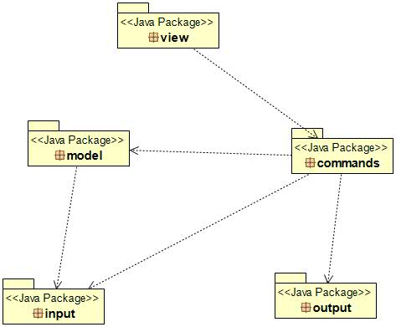

Package view: In this package we created the GUI class that contains the graphical user interface and AdvancedText2SpeechApp class that has the main method.
Package output: In this package we created classes that read and create the files for the project.
Package model: In this package we created Document and TTSFacade classes that help combining files with freetts library.
Package input: In this package we created the classes responsible to read any kind of file type and decoding them in ROT13 or AtBash.
Package commands: In this package we have the CommandsFactory responsible for the buttons’ operation.

Design
Below you can see the Class Uml of the project.
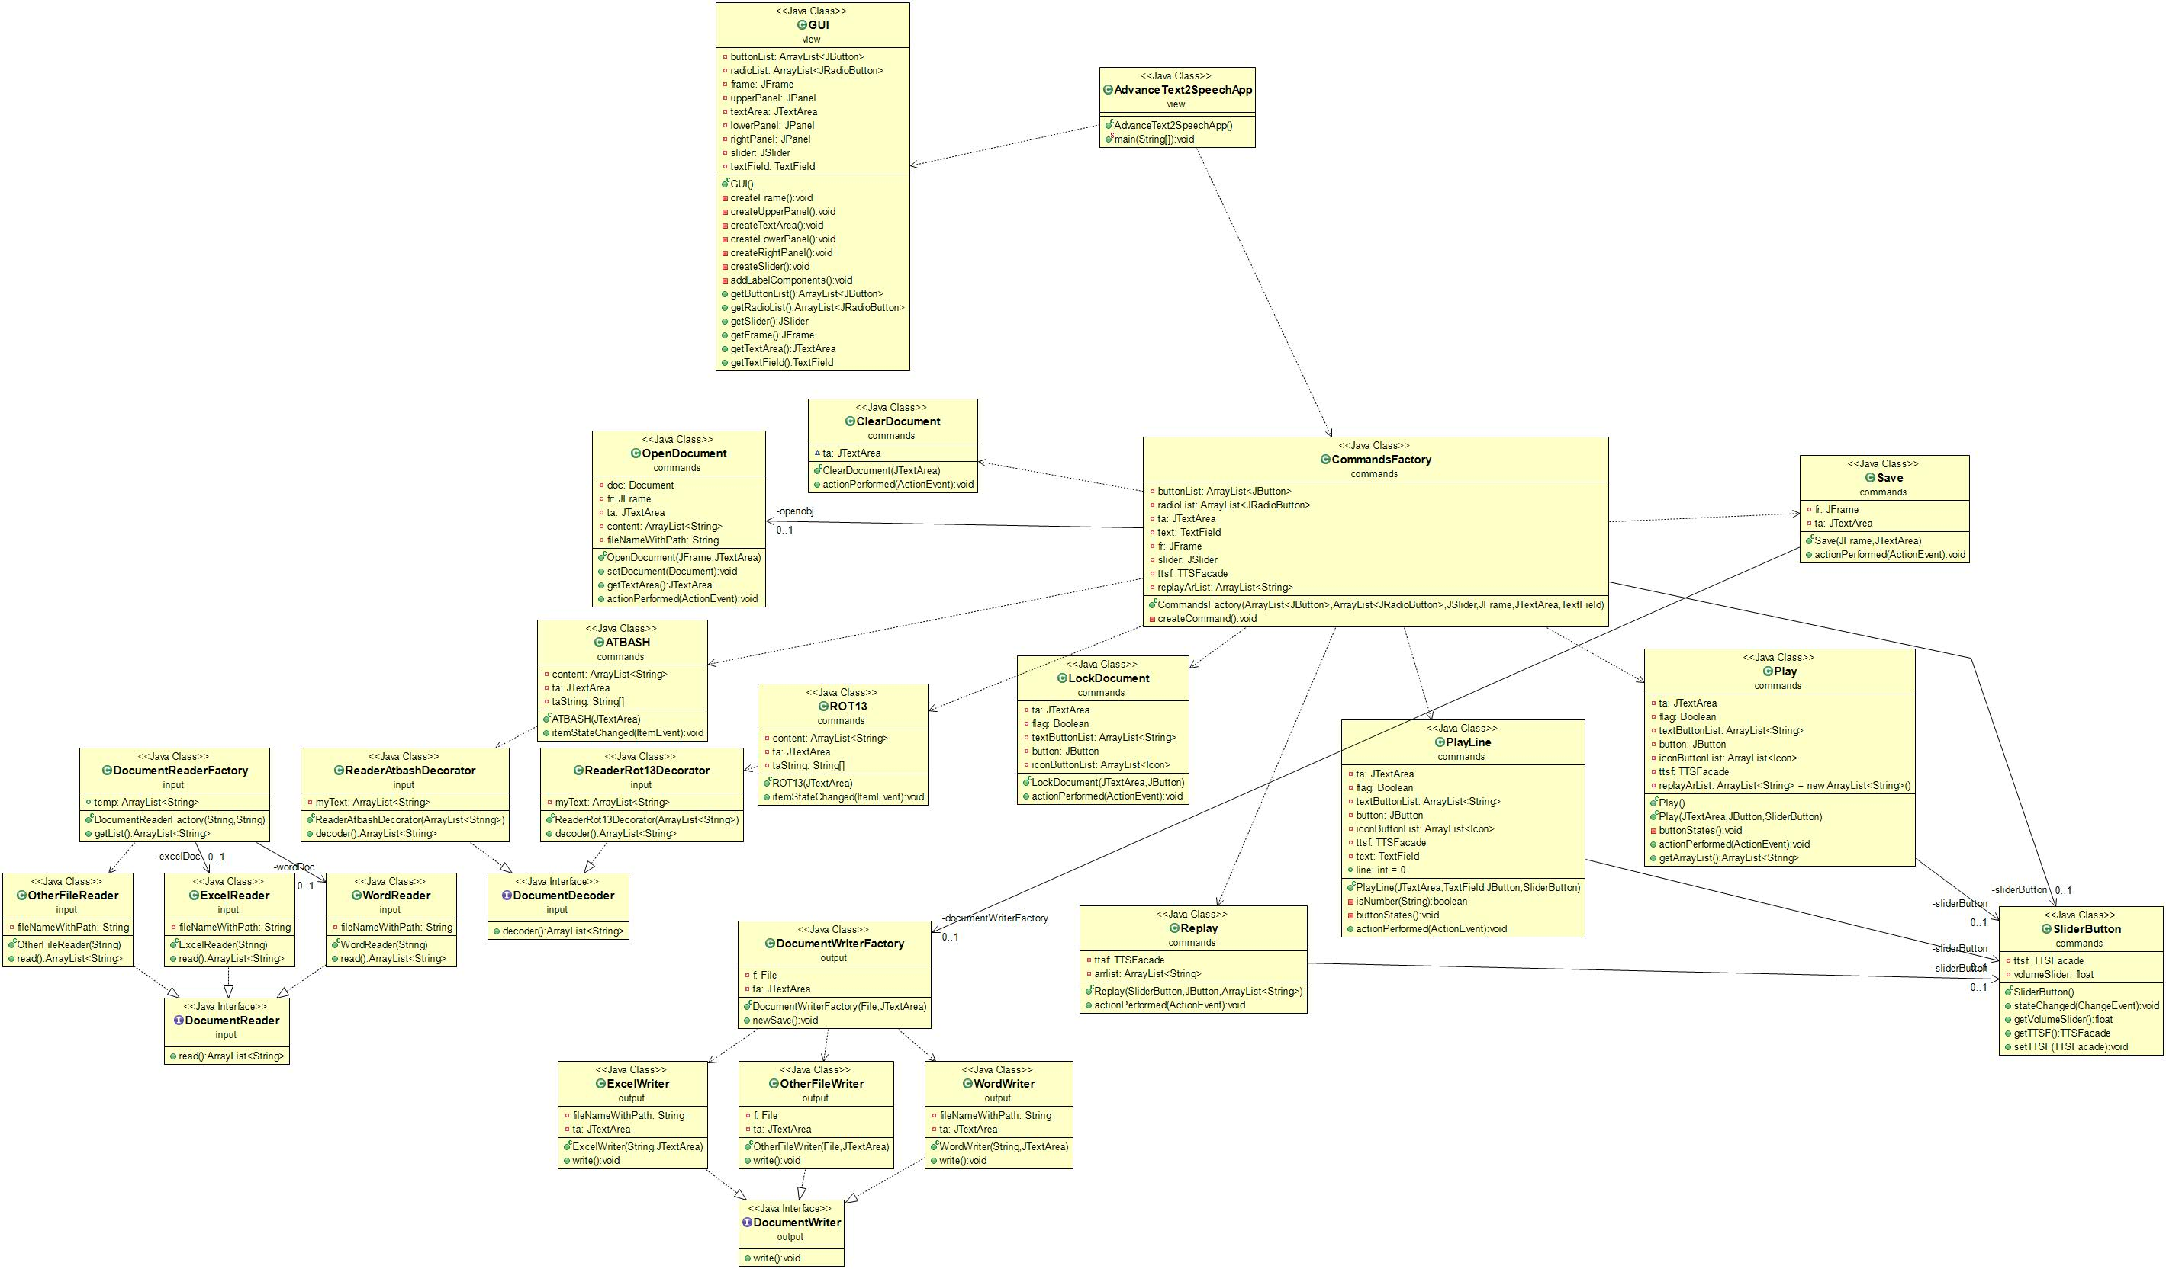

Class Name: AdvanceText2SpeechApp
Responsibilities:  - has the main method  - calls the GUI class  - calls the CommandsFactory class | Collaborations:  - with the commands packet that contains CommandsFactory

Class Name: GUI
Responsibilities:  - Creates the Frame  - Creates the Panels  - Creates the TextArea  - Creates the Slider | Collaborations:  - it is called from the other classes in the packet

Class Name: ATBASH
Responsibilities:  - AtBash itemListener for the radioButton, encypts and decrpts | Collaborations:  - with the input package to get ReaderAtbashDecorator  - and the GUI class to get TextArea

Class Name: ClearDocument
Responsibilities:  - ActionListener to clear the TextArea | Collaborations:  - With the GUI to get the TextArea

Class Name: CommandsFactory
Responsibilities:  - calls evey command on the GUI  - puts actions on the frame | Collaborations:  - with every class in the commands packet  - with packet model to get TTSFacade class

Class Name: LockDocument
Responsibilities:  - actionListener to lock text area | Collaborations:  - with the GUI to get text area and the JButton

Class Name: OpenDocument
Responsibilities:  - is responsible to open .docx , .xlsx or other tyoe of file and adding their content in text area  - actionListener for the Open JButton | Collaborations:  - package model to get Document class  - with the GUI to get Jframe and JTextArea

Class Name: Play
Responsibilities:  - plays content of the text area  - plays selected content in text area  - actionListener for the Play JButton | Collaborations:  - packet model to access TTSFacade class  - with the GUI to get text area, JButton  - with SliderButton class to ger value of the volume

Class Name: PlayLine
Responsibilities:  - plays selected line that the user inputs in the text field  - actionListener for the PlayLine Jbutton  - restricts the text field just to get digits. | Collaborations:  - with package model to get TTSFacade functions  - with SliderButton to get volume value  - with GUI to get text area, text filed and button

Class Name: Replay
Responsibilities:  - actionListener for the Replay JButton  - replays content that has been played so far | Collaborations:  - with package model to get TTSFacade functions  - with GUI to get button

Class Name: ROT13
Responsibilities:  - itemListener for the ROT13 RadioButton  - when selected decodes content in text area to Rot13 | Collaborations:  - with GUI class to get radioList and text area  - with input package to get ReaderRot13Decoder

Class Name: Save
Responsibilities:  - actionListener for the Save JButton  - saves content of the text area into a file that the user creates or in already existing file | Collaborations:  - with the GUI to ger Jframe and JTextArea  - with output package to get access in DocumentWriterFactory class

Class Name: SliderButton
Responsibilities:  - addChangeListener for the slider  - gets volume from TTSFacade | Collaborations:  - with the package model to get access in TTSFacade class  - with any class that plays content from the text area to give volume value

Class Name: DocumentDecoder
Responsibilities:  - interface for the ArrayList<String> decoder() | Collaborations:  - with ReaderAtBashDecorator class  - with ReaderRot13Decorator

Class Name: DocumentReader
Responsibilities:  - interface for the ArrayList<String> read() | Collaborations:  - with WordReader class  - with ExcekReader class  - with OtherFileReader class

Class Name: DocumentReaderFactory
Responsibilities:  - checks file type to call the proper class to open the file  - gets the the list that has file content | Collaborations:  - with WordReader class  - with ExcekReader class  - with OtherFileReader class

Class Name: ExcelReader
Responsibilities:  - opens .xlsx file  - puts file’s content in a list | Collaborations:  - with DocumentReader class  - with DocumentReaderFactory class

Class Name: WordReader
Responsibilities:  - opens .docx file  - puts file’s content in a list | Collaborations:  - with DocumentReader class  - with DocumentReaderFactory class

Class Name: OtherFileReader
Responsibilities:  - opens any type of file  - puts file’s content in a list | Collaborations:  - with DocumentReaderFactory class  - with DocumentReader class

Class Name: ReaderAtBashDecorator
Responsibilities:  - decodes the list with the contents of the file that the user opens with AtBash | Collaborations:  - with DocumentDecoder class  - with packet commands in ATBASH class

Class Name: ReaderRot13
Responsibilities:  - decodes the list with the contents of the file that the user opens with Rot13 | Collaborations:  - with DocumentDecoder class  - with packet commands in Rot13 class

Class Name: DocumentWriter
Responsibilities:  - interface with write method | Collaborations:  - with ExcelWriter class  - with OtherFileWriter class  - with WordWriter class

Class Name: DocumentWriterFactory
Responsibilities:  - checks file type and opens proper file type to save the text area content when the user presses Save button | Collaborations:  - with WordWriter class  - with ExcelWriter class  - with OtherFileWriter class

Class Name: ExcelWriter
Responsibilities:  - Saves content in .xlsx file | Collaborations:  - with DocumentWriter class  - with DocumentWriterFactory class

Class Name: OtherFileWriter
Responsibilities:  - Saves content in .docx file | Collaborations:  - with DocumentWriterFactory class  - with DocumentWriter class

Class Name: WordWriter
Responsibilities:  - Saves content in any file type the user chooses | Collaborations:  - with DocumentWriterFactory class  - with DocumentWriter class

Class Name: Document
Responsibilities:  - gets the path of the file that we open or we save  - gets content list from the files that the user selects to open  - opens files with the DocumentReaderFactory | Collaborations:  - with input package to access DocumentReaderFactory  - with TTSFacade class

Class Name: TTSFacade
Responsibilities:  - gets voice funtions for the audio from freetts package | Collaborations:  - with commands package with every kind of play button and the slider

