CS 3101 Computer Organization

Homework 3

Type your answers in this Word document. Write your name in the header. Rename the file to YourLastname_hw3.docx and submit in the correct folder in BlazeView.

You can use Equations in Word to write the Boolean expressions, use Insert Shapes in Word to draw the circuits, and use Insert Tables in Word to draw the Kmaps. If you write formulas and draw charts by hand, make sure your writing and drawings are legible.

- Simplify the following functional expression using Boolean algebra and its identities. List the identity used at each step.

$$F\left(x,y,z\right)=\overline{x}y+xy\overline{z}+xyz$$
$F\left(x,y,z\right)=\overline{x}y+xy(\overline{z}+z)$ Distributive
$F\left(x,y,z\right)=\overline{x}y+xy(1)$ Inverse
$F\left(x,y,z\right)=\overline{x}y+xy$ Identity law
$F\left(x,y,z\right)=y(\overline{x}+x)$ Distributive
$F\left(x,y,z\right)=y(1)$ Inverse
$F\left(x,y,z\right)=y$ Identity law

- Use any method to prove the following either True or False.

$$yz+xy\overline{z}+\overline{x}\overline{y}z=xy+\overline{x}z$$
$z(y+\overline{x}\overline{y})+xy\overline{z}$ Distributive
$z(\left(y+\overline{x}\right)\left(y+\overline{y}\right))+xy\overline{z}$ Absorption law $z(\left(y+\overline{x}\right)\left(1\right))+xy\overline{z}$ Inverse
$1yz+1\overline{x}z+xy\overline{z}$ Distributive
$yz+\overline{x}z+xy\overline{z}$ Identity law
$y(z+x\overline{z})+\overline{x}z$ Distributive
$y(\left(z+x\right)\left(z+\overline{z}\right))+\overline{x}z$ Absorption law
$y(\left(z+x\right)(1)+\overline{x}z$ Inverse law
$1yz+1xy+x\overline{z}$ Distributive
$yz+xy+x\overline{z}$ Identity law
FALSE
There is probably an easier method to solve this. Am I close to getting this right?

- Given the function: $F\left(x,y,z\right)=x\overline{y}z+x\overline{y}\overline{z}+xyz$
  - List the truth table for $F$.

x | y | z | $$x\overline{y}z$$ | $$x\overline{y}\overline{z}$$ | $$xyz$$ | $$x\overline{y}z+x\overline{y}\overline{z}+xyz$$
0 | 0 | 0 | 0 | 0 | 0 | 0
0 | 0 | 1 | 0 | 0 | 0 | 0
0 | 1 | 0 | 0 | 0 | 0 | 0
0 | 1 | 1 | 0 | 0 | 0 | 0
1 | 0 | 0 | 0 | 1 | 0 | 1
1 | 0 | 1 | 1 | 0 | 0 | 1
1 | 1 | 0 | 0 | 0 | 0 | 0
1 | 1 | 1 | 0 | 0 | 1 | 1

  - Draw the logic circuit using the original Boolean expression

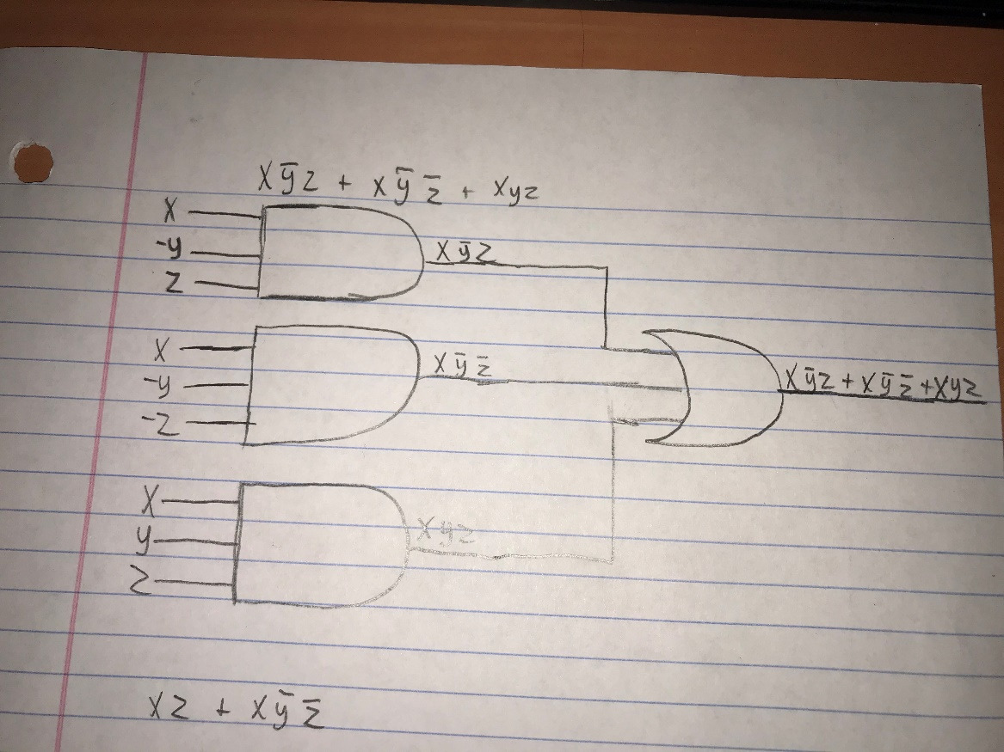

  - Simplify the expression using Boolean algebra and identities.
$$x\overline{y}z+x\overline{y}\overline{z}+xyz$$
$x(\overline{y}z+\overline{y}\overline{z}+yz)$ Distributive
$x(z(\overline{y}+y)+\overline{y}\overline{z})$ Distributive
$x(z(1)+\overline{y}\overline{z})$ Inverse law
$x(z+\overline{y}\overline{z})$ Identity law
$xz+x\overline{y}\overline{z}$ Distributive

  - List the truth table for your answer in Part c.

x | y | z | $$xz$$ | $$x\overline{y}\overline{z}$$ | $$xz+x\overline{y}\overline{z}$$
0 | 0 | 0 | 0 | 0 | 0
0 | 0 | 1 | 0 | 0 | 0
0 | 1 | 0 | 0 | 0 | 0
0 | 1 | 1 | 0 | 0 | 0
1 | 0 | 0 | 0 | 1 | 1
1 | 0 | 1 | 1 | 0 | 1
1 | 1 | 0 | 0 | 0 | 0
1 | 1 | 1 | 1 | 0 | 1

  - Draw the logic diagram for the simplified expression in Part c.
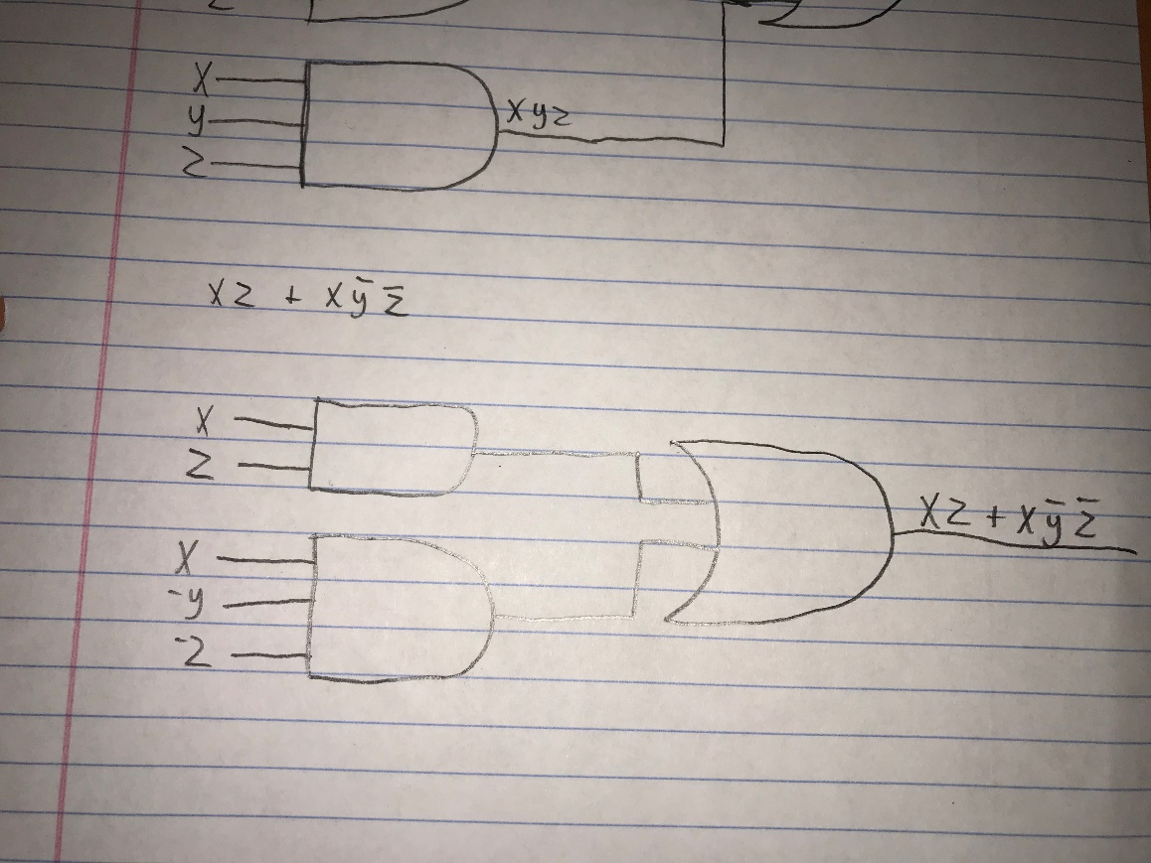

- Write a simplified expression for the Boolean function defined by the following Kmap.

yz  wx | 00 | 01 | 11 | 10
00 | 1 |  |  | 1
01 | 1 |  |  | 1
11
10 | 1 |  | 1 | 1

Y= $\overline{W}\overline{Z}$+$\overline{X}\overline{Z}$+$W\overline{X}Y$

- Write a simplified expression for the Boolean function defined by the following K-maps:

yz  x | 00 | 01 | 11 | 10
0 | 1 | 0 | 0 | X
1 | 1 | 1 | 1 | 1
Y= $X+\overline{Z}$

yz  wx | 00 | 01 | 11 | 10
00 | 1 | 1 | 1 | 1
01 |  | X | 1 | X
11 |  |  | X
10 | 1 |  | X | 1

Y= $\overline{X}\overline{Z}$+$\overline{W}Z$

