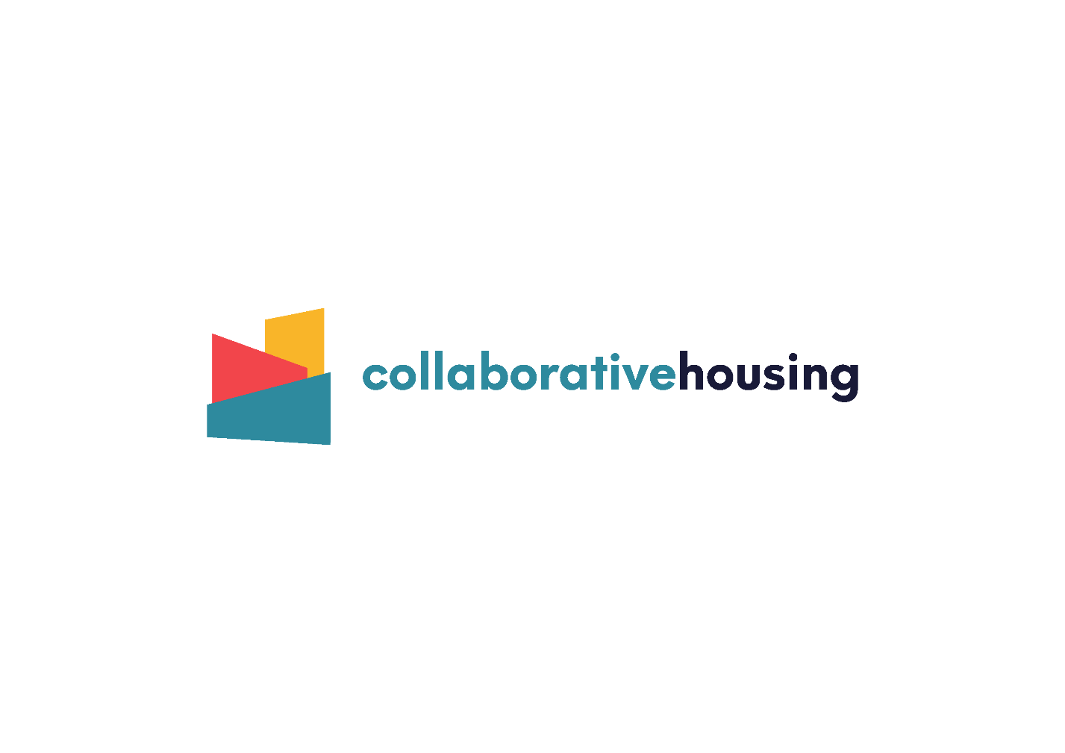

**Collaborative Housing Agile Fund**

# **APPLICATION FORM**

* The Agile Fund is a grant fund supported by and administered by Collaborative Housing.
* The maximum amount you can apply for is £1000.

|  |
| --- |
| **Please read the application guidance on pp. 4 - 5 and**  **date and sign your agreement to the Terms and Conditions BEFORE completing this form.** |

## **Contact details**

**What is the name of your community-led housing group?**

|  |
| --- |
|  |

**What is the name of the person completing this form?**

|  |
| --- |
|  |

**Contact details: email and telephone**

|  |
| --- |
|  |

## **What you would like the grant for?**

**Please describe what you would like to do with your grant monies and how the funding would benefit the development of your community-led housing project.**

|  |
| --- |
|  |

## **Project costs**

**Check your figures carefully and make sure all costs listed add up to the total.**

|  |  |
| --- | --- |
| **Activity** | **Costs** |
|  |  |
|  |  |
|  |  |
|  |  |
|  |  |

**Total amount applied for:**

**Are you an existing and constituted group?**

**YES or NO**

|  |
| --- |
| **NOTE:**  **Where groups are not incorporated and do not have banking facilities Collaborative Housing can order item/s on the group’s behalf.** |

## **If you are, please give details of your organisation’s bank account details.**

**Please note this must be in the name of the organisation applying for the funding and not a third party.**

Name of Bank:

Account Name:

Account Number: Sort Code:

## **Declaration**

**I / we hereby confirm that the information contained within this form is accurate. By completing and signing this form, I give consent for my information to be processed in accordance with the purposes set out in this document.**

**Signature………………………………………………………………………………**

**Position in organisation / group …………………………………………….**

**Name……………………………………………………………………………………**

**Date……………………………………………………………………………………..**

Please return to:

[**fiona@cohohub.org.uk**](mailto:fiona@cohohub.org.uk)

For office use:

|  |  |
| --- | --- |
| Date received |  |
| Reference |  |
| Date Paid |  |
| Finance report received |  |

Collaborative Housing Agile Fund - application guidance

|  |
| --- |
| **Please read these notes carefully, together with the application form, before making an application. If you need help to do this,**  **please talk with Fiona Brown.** |

* The Agile Fund is a grant fund supported by and administered by Collaborative Housing.
* The maximum amount you can apply for is £1000.00.

* Funds will be offered on a first come first served basis.
* Monies that are granted will need to be spent by September 2021.
* Groups will be required to provide evidence of how the money has been spent though invoices or receipts.

## **Who is the fund for?**

This fund is made available from Collaborative Housing and is aimed at community-led housing groups in the early stages of the community-led housing process.

## **What can the Agile Fund be used to pay for?**

The fund is intended to cover the cost of things like:

* Community engagement costs (e.g. publicity materials, Zoom licence)
* Development of a website
* Legal advice on governance
* Incorporation costs
* Training
* Surveys etc.

## **What happens next?**

Once your application form has been received our Grant Panel will look at whether your proposal meets the priorities for this scheme. We will assess this on the following basis:

* The group has signed the terms and conditions of Collaborative Housing membership and is engaged with training and support offered as part of that membership.
* The group doesn’t have funds from elsewhere to pay for the intended item/s.
* There is not an alternative funding route for the item/s required.
* The money will further the group’s progress toward a viable community-led housing project.

## **Grant payment**

Where groups are not incorporated and do not have banking facilities Collaborative Housing can order item/s on the group’s behalf.

Groups will be required to provide evidence of how the money has been spent though invoices or receipts.

You must keep accurate records of all expenditure and send a statement along with evidence of expenditure to: [fiona.brown@cohohub.org.uk](mailto:fiona.brown@cohohub.org.uk)

Any under-spend, must be returned to Collaborative Housing within three months of the end of the project along with a final statement of expenditure.

## **Terms and conditions**

**I/ we agree**

* To ensure the grant is spent on the proposal outlined in the grant application.
* To discuss with Fiona Brown if the project needs to change from the original proposal.
* To keep accurate financial records of expenditure and provide an end of project statement to Collaborative Housing.
* To return any unspent money to Collaborative Housing within three months of end of project.
* To ensure the project does not break any UK laws.

**Signed:**

**Date:**