Abstract

Introduction

Proposed Solution

Objectives

Significance

Scope

Development Tools

Project Highlights (Advantages of the system)

How the System Works

**Login Form**

**Admin Dashboard**

* number of file category
* number of files
* number of users

**File Category Information**

* Category name
* Description

**File Management**

* File name
* Category name – drop down
* Description
* Tags
* File Upload
* File Type - .docx, .pptx, .xlsx
* Uploaded by
* Date uploaded

**Commit File Update**

* Select source file
* File name
* Commit Remarks
* Committed by
* Date

**Document Log History**

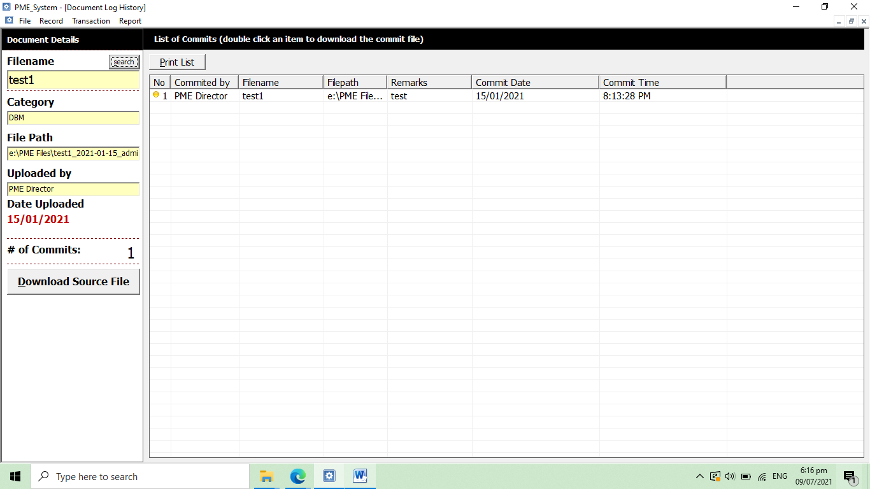

**Commit Details**

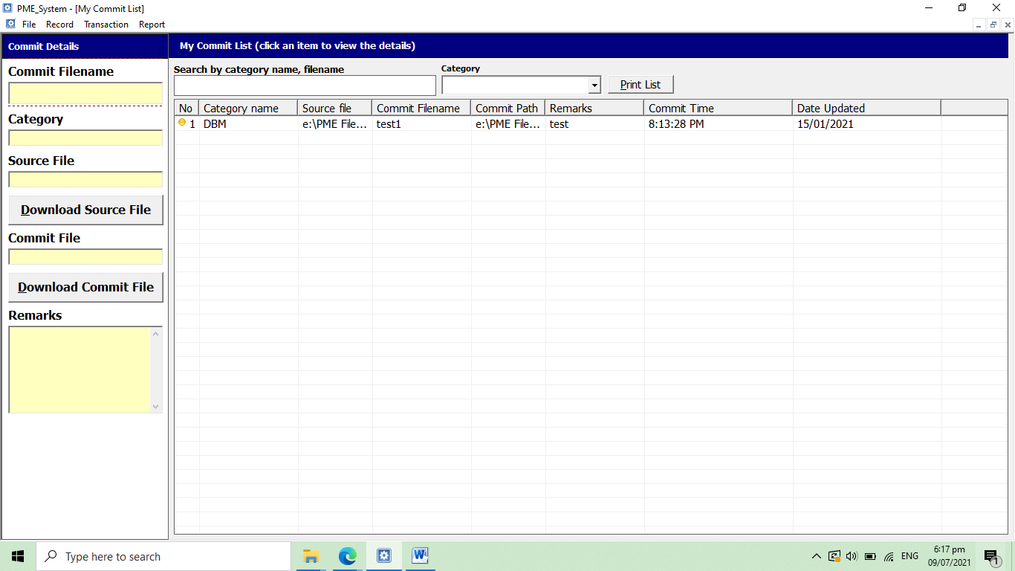

**User Log History**

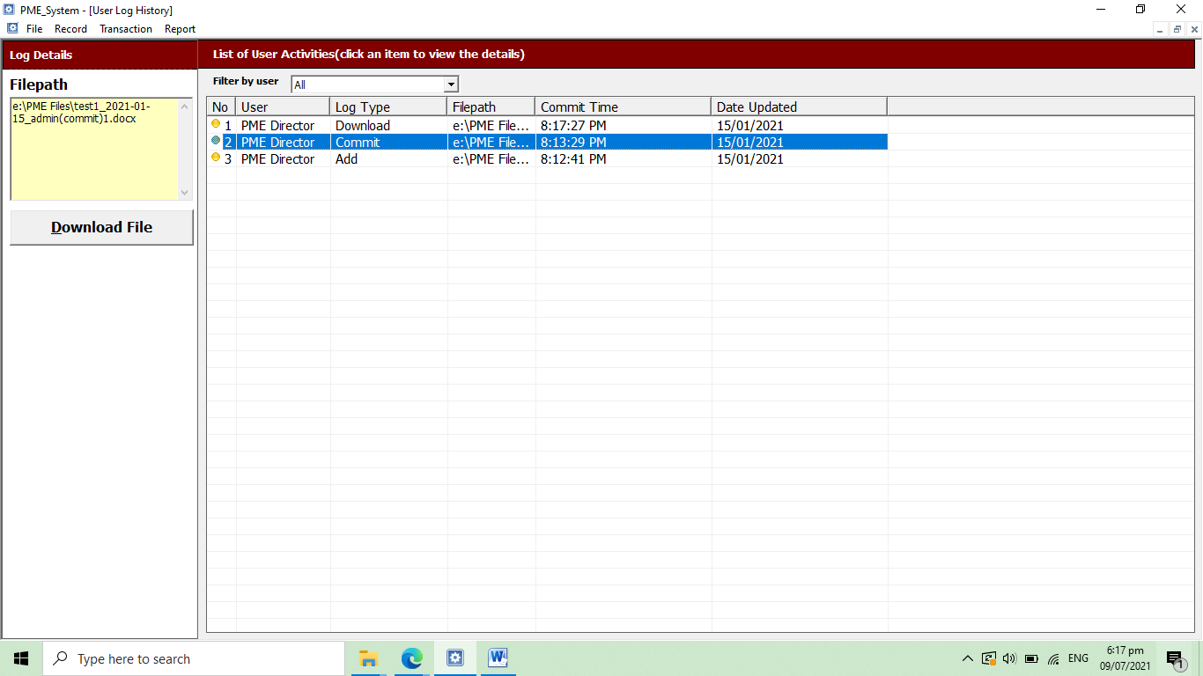

**User Management**

* Full name
* Username
* Password
* Confirm Password
* Category
* Codename

**Backup Database**

**Office Settings**

* Office Code
* Office name
* Head of Office
* Contact
* Email Address

Conclusion

Recommendations