**Free Maternal Records Management System**

Introduction of the Study

Proposed Solution

Objectives of the Study

Significance of the Study

Development Tools

Project Highlights (Advantages of the system)

How the System Works

**Login Form**

**Admin Dashboard**

* Number of patient

**Patient Information**

* Patient Code
* Last name
* First name
* Middle name
* Contact
* Email
* Address
* Birthdate
* Age
* Status

**Prenatal Records**

* Patient Code
* Patient Name
* Prenatal Schedule
* Midwife/Nurse/Doctor
* Blood Pressure
* Weight
* Size of Tummy
* Remarks

**Child Records**

* Mother name
* Child last name
* Child first name
* Child middle name
* Gender
* Birthdate
* Weight
* Height

**Child Immunization Record**

* Child name
* Age
* Immunization Type
* Date of Immunization
* Remarks

**Reports**

**Number of Prenatal per month** – Table and Graph

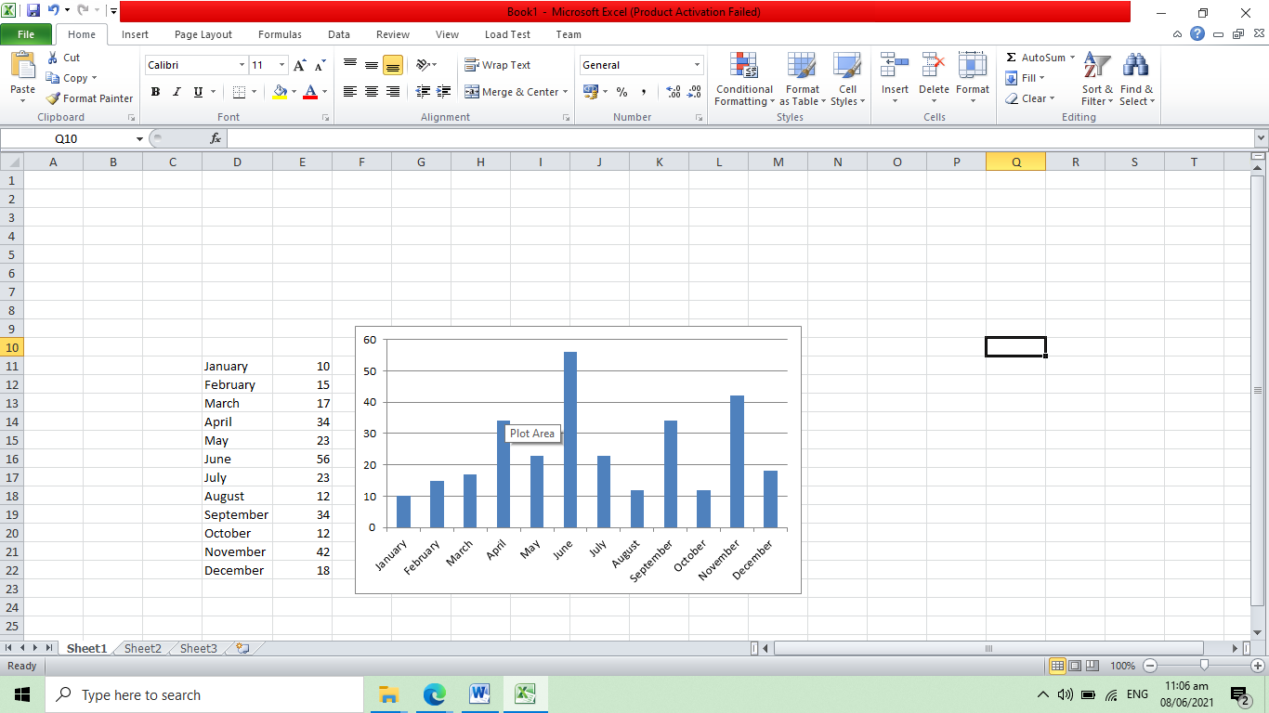

**Number of Vaccinated Children** – table and graph

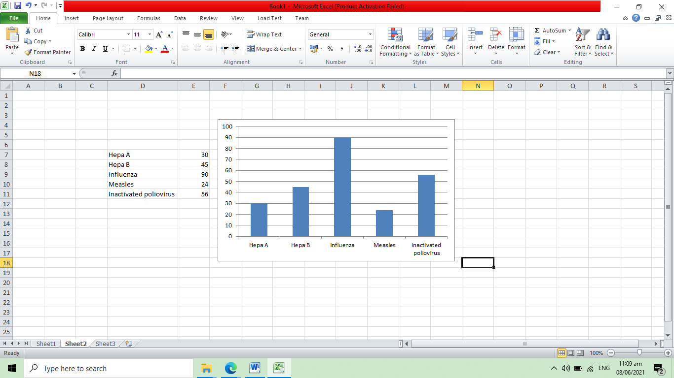

Conclusion

Recommendations