[GigToDo - Freelance Marketplace Script by Pixinal_Studio | CodeCanyon](https://codecanyon.net/item/gigtodo-freelance-marketplace-script/23855397)

<https://codecanyon.net/item/gigtodo-freelance-marketplace-script/23855397>

**Login Form**

**Post Job – sundin mu ang form tapus mag add ka lng ng Amount**

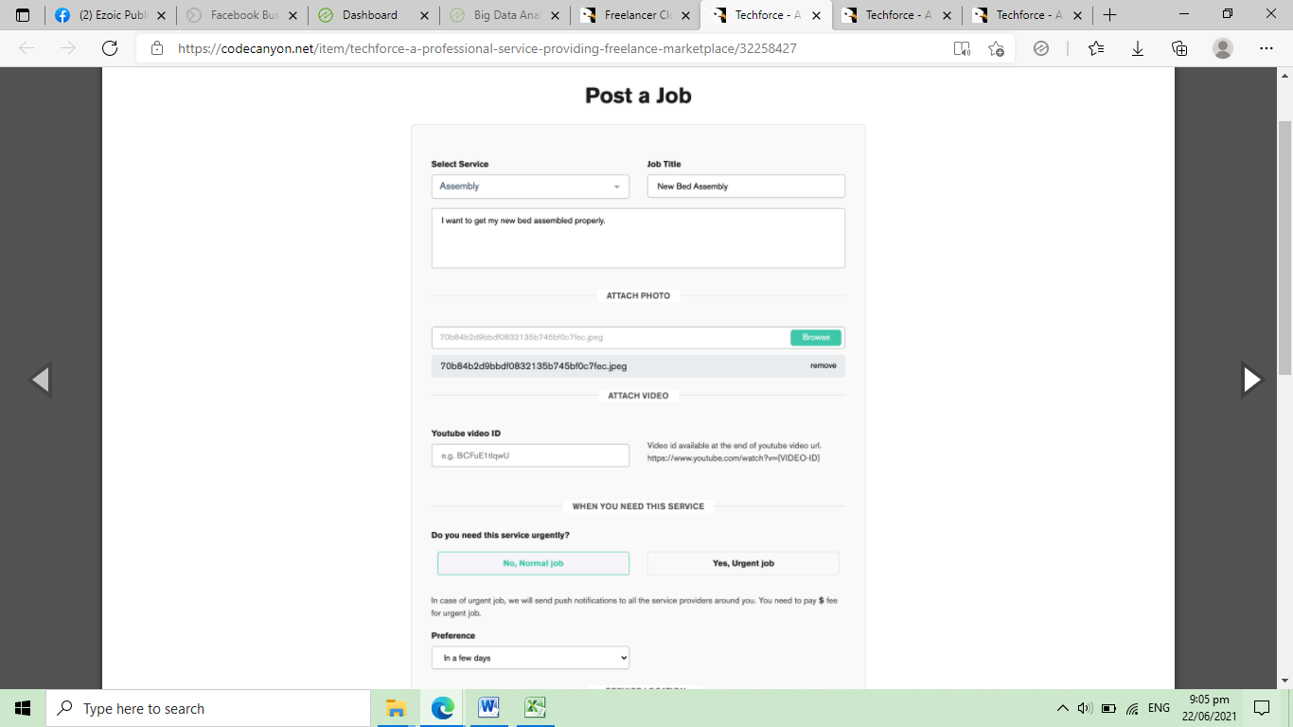

**Admin Dashboard**

* Number of customers
* Number of service providers
* Number of jobs completed
* Payment Collected

**Service Category**

* Category name

**Services**

* Category name – drop down
* Service name
* Description
* Image Banner
* Status – active, inactive

**Customer Records**

* Last name
* First name
* Middle name
* Gender
* Contact
* Email
* Complete Address
* Profile Picture
* Username
* Password
* Account Status

**Service Provider Records**

* Last name
* First name
* Middle name
* Gender
* Contact
* Email
* Complete Address
* Profile Picture
* Company
* Work Experience
* Average Rating – pki check sa sample form
* Username
* Password
* Account Status

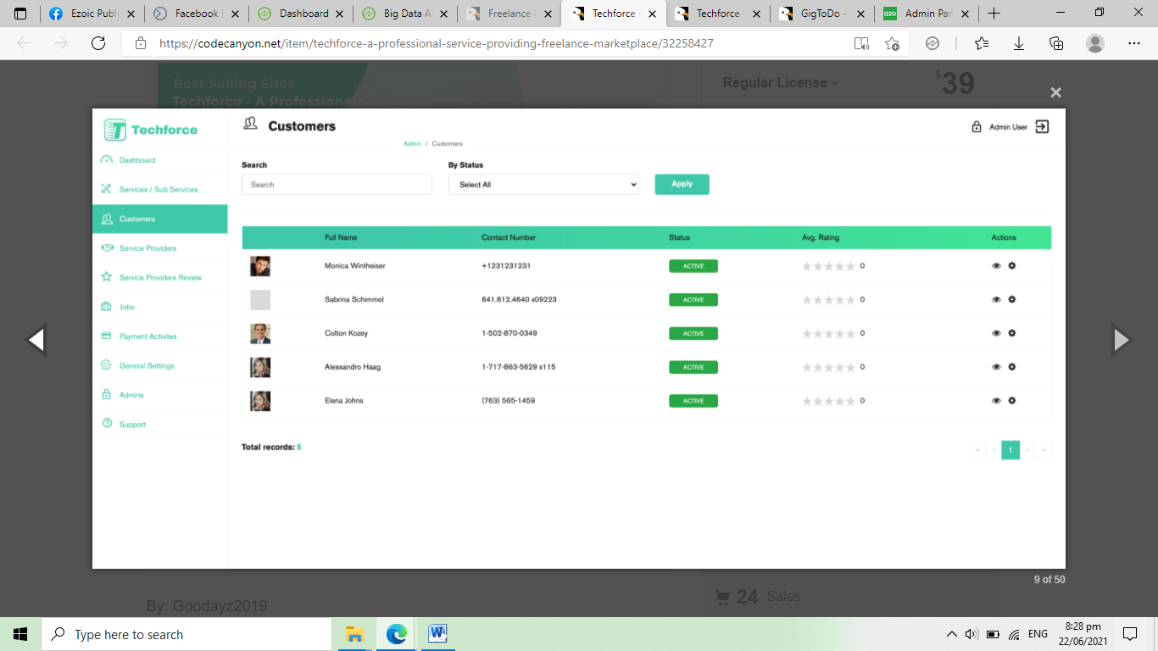

**Services Posted**

* Service Provider – drop down
* Service Name – drop down
* Description
* Rate
* Availability
* Contact
* Email
* Complete Address
* Customer Rating – 1 to 5 star
* Status – active, inactive

**Services Transaction**

* Reference number
* Customer
* Service Provider
* Service Name
* Amount
* Status – pending, cancelled, completed
* Remarks
* Date of Transaction

**Payment Activities**

* Reference number
* Paid By
* Amount
* Date of payment

**Admin and Support Accounts**

* Last name
* First name
* Email Address
* Contact
* Access Level – full access, support
* Username
* Password
* Account Status – active, inactive

**Payment Collection Report**

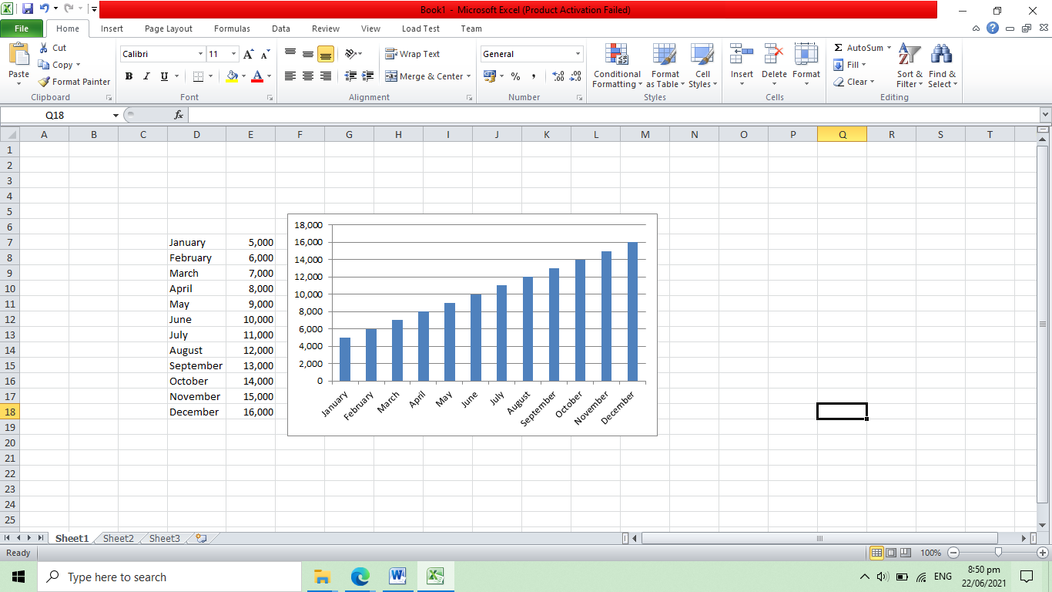

**Job Count by service type**

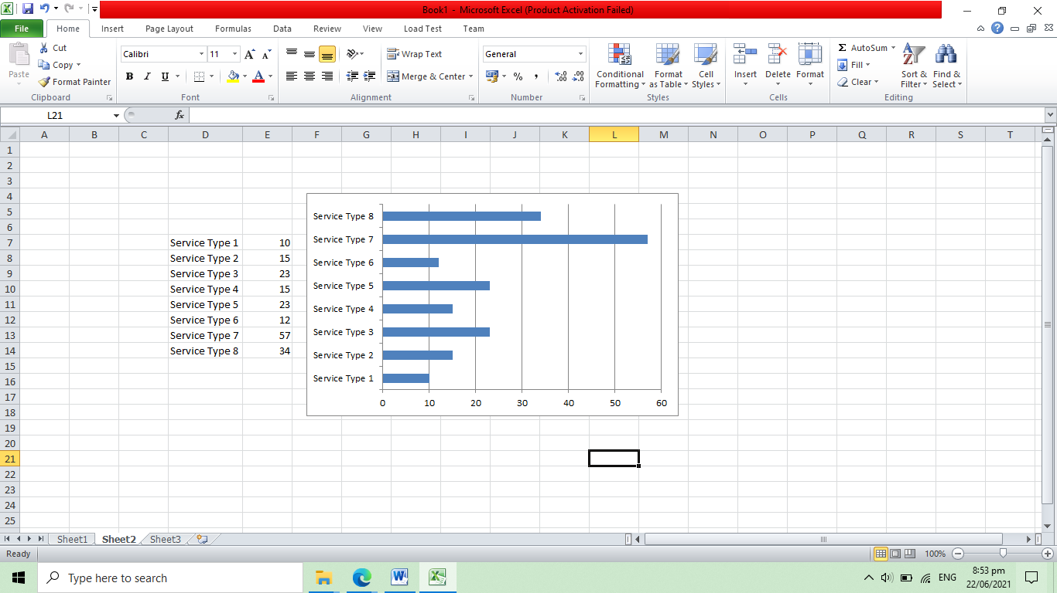

**Top 10 Service Providers**

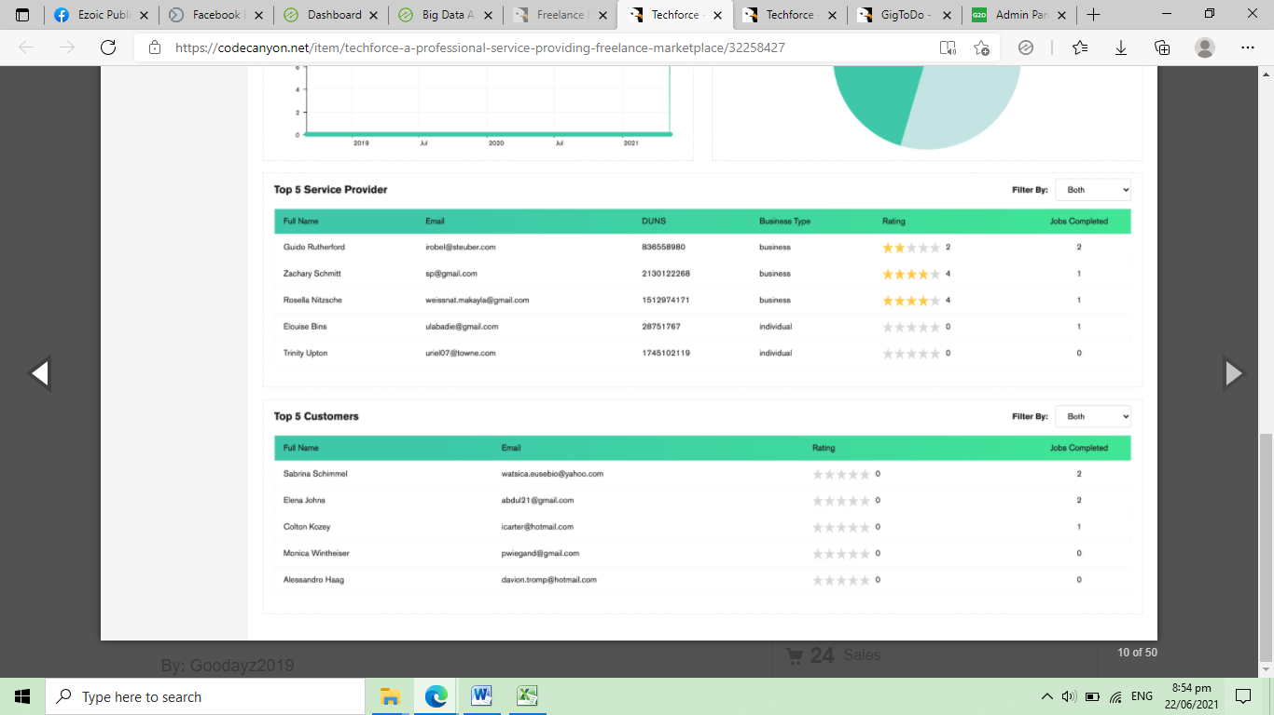

**Total Jobs Completed**

