**Student Tracking Performance System**

**Login Form**

**Dashboard**

* Number of students
* Number of subjects

**Setup School Year and Term**

* School Year/Term – (2021-1, 2021-2, 2021-3)

**Setup Grade/Year Level**

* Grade/Year Level name

**Setup Criteria**

* Criteria Name **– (**quiz, project, exam, participation, attendance, final grade)

**Subject Management**

* Subject Code
* Subject Description

**Student Information**

* Last name
* First name
* Middle name
* Gender
* Birthdate
* Age
* Complete Address
* Contact
* Email Address
* Profile Picture
* Username
* Password
* Account Status

**Score Management**

* Student name
* School Year/Term
* Subject
* Criteria
* Score

**Score Report**

* Select by student – drop down

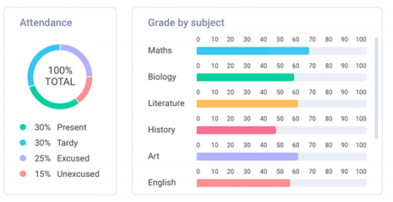

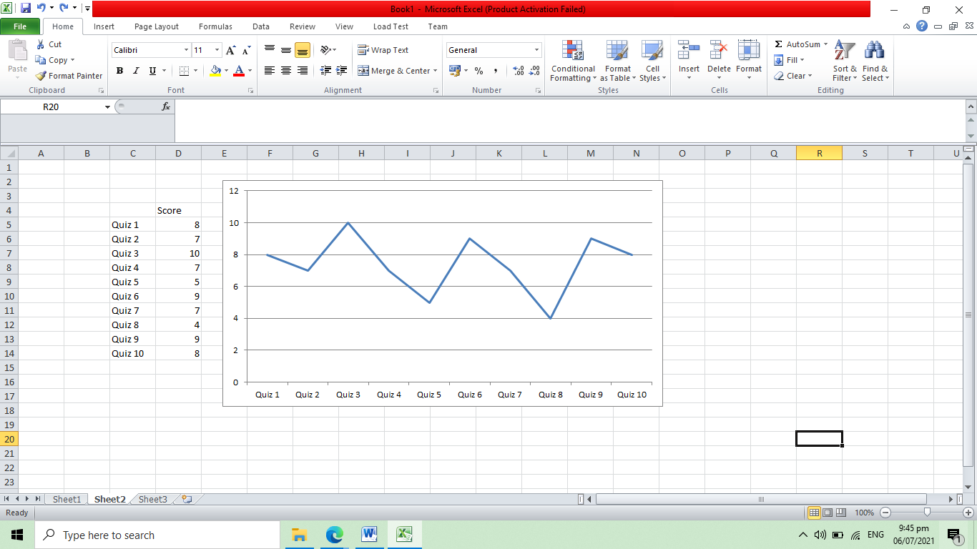

**Compare Score**

