**Vehicle Franchising and Drivers Offense Software**

Introduction of the Study

Proposed Solution

Objectives of the Study

Significance of the Study

Development Tools

Project Highlights (Advantages of the system)

How the System Works

**Login Form**

**Dashboard**

* Number of Operators
* Number of Drivers
* Number of Vehicles
* Number of Offenses
* Income

**Operator Information – table and form**

* Operator Control Number – system generated
* Name of Operator
* Address
* Contact
* TIN No
* Expiration
* Profile Image
* Username
* Password

**Driver Information – table and form**

* Driver Control Number – system generated
* Name of Operator
* Address
* Contact
* License No
* OR/CR Expiration
* Franchise Expiration
* Profile Image
* Username
* Password

**Vehicle Information – table and form**

* Vehicle Code – System Generated
* Vehicle Type
* Vehicle Model
* Engine Number
* Franchise Number
* Operator Number
* Driver Name

**Enforcer Information – table and form**

* Enforcer Code – System generated
* Last name
* First name
* Middle name
* Profile Image
* Contact
* Address
* Username
* Password

**Offense Type – table and form**

* Offense name
* Description

**Offense Information – table and form**

* Offense Code – System Generated
* Offense name – combo box
* Remarks
* Date
* Driver – combo box
* Operator – combo box
* Vehicle – combo box
* Enforcer
* Status (pending, paid)

**Payment Information – table and form**

* Receipt Number
* Amount
* Offense code
* Paid By
* Payment Date

**Income Report – table and graph**

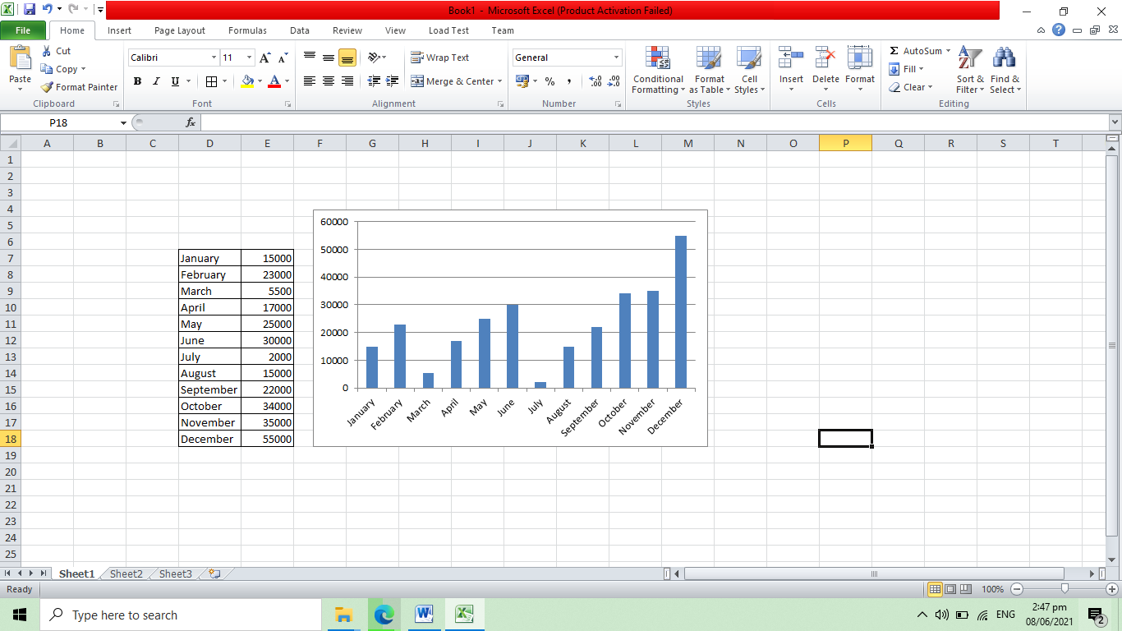

**Number Offenses Report- table and graph**

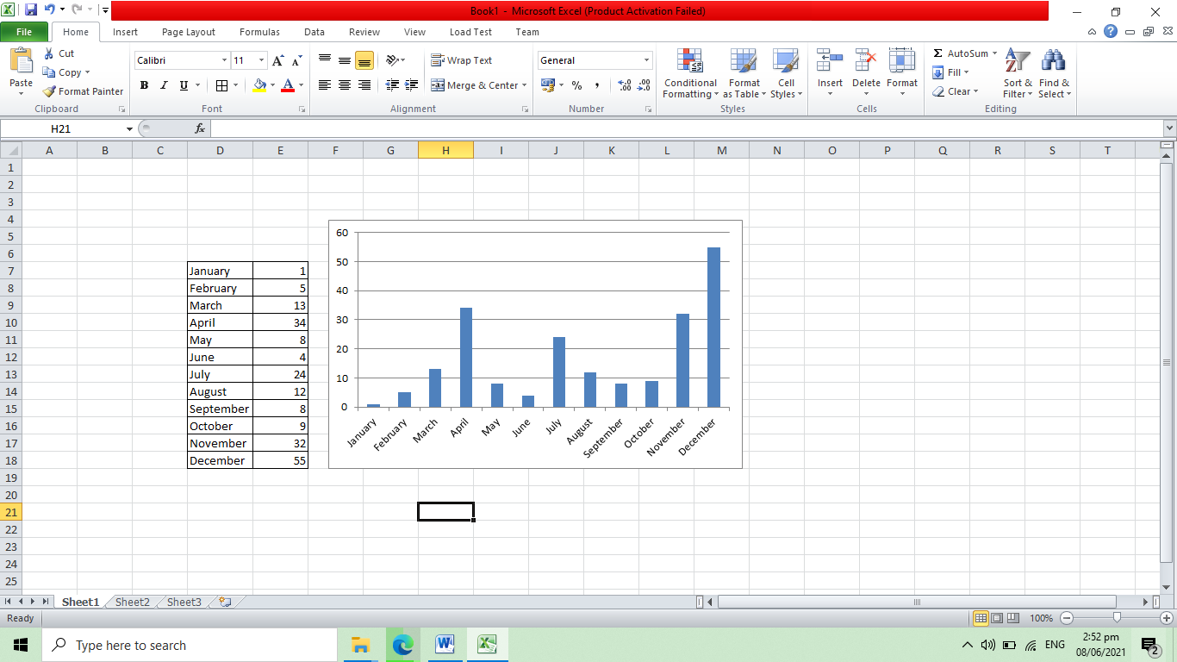

**Type of Offenses**

**Operator Dashboard**

* Number of vehicles
* Number of offenses

**List of offenses – table only**

* Offense Code – System Generated
* Offense name – combo box
* Remarks
* Date
* Driver – combo box
* Vehicle – combo box
* Enforcer
* Status (pending, paid)

**Payment History – table only**

* Receipt Number
* Amount
* Offense code
* Paid By
* Payment Date

**Driver Dashboard**

* Number of vehicles
* Number of offenses

**List of offenses – table only**

* Offense Code – System Generated
* Offense name
* Remarks
* Date
* Operator
* Vehicle
* Enforcer
* Status (pending, paid)

**Payment History – table only**

* Receipt Number
* Amount
* Offense code
* Paid By
* Payment Date

Conclusion

Recommendations