CHAPTER V
SYSTEM TESTING
SkillBridge Malawi
Test plan, tools, execution results and evidence
Verification date: 10 November 2026

5.1 INTRODUCTION
This chapter describes the system testing carried out for SkillBridge Malawi, a web-based career guidance, skills assessment and employment-matching platform. Testing was used to check that important application logic behaves as expected, that the frontend can be prepared for production, and that static code-quality rules identify implementation issues before release.
The project uses a React and Vite frontend, a Node.js API, and Supabase services for authentication, relational data and file storage. The verification reported here was run locally against the project workspace using its configured automated test, build and lint commands. No production database or real user records were used.
The automated test suite completed successfully, and the production build completed successfully. The lint check did not pass: it reported seven React Hooks rule errors. Accordingly, the result is reported as a partial pass rather than a complete release sign-off. Browser-based end-to-end testing and live Supabase workflows were not executed as part of this verification.

5.2 TEST PLAN
The test plan combines automated checks of business rules and services with build validation and static analysis. Test execution used synthetic or isolated test data; live accounts, external AI services and production data were not required for the local automated suite.

5.2.1 Software and tools used
Software / tool | Version / configuration | Use in testing
Node.js | v24.12.0 | Runs the application scripts and built-in test runner.
npm | v11.6.2 | Runs the project test, build and lint scripts.
Node.js test runner | node:test | Executes the repository automated unit and service-level tests.
Vite | v8.3.2 | Builds the React frontend for production.
ESLint | v10.11.0 | Checks JavaScript/JSX code against configured quality rules.
Supabase client | v2.117.2 | Platform integration used by the application; live remote services were not tested here.

5.2.2 Test cases and expected outcomes
Table 5.1 summarizes the main test areas, expected outcomes and the status from the current local verification.
ID | Test area | Expected result | Method | Result
TC-01 | CV document parsing and validation | Valid document text is extracted; invalid or oversized inputs are rejected. | Automated tests | Pass
TC-02 | AI input/output validation and governance | Malformed inputs or outputs are rejected and governance rules are applied. | Automated tests | Pass
TC-03 | Skills and career recommendations | Canonical skills, proficiency gaps and explainable recommendations are calculated consistently. | Automated tests | Pass
TC-04 | Job and internship matching | Matching and readiness logic returns expected results for candidate and opportunity data. | Automated tests | Pass
TC-05 | Learning recommendations | Relevant resources are matched; unsafe or missing links are not presented as valid resources. | Automated tests | Pass
TC-06 | Applications and recruitment workflows | Application and recruitment service rules preserve expected status and authorization behavior. | Automated tests | Pass
TC-07 | Analytics, labour-market and data quality | Aggregations and validation rules produce consistent summaries for supplied test data. | Automated tests | Pass
TC-08 | Notifications, caching and security validation | Notification, cache and security validation checks meet their tested conditions. | Automated tests | Pass
TC-09 | Production frontend build | Vite completes a production build without errors. | npm run build | Pass
TC-10 | Static code-quality checks | ESLint exits successfully with zero errors and warnings. | npm run lint -- --max-warnings=0 | Fail: 7 errors
TC-11 | Role-based browser workflows | Student, employer and administrator journeys work in a browser using test accounts. | Manual / browser E2E | Not run
TC-12 | Live Supabase integration | Authentication, RLS, uploads and data workflows work against a staging project. | Staging integration | Not run

Table 5.1: Test Plan Table

5.2.3 Test execution and results
The automated suite ran 168 tests: 168 passed and 0 failed. The Vite production build succeeded. The strict ESLint command reported 7 errors and 0 warnings; therefore that quality gate failed. The reported lint rule is react-hooks/set-state-in-effect and the findings occur in the student and employer module pages.
Command | Observed result | Status
npm test | 168 tests; 168 passed; 0 failed. | PASS
npm run build | Vite production build completed successfully. | PASS
npm run lint -- --max-warnings=0 | 7 ESLint errors; 0 warnings. Strict lint command returned a failure. | FAIL

Table 5.2: Summary of Test Execution Results
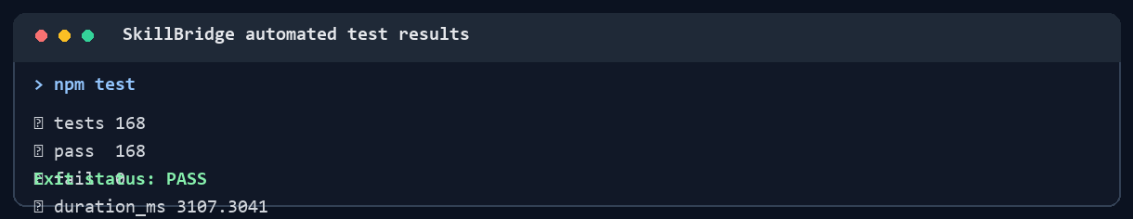
Figure 5.1: Automated test results captured from the npm test command.
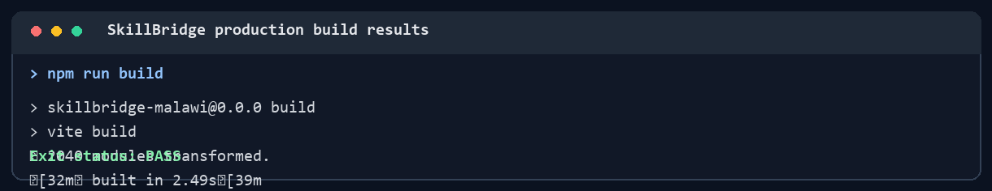
Figure 5.2: Production build results captured from the Vite build command.
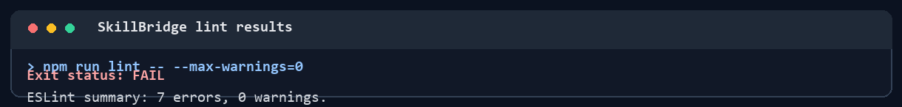
Figure 5.3: ESLint output showing the seven current rule violations.

5.2.4 Interpretation and limitations
The passing automated suite provides evidence for the tested parsing, validation, matching, analytics, notification, security-validation and related service logic. The successful production build confirms that the current frontend can be bundled. These results do not prove that every screen or live service workflow is correct.
The lint failures are code-quality findings that should be reviewed before treating the project as release-ready. The browser-based student, employer and administrator flows, responsive behavior across browsers, live authentication, Supabase row-level security, file uploads, external job feeds and optional AI calls were not exercised in this test run. They should be verified in a controlled staging environment using synthetic accounts and data.

5.2.5 Overall test conclusion
Overall result: PARTIAL PASS
Reason: 168 of 168 automated tests passed and the production build passed, but the strict lint check failed with 7 errors. Browser end-to-end and live-service tests remain outstanding. The system should not be described as fully accepted until the lint findings are addressed and the relevant staging workflows are tested.

