CHAPTER VI
SYSTEM IMPLEMENTATION
SkillBridge Malawi
Implementation overview, module screenshots, code and user feedback
Prepared: 10 November 2026

6.1 INTRODUCTION
This chapter describes the implementation of SkillBridge Malawi, a web-based career guidance, skills assessment and employment-matching platform for students and graduates. The system also provides employer recruitment tools and administrator functions. Its main workflow helps a learner build a profile, understand skills and career options, follow learning recommendations, and explore jobs or internships.
The user interface is implemented with React and Vite. Public and protected routes are configured with React Router, and role-based route guards distinguish student, employer and administrator areas. The browser uses the Supabase client for authentication and authorized platform data. A Node.js API supports selected server-side features such as AI career assistance, CV analysis and public placement search. Supabase provides authentication, PostgreSQL data storage and file storage. Optional integrations include AI narrative features and external job feeds.
The following screenshots were captured from the local development version of the application on 10 November 2026. They show public pages that can be viewed without a user account. Protected student, employer and administrator dashboards are not included because no authorized demonstration accounts or staging dataset were provided for this document.

6.2 SCREENSHOTS
The figures below show representative screens from the implemented application. Each image is a direct browser capture; no personal account information is displayed.

6.2.1 MODULE SCREENSHOTS
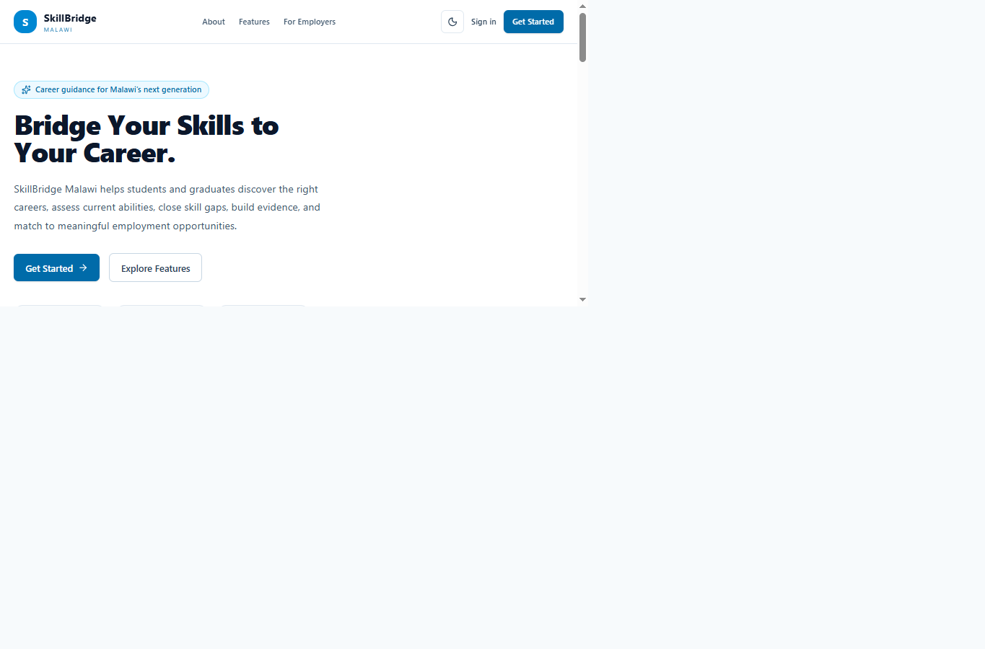
Figure 6.1: SkillBridge Malawi public landing page and career journey overview.
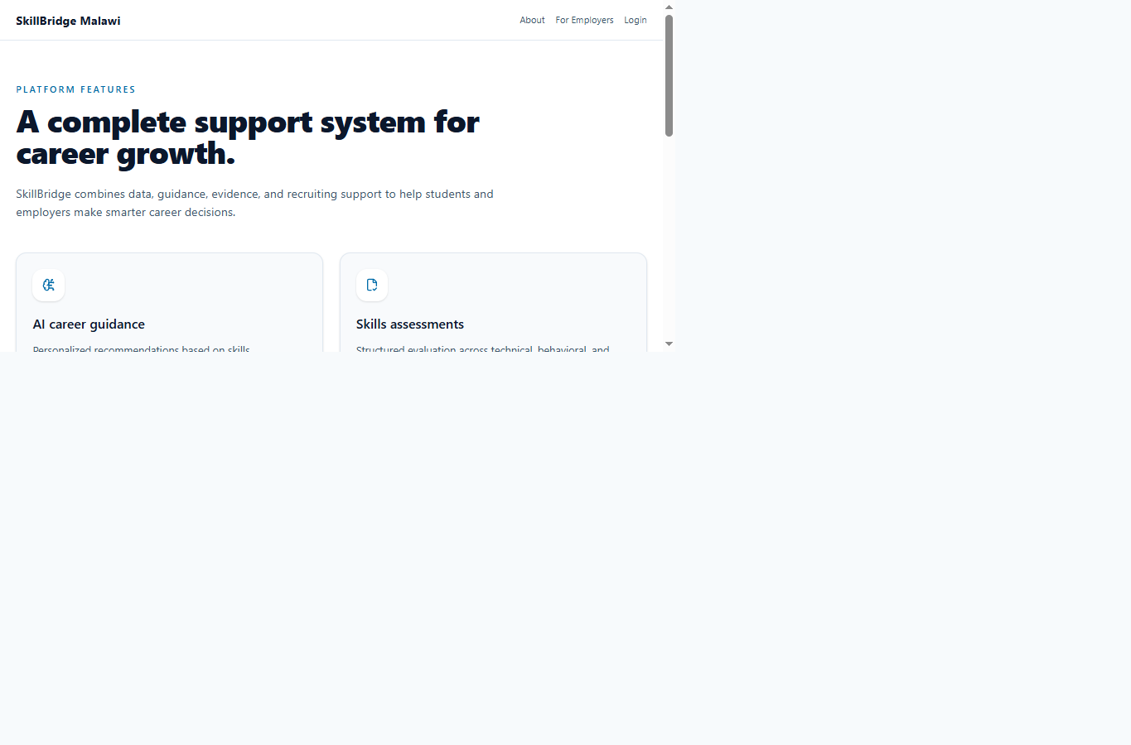
Figure 6.2: Platform features covering guidance, assessment, learning, evidence and matching.

6.2.1 MODULE SCREENSHOTS (CONTINUED)
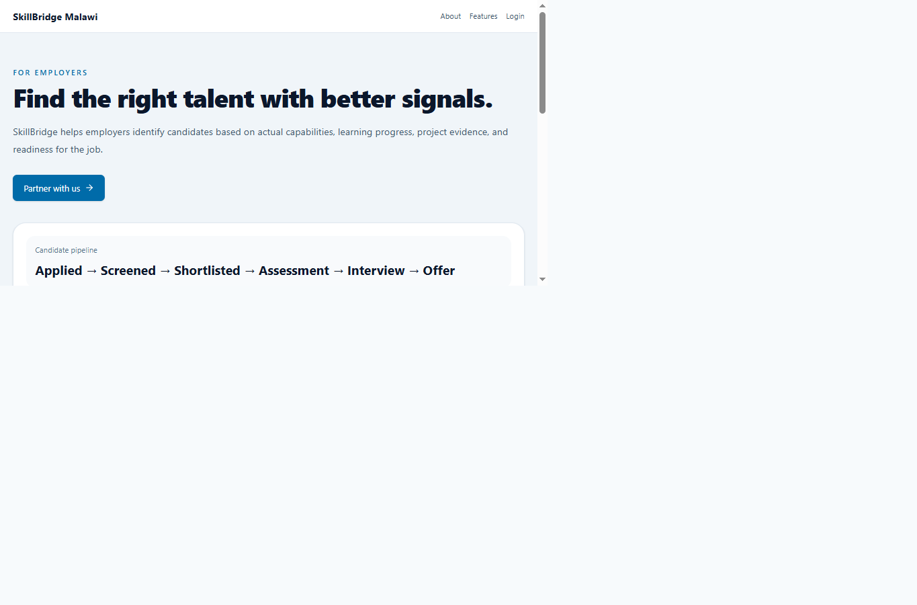
Figure 6.3: Employer information page describing candidate matching and recruitment.
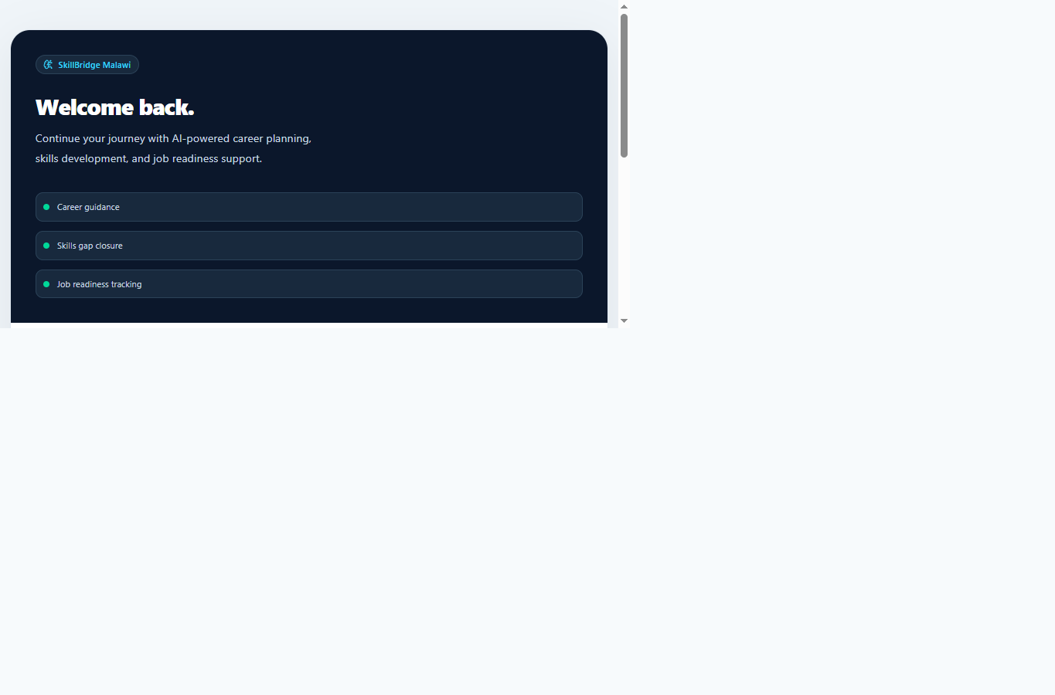
Figure 6.4: Sign-in page for registered SkillBridge users.

6.2.2 CODING
The code examples below are short excerpts from the current project source. They illustrate route selection and access control in the frontend and authenticated request handling in the backend. The excerpts are provided for explanation; the complete implementation is in the referenced source files.

6.2.2.1 FRONT END
The frontend is a React single-page application. AppRoutes.jsx declares lazy-loaded pages and protects authenticated routes. RoleRoute restricts each route to the permitted role, while ProtectedRoute requires a signed-in user. Supabase client configuration is read from frontend environment variables; a publishable/anonymous key is used in the browser, not a service-role secret.
const StudentDashboardPage = lazy(() =>
import('../pages/student/StudentDashboardPage'))

<Route element={<ProtectedRoute />}>
<Route path="/student/dashboard"
element={<RoleRoute allowedRoles={['student']}>
<StudentDashboardPage />
</RoleRoute>} />
</Route>

Code 6.1: Lazy-loaded student page and protected, role-restricted frontend route (src/routes/AppRoutes.jsx).
The project also configures the Supabase browser client to persist and refresh the user session and to detect authentication callbacks. Row-level security policies in the database are part of the authorization boundary for private records.

6.2.2.2 BACKEND
The backend is a Node.js HTTP API. It validates bearer tokens through Supabase Auth before serving protected endpoints, dispatches requests by HTTP method and path, and returns JSON responses. For example, public placement search requires an authenticated user. Server-only service credentials and optional AI provider credentials are configured on the server and must not be exposed in frontend code.
async function getAuthenticatedUser(req) {
const authorization = req.headers.authorization || ''
const accessToken = authorization.startsWith('Bearer ')
? authorization.slice(7)
: ''
if (!accessToken || !supabaseAdmin) return null

const { data, error } = await supabaseAdmin.auth.getUser(accessToken)
if (error || !data.user) return null
return data.user
}

if (req.method === 'GET' && url.pathname === '/health') {
sendJson(res, 200, { ok: true, data: { status: 'ok' } })
return
}

Code 6.2: Bearer-token verification and API health route (server/index.js; excerpt simplified for presentation).
The API also exposes selected endpoints for career recommendations, career-chat conversations, CV analysis and placement search. Optional AI and job-feed integrations support specific features; these external services are not required to describe the core frontend and data architecture.

6.3 FEEDBACK FROM USER
No completed user questionnaires, interview transcripts or signed acceptance records were available in the project materials reviewed for this chapter. Therefore, actual participant ratings or quotations cannot be reported here. This limitation is stated explicitly so that sample or invented feedback is not presented as research evidence.
User feedback should be collected during a supervised pilot with consenting students/graduates, employers and administrators. Participants should be asked to complete representative tasks and then comment on ease of use, clarity, usefulness, accessibility and errors. The summary table below records the current evidence status and can be updated with real results after the pilot.
User group | Responses | Current evidence | Suggested feedback focus
Student / graduate | Not recorded | No verified response data supplied. | Collect task-based feedback on profile setup, career guidance, skills and job applications.
Employer | Not recorded | No verified response data supplied. | Collect feedback on job posting, applicant review and recruitment tracking.
Administrator | Not recorded | No verified response data supplied. | Collect feedback on user management, monitoring and reports.

Table 6.1: User feedback evidence status and proposed pilot focus.

Suggested questions for the pilot
- Were you able to complete your assigned task without assistance?
- Which screen or step was easiest to understand, and which was most difficult?
- Did the information or recommendations appear relevant to your role and needs?
- Did you encounter an error, confusing message or accessibility barrier?
- What one improvement would make SkillBridge more useful to you?
After collecting responses, report the number of participants by role, task completion observations, recurring themes and actions taken. Remove names and contact details from the chapter unless participants have given explicit permission to be identified.

