Model Railway Signalling

Quick-start Guide

This guide is intended to provide an introduction to the Model Railway Signalling Application and the art of the possible in terms of the configurations that can be achieved.
However, as always, Rule 1 of Railway Modeling applies – it’s your layout and its therefore entirely up to you how you use the application to signal your layout. Hopefully the features provided by the application will enable you to achieve what you want to achieve.
The example layouts used in this guide are all available in the ‘user_guide’ folder within the Github repository (https://github.com/johnrm174/model-railway-signalling).

Table of Contents
Introduction 2
The Schematic Editor 3
Drawing your layout schematic 4
Planning your signalling scheme 5
Do your research 5
Define the train movements you want to signal 5
Adding signals to the layout schematic 6
Configuring the basic interlocking 8
Signal 1 8
Signal 2 9
Signal 3 9
Signal 4 10
Signal 5 10
Point 1 10
Testing the basic interlocking 11
Operating your Layout 13
Adding and configuring track occupancy 14
Testing track occupancy changes 15
Configuring external track sensors 17
Interlocking with Track Sections 18
Saving and loading your layout 20
Appendix 1 - Using semaphore signals 21
Appendix 2 - DCC programming of signals and points 22

Introduction
This application enables users to easily create, configure and control prototypical interlocked signalling schemes for model railway layouts, without the need for complex layout wiring. All layout configuration and control is achieved via the application’s graphical user interface, avoiding the need for specialist computer skills (if you use PC applications, you should be able to use this).
The application has primarily been developed to run on a Raspberry Pi computer, hosting a Pi-SPROG DCC programmer controller:
- The Raspberry Pi is a low-cost single-board computer which provides a “Windows-like” user experience (and versions of all the usual applications you would expect, such as web-browser, email, office-type applications etc).
- The Pi SPROG DCC programmer controller connects directly to the Raspberry and provides a DCC ‘accessory bus’ output to control the points and signals out on the layout.
The use of a separate ‘accessory bus’ makes the system suitable for use with layouts that use DCC or analogue for control of trains (when used with DCC layouts, the accessory bus for control of the signals/points needs to be electrically separated from the main DCC track bus).
Several manufactures now provide DCC signals (e.g. Train-Tech from Gaugemaster) and point motors (e.g. Cobalt from DCC Concepts), making this method of control ideal for ‘new-build’ layouts. There are also numerous DCC signal/point decoders available for those wishing to upgrade to DCC control without the expense of wholesale replacement of their existing units.
The application uses the flexibility of the Raspberry Pi General Purpose Input/Output (GPIO) interface to provide feedback on train location. Simple sensors providing a ‘normally-open’ output (momentarily closed when triggered) can be connected directly to the appropriate GPIO pins to generate ‘signal passed’ events as the passing train triggers the sensor (e.g. the slim vertical magnetic sensors from DCC Concepts). These events can then be configured within the application to provide a ‘mimic’ diagram of train location and provide a level of signal automation.
Note that other sensor types (providing a switched voltage) should never be connected directly to the GPIO pins as this could damage the Raspberry-Pi. In these cases, external opto-isolators should be used - I’ve been using the PC817 2, 4 or 8 channel opto-isolator modules (available from several Ebay sellers) for my layout. Connection of these is relatively straight forward, but if you have any doubts then seek expert advice.
For added flexibility, the software enables multiple signalling applications to be networked together, making it ideal for control of larger layouts (where the layout gets broken down into multiple signalling areas) or splitting smaller layouts down to individual signal boxes (with simulated block instruments) for real ‘true to prototype’ operation. Note that in this case only one instance of the application needs to be running on a Raspberry Pi (the instance providing the interface to the DCC bus and track sensor inputs from the GPIO pins). As the application has been designed to be platform independent, other instances can be hosted on Windows or Linux as required.

The Schematic Editor
The application opens in ‘Edit’ mode with a blank drawing canvas. The panel on the left contains the buttons to add schematic drawing objects to the canvas, whilst the Menubar across the top of the window contains various controls and options for configuring the application.
For the time being we’ll focus on the basic controls and options needed to get you up and running:
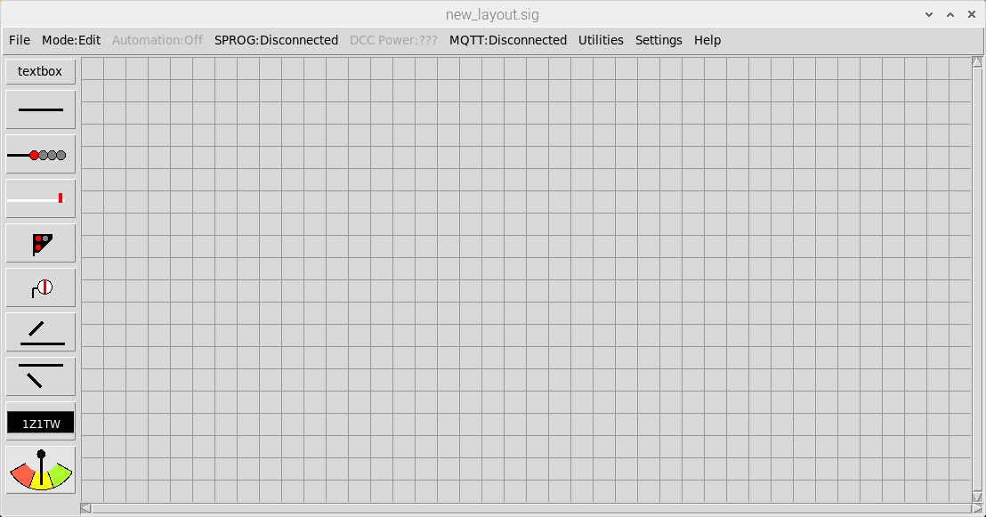
File Save
and Load
Mode selection
(Edit mode )
SPROG DCC
controls
GO HERE
FIRST !!!
Signals
Lines
Points
Track
Sections
Block
Instruments

Firstly, open the Help Window from the Main Menubar ( Help => Help) to familiarise yourself with the basic Schematic Editor functions and practice creating, moving and deleting objects:
- Add objects to the canvas by left-clicking the buttons on the left hand side.
- Select objects by left-clicking on them (small circles will be displayed at each end of lines to show they are selected - a border will be displayed around other drawing objects)
- Add/Remove objects to/from the current selection by shift-left-clicking on them
- Move selected objects by dragging and dropping (left-click => move => left-release).
- Move the ends of a line by selecting the line and then dragging and dropping the line ends
- Rotate selected objects (points and signals) by pressing the ‘r’ key
- Delete selected objects by using the backspace key
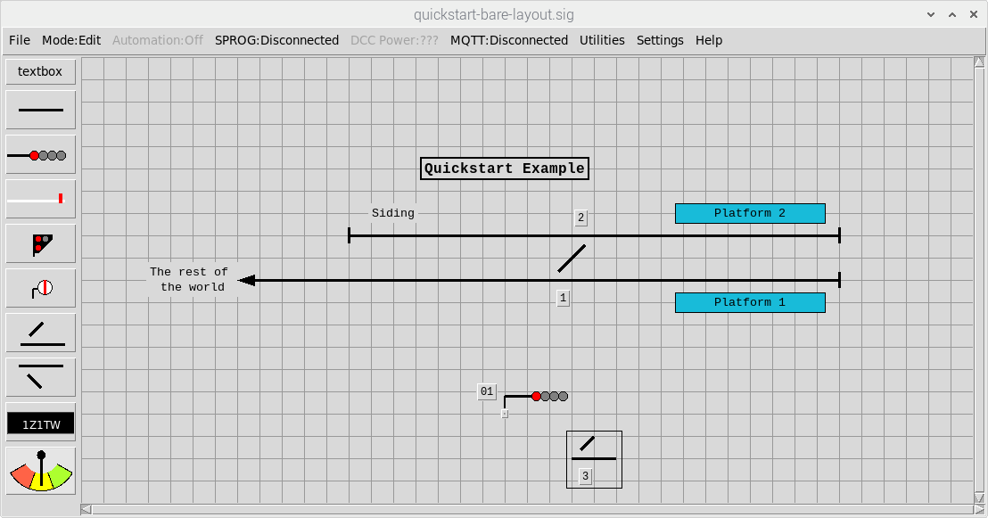
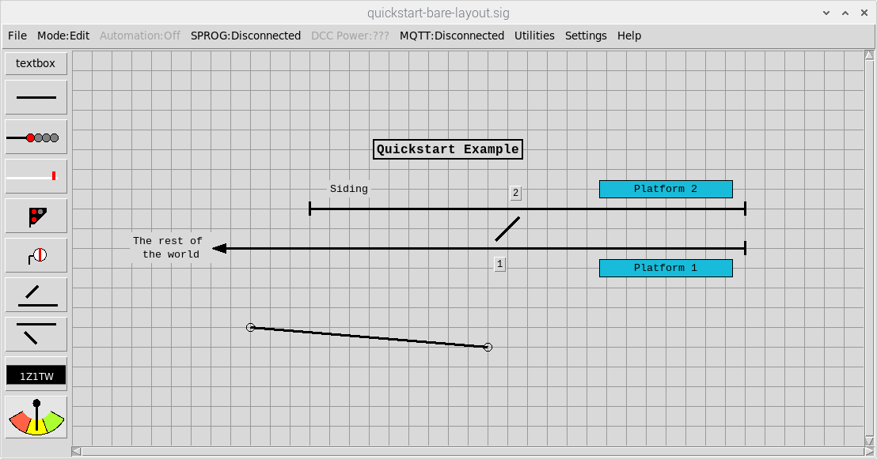
Drag and drop line end
with left mouse button
Point is selected
Line is selected

There are other Schematic Editor functions detailed in the Help window, but once you are comfortable with the basics as described above, we’ll continue with the quickstart example by clearing down the schematic to start afresh (from the Main Menubar select File => New).

Drawing your layout schematic
For this exercise, we are going to create a simple layout comprising a single track line serving a small double platformed terminus station (with no run round facilities):
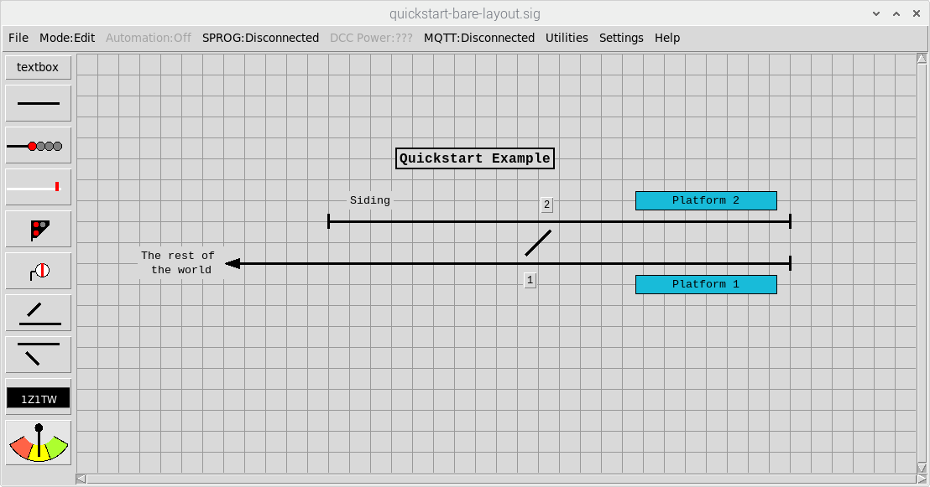

Point 1 (left hand point) can be added straight to the layout and moved into the appropriate position. To create point 2, either add another left hand point to the layout or, alternatively, select point 1 (Left Click on the point) and then copy/paste (Cntl-c / Cntl-v). When items are created, they are assigned the next available ‘one-up’ identifier so in this case the added / pasted point will be created as Point 2. Whilst it remains selected, press the ‘r’ key to rotate by 180 degrees, it can then be moved into position to form the required crossover.
Now add the track lines to the schematic. To add end-stops or arrows to the lines, double-left-click on the line to bring up the configuration dialog. A different line end style can then be selected and applied to one or both ends. Once the required selection has been made, click the OK button to apply the changes and close the configuration dialog.
Text boxes can be added to annotate the schematic. Once created, double-left click on the ‘Text’ to bring up the configuration dialog and edit the contents. Note that textboxes will always be sized to fit the contents on the schematic, but padding (extra lines or spaces) can be used if required. In this example, text boxes with padding before and after the text have been used for the two ‘platforms’.
To complete the track layout, we’ll configure the points to switch together and add a facing point lock. Firstly, double-left-click on point 2 to bring up the configuration dialog, set it to be fully automatic and then Apply the changes. Now double-left-click on Point 1, configure it to switch Point 2 and select the facing point lock. We’ll also configure the DCC address we’re going to use to switch the points out on the layout (as both points are switched together, we only need a single address to switch both points) before Applying the changes.
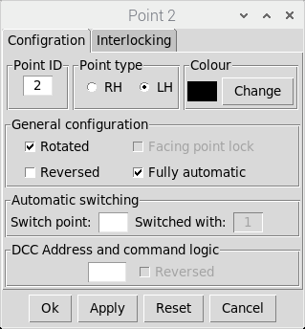
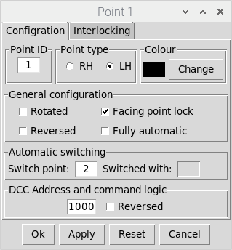
Set Point 2 to be
Fully Automatic
Set Point 1 to
Switch Point 2
Point 1 has a
Facing Point Lock
Indication that Point 2
is now configured to be
switched with point 1
(on re-loading window)
Point 2 has already been
rotated on the schematic
Set the DCC
Address

Planning your signalling scheme

Do your research
This is probably the most important (and potentially time consuming) part of the process. If you’re reading this document and planning to use the application to develop a signalling scheme for your model railway then I’d recommend building familiarity with British railway signalling practice. There are lots of great resources out there, but some of the best I’ve come across are:
- https://signalbox.org/ - Comprehensive information on signal types and the ‘Block System’ and a vast library of signal box diagrams for you to draw inspiration.
- https://en.wikipedia.org/wiki/UK_railway_signalling – Its Wikipedia (enough said).
- http://www.railway-technical.com/signalling/ - A section of the Railway Technical Website covering signalling. There are many great resources on these pages including:
  - http://www.railway-technical.com/signalling/infopaper-6-basic-railway.pdf – A paper (downloadable pdf format) on Basic Railway Signalling.
  - http://www.railway-technical.com/signalling/british-signalling--what.pdf – A paper (downloadable PDF) on “What the driver sees”.
But Beware – Railway modeling is always about compromise and that is definitely going to be the case for whatever signalling scheme you design and implement for your layout. Although the application has been developed to add a touch of realism to the operation of your layout, it will never measure up to the million-pound-plus signalling systems of the ‘real thing’.

Define the train movements you want to signal

For this example, the main movements we want to signal are:
- Rest of the world => Platform 1 or Platform 2
- Platform 1 => Rest of the world
- Platform 2 => Rest of the world
We also want to signal the following shunting movements:
- Platform 2 => Siding
- Siding => Platform 2

Adding signals to the layout schematic
Use the buttons on the left hand side of the window to add signals to the schematic and move them into position (rotating as required). To keep things simple, we’ll use two aspect colour light signals for the main signals. The signals are initially created as four aspect but we’ll change them to two aspect as we configure them. Signal 4 will be a ground position (shunting) signal.
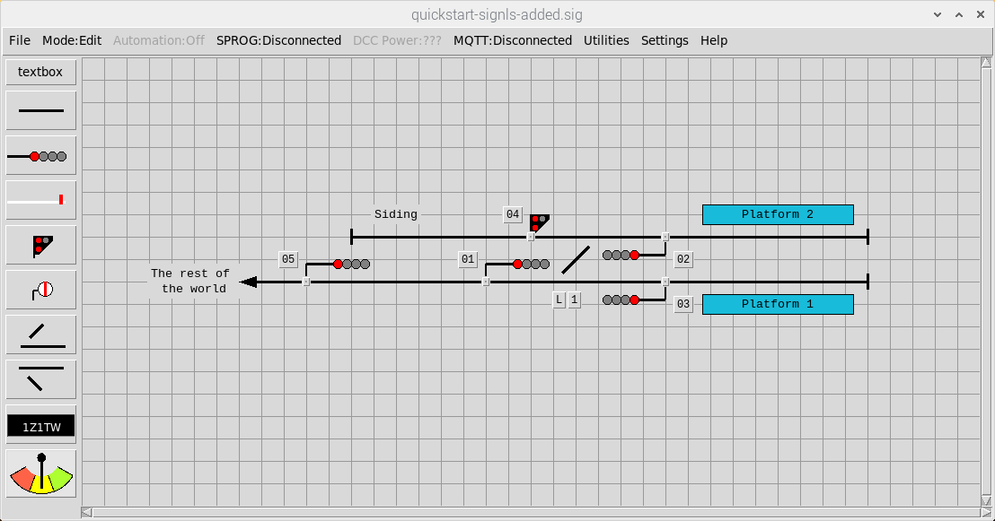

To signal the train movements we have defined, we need to edit Signal 1 to provide a route indication (to differentiate between the routes into Platform 1 and Platform2). At the same time, we’ll change it to a two-aspect signal and configure the DCC addresses. As before, double-left-click to bring up the configuration dialog and use Apply or OK to save the changes
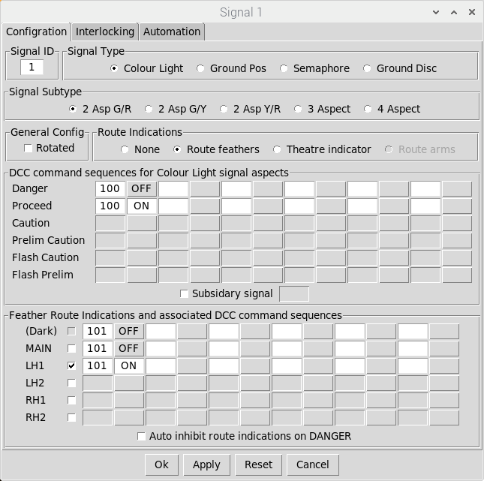
Configure a single
feather indication
For the diverging
Left hand route
Example configuration
for a 2 aspect signal
that uses a single DCC
Address (toggle on/off)
to set the aspect
Change the signal to
Two-aspect (green/red)
The feather for the
diverging route is
controlled (On or Off)
by a single DCC
Address. Note that this
needs to be set Off when
The signal is at Danger
(the ‘Dark’ aspect) and
also set Off when the
Main route is set
Select feathers
to provide the
route indication
No feather is
provided for the
MAIN (default) route

We also need to add a subsidiary aspect to Signal 2 to signal the shunting move from platform 2 into the siding (we’ll also change this one to a two aspect signal and set up the DCC addresses).
Note that we don’t need route indications for Signal 2 as the only route controlled by the main aspect is the departure out to the rest of the world (the MAIN route for this signal). The subsidiary aspect controls the shunting move back into the siding, which is effectively a right hand divergence from the main route (the RH1 route for this signal).

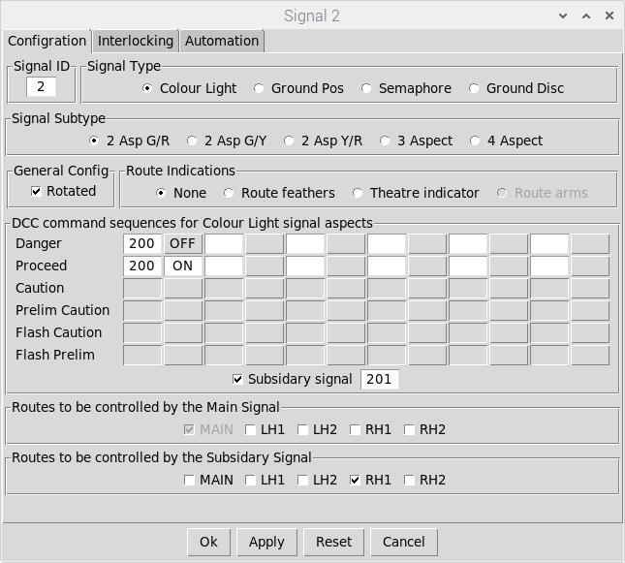
The shunting
Movement back into
The siding is a right
Hand divergence
From the main route
The 2 aspect signal
uses a single DCC
Address (toggle on/off)
to set the aspect
Change the signal to
Two-aspect (green/red)
The only route
Controlled by the
Main signal aspect
Is out to the rest
Of the world
The subsidiary aspect
Uses a single DCC
address (toggle On/Off)
Select to add a
Co-located subsidiary
Signal

Signals 3 and 5 also need to be edited to change them to two-aspect signals and have their DCC addresses configured. Note that Signal 5 should be configured as a two-aspect Green/Yellow signal to act as the distant signal for our layout (as this is a terminus station, we’ll configure it as a fixed distant when we configure the interlocking later in this example).
Finally, configure the DCC addresses for signal 4 (the ground position signal).
Once all signal configurations have been applied, the schematic should look like this:
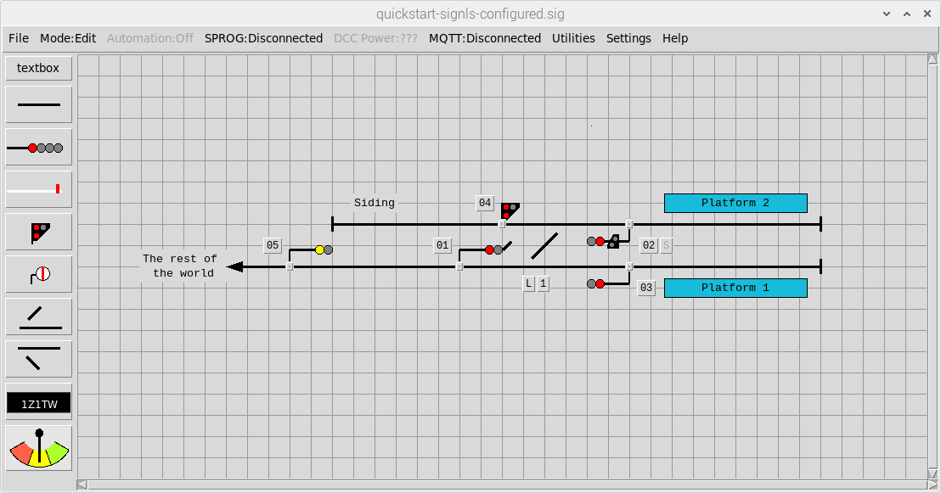
Distant Signal
Single feather indication is for for Platform 2
(no feather indication for the main route into platform 1)
Subsidiary signal
Is for siding

Configuring the basic interlocking
The application allows signals to be interlocked with points, conflicting signals, track sections, and block instruments. Initially, we’ll configure interlocking with points and conflicting signals. In this context, ‘conflicting signals’ are any other signals that could clear a train movement that would conflict with a train movement cleared by the signal.
All interlocking is defined via the configuration dialog of the appropriate signals. Double-left-click on a signal to bring up the configuration dialog and select the Interlocking tab.

Signal 1
From the schematic on the previous page, Signal 1 needs to be interlocked with Point 1, but there are two possible routes (into platform 1 and into platform 2). To enable Signal 1 to be cleared for the MAIN route (into platform 1), Point 1 needs to be NORMAL. To enable Signal 1 to be cleared for the LH1 route (into platform2), Point 1 need to be SWITCHED. We do not have to interlock the signal with Point 2 as we have already configured this to be ‘switched with’ Point 1.
Each ‘route’ from Signal 1 also needs to be interlocked with any signals that could clear conflicting movements, in this case Signals 2 and 3. Both of these signals only have a single route controlled by the main signal aspect (out to the rest of the world), so we only need to interlock with the MAIN routes controlled by these two signals.
The MAIN route for Signal 1 (into Platform 1) therefore needs to be interlocked with the MAIN route (departing from Platform 1) for Signal 3. Similarly, The LH1 route for Signal 1 (into platform 2) needs to be interlocked with the MAIN route (departing from Platform 2) for Signal 2.
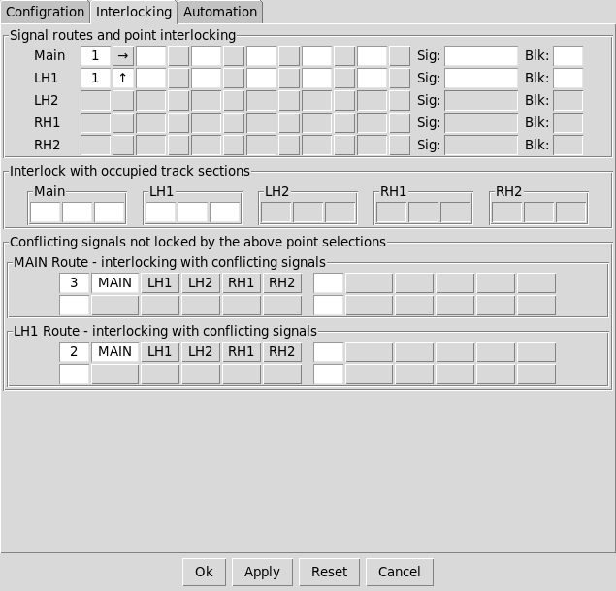
The MAIN route for
Signal 1 into Platform 1
Requires Point 1
to be NORMAL
The LH1 route for
Signal 1 into Platform 2
Requires Point 1
to be SWITCHED
The LH1 route for
Signal 1 into Platform 2
Is interlocked with the
MAIN route for Signal 2
(to rest of the world)
The MAIN route for
Signal 1 into Platform 1
Is interlocked with the
MAIN route for Signal 3
(to rest of the world)

Signal 2
Signal 2 also needs to be interlocked with Point 2, but in this case, the only valid route for the main signal aspect is out from Platform 2 to the rest of the world (see below for shunting routes). Point 2 therefore needs to be SWITCHED to allow Signal 2 to be cleared for the MAIN route.
When Signal 2 was initially configured (see earlier), the subsidiary aspect was configured to allow a shunting move is back into the siding (which is a right-hand diverging route). Point 2 therefore needs to be NORMAL to enable the subsidiary signal to be cleared for the RH1 route.
For the MAIN route (departure from Platform 2 to the rest of the world), Signal 2 needs to be interlocked with the LH1 route of Signal 1. For the RH1 route (back into the siding), Signal 2 needs to be interlocked with the MAIN route of Signal 4.

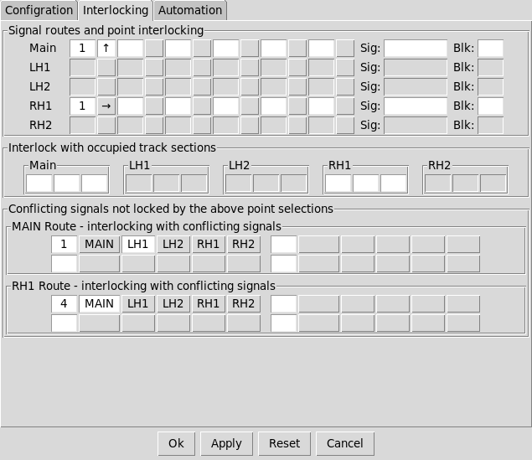
The MAIN route for
Signal 2 to the rest
Of the world requires
Point 1 to be SWITCHED
The RH1 (shunting) route
for Signal 2 back into the
siding requires Point 1
to be SWITCHED
The RH1 (shunting) route
for Signal 2 back into the
Siding is interlocked with
the MAIN route for Signal 4
The MAIN route for Signal
2 to the rest of the world
is interlocked with the
LH1 route for Signal 1

Signal 3
Signal 3 controls a single MAIN route (from Platform 1 out to the rest of the world) which needs to be interlocked with Point 1 (which needs to be SWITCHED to allow Signal 3 to be cleared). The signal also needs to be interlocked with the MAIN route of Signal 1.
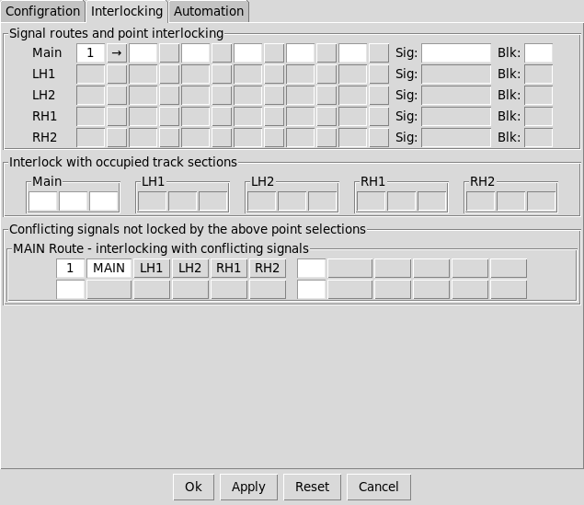
The MAIN route for
Signal 3 to the rest
Of the world requires
Point 1 to be NORMAL
The MAIN route for
Signal 3 to the rest
Of the world Is
Interlocked with the
MAIN route for Signal 1

Signal 4
Signal 4 controls a single shunting route (from the siding to Platform 2) which needs to be interlocked with Point 1 (which needs to be NORMAL to allow Signal 4 to be cleared. The signal also needs interlocking with the RH1 route of Signal 2 (the shunting route into the siding).
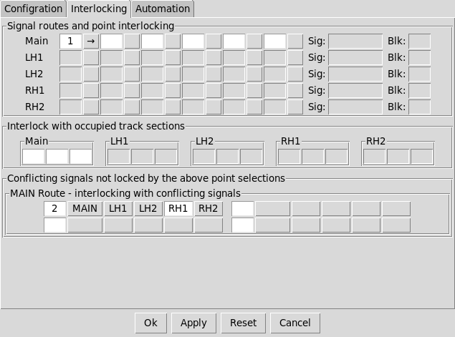
The MAIN route for
Signal 4 into Platform 2
requires Point 1
to be NORMAL
The MAIN route for
Signal 4 into Platform 2
is interlocked with the
RH1 route for Signal 2

Signal 5
As mentioned earlier, Signal 5 will be configured as a ‘fixed distant’. In this case we can just pick any point and configure the signal such it is only unlocked when the point is both SWITCHED and NORMAL (which can never happen, meaning the signal is always locked at Caution).
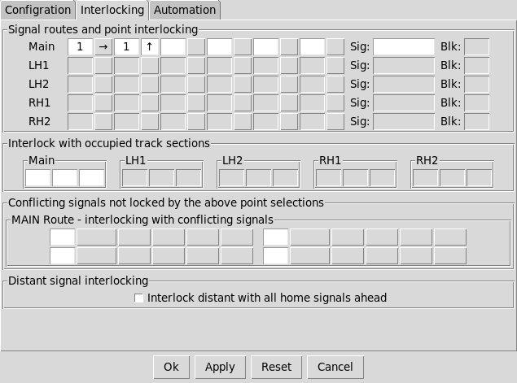
The MAIN route for
Signal 5 requires Point 1
to be both NORMAL
and SWITCHED

Point 1
Once all signals have been configured, the interlocking for Point 1 can be viewed via the Interlocking tab of the point configuration dialog (read only).
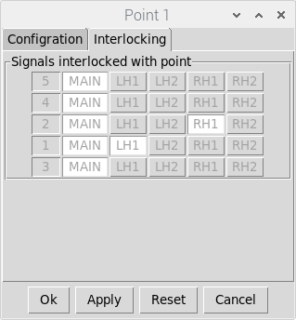
Point 1 is additionally
Interlocked with the
RH1 route of signal 2
(Platform 2 => Siding)
Point 1 is interlocked
with the MAIN route
of all signals
Point 1 is additionally
Interlocked with the
LH1 route of signal 1
(Into Platform 2)

Testing the basic interlocking
Once configured, the basic interlocking can be tested. If a signal or point is ‘locked’ then the associated control buttons will be ‘greyed out’ and unresponsive.
Firstly, ensure the layout is in a default state by selecting Mode => Reset from the Main Menubar and selecting OK in the pop-up dialog to confirm. This will reset all signals to ‘ON’ and reset all points to NORMAL with their Facing Point Locks (FPLs) ACTIVE.
Signal 5 will be locked as we configured this as a ‘fixed distant’. The main aspect of Signal 2 will also be locked as the route controlled by this signal is out from Platform 2 to the rest of the world and the points are currently set back into the siding. The subsidiary aspect of signal 2 (controlling the shunting route back into the siding) will be unlocked.
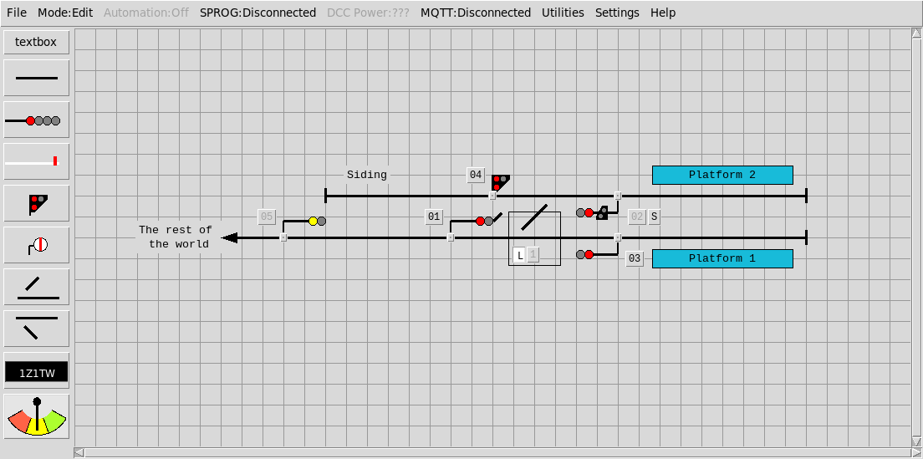
Signal 2 main aspect locked
Signal 2 subsidary aspect unlocked
FPL Active (‘L’ Button)
Signals 5 (fixed
Distant) locked

In this state, the interlocking with conflicting signals can be tested. If Signal 4 is switched ‘OFF’ then the subsidiary aspect of Signal 2 will be locked. Similarly, if signal 1 is switched ‘OFF’ then signal 3 will be locked. Note that as soon as a signal is switched ‘OFF’ to clear a route over the points then the points are locked and cannot be changed until the signals are returned to ‘ON’
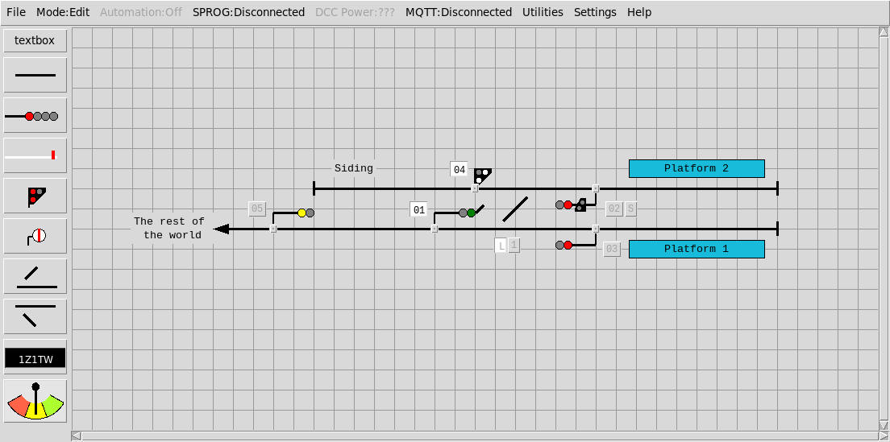
Signal 4 is OFF
Signal 3 is Locked
Subsidiary Signal 2 is Locked
Signal 1 is OFF
Point 1 is Locked

As soon as Signal 1 is returned to ‘ON’ then Signal 3 will be unlocked. Similarly when signal 4 is returned to ‘ON’ then the subsidiary of Signal 2 will be unlocked.
The interlocking can then be tested the other way – setting Signal 3 to ‘ON’ will lock signal 1 and setting the subsidiary of Signal 2 to ‘ON’ will lock Signal 4.
Once all signals have been returned to ‘ON’ then the points can be changed to test the other signal routes. Click on the ‘L’ button to ‘release’ the Facing Point Lock (FPL) and enable the main point control button. The point can then be switched . Note that as soon as the FPL is ‘released’ then all signals will be locked to prevent a route being cleared across the points and will remain locked until the FPL is ‘reactivated’ (after the points have been switched).
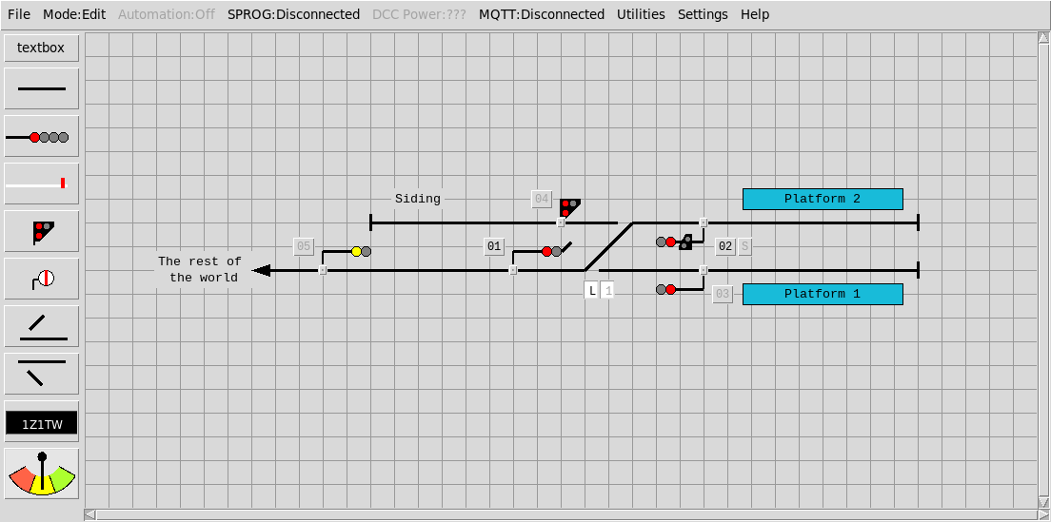
Point 1 switched
with FPL active
Signal 3 locked (no route)
Signal 4 locked (no route)
Signal 1 unlocked
Signal 2 main aspect unlocked
Signal 2 subsidiary aspect locked

The interlocking with conflicting signals can now be tested in this configuration. If signal 1 is set to ‘OFF’ then Signal 2 will be locked and vice-versa. Note that when Signal 1 is ‘OFF’ it will display the appropriate route indication (in this case a left hand feather).
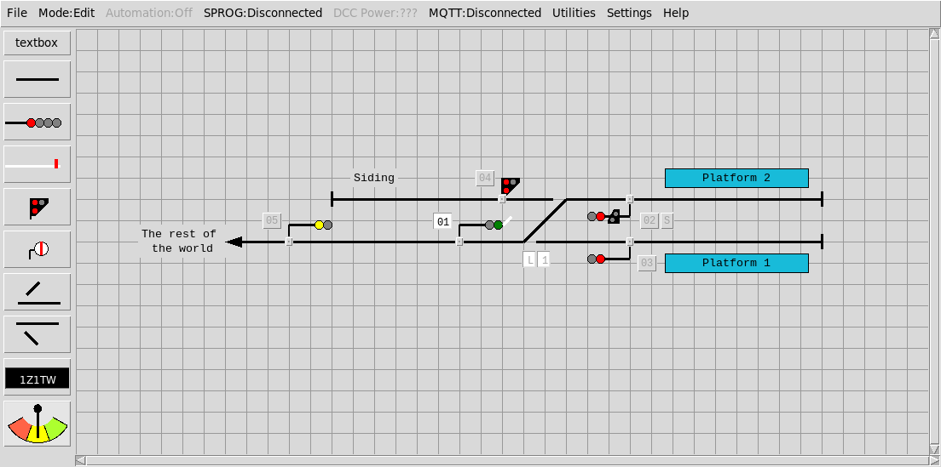
Signal 1 cleared for Platform 2
Signal 2 locked
Point 1 locked

Operating your Layout
Once you are happy with your layout you can ‘lock’ the schematic to prevent further editing by setting RUN mode. Either use the keyboard shortcut to toggle into RUN Mode (Cntl-a) or select via the Menubar (Mode => Run). This also removes the grid lines and the schematic object add buttons down the left hand side of the window in Run Mode.
If you are running the application on a Raspberry-Pi with a Pi-SPROG DCC programmer controller then controlling the signals and points out on the layout is simple.
- Select SPROG => Connect from the Menubar. If connection is successful then the Menubar will show a SPROG status of CONNECTED and the Menubar DCC Power selection will be enabled.
- Select DCC Power => ON from the Menubar to enable DCC Power. If the power was successfully turned on then the Menubar will show a DCC Power Status of ON.
The default configuration should work ‘out of the box’ as long as the Pi-SPROG has been installed correctly following the instructions provided with the Pi-SPROG. If not then the SPROG connection settings can be checked by Menubar => Settings => SPROG )
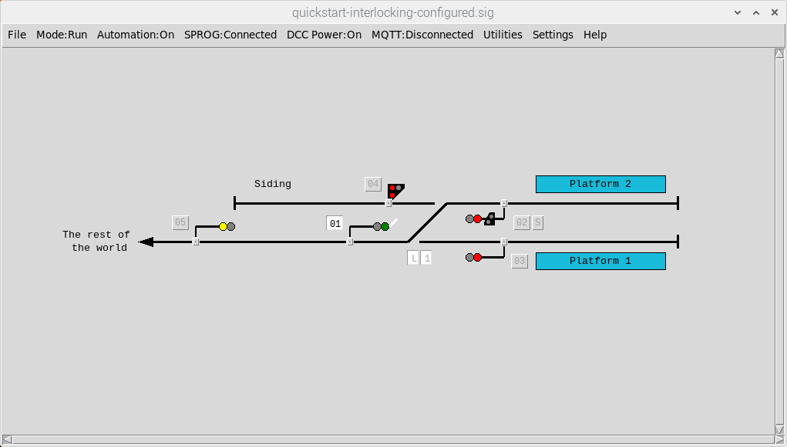
RUN Mode
SPROG is CONNECTED with
DCC Power to the Accessory Bus ON

Note that the actual states of the signals and points out on the layout may not reflect the state of the points and signals shown in the application (as we haven’t sent out any DCC commands yet). To synchronise everything, set the layout back to its default state via the Menubar (Mode => Reset). This will send out the required DCC commands to all signals and points on the layout.
All subsequent changes to signals or points in the application will send out the required DCC commands to change the signals and points on the layout accordingly.

Adding and configuring track occupancy
If you have completed all of the steps above, you will have have created a layout configuration that provides basic interlocking of signals / points, and DCC control of the signals and points out on the layout. The next step is to add track occupancy indications to provide a ‘mimic’ diagram showing the position of trains out on the layout.
Firstly (in EDIT mode), add ‘track sections’ to the schematic and position them on the layout accordingly. Track sections should be provided for all positions a train could occupy within the signalling scheme. In this case, trains could occupy Platform 1, Platform 2, the Siding, the section of track between the distant and home signals and the ‘rest of the world’.
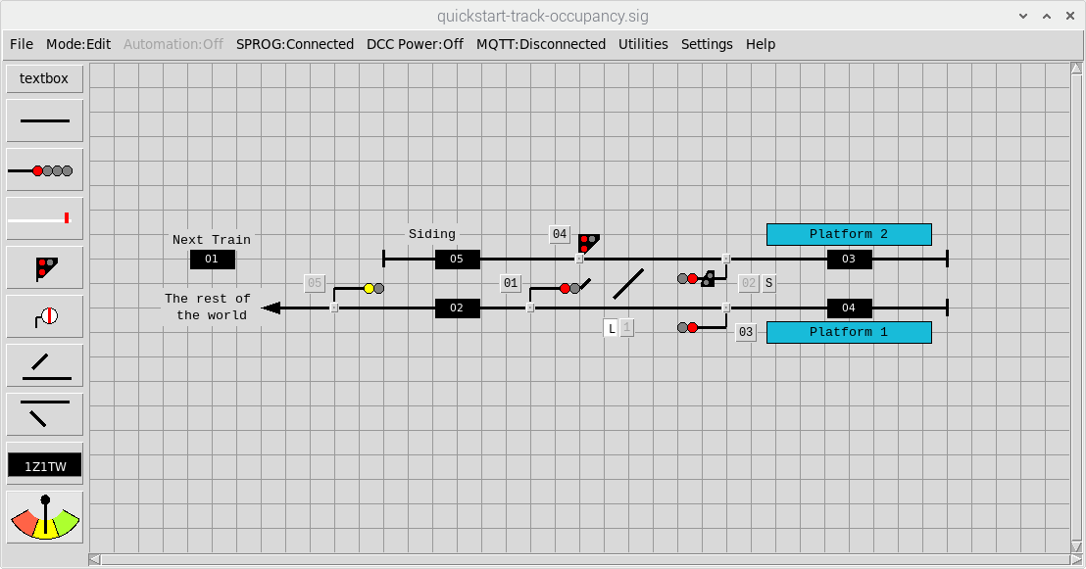
Track Sections

Each signal then needs to be edited to define the track section ‘in the rear of’ the signal (i.e. the track section that would be ‘cleared’ when the signal is passed) and the track section ‘ahead of’ the signal (i.e. the track section that would be set to ‘occupied’ when the signal is passed). For signals controlling multiple routes, the track section ‘ahead’ needs to be defined for each route. This configuration is defined via the Automation tab of the signal configuration dialog.
Signal 1 controls two routes (into platform 1 and into platform 2) so the configuration would be:
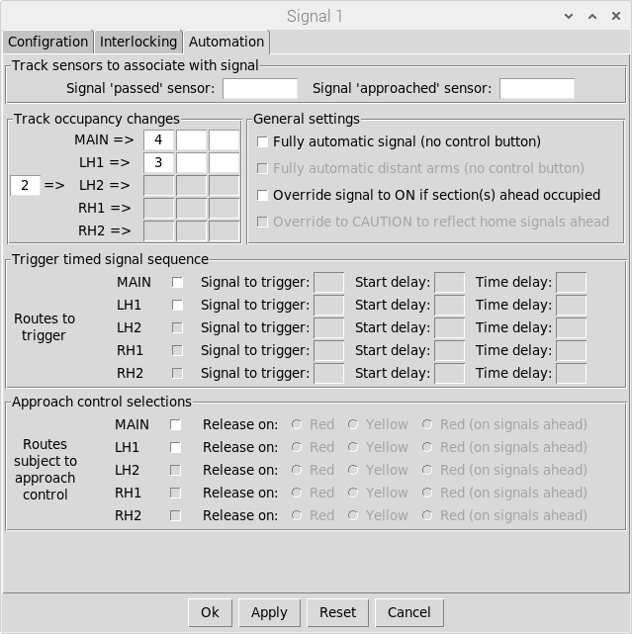
Section 2 will be CLEARED
when Signal 1 is passed
in the direction of travel
Section 4 will be OCCUPIED
when Signal 1 is passed with
the route into Platform 1 set
Section 3 will be OCCUPIED
when Signal 1 is passed with
The route into Platform 2 set

Signal 2 similarly controls two routes (the MAIN route from platform 2 out to the rest of the world and the RH1 route from platform 2 back into the siding) so the configuration would be:
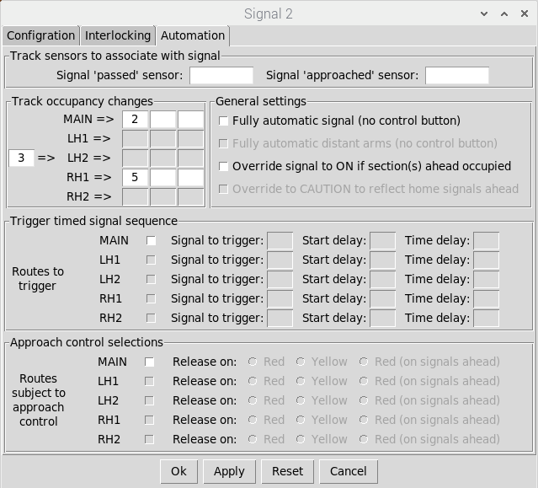
Section 3 will be CLEARED
when Signal 2 is passed
in the direction of travel
Section 2 will be OCCUPIED
when Signal 2 is passed with
the route set out to the
Rest of the world
Section 5 will be OCCUPIED
when Signal 2 is passed with
The route set into the siding

All other signals control a single (MAIN) route, so the configuration is straightforward:
- Signal 3 – Section behind is Section 4, Section Ahead is Section 2
- Signal 4 – Section behind is Section 5, Section Ahead is Section 3
- Signal 5 – Section behind is Section 1, Section Ahead is Section 2

Testing track occupancy changes
Once all signals have been configured, track occupancy changes can be tested in RUN mode. Although we haven’t configured any external track sensors, the ‘signal passed’ events to trigger track occupancy changes can be simulated by clicking on the buttons at the base of each signal.
On entering RUN mode, all track sections will initially show as CLEAR (greyed out). To set up the ‘next train’ to run into the layout, right-click on the track section and enter an appropriate train designation code (for this example we’ll use ‘HST’ for simplicity). Once entered, this will set the track section to OCCUPIED (signified by white text on a black background). Track sections can also be toggled between OCCUPIED and CLEAR by left-clicking on them.
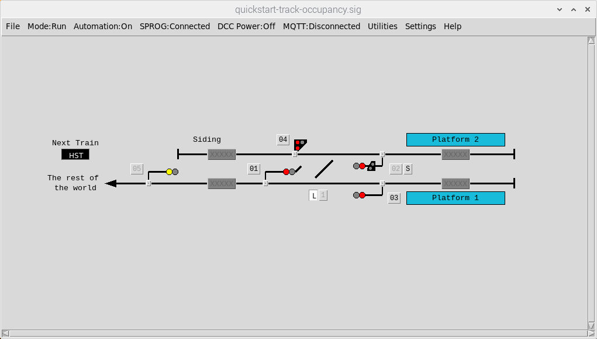
Left-click to toggle between
OCCUPIED and CLEAR
Right-click to enter a train
Designation code and set the
track section to OCCUPIED
Other track sections
remain CLEAR

To simulate a train movement from the rest of the world into Platform 2, first configure the route into platform 2 (ensure all signals are ‘ON’, release the FPL for point 1, switch the point and then re-activate the FPL) and then clear the route (set Signal 1 to ‘OFF’).
Note that for all signal types apart from distant signals, the signal must be off ‘OFF’ for ‘signal passed’ events to trigger track occupancy changes. As per the ‘real thing’, it is the driver’s responsibility not to pass a signal at danger!
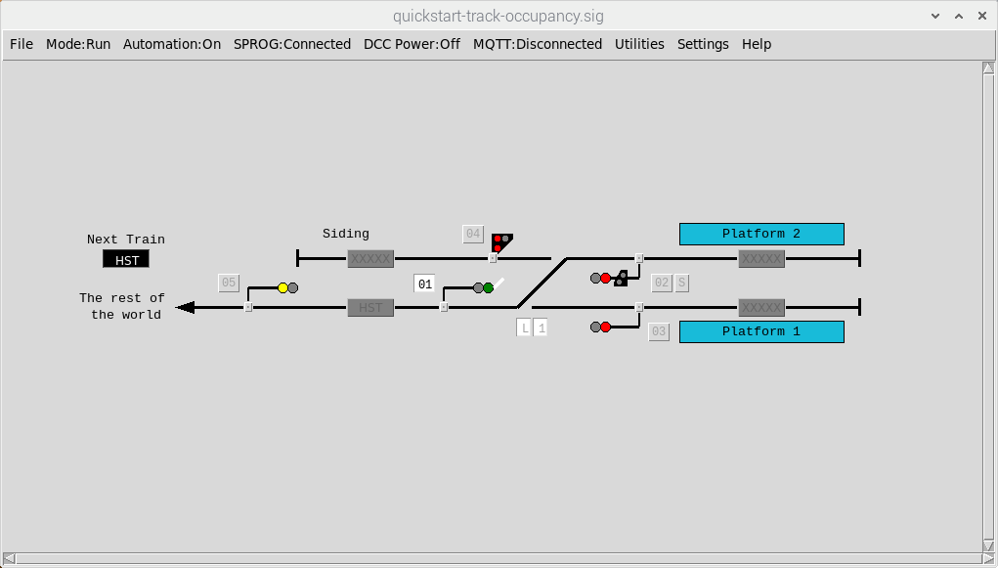
Route set and cleared from the
Rest of the world into Platform 2

Next, trigger a ‘signal passed’ event for Signal 5 by left-clicking on the small button at the base of the signal to ‘pass’ the train onto the next track section.
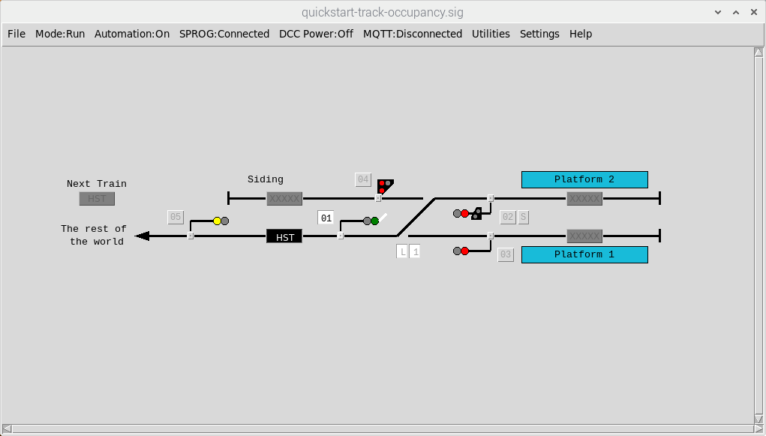
Click on the button to simulate
A ‘signal passed’ event
Next Track Section
Is now OCCUPIED
Track Section
Is now CLEAR

Finally, trigger a ‘signal passed’ event for Signal 5 to ‘pass’ the train into Platform 2.
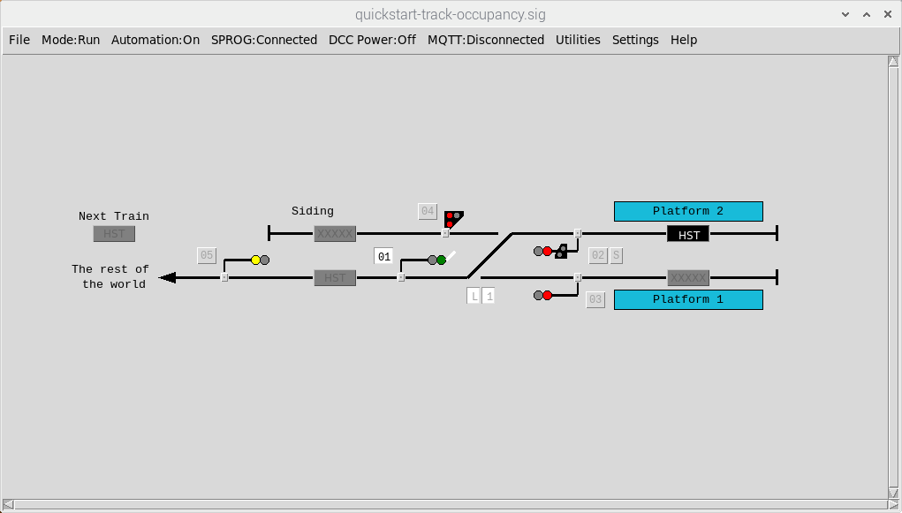
Click on the button to simulate
A ‘signal passed’ event
Track Section
Is now CLEAR
Next Track Section
Is now OCCUPIED

At completion of the movement, all signals should be returned to ‘ON’, ready for the next movement. Other movements you could simulate would be Platform 2 back into the siding, Platform 2 to the rest of the world, rest of the world to Platform 1 and Platform 1 to the rest of the world – but Remember, signals need to be OFF to pass trains onto the next track section.

Configuring external track sensors
The benefit of using the Raspberry-Pi is that we can connect in external track sensors and use them to trigger the ‘signal passed’ events we simulated in the previous section.
Firstly, we need to define the physical GPIO pins we want to use for track sensors. To do this, open the GPIO Sensors window by selecting Settings => Sensors from the Main Menubar. Individual ‘track sensors’ can then be associated with each of the GPIO inputs.
For this example, we’ll allocate ‘track sensors’ to each signal, following the numbering of each signal. To do this, just enter the number of a ‘track sensor’ against the required GPIO port (this number will be the number we refer to when subsequently configuring the signals). We have a total of 5 signals so need to allocate a total of 5 Sensors, each mapped to a GPIO port.
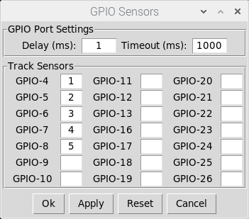
A trigger on GPIO input 4
Will trigger “Track Sensor 1”
A trigger on GPIO input 5
Will trigger “Track Sensor 2”
Etc

Each signal then needs to be configured to use a Track Sensor to generate the ‘signal passed’ event. This configuration is defined via the Automation tab of the signal configuration dialog.
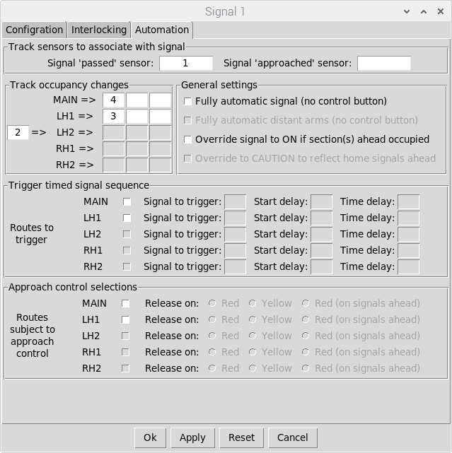
Map each signal to its
Associated track sensor
(Signal 1 => Sensor 1 etc)

Once all signals have been mapped to their associated track sensors, ‘signal passed’ events will be triggered whenever the associated GPIO input is taken down to 0V.
Normally Open (closed when triggered) sensors can be connected directly between the appropriate GPIO input pin and a 0V DC pin (available on the GPIO header).
Note that other sensor types (providing a switched voltage) should never be connected directly to the GPIO pins as this could damage the Raspberry-Pi. In these cases, external opto-isolators are recommended to protect the GPIO input pins.

Interlocking with Track Sections
So far, we have configured interlocking for signals and points, but it would still be possible to signal a train onto a track section that was already occupied.
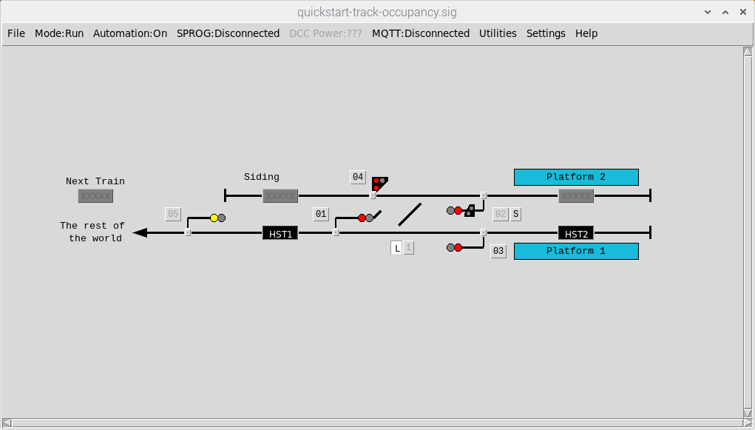
Track Section 2 is already
Occupied by a Train (HST1)
Signal 3 is unlocked so could be cleared
to signal a departure from Platform 2

To overcome this, we can also interlock signals with Track sections. In this case we want to Interlock Signal 3 with Track Section 2 and also Track Section 1 (representing a train about to enter the layout from the rest of the world). To configure this, open the signal configuration dialog (in EDIT mode) and select the Interlocking Tab.
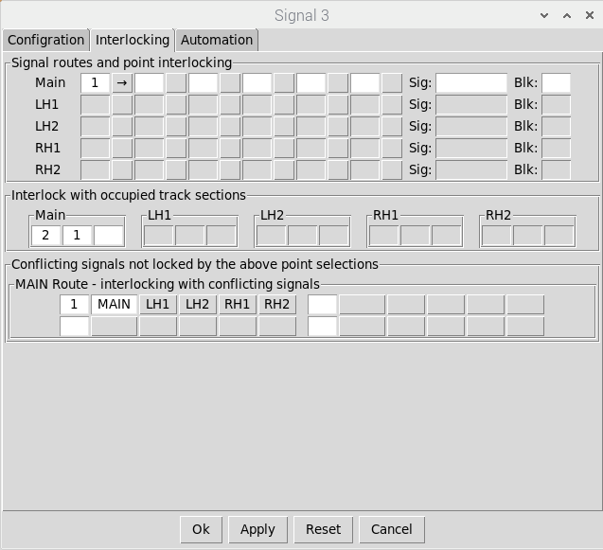
The MAIN route for Signal 3
will be locked (at DANGER)
If Track Section 1 or Track
Section 2 is OCCUPIED

Signal 1 will now be locked (at ‘ON’) whenever Track Section 1 or 2 is OCCUPIED. Note that if a signal is ‘OFF’ when a Track Section becomes OCCUPIED then it will only be locked when returned to ‘ON’ (signals must always be capable of being returned to DANGER).
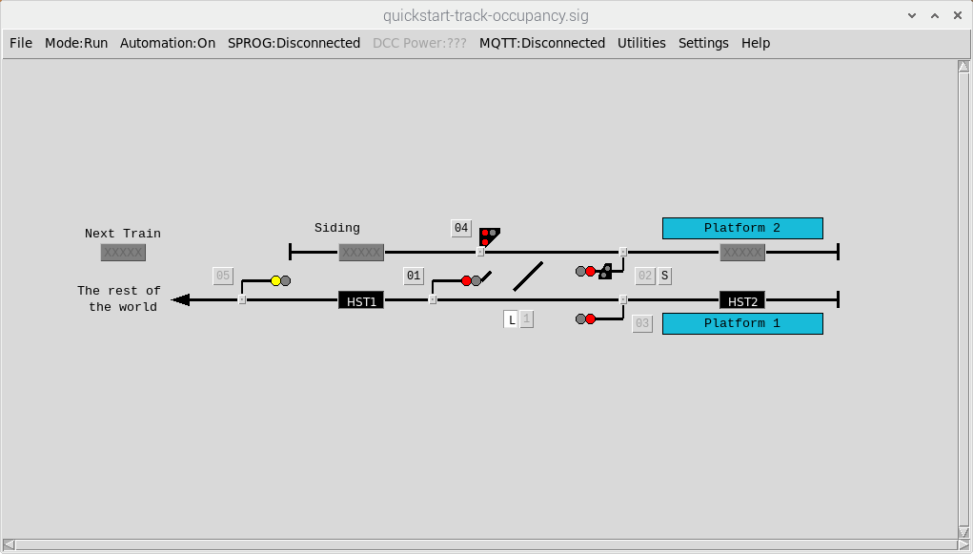
Track Section 2 is already
Occupied by a Train (HST1)
Signal 3 is unlocked so could be cleared
to signal a departure from Platform 2
Track Section 2 is already
Occupied by a Train (HST1)
Signal 3 is now Locked (at DANGER)
Preventing a departure from Platform 2

Other signals should be similarly configured to complete the interlocking schema. For example, signal 2 should be interlocked with Track Sections 1 and 2 for the MAIN route (out to the rest of the world) and Track Section 5 for the RH1 route (back into the siding).
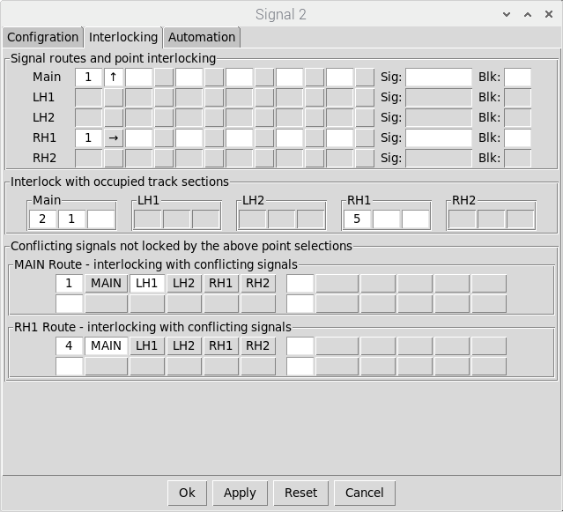
The MAIN route for Signal 2
will be locked (at DANGER)
If either of the Track sections
Out to the rest of the world
Are OCCUPIED
The RH1 route for Signal 2
will be locked (at DANGER)
If The Track Section for the
Siding is OCCUPIED

Once all signals have been configured, the interlocking of signals with Track Sections can be viewed via the Interlocking tab of the Track Section configuration dialog (read only).
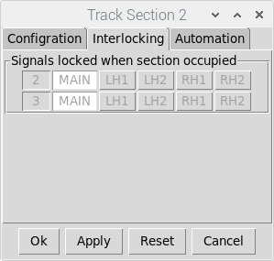
The MAIN routes for Signal 2
and Signal 3 will be locked
When Track Section 2
Is OCCUPIED

Saving and loading your layout
Once you are happy with your layout, it can be saved to file (select File => Save or File => Saveas from the Main Menubar – in the case of a ‘first time’ save or ‘save as’, this will bring up a dialog to choose the filename and destination folder). Files are saved with a ‘.sig’ extension.
Note that the current state of the layout (in terms of signal and point settings) is saved with the configuration, allowing you to pick up a running session from where you left off.
The current mode is also saved so if your layout was saved in RUN mode it will be loaded in RUN mode (and if saved in EDIT mode it will be loaded in EDIT Mode).
To load your layout select File => Load from the Main Menubar. This will bring up a dialog to choose the filename load the layout configuration in the mode/state at the point of save.
When a layout is loaded, the Pi-SPROG settings will default to DISCONNECTED with DCC Power OFF. If you are using the application in a ‘fixed’ configuration (i.e. with the Pi-SPROG permanently connected to your layout), then you can also configure the layout to connect to the Pi-SPROG and turn on DCC Power on layout file load. This is achieved via the application settings (select Settings => SPROG from the Main Menubar, select the appropriate checkboxes and click on OK or APPLY to save the changes).
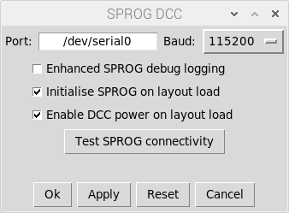
Application will connect
To the Pi-SPROG and
Enable DCC Power
On Layout Load

Note that these SPROG settings are specific to the layout (i.e. saved and loaded as part of the layout configuration file) and will not apply to other layouts you load into the application.
Similarly the Track Sensor configuration (in terms of GPIO port mappings to ‘Track Sensors’) is specific to the layout and will be saved / loaded with the rest of the layout configuration.

Appendix 1 - Using semaphore signals
In the quick start example above, we configured a layout using colour light signals. Depending on the period modeled, you might prefer the use of semaphore signals on your layout.
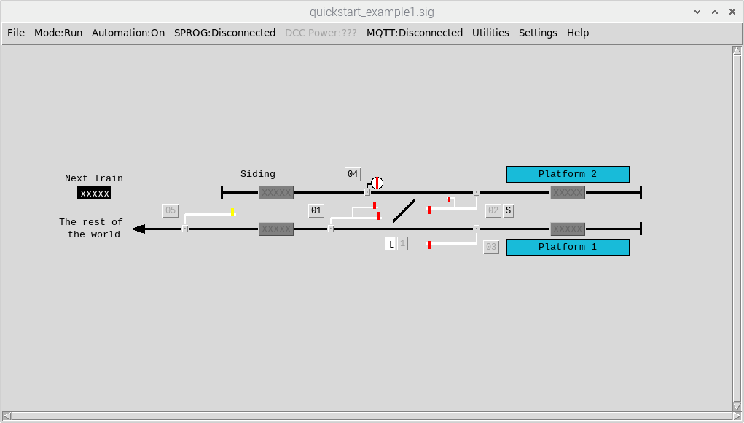
Ground Disc Signal
Semaphore with a subsidary arm
For the RH1 route into the siding
Semaphore with a secondary route arm
For the LH1 route into Platform 2

The only major differences in the configuration of the two signal types are:
- The route indications – route feathers vs additional semaphore route arms
- DCC addressing – DCC command sequence per colour light aspect vs a single DCC address for each semaphore arm (which is either OFF or ON)
Signal 1 has been changed to a Semaphore Home signal with Route Arms (a MAIN route arm for the route into Platform 1 and a LH1 route arm for the route into platform 2). Each signal arm has been allocated its own DCC address. The remainder of the configuration (on the Interlocking and Automation tabs) remains identical to Signal 1 in the colour light signalling example.
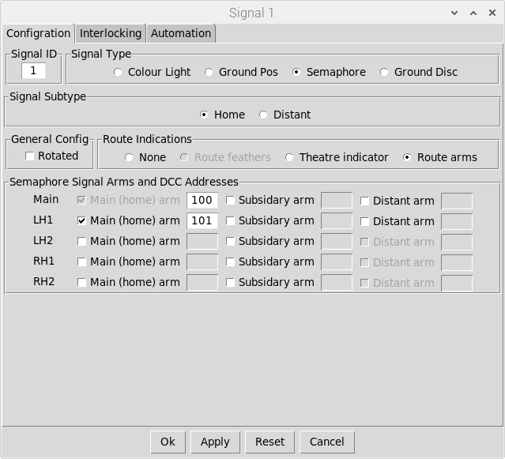
Signal Type and
Subtype have
Been updated
Signal Type and
Subtype have
Been changed
Route Arms
Selected
Additional route arm
Selected for the LH1
Route (MAIN route
Is always selected)
Single DCC address
For each arm

The other signals have also been changed to Semaphore types. Note that for signal 2 the MAIN route (controlled by the main semaphore arm) remains the route out from platform 2 to the rest of the world. A subsidiary arm controls the RH1 route back into the siding.
As per Signal 1, only the signal types, route indications and DCC addressing has been changed. The rest of the configuration remains identical to the colour light signalling example.

Appendix 2 - DCC programming of signals and points
A basic DCC programming utility is provided to enable ‘one touch’ programming (suitable for the majority of ‘DCC ready’ point & signal decoders on the market) and Configuration Variable (CV) programming (suitable for more complex decoders such as the Signallist SC1).
‘One touch’ programming, if supported by the device, is always the preferred method as this can be done ‘on layout’ without disconnecting all other devices from the DCC accessory bus.
The utility can be opened by selecting Utilities = > DCC Programming from the Main Menubar. Note that The Pi-SPROG needs to be CONNECTED with DCC Power ON to program devices (refer to the ‘Operating your layout’ section).
For this quick start guide, we’ll focus on ‘one touch’ programming:
- Ensure the device it is connected to the DCC bus and has been put into ‘one touch’ Programming mode (refer to the device documentation for specific instructions).
- Enter the required DCC address and click the required command (On or Off) to program. Once programmed, the device should respond to all subsequent DCC commands.
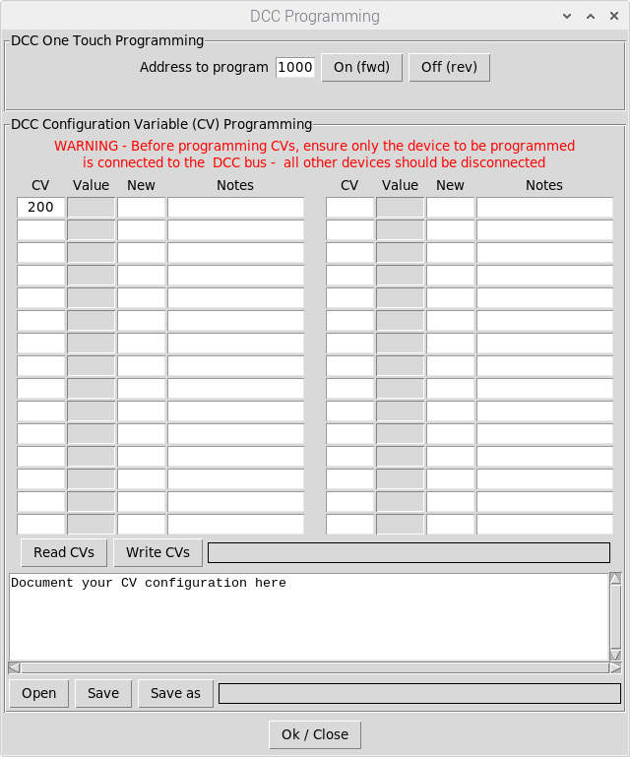
Enter the required
DCC address
Click the appropriate
Button to send the
Required DCC command

Facing Point locks (FPLs) physically lock points in position to prevent them accidentally changing as a train passes over them. In the UK it is not permitted for passenger trains to pass over points from a facing direction (diverging direction) without them being locked into place.
When a signal is ‘ON’, it is displaying its most restrictive aspect (DANGER for Home signals or CAUTION for distant signals). When a signal is ‘OFF’ it is displaying its least restrictive aspect (PROCEED for most signal types)

