

https://www.model-railway-signalling.co.uk/
© DCC Model Railway Signalling. All Rights Reserved.
Signalling Application Quick-start Guide
Version 8 – October 2025
This guide is intended to provide an introduction to the Model Railway Signalling Application and the art of the possible in terms of the signalling configurations that can be achieved.
All of the example layouts used in this guide (and other example layout files) are packaged with the application. These can be accessed by selecting File => Examples from the Main Menu-bar and then selecting the appropriate file.

Other documentation (such as the Application Networking Guide) is also packaged with the application (Select Help => Docs from the Main Menu-bar):

Table of Contents
Introduction 3
The importance of research 5
The schematic editor 6
Quick start example 1 – colour light signals 8
Drawing your layout schematic 8
Planning your signalling scheme 9
Adding signals to the schematic 10
Configuring basic interlocking 12
Testing basic interlocking 15
Configuring the DCC bus output 17
Configuring track occupancy 19
Testing track occupancy 21
Automating signals based on track occupancy 23
Enabling Signal Passed At Danger (SPAD) warnings 24
Using external sensors to drive track occupancy 25
Configuring interlocking with occupied track sections 27
Configuring ‘one-click’ route setting 29
Saving and loading your layout 35
Quick start example 1a – NX Panel operation 36
Configuring track occupancy highlighting 36
NX route configuration 39
NX route configuration is similar to ‘one-touch’ route configuration but multiple routes can be specified from each Entry Buttons (to an associated Exit button). As an example, the configuration for the main layout entry button (from the fiddle yard) would be: 39
Quick start example 2 – semaphore signals 40
Quick start example 3 – signal box levers 42
Simulated signal box levers 42
Physical switches/levers 44
Quick start example 4 - more automation 47
Configuring interlocking 47
Configuring track occupancy 48
Configuring basic automation 48
Configuring timed signals 49
Configuring approach control 50
Testing the competed layout 51
Quick start example 5 – intermediate track sensors 52
Quick start example 6 – DCC accessory switches 54
Using DCC switches in route configurations 55
Using DCC Switches to trigger sound files 56
Still to discover 57
Appendix 1 – How track occupancy works 58
Appendix 2 – Using ‘track circuit’ / ‘block’ sensors 59
Appendix 3 – The DCC programming utility 60
One-touch DCC programming 60
DCC CV programming 61

Introduction
The DCC Signalling Application enables users to easily create, configure and control prototypical interlocked signalling schemes for model railway layouts, without the need for complex layout wiring or bespoke software development. All layout configuration and control is achieved via the application’s graphical user interface, avoiding the need for specialist computer skills (if you use other computer applications, you should be able to use this).
Key features of the application include:

- Allows you to create a schematic representation of your layout within the application:
  - Supports most types of UK colour light signals, semaphore signals, and ground signals.
  - Supports complex track work formations such as crossovers, slips and 3-way points.

- Interfaces with the Pi-SPROG command station to control all your DCC Accessories:
  - Uses a DCC Accessory bus (separate from the track bus) to control your layout.
  - Supports all standard DCC signals, points and other DCC accessory decoders.
  - Includes a DCC programming utility for both 'one touch' and CV Programming.

- Uses external track sensors to get feedback from the layout on train movements:
  - ‘Track Sections' on the schematic provide a mimic diagram of train location.
  - Train designators 'move' through the schematic based on 'train passed' events.

- Provides prototypical interlocking of points and signals on the layout
  - Signals can be interlocked with points, other signals and track sections.
  - Points can be interlocked with signals and track sections.

- Provides prototypical automation of layout signalling:
  - Signals will change to danger when the section ahead is occupied.
  - Multiple aspect signals will reflect the state of the signal ahead.
  - Advanced features such as approach control are also supported.

- Enables prototypical signal box simulations to be created to for your layout:
  - Virtual 'Levers' can be added to the schematic to control the signals and points.
  - External Levers (e.g. DCC Concepts Cobalt S Levers) can easily be integrated.
  - Virtual 'Block Instruments' can be used for coordination between signal boxes.

- Can be used to simulate NX (Entry/Exit) panel operation for control of your layout:
  - Routes can easily be set up by clicking on the ‘Entry’ and ‘Exit’ button.
  - Routes are highlighted on the schematic to show they have been successfully set.
  - Track Sections can be configured to highlight route lines for track occupancy.
  - Interlocking is preserved - Routes are disabled if conflicting movements are set.
  - ‘One Click’ route setting is also provided as an alternative to NX operation.

- Incorporates MQTT networking allowing multiple applications to be linked.
  - Enables multiple signalling areas and/or signal boxes to be simulated for larger layouts.
  - Multiple applications can use the same DCC command station for control of your layout.
  - Provides an easy way to expand of the number of external track sensors that can be used.

The application has primarily been developed to run on a Raspberry Pi computer, hosting a Pi-SPROG DCC programmer controller:
- The Raspberry Pi is a low-cost single-board computer which provides a “Windows-like” user experience (and versions of all the usual applications you would expect, such as web-browser, email, office-type applications etc).
- The Pi SPROG DCC programmer controller connects directly to the Raspberry and provides a DCC ‘accessory bus’ output to control the points and signals out on the layout.
The use of a separate ‘accessory bus’ makes the system suitable for use with layouts that use DCC or analogue for control of trains (when used with DCC layouts, the accessory bus for control of the signals/points needs to be electrically separated from the main DCC track bus).
Several manufactures now provide DCC signals (e.g. Train-Tech from Gaugemaster) and point motors (e.g. Cobalt from DCC Concepts), making this method of control ideal for ‘new-build’ layouts. There are also numerous DCC signal/point decoders available for those wishing to upgrade to DCC control without the expense of wholesale replacement of their existing units.
The application uses the flexibility of the Raspberry Pi General Purpose Input/Output (GPIO) interface to provide feedback on train location. Simple sensors providing a ‘normally-open’ output (momentarily closed when triggered) can be connected directly to the appropriate GPIO pins to generate ‘signal passed’ events as the passing train triggers the sensor (e.g. the slim vertical magnetic sensors from DCC Concepts). These events can then be configured within the application to provide a ‘mimic’ diagram of train location and provide a level of signal automation.
Note that other sensor types (providing a switched voltage) should never be connected directly to the GPIO pins as this could damage the Raspberry-Pi. In these cases, external opto-isolators should be used - I’ve been using the PC817 2, 4 or 8 channel opto-isolator modules (available from several Ebay sellers) for my layout. Connection of these is relatively straight forward, but if you have any doubts then seek expert advice.
For added flexibility, the software enables multiple signalling applications to be networked together, making it ideal for control of larger layouts (where the layout gets broken down into multiple signalling areas) or splitting smaller layouts down to individual signal boxes (with simulated block instruments) for real ‘true to prototype’ operation. Note that in this case only one instance of the application needs to be running on a Raspberry Pi (the instance providing the interface to the DCC bus and track sensor inputs from the GPIO pins). As the application has been designed to be platform independent, other instances can be hosted on Windows or Linux as required.

The importance of research
This is probably the most important (and potentially time consuming) part of the process. If you’re reading this document and planning to use the application to develop a signalling scheme for your model railway then I’d recommend building familiarity with British railway signalling practice. There are lots of great resources out there, but some of the best I’ve come across are:
- https://signalbox.org/ - Comprehensive information on signal types and the ‘Block System’ and a vast library of signal box diagrams for you to draw inspiration.
- https://en.wikipedia.org/wiki/UK_railway_signalling – Its Wikipedia (enough said).
- http://www.railway-technical.com/signalling/ - A section of the Railway Technical Website covering signalling. There are many great resources on these pages including:
  - http://www.railway-technical.com/signalling/infopaper-6-basic-railway.pdf – A paper (downloadable pdf format) on Basic Railway Signalling.
  - http://www.railway-technical.com/signalling/british-signalling--what.pdf – A paper (downloadable PDF) on “What the driver sees”.
- https://www.s-r-s.org.uk/archivevideo.php – The film archive of the Signalling Record Society. There are some excellent “Signalling Primer and Educational Videos’ on here, including a number of videos explaining NX Panel Operation.
But Beware – Railway modeling is always about compromise and that is definitely going to be the case for whatever signalling scheme you design and implement for your layout. Although the application has been developed to add a touch of realism to the operation of your layout, it will never measure up to the million-pound-plus signalling systems of the ‘real thing’.
And never forget - Rule 1 of Railway Modelling applies – it’s your layout and its therefore entirely up to you how you signal your layout. Hopefully the features provided by the application will enable you to achieve whatever level of realism you want to achieve.

The schematic editor
The application opens in ‘Edit’ mode with a blank drawing canvas. The panel on the left contains the buttons to add schematic drawing objects to the canvas, whilst the Menu-bar across the top of the window contains various controls and options for configuring the application.

File Save
and Load
Edit/Run mode, layout reset
and automation controls
GO HERE
FIRST !!!
Signals (main types)
Route Lines
Points (main types)
Track Sections
Block Instruments
Track sensors
SPROG DCC
controls
Dropdown menus
for further selections
Networking
controls
Text Boxes
Signal box Levers
Schematic Routes
DCC Switches

Open the Help Window from the Main Menu-bar ( Help => Help) to familiarise yourself with the basic Schematic Editor functions and the various Main Menu-bar options.
Use thee basic editor functions to practice creating, moving and deleting objects:
- Create objects by left-clicking the buttons on the left hand side, drag them to the required position on the drawing canvas and then ‘place’ them via another left-click.
- Select objects by left-clicking on them (small circles will be displayed at each end of lines to show they are selected - a border will be displayed around other drawing objects)
- Move selected objects by dragging and dropping (left-click => move => left-release).
- Move the ends of a line by selecting the line and then dragging and dropping the line end.
- Rotate selected objects (points and signals) by pressing the ‘r’ key
- Flip selected objects (points and signals) by pressing the ‘f’ key
- Delete selected objects by using the backspace key


Drag and drop line end
with left mouse button
Point is selected
Line is selected

Once you are happy with the basic schematic editor functions, try double (left) clicking on some of the objects you have created to bring up their configuration windows. Although the number of settings and options may look daunting, don’t worry – the application has built-in help in the form of ‘tool-tips’ which provide more information on what the settings are for and what type of information should be entered. To bring up the tool-tip for a setting, just hover the cursor over it.
For many schematic objects, the configuration windows allow you to change the type (and sometimes sub-type) of the object. This is particularly important for signals and it allows you to select the most appropriate signals for your layout (most UK signal types are supported):
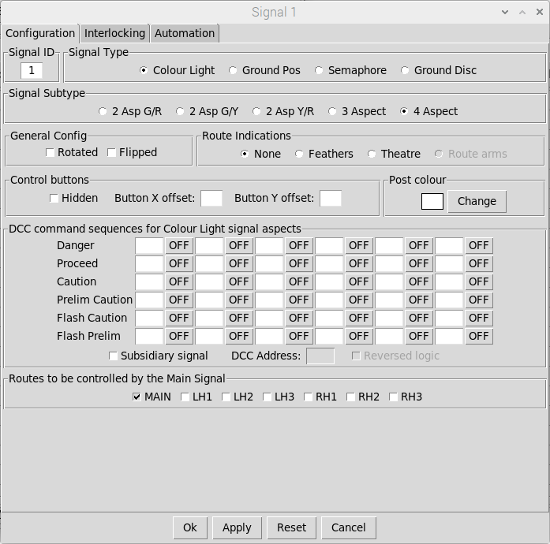
Signal subtype selection
(available selections will
Change depending on
Signal type selection)
Signal Type selection
Route indications
Supported by this
Signal type/subtype
DCC command sequences
For each available aspect
The unique ID for the
Signal (no two signals
Can share the same ID)
Tabs for the signal
Configuration (click on the
required tab to select)
Each signal can support
up to 7 diverging routes.

Routes are defined on
The interlocking tab.
Buttons to apply
The updated configuration

Similarly for points, the type and sub-type options allows you to represent complex track formations (such as single/double slips, scissor crossovers, and trap points). Hover the cursor over the point sub-type selection for further information.
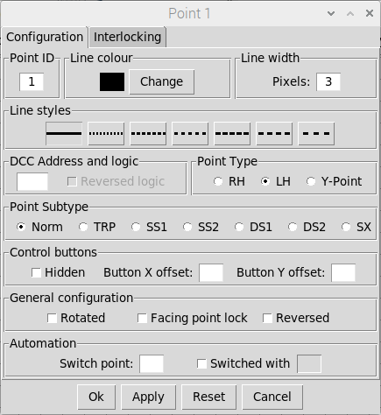
Point subtype selection
(available selections will
Change depending on
Point type selection)
Point Type selection
DCC address of the point
The unique ID for the
Point (no two points
Can share the same ID)
Tabs for the point
Configuration (click on the
required tab to select)
Default colour for the point
Points can be configured to be
‘switched with’ other points. Points can
also be configured to switch other points
(that are configured as ‘switched with’)
Other point attributes

Once you have mastered the basic editor functions, then clear down the schematic (from the Main Menu-bar select File => New) to create a blank canvas.

Quick start example 1 – colour light signals

Drawing your layout schematic
For the Quick Start Example 1, we are going to create a simple layout comprising a single track line serving a small double platform terminus station (with no run round facilities):


Point 1 (left hand point) can be added straight to the layout and moved into the appropriate position. To create point 2, either add another left hand point to the layout or, alternatively, select point 1 (Left Click on the point) and then copy/place (Ctrl-c then move/place). When items are created, they are assigned the next available ‘one-up’ identifier so in this case the added / pasted point will be created as Point 2. Whilst Point 2 remains selected, press the ‘r’ key to rotate by 180 degrees, it can then be moved into position to form the required crossover.
Now add the track lines to the schematic. To add end-stops or arrows to the lines, double-left-click on the line to bring up the line configuration dialog. A different line end style can then be selected and applied to one or both ends. Once the required selection has been made, click the OK button to apply the changes and close the configuration dialog.
Text boxes can be added to annotate the schematic. Once created, double-left click on the ‘Text’ to bring up the configuration dialog and edit the contents. Note that text boxes will always be sized to fit their contents, but padding (extra lines or spaces) can be used if required. In this example, text boxes with padding before and after the text have been used for the two ‘platforms’.
To complete the track layout, we’ll configure the points to switch together and add a facing point lock. Firstly, double-left-click on point 2 to bring up the configuration dialog, set it to be fully automatic and then OK/Apply the changes. Now double-left-click on Point 1, configure it to switch Point 2 and select the facing point lock. We’ll also configure the DCC address we’re going to use to switch the points out on the layout (as both points are switched together, we only need a single address to switch both points). Again, click OK/Apply for the changes to take effect.
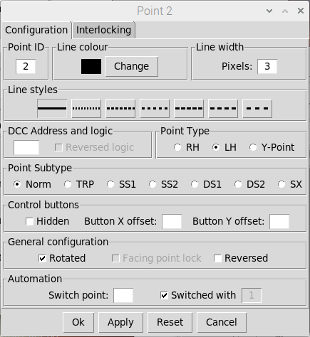
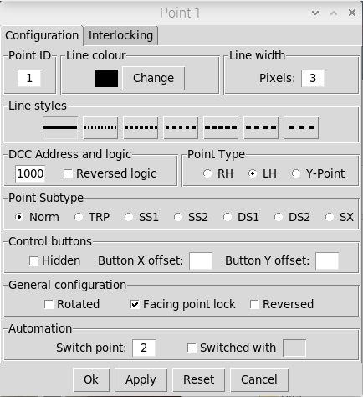
Set Point 2 to be
‘switched with’
Another point
Set Point 1
to Switch
Point 2
Point 1 has a
Facing Point Lock
Point 2 has already been
rotated on the schematic
Set the DCC
Address
Indication that Point 2
is now configured to be
‘switched’ with point 1
(on re-loading window)

The schematic should now look as follows. Point 2 no longer has a control button as it will now be switched with Point 1, and Point 1 now has an additional ‘L’ button for the facing point lock (FPL). When this is active, then the main point control button is ‘greyed out’ and unresponsive. To switch the point, first click on the ‘L’ button to release the FPL. Once the FPL has been released, you can switch the point and then re-activate the FPL to lock the point in the switched position.


Planning your signalling scheme
The next step is to plan your signalling scheme in terms of the possible train movements on the layout. For this example, the main movements we want to signal are:
- Rest of the world => Platform 1
- Rest of the world => Platform 2
- Platform 1 => Rest of the world
- Platform 2 => Rest of the world

We also want to signal the following shunting movements:
- Platform 2 => Siding
- Siding => Platform 2

This planning, together with the knowledge gleaned from our research in the previous section, allows us to define the signals we want to add to the layout and where they should be positioned.

Adding signals to the schematic
Use the buttons on the left hand side of the window to add signals to the schematic and move them into position (rotating as required). The signals are initially created as four aspect but we’ll change them to two aspect as we configure them. Signal 4 will be a ground position (shunting) signal.


To signal the train movements we have defined, we need to edit Signal 1 to provide a route indication (to differentiate between the routes into Platform 1 and Platform2). At the same time, we’ll change it to a two-aspect signal and configure the DCC addresses. As before, double-left-click to bring up the configuration dialog and use Apply or OK to save the changes
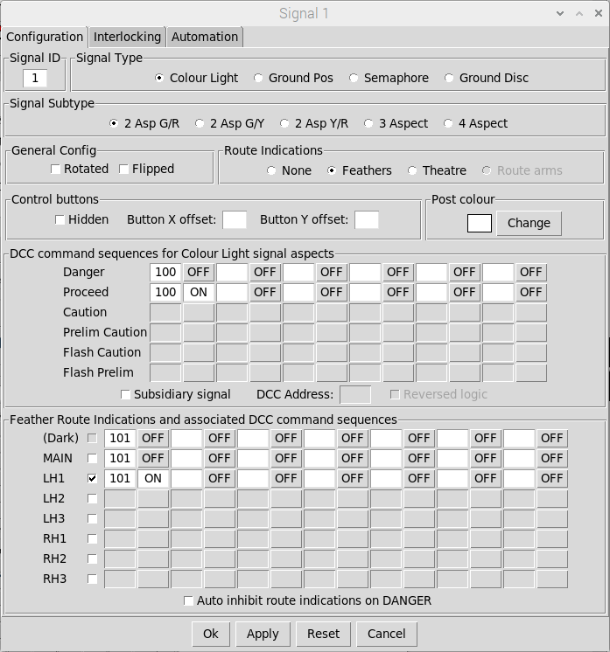
Configure a single
feather indication
For the diverging
Left hand route
Example configuration
for a 2 aspect signal
that uses a single DCC
Address (toggle on/off)
to set the aspect
Change the signal to
Two-aspect (green/red)
The feather for the
diverging route is
controlled (On or Off)
by a single DCC
Address. Note that this
needs to be set Off when
The signal is at Danger
(the ‘Dark’ aspect) and
also set Off when the
Main route is set
Select feathers
to provide the
route indication
No feather is
provided for the
main (default) route

We also need to add a subsidiary aspect to Signal 2 to signal the shunting move from platform 2 into the siding (we’ll also change this one to a two aspect signal and set up the DCC addresses).
Note that we don’t need route indications for Signal 2 as the only route controlled by the main aspect is the departure out to the rest of the world (the MAIN route for this signal). The subsidiary aspect controls the shunting move back into the siding, which is effectively a right hand divergence from the main route (the RH1 route for this signal).
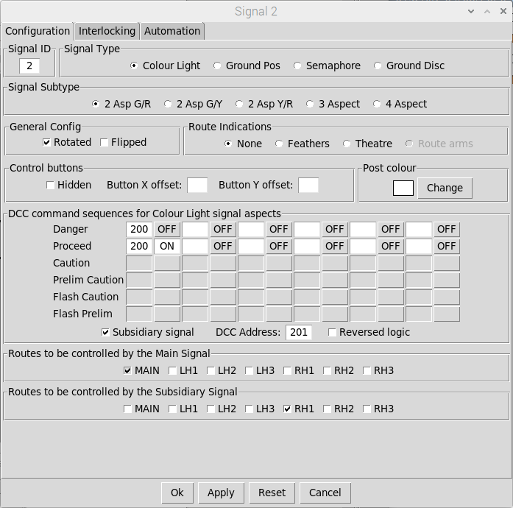
The shunting
Movement back into
The siding is a Right
Hand divergence
From the main route
The 2 aspect signal
uses a single DCC
Address (toggle on/off)
to set the aspect
Change the signal to
Two-aspect (green/red)
The only route
Controlled by the
Main signal aspect
Is out to the rest
Of the world
The subsidiary aspect
Uses a single DCC
address (toggle On/Off)
Select to add a
Co-located
Subsidiary Signal
Tick this box if the
subsidiary requires
Reversed DCC logic

Signals 3 and 5 also need to be edited to change them to two-aspect signals and have their DCC addresses configured. Note that Signal 5 should be configured as a two-aspect Green/Yellow signal to act as the distant signal for our layout (as this is a terminus station, we’ll configure it as a fixed distant when we specify the interlocking later on).
Signal 4 has been created as a shunting signal and only needs to control a single route (back into Platform 2). We therefore only need to specify the DCC addresses to complete the configuration.
Once all signal configurations have been applied, the schematic should look like this:

Distant Signal
Single feather indication is for for Platform 2
(no feather indication for the main route into platform 1)
The subsidiary aspect is for
The RH1 route into the siding

Configuring basic interlocking
The application allows signals to be interlocked with points, conflicting signals, track sections, and block instruments. Initially, we’ll configure interlocking with points and conflicting signals. In this context, ‘conflicting signals’ are any other signals that control a route that would conflict with a route controlled by the signal we are configuring.
All interlocking is defined via the configuration dialog of the appropriate signals. Double-left-click on a signal to bring up the configuration dialog and select the Interlocking tab.

Signal 1
From the schematic on the previous page, Signal 1 needs to be interlocked with Point 1, but there are two possible routes (into platform 1 and into platform 2). To enable Signal 1 to be cleared for the MAIN route (into platform 1), Point 1 needs to be NORMAL. To enable Signal 1 to be cleared for the LH1 route (into platform2), Point 1 need to be SWITCHED. We do not have to interlock the signal with Point 2 as we have already configured this to be ‘switched with’ Point 1.
Each ‘route’ from Signal 1 also needs to be interlocked with any signals that could clear conflicting movements, in this case Signals 2 and 3. Both of these signals only have a single route controlled by the main signal aspect (out to the rest of the world), so we only need to interlock with the MAIN routes controlled by these two signals.
The MAIN route for Signal 1 (into Platform 1) therefore needs to be interlocked with the MAIN route (departing from Platform 1) for Signal 3. Similarly, The LH1 route for Signal 1 (into platform 2) needs to be interlocked with the MAIN route (departing from Platform 2) for Signal 2.
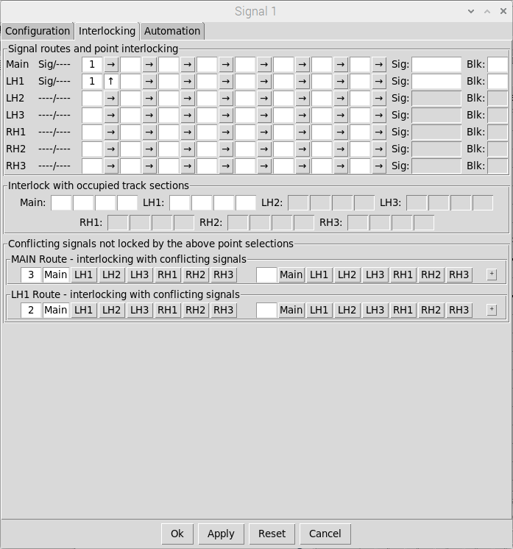
The MAIN route for
Signal 1 into Platform 1
Requires Point 1
to be NORMAL
The LH1 route for
Signal 1 into Platform 2
Requires Point 1
to be SWITCHED
The LH1 route for
Signal 1 into Platform 2
Is interlocked with the
MAIN route for Signal 2
(to rest of the world)
The MAIN route for
Signal 1 into Platform 1
Is interlocked with the
MAIN route for Signal 3
(to rest of the world)
Indication that the
Signal is configured to
Control the 2 Routes
(Main and LH1)
If interlocking with more
Than 2 opposing signals
Is required then click
This button to add
Additional entries

Signal 2
Signal 2 also needs to be interlocked with Point 1, but in this case, the only valid route for the main signal (as opposed to the subsidiary signal) is out from Platform 2 to the rest of the world. Point 1 therefore needs to be SWITCHED to allow Signal 2 to be cleared for the MAIN route.
When Signal 2 was initially configured (see earlier), the subsidiary aspect was configured to allow a shunting move is back into the siding (which is a right-hand diverging route). Point 1 therefore needs to be NORMAL to enable the subsidiary signal to be cleared for the RH1 route.
For the MAIN route (departure from Platform 2 to the rest of the world), Signal 2 needs to be interlocked with the LH1 route of Signal 1. For the RH1 route (back into the siding), Signal 2 needs to be interlocked with the MAIN route of Signal 4.
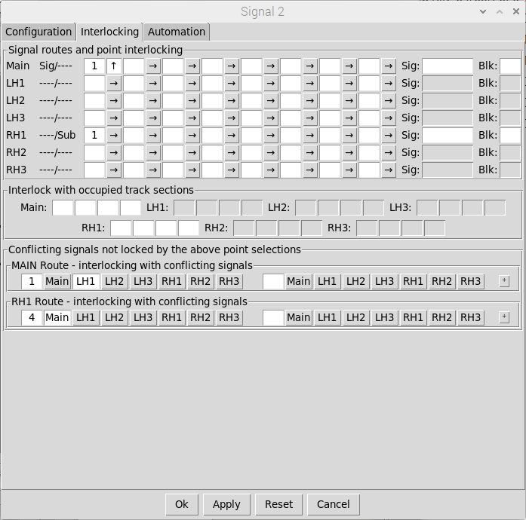
The MAIN route for
Signal 2 to the rest
Of the world requires
Point 1 to be SWITCHED
The RH1 (shunting) route
for Signal 2 back into the
siding requires Point 1
to be SWITCHED
The RH1 (shunting) route
for Signal 2 back into the
Siding is interlocked with
the MAIN route for Signal 4
The MAIN route for Signal
2 to the rest of the world
is interlocked with the
LH1 route for Signal 1
Indication that the
Signal is configured to
Control the the Main
Route and the subsidiary
Is configured to control
The LH1 Route

Signal 3
Signal 3 controls a single MAIN route (from Platform 1 out to the rest of the world) which needs to be interlocked with Point 1 (Point 1 needs to be NORMAL to allow Signal 3 to be cleared). The signal also needs to be interlocked with the MAIN route of Signal 1.
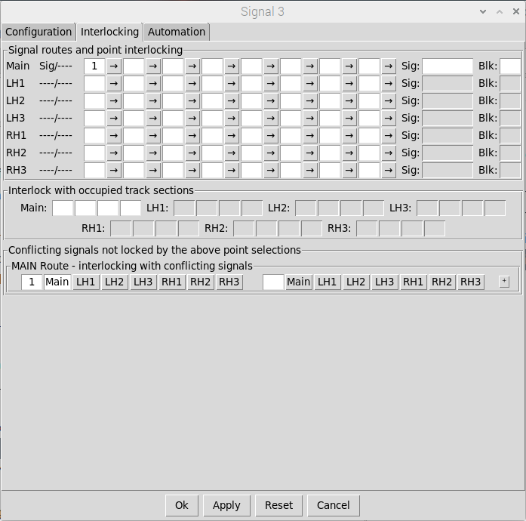
The MAIN route for
Signal 3 to the rest
Of the world requires
Point 1 to be NORMAL
The MAIN route for
Signal 3 to the rest
Of the world Is
Interlocked with the
MAIN route for Signal 1

Signal 4
Signal 4 controls a single shunting route (from the siding to Platform 2) which needs to be interlocked with Point 1 (Point 1 needs to be NORMAL to allow Signal 4 to be cleared). The signal also needs interlocking with the RH1 route of Signal 2 (the shunting route into the siding).
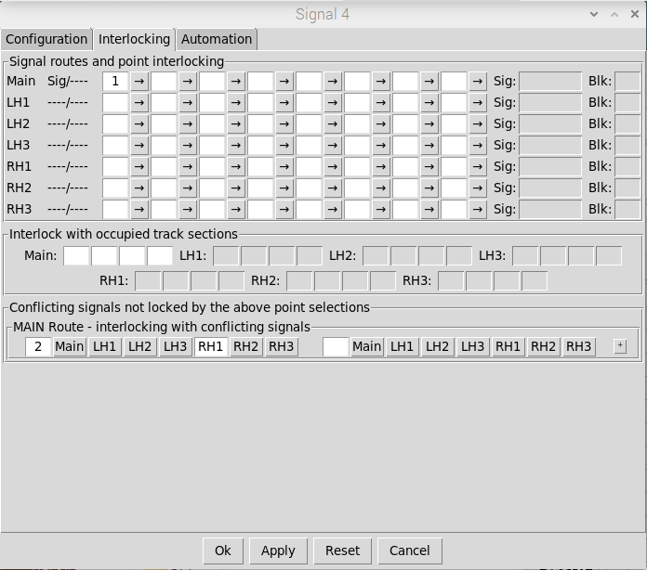
The MAIN route for
Signal 4 into Platform 2
requires Point 1
to be NORMAL
The MAIN route for
Signal 4 into Platform 2
is interlocked with the
RH1 route for Signal 2

Signal 5
As mentioned earlier, Signal 5 will be configured as a ‘fixed distant’. In this case we can just pick any point and configure the signal such it is only unlocked when the point is both SWITCHED and NORMAL (which can never happen, meaning the signal is always locked at Caution).
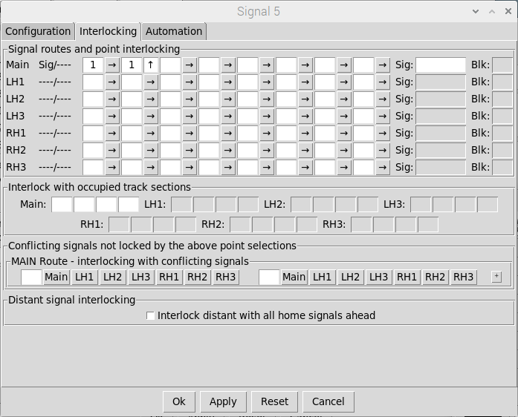
The MAIN route for
Signal 5 requires Point 1
to be both NORMAL
and SWITCHED
For ‘through’ layouts
(where we don’t require
the distant to be fixed at
CAUTION), the distant
signal can additionally be
locked with all Home
signals on the route ahead

Testing basic interlocking
Once configured, the basic interlocking can be tested. If a signal or point is ‘locked’ then the associated control buttons will be ‘greyed out’ and unresponsive.
Firstly, ensure the layout is in a default state by selecting Mode => Reset from the Main Menubar and selecting OK in the pop-up dialog to confirm. This will reset all signals to ‘ON’ and reset all points to NORMAL with their Facing Point Locks (FPLs) ACTIVE.
Signal 5 will be locked as we configured this as a ‘fixed distant’. The main aspect of Signal 2 will also be locked as the route controlled by this signal is out from Platform 2 to the rest of the world and the points are currently set back into the siding. The subsidiary aspect of signal 2 (controlling the shunting route back into the siding) will be unlocked.

Signal 2 main aspect locked
Signal 2 subsidiary aspect unlocked
FPL Active (‘L’ Button)
Signals 5 (fixed
Distant) locked

In this state, the interlocking with conflicting signals can be tested. If Signal 4 is switched ‘OFF’ then the subsidiary aspect of Signal 2 will be locked, and vice versa. Similarly, if signal 1 is switched ‘OFF’ then Signal 3 will be locked, and vice versa. Note that when a signal is set to ‘OFF’ the points are locked and cannot be changed until the signals are returned to ‘ON’.

Signal 4 is OFF
Signal 3 is Locked
Subsidiary Signal 2 is Locked
Signal 1 is OFF
Point 1 is Locked

Once all signals have been returned to ‘ON’ then the points can be changed to test the other signal routes. Click on the ‘L’ button to ‘release’ the Facing Point Lock (FPL) and enable the main point control button. The point can then be switched .
Note that as soon as the point FPL is ‘released’ then Signals 1, 2, 3 and 4 will be locked, to prevent a train movement being cleared ‘through’ the points, and will remain locked until the point FPL is ‘reactivated’ (after the points have been switched).
Once Point 1 has been switched (and the FPL re-activated) the layout should be as follows:

Point 1 switched
with FPL active
Signal 3 locked (no route)
Signal 4 locked (no route)
Signal 1 unlocked
Signal 2 main aspect unlocked
Signal 2 subsidiary aspect locked

The interlocking with conflicting signals can now be tested in this configuration. If signal 1 is set to ‘OFF’ then Signal 2 will be locked and vice-versa. Note that when Signal 1 is ‘OFF’ it will display the appropriate route indication (in this case a left hand feather).

Signal 1 cleared for Platform 2
Signal 2 locked
Point 1 locked

Although interlocking is defined via the signal configuration dialog , the resultant Point interlocking can be viewed (as read only) via the Interlocking tab of the point configuration dialog. This shows all the signals/routes which (when cleared for a movement) would lock the point.
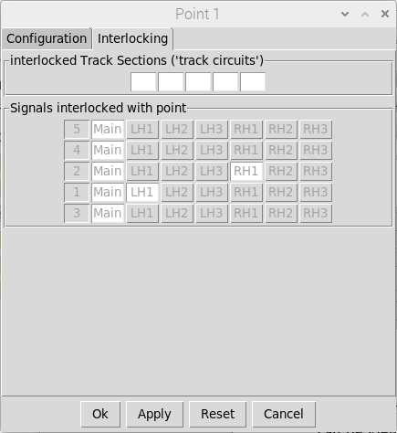
Point 1 is additionally
Interlocked with the
RH1 route of signal 2
(Platform 2 => Siding)
Point 1 is interlocked
with the MAIN route
of all other signals
Point 1 is additionally
Interlocked with the
LH1 route of signal 1
(Into Platform 2)
We’ve used Point 1 to ‘lock’ Signal 5
at caution (to make it a fixed distant).
This means it can never be cleared
so will never be able to lock Point 1

Configuring the DCC bus output
Once you are happy with your layout configuration you can ‘lock’ the schematic to prevent further editing by setting RUN mode. Either use the keyboard shortcut to toggle into RUN Mode (Cntl-a) or select via the Menu-bar (Mode => Run). This also removes the grid lines and the schematic object buttons down the left hand side of the window.
If you are running the application on a Raspberry-Pi with a Pi-SPROG DCC programmer controller then controlling the signals and points out on the layout is simple.
- Select SPROG => Connect from the Menu-bar. If connection is successful then the Menu-bar will show a SPROG status of CONNECTED and the Menu-bar DCC Power selection will be enabled.
- Select DCC Power => ON from the Menu-bar to enable DCC Power. If the power was successfully enabled then the Menu-bar will show a DCC Power Status of ON.
The default configuration should work ‘out of the box’ for the Pi-SPROG 3 v2 (as long as it has been installed correctly following the instructions provided). If you are using an earlier Pi-SPROG then the baud rate will need reducing - Menu-bar => Settings => SPROG )

RUN Mode
SPROG is CONNECTED with
DCC Power to the Accessory Bus ON

All changes you make to signals or points in the application will now send out the required DCC commands to change the signals and points on the layout accordingly.
Note that the state of the signals and points on the layout may not initially reflect the state of the points and signals shown in the application. To synchronise everything you may need to operate each signal or point on the schematic in turn - to send out the required DCC commands to set the initial state of the signals and points on your layout.

Alternatively, you can save and re-load the layout with the SPROG set to auto connect and apply power on layout load. The application will then send out the required DCC commands to synchronise your physical layout with the loaded state of your schematic. This can be configured via the SPROG settings dialog (from the Main Menu-bar select Settings => SPROG):

Select these two checkboxes
Prior to saving the layout to enable
Automatic connect/power on on
Next layout load (this will then
Automatically send out the required
DCC commands to synchronise
Your layout with the application
You may need to apply an address
Offset to all DCC commands sent
Out if transitioning from another
DCC system that uses an
Offset addressing mode

When transitioning from other DCC systems to this application (or swapping between the two) you may find that the DCC commands sent out to the accessory bus (by this system) don't align with the DCC addresses you have previously programmed for your accessories (with your other system).
The reason for this is that some DCC equipment manufacturers have interpreted the NMRA DCC Specification slightly differently, specifically how DCC addresses are encoded into the DCC packet.
If all works as expected then the default setting (No Offset) can be left selected. If you experience a discrepancy in the addressing then you should select either '+4' or '-4' as appropriate (click on the extended help button for more information on address offsets).
If you are still having problems, then you can change the application logging level to DEBUG to see what’s going on ‘under the hood’. This can be configured via the Logging settings dialog (from the Main Menubar select Settings => Logging and then select the required level
A typical log output (in the Terminal window) would be:

Log Messages showing DCC commands
Being sent out by the application

Configuring track occupancy
Now we have a schematic that provides basic interlocking of signals / points, and DCC control of the signals and points out on the layout. The next step is to add ‘track sections’ to provide a ‘mimic’ diagram of where the trains are on your layout.
Firstly (in EDIT mode), add ‘track sections’ to the schematic and position them accordingly. Track sections should be provided for all positions a train could occupy within the signalling scheme. In this case, trains could occupy Platform 1, Platform 2, the Siding, the section of track between the distant and home signals and the ‘fiddle yard’. For this example we’re going to represent a ‘cassette’ fiddle yard, so we’ll also add track sections to represent the other cassettes.
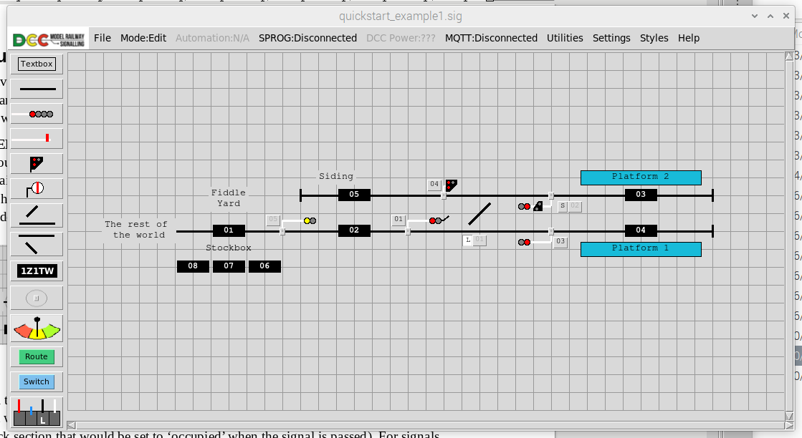
Track Sections

Each signal then needs to be edited to define the track section ‘behind’ the signal (i.e. the track section that would be ‘cleared’ when the signal is passed) and the track section ‘ahead of’ the signal (i.e. the track section that would be set to ‘occupied’ when the signal is passed). For signals controlling multiple routes, the track section ‘ahead’ needs to be defined for each route. This configuration is defined via the Automation tab of the signal configuration dialog.
Signal 1 controls two routes (into platform 1 and into platform 2) so the configuration would be:
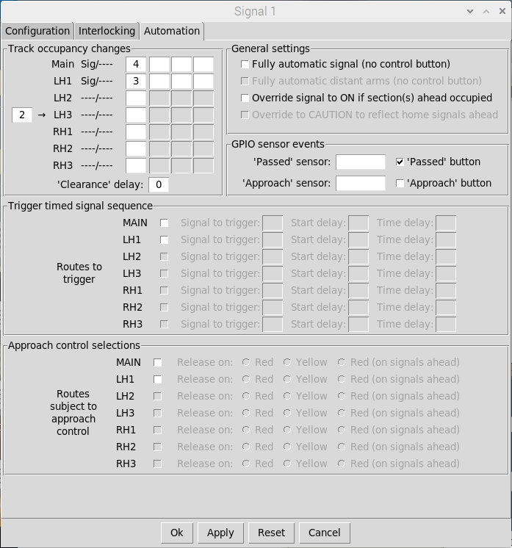
Section 2 will be
CLEARED when
Signal 1 is passed
in the direction
of travel
Section 4 will be
OCCUPIED when
Signal 1 is passed
With the route into
Platform 1 set
Section 3 will be
OCCUPIED when
Signal 1 is passed
With the route into
Platform 2 set
Indication that the
Signal is configured to
Control the the Main
and LH1 Routes
If required, you can
specify a delay
(in seconds) between
the signal being
Passed and the track
Occupancy change
Ensure this remains
selected to create a
‘passed’ button at
the base of the
Signal to facilitate
Testing Occupancy
changes

Signal 2 similarly controls two routes (the MAIN route from platform 2 out to the rest of the world and the RH1 shunting route from platform 2 back into the siding) so the configuration would be:
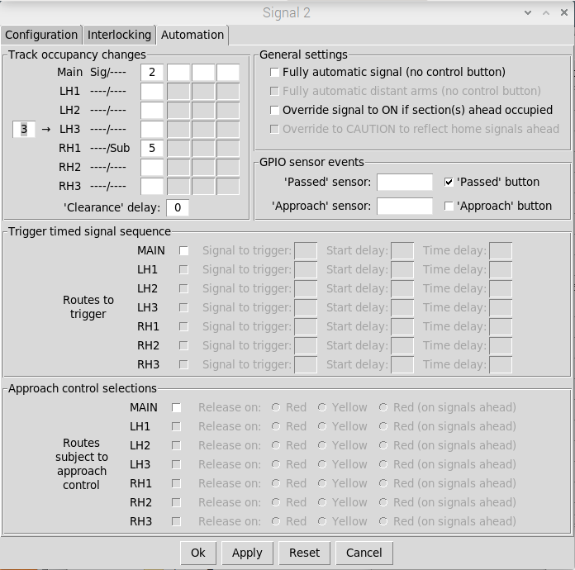
Section 3 will be
CLEARED when
Signal 2 is passed
in the direction
of travel
Section 2 will be
OCCUPIED when
Signal 2 is passed with
the (main signal) route
set to the fiddle yard
Section 5 will be
OCCUPIED when
Signal 2 is passed with
the (subsidiary) route
set into the siding
Indication that the Main
Signal is configured to
Control the the Main
Route and the subsidiary
Signal is configured to
Control the RH1 route

All other signals control a single (MAIN) route, so the configuration is straightforward:
- Signal 3 – Section behind is Section 4, Section Ahead is Section 2
- Signal 4 – Section behind is Section 5, Section Ahead is Section 3
- Signal 5 – Section behind is Section 1, Section Ahead is Section 2

Once the sections ‘ahead of’ and ‘behind’ each signal have been defined, the resultant configuration of each track section can be viewed (as read only) via the Automation tab of the relevant track section configuration dialog. This shows the signals/routes that provide access into the section, and the signals/routes that control access out of the section.
As an example, for Section 3 (Platform 2), there are 2 signals that provide access into the section, the MAIN route from signal 4 (from the siding into Platform 2) and the LH1 route from Signal 1 (from the rest of the world into Platform 2). There are also two routes out of the section (into the siding or out to the rest of the world), both of which are controlled by signal 2 (MAIN and RH1).
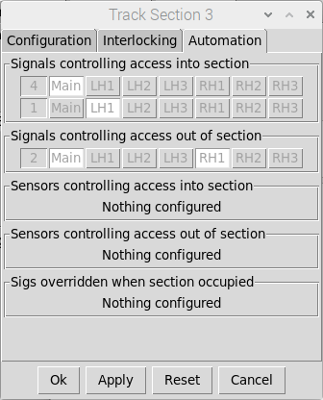
Signal 2 MAIN Route - out to the rest of the world
Signal2 RH1 route – back into the siding
Signal 4 MAIN Route - from the siding
Signal 1 LH1 Route - from the rest of the world

Testing track occupancy
Once all signals have been configured, track occupancy can be tested (in RUN mode). Although we haven’t configured any external GPIO sensors yet, the ‘signal passed’ events to trigger track occupancy changes can be simulated by clicking on the small buttons at the base of each signal.
On entering RUN mode, all track sections will initially show as CLEAR. To set up the initial track occupancy, right-click on a track section and enter an appropriate train designator. Once entered, this will set the track section to OCCUPIED (white text on a black background). Track sections can also be toggled between OCCUPIED and CLEAR by left-clicking on them.
We’ll first set up the trains in our cassette fiddle yard. We’ll use designators of ‘HST1’, ‘HST2’ and ‘DMU’ to keep things simple (although for your layout you can use any designators you want).
Note that if you want to use longer train designators then you can globally adjust the width of the track section objects via the ‘styles’ menubar item (from the Main Menubar select Styles => Track Sections) to bring up the available options.


Right-click to enter a train
Designation code and set the
track section to OCCUPIED
Other track sections
remain CLEAR

We can then choose the next train we want to run on the layout run into the layout by ‘dragging and dropping’ its designator from it’s ‘stock-box’ Track Section to the fiddle-yard entry/exit Track Section (left-click => move => left-release).

Drag and drop HST1 from the stock box
to the fiddle yard departure section

To simulate a train movement from the Fiddle yard into Platform 2, first configure the route into platform 2 (ensure all signals are ‘ON’, release the FPL for point 1, switch the point and then re-activate the FPL and then clear the route by setting Signal 1 to ‘OFF’).


Route set and cleared from the
Rest of the world into Platform 2
Route set and cleared from the
Fiddle Yard into Platform 2

Next, trigger a ‘signal passed’ event for Signal 5 by left-clicking on the small button at the base of the signal to ‘pass’ the train onto the next track section.

Click on the button to simulate
A ‘signal passed’ event
Next Track Section
Is now OCCUPIED
Track Section
Is now CLEAR

Finally, trigger a ‘signal passed’ event for Signal 1 to ‘pass’ the train into Platform 2 and then a ‘signal passed’ event for Signal 2 (as this signal will also be passed by the train as it heads into Platform 2) – Note that this second event will not trigger a change the track occupancy (the software recognises the signal is controlling a movement in the other direction)

Click on the button to simulate
A ‘signal passed’ event
Track Section
Is now CLEAR
Next Track Section
Is now OCCUPIED

At completion of the train movement, all signals should be returned to ‘ON’, ready for the next movement. Other movements you could test would be:
- Platform 2 back into the siding
- From the siding into Platform 2
- Platform 2 to the Fiddle Yard
- Fiddle Yard to Platform 1
- Platform 1 to the Fiddle Yard

Automating signals based on track occupancy
Once we have proved that we have correctly configured track occupancy for the schematic, we can now automate the signals such that they are overridden to DANGER once a train has passed (and will remain overridden to DANGER as long as the Track Section ahead is occupied).
In EDIT Mode, Double-left-click on Signal 1 to bring up the configuration dialog and select the Automation tab. Then select the ‘Override signal to on if section(s) ahead are occupied tab’.
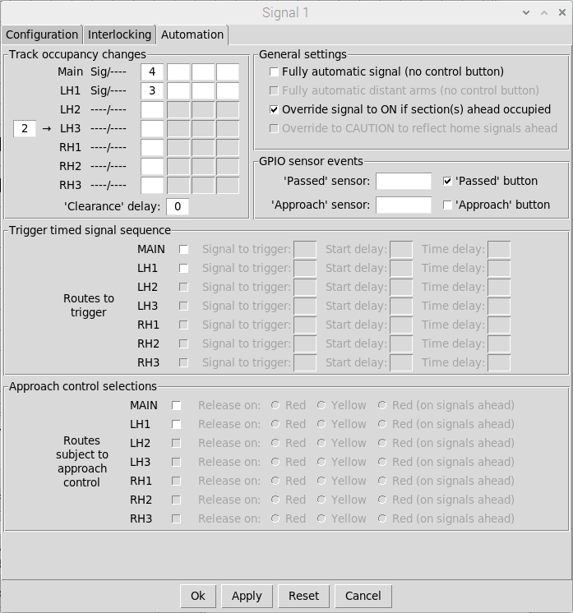
With Override selected, the signal
will be ‘overridden’ to DANGER
if the track section ahead s
OCCUPIED. This will either
Be Section 4 or Section 3
Depending on the Signal Route

Signals 2 should then be similarly configured, but for these this signal, we also need to take into account the Fiddle Yard entry/exit track section. This Track Section (Track Section 1) should be added to the list of track sections ahead of the signal for the MAIN route:
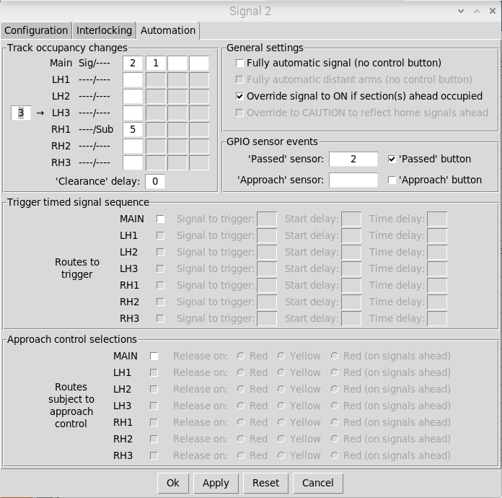
If Signal 2 is set for the MAIN route
Then the signal will be ‘overridden’
To danger if either of the Track
Sections ahead is OCCUPIED

Finally Signal 3 should be configured to be overridden on track sections ahead, also taking into account the Fiddle Yard entry/exit track section. We don’t need to configure Signal 5 as this is a ‘fixed distant’. We also don’t need to configure Signal 4 as this is a shunting signal.
Now when we run trains through the layout to test the track occupancy, the signals will automatically change to DANGER to reflect the passing of the train:

Platform 2 is OCCUPIED
Although Signal 1 is still ‘OFF’ as far as the
Manual control button is concerned, it is
now Overridden to DANGER as the Track
Section on the route ahead is OCCUPIED

Enabling Signal Passed At Danger (SPAD) warnings
As per the ‘real thing’, it is the driver’s responsibility not to pass a signal at danger (the Signalling application doesn’t provide automatic train control), but if you want to shame the drivers then the application can be configured to generate popup Signal Passed At Danger (SPAD) warnings
This is configured via the general settings dialog (from the Menu-bar select Settings => General) :
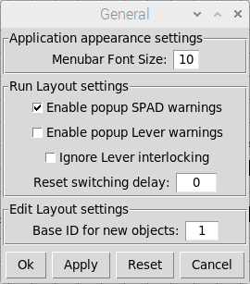
Check Box and click OK or APPLY
to enable popup SPAD warnings

Now, each time a train passes a signal at danger, a popup window will appear with details of the event. If the popup window is left open then subsequent SPAD events will be added to list. If the list gets too long (bad drivers) then the list can be cleared down or the window closed.

Pop up SPAD warnings

Using external sensors to drive track occupancy
The benefit of using the Raspberry-Pi is that we can connect external sensors into the GPIO ports of the Raspberry-Pi and use them to trigger the ‘signal passed’ events.
Firstly, we need to define the physical GPIO pins we want to use for each GPIO sensor. To do this, open the GPIO Sensors window by selecting Settings => GPIO from the Main Menubar. Individual ‘GPIO sensors’ can then be associated with each of the GPIO ports.
Note that only a subset of GPIO ports are available for use by the signalling application. Never connect external sensors to the unsupported GPIO inputs (1, 2, 3, 14, 15, 16, 17)
For this example, we’ll allocate ‘GPIO sensors’ to each signal, matching the numbering of each signal. To do this, just enter a unique identifier for the ‘GPIO sensor’ against the required GPIO port (this identifier will be the identifier we will use when subsequently configuring the signals). We have a total of 5 signals so need to allocate a total of 5 Sensors, each mapped to a GPIO port.
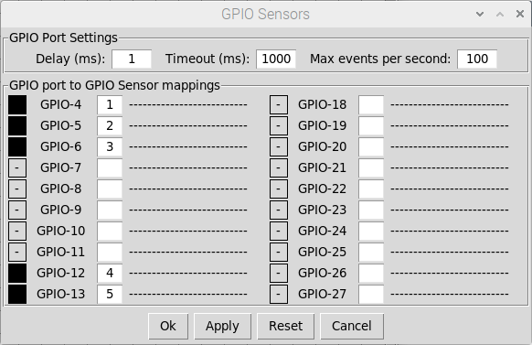
A trigger on GPIO port 4
Will trigger “GPIO Sensor 1”
A trigger on GPIO port 5
Will trigger “GPIO Sensor 2”
Etc
A trigger on GPIO port 6
Will trigger “GPIO Sensor 3”
Port
Strtus

Each signal then needs to be configured to use a GPIO Sensor to generate the ‘signal passed’ event. This configuration is defined via the Automation tab of the signal configuration dialog.
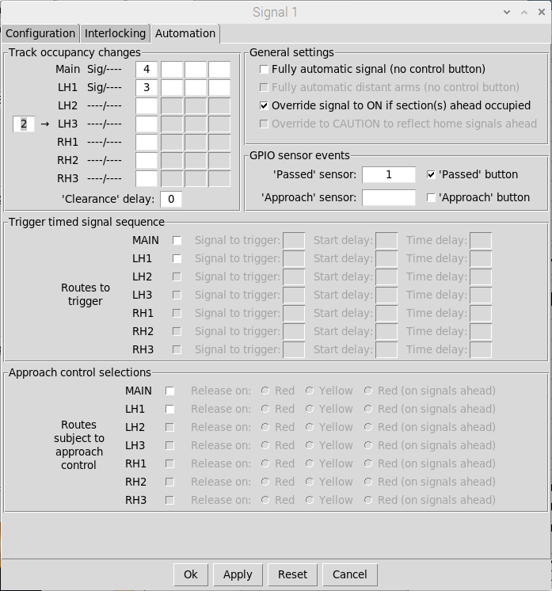
Map each signal to its
Associated GPIO sensor
(Signal 1 => Sensor 1 etc)

Once all signals have been mapped to their associated GPIO sensors, ‘signal passed’ events will be triggered whenever the associated GPIO port is connected to 0V.
Normally Open (closed when triggered) sensors can therefore be connected directly between the appropriate GPIO input pin and a 0V DC pin (available on the GPIO header).
Note that other sensor types (providing a switched voltage) should never be connected directly to the GPIO pins as this could damage the Raspberry-Pi. In these cases, external opto-isolators are recommended to protect the GPIO input pins.
Re-opening the GPIO settings window will now display all Signal mappings to provide an overview of the GPIO sensors (and GPIO Ports) used in the layout configuration.

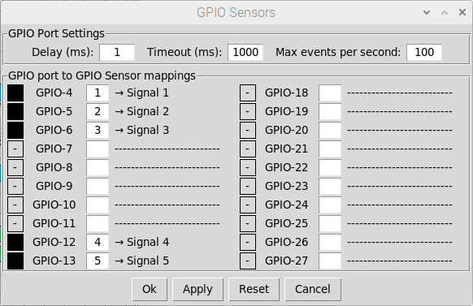
A trigger on GPIO port 4
Will trigger “GPIO Sensor 1”
Mapped to Signal 1
A trigger on GPIO port 5
Will trigger “GPIO Sensor 2”
Mapped to Signal 2
A trigger on GPIO port 6
Will trigger “GPIO Sensor 3”
Mapped to Signal 3
Etc

Configuring interlocking with occupied track sections
So far, we have configured interlocking, track occupancy and signal automation (based on track occupancy), but it is still be possible for signals to be set to ‘OFF’ if the Track section(s) ahead OCCUPIED (although they would still be OVERRIDDEN to DANGER assuming we have configured the automation correctly as per the previous sections).

Track Section is OCCUPIED
Signal 3 is still Unlocked so
Could be changed to OFF

To rectify this, we can also interlock signals with OCCUPIED Track sections. In this case we want to Interlock Signal 3 with Track Section 2 and also Track Section 1 (representing a train already on the single line to/from the rest of the world). To configure Track Section interlocking, open the signal configuration dialog (in EDIT mode) and select the Interlocking Tab.
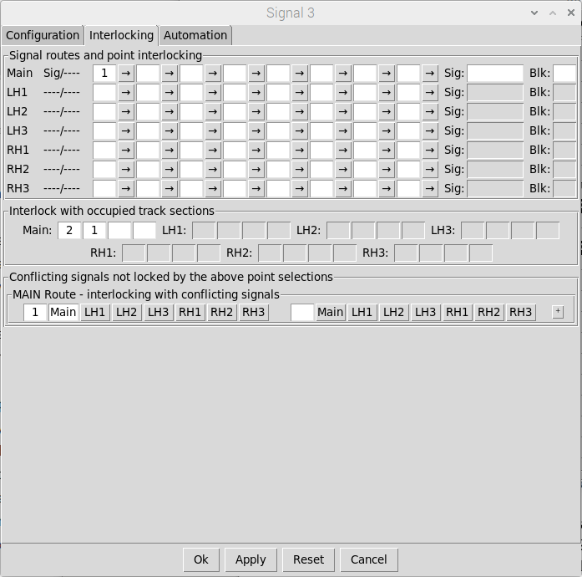
The MAIN route for Signal 3
will be locked (at DANGER)
If Track Section 1 or Track
Section 2 is OCCUPIED

Signal 1 will now be locked (at ‘ON’) whenever Track Section 1 or 2 is OCCUPIED. Note that if a signal is ‘OFF’ when a Track Section becomes OCCUPIED then it will only be locked when returned to ‘ON’ (signals must always be capable of being returned to DANGER).

Track Section is OCCUPIED
Signal 3 is Now Unlocked so
Cannot be changed to OFF

Other signals should be similarly configured to complete the interlocking schema. For example, signal 2 should be interlocked with Track Sections 1 and 2 for the MAIN route (out to the rest of the world) and Track Section 5 for the RH1 route (back into the siding).
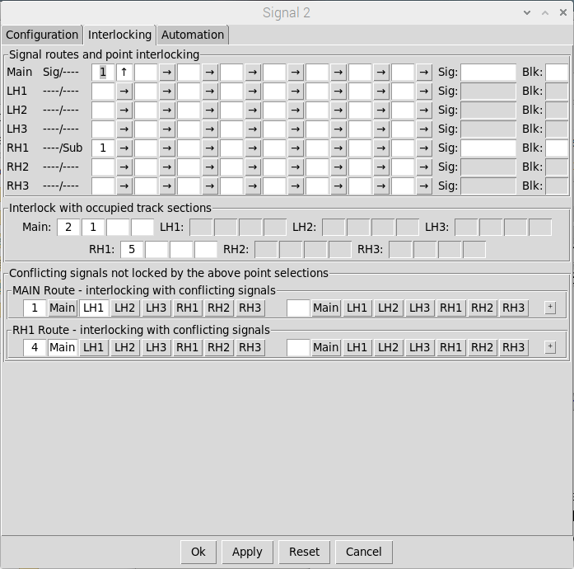
The MAIN route for Signal 2
will be locked (at DANGER)
If either of the Track sections
Out to the rest of the world
Are OCCUPIED
The RH1 route for Signal 2
will be locked (at DANGER)
If The Track Section for the
Siding is OCCUPIED

Once all signals have been configured, the interlocking of signals with Track Sections can be viewed via the Interlocking tab of the Track Section configuration dialog (read only).
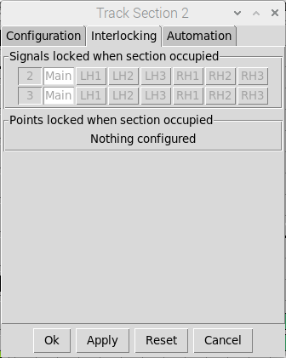
The MAIN routes for Signal 2
and Signal 3 will be locked
When Track Section 2
Is OCCUPIED

Configuring ‘one-click’ route setting
If you’ve followed the previous sections then you should now have a fully interlocked layout, with automatic passing of trains between track sections as they move through the layout.
However, setting up routes through your layout might be time consuming (especially for complex, larger layouts), so if you’d rather concentrate on keeping the trains moving, you might want to use ‘route buttons’ to simplify layout operation. These enable you to automatically set up and clear down routes through your layout with a single click of the mouse.
For this example, we’re going to take the basic layout from the previous section and configure four ‘one-click’ route buttons, one for each of the main movements into and out of the layout:
- Route 1 - The rest of the world to Platform 1
- Route 2 - The rest of the world to Platform 2
- Route 3 - Platform 1 to the rest of the world
- Route 4 - Platform 2 to the rest of the world
We’re also going to use intermediate ‘track sensors’ to automatically clear down routes when the train has cleared all signals and points along the route.
Firstly (in EDIT Mode), add the ‘track sensors’ to the schematic to signify the ‘end’ of each route. Route 3 and Route 4 share the same end-point (the rest of the world), so you only need to add three track sensors to cover all four routes. You might have to slightly re-jig the schematic from the previous section to make room for the track sensors.
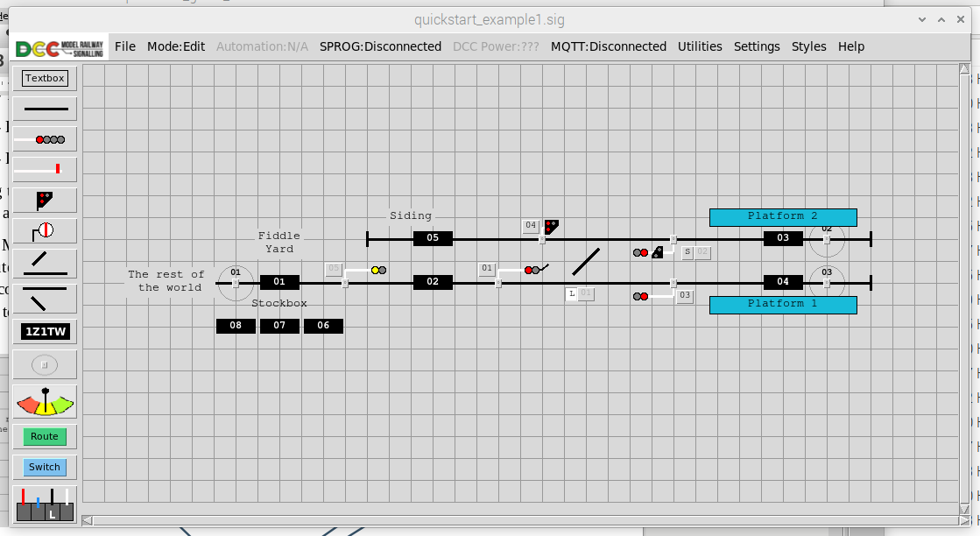
Track Sensor Objects
Button to add
Track Sensors

Note that we are going to refer to the ‘track sensor’ IDs in the route configuration, so make sure you put them in the right place (track sensor 1 going out to the rest of the world, track sensor 2 at the end of platform 2 and track sensor 3 at the end of platform 1).

For the next step, add 4 ‘route buttons’ to the schematic (which we are going to use to set up and clear down the routes through our layout routes).
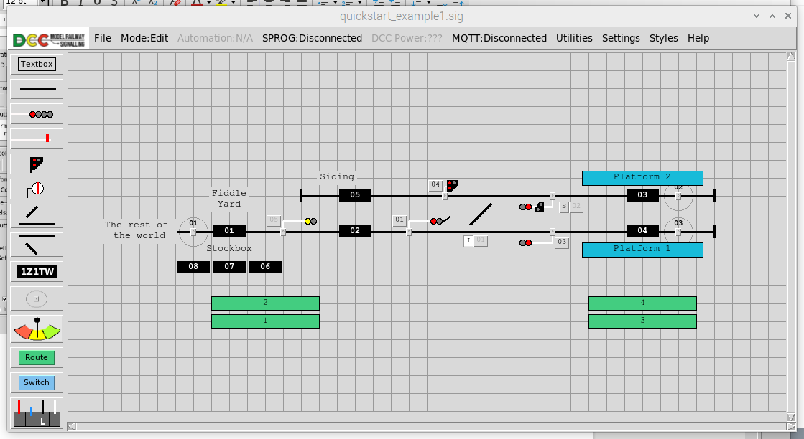
Button to add
Route Buttons
Route Button Objects

Basic configuration of each route is relatively straightforward in that we just need to define the required point settings for the route and list the signals that need to be cleared. We don’t need to worry about point 2 as this is automatically switched with Point 1.
- For Route 1 (into platform 1), we need Point 1 to be ‘normal’ and Signal 1 to be cleared
- For Route 2 (into platform 2), we need Point 1 to be ‘switched’ and Signal 1 to be cleared
- For Route 3 (from platform 1), we need Point 1 to be ‘normal’ and Signal 3 to be cleared
- For Route 3 (from platform 2), we need Point 1 to be ‘switched’ and Signal 2 to be cleared

Defining the highlighting of the route is slightly more complicated in that we need to specify all points and lines which need to be highlighted (in a different colour) when the route is set. This includes any automatic points along the route.
The ID of manually operated points is shown on the control button. To find the ID of lines and automatic points you can either double click on each object in turn to bring up their configuration windows (which shows the ID) or alternatively toggle display of IDs on the schematic (in Edit Mode) by pressing <cntl-i>:
The route configuration on the next page assumes the following:
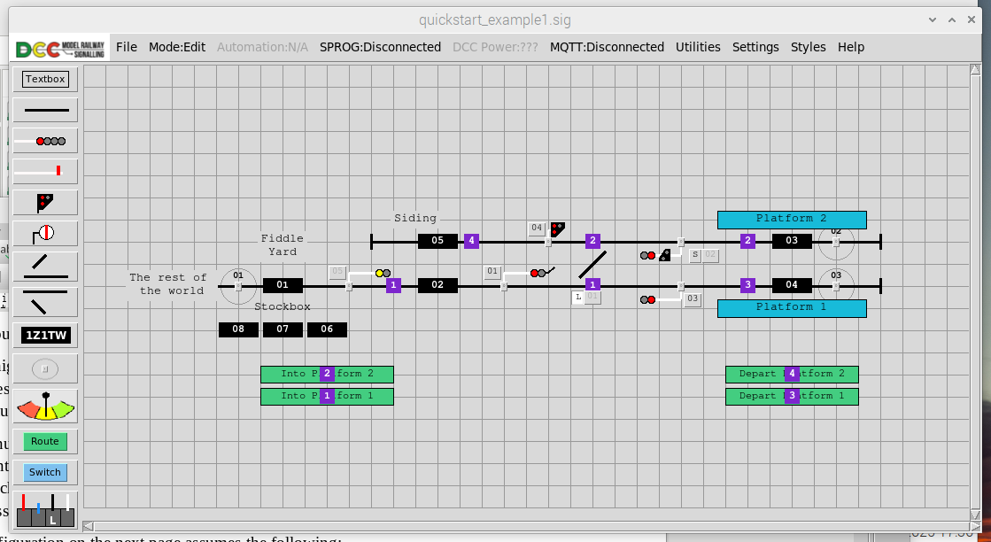
Line ID = 1
Line ID = 3
Line ID = 2
Point ID = 2

To configure a Route, double click on the button (in EDIT Mode) to bring up the Route’s configuration window. For this example we’re going to configure all routes with:
- A switching delay of 1 second (1000 milliseconds) – this will be the time delay between each layout change that needs to be made in order to set up or clear down the route – e.g unlocking a FPL, changing a point, re-locking the FPL, changing a signal etc.
- Automatic clear-down of routes (when the track sensor at the end of a route is triggered).
- Reset of points back to their default (un-switched) state when a route is cleared down rather than leaving them in their switched states.
The first Route we are going to set up is Route 1 (into platform 1 from the rest of the world):
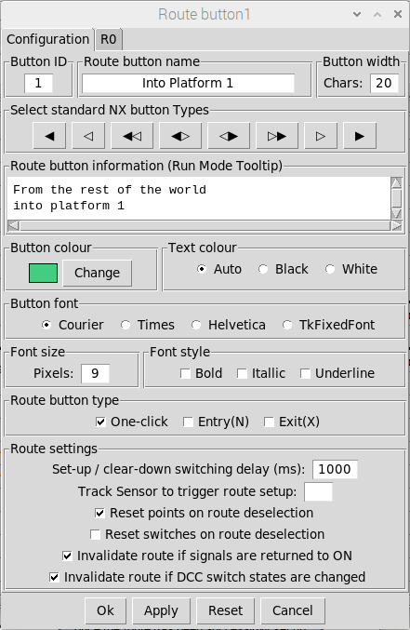
The name that will
appear on the Button
The description that
will appear when you
hover the cursor over
the button in RUN Mode
Points can either be left
‘as is’ when a route Is
cleared down or reset
to their default state.
Track sensors can also
be used to trigger ‘one-click’
route setup if required
The delay between each
Change for route set up
and route clear down
This will be a ‘one-click’
Route button (NX buttons
are covered in a later section
The route will be cleared
down if any signals
along the route are
manually changed
The Configuration Tab
is used to define the
key characteristics
of the route

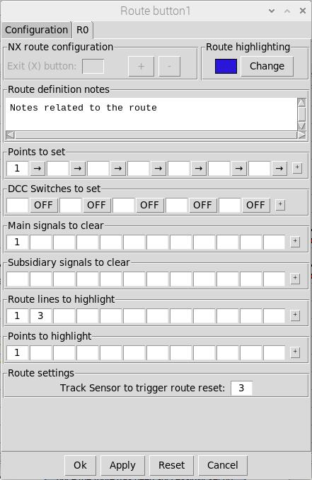
The list of points to
set/lock for the route
and their required state
(normal or switched)
These are the route lines
that will be highlighted
once the route has been
successfully set up
These are the points that
will be highlighted once
the route has been
successfully set up
The list of signals to
clear for the route
The ID of the track sensor
that (when Triggered)
will clear down of the route
The colour that will be used
To highlight the route once
It has been set up
A space to record any notes
About the route configuration
The Second Tab
is used to define the
Route itself

Once you are happy with the configuration click on OK to save it and then similarly configure the other 3 routes, starting with the departure route from platform 2:
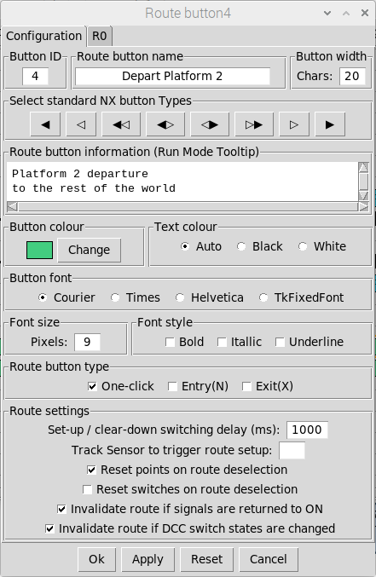
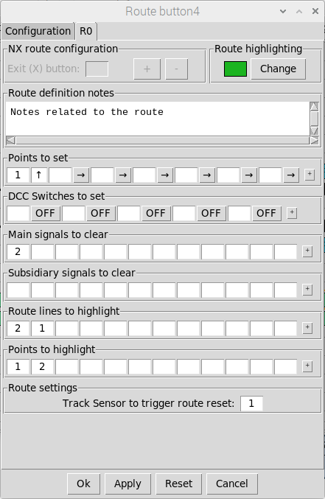
We’ll use a different colour
for the departure routes to
differentiate them from
the arrival routes
For the Platform 2 departure route,
we need to highlight both points
(the one we need to switch and the
automatic point switched with it)
Point 1 needs to be
switched for the
Platform 2 departure route
The basic configuration will be
the same for all route buttons.
Only the button name and
Tooltip text need to be changed

Once the remaining two routes have been configured, they can then be tested in Run Mode:
First, click on the Route 2 button (Into Platform 2) and watch the points and signals being changed in sequence to set up the route. Once the route has been successfully set up it should be highlighted:
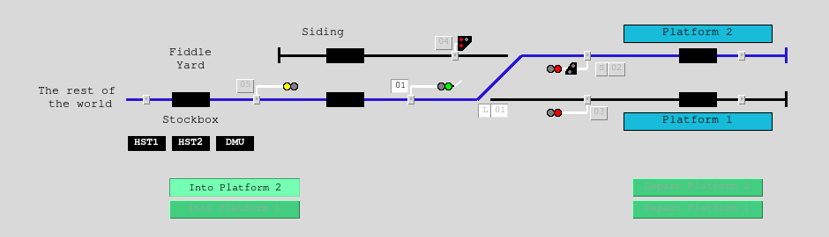
Other Routes are ‘locked’
and cannot be selected
Route
set up

Note that (assuming you have configured interlocking correctly following the previous sections of this guide), the other route buttons will be ‘locked’. If you hover the cursor over these buttons, a ‘tool tip’ will appear to tell you why the route button is ‘locked’.
Routes can be cleared down by either deselecting the route button or triggering the track sensor at the end of the route. The signals will revert to ON and the points along the route will change to their default (un-switched) states. Each change is sequenced in a similar fashion to the route set up.
Once the route has been cleared down then it will be un-highlighted (revert to the default point/line colours) and the other route buttons re-enabled ready for you to set up the next movement.
De-select the Route button to
manually clear down the route or
Click on the track sensor to
automatically clear down the route

Note that if you make any changes that invalidate a route that has been successfully set-up (for example, changing signal 1 back to DANGER), the route highlighting will be immediately cleared down (to show the route has been invalidated), any other signals or points along the route will be reset to their default state (ON) and points will be changed back to their default state (if this option is selected for the route).
Full interlocking (assuming you have configured it correctly) is preserved. For example, if you have set up a movement from the siding back into Platform 2 (point 1 un-switched and Signal 4 cleared) then the routes into and out of Platform 2 will be ‘locked’.
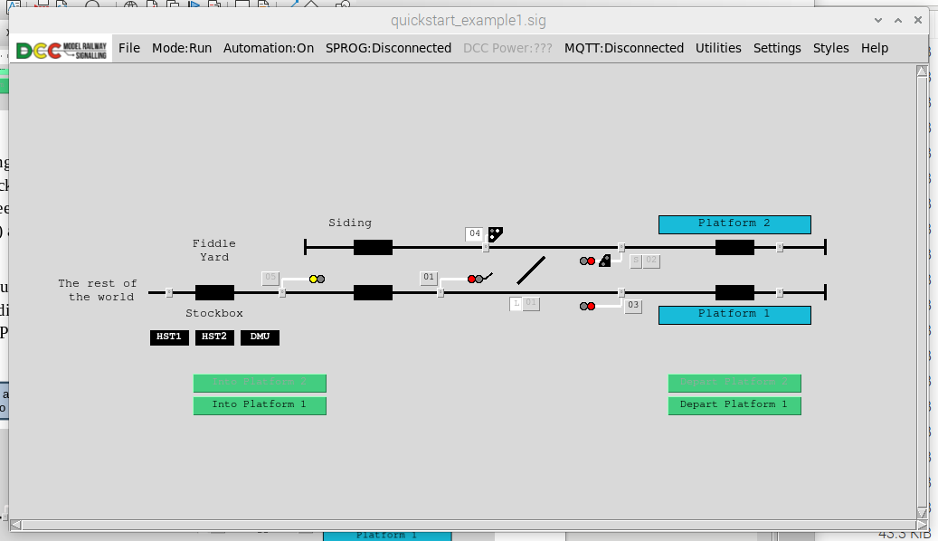
Signal 4 cleared for a movement
From the siding into Platform 2
Routes 2 and 4 ‘locked’ as
Point 1 s locked by Signal 4

The final part of the configuration is to link external GPIO events to the track sensors so they can be triggered by the trains out on your layout.
The first thing to do is to assign another three GPIO ports to your layout via the GPIO Sensor Settings window ( Settings => GPIO ):
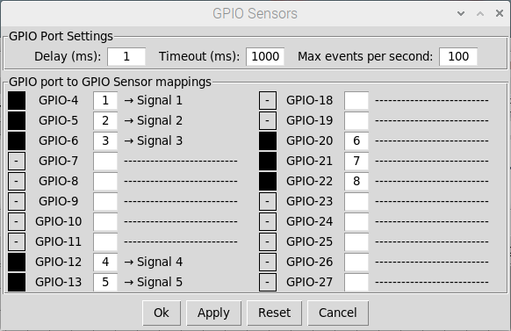
We’ll use GPIO Ports 20, 21 & 22
For the track sensors and assign
Sensor IDs of 6, 7 and 8

Now, in EDIT Mode, click on each track sensor object in turn and configure the GPIO sensors:
- Track Sensor 1 – GPIO Sensor 6
- Track Sensor 2 – GPIO Sensor 7
- Track Sensor 1 – GPIO Sensor 8

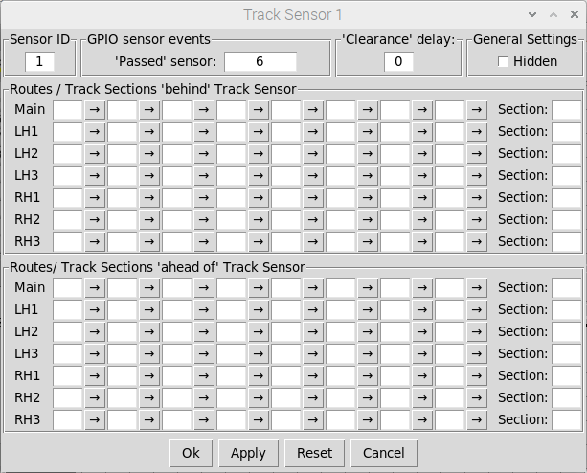
For Track Sensor 1 we’ll assign
GPIO Sensor 6 (mapped to
GPIO Port 20) to trigger
‘track sensor passed’ events
The rest of the configuration can be
ignored as we are only using these
track sensors to automatically clear
down routes and not passing trains
from one track section to another

Once all three track sensors have been configured, our ‘one click’ route configuration is complete.

Saving and loading your layout
Once you are happy with your layout, it can be saved to file (File => Save or File => Save-as from the Main Menu-bar – in the case of a ‘first time’ save or ‘save as’, this will bring up a dialog to choose the filename and destination folder). Files are saved with a ‘.sig’ extension.
Note that the current state of the layout (in terms of signal and point settings) is saved with the configuration, allowing you to pick up a running session from where you left off.
The current mode is also saved so if your layout was saved in RUN mode it will be loaded in RUN mode (and if saved in EDIT mode it will be loaded in EDIT Mode).
To load your layout select File => Load from the Main Menu-bar. This will bring up a dialog to choose the filename load the layout configuration in the mode/state at the point of save.
When a layout is loaded, the Pi-SPROG settings will default to DISCONNECTED with DCC Power OFF. If you are using the application in a ‘fixed’ configuration (i.e. with the Pi-SPROG permanently connected to your layout), then you may want to configure the application to automatically connect to the Pi-SPROG and turn on DCC Power on layout file load.
This is achieved via the application settings (select Settings => SPROG from the Main Menu-bar, select the appropriate check-boxes and click on OK or APPLY to save the changes).
Select these two checkboxes
Prior to saving the layout to enable
Automatic connect/power on on
Next layout load (this will then
Automatically send out the required
DCC commands to synchronise
Your layout with the application

If the layout file is configured to auto connect and apply DCC power then this will also result in DCC commands being sent out to set all signals and points on your layout to to synchronise them with the loaded state of your schematic (useful in case anything has changed between sessions).
One thing to be aware of is that the DCC commands will all be sent out at the same time so, if you have a large layout and a large number of points need to be changed, this may place a significant momentary power load on the DCC accessory bus.
Note that these SPROG settings are specific to the layout configuration (i.e. saved and loaded as part of the layout file) and will not apply to other layouts you load into the application. Similarly the Track Sensor configuration (in terms of GPIO port mappings to ‘Track Sensors’) is specific to the layout and will be saved / loaded with the rest of the layout configuration.

Quick start example 1a – NX Panel operation
In the previous example we covered ‘one-click’ route setting. The application can also be configured to provide a basic representation of Entry/Exit (NX) route setting panels, with highlighting of route lines and points to indicate track occupancy.
Disclaimer – the following example may not be absolutely prototypical in terms of signalling practice but has been created to demonstrate the main functions of the feature in as simple a way as possible. We would recommend researching NX panel operation before applying to your layout.
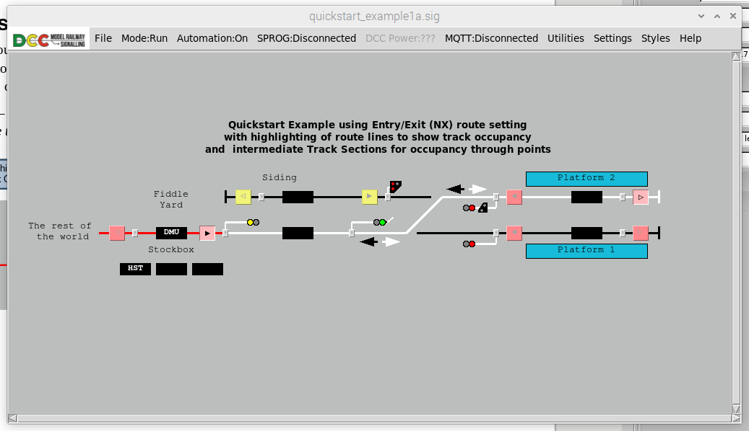
Route Lines highlighted
to show Track Occupancy
Entry button
Exit button
Route set from
N button to X button
(distant signal to stops)

Configuring track occupancy highlighting
If we want the schematic to highlight track occupancy through the point work in a realistic way as possible, then we first need to ‘split’ some of the route lines and add additional Track Sections:
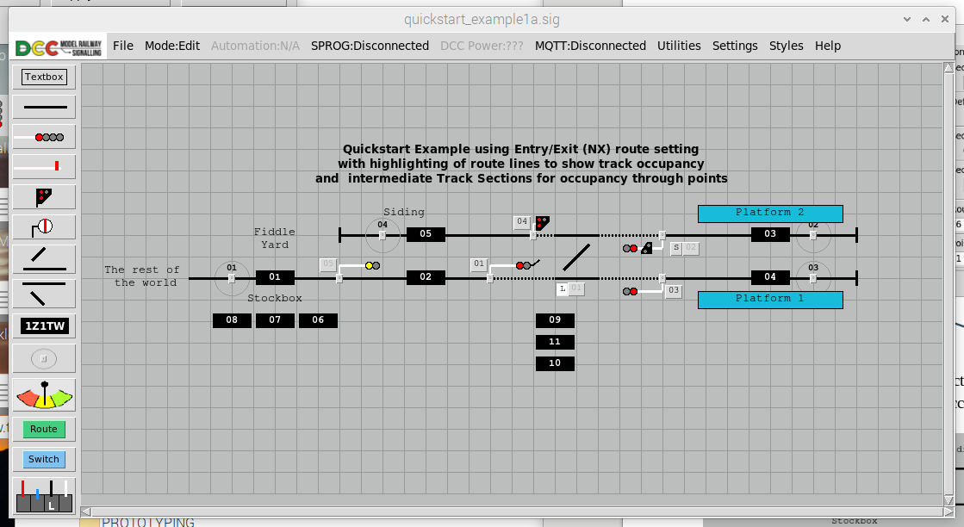
New route lines (shown dotted)
added between the points and signals
Existing route lines shortened so they
only go up to the base of each signal
Three new track sections added to represent
occupancy as trains transit the point work

Each new track section then needs to be configured to highlight the different ‘routes’ through the point work (don’t forget you can use <Cntl-i> in edit mode to toggle display of item IDs to find the IDs of the new lines you have just added). In this case, the routes will be:
- Track Section 9 - Signal 4 (siding) <=> Signal 2 (platform 2)
  - New lines 7, 5 and Point 2
- Track Section 11 – Signal 1 (home) <=> Signal 2 (platform 2)
  - New lines 12, 5 and Points 1, 2
- Track section 10 – Signal 1 (home) <=> Signal 3 (platform 1)
  - New lines 6, 12 and Point 1

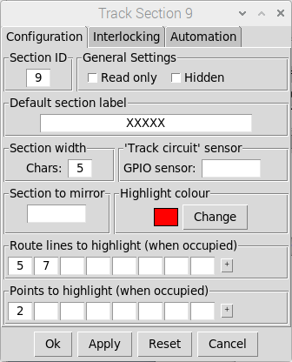
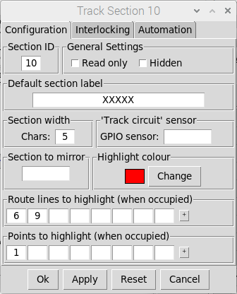
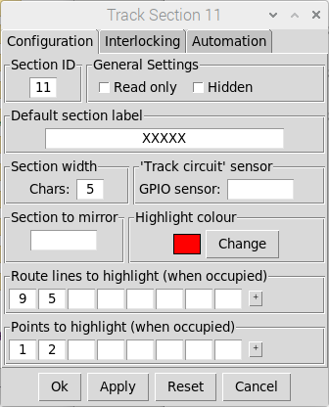
Specify the Route Lines
and points to highlight

Similarly configure all other Track Sections to highlight the appropriate lines when occupied. Once this is complete, the highlighting of occupancy can be tested in Run Mode:
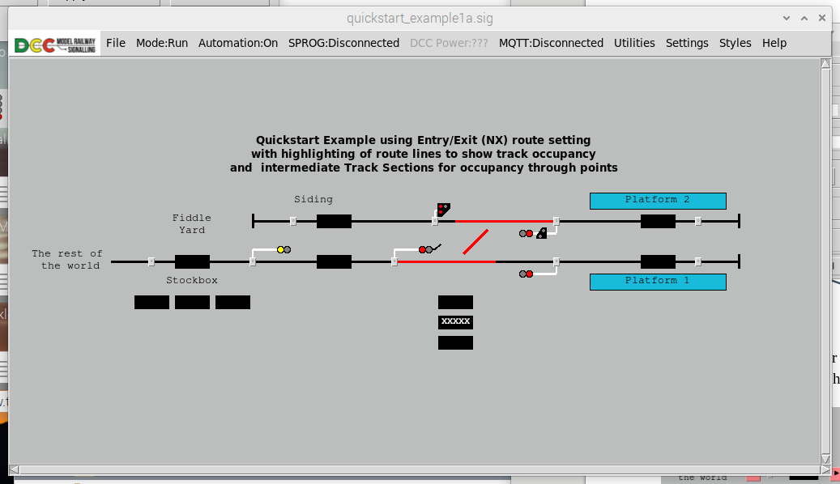
Click on each track section
In turn to check the highlighting

As we have added new ‘intermediate’ Track Sections, we also need to update each signal to pass trains to and from these new sections. For example, Signal 1 (the home signal into the station) should be configured as follows:
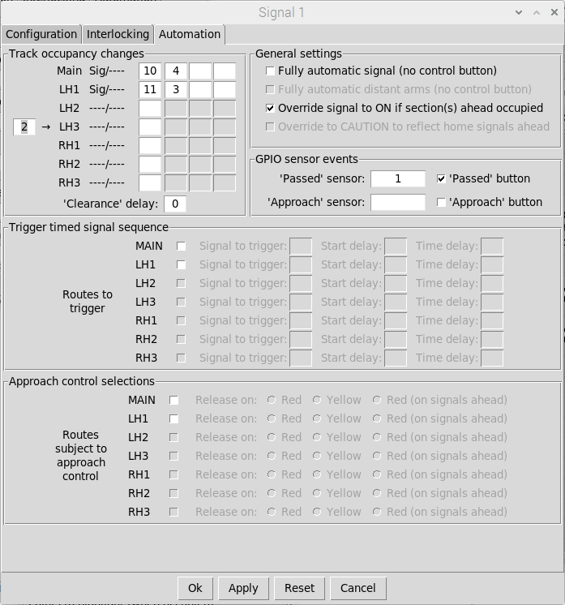
Signal 1 configured to ‘pass’
trains into the new rack sections
(track sections 10 and 11)
Note we still want to override the
Signal to danger if the original track
Sections (4 and 3) are occupied

Once all signals have been updated and all track occupancy changes (on signal ‘passed’ events) tested, these intermediate track sections can then be configured to be ‘hidden’ in Run mode. This can be achieved either by editing each track section in turn and selecting the ‘hidden’ option or alternatively you can select all the track sections and set them to ‘hidden’ by pressing the ‘h’ key (they can similarly be set to ‘unhidden’ by pressing the ‘u’ key).

Configuring NX route buttons
NX route configuration is similar to ‘one-touch’ route configuration but multiple routes can be specified from each Entry Button (to an associated Exit button).
The three basic types of button are:
- Entry (N) Buttons:
  - These are used to ‘initiate’ selection of a NX route.
  - Multiple routes can be defined from the Entry Button.
  - Each route needs to be associated with an Exit Button.

- Exit (X) Buttons:
  - These are used to ‘complete’ selection of a NX route.
  - Multiple Entry Buttons can be associated with an Exit Button.
  - No route definitions are configured for Exit buttons..

- Entry/Exit Buttons
  - These combine the features of the buttons above
  - These are used to ‘complete’ selection of a NX route.
  - Multiple Entry Buttons can be associated with an Entry/Exit Button
  - These can also be used to ‘initiate’ selection of a NX route.
  - Multiple routes can be defined from an Entry/Exit Button.

Firstly we need to add all the required NX buttons to the schematic. The basic configuration of each NX button can be simply achieved by simply clicking on the required NX button type. This automatically sets the route button name (to the required image), the button width and button type:
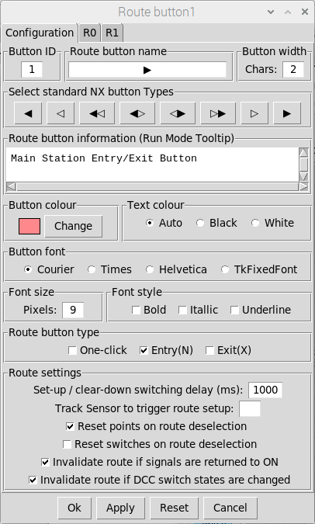
Click on the filled triangle
Symbol to set the basic
NX button configuration
for an Entry Button
The button name, width and
Type are automatically set
Click on other symbols to
Configure other NX button
Types (empty triangle for
an exit button etc)

The NX buttons can then be positioned on the schematic as required. Note that we have also added directional arrows (route lines) positioned just above the track. When we configure the route highlighting, we will also highlight the appropriate arrows to show the direction of travel.
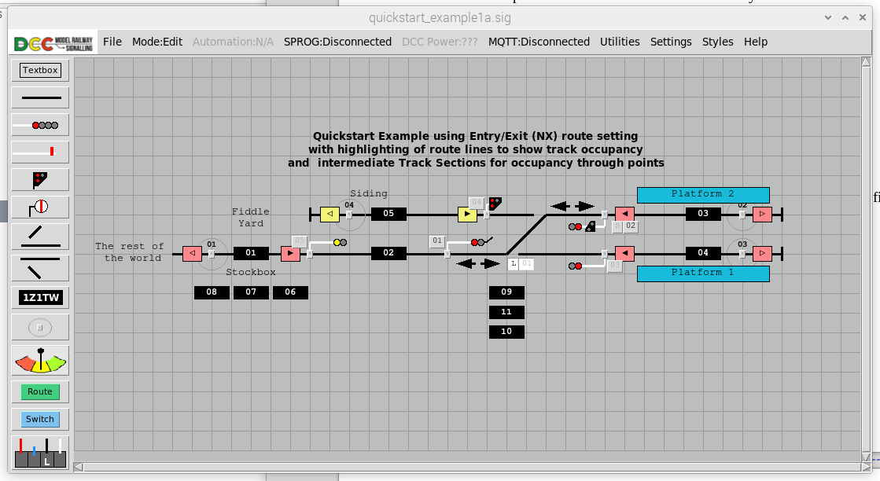
These buttons are a different
Colour to signify shunting movements
Entry Buttons should be positioned at each
signal (don’t worry about overlapping the signal
control buttons as we will ‘hide’ these in Run Mode)
Entry buttons are signified by filled triangles
Exit buttons are signified by empty triangles
Exit buttons should be positioned at
The signal ahead or ‘at the stops’

Once buttons have been positioned on the schematic, each Entry button can be configured with the required NX route definitions. Don’t forget that <Cntl-i> can be used to toggle item IDs (which includes button IDs) to simplify the configuration process:
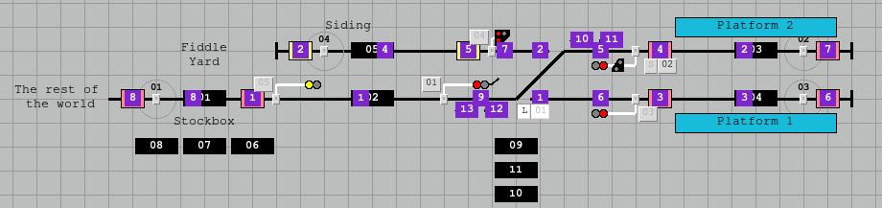

In this example, Route Button 1 is the main Entry Button (from the fiddle yard) and there are are two possible routes into the station (Exit Button 7 and Exit button 6).
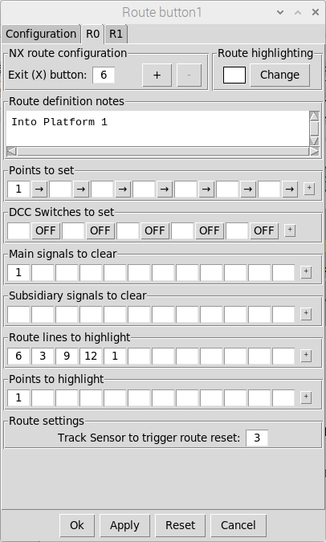
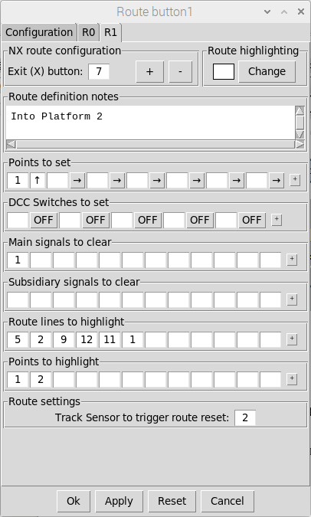
The first route is to Exit
Button 6 (into Platform 1)
The second route is to Exit
Button 7 (into Platform 2)
The remainder of the route
configuration process is exactly
the same as for ‘one-click’ routes
Don’t forget to add the additional
lines into the route highlighting
configuration (and the arrows)

TO DO
Testing the routes (route selection, route completion etc)
Testing track occupancy highlighting along the routes

Quick start example 2 – semaphore signals
In the first quick-start example, we configured a layout using colour light signals. Depending on the period modeled, you might prefer the use of semaphore signals on your layout.
For Quick Start Example 2 we’re going to change our colour light signalling scheme (from Quick Start Example 1) to use the equivalent semaphore signal types
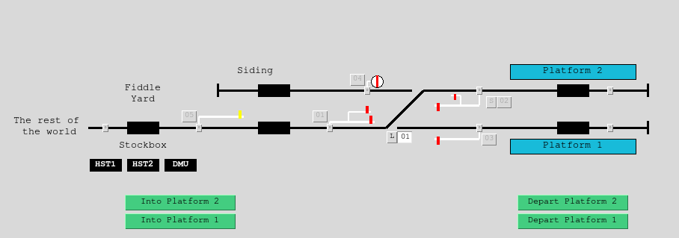
Ground Disc Signal
Semaphore with a subsidiary arm
For the RH1 route into the siding
Semaphore with a secondary route arm
For the LH1 route into Platform 2

As we have fully configured the colour light signalling scheme in terms of interlocking, track occupancy and automation, its easy to swap between the two signal types by editing each signal in turn. The only things to change in the configuration are:
- Signal type and subtype – select ‘semaphore’ and then either home or distant
- The route indications – additional semaphore route arms rather than route feathers
- DCC addressing – each signal arm need to be configured with a single DCC address

Firstly, edit signal 1 and change it to a Semaphore Home signal with Route Arms (a MAIN route arm for Platform 1 and a LH1 route arm for platform 2). Each signal arm should be configured with its corresponding DCC address. The remainder of the configuration (on the Interlocking and Automation tabs) remains unchanged from the colour light signalling example.
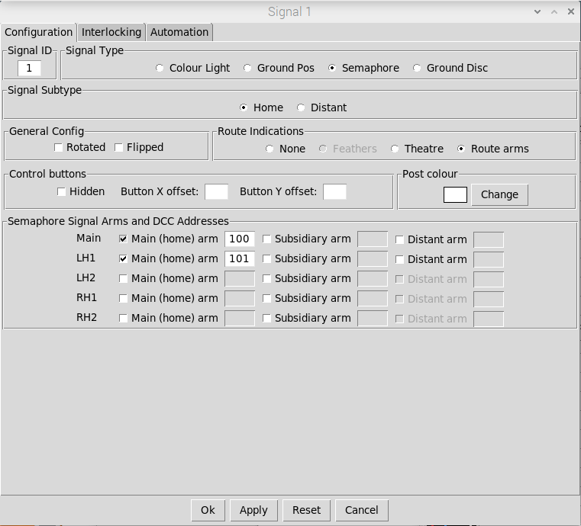
Signal Type and
Subtype have
Been updated
Route Arms
Selected
Additional route arm
Selected for the LH1
Route (MAIN route
Is always selected)
Single DCC address
Specified for each arm

The other signals also need to be changed to Semaphore types. Note that for signal 2, the MAIN route (controlled by the main home arm) remains the route out from platform 2 to the rest of the world. A subsidiary arm controls the RH1 route back into the siding.
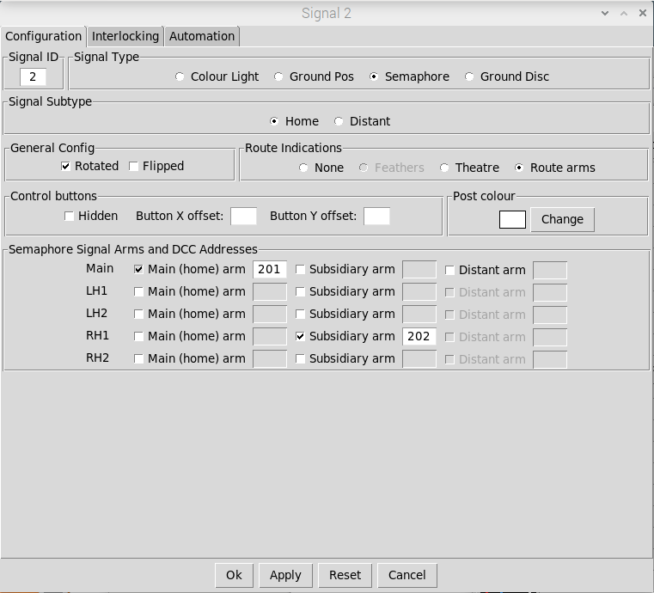
Additional route arm
Selected for the RH1
Subsidiary Route
(into the siding)
The MAIN Route (always
selected) remains the route
out from the Platform to the
Rest of the world
Route Arms
Selected
Single DCC address
Specified for each arm

Changing the other signals (Signals 3, 4 and 5) to semaphore types is relatively straightforward in that only the signal type, sub-type and DCC addresses need to be changed. The remainder of the configuration remains identical to the colour light signalling example.

Quick start example 3 – signal box levers

Simulated signal box levers
For added realism, you can also control your signals and points with virtual levers, allowing to to simulate the layout and operation of a real signal box.
For Quick Start Example 3, we will modify our semaphore signalling example to:
- Add signal box levers and ‘connect’ them to the signals/points on the schematic.
- Configure the point and signal buttons to be hidden in RUN Mode (this is optional).
- Annotate the points and signals on the schematic with their corresponding lever numbers (alternatively you could use the ‘bulk renumbering’ utility to align the Point/Signal IDs with the IDs of their corresponding Levers if not hiding the point/signal buttons). Note that you may need to turn off ‘snap-to-grid’ to position the text boxes appropriately.

Text boxes added to indicate the corresponding Lever number
(Note we have assigned separate levers for each signal arm)
Signal Box Levers added to the schematic
and ‘connected to the corresponding signals/points
Point and Signal buttons will
Be hidden in RUN Mode
Note separate levers for point
Switching and the FPL

The first step is to add the levers to the schematic. These are initially created as White (‘spare’) levers , but will automatically inherit the correct lever colour when connected (Yellow for Distant signals, Red for Stop signals, Blue for FPLs and Black for Points).
To connect the levers to their respective signals and points, double-left-click on each Lever in turn to bring up the configuration dialog. For Lever 1 the configuration would be:
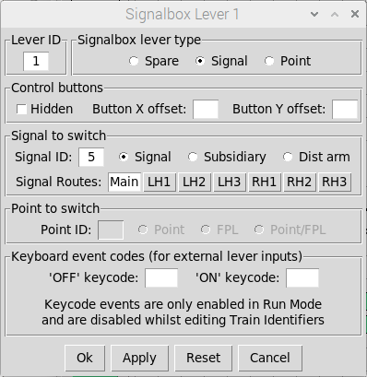
Select the Lever Type
(in this case Signal)
ID of the signal to control
Select the ‘Routes’ to Control with
The lever (this allows you to either
use a single lever for the signal or
Individual levers for each arm)
Point selections are greyed
out as we have selected
a Signal Lever type
Element of the signal to control
Selections for integration
of external physical levers
(covered later)

For this example, we are going to connect Levers 2 and 3 to different signal arms of Signal 1 (although you could use a single lever to controlling ALL routes if you prefer):
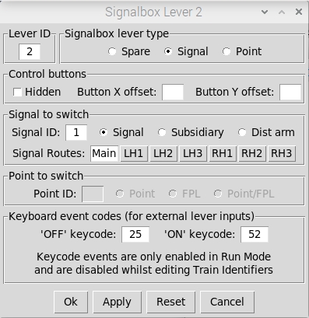
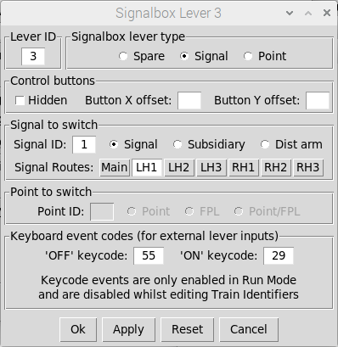
Both Levers are
Linked to Signal 1
Lever 2 is linked
To the MAIN arm
Of Signal 1
Lever 3 is linked
To the LH1 arm
Of Signal 1

Similarly, we’ll use two Levers for Point 1 (one to control the FPL and one to switch the point):
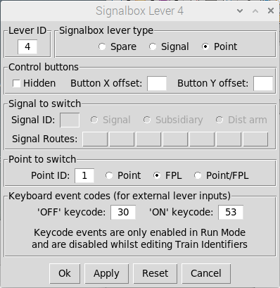
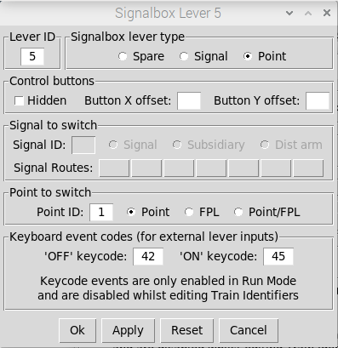
Lever 4 is controlling
The FPL of Point 1
Both Levers are
Linked to Point 1
Lever 5 is controlling
The switching of Point 1

The remaining Levers can then be configured as appropriate (note that we’re also going to use separate Levers for each signal arm of Signal 2).
To finalise the schematic, the signals and points on the schematic need to be annotated with their respective lever numbers (by adding text boxes). The the point and signals buttons can then be configured to be hidden in run Mode – simply edit each Point and Signal in turn, select ‘Hidden’ in the ‘Control Buttons’ section of the dialog and apply the changes.
Operation is identical to the signal/point control buttons, Levers will only be unlocked when their respective Point or Signal is unlocked. When they are unlocked they can be switched as required.


Physical switches/levers
If you prefer to use physical levers or switches for controlling the signals and points on your layout (such as the DCC Concepts Cobalt S Levers) then these can easily be integrated with the application through the use of readily available USB Keyboard encoders.

Choosing and configuring USB keyboard encoders
These devices can be connected into the computer running the application and generate key-press events for the application whenever an input is momentarily activated (they effectively act as an additional USB keyboard for your computer).
Many different units are available from many different suppliers, but we would recommend the Ultimarc I-PAC series of encoders. Although these units are primarily designed for arcade gaming, they have a number of useful features that make it ideal for integrating signal box levers:
- Units are available that provide either 32 or 56 inputs, which should be sufficient for most signal box lever frames (you will need to use 2 inputs per Lever)
- Each input can be programmed to simulate any keyboard event (printable characters, function keys or other control keys present on a standard PC keyboard). Note that the unit would need to be programmed using the WinIPAC PC application, available to download from the Ultimarc website (this runs on Windows PCs only)
- Multiple units (when programmed with different keyboard mappings) can be used in parallel, allowing you to create large lever frames if your layout is complex.
Although you can program each I-PAC input to simulate any key-press event, you need to avoid key-press events which will have an undesired effect on either the application or the platform you are running the application on:
- The following keys are reserved for the application: Ctrl , A, M, R and the Arrow keys
- Other keys which may produce undesired effects are: F10, Caps-Lock and the Windows key

Choosing and connecting external switches/levers
Any type of external switch or lever can be connected into the keyboard encoder as long as it produces a MOMENTARY output, as we only need a single keyboard event to switch the lever (switches or levers that provide a LATCHING output cannot be used). In this respect, the DCC Concepts Cobalt S Levers are ideal as they provide the required MOMENTARY outputs.


DCC Concepts
Cobalt S Levers
I-PAC2 USB
Keyboard Encoder
USB connection
(to computer)
Momentary contacts
Wired between
Input and 0V DC

Configuring signal box levers to use external inputs
Once we have configured the USB keyboard encoder and connected the momentary contacts of the external levers into the USB keyboard encoder, the signal box levers can then to be configured to ‘act’ on the external key-press events.
The first thing you need to do is to find the ‘key-code’ for each key-press event produced by the USB keyboard encoder. The application uses ‘key-codes’ rather than keyboard characters as not all key-press events will produce printable characters (e.g. Function Keys).
The easiest way of finding out the key-codes you have programmed is to set the application into RUN mode and then set the log level to DEBUG (settings => logging from the main menu-bar). Each key-press (with its corresponding key-code) will now be logged to the terminal output:

Key-presses that result
In Printable characters
Key-presses without printable
Characters (in this case the
Function Keys F1 - F4)

Once the required key-codes are known, then they can be mapped to each signal box lever via the Lever configuration dialog:
Specify the key-code to
Pull the lever ‘OFF’
Specify the key-code to
Reset the lever to ‘ON’
Specify the key-code to
Reset the lever to ‘ON’

Operating with external switches/levers
The signalling application will respect interlocking by default, but the external levers or switches you connect into the system will have no mechanism for interlocking. Each simulated lever on the schematic has a clear indication as to its locking state, and it is therefore the responsibility of the user to respect the interlocking and not ‘pull’ any levers that are locked.
If required, the application can be configured to generate pop-up warnings if an external lever is operated whilst ‘locked’ (to shame the signaler).
There is also an option to ignore interlocking (with or without pop-up warnings) if you wanted the state of the schematic (and hence the signals and points on your layout) to always reflect the state of the external levers/switches you are operating the layout with.
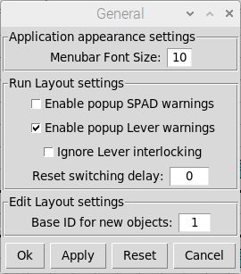


Select to enable
Pop-up lever warnings
Select to ignore
lever interlocking
Example pop-up warnings
With interlocking respected
Example pop-up warnings
With interlocking ignored

When using external levers it is important to note the following:
- Key-press events will only switch signal box levers in RUN Mode
- Key-press events will only switch signal box levers if the signalling application ‘has focus’. If you are doing something in another window, for example editing a text document, then the key-press events will be re-directed to that other window.
- Switching of levers by key-press events will be disabled when editing train designators in Track Sections in RUN Mode (otherwise the characters you type for the train designator may trigger switching of the levers depending on your chosen key-press mappings).

Quick start example 4 - more automation
Now we’ve mastered the basics, we’ll create a new layout to demonstrate some of the advanced automation features provided by the application, with a double track main line junction signalled with 4 aspect colour light signals:


As this layout is quite large, first you need to increase the size of the canvas. To do this, select Settings => Canvas from the Main Menubar and increase the width accordingly.
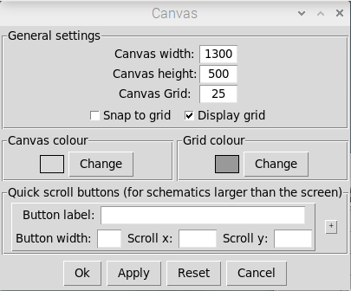
Increase the width of the Canvas
and click OK or APPLY

Configuring interlocking
Now draw the basic schematic as per the diagram above and add the signals and track occupancy sections in the appropriate positions. Point 1 should be configured with a FPL, but point 2 can be left ‘as is’ as this is a trailing point with respect to the direction of travel. Signal 1 should be configured with a left hand route feather for the diverging route.
Interlocking can then be configured for Signals 4, 8 and 10:
- Signal 4 needs to be interlocked with Point 1 (Point 1 needs to be NORMAL for the MAIN route and SWITCHED for the LH1 diverging route).
- Signal 8 needs to be interlocked with Point 2 (Point 2 needs to be SWITCHED).
- Signal 10 needs to be interlocked with Point 2 (Point 2 needs to be NORMAL).

As this layout includes a diamond crossover, we also need to interlock the conflicting Signals:
- Signal 4 needs to be interlocked with the MAIN route of Signal 8.
- Signal 8 needs to be interlocked with the MAIN route of Signal 4.

Configuring track occupancy
The track occupancy configuration should then be defined for each signal:
- Signal 4 needs to be configured with a ‘section ahead’ for both routes (Section 5 for the MAIN route and Section 6 for the LH1 route) and a ‘section behind’ (Section 4).
- Signals 6, 5 and 13 only have a ‘section behind’ configured (no ‘section ahead’) .
- All other signals have a ‘section behind’ and a ‘section ahead’ for the MAIN route.

Configuring basic automation
For this layout, we want all signals to:
- Reflect the state of the ‘signals ahead’ so when the signal is ‘OFF’ the displayed aspect will take into account the displayed aspect of the signal ahead (e.g. if the signal ahead is displaying DANGER, the signal should display CAUTION rather than PROCEED).
- Automatically change to DANGER as soon as a train passes the signal (and then cycle through the aspects back to PROCEED as the train progresses further down the track).
Firstly, configure each signal with details of the ‘signal ahead’ This is achieved via the Interlocking tab of the signal configuration dialog. Note that Signal 4 supports two routes, so we have to specify the signal ahead for each route:
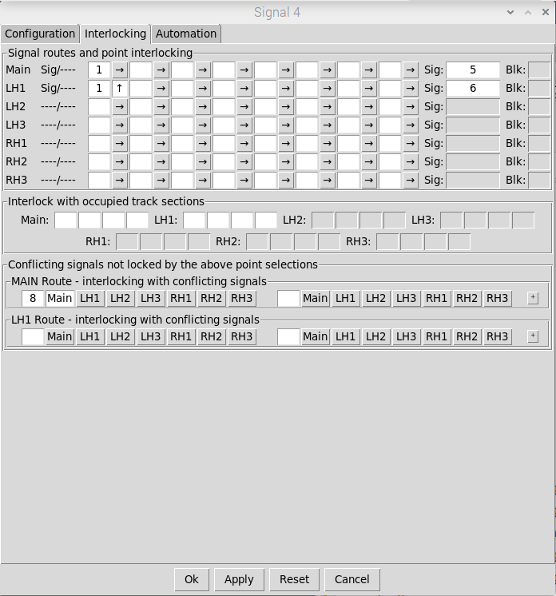
If Signal 4 is cleared for the
MAIN Route then the signal
ahead will be Signal 5
If Signal 4 is cleared for the
LH1 Route then the signal
ahead will be Signal 6

Secondly, configure each signal to be ‘Overridden’ to ‘ON’ if the track section ahead of the signal is occupied (so the signal will display DANGER as soon as the train passes the signal and enters the section). At the same time we can also make the signals we don’t need to manually control ‘fully automatic (without a control button). For this example, the only signals where we need to retain manual control are those signals ‘protecting’ the junction (Signals 4, 8 and 10). These selections are enabled by checkboxes on the Automation tab of the signal configuration dialog.
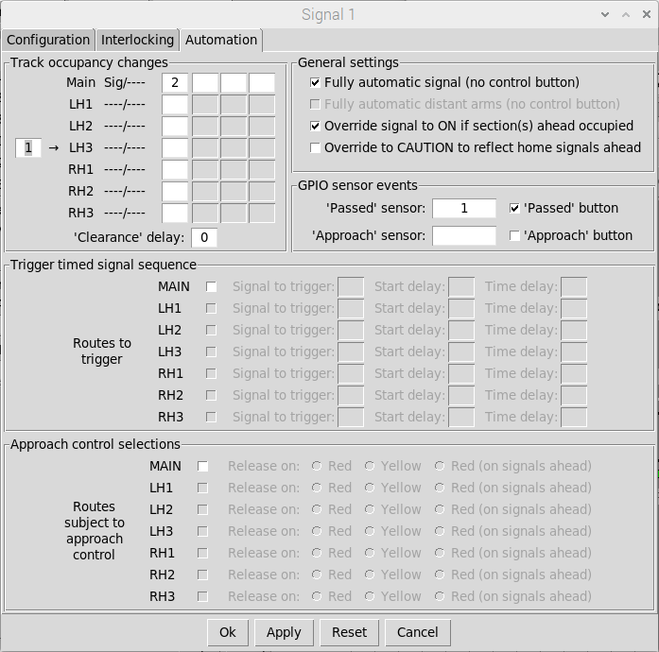
Select to create the signal
without a control button
(all signals apart from 4, 8 & 10)
Select to enable the signal to
be overridden (to DANGER) if
the section ahead Is occupied

Once all signals have been configured, the overriding of signals by Track Sections can be viewed via the Automation tab of the Track Section configuration dialog (read only).
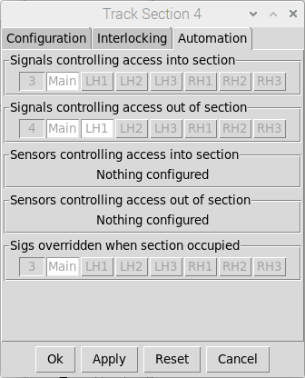
Signal 3 (immediately
Behind this track section)
Will be overridden to ‘ON’
When section 4 is occupied

The configuration can then be tested (in RUN mode with Automation ENABLED) by left clicking on each track section in turn to change from CLEAR to OCCUPIED and then back to CLEAR. When the track section is OCCUPIED, the signal behind the track section will display DANGER.

Configuring timed signals
You will note that Signals 5, 6 and 13 do not have any track sections ‘ahead of’ the signal as these go out to the ‘rest of the world’ . To add realism, we still want these signals to change to DANGER when passed and then cycle back through the aspects to PROCEED as the train supposedly travels further down the track. This is achieved, by configuring them as ‘timed signals’ via the automation tab of the signal configuration dialog.
Timed sequences can be configured for each route supported by the signal. In this case, Signals 5, 6 and 13 control a single route and so we only need to configure a sequence for the MAIN route.

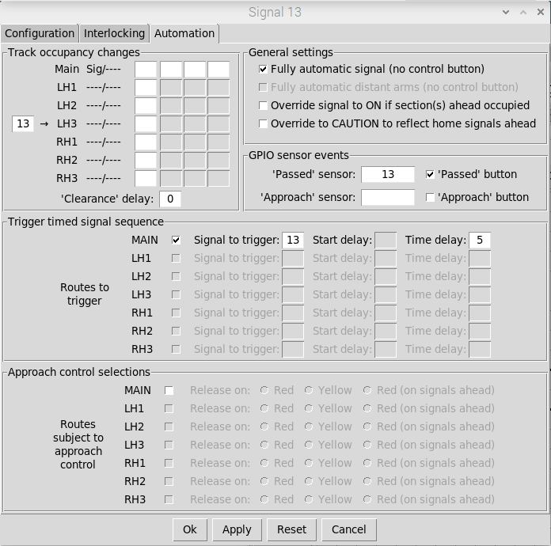
Trigger a timed
Sequence when
The signal is passed
A start delay of blank/zero
means that the sequence
will be started (signal
changed to DANGER)
as soon as the
Signal is passed
The time delay is the
Defines the time between
Subsequent aspect
Changes as the signal
Cycles through the
Supported aspects
Back to PROCEED

To test the timed signal, click on the ‘signal passed’ button at the base of the signal (in RUN mode with Automation ENABLED). The signal will initially change to DANGER and then cycle through the aspects (CAUTION, PRELIMINARY CAUTION) back to PROCEED.

Configuring approach control
Approach control is normally used when a diverging route has a lower speed restriction. Even though the route ahead may be clear, the signal controlling the diverging route will display a more restrictive aspect (either DANGER or CAUTION) to slow down the train. As the train approaches, the signal will then be ‘released’ to display its normal aspect (PROCEED).
Note that if you are going to use approach control for your layout, this will require an additional track sensor located on the approach to the signal, to trigger the ‘signal approached’ event.
The application supports both ‘release on red’ and ‘release on yellow’ approach control modes. For ‘release on red’, the signal will display a DANGER aspect and the signals behind will display the expected aspects (CAUTION, PRELIMINARY CAUTION). For ‘release on yellow’, the signal will display a CAUTION aspect and the signals behind will display special aspects to provide the driver with pre-warning of the diverging route (FLASHING-CAUTION for the previous signal and FLASHING-PRELIMINARY-CAUTION for the signal behind that).
We’ll configure Signal 4 to apply ‘release on yellow’ approach control for the diverging route, and configure an additional track sensor to trigger the ‘signal approached’ event. This is achieved via the automation tab of the signal configuration dialog.
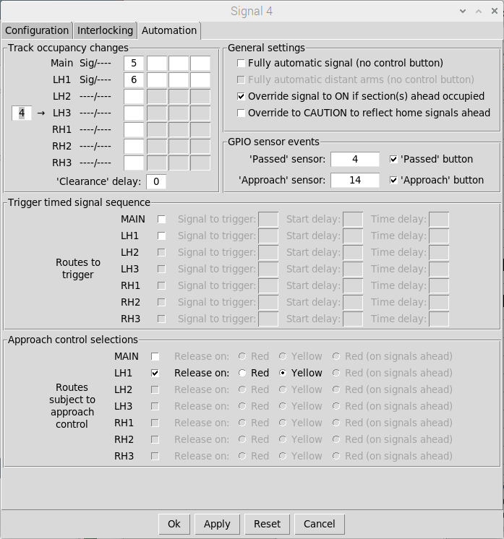
Approach Control
Selected for the
LH1 diverging route
GPIO Sensor to
Trigger the ’signal
Released’ event
Release on yellow
Mode selected
Select to add a small
button in front of the
Signal to simulate
‘signal approached’
events (so we can test it)

Signal 4 will now be displayed with a second button positioned on the track (on the approach to the signal). This is the button to simulate the ‘signal approached’ event to ‘release’ the signal.
This can be tested (in RUN mode with Automation ON) by setting up the diverging route (Point 1 SWITCHED) and clearing Signal 4. Signals 4, 3 and 2 should display CAUTION, FLASH-CAUTION and FLASH-PRELIMINARY-CAUTION respectively. Clicking on the ‘signal approached’ button should then ‘release’ the signal (to PROCEED).

Note that the DCC signalling application does not actually flash the aspects of the signals out on your layout – it just sends the required DCC commands telling the signal/decoder to select the flashing aspect (the signal/decoder actually flashes them). To use approach control on your layout you will therefore need DCC signals or DCC accessory decoders that support the flashing signal aspects - such as the Train Tech DS5HS DCC-enabled 4 aspect signals.

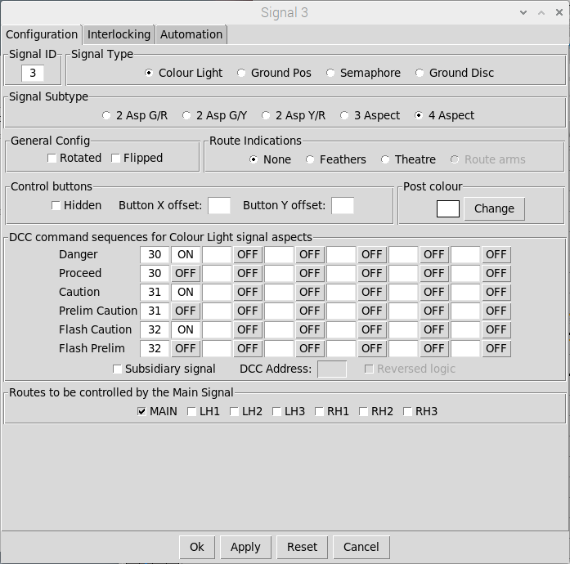
DCC commands /
Command sequences
For flashing signal
aspects

Testing the competed layout
The completed layout can now be tested in much the same way as the first quick-start example layout by feeding trains into the layout (via Track Sections 1, 8 or 9) and then progressing them through the layout from one track section to the next by clicking on the ‘signal passed’ buttons (and the ‘signal approached’ button) along the route.

Flashing
Preliminary
Caution
Button to simulate
‘signal approached’ events
Flashing
Caution
Displaying
Caution
Signal 12 overridden to ON as
track section ahead is occupied
Displayed aspect
Reflects signal ahead
Signal 4 is OFF but in
Approach control mode
For diverging route
Displayed aspects
Reflects signals ahead

Quick start example 5 – intermediate track sensors
In quick-start example 1 we briefly touched on the use of Track Sensors for the clearing down of routes (once the train was ‘clear’ of the last signal on the route).
You can also use Track sensors for finer granularity track occupancy between signals and for extending track occupancy into non-signaled areas of your layout such as storage yards:

Track Sensor objects

The configuration of Signal 1 is straight forward. The signal ahead for the MAIN route (configured via the Interlocking Tab) is Signal 2, and Signal 1 is configured to be OVERRIDDEN if any of the Track Sections ahead are OCCUPIED (configured via the Automation Tab).
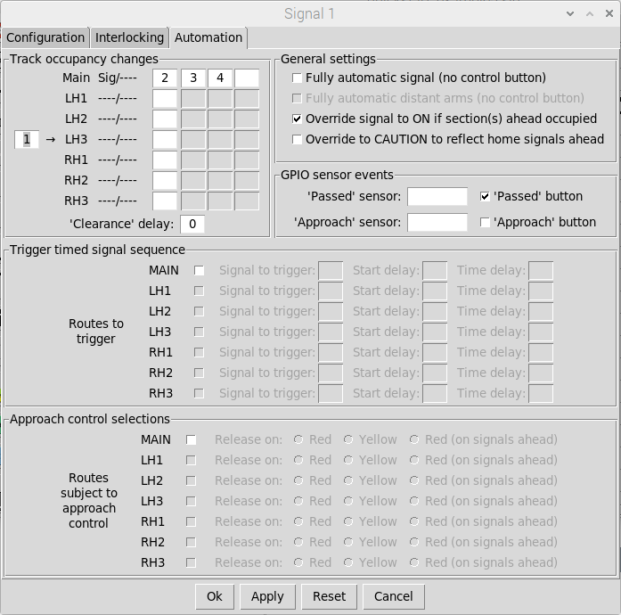
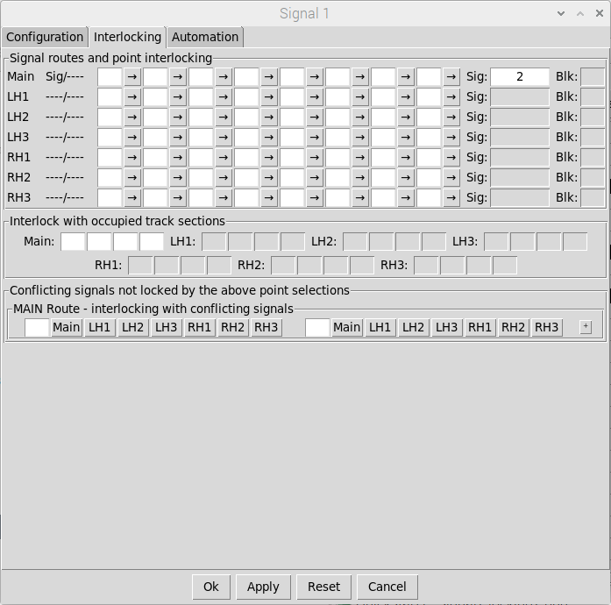
Trains will be passed
From Track Section 1 to
Track Section 2 when
The signal is passed
Signal will be OVERRIDDEN
(to DANGER) if any of the
Track Sections ahead
Are OCCUPIED
Signal Ahead is
Signal 2

To keep things simple, Signal 2 is configured to clear the Track Section immediately behind the signal when the signal is passed by the train:
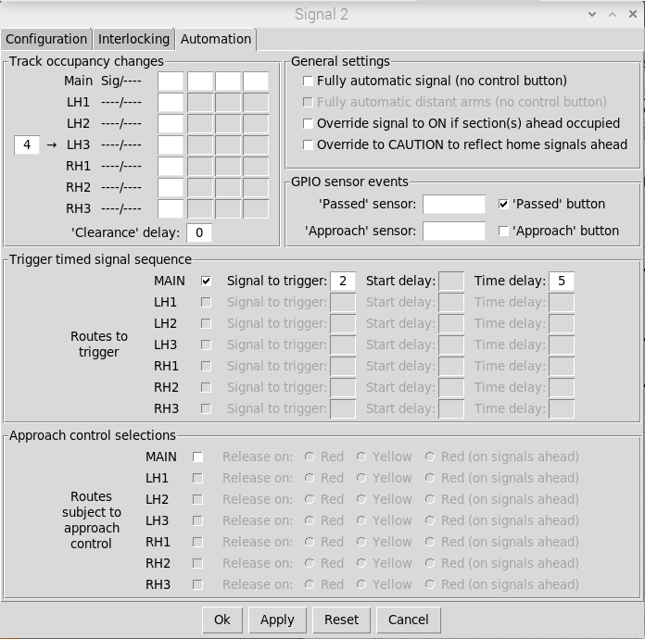
Track Section 4 will
be cleared when
the signal is passed

The intermediate Track Sensors can then be configured to pass Trains from one track Section to the next when a ‘sensor passed’ event is triggered (either by clicking on the small button to simulate an event, or mapping Track Sensors to GPIO sensors for real layout events):
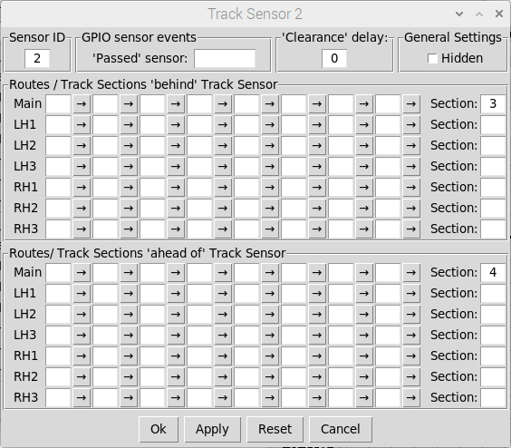
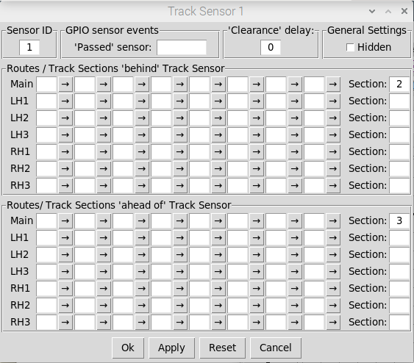
When a Track Sensor 1 ‘passed’ event
is triggered, Trains will be passed
from Track Section 2 to Track Section 3
When a Track Sensor 2 ‘passed’ event
is triggered, Trains will be passed
From Track Section 3 to Track Section 4
GPIO Sensors can be mapped to
Track Sensors to trigger ‘passed’
Events from external train sensors

Track Sensor 3 is configured to pass trains from one Track Section to another depending on the setting of the points either side. Configuration is similar to that of the Signal Interlocking tab but in this case we can define possible routes both ‘before’ and ‘after’ the Track Section:
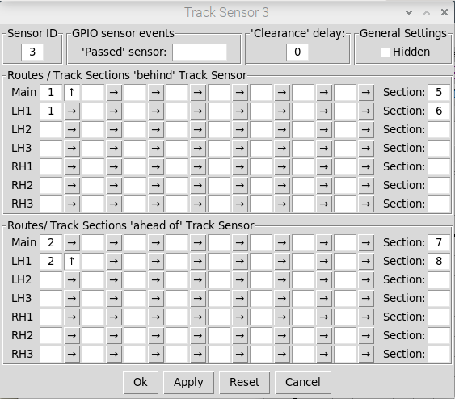
Possible Movements when triggered:

Point 1 Normal, Point 2 Normal : 6 <--> 7
Point 1 Normal, Point 2 Switched : 6 <--> 8
Point 1 Switched, Point 2 Normal : 5 <--> 7
Point 1 Switched, Point 2 Switched : 5 <--> 8

Quick start example 6 – DCC accessory switches
The signalling application also provides ‘DCC switches’ that can be added to the schematic and used to operate any other DCC accessory out on your layout such as track isolating sections (if you are still using analogue for train control), level crossings, light/sound effects etc.
Switches can either be configured as LATCHING or MOMENTARY:
- LATCHING switches can be configured to transmit different DCC command sequences (via the DCC accessory bus) when selected and deselected.
- MOMENTARY Switches can be configured to transmit different DCC command sequences when ‘pressed’ and ‘released’. They can also be configured with a delay to ‘release’ (and transmit the ‘released’ command sequence), a fixed time after the switch was pressed.
For quick-start example 6 we’re going to modify the first example layout to include DCC Switches for track power switching and a horn sound effect.
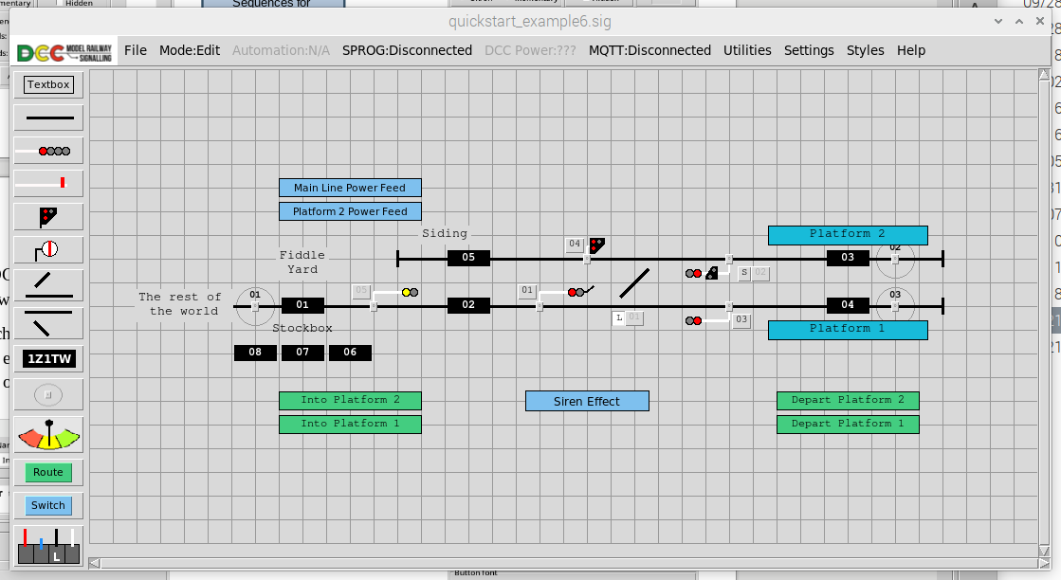
Latching Switches for tack power feeds
Latching Switches for track power feeds
Momentary Switch for sound effect

The Switch objects are added to the schematic and positioned in the normal way. However, you should note that these use the same underlying ‘button’ object as the Schematic Route Buttons and and so the ‘one-up’ numbering will reflect this.
To configure the Switches, double click on each one in turn to bring up its configuration dialog:


DCC command
Sequences for
ON and OFF
Switch 7 is
MOMENTARY
Switch 5 is
LATCHING
Specify a fixed delay for
‘release’. If blank or zero
then switch will be released
when released by the user
DCC command
Sequences for
‘press’ and ‘release’

Once the DCC Switches have been configured, they will send out the specified DCC command sequences when operated (in RUN Mode, with SPROG connected and DCC Power ON).

Using DCC switches in route configurations
DCC Switches can also be specified as part of a Route configuration. In this example, we have configured each Route to apply power to the required track feeds on route setup, and switch off the track feeds on route clear down:
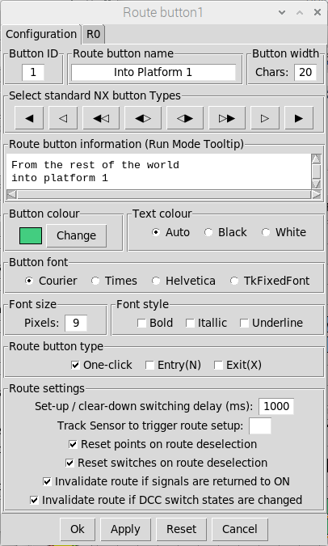
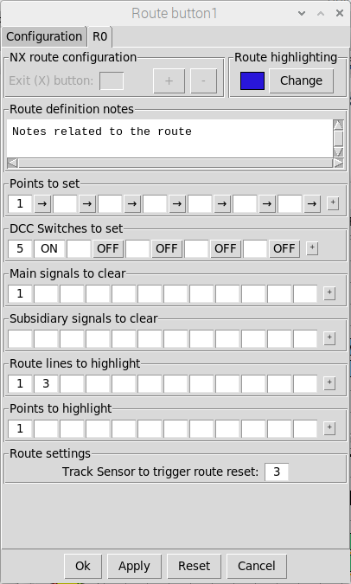
Route 1 will set Switch 5
To ON during route set-up
and revert to OFF during
Route clear-down

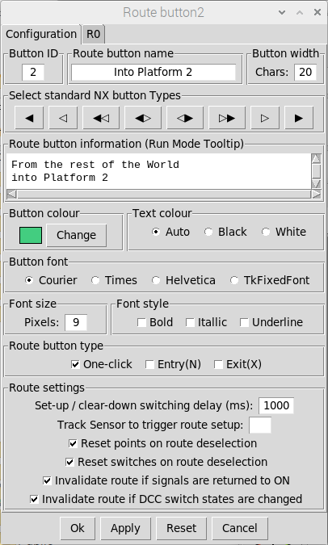
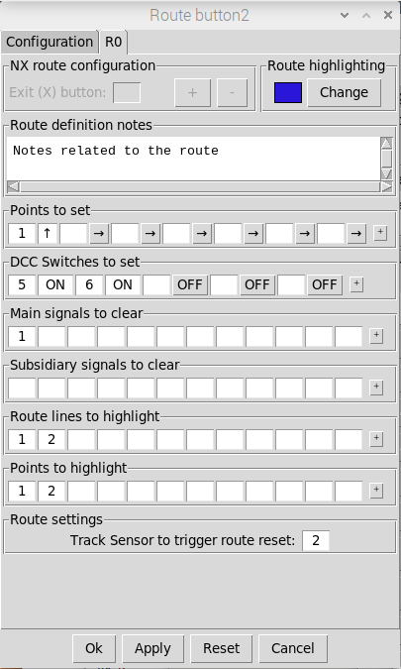
Route 2 will set Switches 5
And 6 to ON during route
Set-up and revert them to OFF
during Route clear-down

The configuration can now be tested in Run Mode. Set-up and clear-down of routes should now automatically enable and disable the latching DCC switches. Pressing the momentary switch should trigger playback of the selected audio file.

Route 1 has enabled the main line
Power feed as part of the route set-up

Using DCC Switches to trigger sound files
Although we have configured the momentary switch to activate a sound effect somewhere out on the layout via a suitable DCC decoder, we can also configure the application to play audio files when triggered by a DCC command generated by the system.
Audio will be played back through your HDMI monitor (assuming it is audio equipped), but you can also connect the system to a remote Bluetooth speaker suitably positioned on your layout.
To open the sound settings select Settings => Sounds from the main menu-bar:
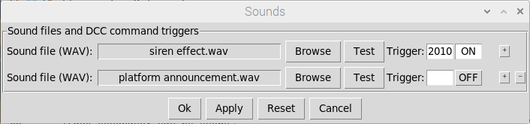
Click to open the file-chooser dialog
to select the required sound file
Click to test playback
of the sound file
Specify the DCC address and
command logic to trigger
playback of the sound file
Use these buttons to add
and remove sound entries
Selected Sound Files

Note that the system only supports the playback of ‘wav’ files – If you want to play back other audio file formats (e.g. ‘MP3’) then you will need to use a third-party audio manipulation application such as ‘audacity’ to convert them to ‘wav’ files beforehand.

Still to discover
There are still several features of the application that have not been covered in this quick-start guide, but once you are familiar with the features above, you should be able to experiment and figure them out for yourself:
- Theater Route Indications – supported by main semaphore and main colour light signals (use instead of feathers or route arms). Provides the ability to display a single ‘character’ for the selected signal route.
- Block Instruments – intended for layouts split into separate ‘block sections’ . This is a particularly useful feature when using multiple application instances networked together, where each instance represents a different signal box, as the block instruments can be used to communicate (via bell codes) between the signal boxes and control the movement of trains between the two block sections. A basic example including Block Instruments is included in the application networking guide (which can be downloaded from the website).
- Automation - Approach control ‘release on red (signals ahead)’ for automation of Home signals in a block section. In this case, signals are overridden to ‘ON’ if any Home signals ahead are still at DANGER and only ‘released’ to ‘OFF’ as the train approaches them (reverting to ‘ON’ as soon as the train has passed).
- Automation - Override to caution to reflect home signals ahead – For distant signals (semaphore or colour light) – Will override the distant signal to display CAUTION if any home signals ahead (within the block section) are at DANGER.
- Interlocking - Interlock on home signals ahead – For distant signals (semaphore or colour light) - To interlock the distant signal (prevent it being cleared) unless all home signals ahead (within the block section) are also clear.
- MQTT Networking – Publishing and subscribing to Signals, Track Sections, Track sensors and Block Instruments. The ‘remote’ items can then be used within the signalling scheme to provide seamless integration of different signalling areas. This is the subject of a separate networking guide (which can be downloaded from the website).
- The DCC Mappings utility (select Utilities and then DCC Mappings from the main menubar) – Allows you to view all DCC addresses used in your layout configuration an what signals and points they are associated with.
- The Bulk Renumbering utility (select Utilities and then Item Renumbering from the main menubar) – Allows you to re-number all schematic objects to your requirements (e.g. for aligning Signal/Point IDs with their signal box Lever numbers.
- Changing schematic object styles (select Styles and then the required menu) – Allows you to change the styles of ALL or SELECTED objects to “prettify” your schematic as required.
- ‘Slotting’ of Ground Signals with co-located Main Signals – to force the ground signal to ‘OFF’ whenever the Main Signal is displaying ‘OFF’.

Appendix 1 – How track occupancy works
As the Signalling application primarily uses momentary ‘passed’ events to detect train movements, it has to make certain assumptions about train movements based on the ‘route’ that has been set, the state of the signals and the state of the track Sections ahead and behind the signal.
The basic concepts are:
- Normal operation - Trains will be passed from the OCCUPIED to the CLEAR section
- If both sections are OCCUPIED or both sections are CLEAR then no train will be passed
- If there is ‘no route’ either ahead of or behind the signal then no trains will be passed
The following diagram explains what will happen for ‘signal passed’ events under both ‘normal operation’, where the driver is respecting the state of the signals, and some of the ‘edge cases’ that may occur if the driver inadvertently passes a signal at DANGER:


The configuration and operation of Track Sensors is identical, but with the added ability to specify multiple routes (and hence multiple Track Sections) both ‘ahead of’ and ‘behind’ the Track Sensor.

Appendix 2 – Using ‘track circuit’ / ‘block’ sensors
The DCC Signalling system is primarily designed to use ‘event-based’ track sensors to drive track occupancy and ‘pass’ train designators around the layout.
As an alternative, the system can also be configured to use ‘track circuit’ / ‘block’ type sensors (e.g. current sensing or optical sensors) to provide an absolute indication of occupancy. In this case the Track Section (on the schematic) will always represent the state of the external sensor (either ‘occupied’ or ‘clear’), but then will not be able to track train designators around the layout.
Double click on a Track Section (in Edit Mode) to bring up the configuration window and then specify the GPIO sensor linked to the ‘track circuit’. The Track Section should also be set to ‘read only’ to ensure the state always reflects the state of the external ‘track circuit’.
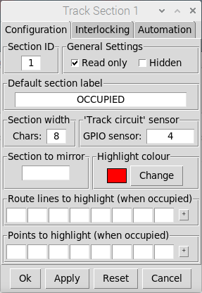
Define the default label
(displayed when the track
Section is occupied)
Specify the GPIO sensor
Linked to the associated
‘track circuit’ on the layout
Set to ‘read only’ so the
Track Section cannot be
Manually toggled or the
Designator changed
The route lines and points
Representing the ‘track
circuit’ can be configured
to be highlighted when the
Track Section is ‘occupied’

On UK railways, track circuits are often employed to prevent points being changed whilst a train is passing over them. This can be configured via the Interlocking tab of the point configuration window by entering the ID(s) of the associated track Section(s):
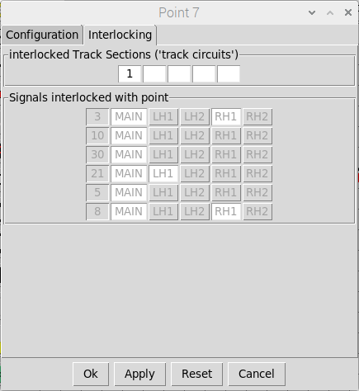
Enter the ID of the Track Section(s)
Representing the Track Circuit(s)
Protecting the point
This is the read-only back
Reference to the signals that
Will lock the point when ‘OFF’

Appendix 3 – The DCC programming utility
A basic DCC programming utility is provided to enable ‘one touch’ programming (suitable for the majority of DCC point & signal decoders on the market) and Configuration Variable (CV) programming (suitable for more complex decoders such as the Harman Signallist SC1).
If ‘One touch’ programming is supported by the device, this is always the preferred method as this can be done ‘on layout’ without disconnecting all other devices from the DCC accessory bus.
The utility can be opened by selecting Utilities = > DCC Programming from the Main Menubar. Note that The Pi-SPROG needs to be CONNECTED with DCC Power ON to program devices (refer to the ‘Operating your layout’ section for further information).

One-touch DCC programming
Ensure the device it is connected to the DCC bus and has been put into ‘one touch’ Programming mode (refer to the device documentation for specific instructions).
Enter the required DCC address and click the required command (On or Off) to program. Once programmed, the device should respond to all subsequent DCC commands.

Enter the required
DCC address
Click the appropriate
Button to send the
Required DCC command

DCC CV programming
Warning – before using the CV programming utility the DCC accessory bus should only be connected to the device you want to program (all other devices should be disconnected).
Enter the addresses of the CVs you want to inspect / program and click Read CVs to retrieve the current values. New values can then be entered and programmed by clicking on Write Cvs.
A partial configuration (for the Harman Signallist SC1 decoder) is shown below:

Free text notes
Values to
Write
CVs to read
Or write
Current values
(populated after
a Read)
Free text notes
Read / Write
Status / Errors
Loaded
configuration file

During a ‘read’ operation, either the retrieved values will be displayed or “---” signifying a particular CV could not be read.
During a ‘write’ operation, the displayed values will either turn Green (if the write was successful) or Red (if the write operation failed).

When a signal is ‘ON’, it is displaying its most restrictive aspect (DANGER for Home signals or CAUTION for distant signals). When a signal is ‘OFF’ it is displaying its least restrictive aspect (PROCEED for most signal types)
The main purpose of intermediate ‘track sensors’ is to extend train tracking into areas of the layout that aren’t fully signalled (e.g. goods yards, fiddle yards etc) or provide a finer granularity of train tracking between signals. They can be mapped to GPIO sensors (similar to how signals can be mapped to GPIO sensors for ‘signal passed’ events) and configured to pass trains from one track section to another when triggered (again, similar to signals). In this instance we’re just going to use them to detect when a train has ‘cleared’ a route.

