

https://www.model-railway-signalling.co.uk/
© DCC Model Railway Signalling. All Rights Reserved.

DCC Signalling System – Additional Signalling Node
Version 5.0 – January 2026

This guide is intended to walk you through the initial setup of your Additional Signalling Node and provide some top tips for the getting the best out of the system.
The Signalling Node runs exactly the same software as the DCC signalling System, with a default configuration to auto-start the application, load a default layout file and publish GPIO sensor events to the rest of your signalling network (i.e. similar to the Remote Sensor Nodes).
The Signalling Node can also be used to run a full layout file (representing another signal box or signalling area), networked with the DCC Signalling System over your home WiFi network (to publish DCC commands out on the DCC accessory bus).
For information on how to use the DCC Signalling Application, refer to the separate Application Quickstart Guide that comes packaged with the application (Select Help => Docs from the Main Menu Bar once the application has been opened).
Table of Contents
Unpacking 2
Initial setup 3
Powering up the system 4
Connecting to your Wi-fi network 5
Changing the default password 5
Powering off the system – Important! 5
Updating the operating system 6
Updating the signalling application 7
Backing up your files 7
Backing up your system 8
Running up the signalling application 8
Disabling application auto-start 8
Connecting external track sensors 9
Type of external track sensors 10
Configuring the System 11
Useful Links 14

Unpacking
The Signalling Node is supplied as a pre-assembled and pre-configured unit comprising:
- A Raspberry Pi 4 single-board computer, providing a “windows-like” user experience (and versions of all the usual applications you would expect to find on a personal computer, such as web-browser, email, office-type applications etc).
- A GPIO terminal breakout 'HAT' (Hardware Attached on Top) providing an easy means of connecting in external track sensors to enable train detection.
- The pre-installed Model Railway Signalling application, which comes packaged with comprehensive user documentation and a number of example layout files.
The DCC Signalling System is supplied with:
- A Raspberry-Pi USB-C UK power supply
- A micro-HDMI to HDMI lead for connecting to your monitor
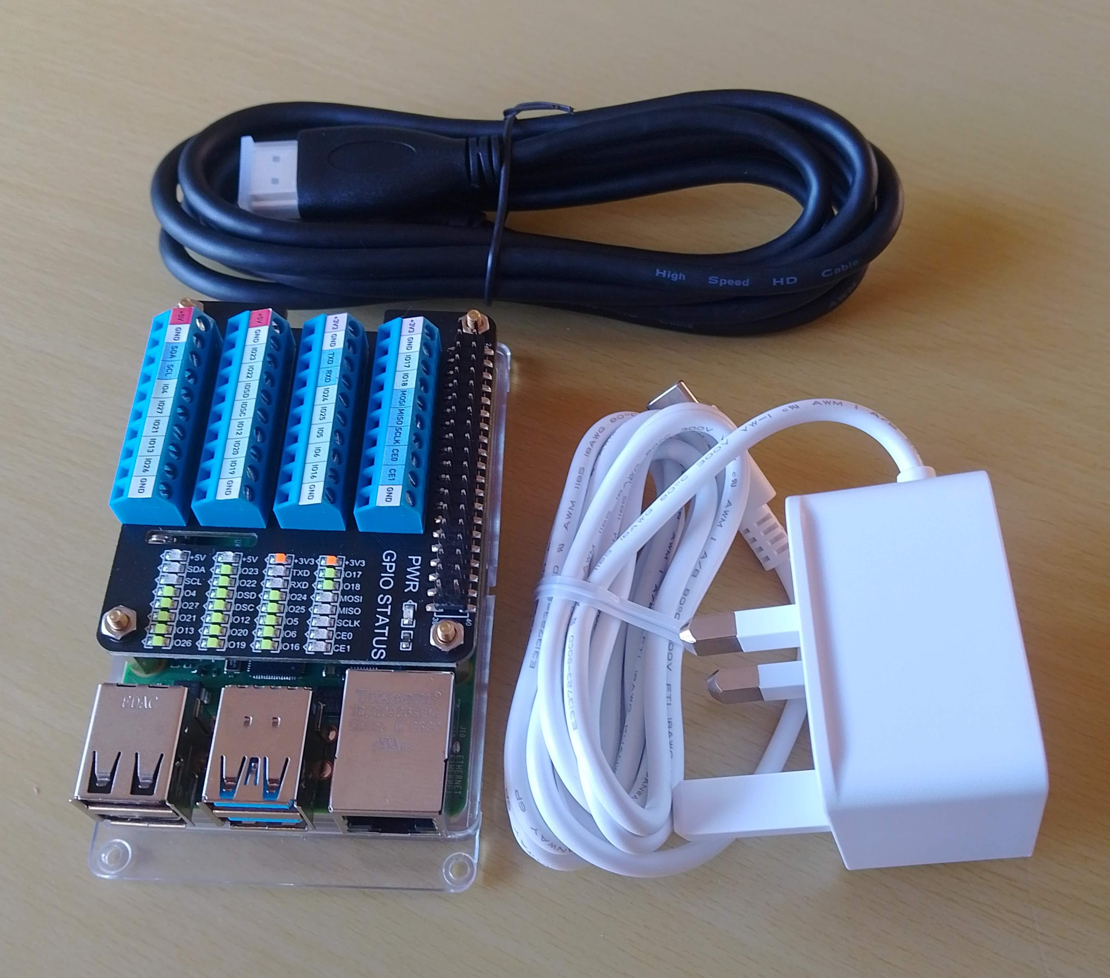

Before proceeding, inspect all of the components carefully for damage (especially the power supply). If you suspect damage then contact DCC Model Railway Signalling immediately to arrange an exchange (see https://www.model-railway-signalling.co.uk/ for contact details).

Initial setup
For the initial setup of the Signalling Node you will need a PC monitor (with a HDMI input port), a USB keyboard and a USB mouse (connecting to track sensors is covered in later sections).
- Connect your keyboard and mouse to the USB ports (there are 4 USB ports in total – any of which can be used for the keyboard and mouse).
- Connect the HDMI lead into the left hand Micro HDMI port and connect the other end to your monitor (the right hand socket can be used for driving a second monitor if required, but you will need another Micro-HDMI to HDMI lead for this).
- Connect the power supply to the USB power supply socket
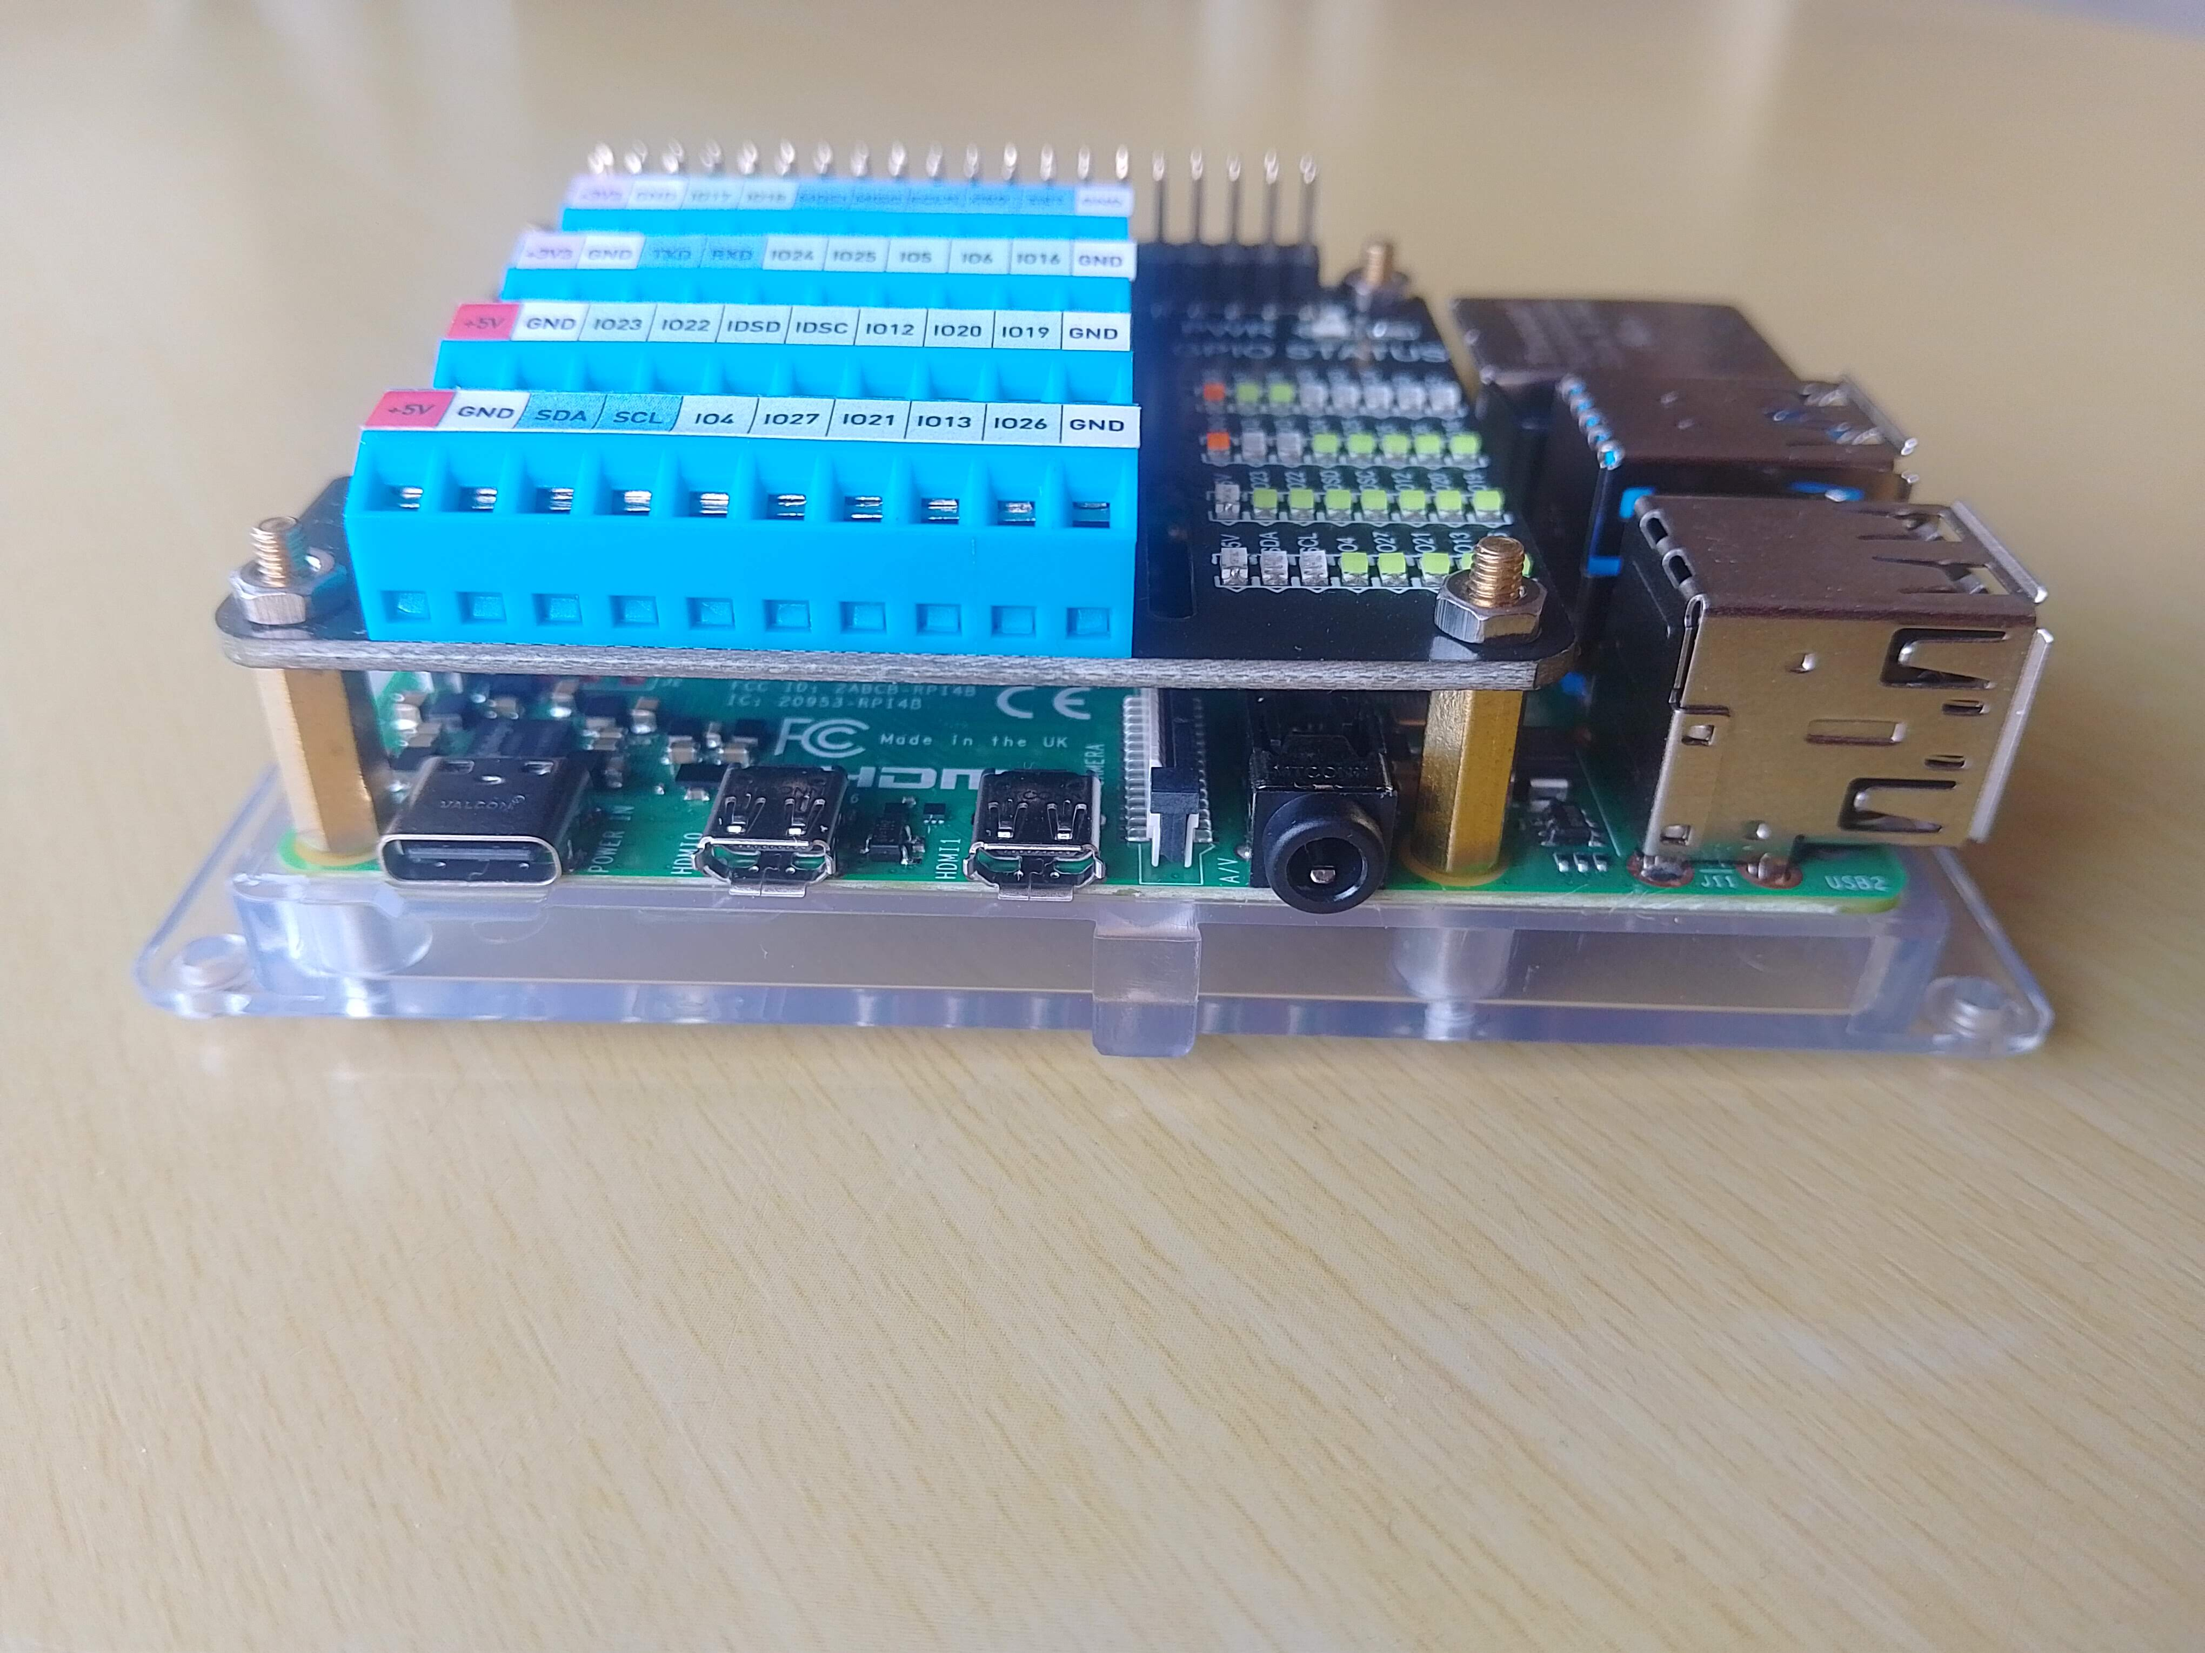
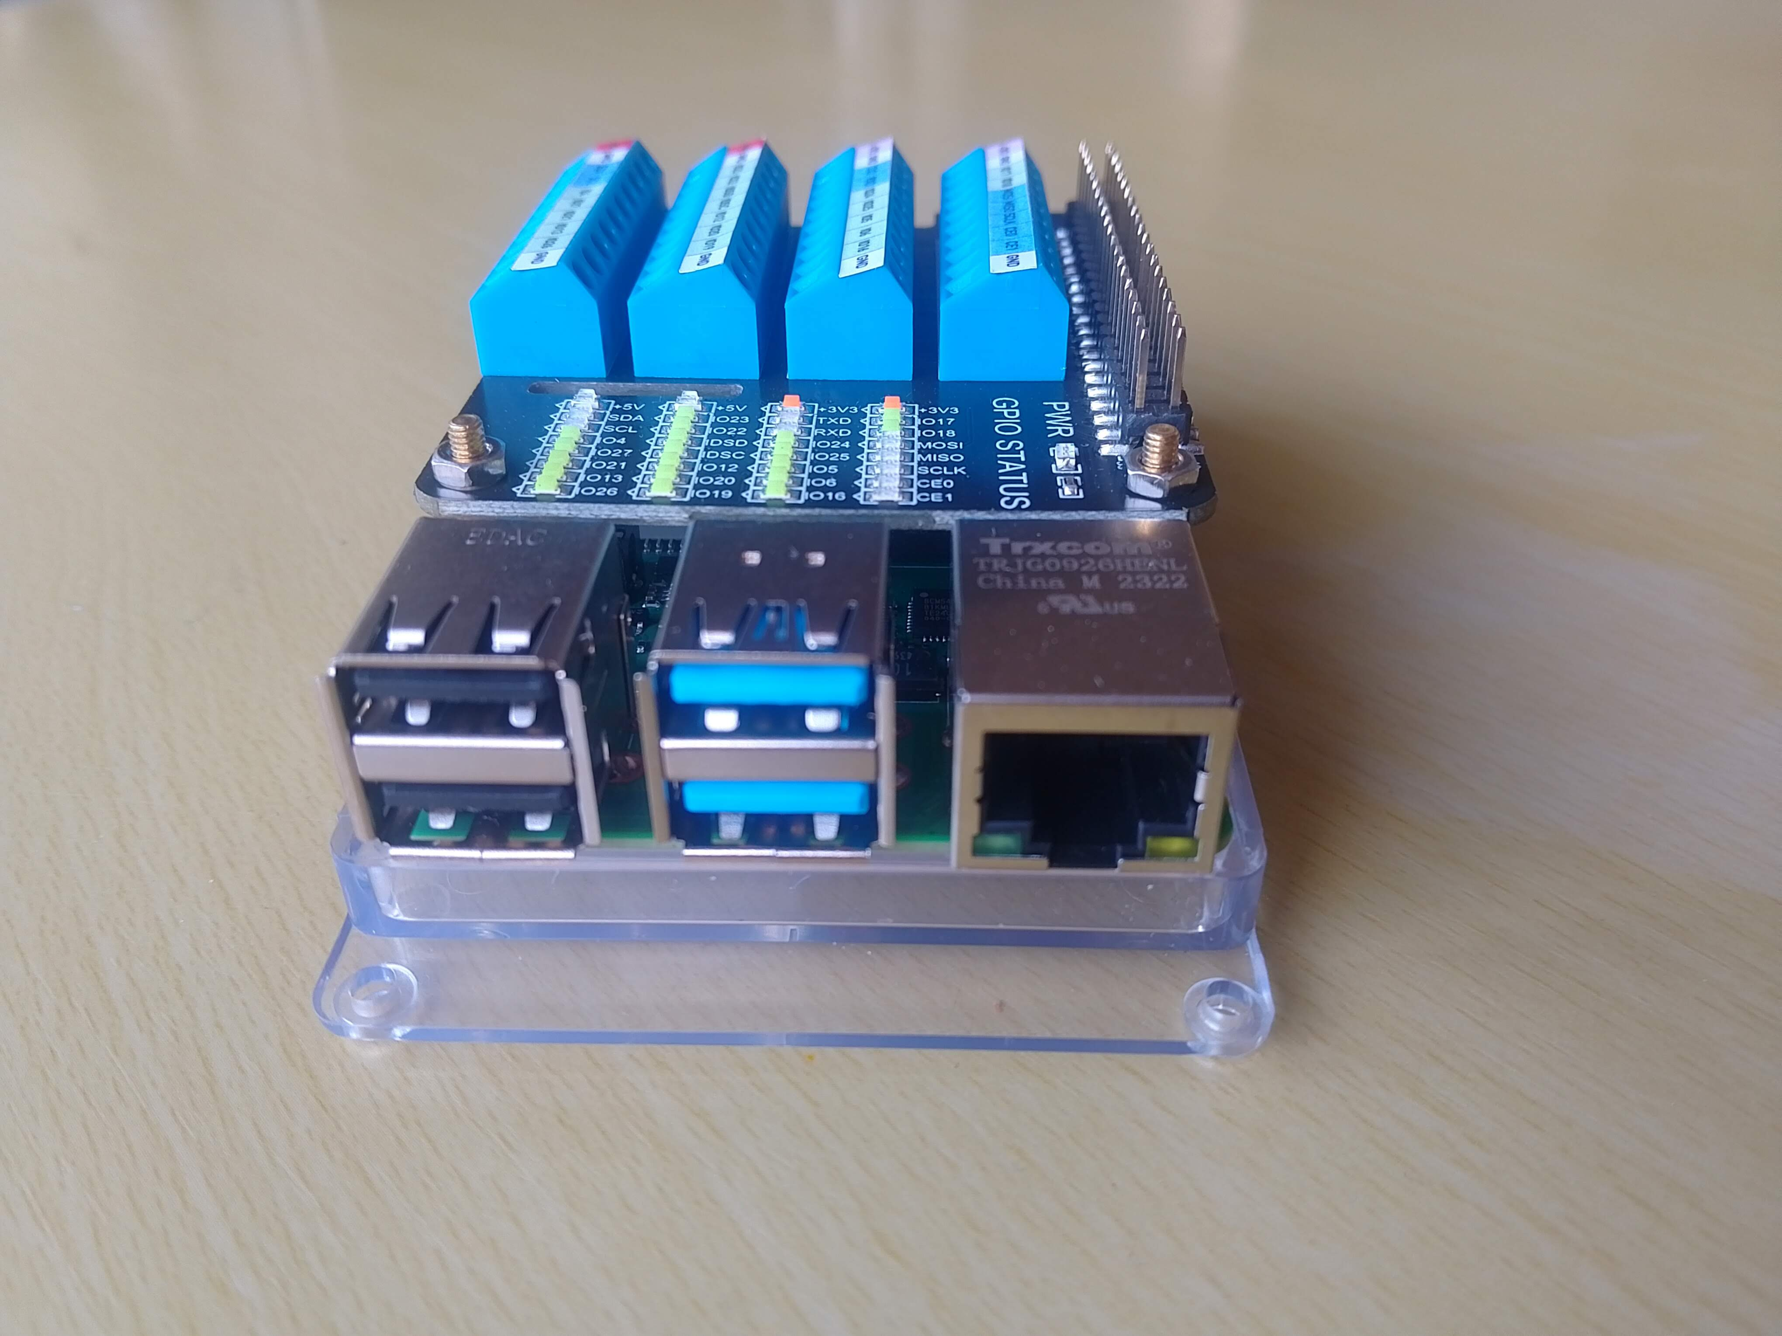
USB C
Power Supply
Socket
Micro-HDMI
ports
USB
Ports

Only ever use the power supply that comes with the system (or another official Raspberry-Pi USB-C power supply) – use of non compatible power supplies may damage the system.

Powering up the system
Once everything is connected, apply power to the system and wait for it to boot up into the desktop.
The Signalling Node is configured to run the DCC Signalling application on start-up (with a 5 second delay to allow the application startup to be aborted if required). To abort the application startup click in the Terminal Window to select it and press <CNTL-C>:
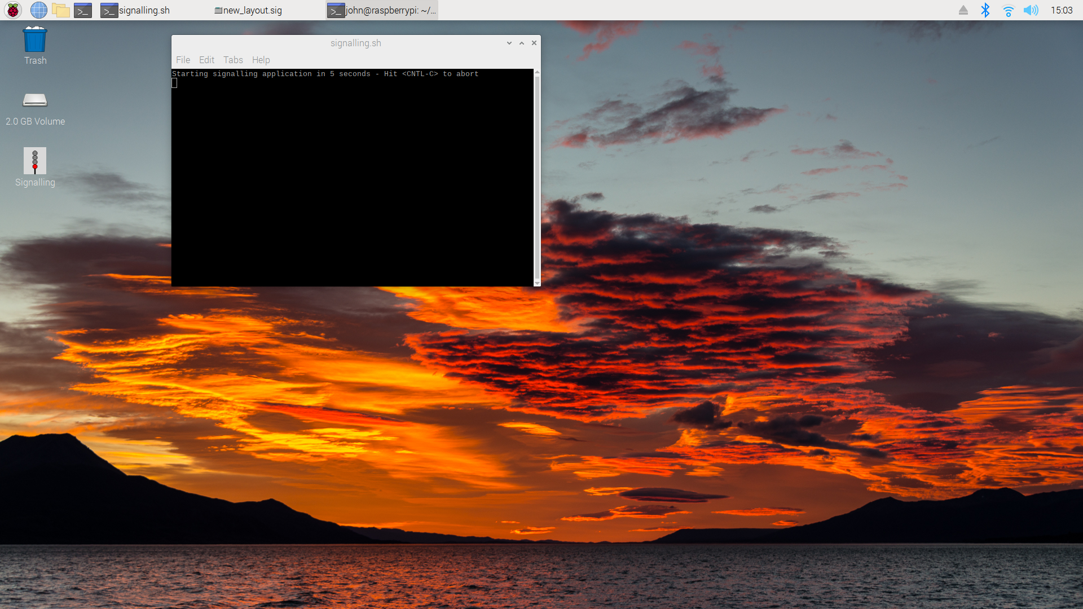
Terminal window
opened on startup to
run up application
Wi-Fi
Network
Selection
Main
Applications
Menu

If the start up sequence is not aborted , the application will open and load the default layout configuration file (‘/home/signalbox/Signalling/Files/sensor_node.sig’) :
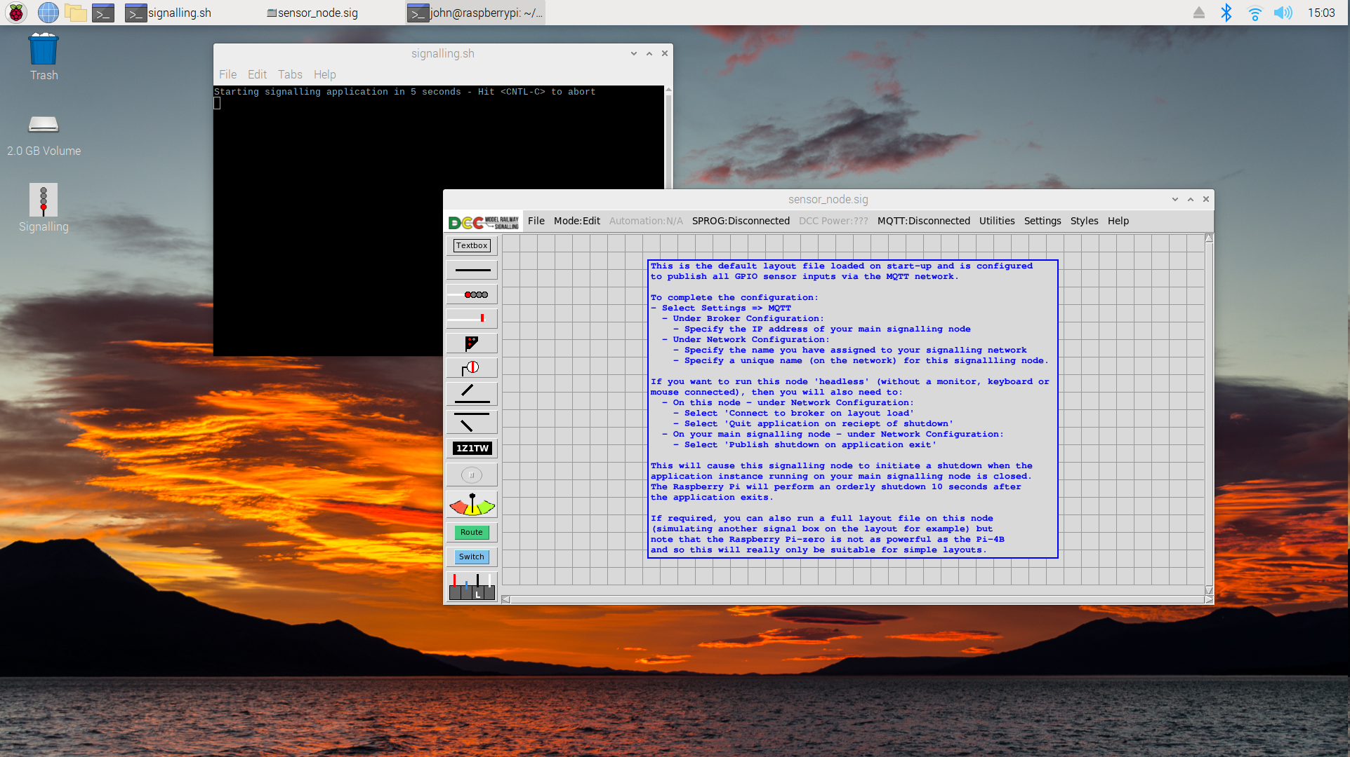

Similarly, when you close the DCC Signalling application, the system will power down after a 5 second delay (with the same opportunity to abort the shutdown by pressing <CNTL-C>).

Connecting to your Wi-fi network
To connect to your home Wi-Fi network:
- Click on the Network icon on the top right of the screen.
- Select your Wi-Fi network from the list of available networks.
- Enter your wireless password and click OK to connect.

Changing the default password
Additional Signalling Nodes are shipped with a default password of 'password1234' and are configured to boot-up without requiring this to be entered, To change the default password:
- Click on the “Raspberry Pi” icon in the top left hand corner of the screen to bring up the Main Applications Menu.
- Select Preferences and then Raspberry-Pi Configuration.
- On the System tab, select Change Password, enter and confirm the new password.
If you are intending to use the Additional Signalling Node as a ‘headless’ Remote Sensor Node (i.e. to be used without keyboard, mouse or monitor connected in normal operation - solely providing additional GPIO sensor inputs for the main DCC Signalling System) then you should never set ‘auto login’ (on the same configuration tab) to Disabled as auto start/shutdown relies on this.

Powering off the system – Important!
Like all computers, you should never just remove power without shutting down as it may corrupt the underlying operating system (rendering the system unusable). To power-off the system:
- Click on the “Raspberry Pi” icon in the top left hand corner of the screen to bring up the Main Applications Menu.
- Select Shutdown from the drop-down list to bring up the Shutdown Menu.
- Select Shutdown from the pop-up menu and wait for the system to shut down.
- After a few seconds, the power can then be removed from the system.

Note that the Additional Signalling Node can be configured to automatically shut down when you exit the DCC signalling application running on the main unit – this is covered later in the documentation. Once configured to do this, the Signalling Node can be used entirely ‘headless’ (without monitor, keyboard or mouse connected).

Updating the operating system
Like Windows (and other operating systems), the Additional Signalling Node should be regularly updated to keep it in the best condition but, unlike Windows, there is no automatic update facility and you therefore have to update the system manually. Do not fear, this is not complicated:
- A ‘download’ icon will appear on the right hand side of the taskbar when system updates are available to download and install .
- Click on the icon to either view the updates or download/install them.

- Re-boot the system for the updates to take effect

Important – If you ever see the following message (or similar) pop up during the install process then always select ‘Keep X’. If you switch to Labwc then performance of the signalling application will be significantly compromised:



Updating the signalling application
The Additional Signalling Node runs exactly the same software as the DCC signalling System and you are always encouraged to use the latest version to benefit from any new features and bug fixes.
Release 5.2.0 and above of the application includes an application upgrade utility to check for and install the latest version of the software. This can be accessed from the Main Menubar ( Utilities => Application Upgrade).
If upgrading from Release 5.1.0 or below you should upgrade as follows:
- Check the latest published version at: https://pypi.org/project/model-railway-signals/.
- Check the currently installed version by opening the application and selecting Help and then About from the main menubar at the top of the application window.
- If there is a newer version available then you can upgrade by opening a Terminal window (double click on the Terminal icon top left corner of the screen next to the “Raspberry Pi” icon) and typing in the following command:
    - sudo pip3 install --upgrade model-railway-signals
- If you get the error message “error: externally-managed-environment“ then try the following:
    - sudo pip3 install --upgrade –break-system-packages model-railway-signals
Note the two hyphens in front of each command line argument.
In the unlikely event you ever need to ‘roll back’ the version then this can be achieved as follows:
- sudo pip3 uninstall model-railway-signals
- sudo pip3 install model-railway-signals==x.y.z
where x.y.z is the application version to install (e.g. 4.9.0)

Backing up your files
Files on your system can be easily backed up (or copied between computers) using USB memory sticks. When a USB stick is plugged into the system, a pop-up window will appear asking if you want to open the device in a file manager window. Once open, files can then be copied as required.
Warning – one major difference to Windows is that you should never just unplug a USB stick as this may corrupt the device. Memory sticks should first be 'ejected' by clicking on the 'eject' icon (that will appear at the top of the screen whenever a USB stick is inserted). Once ejected, the USB stick can be safely unplugged.

Backing up your system
As with all computers, it is good practice to make regular backups of the entire system for disaster recovery purposes (so you can restore it in the unlikely event of fatal system crashes).
To back up your system we would recommend that you use 32GB Micro-SD cards (which are relatively inexpensive and widely available). In the event of a failure, the internal Micro-SD card (running the system) can then simply be swapped out for the backup Micro-SD card, to get you back up and running in the shortest possible time.
To perform a backup, you will also need a USB Micro-SD reader/writer (not supplied with the system but readily available at minimum cost):
- Close all open applications.
- Plug the backup Micro-SD card into the USB adapter and plug the USB adapter into one of the USB ports.
- Click on the “Raspberry Pi” icon in the top left hand corner of the screen to bring up the Main Applications Menu.
- Select Accessories and then SD Card Copier to open the copier application.
- For the 'copy from device', select the internal Micro-SD – this will normally appear at the top of the drop-down list as 'Y016U (/dev/mmcblk0)' or similar.
- For the 'copy to device', select the new Micro-SD card.
- Perform the backup – and then keep the backup in a safe place.
In the unlikely event you ever need to restore the system, contact DCC Model Railway Signalling (https://www.model-railway-signalling.co.uk/) for advice.

Running up the signalling application
As previously mentioned, the Signalling Node is supplied pre-configured to open the DCC Signalling application on power-up and load the default layout file (‘sensor_node.sig’) unless aborted by the user (during the 5 second period from boot to application start).
Alternatively, you can just double click on the desktop icon to open the application.

Disabling application auto-start
If you want to disable the auto-start functionality then:
- Open a File Manager window and select View => Show Hidden Files
- Navigate to the /home/signalbox/.config/autostart folder
- Rename the ‘signalling.sh’ file to ‘signalling.sh.old’
To re-enable at any time, simply re-name the file back to ‘signalling.sh’.

Connecting external track sensors
As the Signalling Node is based on the same base-hardware as the DCC Signalling System, the method of connecting external Track Sensors into the unit is identical.
To trigger an event, the appropriate GPIO input pin needs to be momentarily connected to one of the 0V supply pins. These are all made available via screw terminals on the top of the unit.

0V DC
(GND)
GPIO
Input 4
GPIO
Status
LEDs

Note that only a subset of GPIO ports are available for use by the application (open the application and select Settings and then GPIO to bring up a list of supported inputs). Also, not all available GPIO ports are explicitly identified on the GPIO header as some ports can support alternative functions (if the Raspberry Pi is configured to use these alternative functions).
To identify these pins, please refer to the diagram overleaf, which provides a translation between the basic GPIO port identifiers and the ‘alternative’ functions – for example, the CE0 and CE1 pins on the screw terminal header map to GPIO 8 and GPIO 7 respectively.
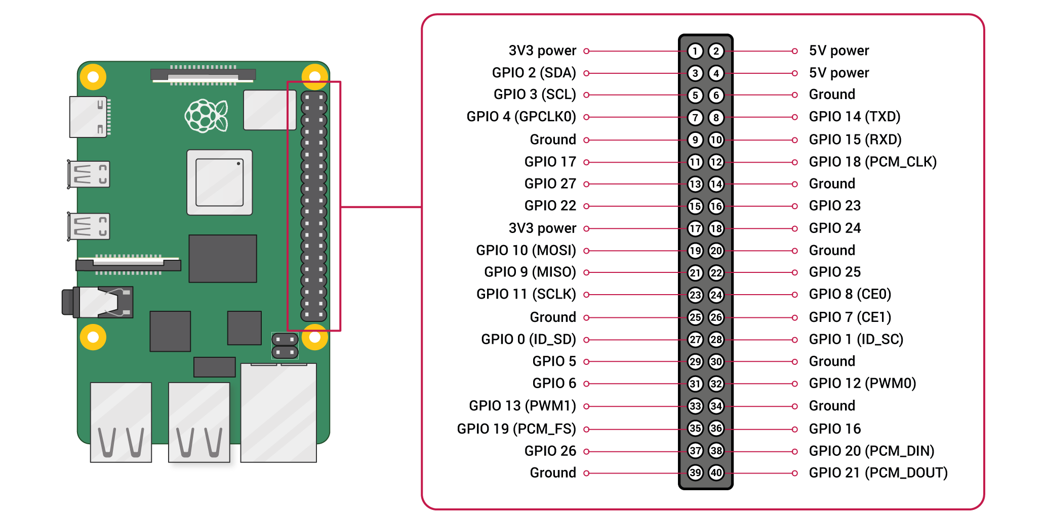

Type of external track sensors
As a reminder, track sensors that provide a floating (electrically separated from all other devices) ‘normally-open’ (momentarily closed when triggered) output are recommended as these can be connected directly between the appropriate GPIO input terminal and one of the 0V DC terminals.
Other types of Track Sensors should never be connected to the unit or this could (almost certainly will) damage the system irreparably. In these cases, external opto-isolator circuits are recommended to protect the GPIO input pins.
Never connect track sensors to the unsupported GPIO inputs or to the +5V terminals (red) or the +3.3V terminals (pink) or this could damage the system irreparably.
The connection into the screw terminals on top of the unit should be the last connection you make, and with the unit powered off. Always power off the unit and disconnect it from your layout for any subsequent layout wiring changes. As an cautionary tale, I managed to trash a couple of GPIO inputs whilst re-soldering a some intermediate sensor connections. It turns out the soldering iron I was using wasn’t particularly “ESD Safe” and must have introduced a spike large enough to cause damage – you have been warned!!!!

Configuring the System
The Signalling Node interfaces with the DCC Signalling System via your home WiFi network, so both the Signalling Node and the DCC Signalling System will need to be connected to the network and then configured to be part of the same “Signalling Network”.
Full information can be found in the DCC Signalling System Networking Guide (packaged with the application: select Help => Docs from the Main Menubar).
The main steps are summarised below for convenience:

Establishing Network Connectivity
On the Main DCC Signalling System:
- Open the MQTT configuration window (Settings => MQTT ) and select the Network tab.
- Check the Broker configuration is set to an Address of 127.0.0.1 and the Port is 1883 (this is the local broker installed on the DCC Signalling Network).
- For the Network Configuration, choose a Network name for your Signalling Network, and a unique Node name for the main DCC Signalling System
- Apply the configuration.
- Connect to the Broker, either by clicking the Test Broker Connectivity button or by clicking on the MQTT button on the Main Menubar and selecting Connect. If successful then the MQTT status (on the main menubar) should show as Connected.
- Find the local IP address of the main DCC Signalling system by selecting the Status tab of the MQTT configuration window. The IP address should be displayed with the ‘last seen’ time in green (if it doesn’t appear straight away, try clicking Refresh Display).
On the Signalling Node:
- Open the MQTT configuration window (Settings => MQTT ) and select the Network tab.
- Under Broker Configuration, change the set the Address to the Address of the main DCC Signalling node (identified in the previous steps). The Port should be set to 1883.
- For the Network Configuration, enter the same Network name that you set for the DCC Signalling System, but then choose a unique Node name for the Signalling Node.
- Apply the configuration.
- Connect to the Broker, either by clicking the Test Broker Connectivity button or by clicking on the MQTT button on the Main Menubar and selecting Connect. If successful then the MQTT status (on the main menubar) should show as Connected.
If successful then the Status tab of the MQTT configuration window on both systems should show both ‘Nodes’, with the ‘last seen’ time in green (try clicking Refresh Display).

Using Remote GPIO Sensors
The default layout file for the Signalling Node (loaded on power-up/application startup) assigns ‘GPIO sensors’ to each of the available GPIO Ports and then ‘publishes’ all events to the network:
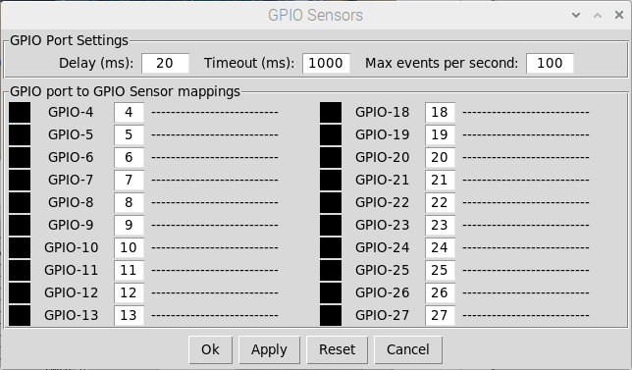

All ‘GPIO Sensors’ are published to the signalling network
All GPIO Ports are mapped to ‘GPIO Sensors’

To use these ‘Remote GPIO Sensors’ in your layout configuration, you first need to ‘subscribe’ to them (as ‘nodename-itemid’) in your layout configuration (running on the main DCC Signalling System). They can then be used to trigger signal or track sensors events on your schematic
The following example configuration assumes you have assigned a Node name of ‘RSN1’ for your Additional Signalling Node (in its Network Configuration).
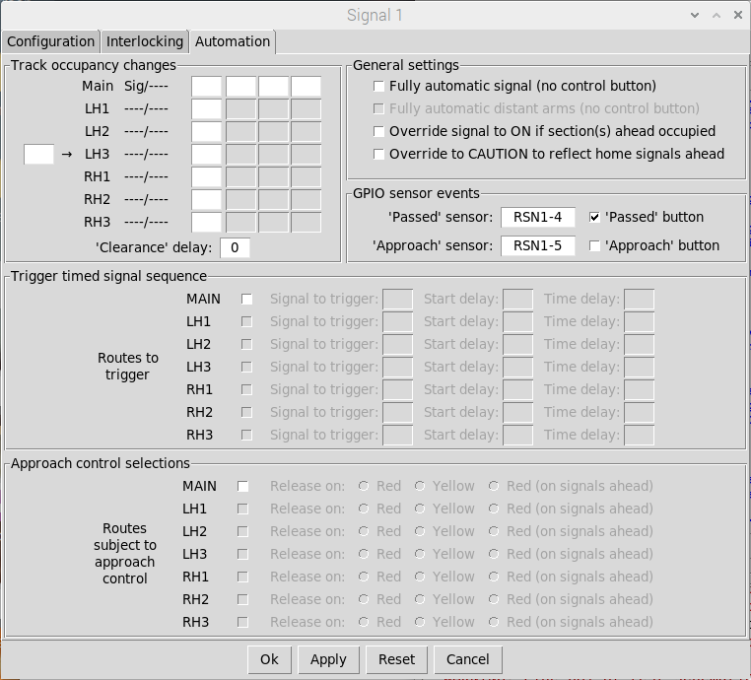

Once subscribed, the Remote GPIO sensors can be used within your layout configuration
Here we have subscribed to a subset of the GPIO Sensors being published by the Remote Sensor Node

Configuring Headless Operation
As mentioned in previous sections, the base-configuration of the Signalling Node is supplied pre-configured to automatically start when power is applied and shutdown when the application exits.
If you require ‘headless’ operation (e.g. if using solely as a Remote Sensor Node), then further configuration is needed to connect to the MQTT broker on layout load and set the application to shut down when it receives a shutdown signal from the main DCC Signalling System.
On the Signalling Node:
- Open the MQTT configuration window (Settings => MQTT ) and select the Network tab.
- Under Network Configuration select Connect to broker on layout load
- Under Network Configuration select Quit application on receipt of shutdown. This will cause the Signalling Node to shut down on receipt of a network shutdown message.
- Apply the changes
On the main DCC Signalling System:
- Open the MQTT configuration window (Settings => MQTT ) and select the Network tab.
- Under Network Configuration select Publish shutdown on application exit. This will cause the DCC Signalling System to issue the network shutdown message.
- Apply the changes


Additional Signalling Node Auto Shutdown Configuration
DCC Signalling System Configuration

The configuration should then be tested to ensure the Signalling Node starts-up and shuts-down correctly before disconnecting the keyboard, mouse and monitor to run it its ‘headless’ mode.

Useful Links

- https://www.model-railway-signalling.co.uk/ - The homepage for the DCC Signalling System providing details of how you can about obtain further information and support.
- https://pypi.org/project/model-railway-signals/ - the Python Package Index page for the signalling application, providing details of the latest published version.
- https://signalbox.org/ - Comprehensive information on signal types and the ‘Block System’ and a vast library of signal box diagrams for you to draw inspiration.
- https://en.wikipedia.org/wiki/UK_railway_signalling – A useful starting point for research to increase your knowledge of British railway signalling practice (its Wikipedia after all).
- http://www.railway-technical.com/signalling/ - A section of the Railway Technical Website covering signalling. There are many great resources on these pages including:
  - http://www.railway-technical.com/signalling/infopaper-6-basic-railway.pdf – A useful paper (downloadable pdf format) on basic railway signalling.
  - http://www.railway-technical.com/signalling/british-signalling--what.pdf – A useful paper (downloadable PDF) on “What the driver sees”.
- https://www.sprog-dcc.co.uk/ - The SPROG DCC web site containing details of their other products (the DCC signalling system uses the Pi-SPROG3-V2 for its DCC interface).

