2DX4: Microprocessor Systems Project

Final Project

Instructors: Dr. Bruce, Dr. Haddara, Dr. Hranilovic, Dr. Shirani

John Ha – L06 – haj9- 400182107

As a future member of the engineering profession, the student is responsible for performing the required work in an honest manner, without plagiarism and cheating. Submitting this work with my name and student number is a statement and understanding that this work is my own and adheres to the Academic

Integrity Policy of McMaster University and the Code of Conduct of the Professional Engineers of Ontario. Submitted by **[John Ha, haj9, 400182107]**

Final Project Interview Links

Question 1: <https://drive.google.com/open?id=1kHkOYwAXWd1oTCO7OxliSSaSJFxhCqti>

Question 2: <https://drive.google.com/open?id=1zqvyj033b8ot-90_4y-H1bqKrtFUML6s>

Question 3: <https://drive.google.com/open?id=1mzUrrjJlZ6kNrJ5_VhvqOXAXDZS2DmZy>

Note: Permission granted to McMaster gmail accounts only

Device Overview

**Features**

* Onboard push button to start the 360° distance measurement
* Onboard LEDs to display status of the distance measurement
* VL53L1X ToF sensor with up to 400cm distance measurement
* VL53L1X ToF sensor with up to 50Hz ranging frequency
* MSP_EXP432E401Y microcontroller with an operating voltage of 3.3V – 5V
* MSP_EXP432E401Y microcontroller uses C language and Assembly
* Baud rate of 115200 bps
* Total cost of ~$150

**General Description**

When the device is plugged into a PC with RealTerm running, pushing the onboard button will start the stepper motor to rotate 360° and give distance measurements from the ToF sensor, which can measure distances up to 400cm. These values will automatically display onto RealTerm allowing for the data to be copied and pasted onto Excel to allow for converting the large cluster of data to xyz coordinates. Afterwards, an xyz file is created and can be modelled in your preferred method, such as MeshLab, Python, MATLAB, etc.

**Block Diagram**

3D Model (.stl)

Modelling Software (MeshLab, Python, MATLAB, etc.)

28BYJ-48 Stepper Motor + VL53L1X ToF Sensor

Data Processing (Excel)

PC (RealTerm)

MSP-EXP432E401Y Microcontroller

Device Characteristic Table

|  |  |
| --- | --- |
| MSP-EXP432E401Y Microcontroller | The central communication device to send and receive data to and from the other devices. It contains the C code used to direct the sensor and motor. |
| VL53L1X ToF Sensor | Operates up to 400kHz with an operating voltage of 2.6V – 3.5V. |
| MPU-9250 IMU Sensor | Operates up to 400kHz with 1MHz SPI serial interface. (Due to circumstances, the part was withheld from the project) |
| 28BYJ-48 Stepper Motor | Operates in half-step rotation with an operating voltage of 5V. The inner motor rotates 4 phases before the outer motor rotates. |
| Button | Operates by using polling. The button starts the stepper motor and ToF sensor. |
| RealTerm | Allows communication between the microcontroller and the PC. Receives the ToF sensor data to be imported to Microsoft Excel. |
| Microsoft Excel | Spreadsheet software to perform mathematical functions on large sets of data. Used to process the raw data set and convert to xyz coordinates for modelling. |
| MeshLab | 3D mesh processing software with many tools to create models from data |

Detailed Description

**Distance Measurement**

The Time-of-Flight sensor performs distance measurements by emitting a laser at a constant velocity to a surface and returning back to the sensor. This is calculated by applying the basic principle of motion v = d/t. Since the laser radiates outwards and comes back to the sensor, the distance is 2d. Therefore, solving for d we get d = (vt)/2 which is how the sensor calculates the distance. This data is then transmitted to the PC through UART and RealTerm which would display the measured data in real time. This data is transferred to Excel to allow for data processing of large sets of data. Excel was used to convert each distance measurement to xyz coordinates to allow for modelling later on. The formula to convert to the z coordinate is distance x COS(motorPosition x 0.703125 x pi/180). For the y coordinate, the sin function was used instead. Finally, these coordinates were saved into an xyz file and modelled in MeshLab.

The preceding paragraph describes the ideal design considering all hardware to be fully functional. My design could not be fully implemented due to a faulty ToF sensor.

**Displacement Measurement**

An IMU measures and reports orientation and velocity by using built-in accelerometers and gyroscopes. This means the IMU would have measured displacement by sensing movement and reporting it. Keep in mind that the IMU must be oriented along the x-axis and stable. Due to the COVID-19 outbreak, displacement was measured manually by taking a step forward and measuring the distance. This was reported as the movement along -x.

**Visualization**

OS: Windows 10 (64-bit)

Processor: Intel(R) Core(TM) i5-7200U CPU @ 2.50GHz 2.70GHz

RAM: 8.00GB

MeshLab Ver. 2020.03

MeshLab is an open source mesh processing system with many tools to allow for quick and easy 3D modelling. It uses data stored in xyz file format to display the points on the coordinate system. Point cloud simplification and ball pivoting was applied to the points to create the 3D model. Point cloud simplification removes redundant points allowing for less memory used and providing a more efficient point cloud. Ball pivoting is an algorithm that reconstructs the surface of the model and produces the final 3D visualized model.

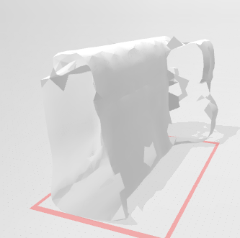

Application Example

1) Plug the microcontroller into any USB slot. The microcontroller should automatically turn on.

2) Download the RealTerm application and go to the “Port” tab to ensure the baud rate is set to 115200. The correct port should be automatically selected if the microcontroller is plugged in. Do not forget to press the “Change” button after configuring the settings.

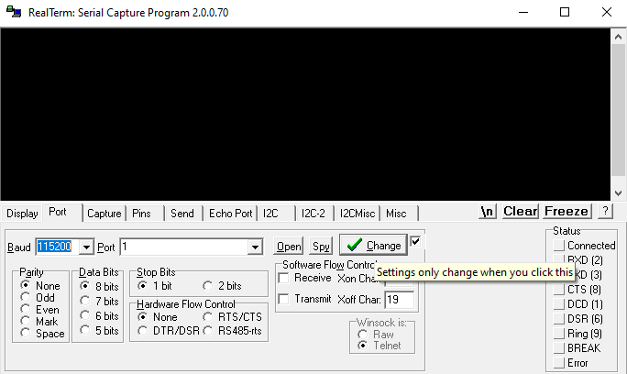

3) Hit the external button to begin the scan. The measurements will display onto RealTerm in real time. After one full scan is complete, move forward (-x direction) and begin another scan to collect sufficient data. Make sure to record the distance that was moved forward as data for the x-axis. Repeat this step until sufficient data is collected. Horizontal measurements are recorded on the z-axis and vertical measurements are recorded on the y-axis.

4) Copy and paste the cluster of data onto Excel to process it. For each point, apply the COS and SIN function to convert to xyz coordinates.

5) Export these coordinates to an xyz file format by renaming a NotePad file extension to .xyz.

6) Download MeshLab and open the xyz file. Apply Point Cloud Simplification and Ball Pivoting to obtain the 3D model.

7) Save the model in the file of your choice, such as .stl.

Limitations

1) The limitation of the microcontroller could reduce accuracy of numbers during rounding. This is especially evident when using small angle increments as this results in further rounding errors.

2) The maximum quantization error for the ToF sensor is 8 bits and the maximum quantization error for the IMU sensor is 16 bits.

3) The maximum standard serial communication rate was 115.2kbps. I verified this by trying to implement a higher kbps but this did not work. Additionally, lowering the kbps slows everything down.

4) The communication method used between the microcontroller and ToF is I2C, effective for short-ranged communication. The speed is 1M bps.

5) The UART baud rate will be the primary limitation on speed because you can set 400kbps on the microcontroller and ToF but the maximum UART baud rate is 115.2kbps.

6)

Circuit Schematic

Programming Logic Flowchart(s)

End

Start stepper motor and ToF scan

End

Wait for button press

Initialize PortN for ToF, PortM and PortE for button, and PortH for stepper

Start