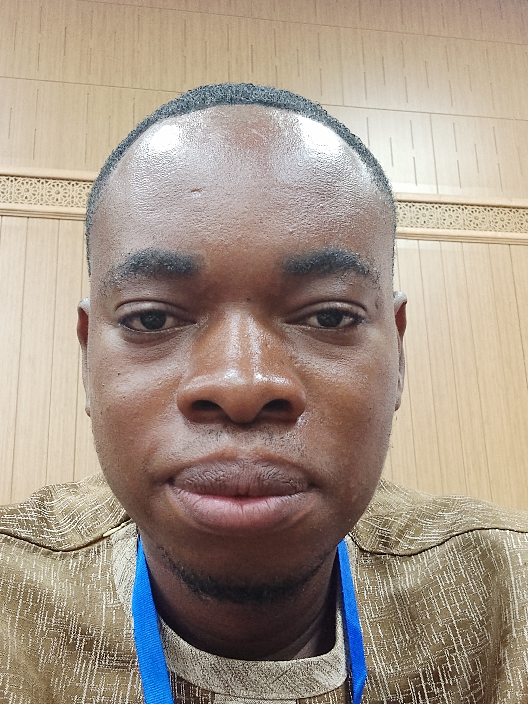
John | +233555731434 | johnsenanu36@gmail.com

About_me
A computational neuroscientist interested in unravelling molecular mechanisms that underpin neurological conditions using computational appproaches. To this end, we are exploring programming languages

Work experience
University of Ghana 2018-2019
Using meta search to conduct systematic literature reviews on spexcific topics of interest
Entrance University 2020-2022
Biochemistry Lecturer teaching both theory and practicals

Skills
- Programming
- Polymerase chain reaction
Machine Learning 2023-2024
An AL programmer to classdify diseases, gender

Skills
- Python
- R programming

