**CMSI 498 – Assignment 1**

**[30 Points]**

**Instructions:**

This worksheet gives you some important practice with the basics of causal inference, including the distinction between observational and experimental queries, and practice with both fully- and partially-specified Structural Causal Models (SCMs). Specific notes:

* Provide answers to each of the following questions and write your responses in the blanks. If you are expected to show your work in arriving at a particular solution, space will be provided for you.
* Place the names of your group members below:

**Group Members:**

1. **______________________________________________________**
2. **______________________________________________________**
3. **______________________________________________________**
4. **______________________________________________________**

**Problem 1 – Causal Bayesian Networks**

Causal models have a lot of utility in policy analysis, wherein their parameters are based off of large datasets that can be used in pursuit of informing systemic decisions, and determining how the effects of those decisions can affect a variety of variables. Some (actual) studies have pursued causal modeling for assessing political issues like (in the present example) causal factors that lead to terrorism.

Consider the following toy example with factors that have been studied as predictors of terrorist activity:

|  |  |  |
| --- | --- | --- |
| $$P=political system$$ | $$F=foreign intervention$$ | $$W=\text{weapon availability}$$ |
| $$R=\text{regional instability}$$ | $$E=\text{education level}$$ | $$T=\text{terrorist activity}$$ |

From these, we collect data across a variety of studies (the origin of which we’ll discuss in future sections) and produce the following Causal Bayesian Network (CBN):

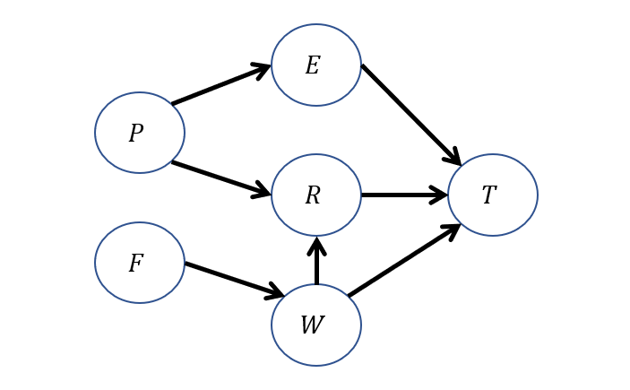

* 1. Write the Markovian Factorization of the joint distribution for the CBN above.

|  |
| --- |
|  |

* 1. Determine if any of the following *associational* queries can be simplified. Write their most-simplified version in the right column.

|  |  |
| --- | --- |
| **Original Query** | **Simplified Version** |
|  |  |
|  |  |

* 1. Translate the following English sentence into a query, then, detail the enumeration inference steps you would use to solve it if you were given the CBN CPTs:  
     “What is the likelihood of there being terrorism $\left(T=1\right)$ in nations with low education $(E=0)$ and ample access to weapons ?

|  |
| --- |
|  |

* 1. Translate the following English question into a *causal* query, and then draw the interventional subgraph $G_{x}$ that it would operate within.

|  |  |
| --- | --- |
| **Sentence** | “What would be the likelihood of terrorism $\left(T=1\right)$*if* a UN Peacekeeping mission restored region stability $\left(R=1\right)$ to regions with low education $\left(E=0\right)$?” |
| **Causal Query** |  |
| **Interventional Subgraph** |  |

* 1. For the query in (1.4), detail the enumeration inference steps you would use to solve it if you were given the CBN CPTs, using the interventional subgraph that you found above.

|  |
| --- |
|  |

* 1. For each of the following pairs of causal & associational queries, determine if the two are equal or not [Hint: this is equivalent to asking if the dependence between the *observed* evidence and any nodes that the query depends on in the original vs. interventional subgraph are the same].

|  |  |  |
| --- | --- | --- |
| **Causal Query** | **Associational Query** | **Equivalent?** |
|  |  |  |
|  |  |  |

* 1. For each of the following English sentences, provide an expression that would compute the quantity requested.

|  |  |
| --- | --- |
| **Sentence** | **Expression** |
| “What causal effect does Education (0 = no college, 1 = college) have on the presence of Terrorism (T = 1)?” |  |
| “With what greater risk of Terrorism (T = 1) is an unstable region (R = 0) compared to a stable one (R = 1)?” |  |

**Problem 2 – Fully-Specified SCMs**

SCMs can be used to make complex inferences from narratives and logical relationships. To see this in practice, it’s time for you to cross off a rite of passage in the study of causal inference: the bizarre and grim Firing Squad example. I once asked a lab mate why this made it into the textbook / several papers to which he replied, “Scientists are weird.” So anyways, here it is so you can share in the collective shock and bemusement of students before you:

Rarely, prisoners whose crimes have been deemed egregious enough by the court marshal are put in front of the firing squad. The mechanics of this are unsurprising: A Court Verdict [$V=\left\{innocent, guilty\right\}=\{0,1\}$] is issued for the firing squad, after which a captain of the guard [$C=\left\{abstains,signals\right\}=\{0,1\}$] gives the signal for 2 soldiers [$S_{1},S_{2}=\left\{abstain,fire\right\}=\{0,1\}$] to fire. Both are good shots, so if either fire, the prisoner will die [$D=\left\{alive,dead\right\}=\{0,1\}$]. However, soldier 2 is a bit nervous [$N=\left\{steady, nervous\right\}=\{0,1\}$] and tends to fire sometimes independent of the captain’s order. The SCM modeling this scenario is defined as follows:

$$M: \\ U=\left\{V,N\right\} \\ V=\left\{C,S_{1},S_{2},D\right\} \\ P\left(u\right)=\left\{P\left(V=1\right)=0.1;P\left(N=1\right)=0.2\right\} \\ F=\{ \\ C←f_{c}\left(V\right)=V \\ S_{1}←f_{s_{1}}\left(C\right)=C \\ S_{2}←f_{s_{2}}\left(C,N\right)=C ∨N \\ D←f_{d}\left(S_{1},S_{2}\right)=S_{1}∨S_{2} \\ \}$$

**2.1.** Draw the graphical model associated with the SCM $M$ as defined above.

|  |
| --- |
|  |

**2.2.** From the SCM $M$, find the CPTs that would be associated with each endogenous variable given their parents.

|  |
| --- |
|  |

**2.3.** Using the above, compute the likelihood that a guilty prisoner dies if soldier 1 has a change of heart and becomes a hippy (i.e., compute $P\left(D=1 | do\left(S_{1}=0\right),V=1\right)$

|  |
| --- |
|  |

**Problem 3 – Causality and Cognition**

Here are some questions to pique your curiosity following our guest lecture from Dr. Hellige… and beyond! A simple paragraph will suffice for each of the following.

**3.1.** As a group (or solo if you’re working as such!), what were (a) your favorite parts about Dr. Hellige’s lecture, and (b) how do you believe they tie into the study of causality as a model of (key parts of) cognition?

|  |
| --- |
|  |

**3.2.** Check out the Wikipedia page of Cognitive Biases and pick one that you find interesting or amusing. Provide a summary of it, and reflect: why do you think that humans suffer from these? (<https://en.wikipedia.org/wiki/List_of_cognitive_biases>)

|  |
| --- |
|  |