MANNA GOODNEWS ACADEMY
Education Management System (MGAEMS)

Entity Relationship Diagram (ERD)

Document Version 1.0
Prepared: July 31, 2026
Status: Draft for Review

1. Purpose & Notation
This document presents the logical Entity Relationship Diagram (ERD) for MGAEMS, split into four related views for readability: Academic & Student Records, HR & Staffing, Sponsorship & Partnerships, and Communication/Visitor/Audit. Each entity is shown with its primary key (PK) and foreign keys (FK); relationship lines are labeled with cardinality (e.g., 1:N, 1:1). The full, normalized column-level schema is provided in the companion Database Schema document.
Color key:
- Navy — general reference/operational entities
- Gold — students (the central entity of the system)
- Green — staff (teaching and non-teaching)
- Purple — sponsorship-related entities

2. Academic & Student Records ERD
Covers the academic calendar, class/stream/subject structure, teacher allocation, timetabling, the student record itself, guardians, medical information, documents, promotions/transfers, assessments, report cards, and learner attendance.
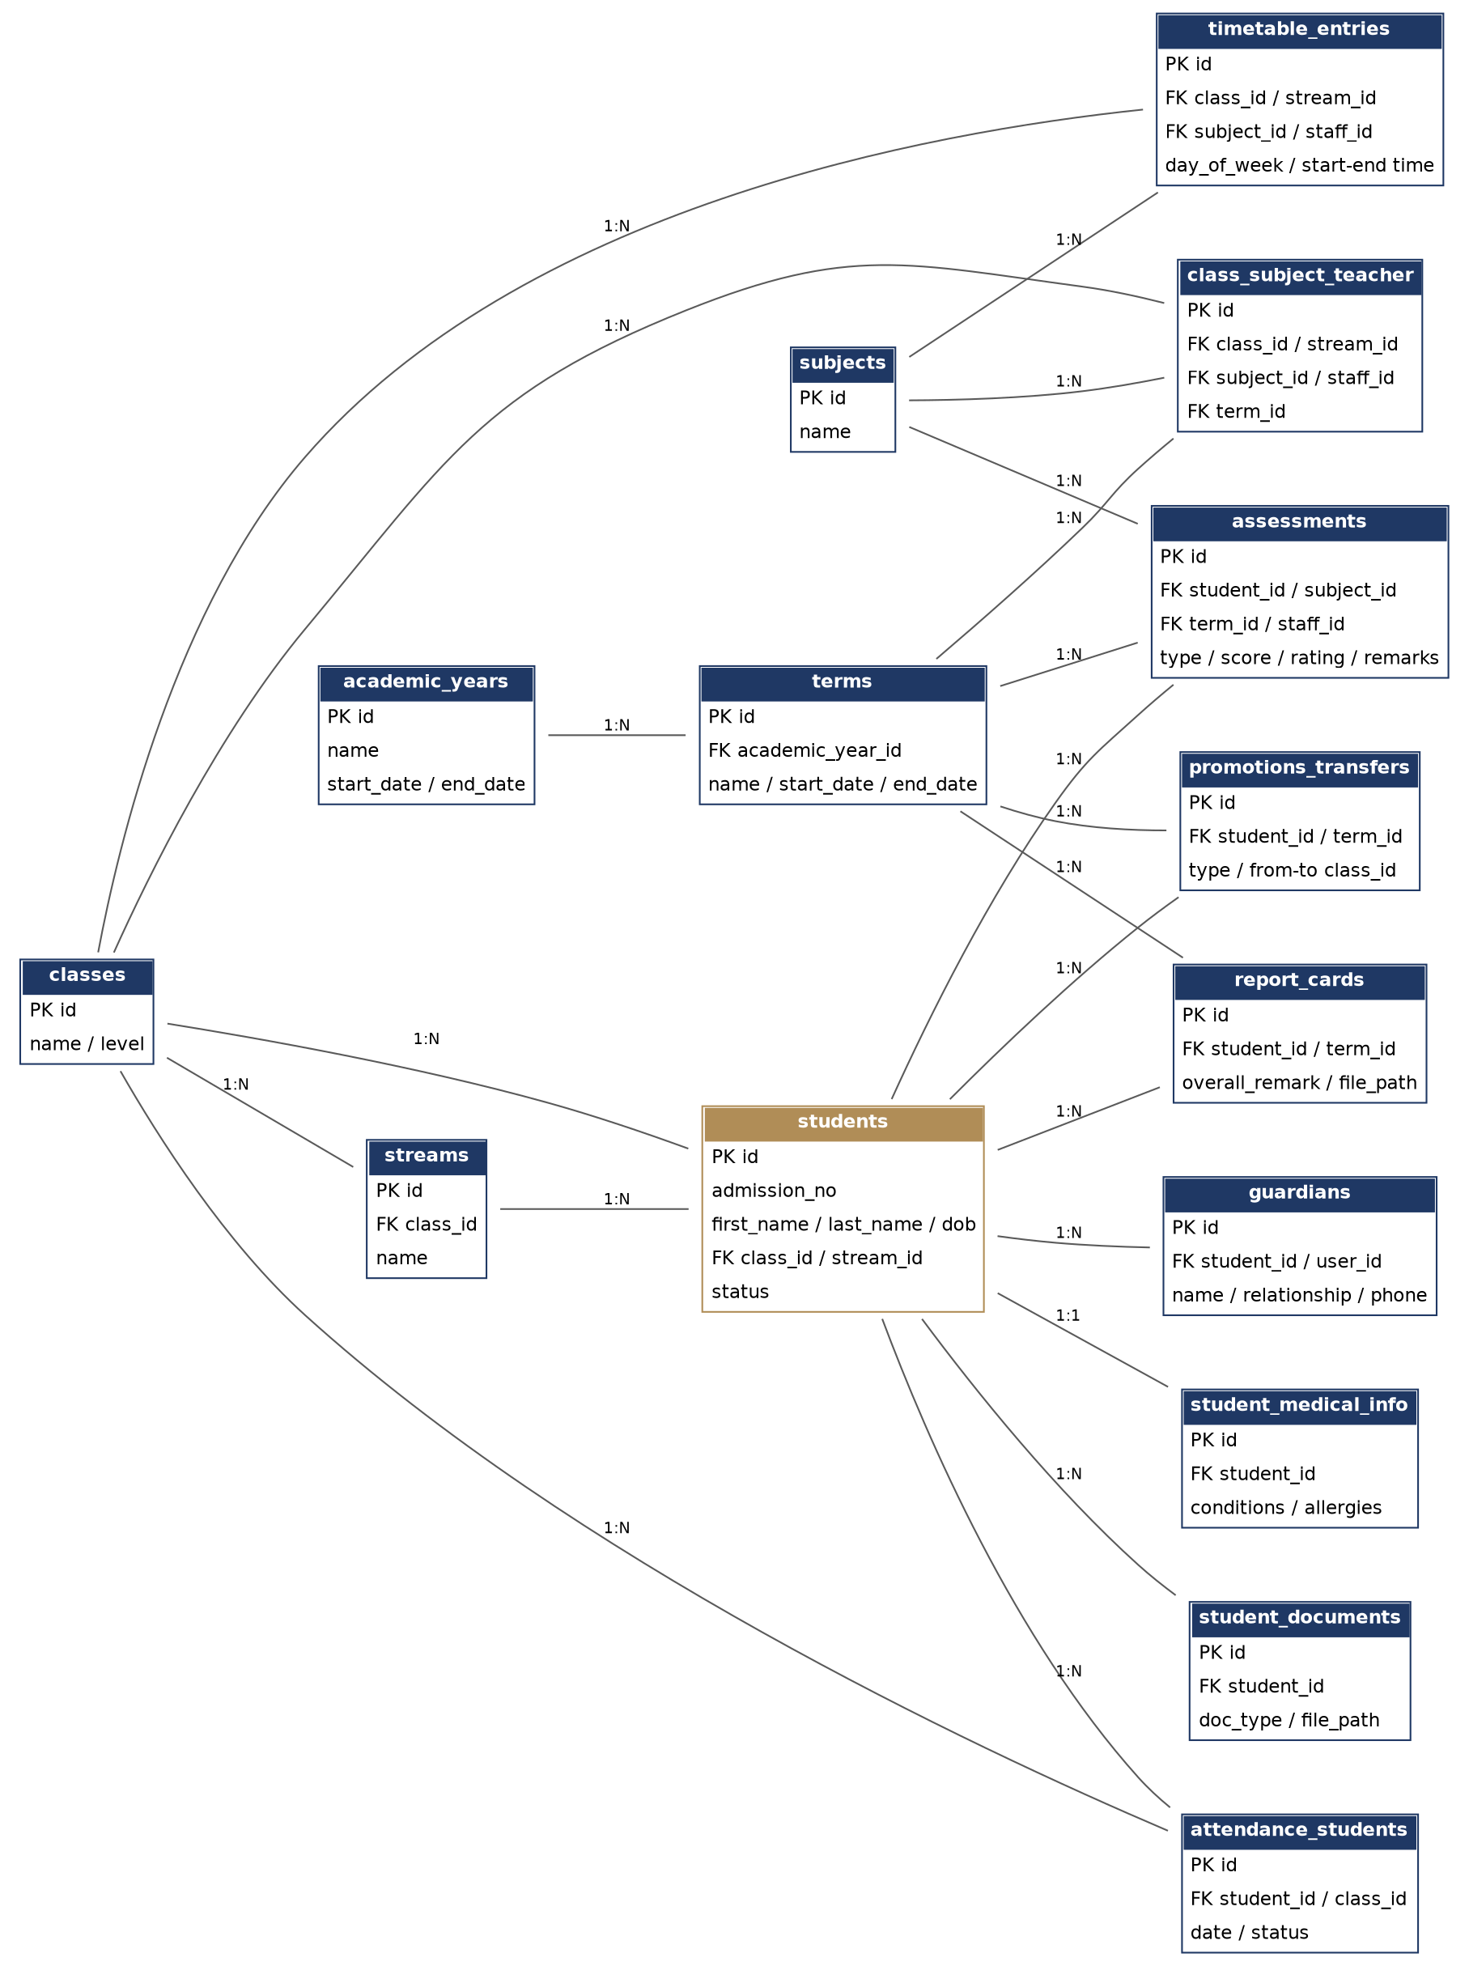
Figure 1 — Academic & Student Records ERD

3. HR & Staffing ERD
Covers user accounts and roles, departments, and full staff records for both teaching and non-teaching staff, including qualifications, documents, emergency contacts, and staff attendance.
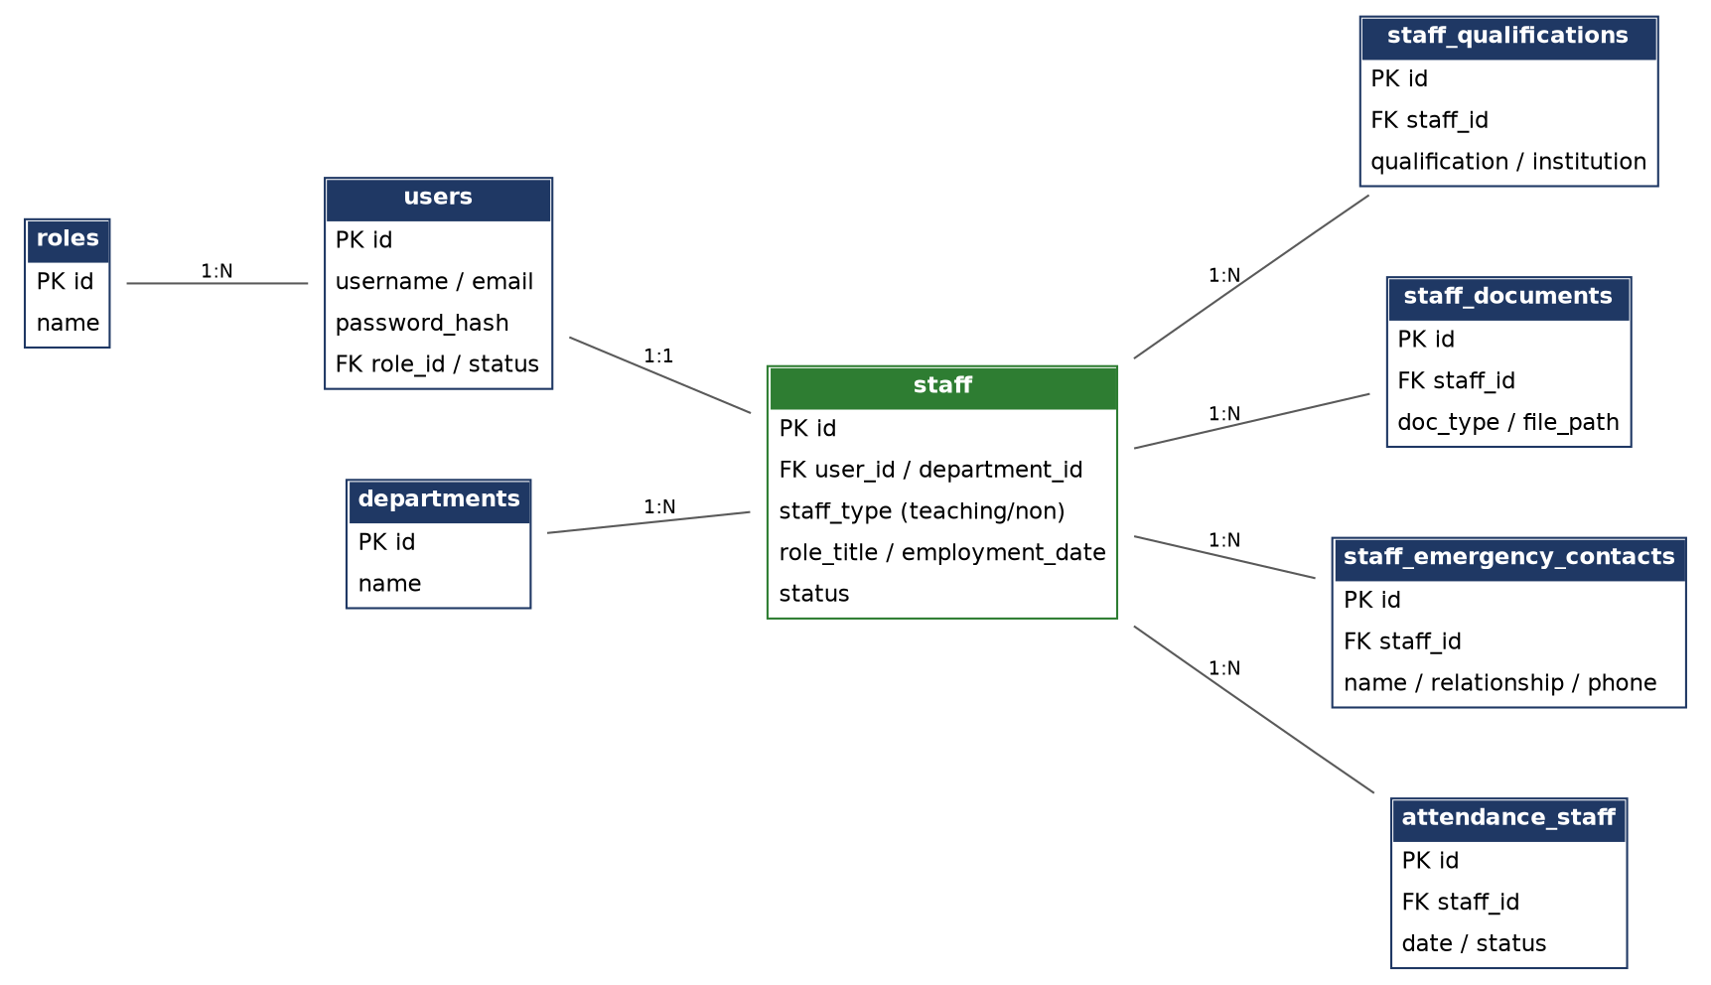
Figure 2 — HR & Staffing ERD

4. Sponsorship & Partnership ERD
Covers sponsor profiles (individuals, churches, ministries, NGOs, foundations, and general school sponsors) and their sponsorship assignments, which may target an individual learner, be left unassigned to a specific learner for group/school-wide programs, or reference a named program.
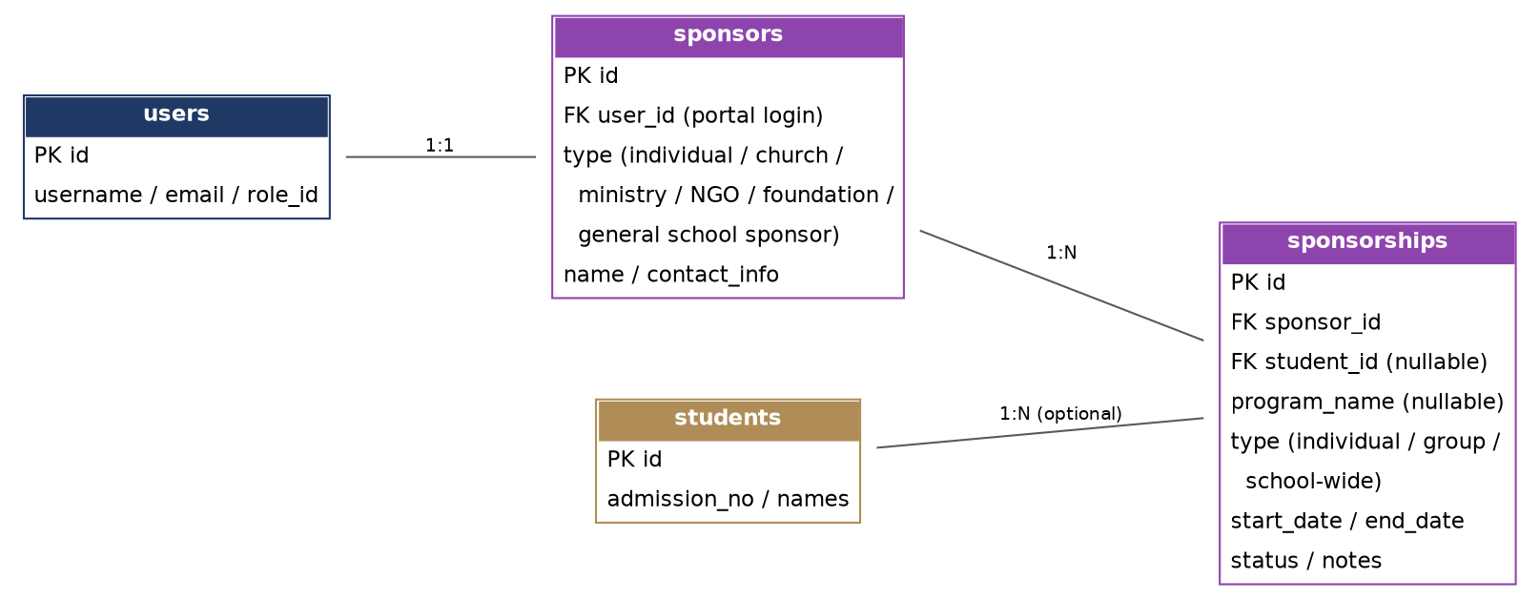
Figure 3 — Sponsorship & Partnership ERD

5. Communication, Visitor & Audit ERD
Covers announcements, internal messaging, visitor/volunteer records, and the system-wide audit log, all anchored to the central users entity.
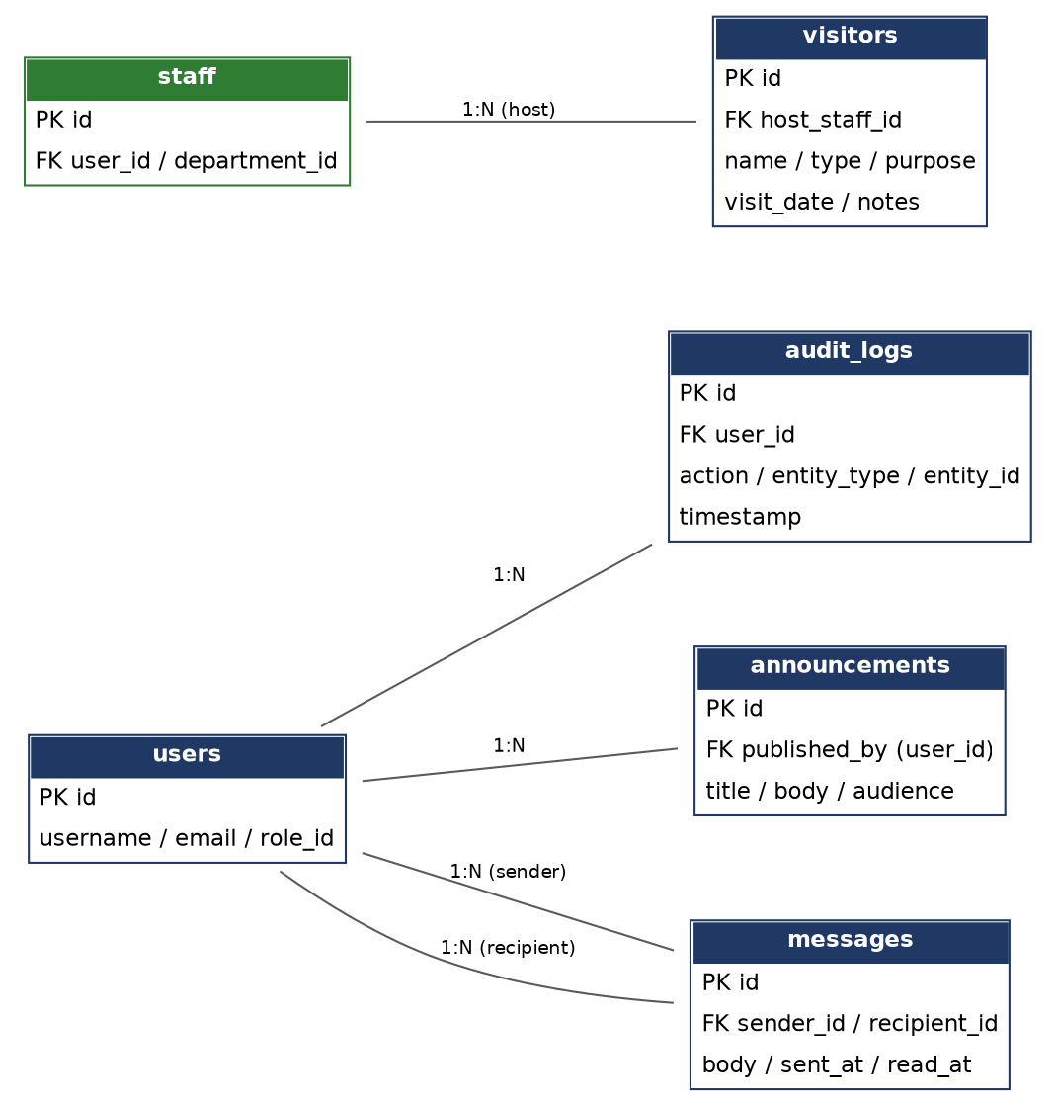
Figure 4 — Communication, Visitor & Audit ERD

6. Entity Summary
Entity | Purpose
roles | Defines the system's user roles (System Administrator, Head Teacher, etc.)
users | Central authentication record; every login-capable person (staff, parent, sponsor) has one
audit_logs | Records significant actions taken by users for security and accountability
academic_years / terms | Defines the school calendar structure
classes / streams / subjects | Defines the academic structure for Primary and Junior School
class_subject_teacher | Junction entity allocating teachers to subjects/classes/streams per term
timetable_entries | Defines the weekly class timetable
students | The central learner record, including admission number and current class/stream
guardians | Parent/guardian details linked to one or more students, optionally with portal login
student_medical_info | Medical conditions, allergies, and emergency contact for a student
student_documents | Uploaded documents for a student
promotions_transfers | History of class promotions and school transfers
assessments | Continuous and end-term assessment records per student/subject/term
report_cards | Generated report card per student per term
attendance_students | Daily attendance record per student
departments | Organizational departments for staff
staff | HR record for teaching and non-teaching staff
staff_qualifications / staff_documents / staff_emergency_contacts | Supporting HR records for staff
attendance_staff | Daily attendance record per staff member
sponsors | Profile of an individual or institutional sponsor, optionally with portal login
sponsorships | Assignment linking a sponsor to a learner, group, or program, with history
announcements | School-wide or targeted announcements
messages | Internal messages between authorized users
visitors | Records of visitors, volunteers, teams, and donors

