MANNA GOODNEWS ACADEMY
Education Management System (MGAEMS)

System Architecture Diagram

Document Version 1.0 | Prepared: July 31, 2026

1. Architectural Overview
MGAEMS follows a layered, modular architecture built on the MVC pattern. A single web/API server hosts independent business-logic modules that all share one authentication/RBAC service and one MySQL database. This allows each module (Student Management, Academic Management, CBC Assessment, Attendance, HR, Sponsorship, Communication, Visitor/Volunteer, Reporting, Administration) to evolve independently while remaining consistent on identity, permissions, and data.
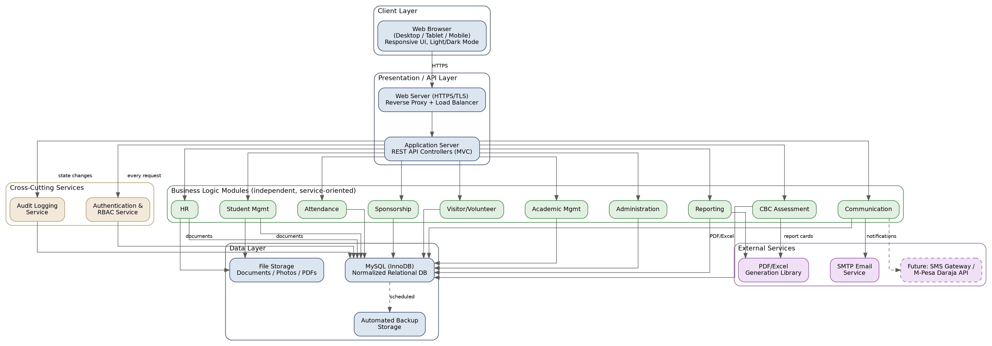
Figure 1 — MGAEMS System Architecture

2. Layer Descriptions
Layer | Responsibility
Client Layer | Responsive web UI rendered in the browser on desktop, tablet, and mobile; consumes the API over HTTPS
Presentation / API Layer | Reverse proxy/load balancer and the application server hosting versioned REST API controllers following MVC
Cross-Cutting Services | Authentication & RBAC enforced on every request; audit logging triggered on state-changing actions
Business Logic Modules | Ten independent, service-oriented modules, each owning its own business rules but sharing the same data layer and auth/audit services
Data Layer | Normalized MySQL (InnoDB) database, file storage for documents/photos/PDFs, and scheduled automated backups
External Services | SMTP for email notifications, a PDF/Excel generation library for reports and report cards, and (future) SMS/M-Pesa gateways

3. Key Architectural Principles
- Single sign-on across modules: one login and one session model serve every module.
- Enforcement at the service layer: RBAC checks happen in the API layer, not just the UI, so no module can be bypassed by a direct API call.
- Loose coupling: modules communicate through well-defined internal service interfaces/APIs rather than directly querying each other's tables where avoidable, easing future extraction into separate services if needed.
- Shared data layer: a single normalized MySQL database avoids data duplication and keeps referential integrity across modules (e.g., a student record is the same row referenced by Assessment, Attendance, and Sponsorship modules).
- Statelessness at the API layer: session state is externalized (database- or cache-backed) so the application server can scale horizontally behind the load balancer if needed.
- Defense in depth: TLS in transit, hashed credentials at rest, input validation and output encoding at the API layer, and audit logging of sensitive actions.

4. Deployment Topology (Summary)
A minimal production deployment consists of one application server (which may host the reverse proxy, API, and static assets) and one MySQL database server, which may initially co-locate on a single host for a school of this size and scale out to separate application/database tiers as usage grows. Full deployment steps are provided in the companion Deployment Guide.

