MANNA GOODNEWS ACADEMY
Education Management System (MGAEMS)

UI/UX Wireframes

Document Version 1.0 | Prepared: July 31, 2026

1. Purpose
This document presents low-fidelity wireframes for the core MGAEMS screens, illustrating layout, navigation, and key components ahead of visual/UI design. These wireframes intentionally omit final colors, typography, and imagery; they focus on structure and content placement, consistent with the responsive, sidebar-navigated, card-based interface described in the SRS (Section 4.1).
Common patterns used across all screens:
- Persistent top bar with system name, notifications, and user profile menu
- Collapsible sidebar navigation grouped by module (visible to authenticated staff roles)
- Card-based summary widgets on dashboards
- Consistent primary-action button styling (navy, bold) and secondary/outline buttons
- Light/dark mode toggle available from the top bar or profile menu

2. Login Screen
Entry point for all users; a single, role-agnostic login form that routes to the appropriate dashboard after authentication.
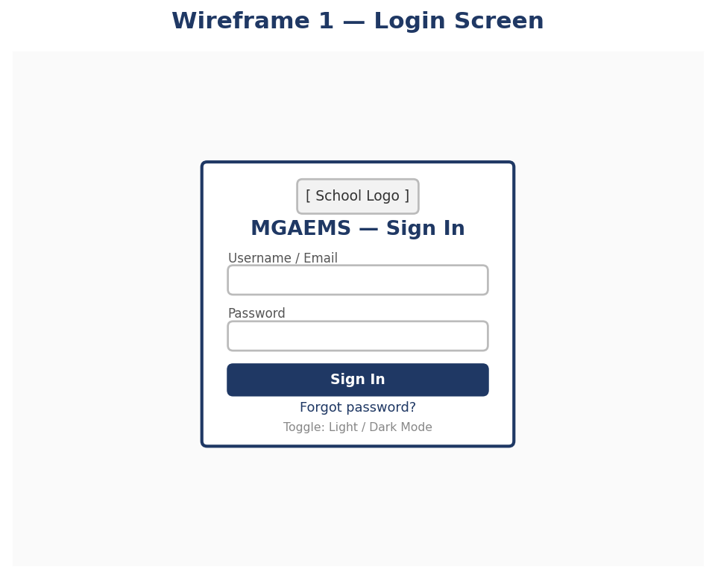
Wireframe 1 — Login Screen

3. Role-Specific Dashboard
Example shown for the Head Teacher role: sidebar navigation, key statistics, an attendance trend chart, recent activity, and quick shortcuts. Other roles see the same layout populated with role-relevant cards and a narrower sidebar (per the User Role Matrix).
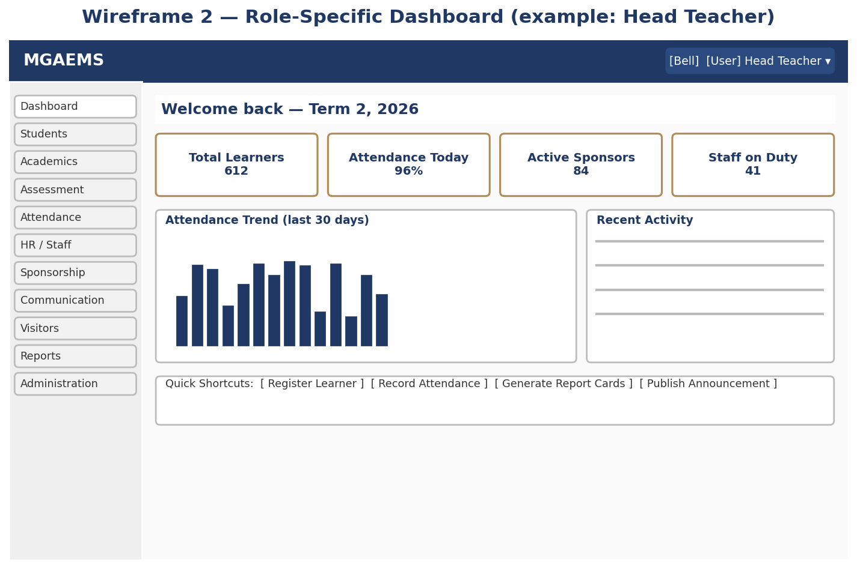
Wireframe 2 — Role-Specific Dashboard

4. Register New Learner
A multi-step form (Bio-Data → Guardians → Medical Info → Documents) used by administrators and Head Teacher/Deputy to register a new learner, with an auto-generated admission number.
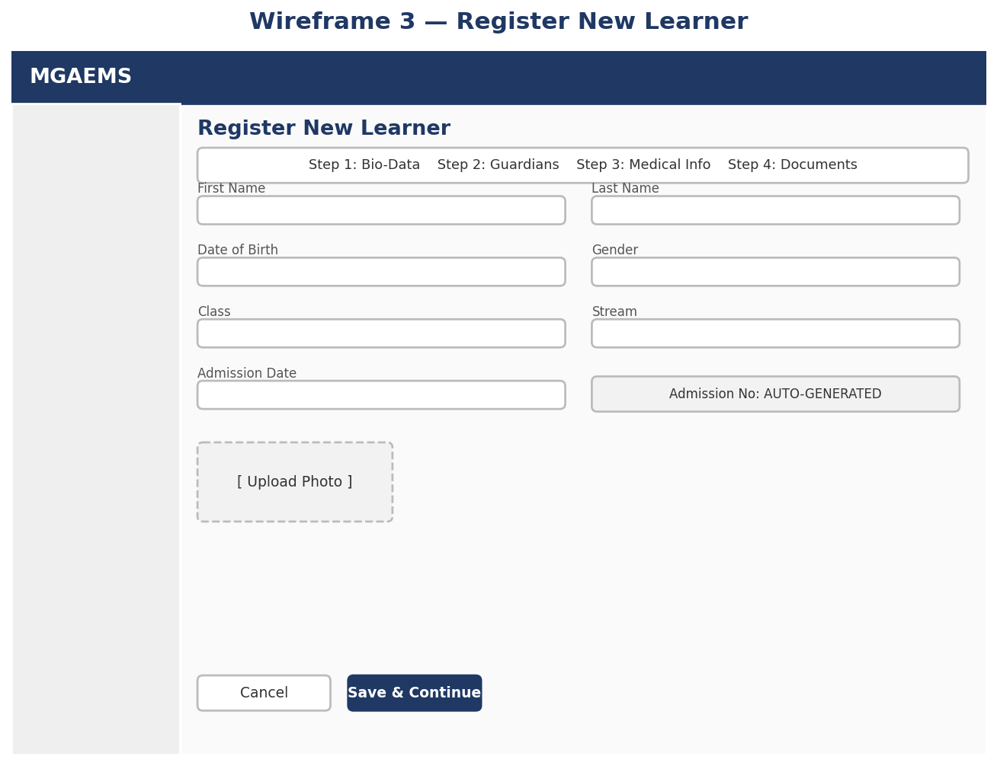
Wireframe 3 — Register New Learner

5. Report Card View
Displays a learner's per-subject CA/exam scores, CBC competency ratings, and remarks, with the overall Head Teacher remark and PDF download/print actions. Viewable by staff for their own classes, and by the relevant Parent/Guardian or Sponsor for their own learner only.
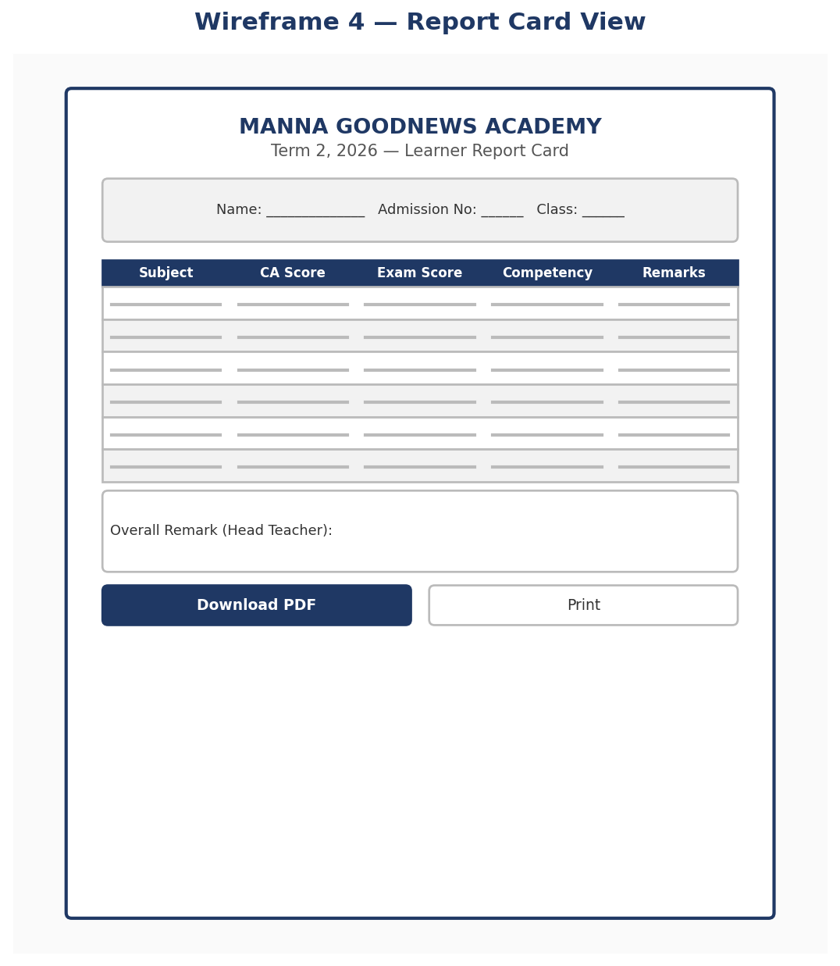
Wireframe 4 — Report Card View

6. Parent Portal — My Child
Self-service view for a parent/guardian, scoped strictly to their own child(ren), with tabs for Attendance, Report Cards, Academic Progress, and Announcements.
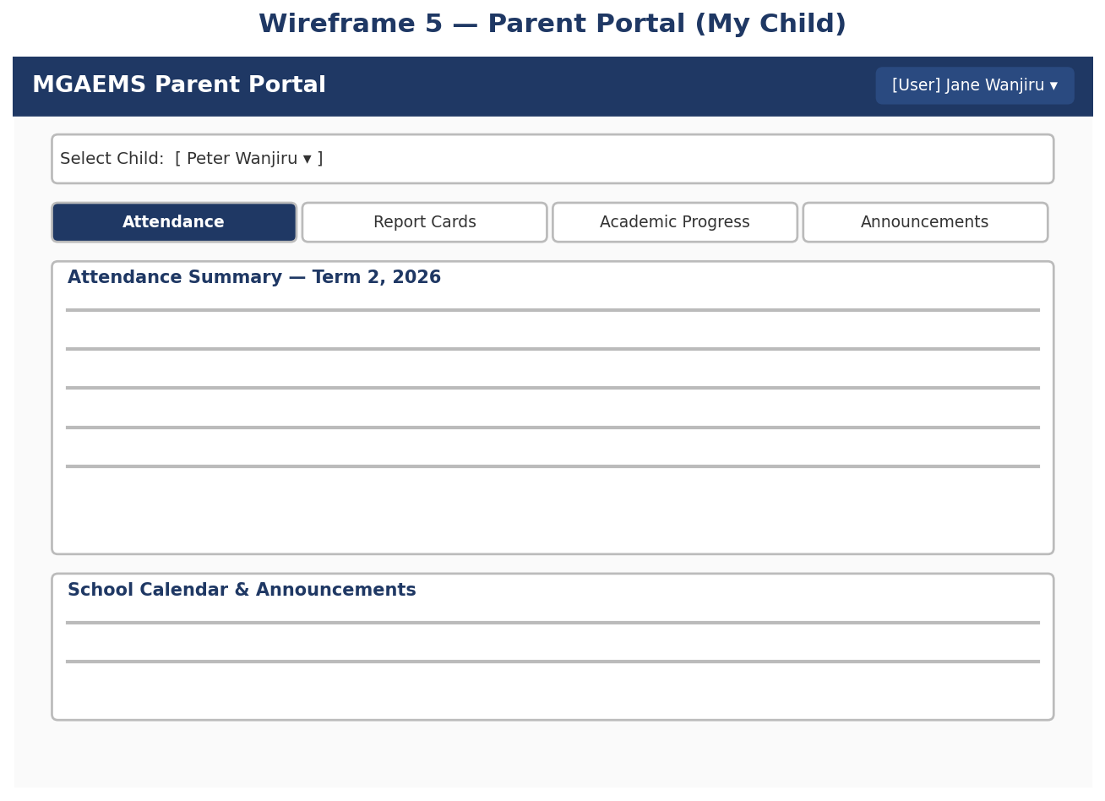
Wireframe 5 — Parent Portal

7. Sponsor Portal — My Sponsorship
Self-service view for a sponsor, scoped strictly to their sponsored learner(s) or program, with attendance summaries, academic reports, teacher comments, and appreciation messages.
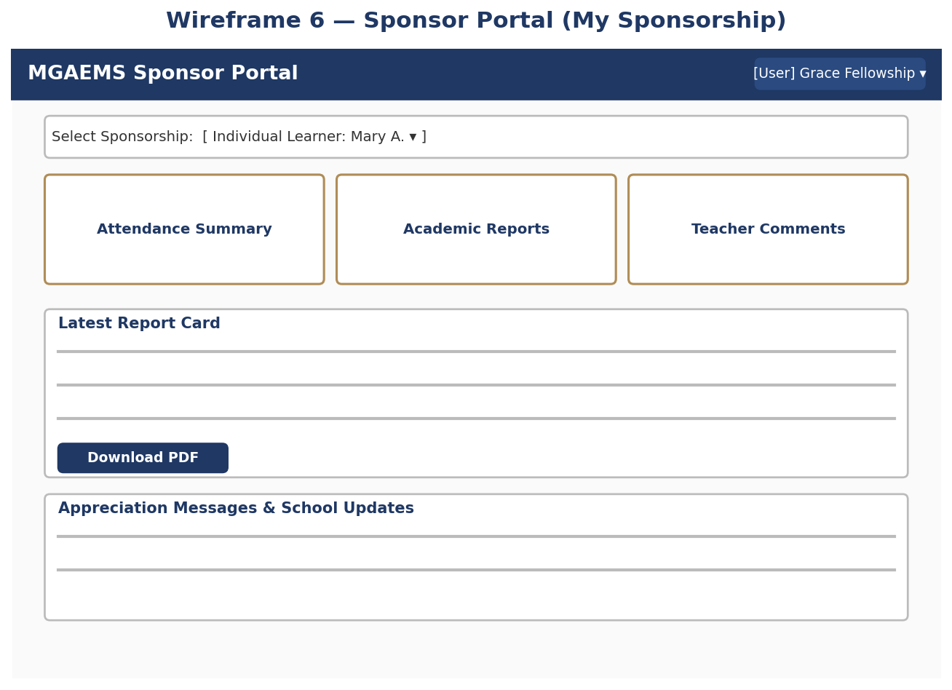
Wireframe 6 — Sponsor Portal

8. Responsive Behavior Notes
Breakpoint | Layout Adaptation
Desktop (>= 1200px) | Full sidebar visible; multi-column dashboard cards; side-by-side form fields
Tablet (768–1199px) | Sidebar collapses to icons with labels on hover/tap; dashboard cards wrap to 2 columns
Mobile (< 768px) | Sidebar becomes a slide-out drawer via a hamburger menu; cards and form fields stack to a single column; tables become horizontally scrollable or convert to stacked card lists

9. Accessibility Notes
- All interactive elements (buttons, form fields) are keyboard-navigable and carry visible focus states.
- Color is never the sole indicator of status (e.g., attendance status uses both color and a text/icon label).
- Form fields include visible labels (not placeholder-only) and inline validation messages.
- Minimum contrast ratios follow WCAG 2.1 AA guidance for both light and dark modes.

